PISTON 2019 Daily Science Summary

10 September Daily Summary:
LearJet Flight and 95L outskirts
PISTON 2, R/V Sally Ride

Prepared by: Brenda Dolan, Kyle Chudler, Adam Clayton, and Marqi Rocque

Today was the second consecutive day of coordination with CAMPEx, this time with the LearJet working around the Sally Ride. There were multiple cloud layers throughout the flight, including shallow boundary layer clouds with heights on the order of 2 km, AltoCu and AltoStratus at 5 km, and some high cirrus (maybe 10 km?). The midlevel clouds showed up on SEA-POL at times. The LearJet focused on a very small cell north of the ship, with an echo top of around 2km. The flight path is given in Fig. 1, and an RHI of the “storm” they were making passes through is in Fig. 2. The Lear reported several interesting things, including drizzle below the cloud (on which they got droplet spectra), and reported mostly liquid at -10 C as they ascended through the altostratus layer. At one point Derek noted that the HSRL showed the AltoCu layer at 7.5 km was liquid but possibly precipitating ice, but the Lear reported mostly liquid with a few large drops and no clear indication of ice at -10 to -11 C. The cell essentially rained out by 0238 UTC from radar, with the Lear confirming. Overall our tactic of RFI mitigation during aircraft ops of turning the port antenna away from SEA-POL seems to have resulted in some good data.

The ship spent the day once again with 95 L to the west, and dry conditions to the north (Fig. 3). After a brief time with a weak low-level southwesterly monsoon flow yesterday, balloon soundings showed that the sfc-500mb winds slowly rotated back to a northerly or easterly direction throughout the day (Fig. 4). In fact a time-height series from the soundings has shown the onset of easterlies throughout the column by 18Z, in contrast to the sheared flow we’ve been sampling with lower level westerlies and upper level easterlies (Fig. 5). This may be the influence of 95L as it grows larger, more organized, and begins to move westward.

On radar, the day was once again characterized by small, shallow convection with echo tops rarely going above 7km. Small, newly developing storms with very high ZDR were once again common. Around 0900, one of these cells passed within 5km of the ship (Fig. 6), which allowed for a close up RHI of the high ZDR (Fig 7.).

That night, around 1230Z, a larger area of precipitation begin to appear in SEAPOL’s view to the east (Fig. 8). Initially the edges of the precipitation were getting removed by the QC process, likely due to being obscured by second trip echo from the stronger precipitation still out of range to the east.

Zooming out, water vapor satellite imagery showed a large area of convection which had formed in the ops region (Fig. 9). This region was arguably associated with 95L, although the invest is still very disorganized and it is tough to decisively say what is and is not “part” of it. Regardless, as the complex moved further into view, RHIs revealed areas of strong embedded convection with echo tops above 15km (Fig. 10). The edge of the storm overtook the ship around 1630Z (Fig. 10), with moderate rain observed. No lightning was observed.

Light-to-moderate rain continued at the ship until around 1930Z, as a large area of stratiform rain moved westward over the radar. Overall, this complex was not particularly well organized, (just a broad area of stratiform with embedded convection), however a good time-series of RHI’s documenting the progression of the system overhead was obtained.

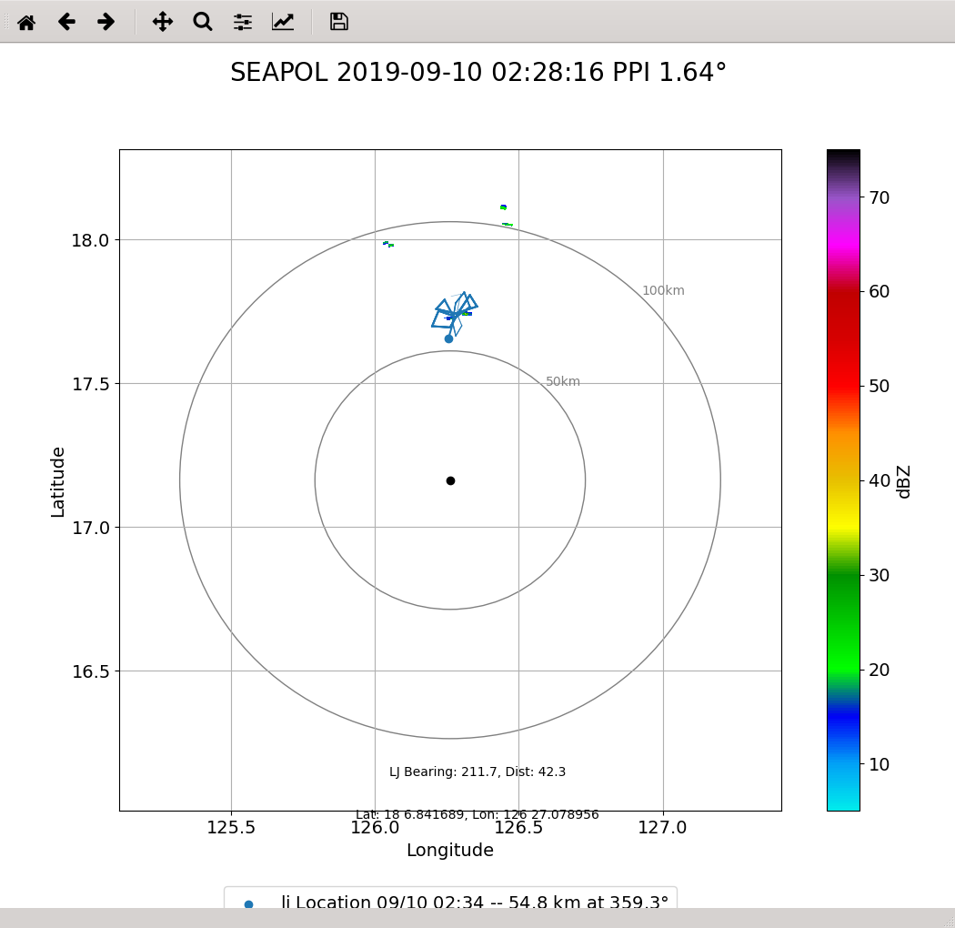

Fig 1. Flight path of the LearJet

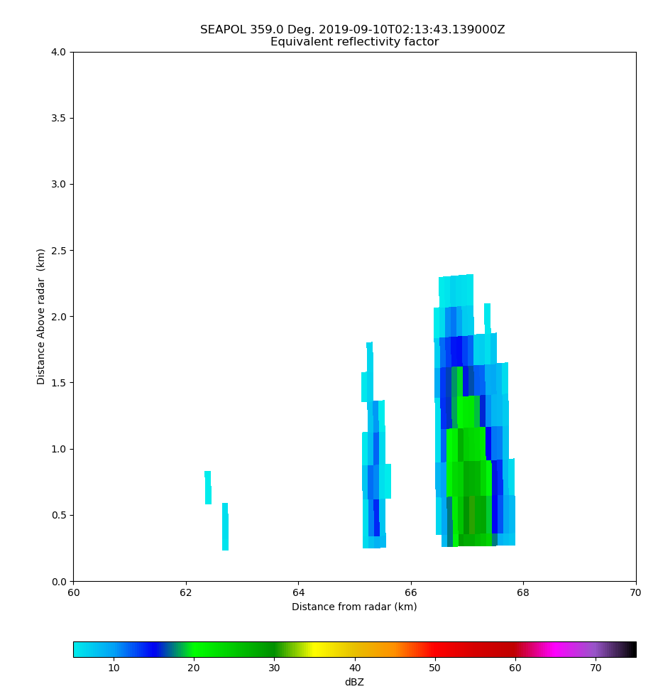

Fig. 2: A very exciting RHI of the storm the LearJet was making passes through.

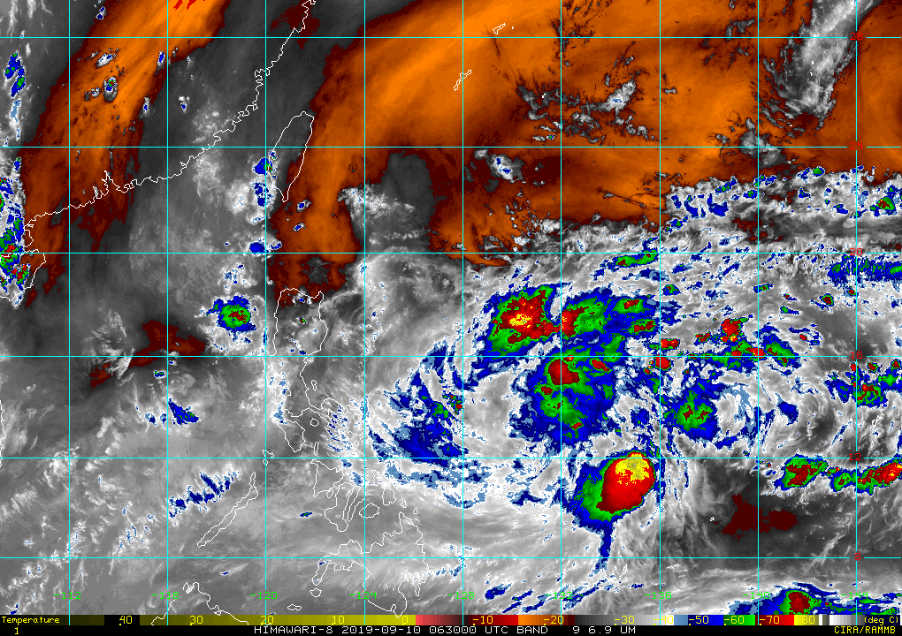

Fig 3.: Water vapor imagery with the ship’s location marked with a blue circle.

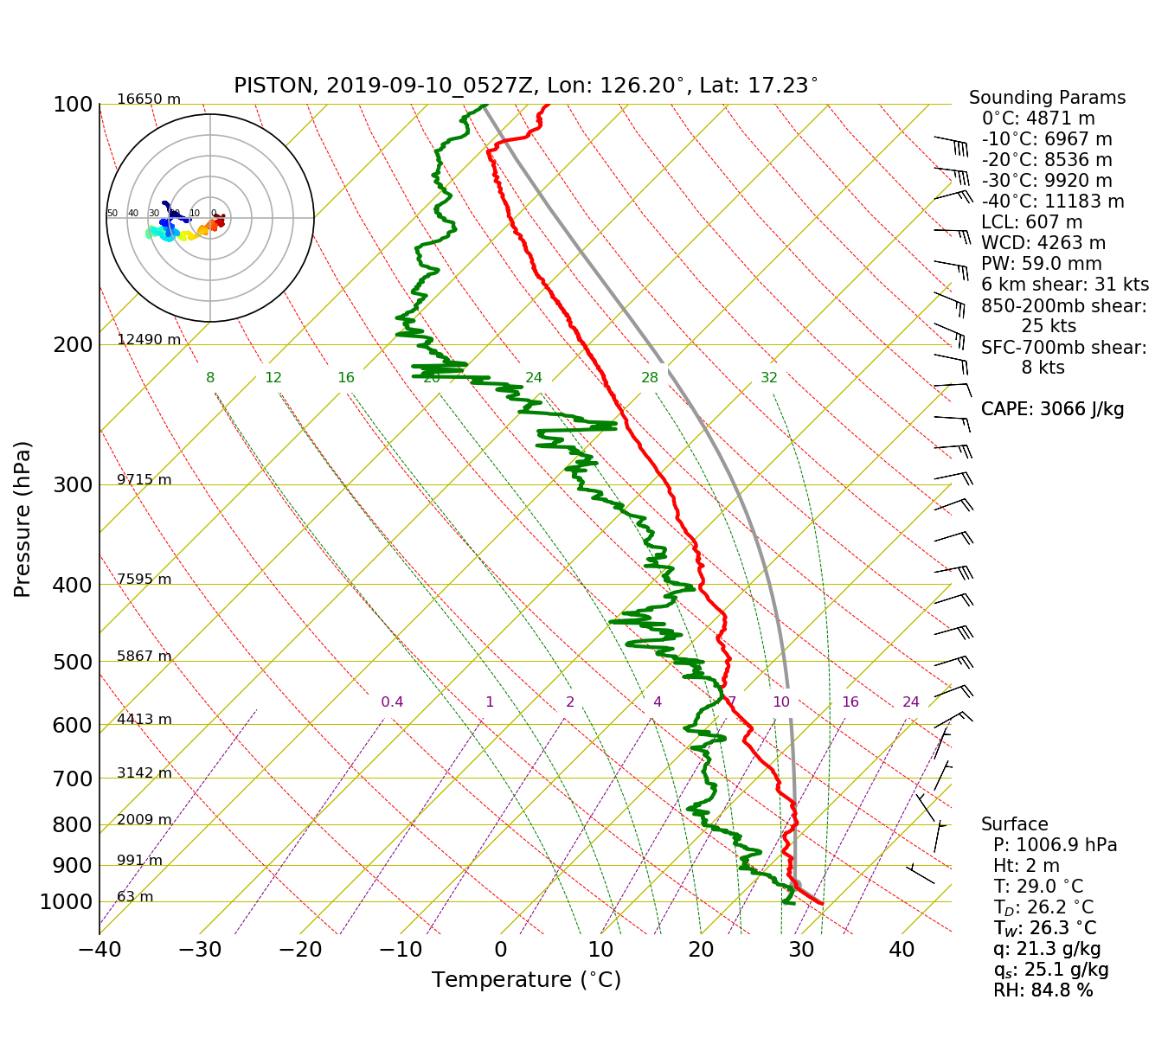
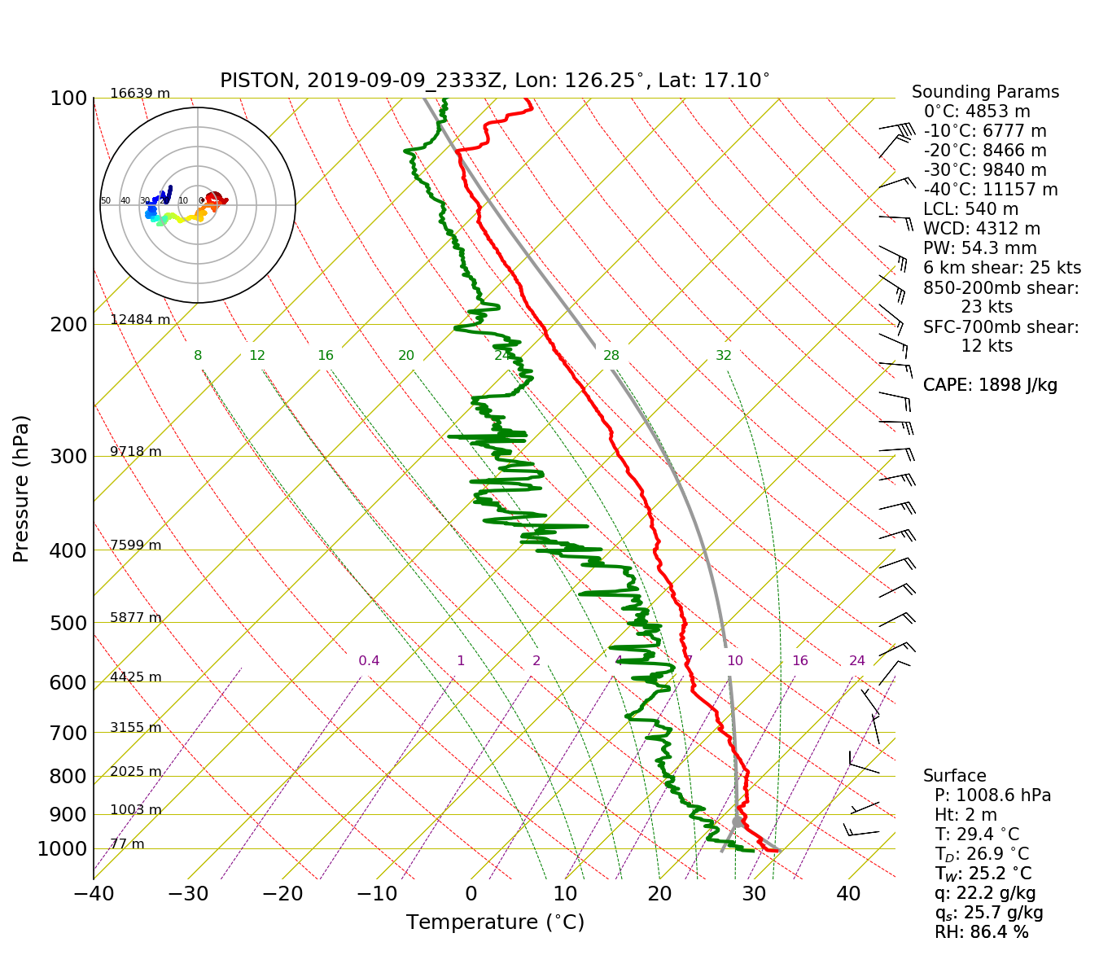

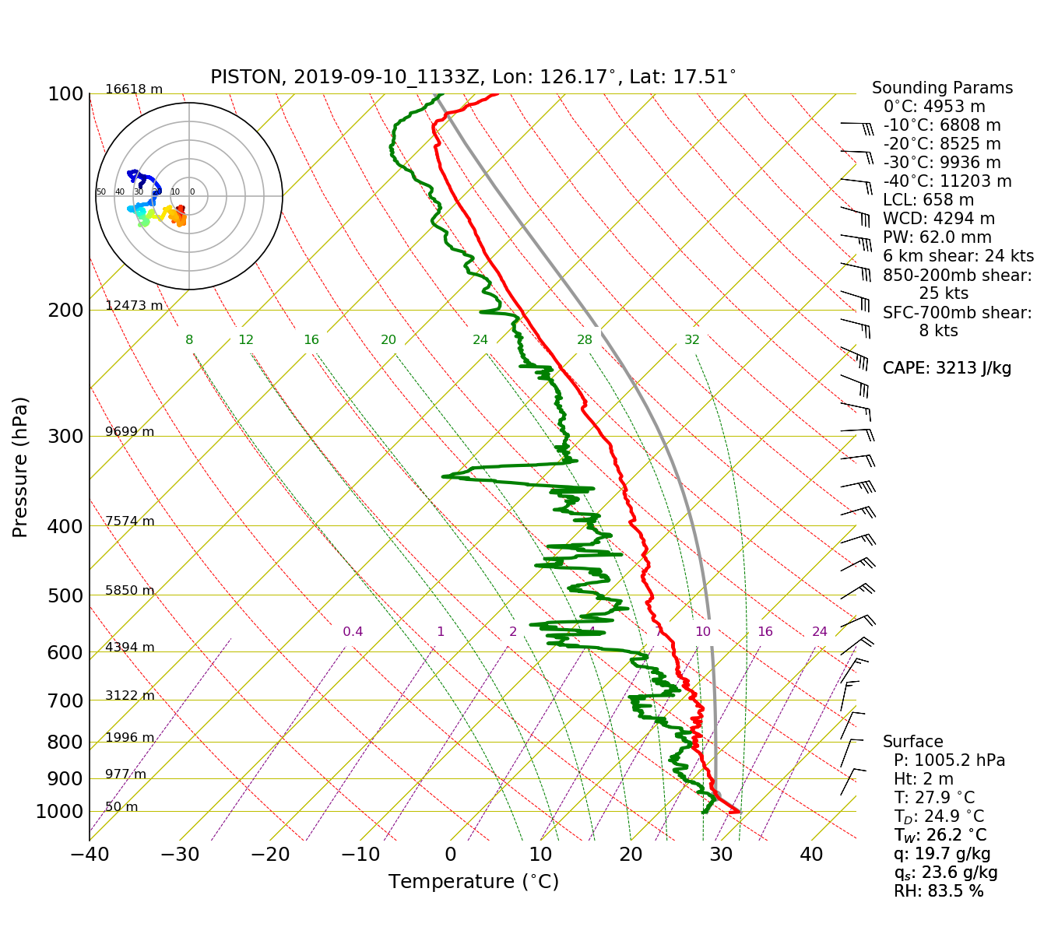
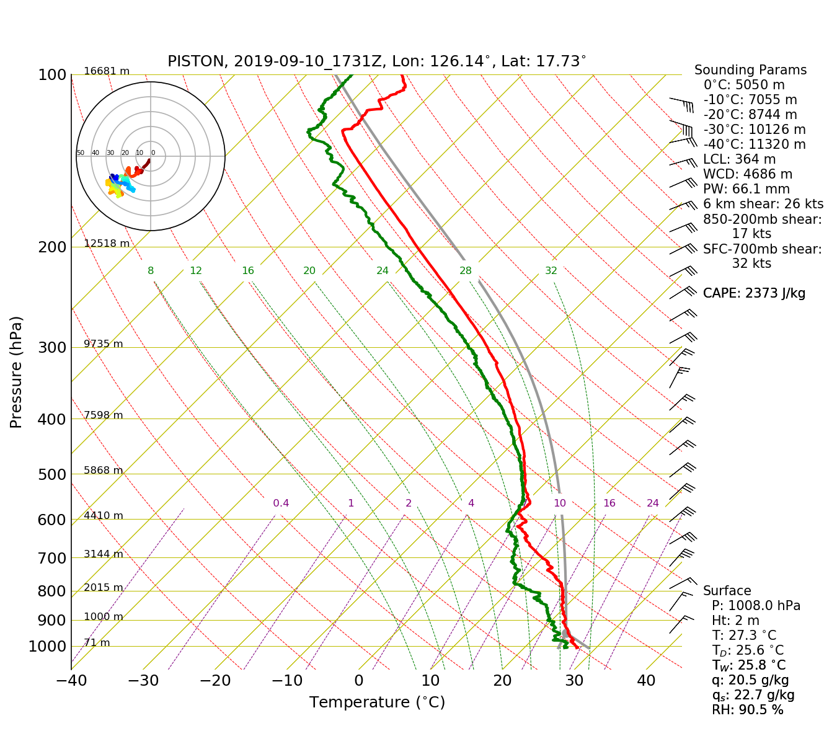
Fig 4: 00,06,12,and 18Z soundings
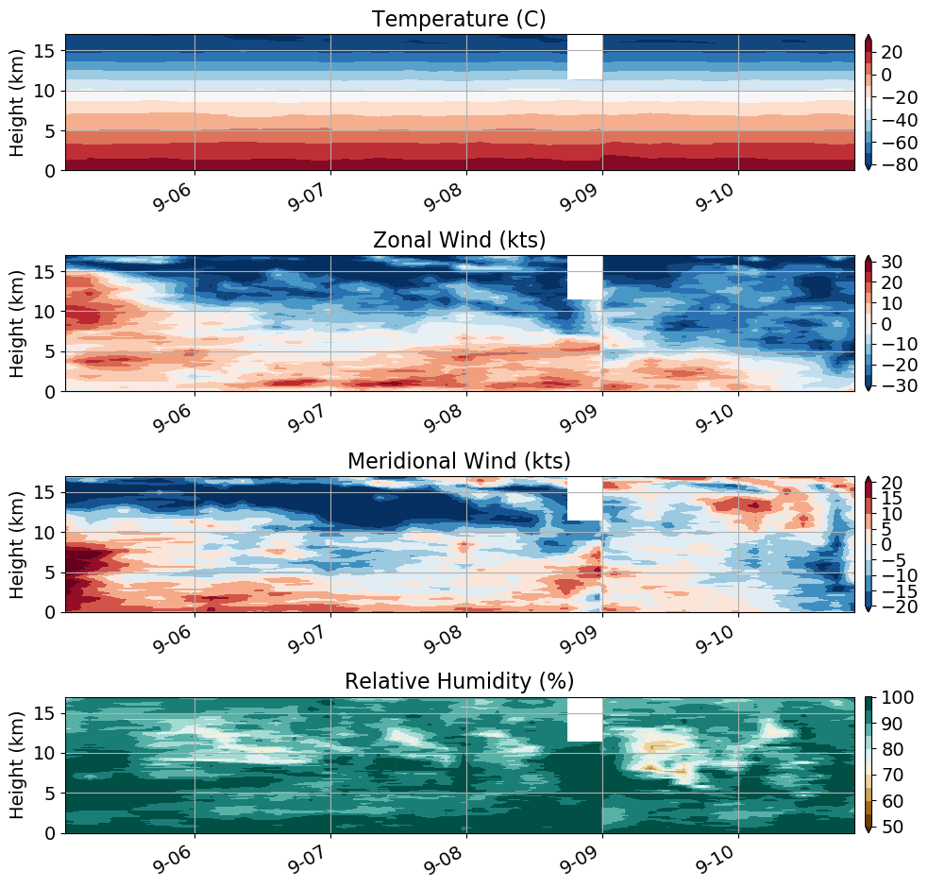
Fig. 5: Time-height series of the soundings. Note the onset of the easterlies.

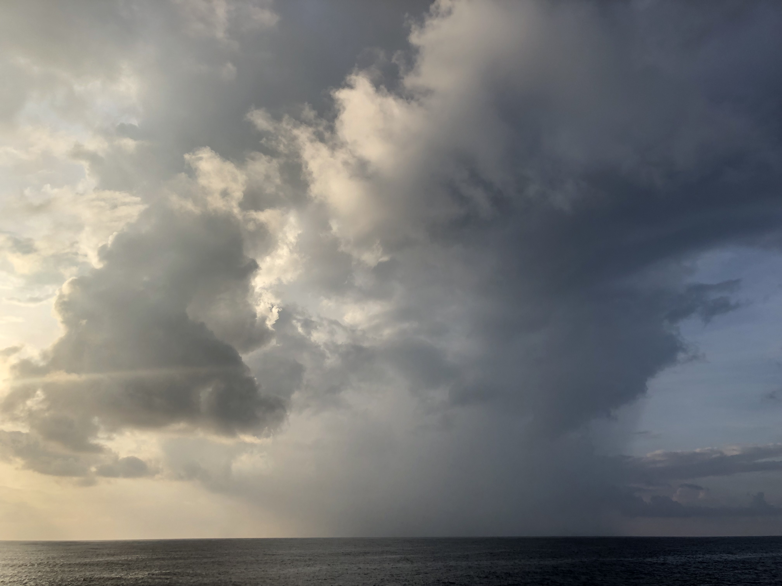

Fig 6: Photo of the small storm which passed close to the ship
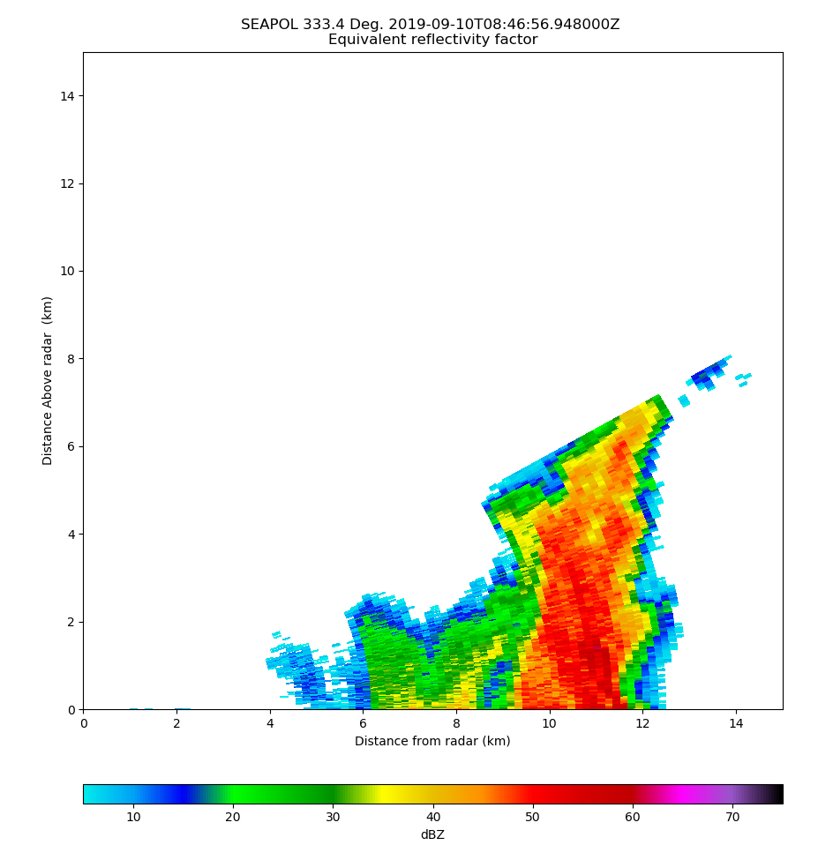
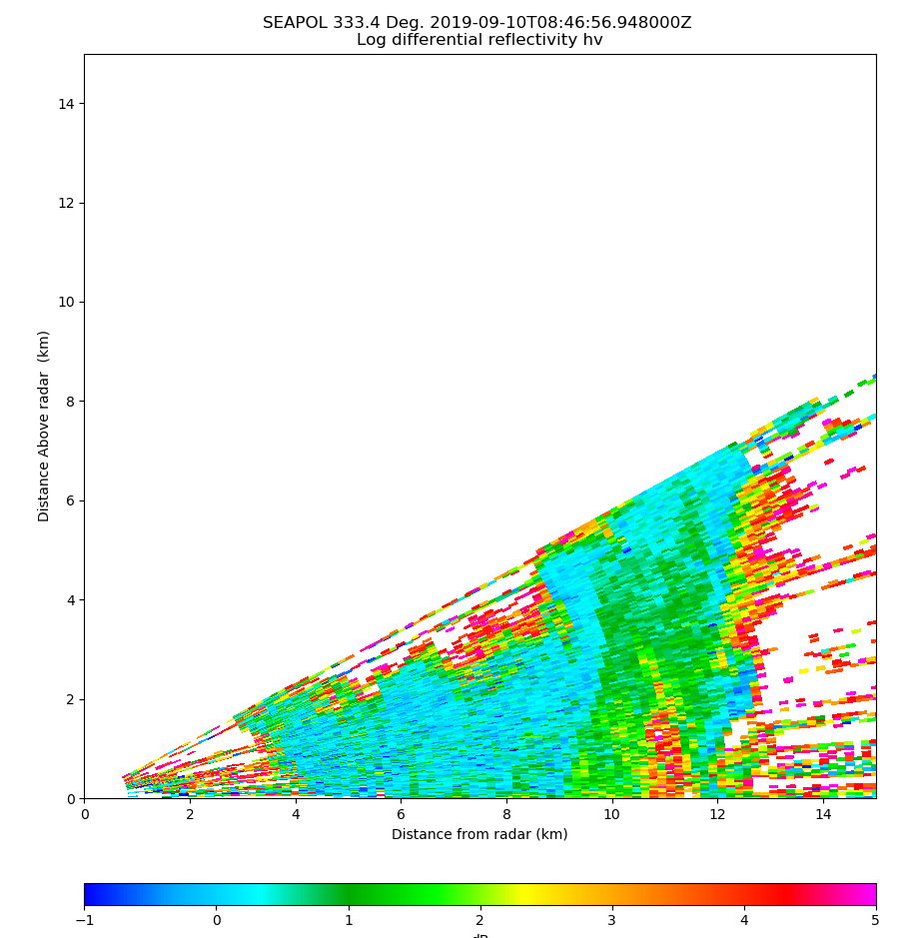

Fig. 7: RHI of the above storm, demonstrating a high-ZDR core (4-5 dB)
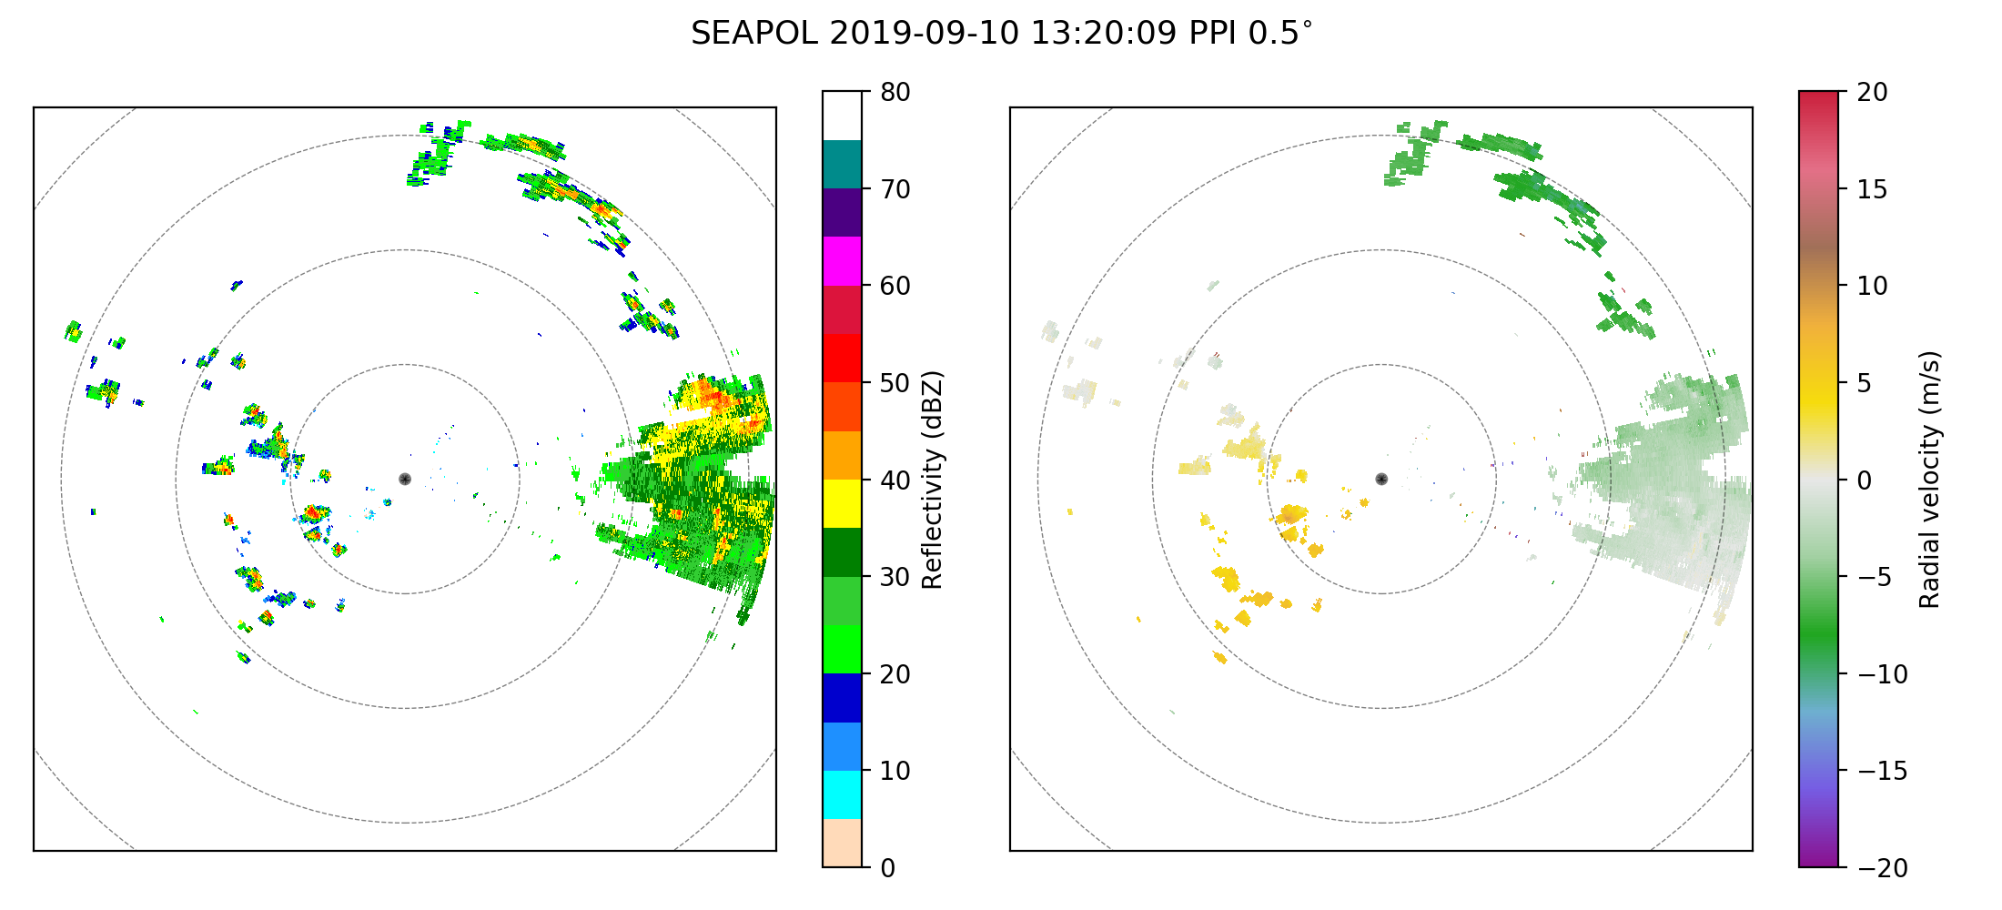
Fig. 8: Convective system entering SEAPOL’s range with second-trip issues.

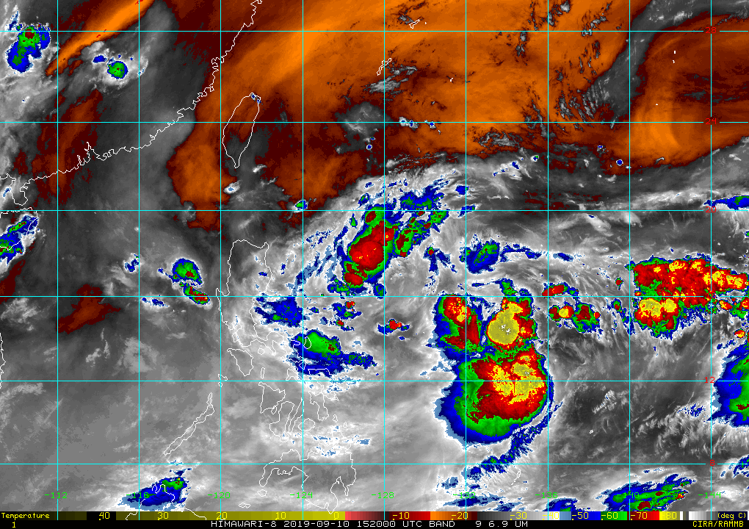

Fig. 9: Water vapor imagery valid at 1520
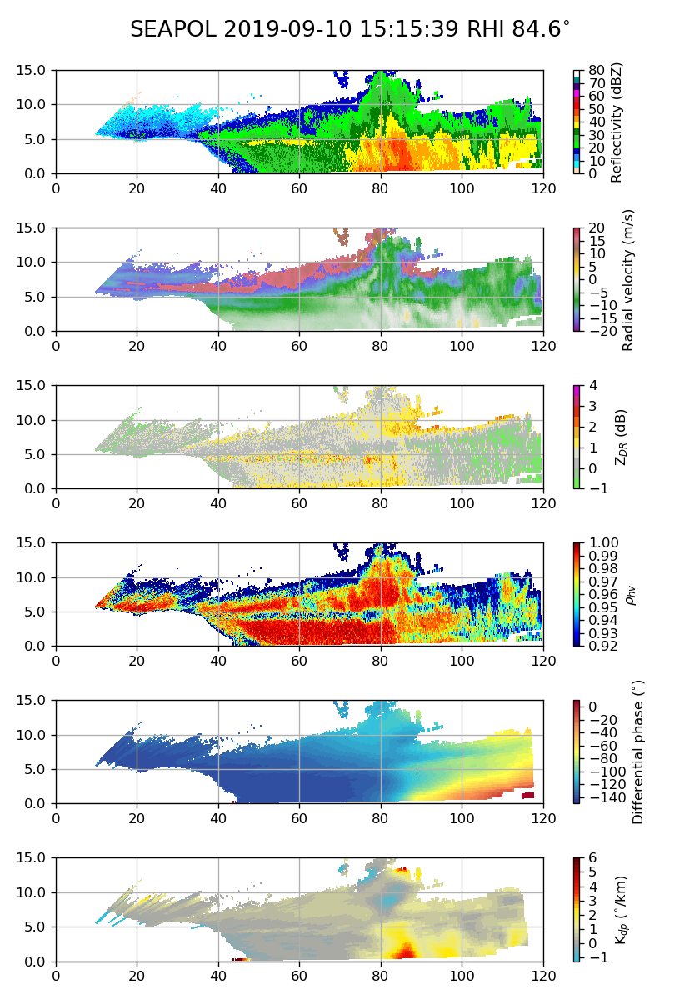

Fig. 10: RHI revealing strong embedded convection

