PISTON 2019 Daily Science Summary

13 September Daily Summary:
Dry air continues to exert influence
PISTON 2, R/V Sally Ride

Prepared by: Kyle Chudler, Brenda Dolan, Adam Clayton, Marqi Rocque, and Jim George

Not much action at the ship today, as a remarkably dry air mass continued to hamper the coverage and intensity of convection. Water vapor satellite imagery once again shows the operations area sandwiched between dry air to the north and west, and slowly organizing 95W to the east and south (Fig. 1). Although moisture slowly increased in the radiosonde profiles through day day (Fig. 2), the mid-level dry layer appeared to limit the growth of any convection that managed to develop at the surface, with radar echo heights rarely reaching above 6km with any storm.

Although precipitation has been suppressed, interesting data can still be found in a time-height plot of sounding data (Fig 3). Beginning around 00Z on Sept. 12, a pocket of dry air materializes between about 7-13 km MSL. As time moves on, this layer dries out further, and begins to descend towards the surface. Moving in tandem with this dry air mass is an area of mid-upper level southerly winds (positive meridional winds), which begins in the upper troposphere and then moves downward. Also interesting is the small layer of moisture rich air which actually appears to rise from 5 km to about 8 km MSL over a period of about 24 hours, even while the larger dry air mass around it was descending.

The Lear Jet operated in the area from 0600 UTC to 0740 UTC. This mission was somewhat complicated by the fact that the Lear was not reporting their location in realtime, but VHF comms and Xchat served to coordinate location with the Sally Ride. SEA-POL supported them with a mix of narrow, short PPI volumes (~2 minutes) and numerous RHIs. At times we opened up scanning in order to see what else might be of interest in the area to help direct the next target. While they had hoped for deeper convection, they sampled mostly warm rain and mixed phase cumulus with tops below 8 km because convection could not break through the cap. Initially they worked a couple of isolated warm rain cells to our NW at around 313. These were the standard ubiquitous warm rainers of the tropics (Fig. 4), with the Lear reporting robust warm rain processes and similar evolution in all the cells they sampled in that area. We then sent them to a deeper convective cluster that was at the very edge of our view (Note: The ship heading was an optimization problem of maintaining internet signal in order to communicate with the aircraft, keeping the ship from rolling too much for RHIs, and trying to keep an active view of the western part of the domain. Therefore a heading of 260 was about the best we could do). They reported more interesting microphysics in these quickly growing cells, including some ice in the turrets; graupel, columns, and LWC at -5 C (Fig. 5). The clouds began dissipating visually and on radar around 0718 UTC. At this point there were a few isolated cells to the west, and after the Lear penetrations they reported “fast growing turret at -4 C, with lots of large drops but no obvious ice” (Fig. 6). We confirmed that “big drops” to the Lear are 1-2 mm. Lear also reported lots of drizzle drops in the warm rain region ~0.5 mm. The Lear left for home at 0740 UTC.
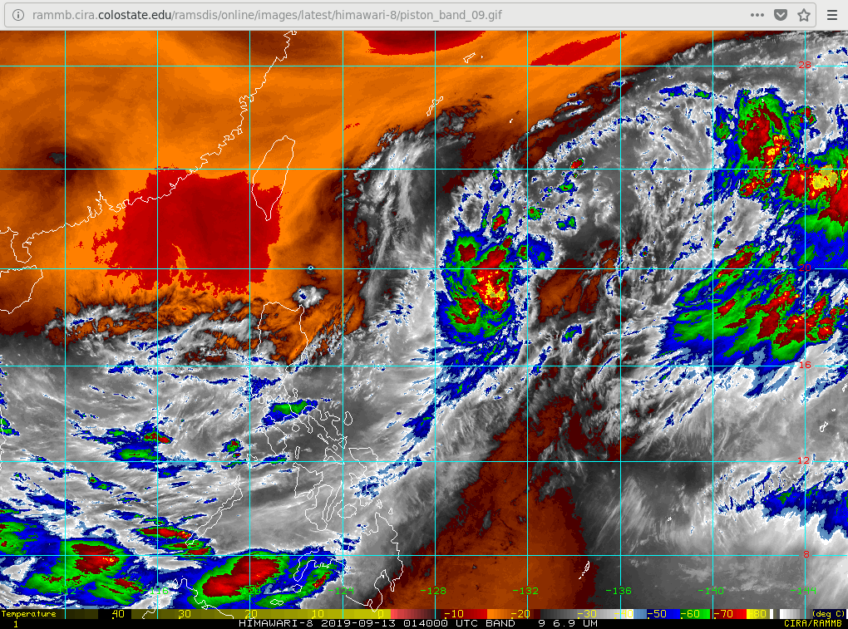
Fig. 1 Himarawi water vapor imagery, valid at 0140Z

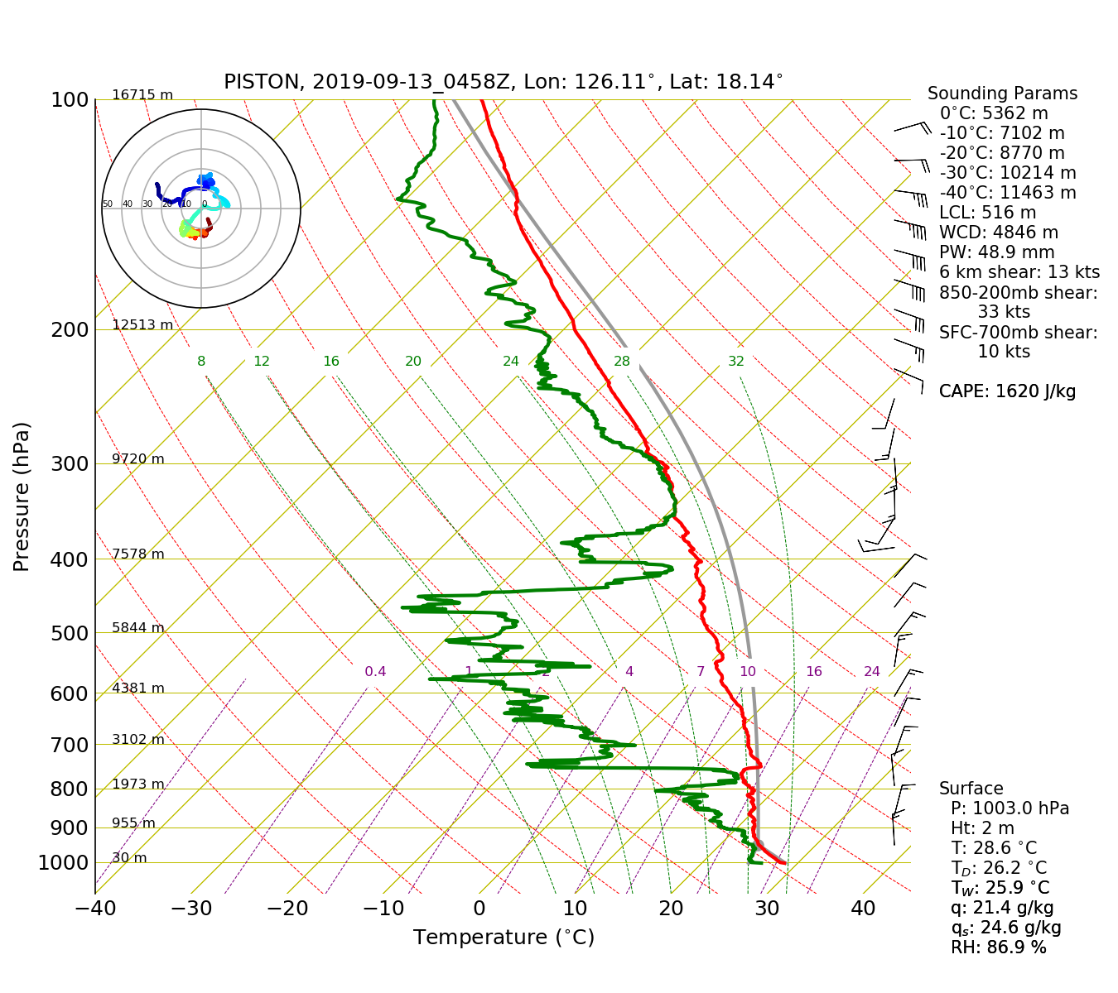
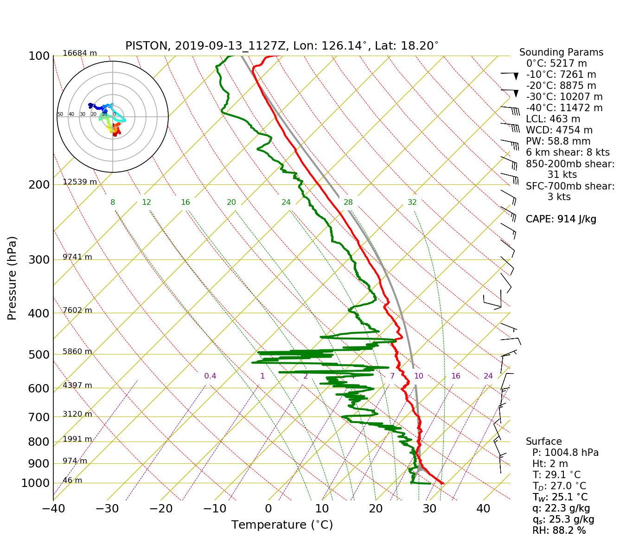
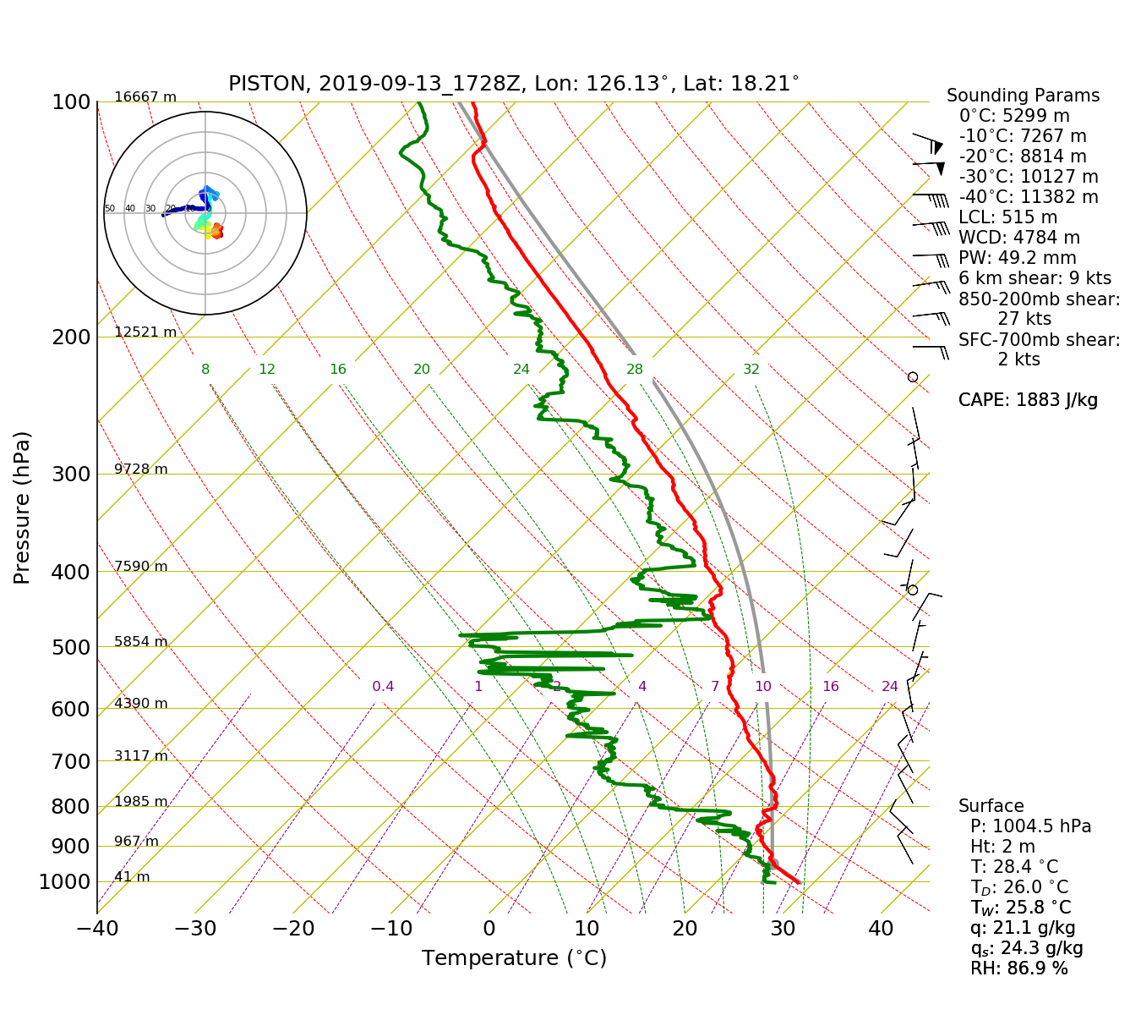
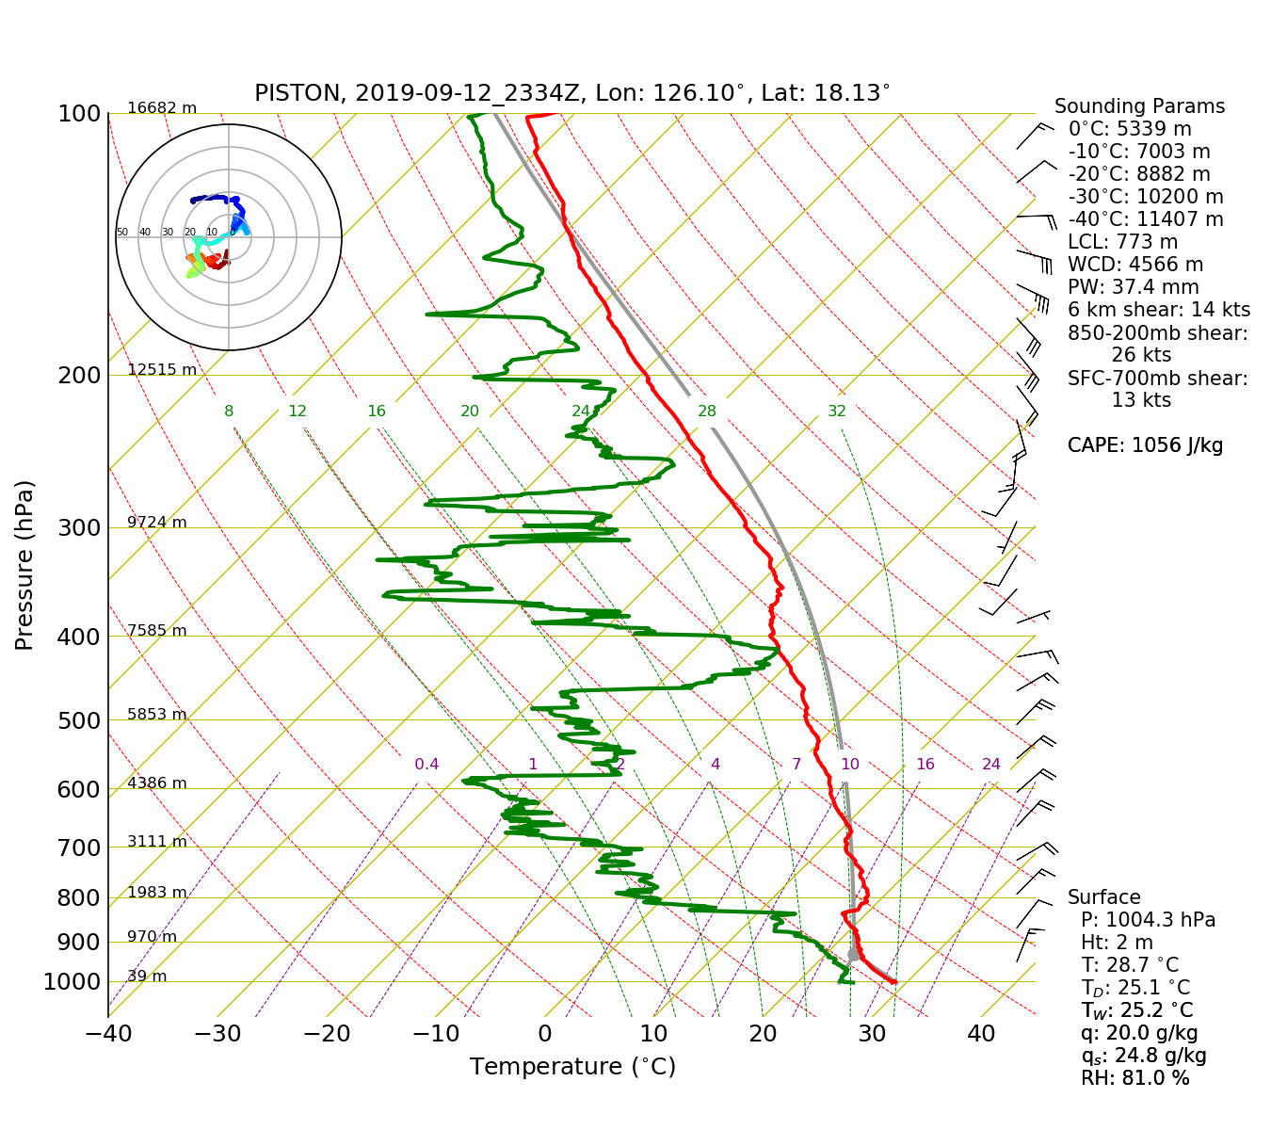

Fig. 2: 00,06,12,18Z Soundings

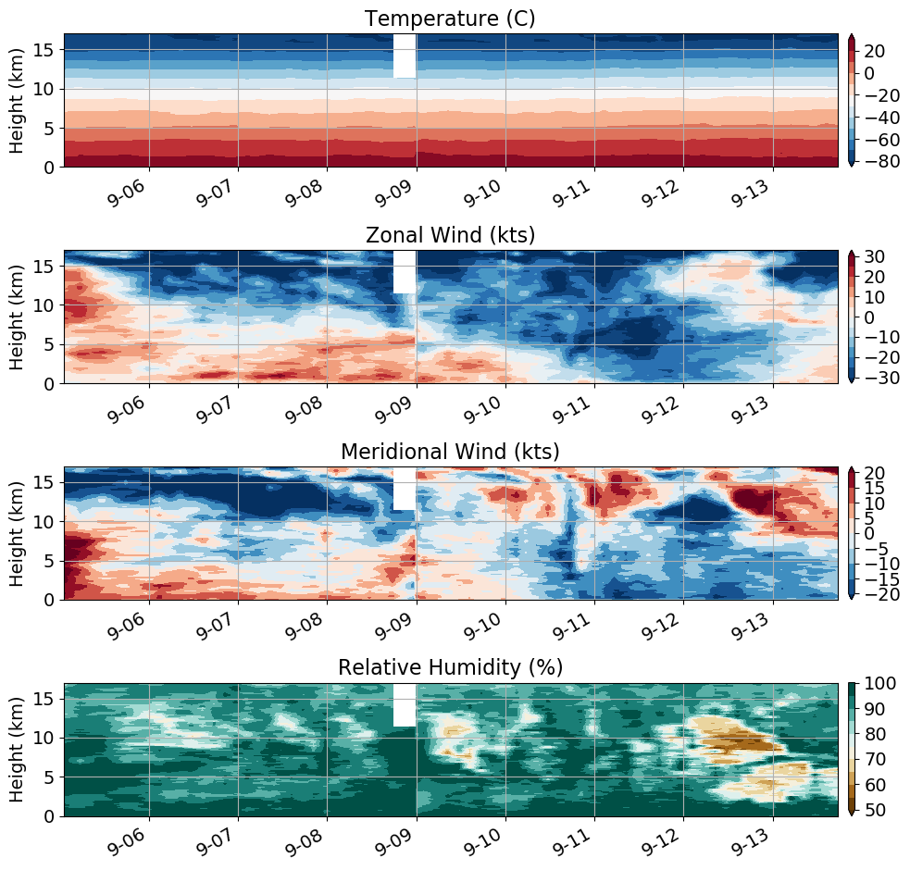
Fig. 3: Time-height plot of radiosonde data, with features mentioned in the discussion highlighted

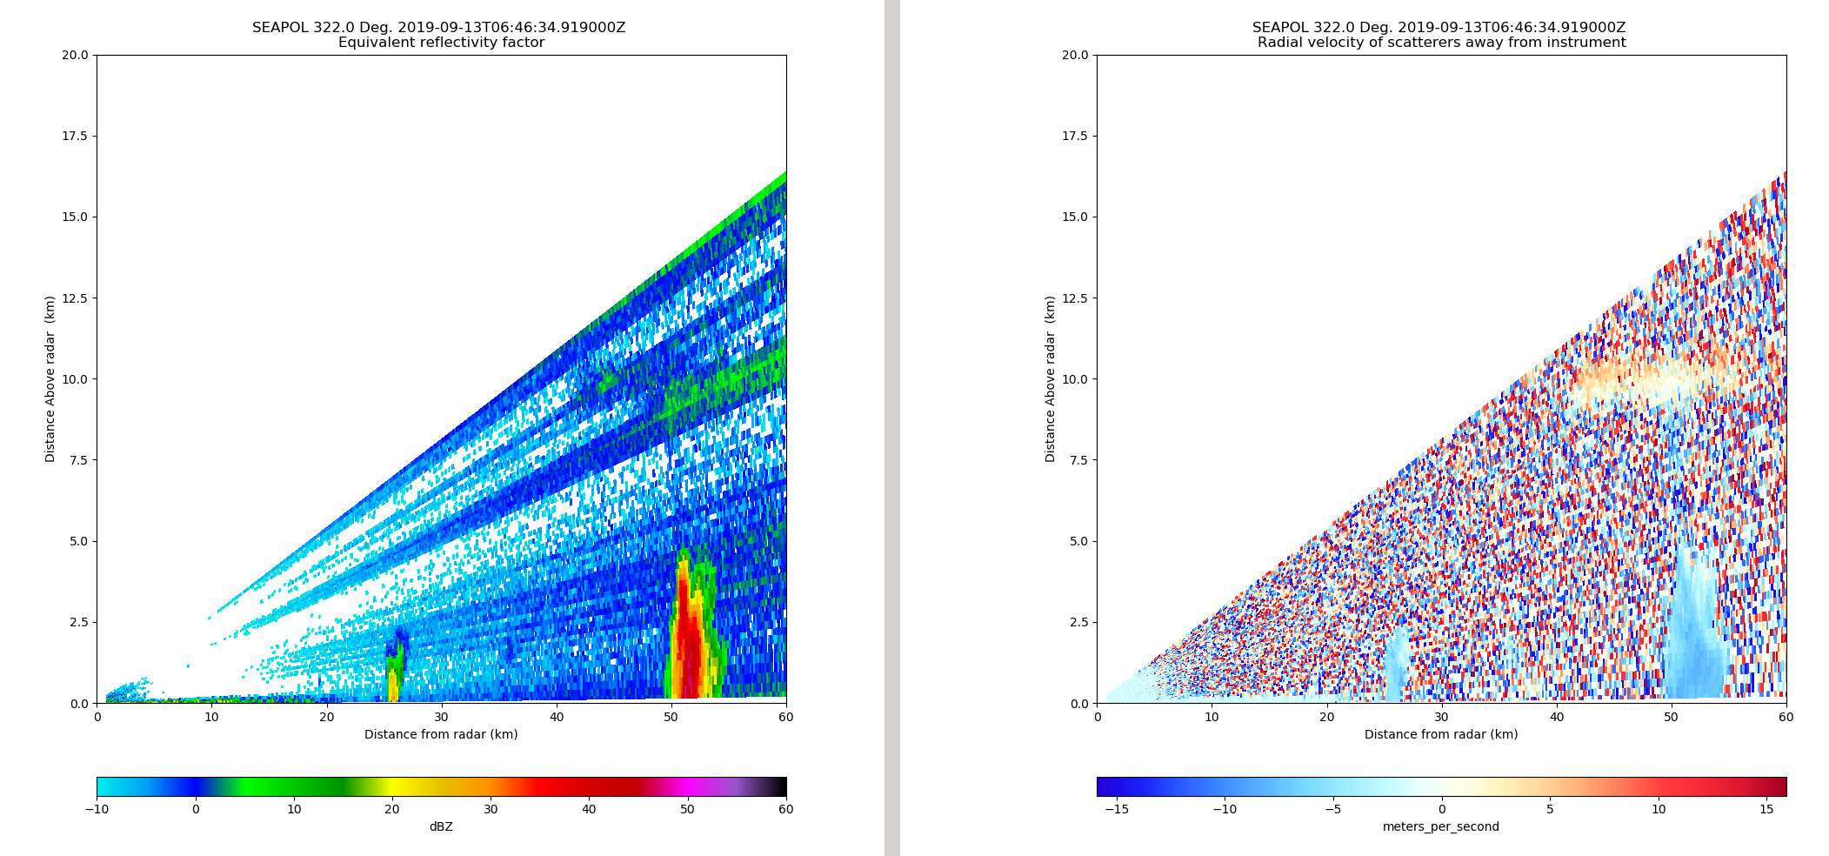

Fig. 4: Ubiquitous warm rain cell sampled by the Lear.
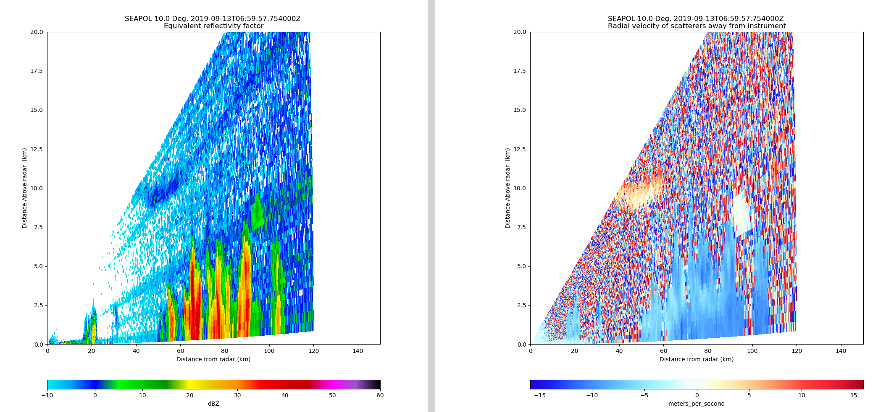

Fig 5: Convective complex sampled by the Lear at the NE most edge of SEA-POL’s view.

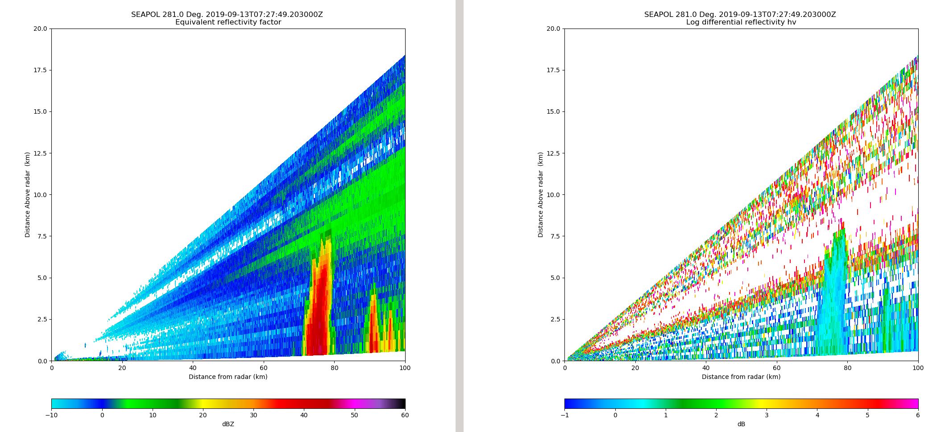

Fig. 6: Convection sampled by Lear at 0730 to the west of SEA-POL.

