PISTON 2019 Daily Science Summary

15 September Daily Summary: Lear mission, 6 km caps, and boundary echoes
PISTON 2, R/V Sally Ride

Prepared by: Brenda Dolan, Kyle Chudler, Adam Clayton, and Marqi Rocque; with discussion from Jim George and Jim Moum

We continue to sit under a dry mid-tropospheric layer, leading to dismal conditions for the development of deep convection around the Sally Ride. The soundings were very similar throughout the day, with westerlies in the low levels and an abrupt drying at 600 mb. CAPE struggled to reach even 1500 J/kg, while PW stayed close to 50 mm. Nonetheless, maritime convection persisted, and we saw scattered echoes throughout the day which reached 6 km in height before dying out. These types of cells are the generators of our “mega” Zdr columns (Zdr’s > 4dB), and we captured many of these throughout the day. A really nice example was at 0006 Z at a range of 75 km (Fig. 2). This was an interesting case because reflectivities were also significant; we rarely see reflectivities larger than 55 dBZ in these isolated maritime convective cells. Here they are nearly up to 60 dBZ with differential reflectivities larger than 5 dB, while echo tops are just barely exceeding the melting layer.

The Lear Jet was looking for deeper convection today in order to sample the ice phase, so they wanted to know when cells started topping 8-10 km. Around 12:45 LT we noted a couple of echo tops reaching 7.5 km. I notified the Lear, and after watching for a few more hours with mostly 6 km tops, they determined the mission was a go. They arrived in the ops area at 0830 UTC, and we initially targeted a cluster of convection at a range of about 50 km from SEA-POL along the 315 deg radial (Fig. 3). The Lear made several penetrations through the highest tops and saw SLW but little ice, and found rain at 18kft at a temperature of -1 C. At 0840 UTC they made penetrations and reported mostly 0.5 mm to mm sized drops, lots of drizzle, and rain on the wind screen. At the same time, along the 313 radial, SEA-POL noted another extremely large reflectivity core with reflectivities at or exceeding 60 dBZ (Fig. 4) and Zdrs of 4 dB or slightly larger. We do not believe the Lear was sampling this area at this time, however. The Lear made a comment that the storm was good convection and the system was still very active. The Lear flew to the cloud base at 1300 ft and noted that the temperature was 26.7 C at 500 ft above the ocean. They then began penetrations of the rain shaft and reported 2 mm drops and mostly smaller. The Lear continued to sample the convection as it marched closer to the Sally Ride. At 0909 they observed it was all drizzle drops at 10kft. Around 0915 UTC we noted that the cells were too close to SEA-POL to cover (but were close enough for visuals, Fig. 5), and sought out a new cell to look at. A surveillance scan (Fig. 6) showed the only other convection was at a bearing of 303 and 30 km from the Sally Ride, so the Lear headed there. However, by the time they arrived the cell was dissipating rapidly. The Lear noted rainbows in the rain shaft (and generally many rainbows around). The Lear Jet headed home to Clark at 1930 UTC, as the Sally Ride was getting some rain.

As can be seen in Fig. 6, there were a multitude of boundaries /cold pools that likely drove the convective initiation today. In looking back at the SEA-POL scans, it appears that the storm sampled by the Lear Jet may have been initiated on colliding boundaries. One eternal question about these boundary echoes is: what produces the scattering signature? The science team discussed several of the usual suspects, including dragon flies/ birds (not nearly enough around for this much coverage), sea spray (would not have the large differential reflectivity that we see, and these echoes have narrower spectrum width and are more coherent than typical sea clutter), Bragg scatter (signal is too large to be Bragg scattering at C-band), capillary waves on the ocean surface with a wavelength in the 10’s cm, or small gust front clouds (maybe we would see this in other instruments like W-band radar or lidar if passing over the ship. But again, enhanced Zdr would indicate flattened particles).

Epilogue: We also note that we are able to see these boundaries due to our RFI mitigation efforts during aircraft operations. In this case, we were at a heading of 330 deg, which is typically bad for interference because the Hi-seas net has to use the port antenna which is closer to SEA-POL. However, we pointed it away for this time period (and relied on the starboard antenna and the slower backup internet) and therefore we were able to see these very light echoes that are otherwise swamped by the RFI (Fig. E1).

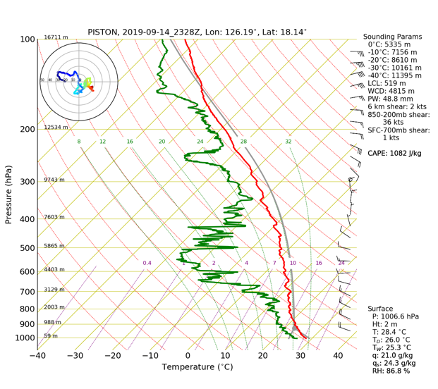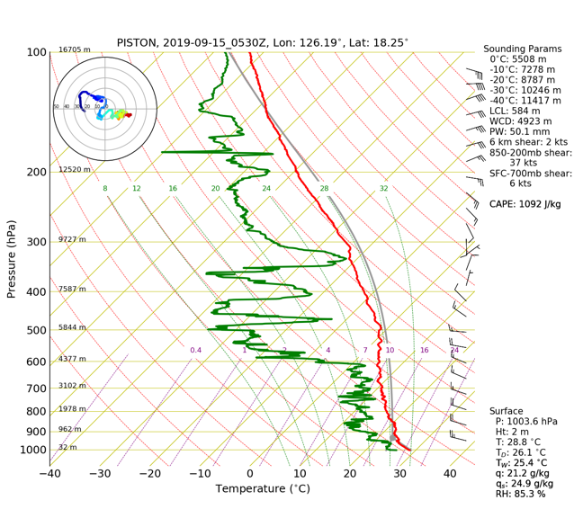
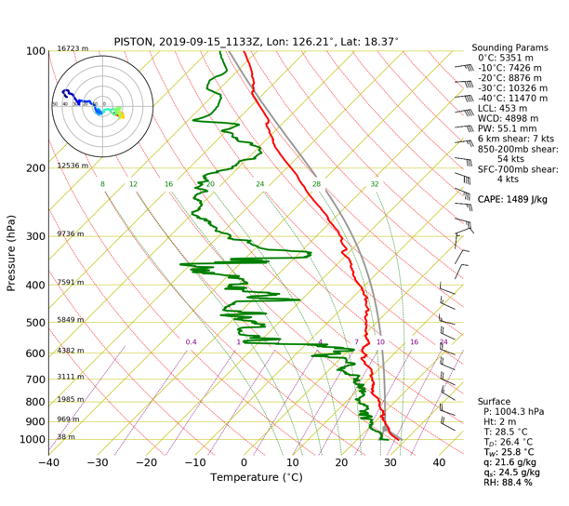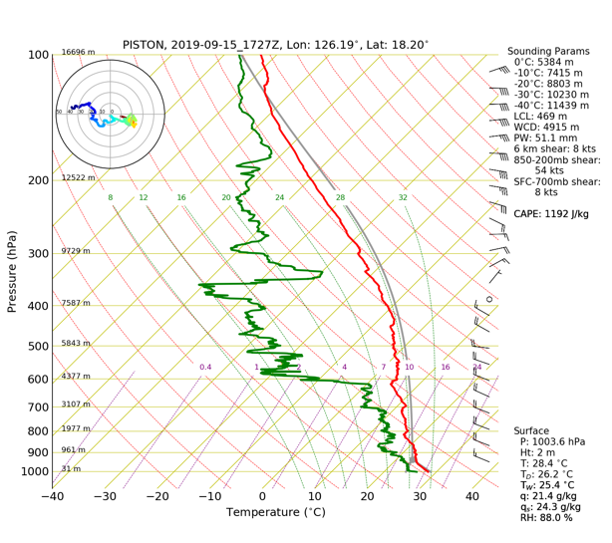
Fig 1: 0Z, 6Z, 12Z, 18Z soundings.

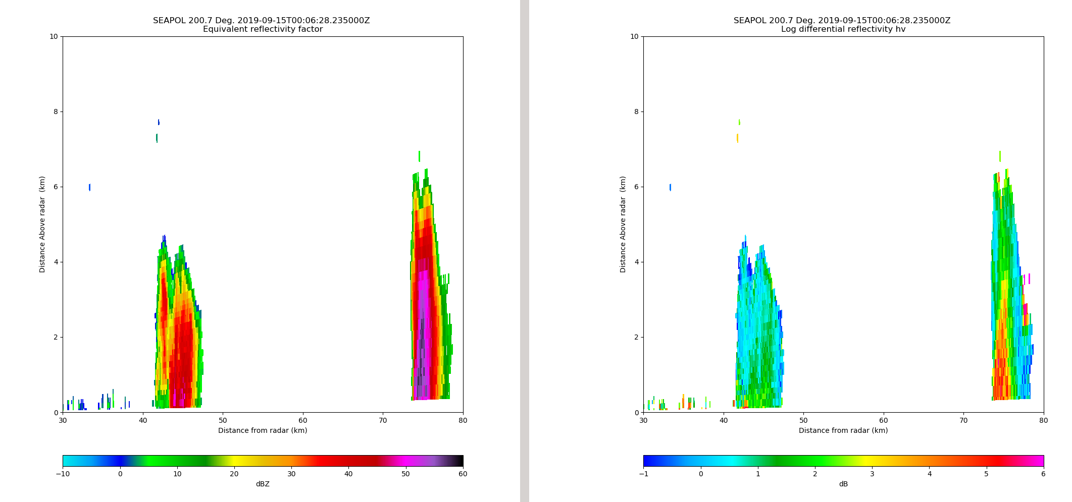
Fig 2: Maritime cell with reflectivitiy near 60 dBZ and associated Zdr core of 4-5 dBZ.

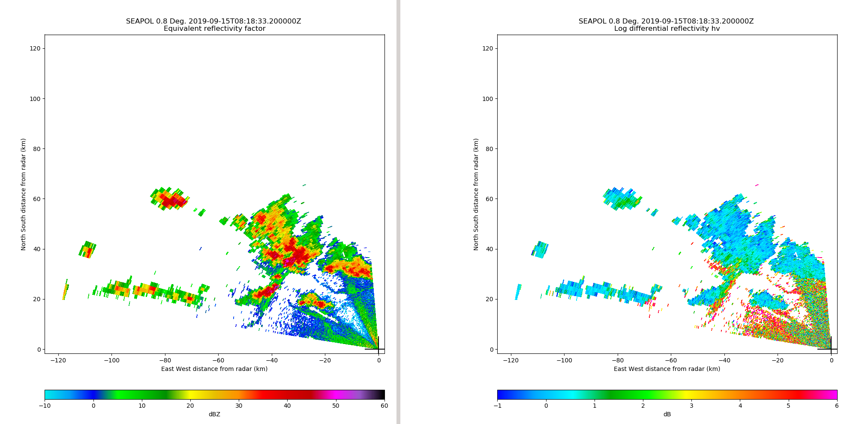
Fig 3: Initial Lear target to the NW of the Sally Ride.

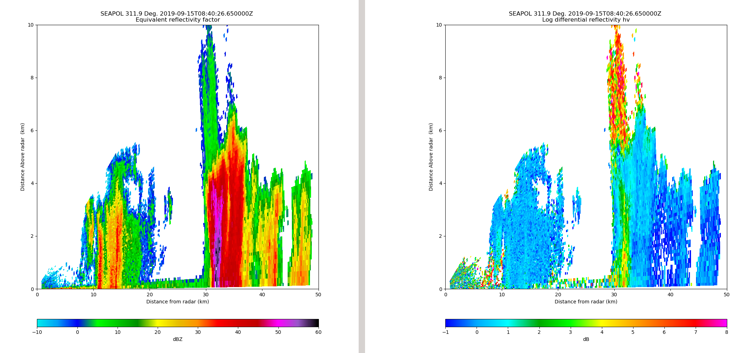
Fig 4: Cell penetrated by the Lear at 0840 UTC.

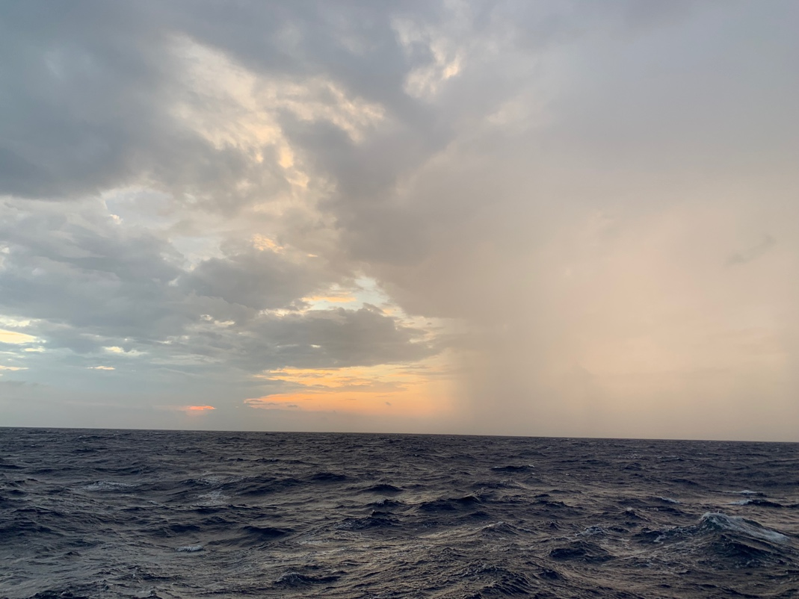
Fig. 5: Rain shaft on convective complex as seen from the Sally Ride. Looking to the W.
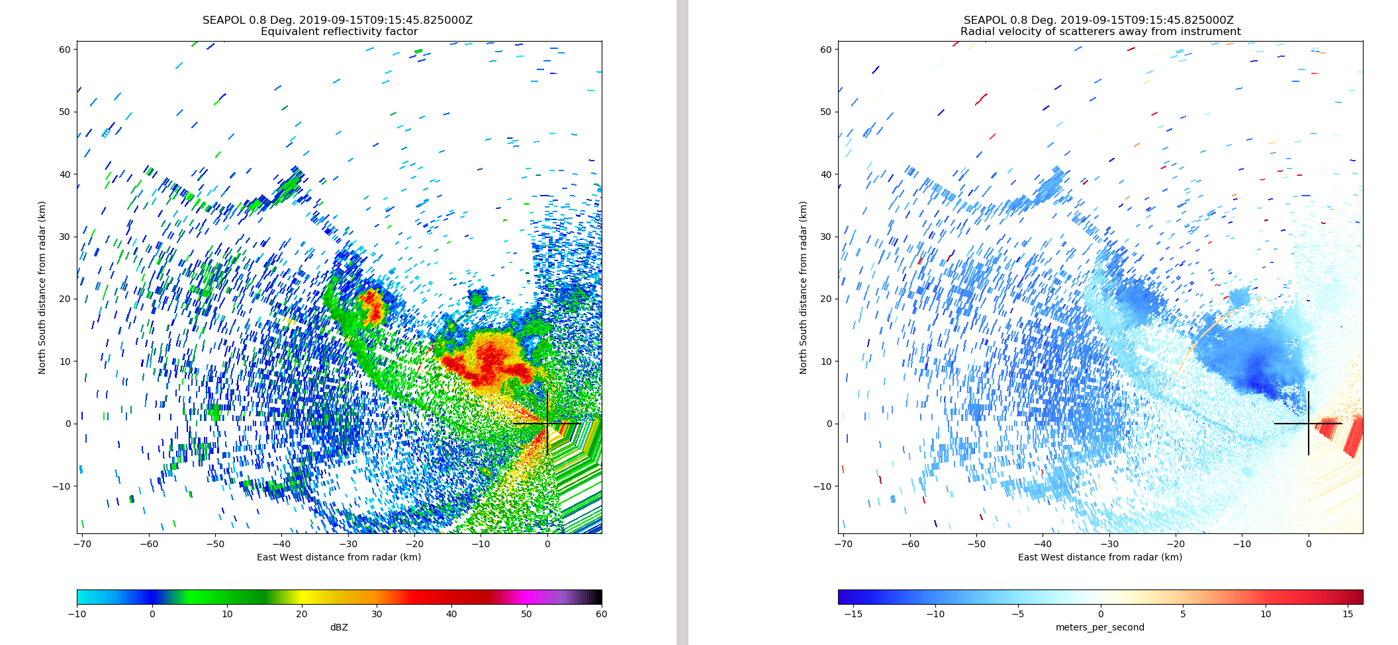
Fig. 6: Boundaries on the low-level surveillance scan at 0915 UTC.

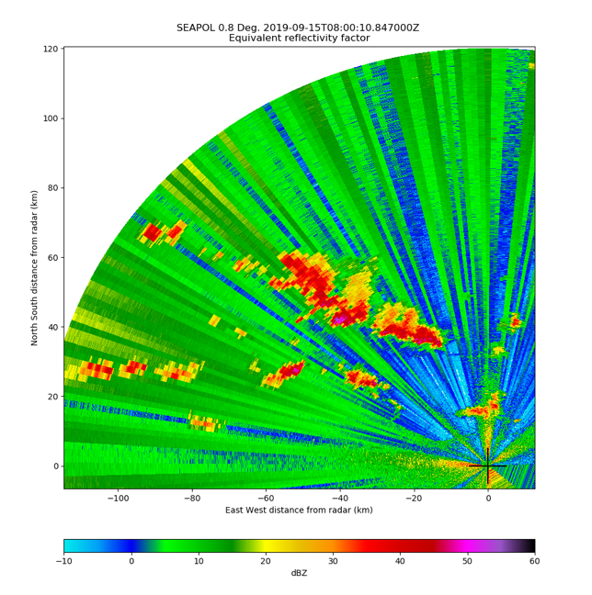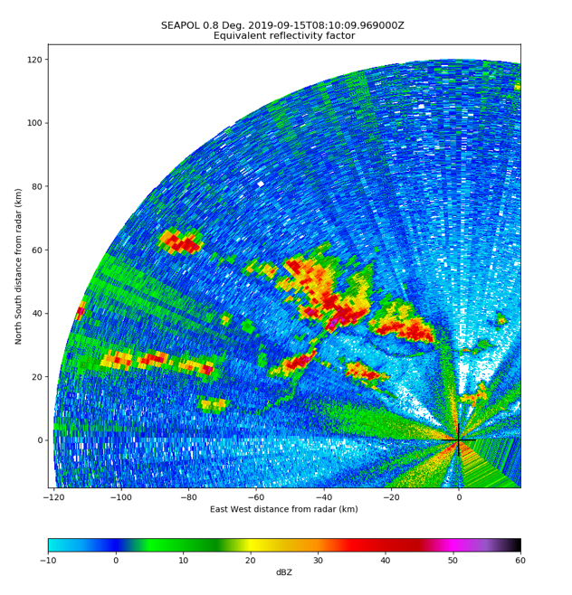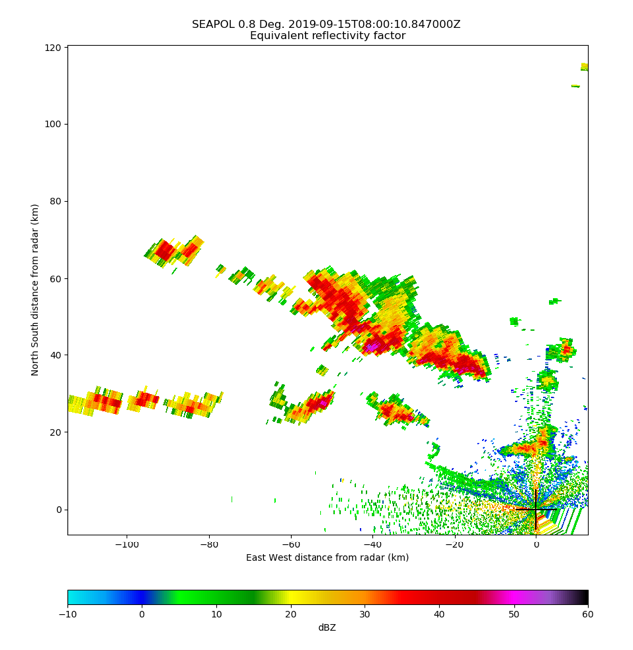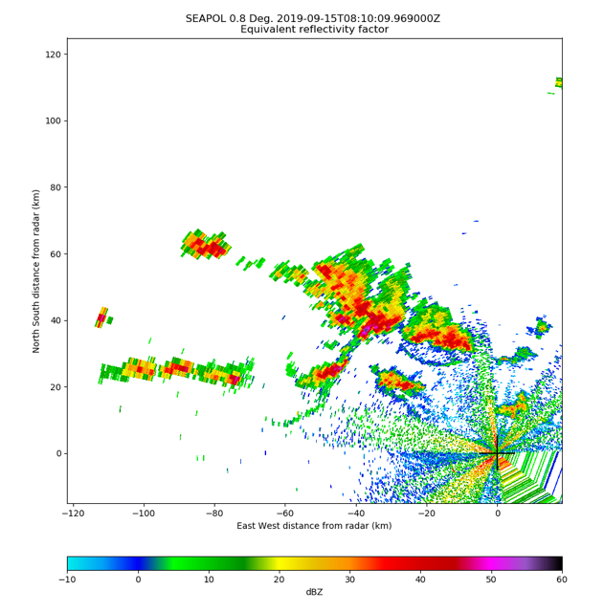
Fig. E1: Example of echoes with HiSeas Net antenna “active” (left) and “pointed away” (right). Echoes are 10 minutes apart at 0.8 deg elevation. Bottom: Same as above, but filtered using NCP >=0.45 and ρ_{hv} > 0.7.

