PISTON 2019 Daily Science Summary

17 September Daily Summary: MCS, Shear and Lear!
PISTON 2, R/V Sally Ride

Prepared by: Brenda Dolan, Kyle Chudler, Adam Clayton, and Marqi Rocque

We spent the day under a large MCS that had exploded overnight (Fig. 1), bringing with it plenty of moisture, clouds and convection. The soundings throughout the day show strong upper level easterlies with strong surface westerlies, and weak mid-level flow (Fig. 2). During the day the shear depth deepened from ~2 km at 3 Z to nearly 7 km by 18Z. In fact, the winds and the swells conspired to make finding good headings for the ship a challenge because they were coming from different directions. We eventually found that 0 and 270 were stable enough to get good RHIs without losing stabilization, but a heading of 270 really threw water on the stern and drenched the chameleon folks. So, we spent the day between these two headings, and when the seas were too rough and the rolls or pitches were > 6 (this occurred especially when the ship was turning), we ceased RHIs. At around 03 Z, the winds increased to 35 knts for a short period, before decreasing to 7 knts and finally resuming 20 knts for the remainder of the day (Fig. 3). These really strong surface winds and wind shear were evident in the SEA-POL data as well (Fig. 4). From about 03-05 UTC, there was a thick anvil cloud with mammatus present on SEA-POL; this anvil cloud reached down to 6 km at times. Meanwhile, convection would continue to boil up below (Fig. 5). An RHI loop along a radial showed the convection initiate and grow, and as it reached the shear layer it would shear off and the storm would dissipate (not shown). Very few echoes were able to penetrate 6 km due to this strong shear. The Lear noted that convection was not going that deep when being fed by ice above.

The Lear made a mission to the ops area around mid-day. They wanted to target convection to the SE of the Sally Ride, which was more isolated in comparison to the widespread stratiform with embedded convection that filled the rest of the domain. They entered the ops area around 0520 UTC, and we sent them to the deepest tops we were seeing along a radial of 138 and 35 km from the SR. The Lear reported being still in a lot of cloud in that area, which was quickly developing into a convective line under a thick convective anvil. They retreated to a clearer area 70 km distance from SEA-POL and made some passes over some relatively shallow stuff with 6 km tops. We then sent them to a radial of 120º to fly a leg from 25 km to 75 km at 13 kft, where we were seeing some elevated Zdrs (2-3 dB) and moderate Kdp’s (2-3º/km) (Fig. 6). They penetrated the cloud reporting maximum drop sizes of 3 mm and moderate rain. They then ascended to 17 kft (approximately 0 C) to make another pass. We suggested they move over to 117 radial as things were advecting and evolving quickly. They made one more pass in the heaviest echoes before heading home (Fig. 7). On the transit back west through the SEA-POL domain, they sampled some echoes that were forming a line of convection (Fig. 7), and reported very active turrets with SLW and strong updrafts (8-9 m/s)!

Oceanographic equipment was recovered in the evening to elicit speedy retreat southward away from rough seas and high winds stirred up by 95W. However, Jim reported seeing a freshwater lens in the ship’s TSG data (or perhaps from the chameleon) due to all the rain.

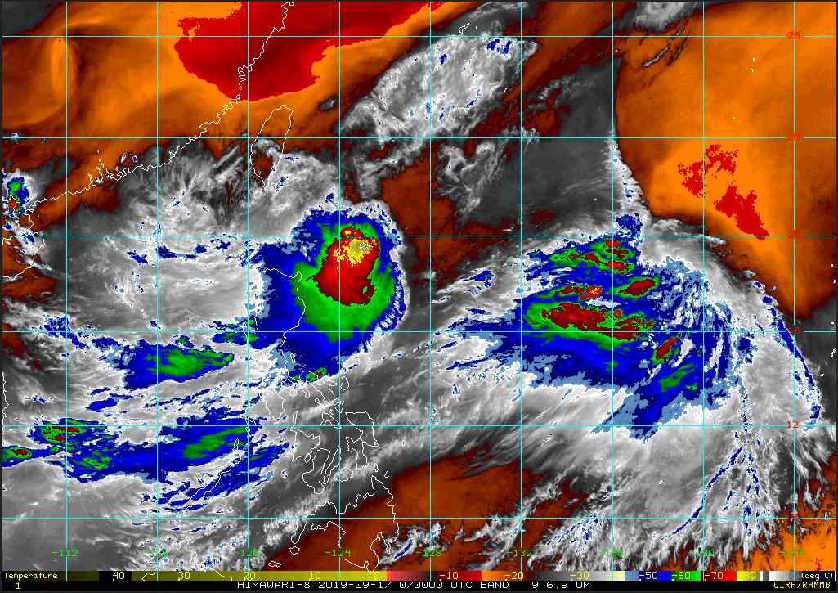
Fig 1: Satellite water vapor image of the MCS sitting near the PISTON ops box at 0700 UTC.

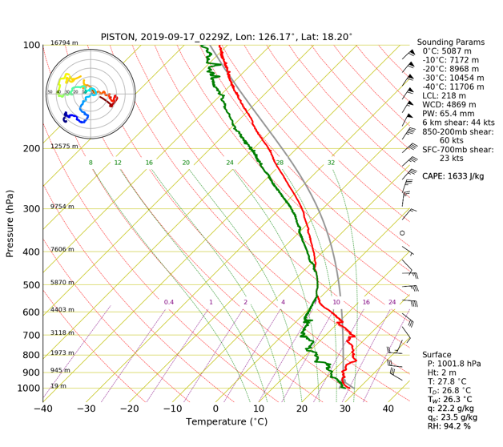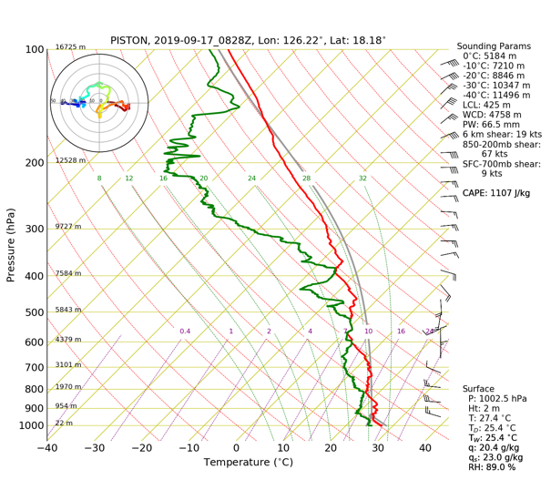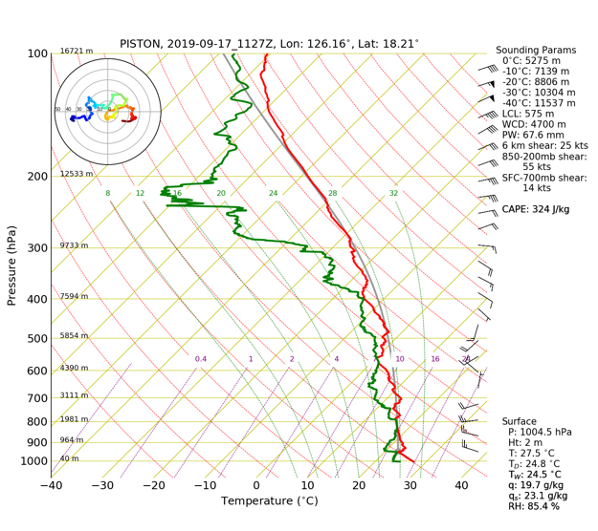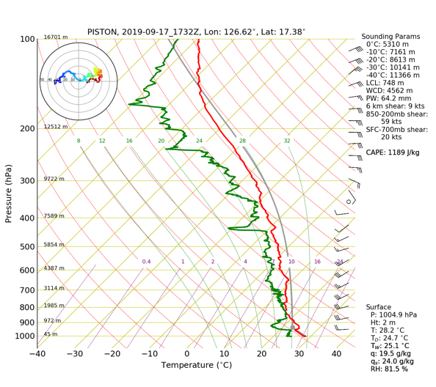
Fig. 2: 3 Z, 9Z, 12 Z and 18 Z soundings.

Fig 3: Ship’s Meteorological trace. Note the wind increase before 03 Z and the subsequent drop.

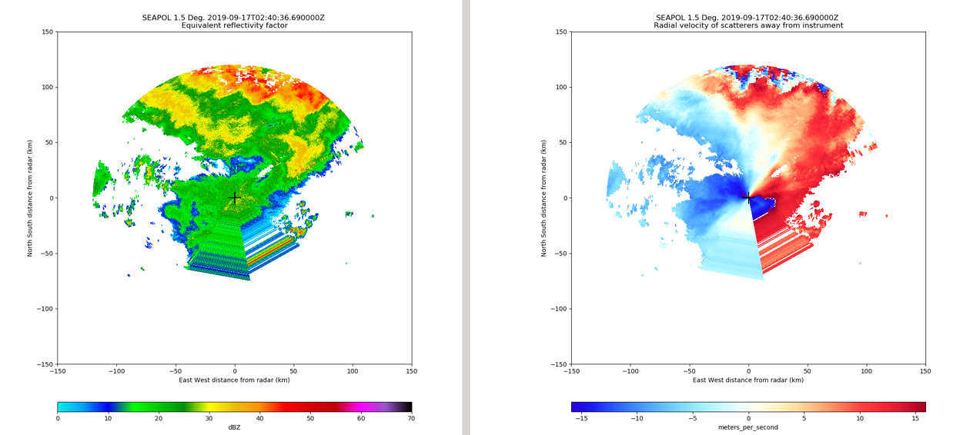
Fig. 4: Reflectivity and radial velocity at 0240 UTC. Note the folded outbound velocity at the surface.

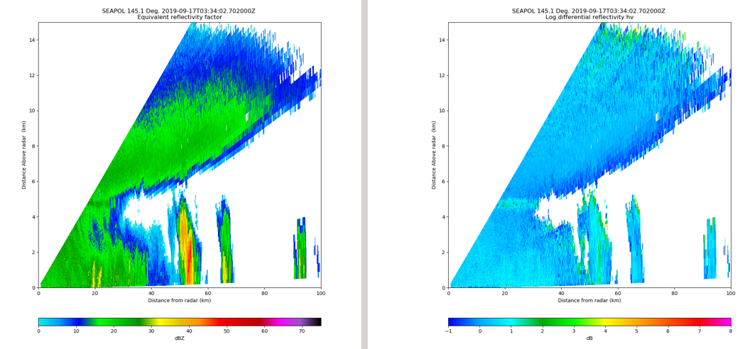
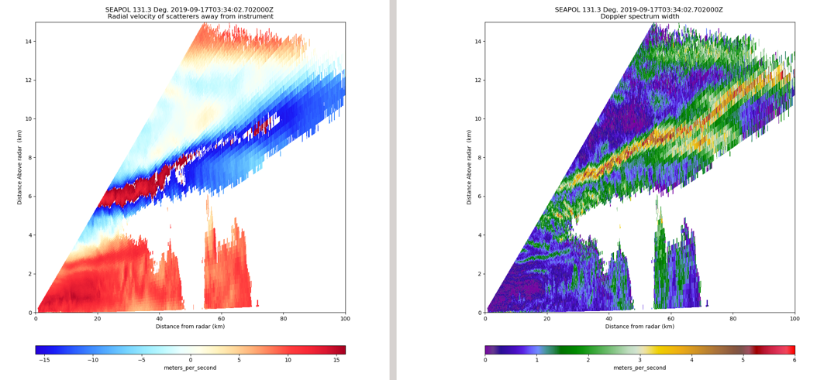
Fig. 5: Building convection under a thick anvil. Note the shear between the anvil moving toward the radar and the convection in the lower levels moving away. Reflectivity (upper left), Zdr (upper right), velocity (lower left) and spectrum width (lower right).

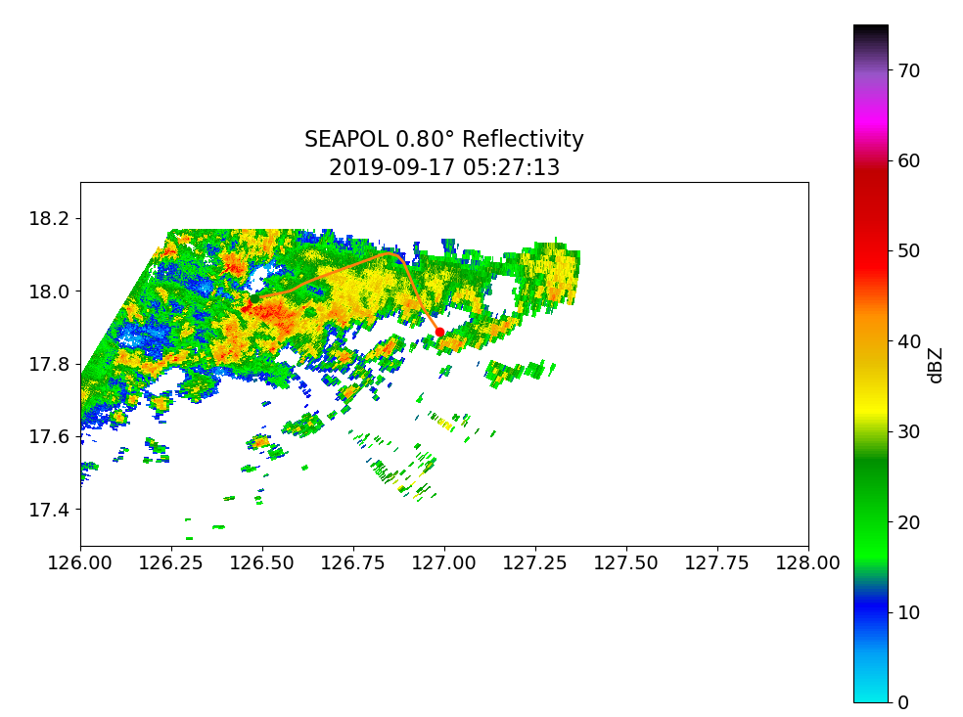
Fig. 5: Lear in convection at 0523 UTC (top) 0527 UTC (bottom). Green point indicates start and red the end point of the track during the approximate volume.

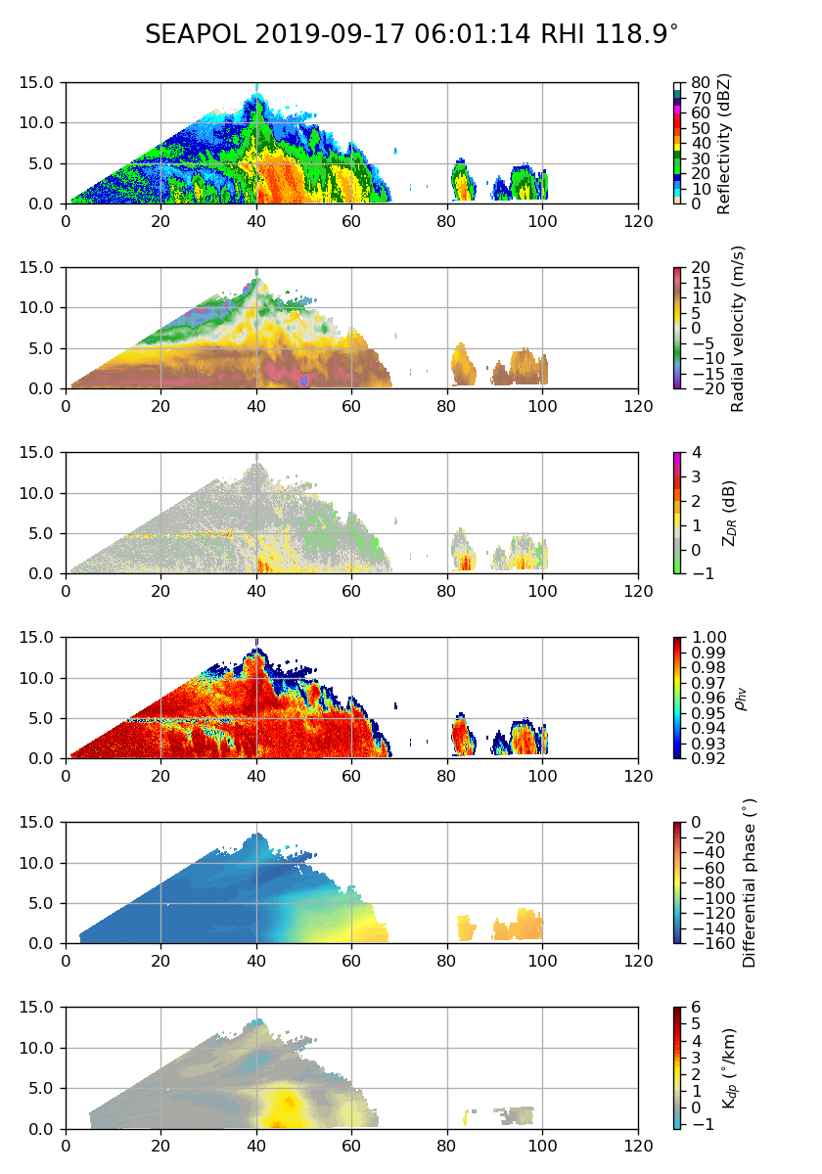
Fig. 6: Reflectivity, radial velocity, differential reflectivity, correlation coefficient, differential phase, and specific differential phase at 119º radial at 0601 UTC.
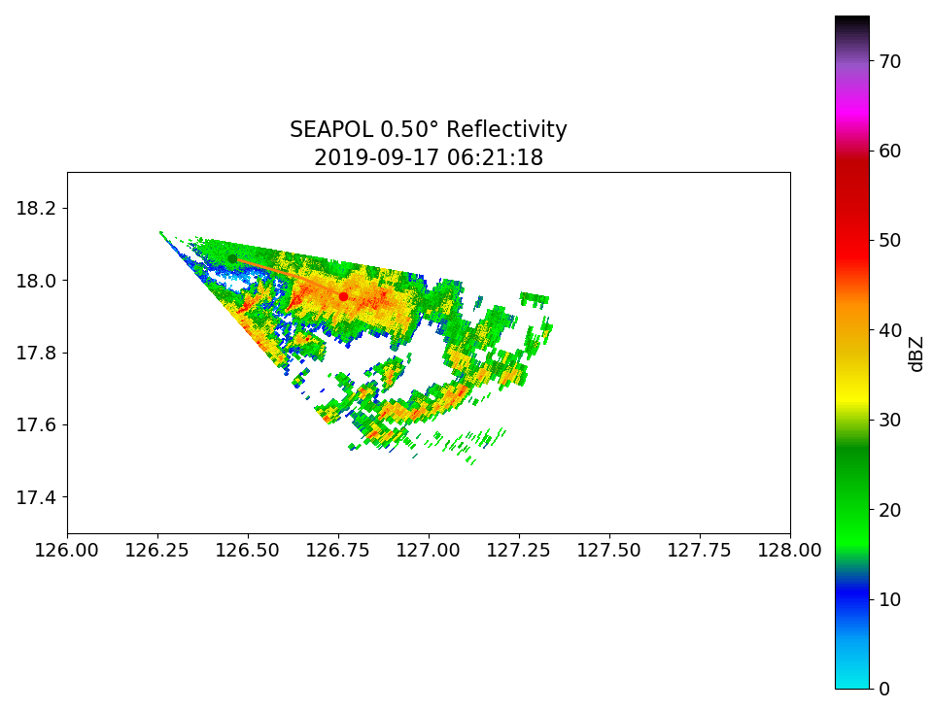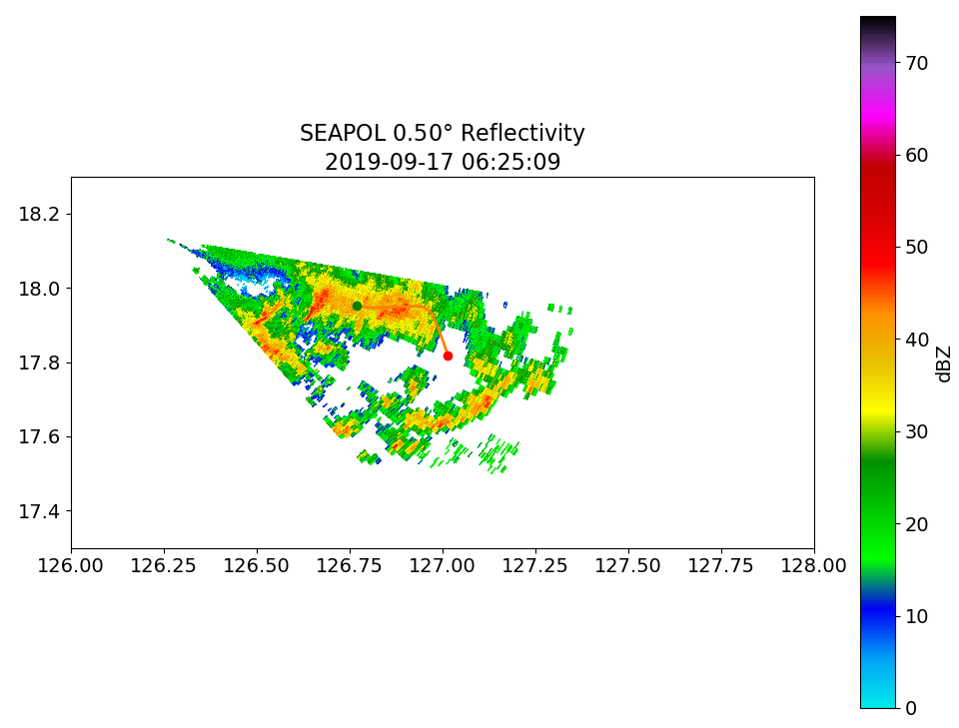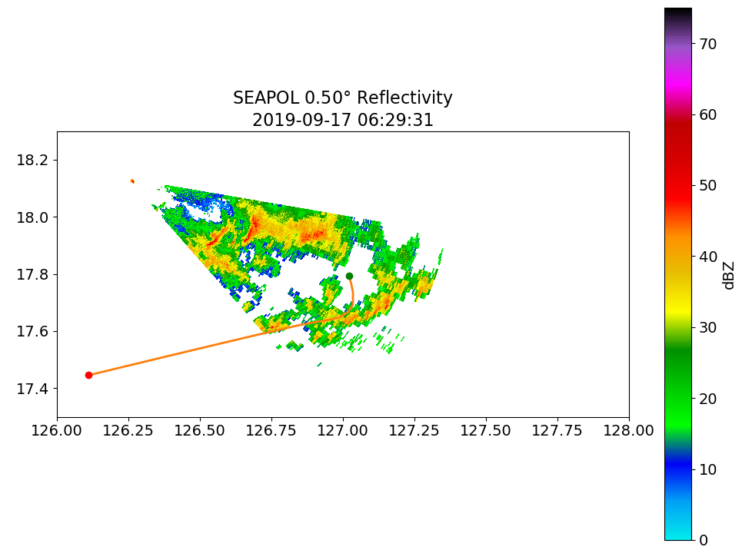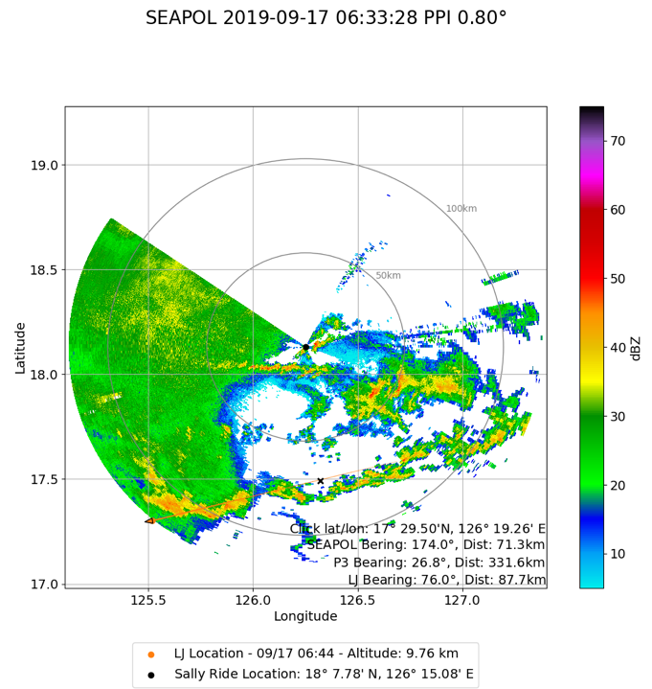
Fig. 7: Final legs of the Lear Jet through echoes to the SE of the SR at 0621 (upper left), 0625 (upper right), 0629 (lower left), and Lear during transit back to Clark long line of convection (lower right).

