PISTON 2019 Daily Science Summary

20 September Daily Summary: T.S. Tapah
PISTON 2, R/V Sally Ride

Prepared by: Kyle Chudler, Brenda Dolan, Adam Clayton, and Marqi Rocque

The Sally Ride spent they day transiting NW back to the previous operations location. At the same time, Tropical Storm Tapah was becoming more organized, and pushing away to the north (Fig 1). Despite the northerly motion of Tapah away from the ops region, the usual monsoon enhancement was ongoing on the southern side of the storm, and several rain bands impacted the ship, along with a return of moisture throughout the column in balloon soundings (Fig. 2). Interestingly, a mid-level dry layer returned to the 18Z sounding, despite this being launched close to heavy convection.

The day began with the edge of the first rain band just impacting the ship at 00Z (Fig. 3). Heavy rain, lightning, and a 3 degree C temperature drop (Fig. 4) were observed at the ship. This band of convection had tops above 10 km at times (Fig. 5), and was a large area of stratiform with embedded convection. A second band of showers, substantially weaker than the first, followed closely behind, and impacted the ship at 05Z.

For the next several hours, SEAPOL observed mainly showers and old dying convection. Around 16Z, larger and more intense echoes quickly moved into SEAPOL’s range. Unlike the morning rain, which which were large SW-to-NE oriented bands moving to the SE, this convection was more scattered, and moving northeastward.

At 1630, a quickly-growing thunderstorm passed over the ship, and a lightning strike was observed very close by; there was approximately 1 second between the flash and thunder. Behind this, a bowing line of thunderstorms was quickly forming to the SW. At 1750, the apex of this bow hit the ship (Fig. 6). Heavy rain, moderate lightning, and a 37kt wind gust were observed at the ship, along with a ragged shelf cloud which was illuminated in the lightning (Fig. 7).

Multiple instances of convection passing directly over the ship today allowed the special close-range RHI to be used extensively, and several high temporal and spatial resolution RHI time-series were obtained.

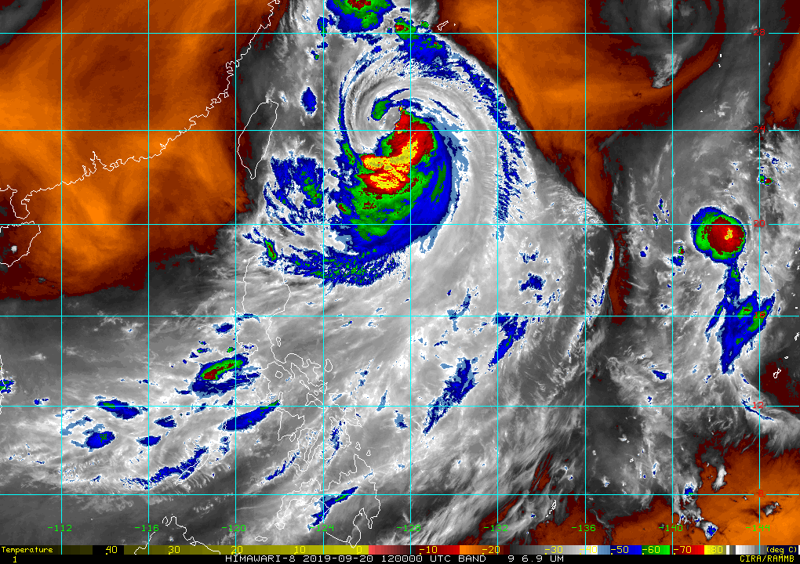
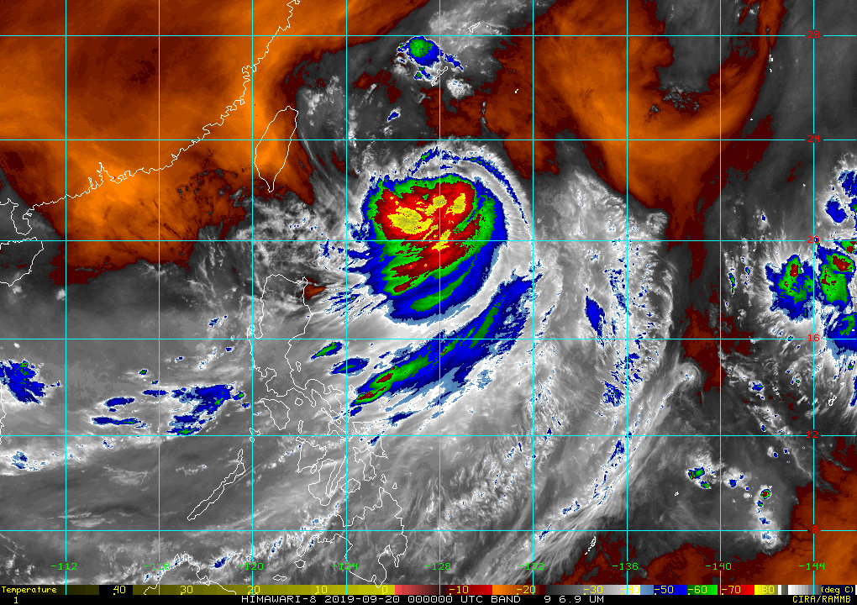

Fig. 1: Himawari water vapor satellite imagery from 00Z (left) and 12Z (right)

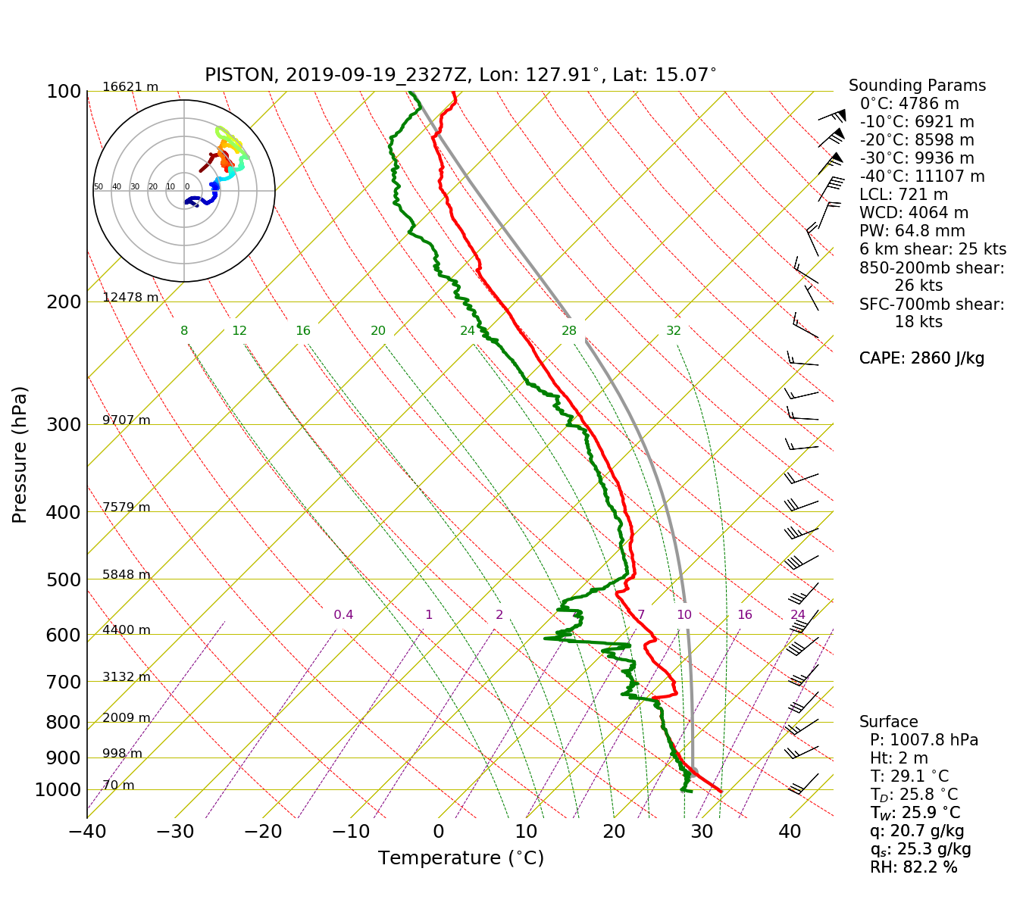
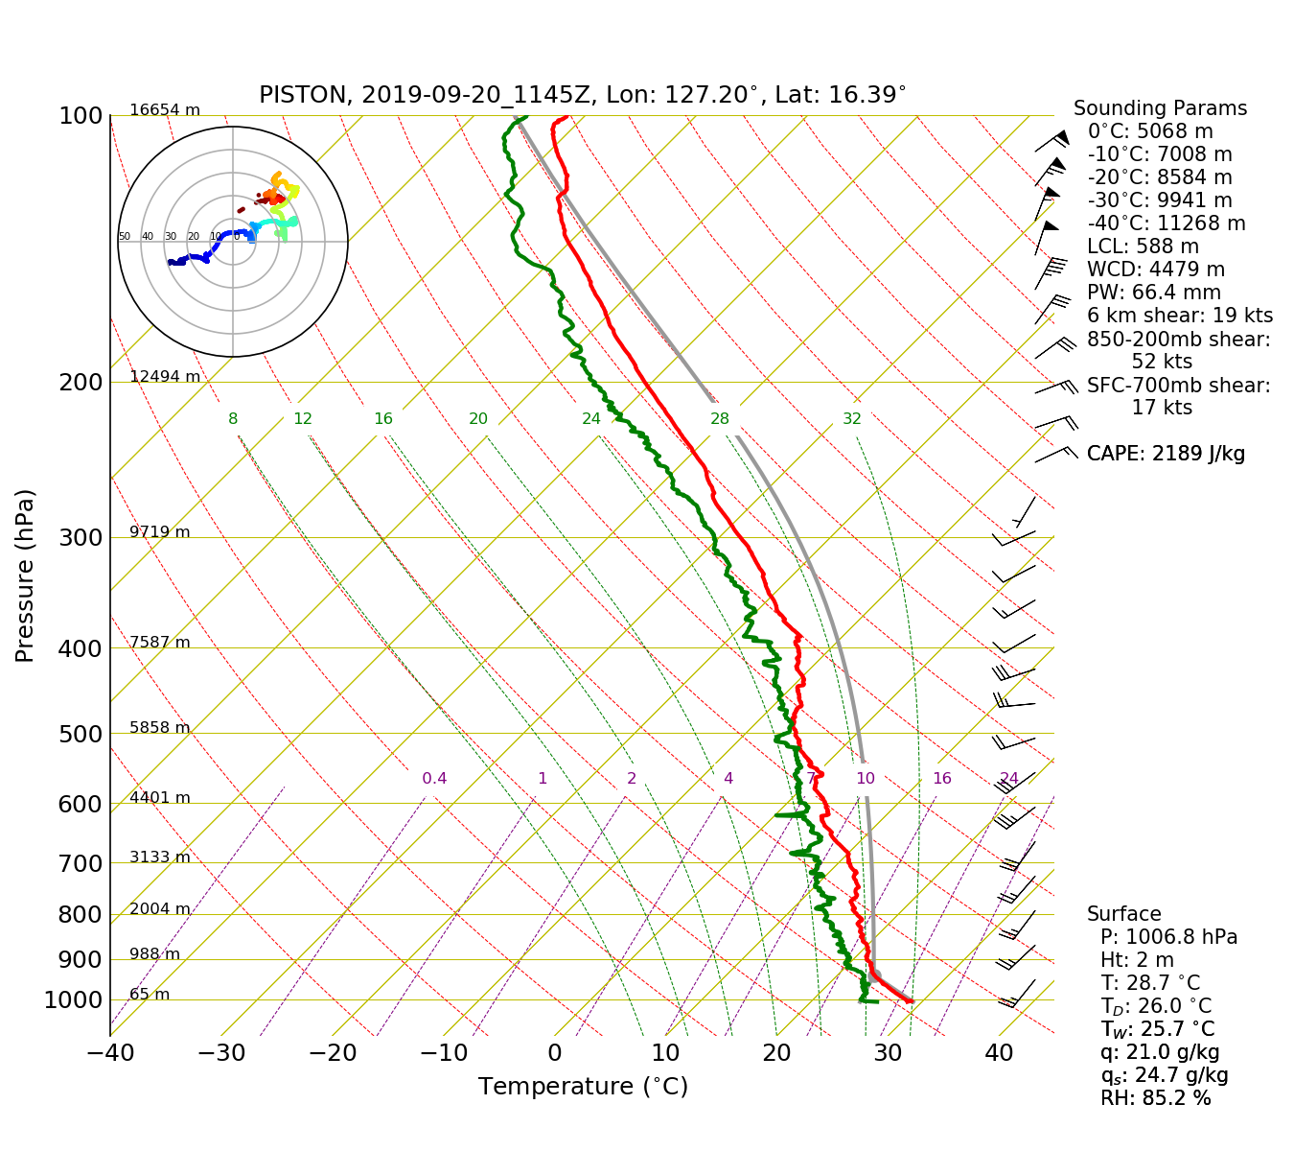
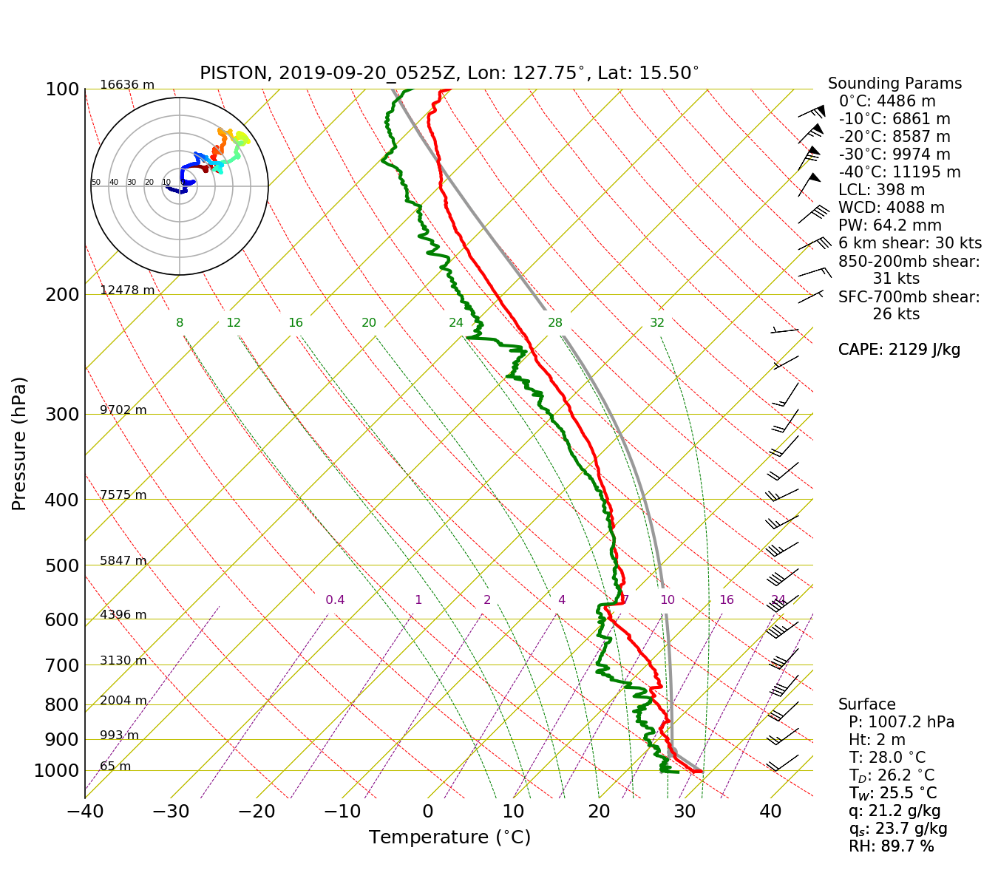
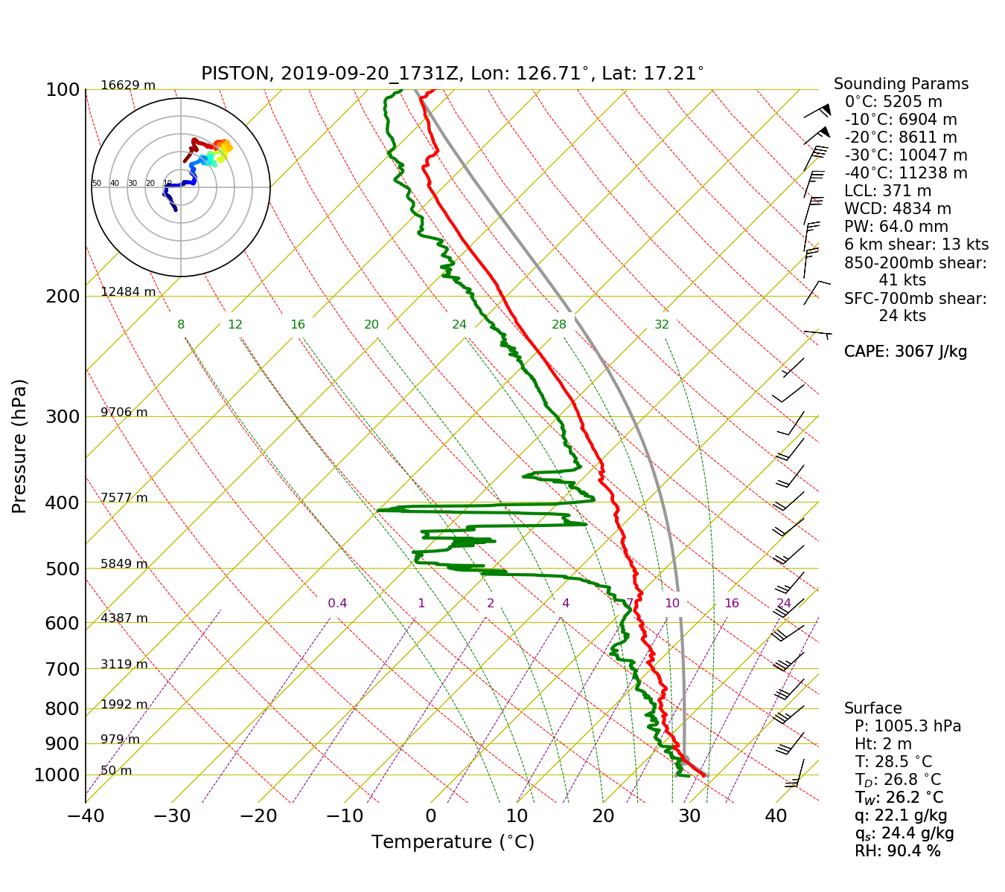
Fig. 2: 00,06,12,18Z Soundings

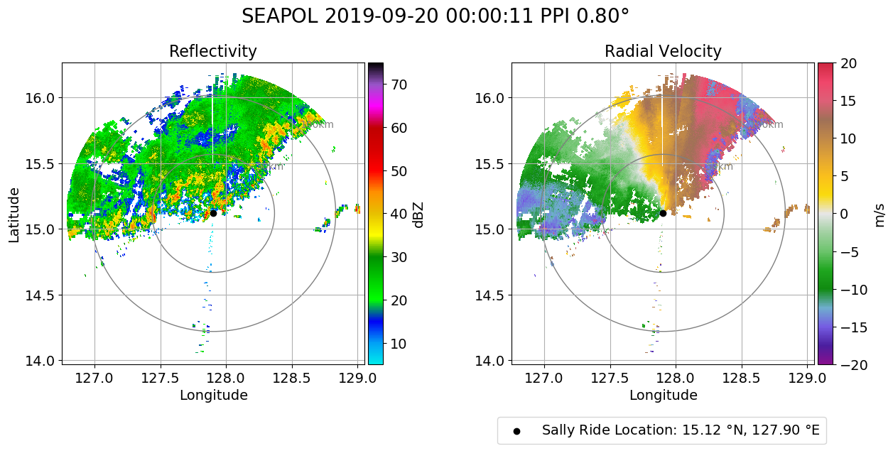
Fig. 3: Rain band impacting the ship at 00Z
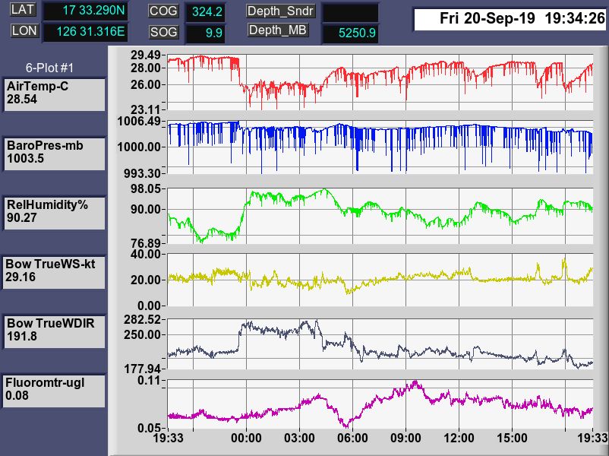

Fig. 4: Time-series of meteorological measurements from the mast, showcasing the impact from several bouts of convection at the ship

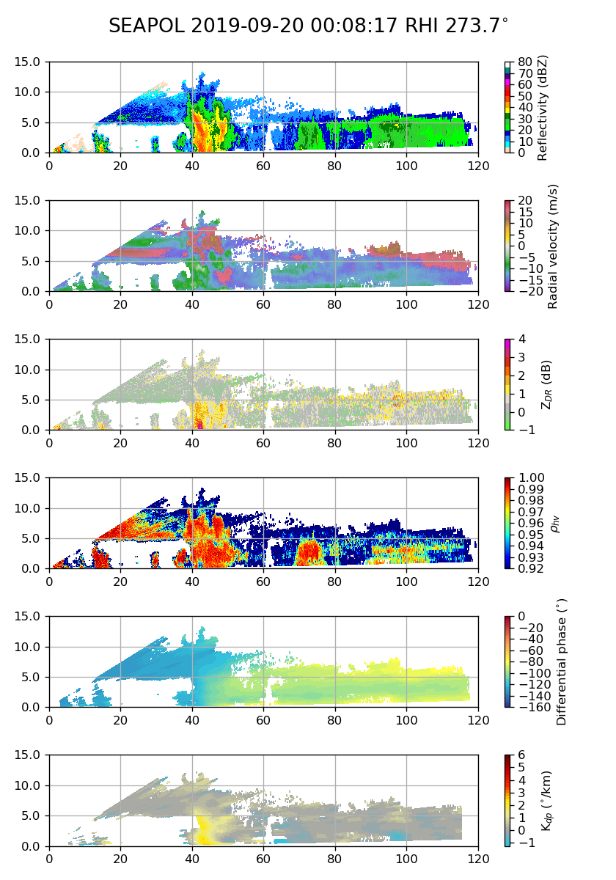

Fig. 5:convective core with echo heights above 10 km and 40 dBZ above 6 km.
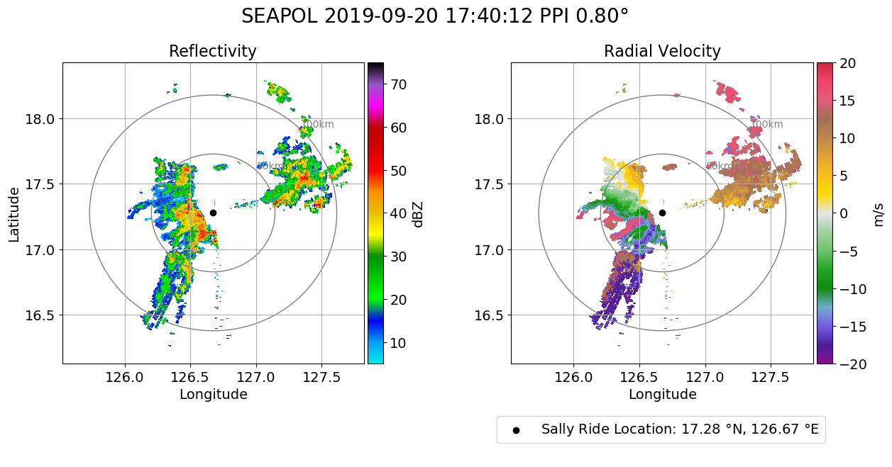
Fig. 6: Slightly bowing convective line moving up from the SW, about to impact the ship.

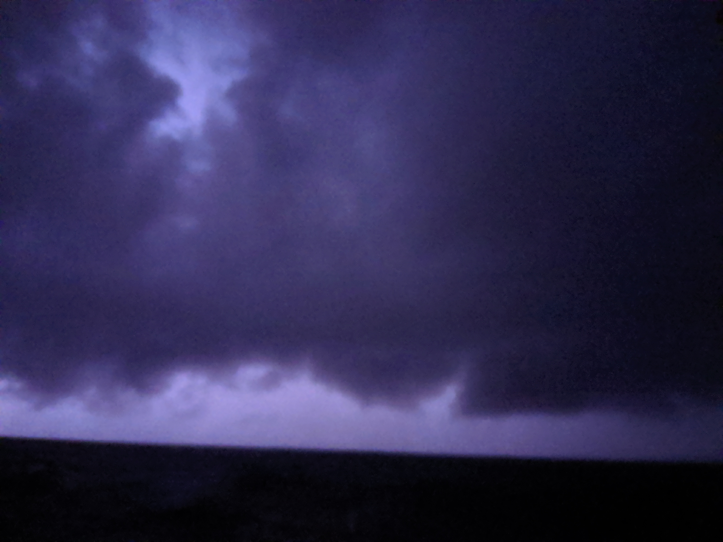

Fig. 7: Storm from Fig. 6 moving in, illuminated by lightning.

