PISTON 2019 Daily Science Summary

22 September Daily Summary: CAMPEx, Boundaries
PISTON 2, R/V Sally Ride

Prepared by: Brenda Dolan, Kyle Chudler, Adam Clayton, and Marqi Rocque

Precipitation returned to a very suppressed state today as Tapah accelerated away to the north (Fig. 1). The P3 and Lear planned to rendezvous with the Sally Ride for coordinated sampling around 0000 UTC. The Lear was after ice microphysics again, while the P3 was hoping to work some convection with SEA-POL, and perhaps do some SST measuring. Additionally, the CAMPEx operation center was seeing an aerosol boundary forming in the models not too far from the Sally Ride. However, there were very few echoes within the SEA-POL domain (Fig. 2). They worked a very weak cell together to the NE at 40 km, where they found shallow cumulus. The Lear then headed to the western side of the domain with some larger echoes that were about 110 km from SEA-POL (Fig. 3). We supported them as best we could with scanning despite the long range. The Lear reported 15 kft tops at 0101 UTC, but by 0111 UTC they reported all tops were below 14 kft (approximately melting level) but strong coalescence. Meanwhile, the P3 made perpendicular passes of 50 km in length across the ship at 300 ft in order to map the spatial variability of SST as requested by Jim Moum. CAMPEx was also interested in catching a satellite overpass at 0222 UTC to the NW of the Sally Ride. The Lear continued to sample some clouds to the west near a boundary. The Lear returned to Clark at 0135, and the P3 finished the SST legs over the Sally Ride and headed to the Worldview satellite overpass. The P3 came back to the ship around 0302 for a HSRL transect, straight and level on an eastward pass at high altitude (Fig. 4). The P3 left the Sally Ride domain at about 0355 UTC.

The P3 dropped a dropsonde at 2342 UTC (Fig. 5), meanwhile the Ride launched the 0Z balloon an hour early to accommodate the flight coordination (Fig. 5). Both show a dry layer below 6 km, although the Sally Ride sounding went through an early morning cloud layer present at the ship. The 03 UTC sounding was delayed by 1.5 hrs, again to accommodate the departing P3. The soundings throughout the day showed this dry layer persisted, yielding a beautiful sunset, but little convection (Fig. 6).

In the afternoon, a the ship was on heading which minimized RF interference. The low-noise environment allowed SEAPOL to pick up on several low-level gust front boundaries which were tied to/emanating from small convective cells around the ship (Fig. 7). An RHI scan of one of these boundaries showed high (8-12 dB) ZDR (Fig. 8), suggesting the targets within the boundary were likely biological. In-situ zoological observations confirmed that the number of insects and birds resting on the ship appeared to be anomalously high today.

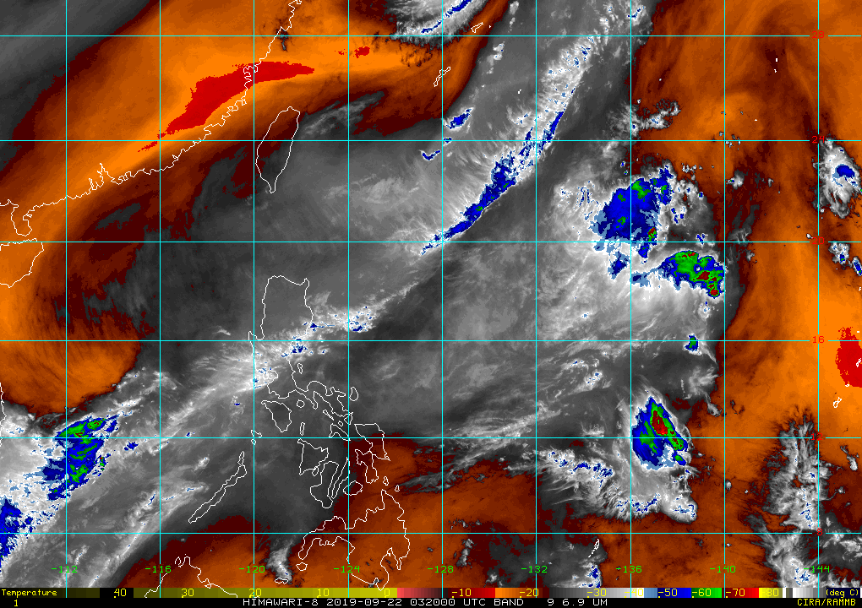

Fig. 1: Himiwari-8 band 9 image of the ops area at 0340 UTC.

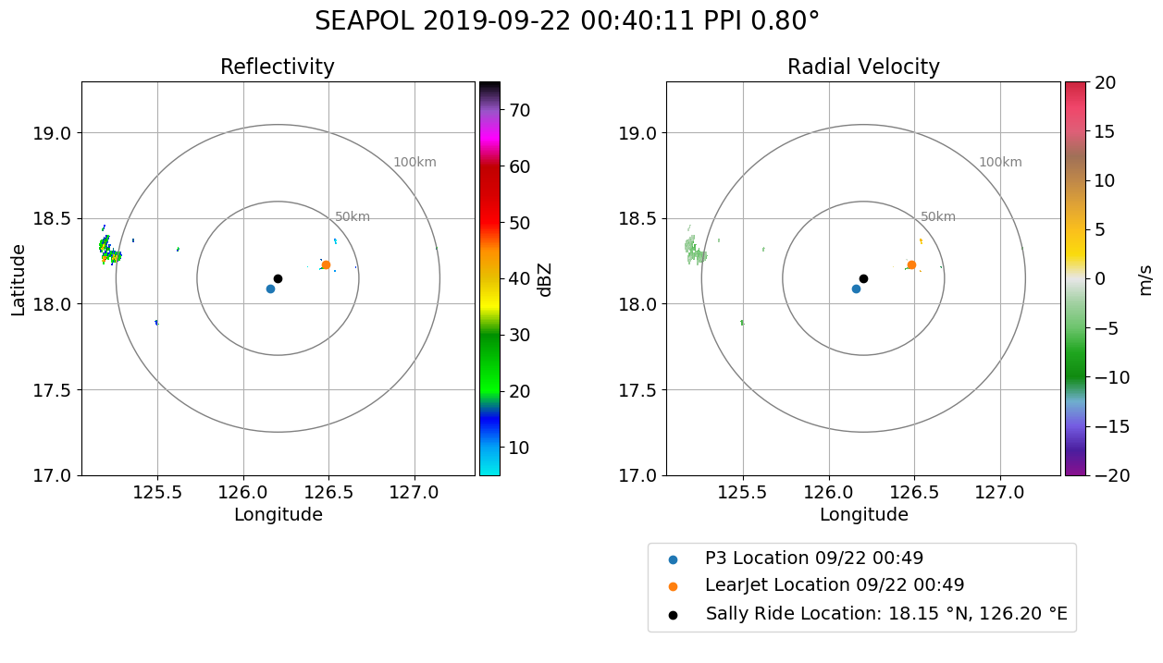

Fig. 2: SEA-POL reflectivity and radial velocity at 0040 UTC with the location of the P3 (blue) and the Lear (orange) denoted.

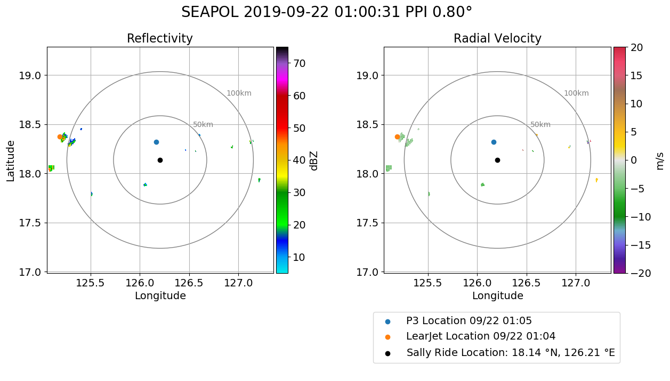

Fig. 3: The Lear working convection on the edge of SEA-POL domain while the P3 performs transects over the Sally Ride for SST measurements.
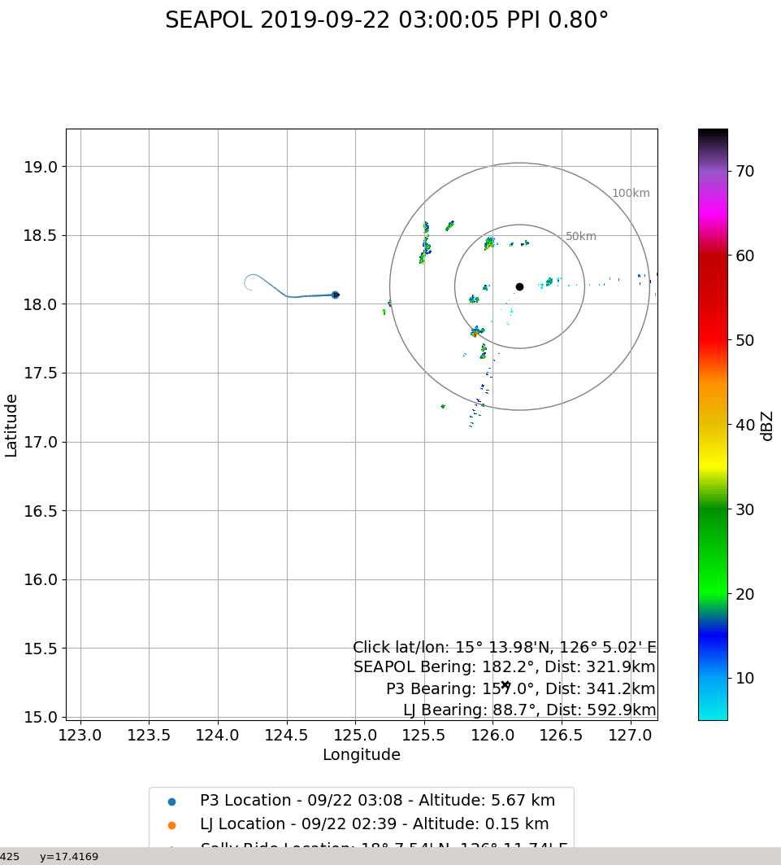

Fig. 4: The P3 heading back to the Sally Ride for HSRL pass at 0300 UTC.

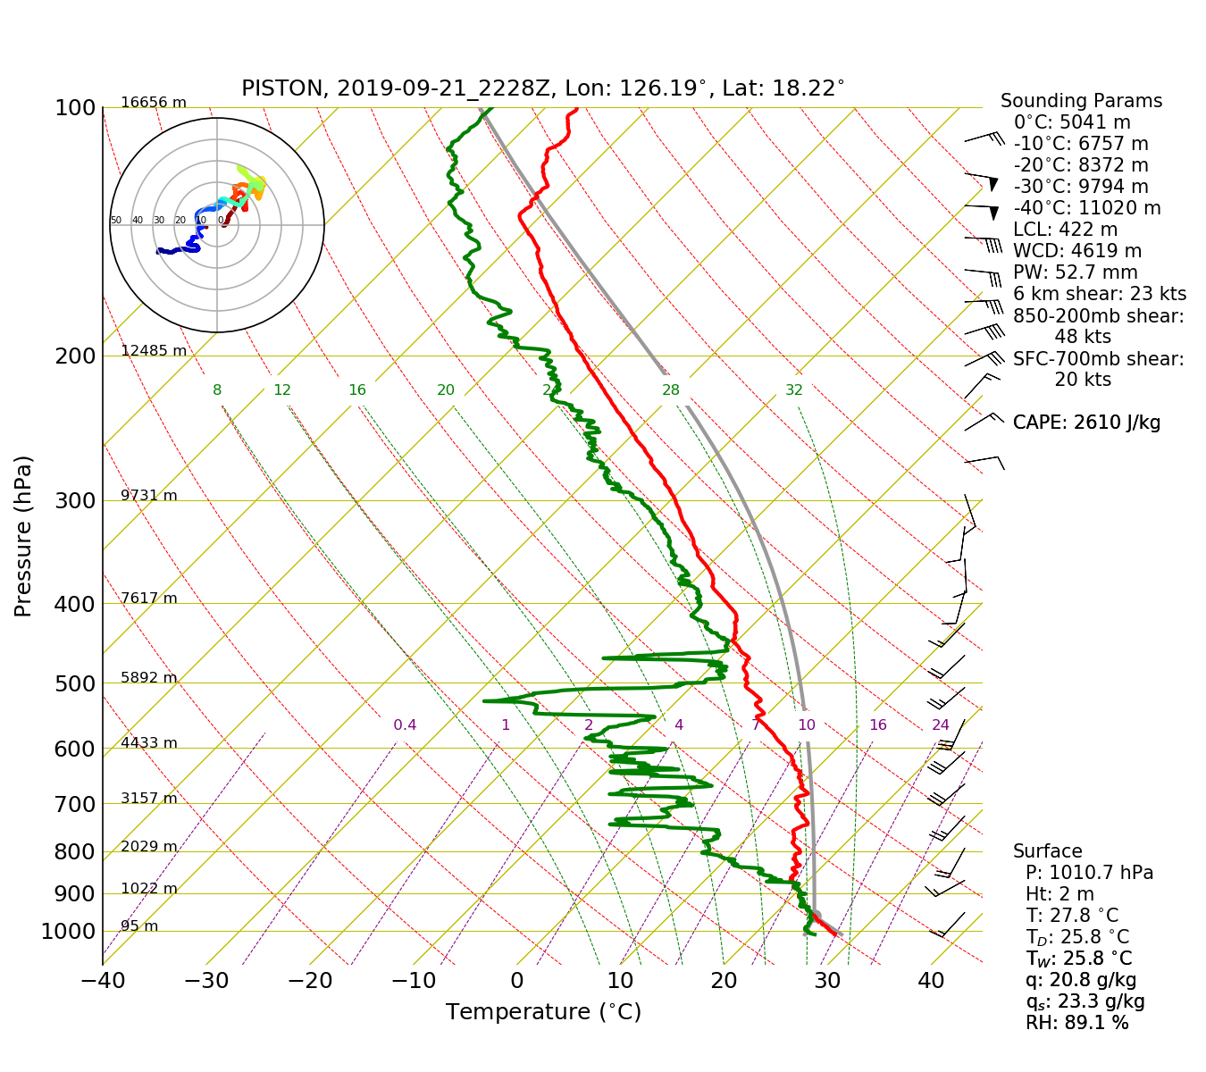
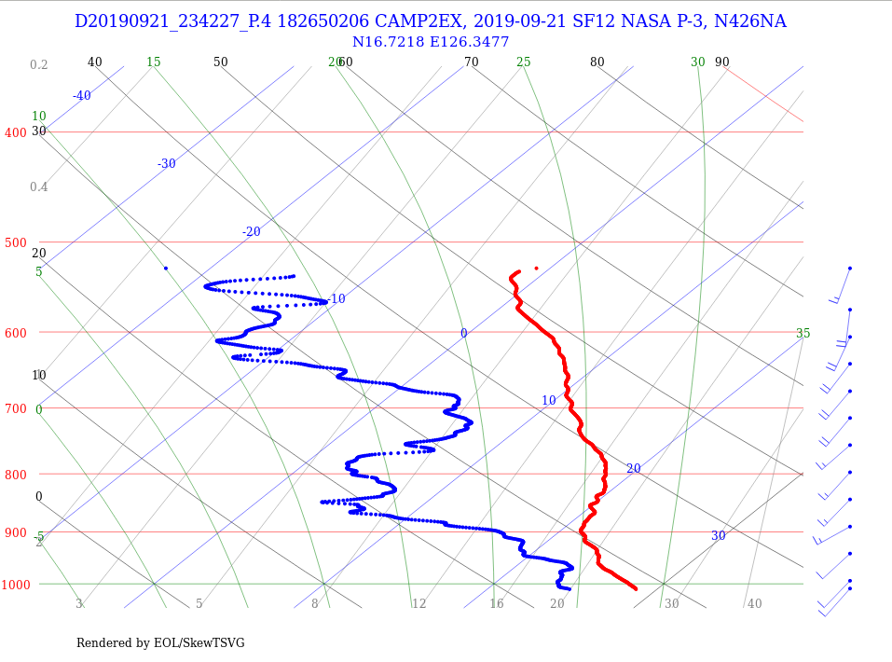
Fig. 5: Drop sonde from the P3 at 2340 UTC, radiosonde from the Sally Ride at 2228 UTC.

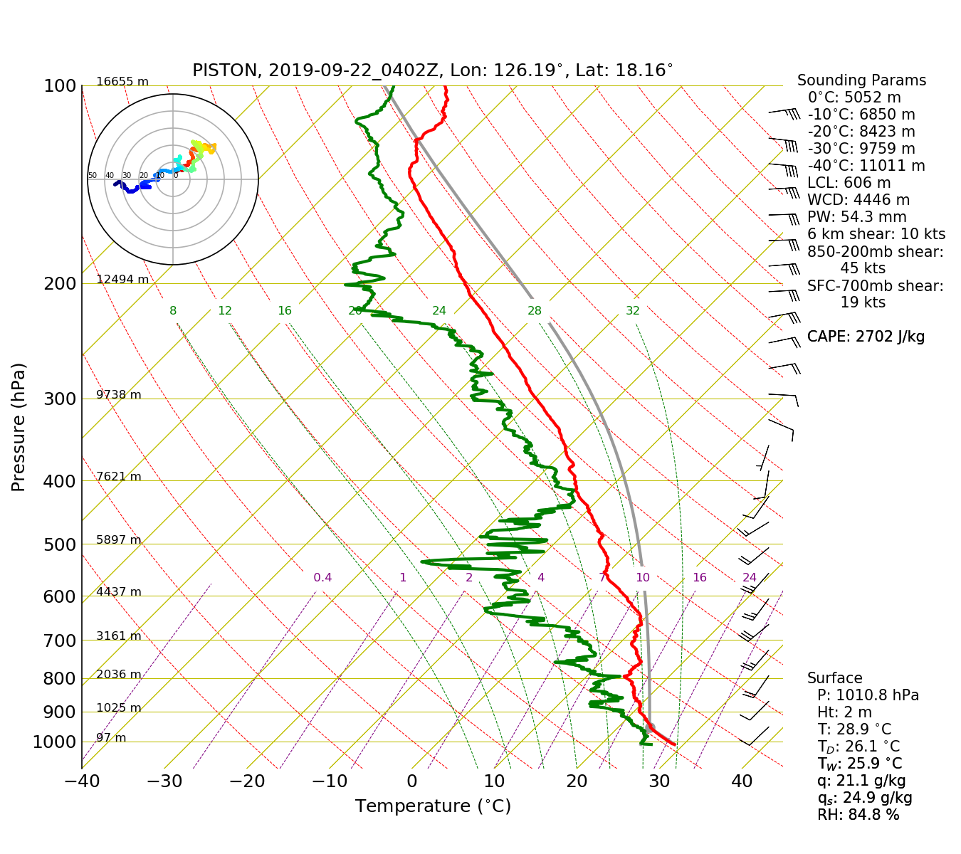
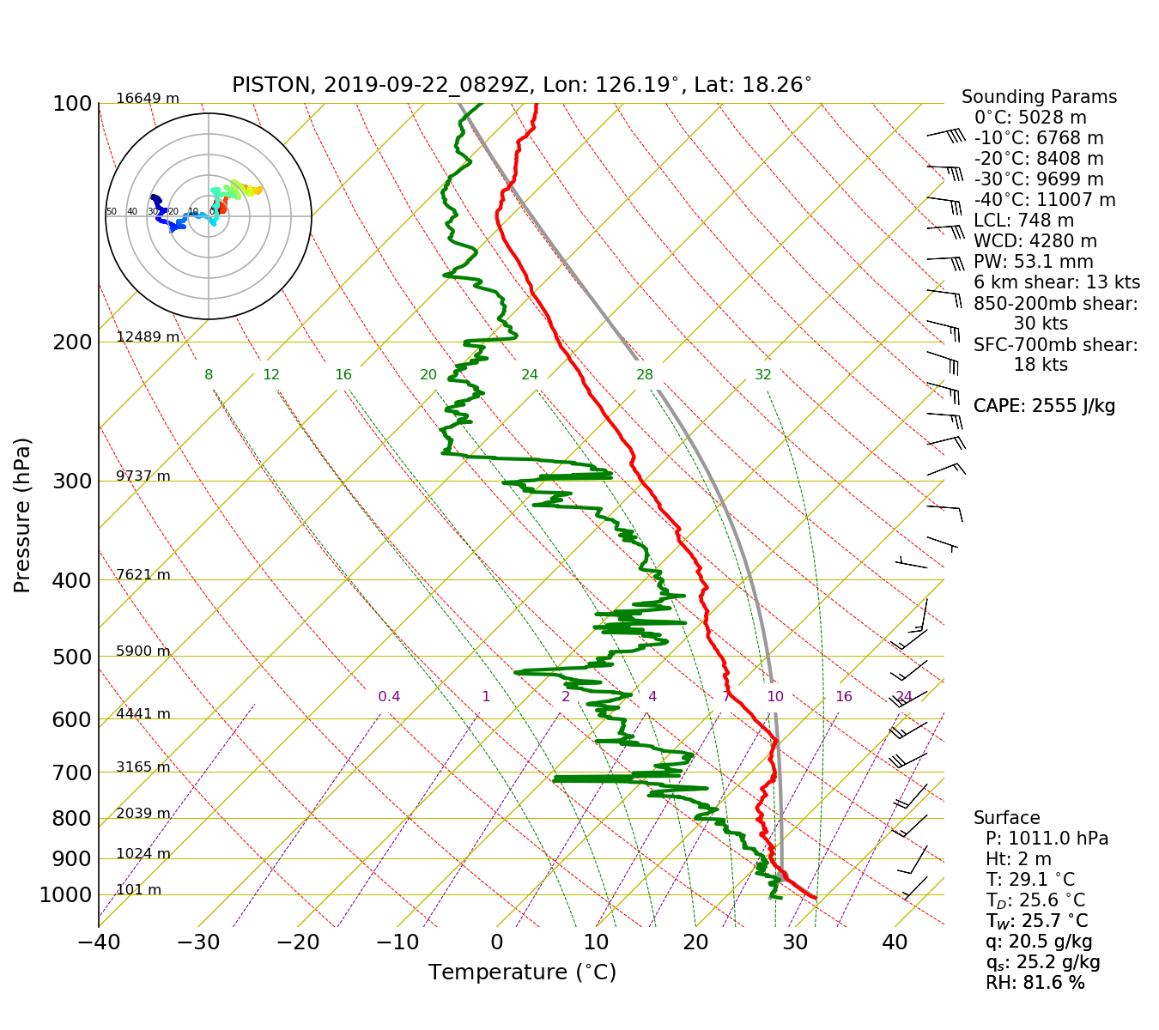

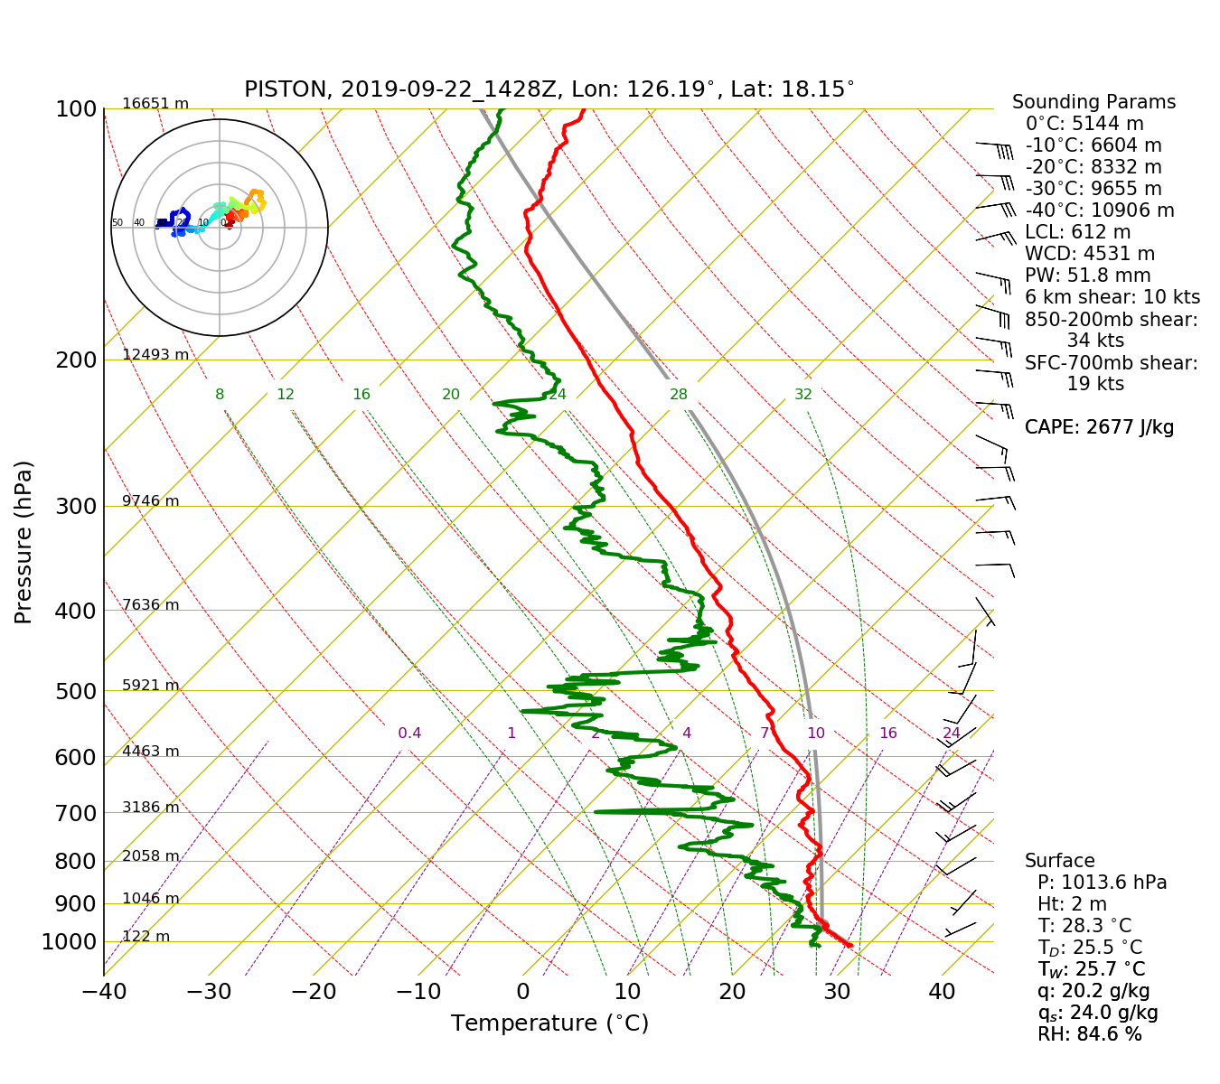
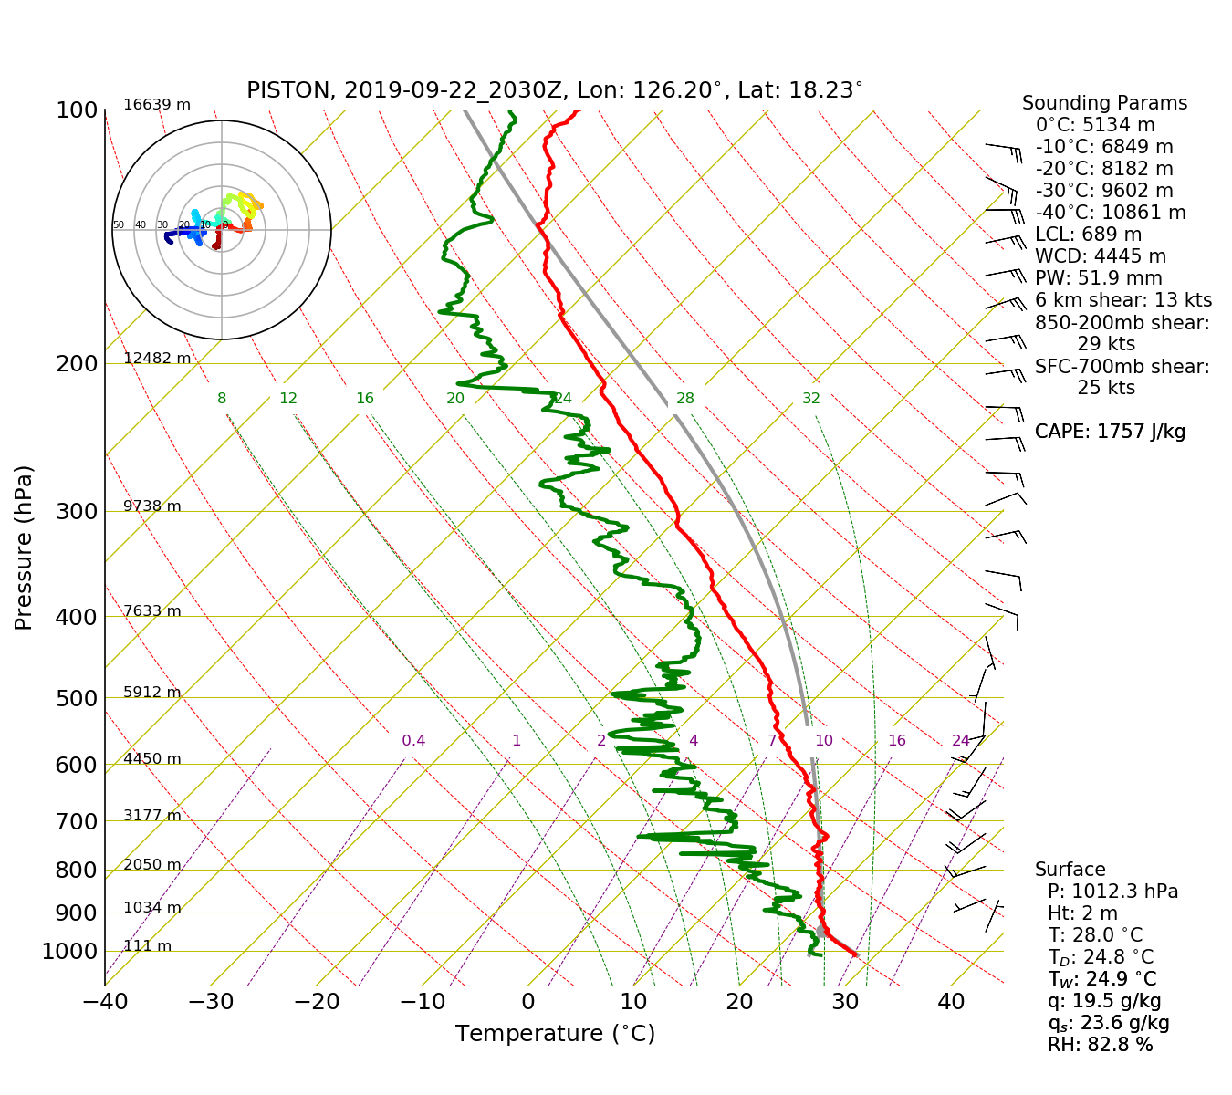

Fig. 6: 04 ,9, 15, 21 Z Soundings.

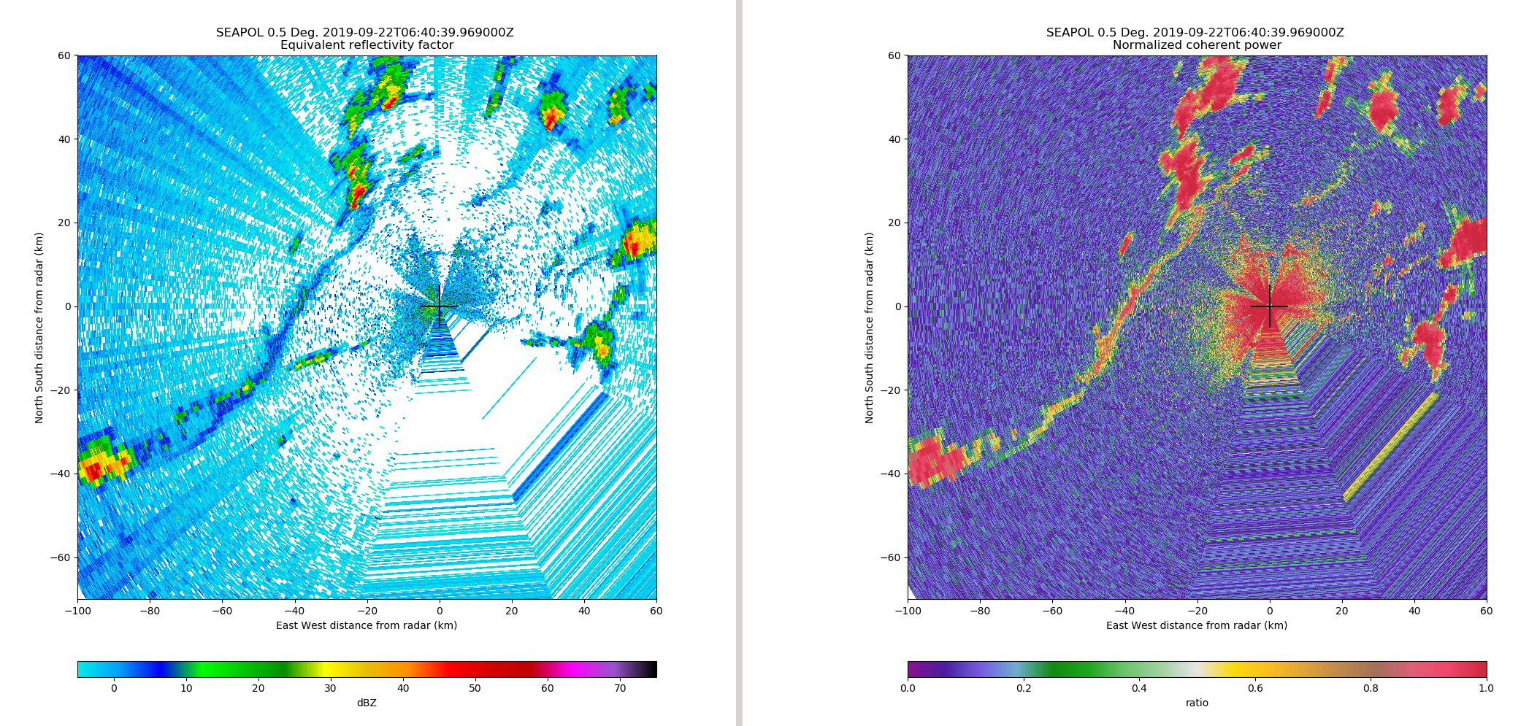
Fig. 7: Reflectivity (left) and NCP (right) of a gust front seen by SEAPOL

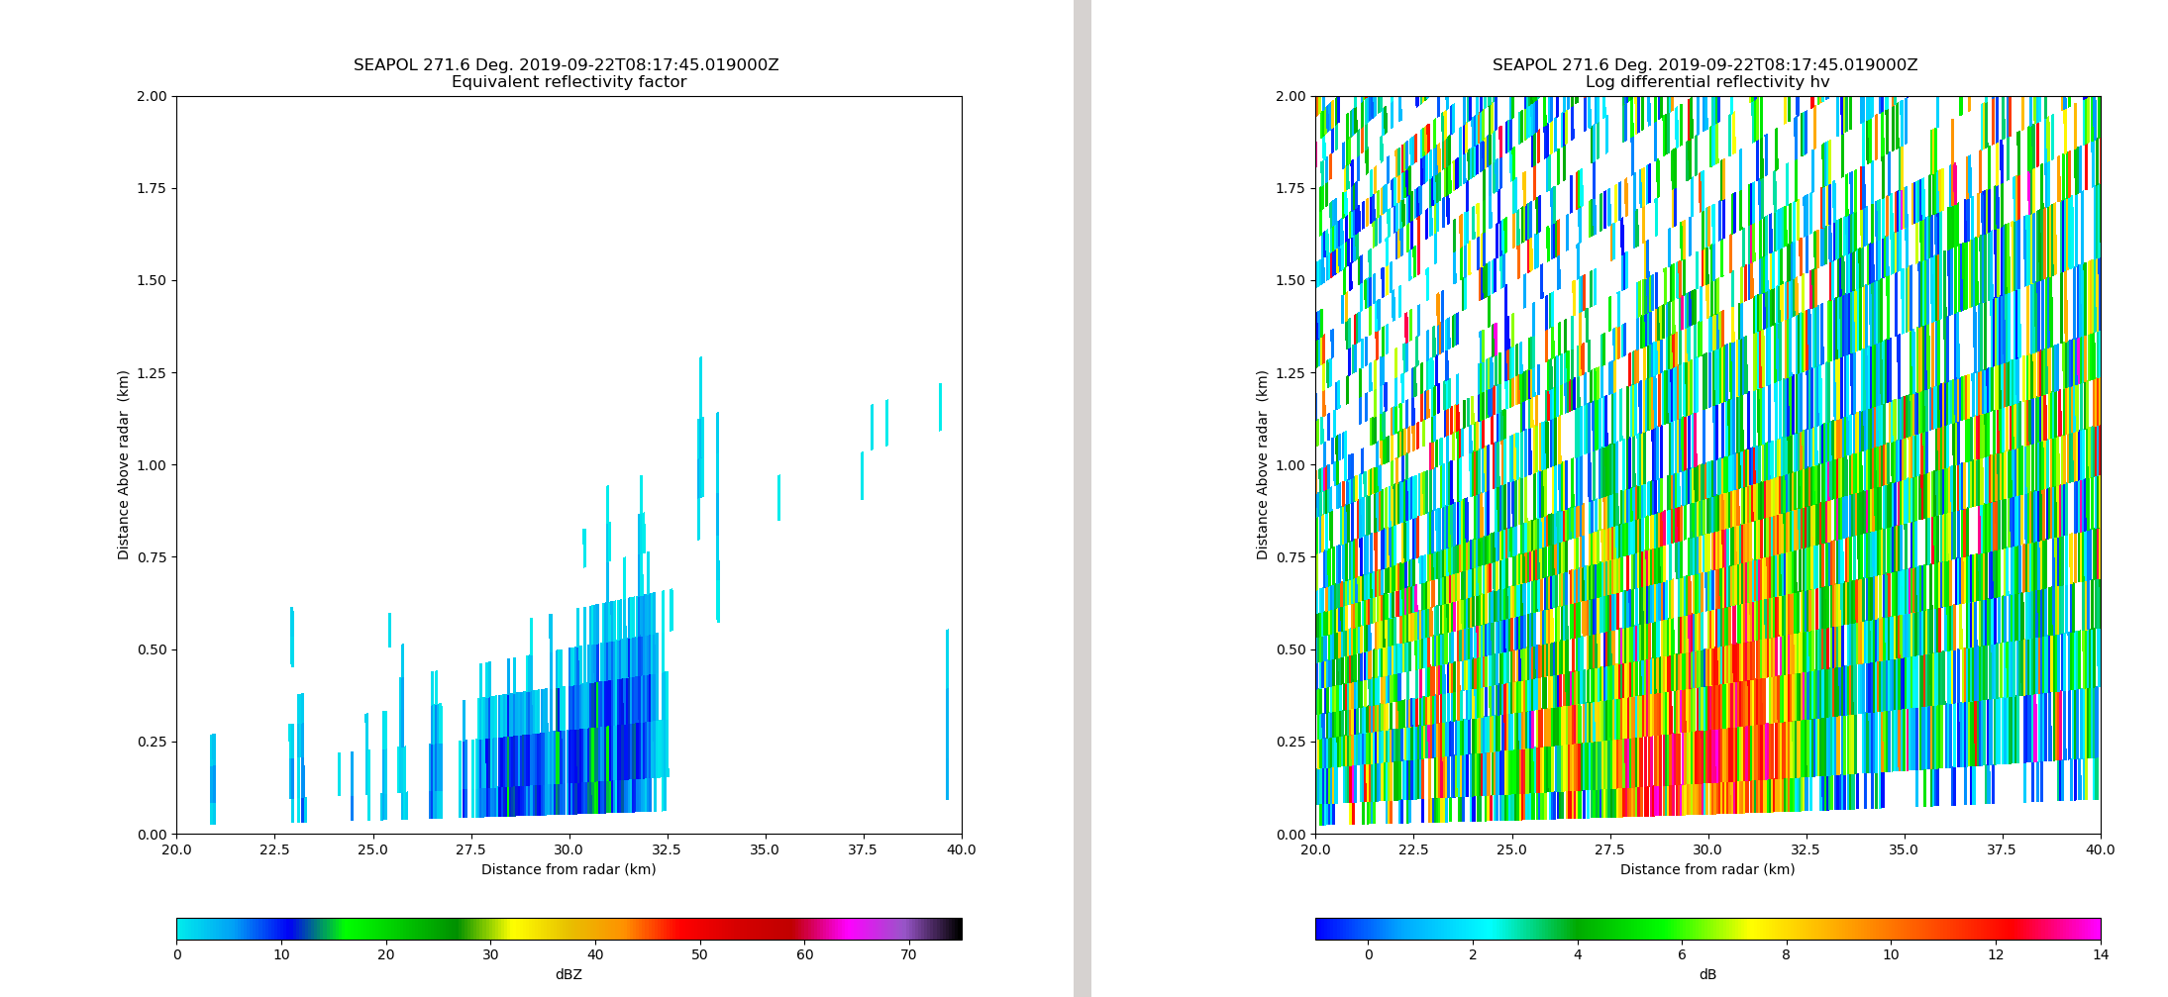
Fig. 8: RHI of the boundary in Fig. 2, showing reflectivity (left) and ZDR (right).

