PISTON 2019 Daily Science Summary

23 September Daily Summary: Diurnal Warm Layer
PISTON 2, R/V Sally Ride

Prepared by: Kyle Chudler, Brenda Dolan, Adam Clayton, and Marqi Rocque
Guest contributor: Elizabeth Thompson, NOAA ESRL PSD

For only the second time on this cruise, today was marked by calm seas and clear skies. While this (combined with increasingly dry air through the troposphere, Fig. 1) limited precipitation to only a few shallow warm rain cells, it led to a very exciting day for observations of atmosphere-ocean interaction.

As the sun rose, sea surface temperatures quickly climbed as strong solar insolation and light winds allowed the upper few meters of the ocean to quickly warm. As the day progressed, sea surface temperatures climbed to a cruise-high of 31.1 C. This led to anomalously high air-sea gradients in q and T, which fueled substantial latent and sensible heat fluxes upward off the sea surface despite low wind conditions (Fig. 2, publication in progress by E. Thompson using DYNAMO and PISTON observations). This encouraged vigorous cumulus growth within the atmospheric boundary layer in the late afternoon. The NOAA ESRL ceilometer and W-band radar showed cloud base heights of only 500-600 m and cloud tops within the lower 1 km. No surface rainfall was detected at ship or with remote sensing. By sunset, several cumulus clouds were visually observed to have grown taller than they were wide into the dry, inhospitable layer above but not much further than the boundary layer itself (Fig. 3). While unfavorable tropospheric conditions precluded further growth into deep convection, the tie between the ocean and the atmosphere, including the impact of these diurnal warm layers on cloud growth and moistening the boundary layer, was on full display today.

On the radar side of things, the only notable observation was a tendency for storm cores to develop at the “top” of the storm (only a few km up), and then rain downwards (Fig. 4). These cores were also occasionally associated with a high ZDR values. ZDR values would grow larger as the core descended, suggesting continued coalescence. Previously observed storms on this cruise have evolved in a more traditional way, with the highest reflectivities originating at the base and moving upward as the storm deepens with time. However, it could be that this RHI is offset in azimuth from the main updraft.

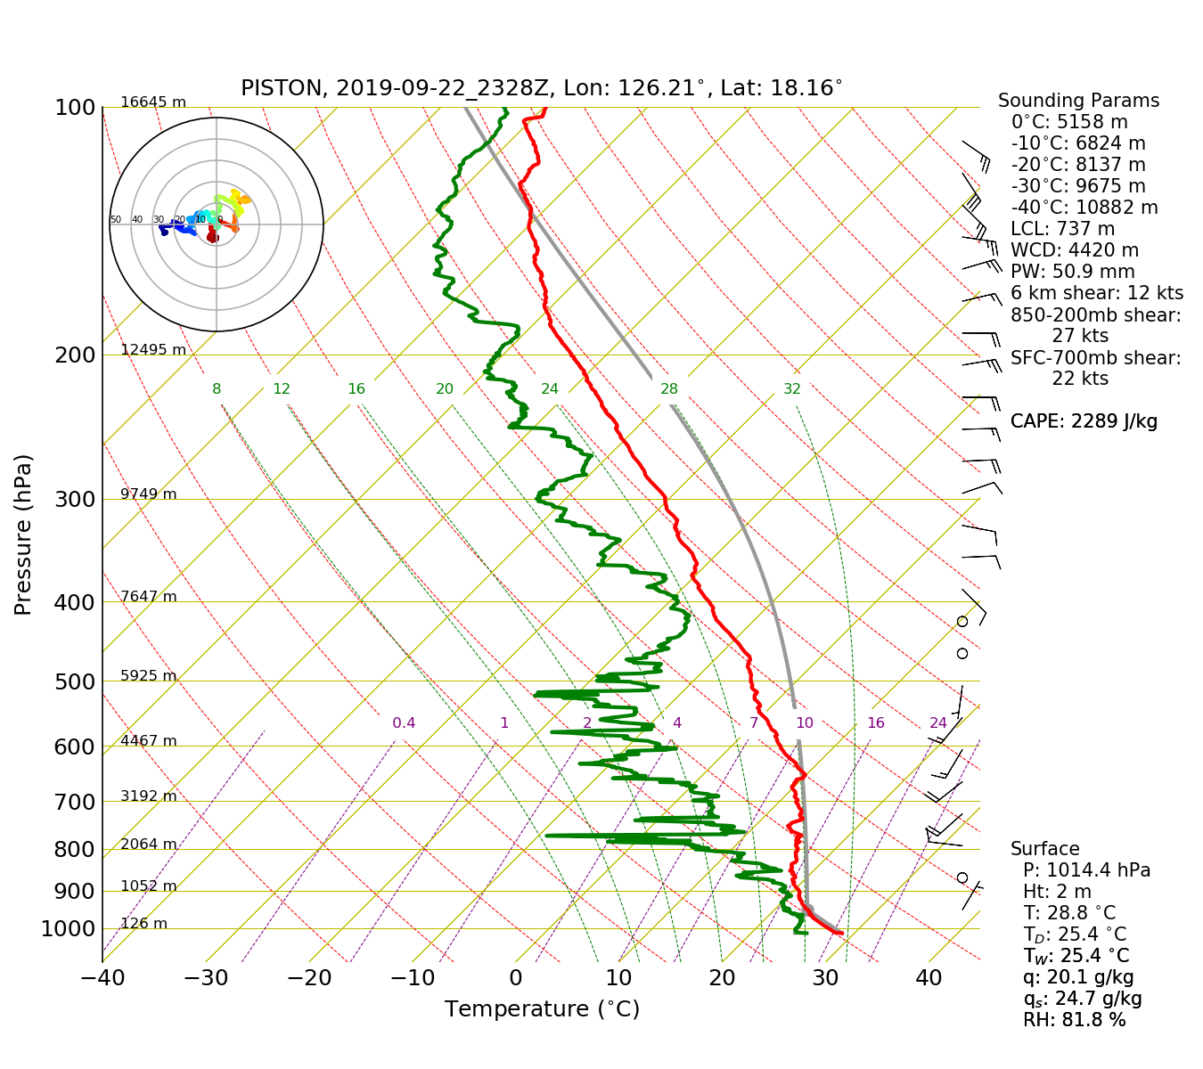
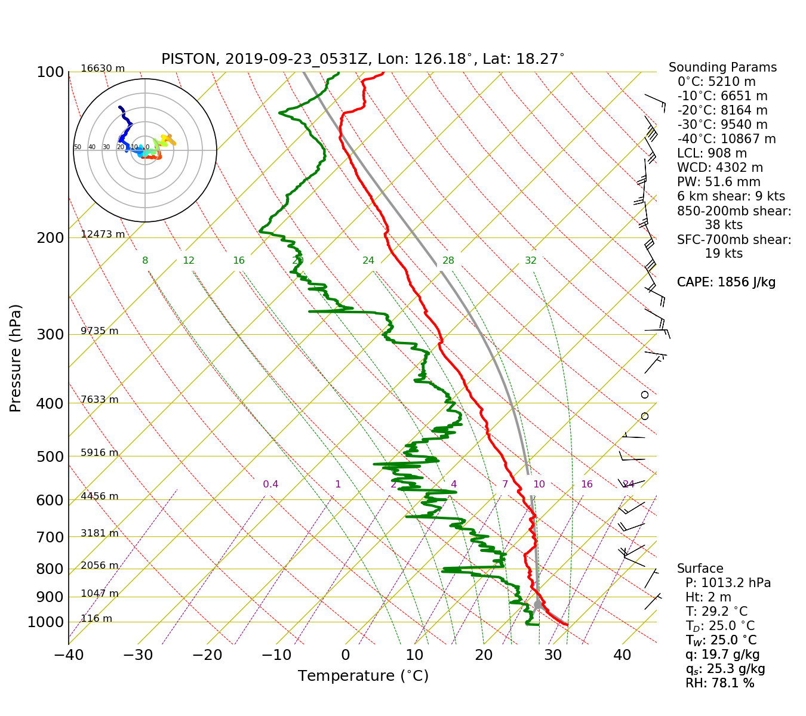
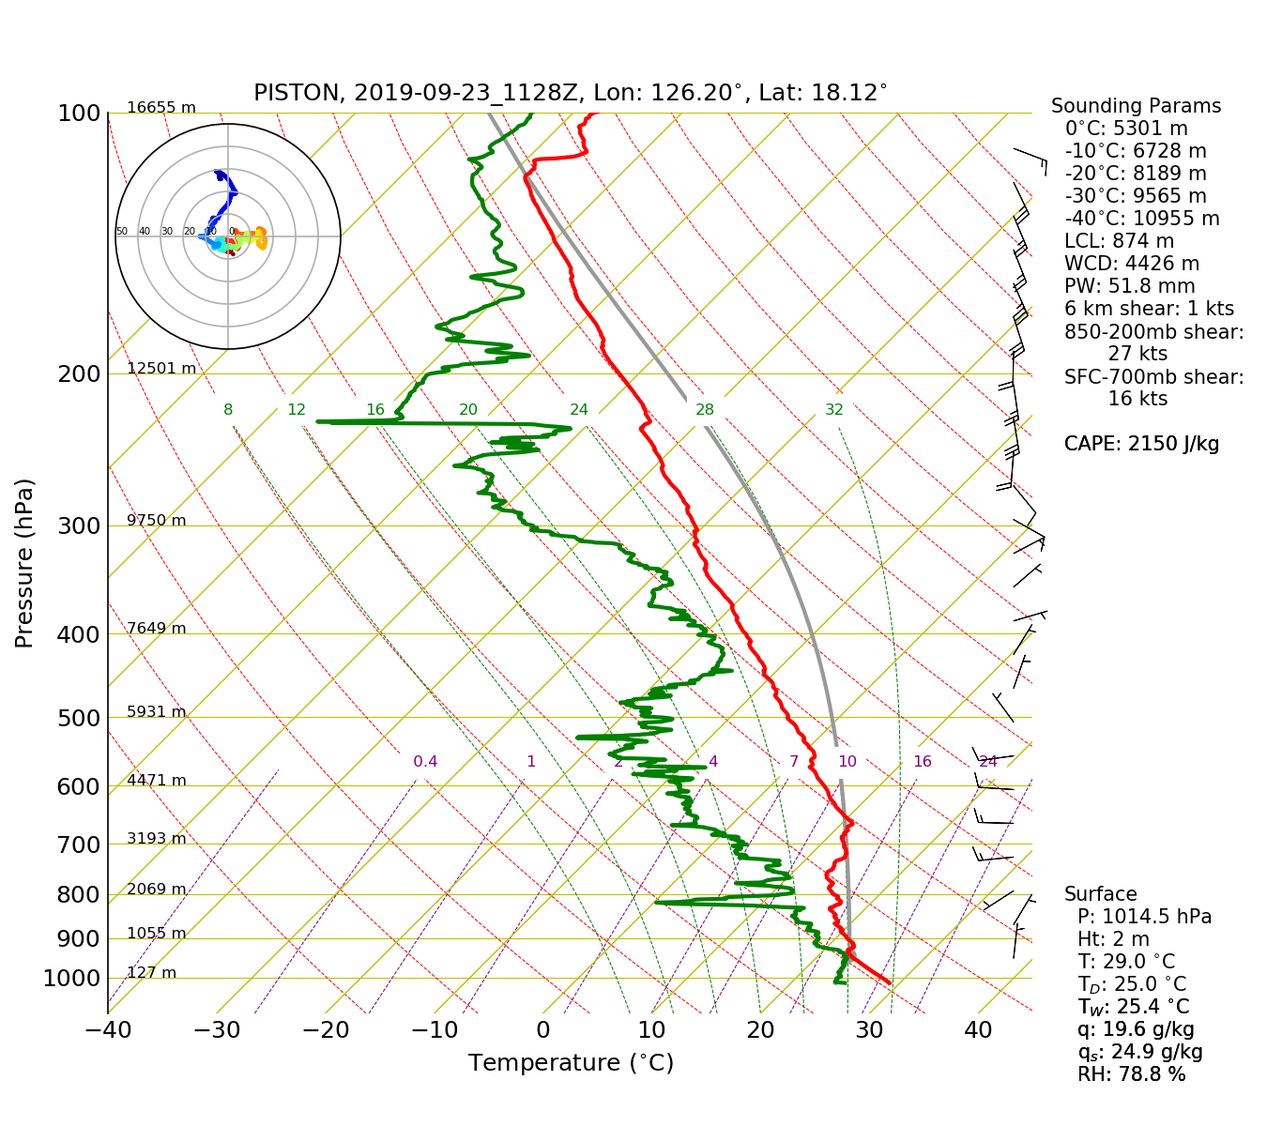
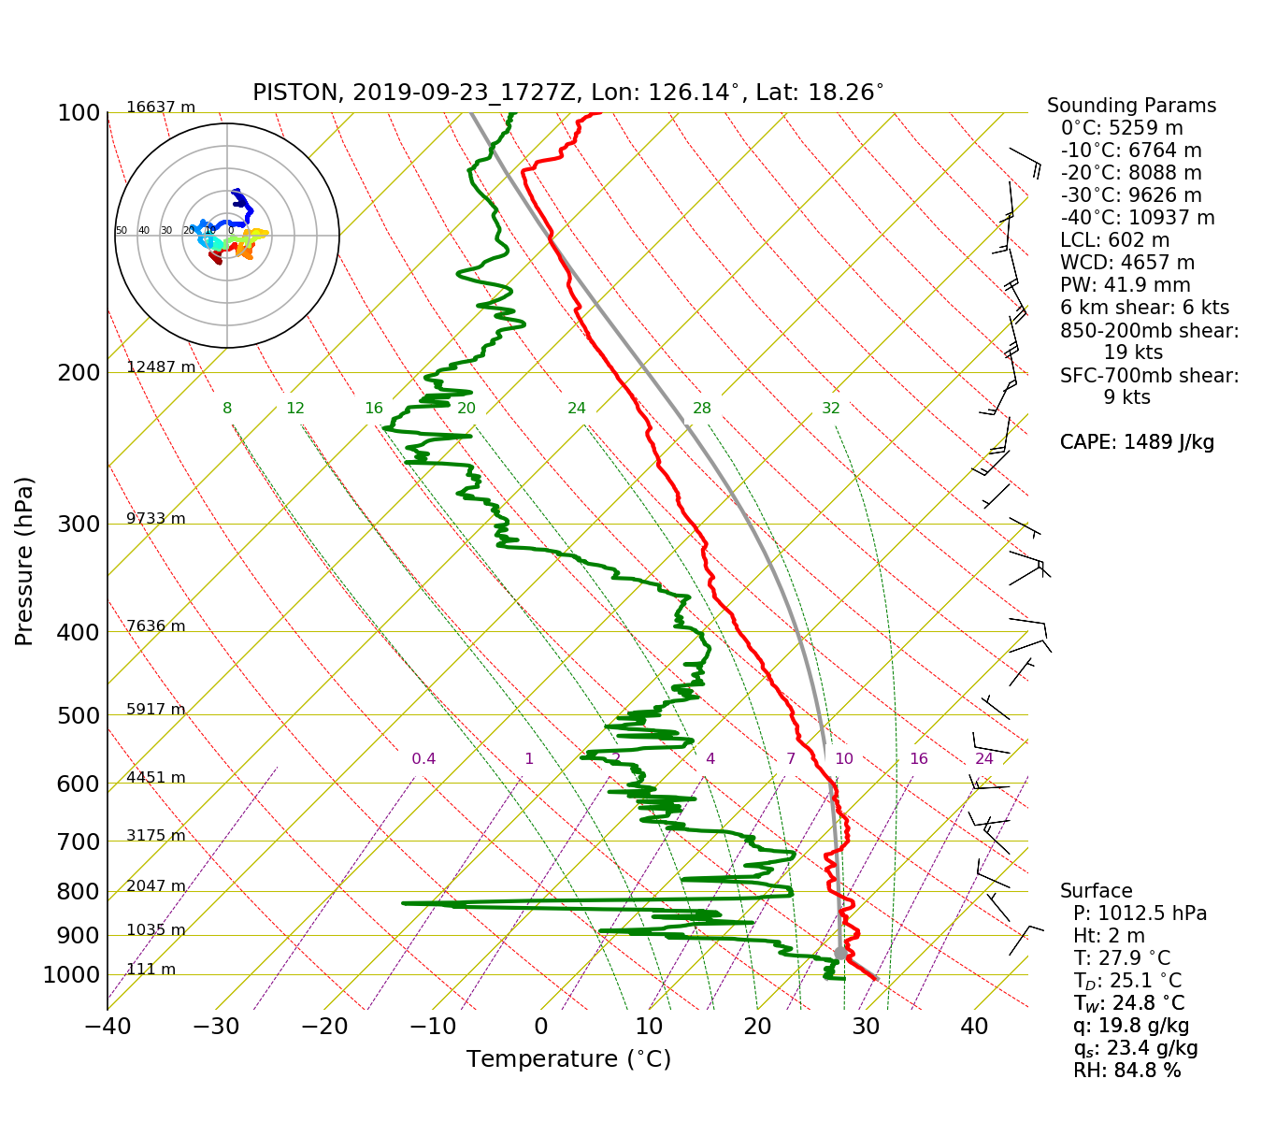
Fig. 1: 00,06,12,18Z Soundings

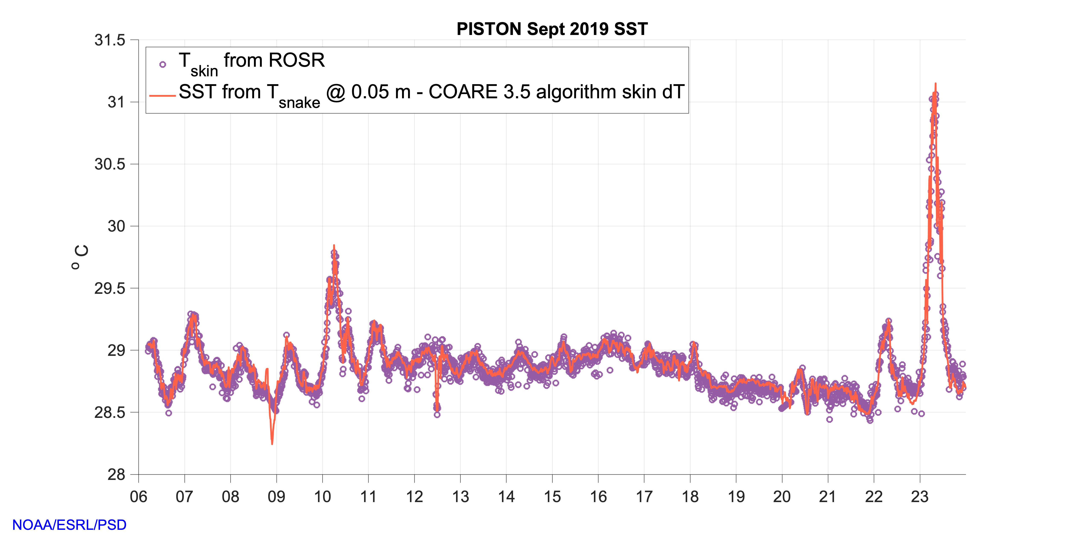
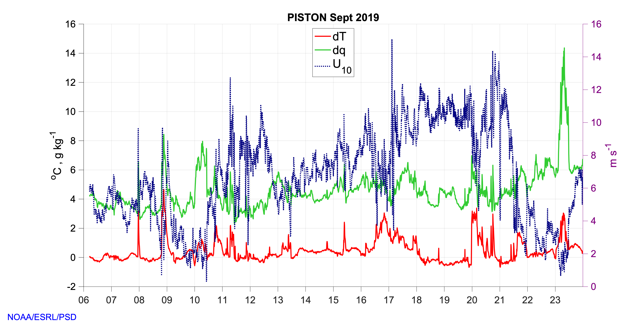
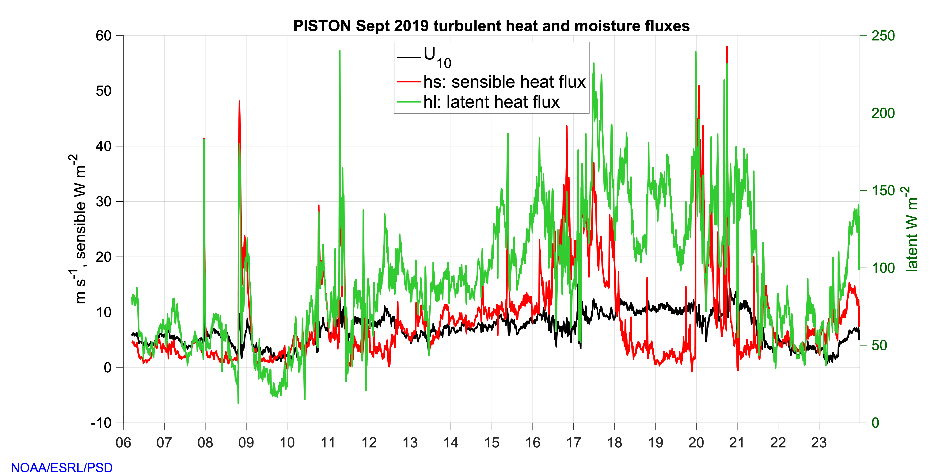
Fig. 2: Plots provided by E. Thompson, available in cruise share in NOAA directory using 10-min flux and meteorological dataset provided by NOAA ESRL PSD. Air-sea T and q differences are defined as SST – T10 and qs -q10, positive = upward into the atmosphere. T10, U10, and q10 are the 10-m adjusted values of each variable after also adjusting for neutral atmospheric stability. T_skin was the measured skin T of the ocean using the ROSR (infrared radiometer) deployed by NOAA ESRL / APL-UW. SST is the matching “best” value of sea surface temperature computed as: T measured by the sea snake at 0.05 m minus the cool skin T magnitude that is estimated by COARE 3.5 algorithm being run on board by NOAA ESRL. The very skin of the sea surface is cooler than the water at 0.5-1 mm depth due to evaporation and conduction. See readme for flux file for more details.


Fig. 3: Cumulus clouds at sunset that are taller than they are wide.

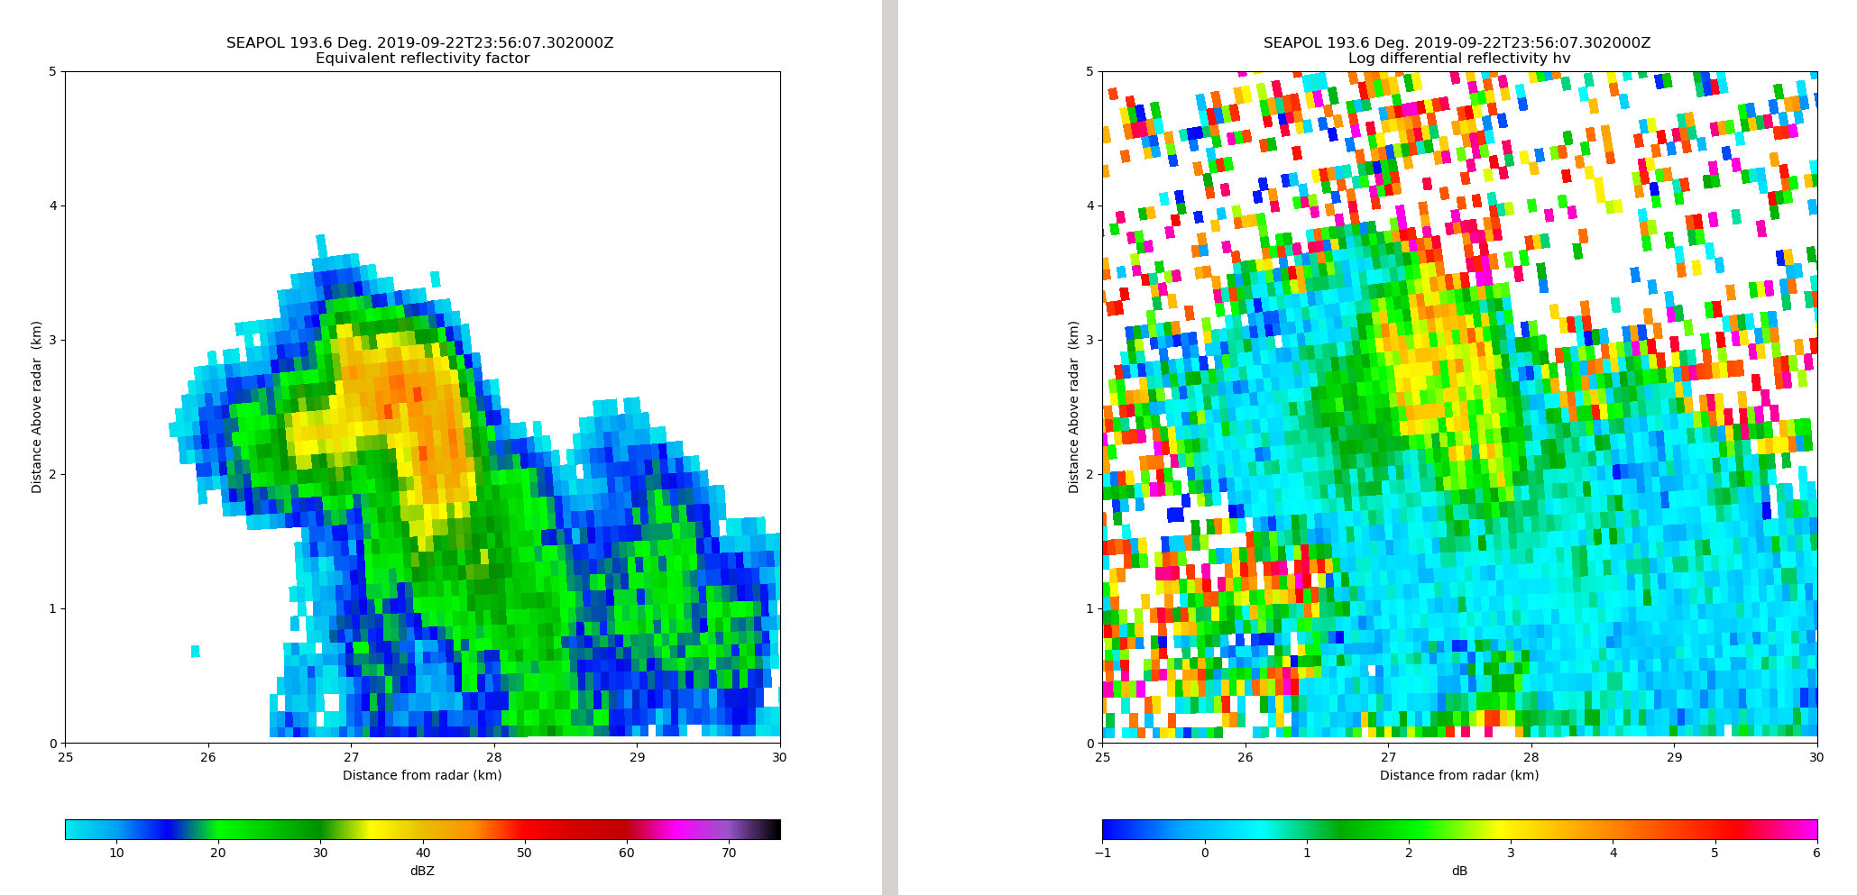

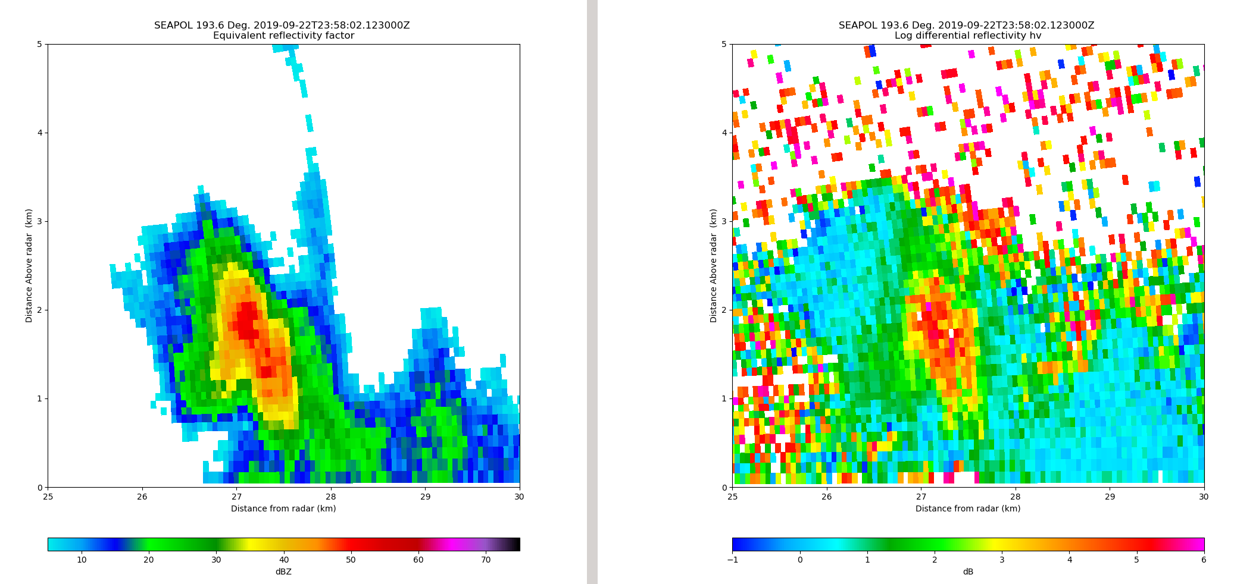

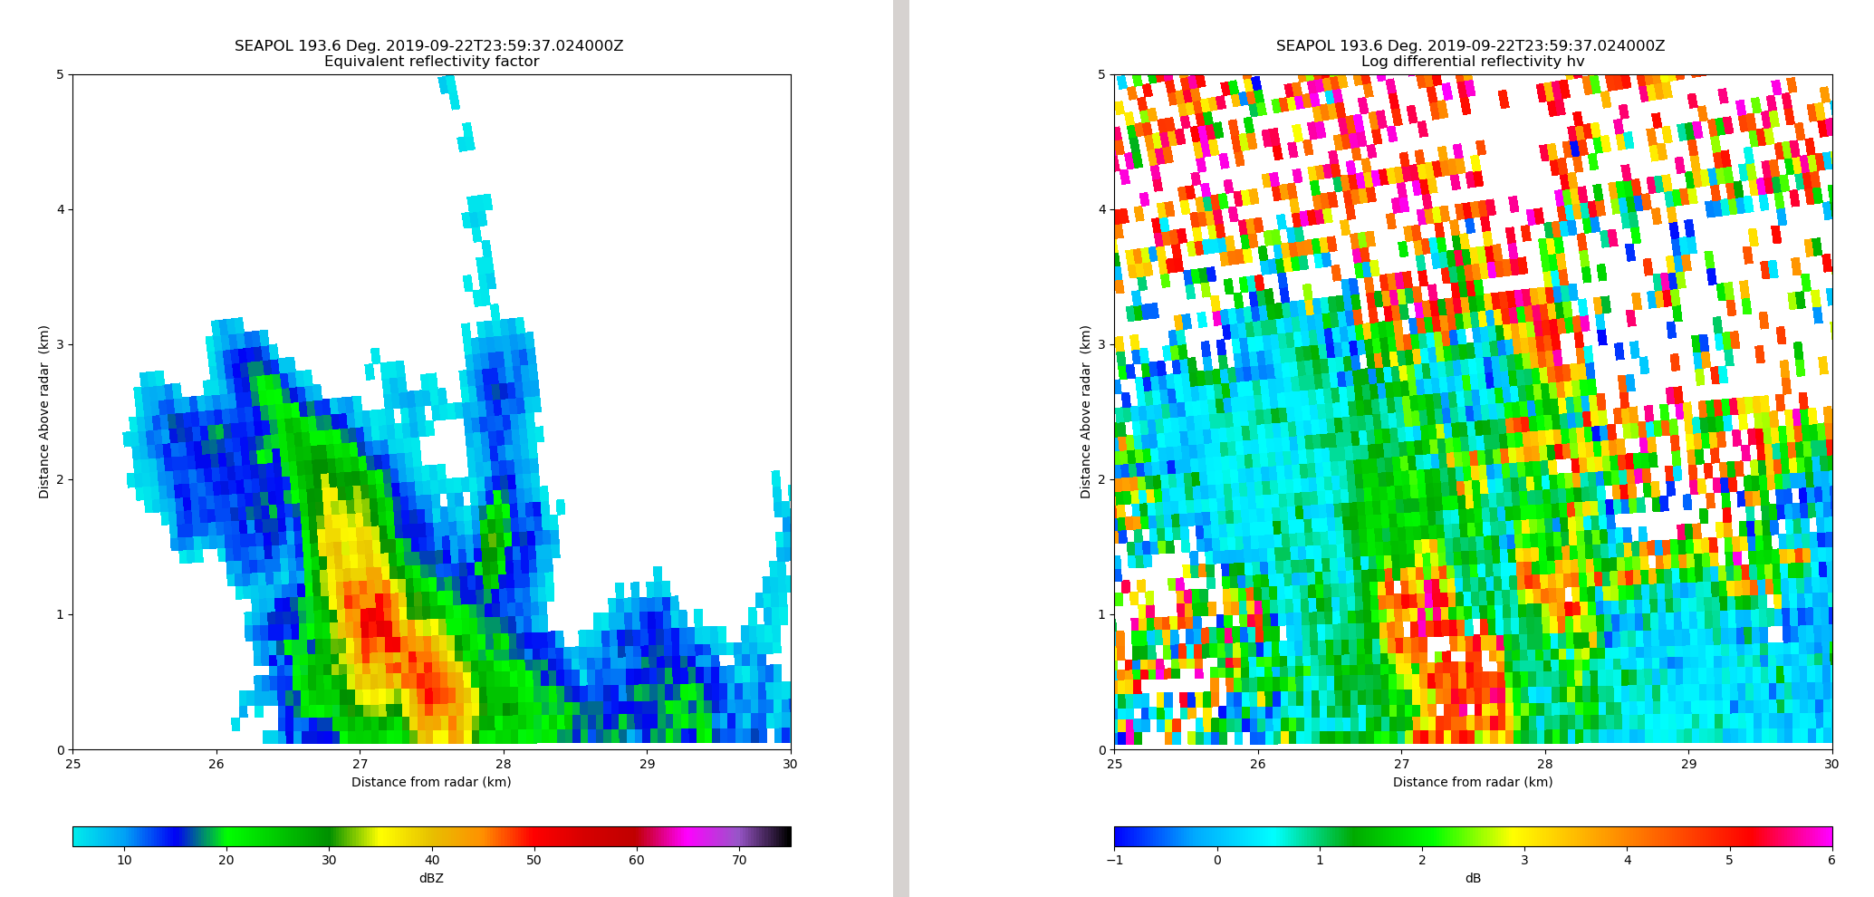

Fig. 4: Timeseries of reflectivity (left) and ZDR (right) RHIs of a storm with a ZDR core developing aloft and descending with time.

