PISTON 2019 SEA-POL and Sounding Report

Brenda Dolan, Kyle Chudler, Adam Clayton, Marqi Rocque, and Jim George

The CSU SEA-POL radar was built on the dock beside the Sally Ride over 3.5 days from 27 August to 1 September 2019. Final installation of the radar on the forward O1 deck occurred on 1 September. The location of the SEA-POL radar relative to the bridge and ship super structure resulted in a 80º blanking sector, allowing for a 280º view of port, bow and starboard relative to the ship (Fig. 1).
The SEA-POL scanning strategy was designed with three main objectives: 1) continuous near-surface rain mapping, 2) microphysics and lifecycle studies of convection, and 3) support of CAMP2Ex aircraft missions in the vicinity. During normal operations, a heartbeat of 10 minutes was selected which included a 3 minute rain volume scan with 7 elevation angles (Fig. 2) starting on the 10 minute, followed by 6.5 minutes of RHI “volumes”. Such RHI volumes were selected by the radar scientist with the objective of capturing the lifecycle and microphysics of convection, and therefore the cells were “tracked” over their lifetime no matter if other things of interest were in the domain. Priority was given to cells and convection moving along a SEA-POL radial in order to maximize the ability to determine the flow structure, as well as allowing a single RHI angle to capture a consistent cross-section of the storm over time. Typically, these “volumes” included 4 azimuth angles that were repeated several times over the six minutes. Occasionally long-range surveillance scans, with range out to 300 km, were included to place the observations in context, understand contamination from second trip, and to determine what else might be lurking beyond SEA-POLs normal radius of 120 km. When the ship experienced light rain, bird bath scans were recorded in order to determine the Zdr bias, which was nominally found to be 0.3 dB, as in previous deployments. For CAMP2Ex missions, the rain mapping scan was discontinued in order to have the agility to work with the planes on a faster timescale. During these periods, small sector volume PPIs around the echo the planes were working were performed that took about 2 minutes. These were followed by RHI volumes on the same echoes to provide high-resolution vertical structure. Finally, a quick 360 surveillance scan was occasionally included in order to look for other potential targets for the aircraft. SEA-POL ran nearly continuously from the start of operations on 5 September through 08 Z on 25 September. At times, RHIs were ceased due to excessive rates of pitch and roll which would cause the antenna to dip below the minimum elevation limit. This primarily occurred on 21 September. During the cruise, over 39000 RHIs, 20000 PPIs, and 300 SUR scans were performed (Fig. 3). For CAMPEx, SEA-POL supported 5 Lear missions to the area and 3 P3 flights.
We found significant interference with the ship’s HiSeas Net internet antennas. A test was performed on 7 September to characterize the interference. The ship rotated 45 degrees in heading every half hour, and the headings with good / bad interference were documented (Fig. 4). Headings from NNE to SSE experienced less RFI than west headings. With the help of the ship’s IT professional, it was determined that the port side HiSeas Net antenna, also operating at C-band, had a direct line of sight to SEA-POL at those headings. If that antenna was pointed away from SEA-POL, the RFI cleared up. It was determined that this could be done for case studies (such as CAMPEx flights) for headings from 180-260 and internet would be preserved. Therefore, during CAMPEx operations, the ship was generally oriented between 0 – 266 degrees and the port antenna pointed away. This worked so amazingly that very light echoes such as gust fronts and boundary layer clouds could be detected by SEA-POL (Fig. 5)
Official operations began the morning of 5 September after 2 days of eastward transit to evade the influence of typhoon Lingling, and ended on 25 September at 8 Z during the transit back to Keelung. SEA-POL operated nearly continuously and without major issues for the entire duration. During this time period, SEA-POL observed five major precipitation events (Fig. 6). The “monsoon tail” of typhoon Lingling were sampled on 5 September, followed by a relatively quiet period with little rain or echo around the ship. A large mesoscale convective system moved through on 8-9 September, bringing several hours of precipitation and echo. The monsoon gyre 95W brought moisture to the domain 10-12 September, followed by a large MCS on 17 September which yielded the highest domain averaged rain rates of the cruise, over 1.75 mm/hr. Finally, as 95W spun up into tropical storm Tapah 20-21 September, SEA-POL sampled the outer rainbands. During the quiet periods, warm rain cells which largely remain below the melting layer height of 5 km were still ubiquitous, and sampled with many RHI volumes. Overall, SEA-POL sampled a wide variety of echoes, including non-precipitating boundary layer cumulus, shallow warm rain cells, isolated deep, electrified convection, and MCS-scale convection and stratiform regions (Fig. 7). Several interesting questions arose from these observations, including how can warm rain cells generate extremely large reflectivities (> 60 dBZ) and extremely large rain drops (>5 mm, 4+ dB ZDR)? Do these large drops form under certain sea states or environmental conditions? What is causing the scattering when SEA-POL can see oceanic boundaries such as gust fronts? What determines if a cell is able to become electrified? What is the microphysical structure of the stratiform region of an MCS over the ocean? What are the flow structures in all of these echoes?
SEA-POL and the Sally Ride supported 7 CAMPEx missions to the area. The P3 visited three times on 10 September, 22 September, and 24 September. However, convection was limited on these days so only a few cells were sampled within the SEA-POL domain. In addition to the joint mission with the P3 on 22 September, the Lear Jet worked convection near the Sally Ride four other times: 10, 13, 15 and 17 of September. During these days, the Lear and the Sally Ride worked together to find interesting targets for the Lear to fly though (Fig. 8). These ranged from shallow convection to warm rain and embedded convection.
To characterize the environmental conditions during the cruise, atmospheric soundings were launched every 3 hours beginning 6 September. During transit on 5 September, 4 balloons were launched at 0, 6, 12, and 18 UTC. Balloons were launched from the stern of the ship 30 minutes prior to 0, 3, 6, 9, 12 ,15, 18, and 21 UTC in order to center the profile at that time. However, during CAMPEx aircraft operations in the area, sondes were occasionally launched early, delayed, or in one case, skipped, per request of the aircraft pilots. During the cruise, 160 balloons were launched, with 3 sonde failures and 7 balloon failures (all failures were immediately relaunched). The resulting time-height series of the anomalies (as measured against the cruise mean) shows the different environmental influences experienced by the ship (Fig. 9). The middle of the cruise was anomalously hot and dry, with the winds shifting from easterly to westerly. In fact, the precipitable water reached a surprising minimum of 37 mm on 12 September 21 UTC. The developing Tapah brought more northeasterly winds and a moister troposphere around 17 September. The last week of the cruise was marked by a cooler but drier upper troposphere, strong southeasterlies aloft and north westerlies near the surface. This period brought the lowest observed CAPE of 890 J/kg on 24 September at 06 UTC.

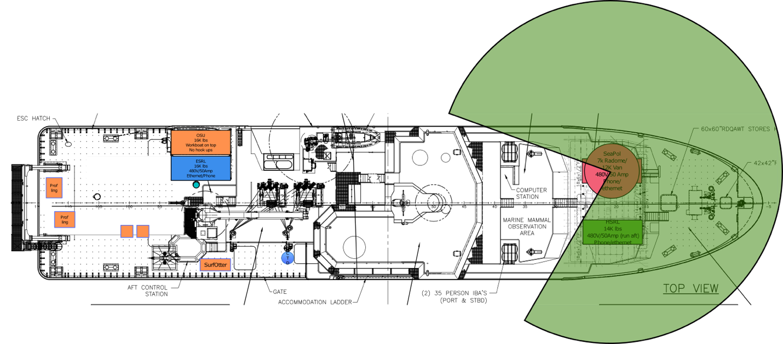
Figure 1: SEA-POL radar coverage area (green) on the Sally Ride.

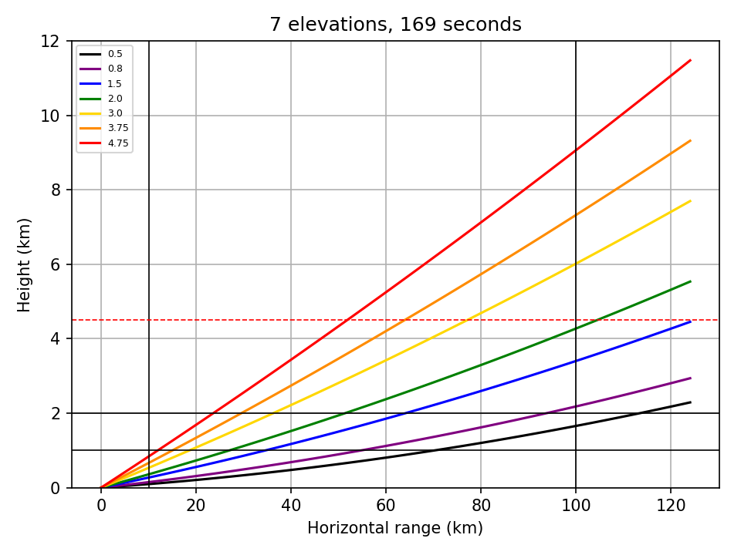
Figure 2: Elevation angles used in the PISTON 2019 rain mapping ppi volumes.

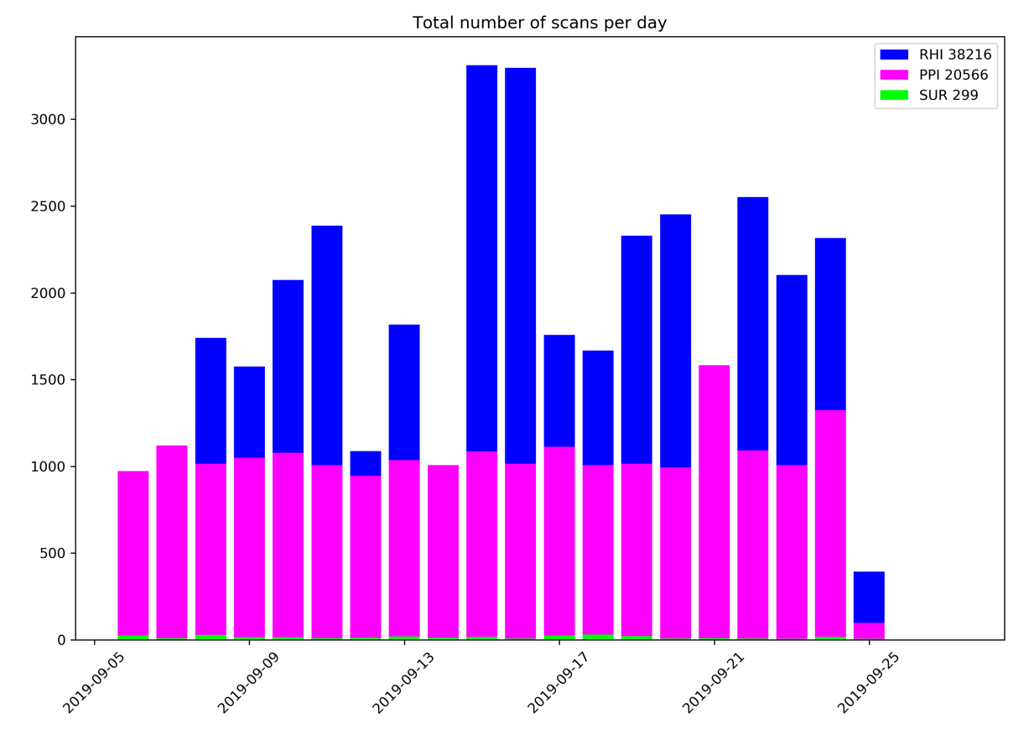
Figure 3: Breakdown of scan type per day of the cruise.

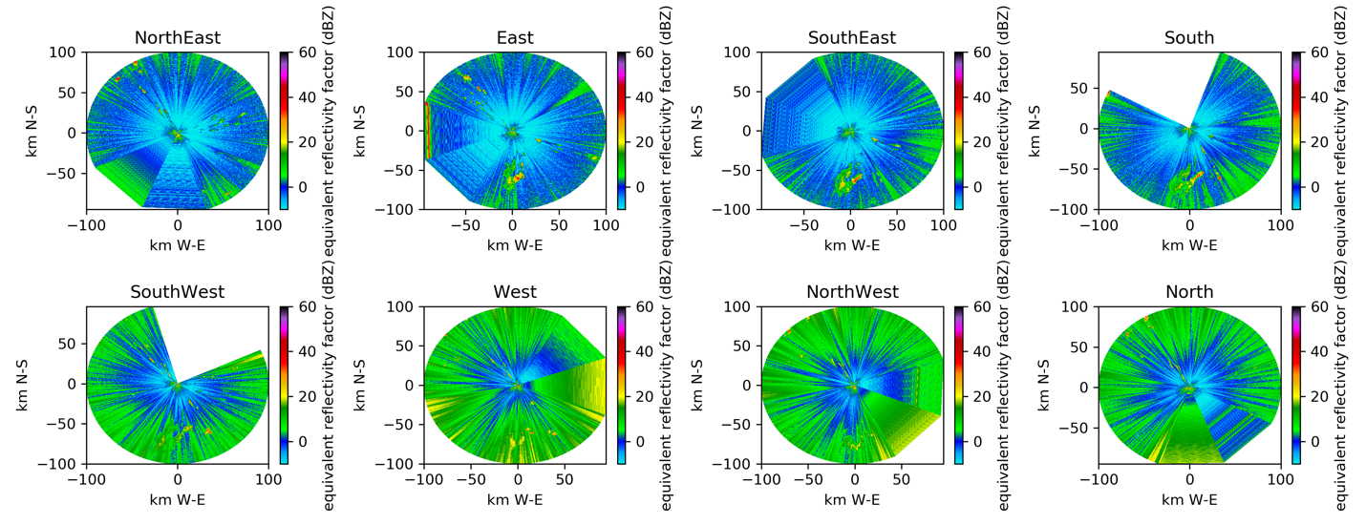
Figure 4: SEA-POL images as a function of ship heading. Note the RFI raises the noise floor about 10 dB, resulting in more green colors.

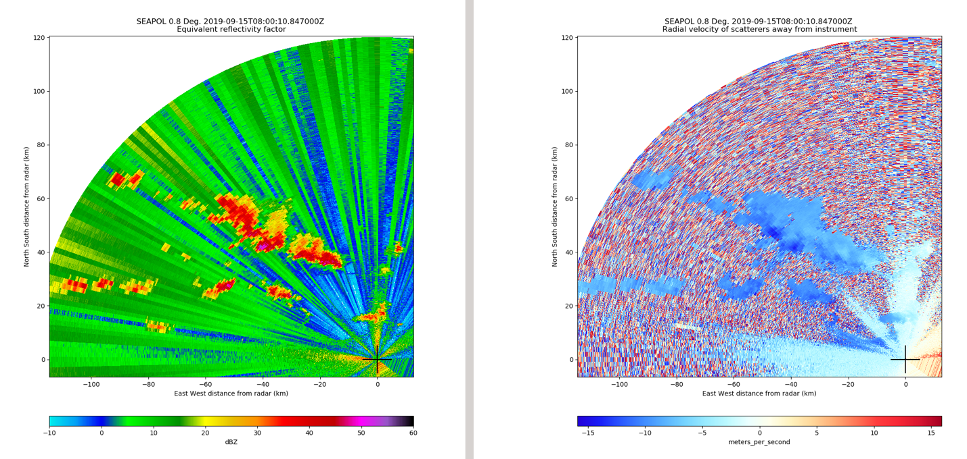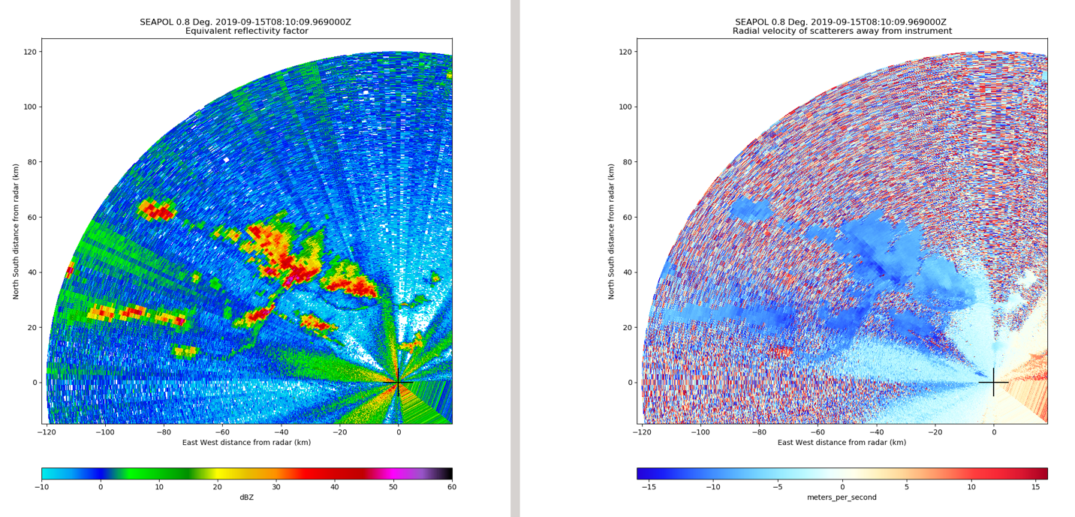
Figure 5: SEA-POL PPI with port HiSeas Net antenna in normal operations (top) and with the antenna pointed away from SEA-POL (bottom).

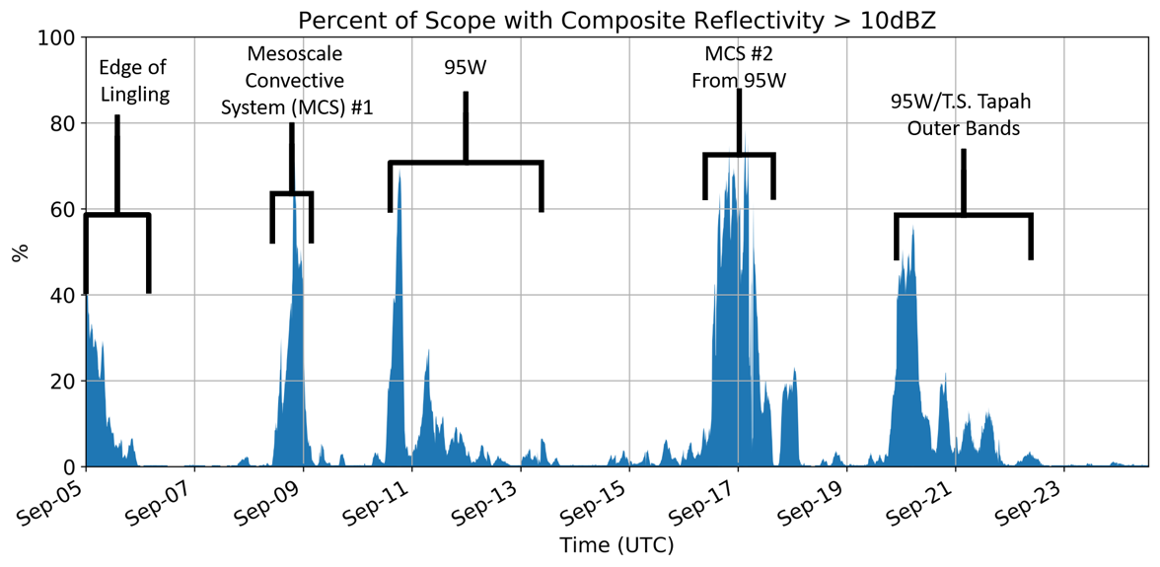
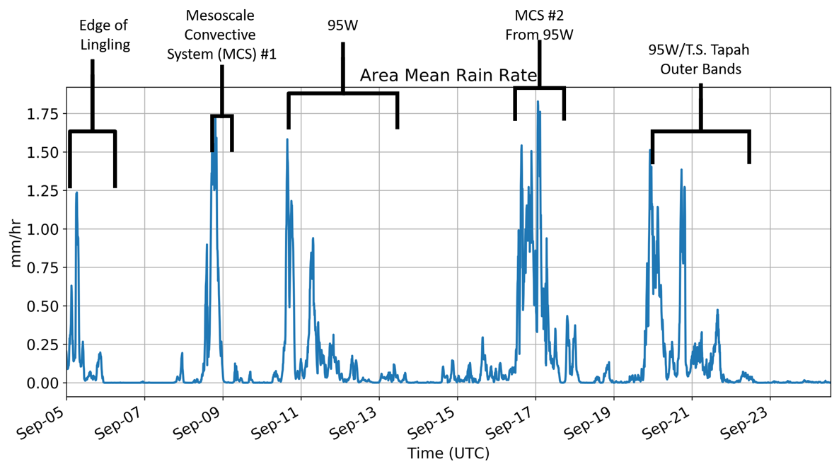
Figure 6: Timeseries of SEA-POL coverage area (> 10 dBZ; top) and domain mean rain rate (bottom).

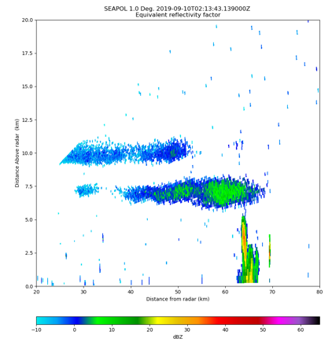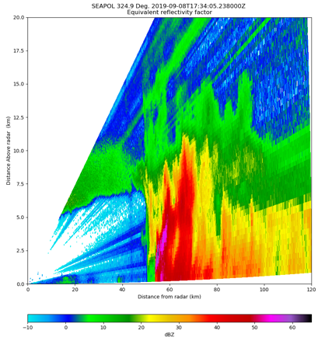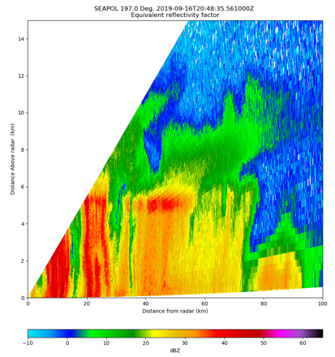
Figure 7: Reflectivity examples of clouds and shallow convection (top left), robust warm rain (top middle), isolated deep convection (top right), electrification (lower left), MCS convective line (lower middle), and stratiform rain (lower right) sampled by SEA-POL during PISTON 2019.

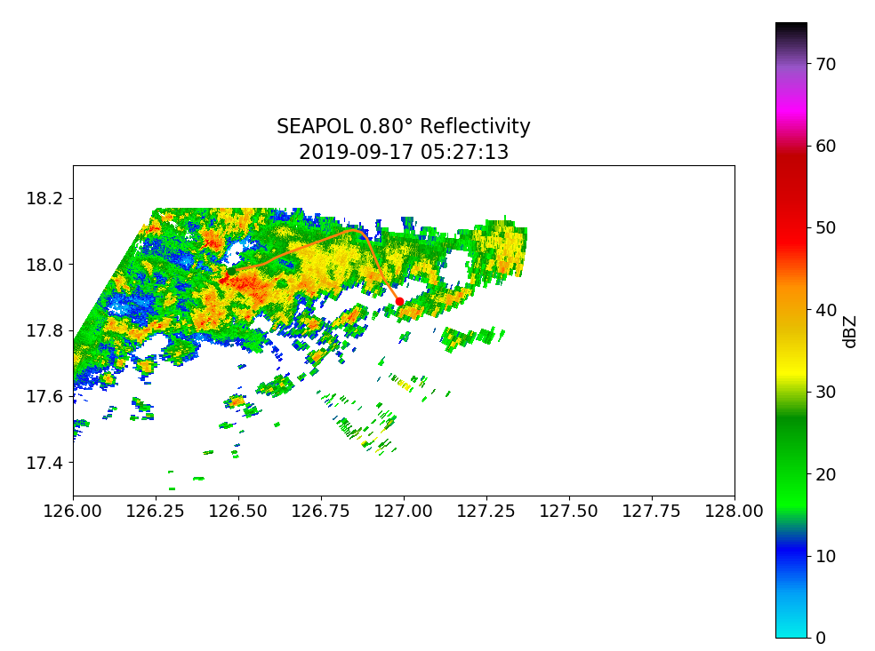
Fig. 8: Lear in convection at 0527 UTC (top) 0523 UTC (bottom). Green point indicates start and red the end point of the track during the approximate volume.

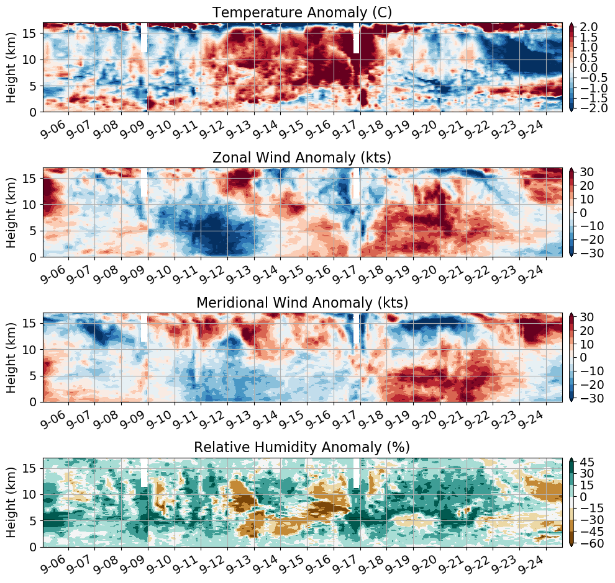
Figure 9: Atmospheric radiosonde time-height series of the cruise-averaged temperature (top), zonal and meridional wind (middle two), and relative humidity (bottom) anomalies.

