20180821
Day Shift (4a-4p L)
Timothy Lang

0002 – RHIs in the 130-150 range, covering distant convection to SE.

0013 – Storm to SE, 75-100 km out
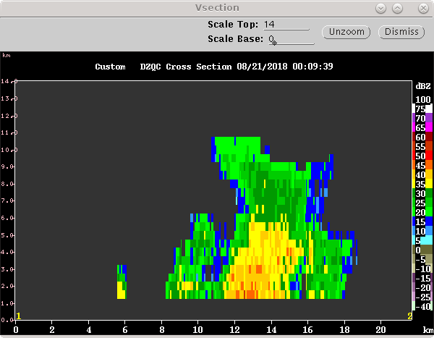
0019 – Storms to SE starting to put out a significant combined anvil. RHIs 118-140 az.

0037 – RHIs 98-120. No good CYGNSS overpasses expected today. Switching to PISTON_FAR due to proximity to SE storm.

0100 – Overall weakening trend in convective pattern, as revealed by movie loops.

0113 – Switching to PISTON_LOW due to limited height/coverage of convection.

0116 – RHIs 84-110, spaced 2 deg. 14 sweeps to 25 deg provides good timing.

0131 – RHIs 94-120, not very exciting out there. Only decent convection over 100 km out to SE.

0147 – RHIs 92-118, two cells beyond 100 km in that azimuthal block.
0203 – No RHI changes.

0215 – Ceasing radar ops temporarily to allow lidar work atop seatainer.

0245 – Recommencing ops. RHIs to distant cell to SW.

0258 – RHIs suggest very shallow cell, 4-5 km. Really not much out there right now.

0303 – Maintaining RHIs. This is a very marginal convective situation, however.

0315 -Lidar requires more work, shutting down scanning for up to 2 h. Not much convection anyway so minimal science impact.

Note: Ship has been moving SE, roughly 120-deg heading, the whole time today.

0705 – Restarted in PISTON_LOW. Scope empty except for some second trip to ENE.

0715 – Restarted 15-min cycle, nothing that isn't topped by 2.5 deg.

0718 – Stopped to allow more lidar work.

0730 – Restarted LOW. Satellite consistent with distant convection NE of max range, high cloud from that advected into our domain. That explains the second trip. Not going to do any RHIs.

Shift Summary: Scattered cells early, some intense, made for a good checkout of the overall PISTON scanning approach as we continued to steam toward the main science region. Then it dried out and there were multiple hours of downtime due to lidar maintenance. After restarting the scope was empty save for apparent second-trip echo to the NE. For RHIs, 12-14 sweeps, depending on top elevation angle, turned out to be a good number to shoot for to make it under 5 min. Two successful soundings (00 and 06 UTC) were launched during the shift as well.

Night Shift (4p-4a L)
Scott Powell

0913: Switched LOW scan to 60-minute cycle with surveillance scans at 0.8 deg occurring every 10 minutes. One cell is due north at range of 120 km. Other convection (showing up as second trip on volume scans) shows up 200 km out toward the NE.

1238: 00 UTC sonde launched. Delayed due to issues with Vaisala software. Restarting Windows fixed the problem. Convection still about 200 km to the NE on surveillance with some trailing stratiform building closer to the radar. Seems that the convection is moving slowly away from the ship.

1315: Switch to FAR scan for stratiform within 100 km of radar due north. RHI sector from 0 to 30 deg chosen. 2nd RHI sector from 56 to 62 degrees to capture isolated convective cell.

1419: Stratiform is out of range, and RHIs of it stopped. RHI will continue for cell between 45 and 60 deg azimuth.

1425: Switching to LOW scan for next cycle to test since only echo is at edge of domain. Trying to get a feel for when LOW scan should be used vs FAR scan.

1436: Tried adding a surveillance scan to the cycle. Saved in iris, and scanned stopped because I can't save to a scheduler while that scheduler is actively being used. Restarted new LOW scan. This is very much a day for testing, and pity be on the person, if any, who has to look through today's data. Fortunately, there's not much going on. A small convective cell to the NE is all.

1439: Vertical resolution of the LOW scan that was terminated early looks pretty good for cell 100 km out. Probably best to use LOW scan when convection is only present at edge of SEAPOL domain, even if that convection is deep. See the CIDD cross-section below of the LOW scan near 60 deg. Surveillance scan successfully added to cycle.

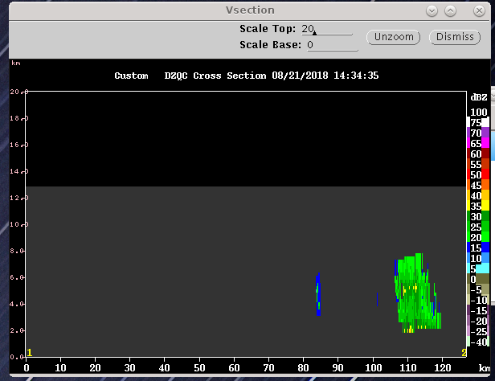
1545: All RHI scans are terminated. Convective cells to NE have weakened and are barely detectable.

1610: Returning to using LOW scan at top of hour with surveillance every 10 minutes. Even if nothing is detected, one full volume scan an hour will contribute to a robust description of how the precipitating cloud population (or lack thereof) evolves.

1730: Sonde launched. I suspect the CAPE values being displayed on all the Skew-T image products so far are too high.

1950: Satellite imagery indicates some high cloud aloft and a quick look from the bow seems to suggest the same. Would be interesting to look at some vertically pointing instrument data for the science summary.

Day Shift (4a-4p L)
Timothy Lang

2003 – Maintaining PISTON_FAR once an hour for now. It still mostly just sees the second trip to the NE from the MCS there, plus a little bit of real anvil near max range. The 300-km surveillance scan is the only thing that actually captures the MCS, however. This fills much of the NE quadrant beyond 100 km. The 10-min surveillance remains on schedule.

2007 – The QC code does not do a very good job with second-trip.

2107 – No significant changes to overall pattern.

2208 – Some possible anvil near max range on normal scan, otherwise not much change to the overall pattern. MCS still out of reach!

2224 – Light precip at the ship caught us unawares. Might be too mixed in with RFI and sea clutter. Going to regular PISTON_LOW 15-min updates.

2240 – RHIs planned 4-30 az thru the anvil from this MCS, which extends as close as ~50 km from ship.

2300 – Stopping scanning while more lidar work occurs. Should be 20-30 min only, hopefully. Only significant echo is the NE anvil cloud. Some small cells starting to occur within range, however. So hopefully shutdown is short-lived.

2330 – Back scanning in PISTON_FAR. There is a small cell in the 0-30 az rang, about 40 km away. Focusing RHIs there.

2344 – Now up to 4 cells in this region, tops ~8 km or so
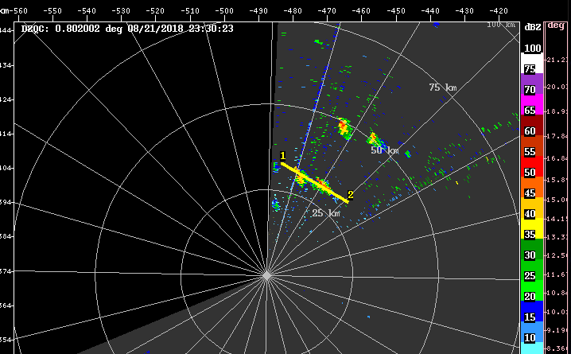
2350 Moving RHIs to roughly 15-45 az to cover strongest convection.

2357 – Close to 60 dBZ in the ~26 az RHI!

