20180823
Day Shift (4a-4p L)
Timothy Lang

0001 – RHIs to 30-52.

0007 – SE storm has matured and now features a large stratiform region. Definitely have the equivalent of an MCS in our eastern quadrant. Very active.

0016 – RHIs to 52-74 az as there is a closer cell there. The distance storms to NE have some nice signatures, however. Significant phase shift thru main core, plus a long anvil extending toward ship.

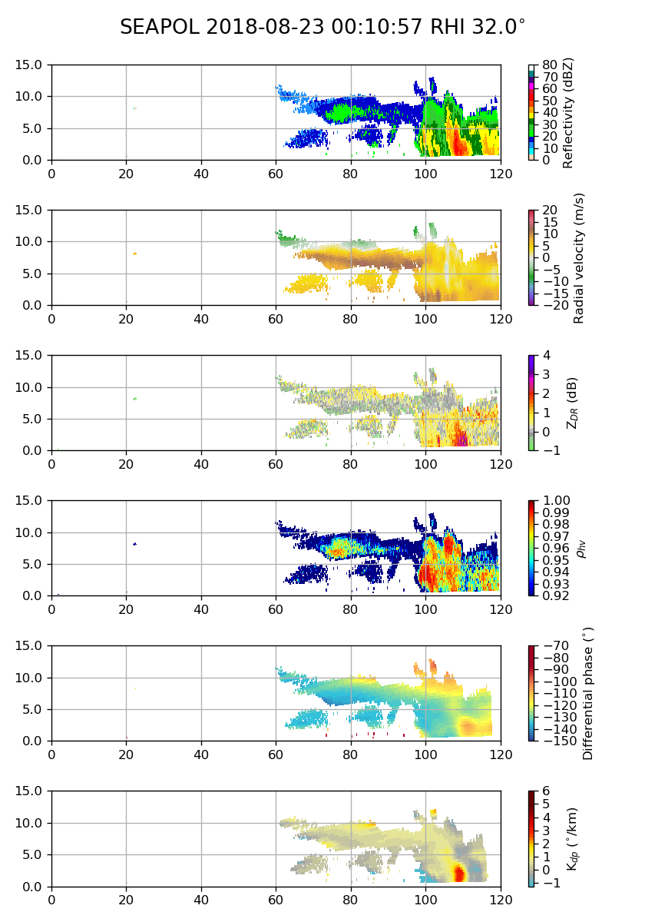

0031 – RHIs to 44-66 to keep up with motion relative to ship. Got good coverage of the main E cell on the last pass.

0042 – RHI thru eastern cell:
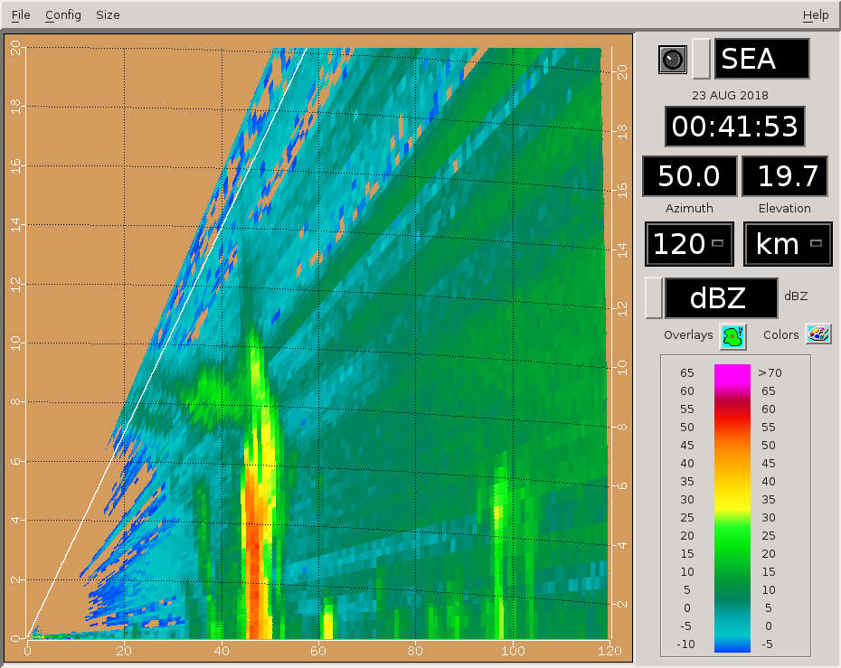
0042 – Overall trend in precipitation situation on scope has been transition to stratiform. We are getting past the mature phase, headed toward decay. Fewer new convective cells lately.

0046 – Continuing with RHI rotation, 38-60 az. Target still the eastern storm near 50 km.

0047 – Here is the full pol RHI at 48 deg, from last volume. Healthy core, but likely not much rimed ice above freezing altitude.

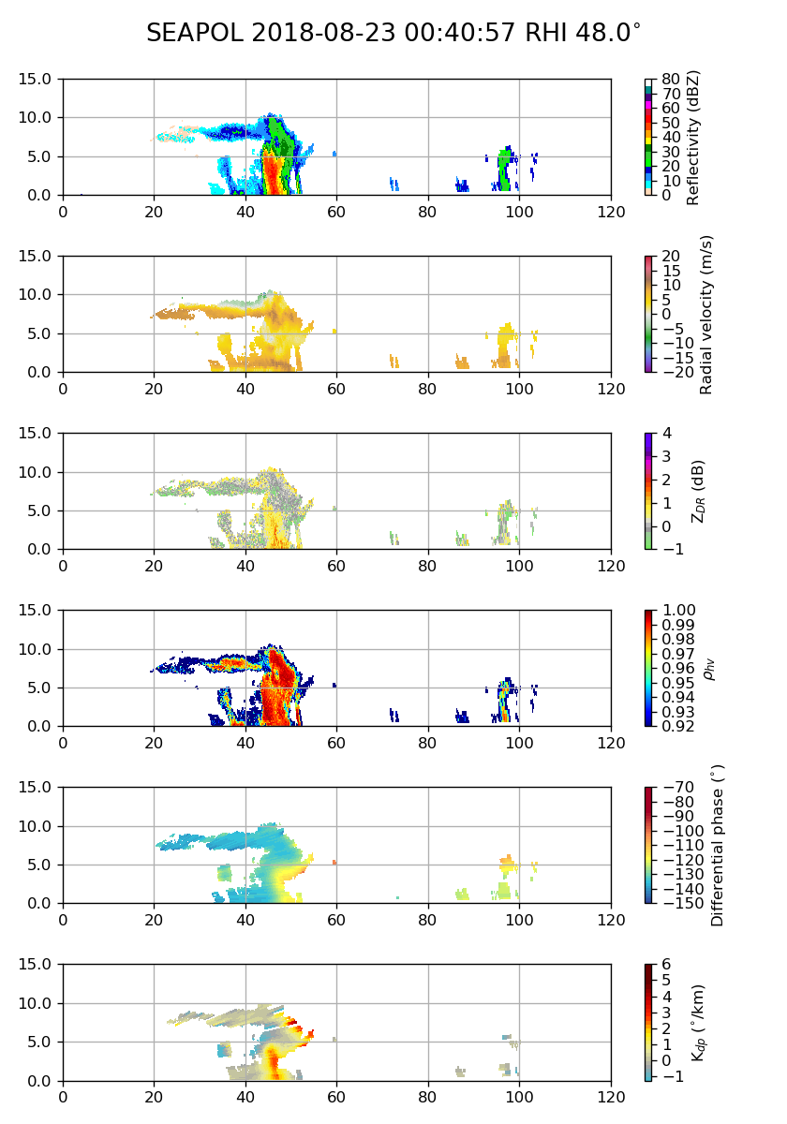

0101 – RHIs to 124-146. Some new cells popping up in the stratiform to SE, and E cell appears to be weakening. The SE convection will be easier to hit with the RHIs.

0112 – Bright band signature in stratiform that is closest to ship.
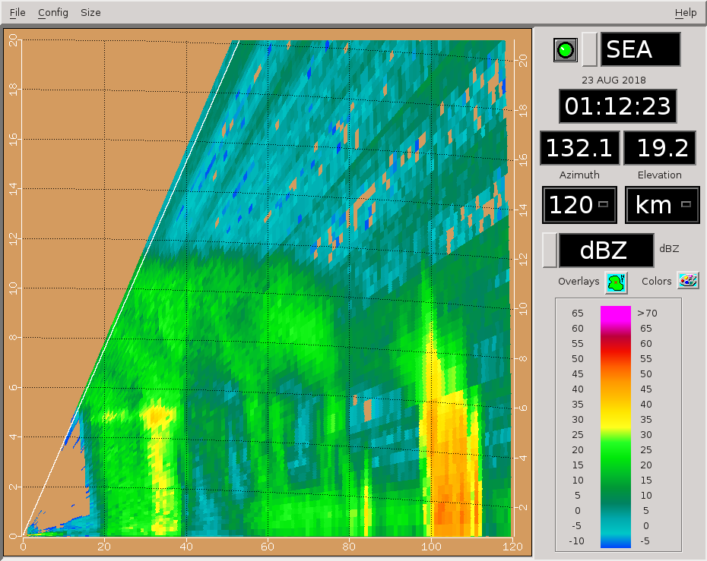
0126 – Missed on updating RHIs, cutting down on sweeps to finish in time. 130-140 az.

0131 – Still nailed storm. RHIs expanded back to 126-148 this round. Nice way of combining stratiform echo near the ship with convection further away.

0136 – Bright band nice and flat with altitude. Tells us radar's stabilization is working well!

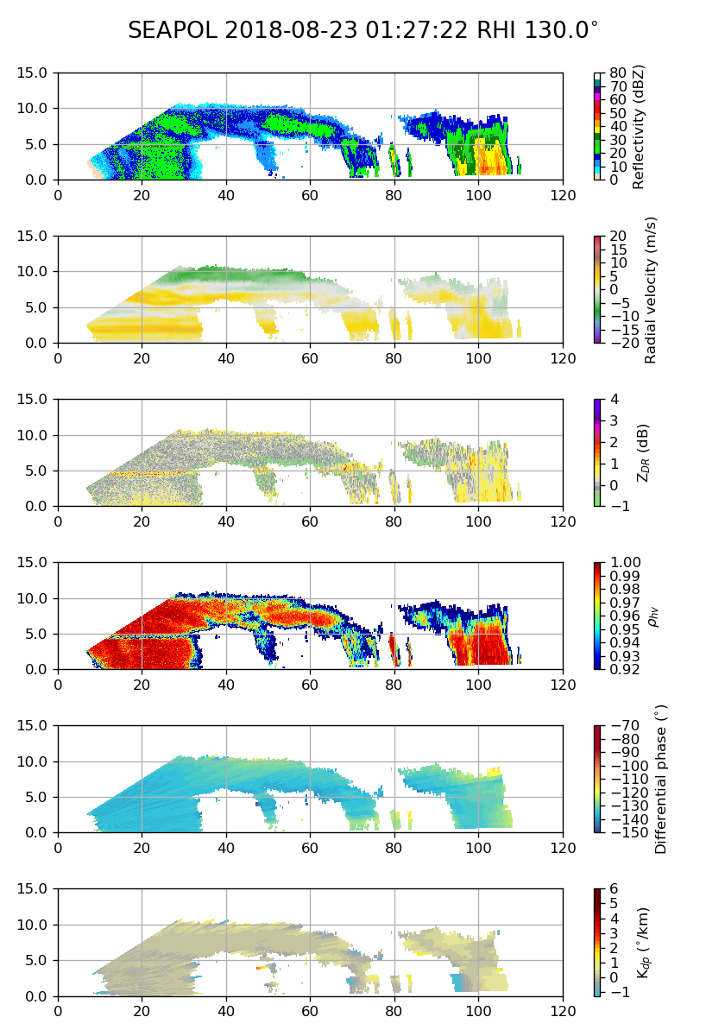
0138 – This next tilt (140) maybe the rocking overcame the stabilization? Slightly tilted bright band. This is the exception rather than the rule, however.
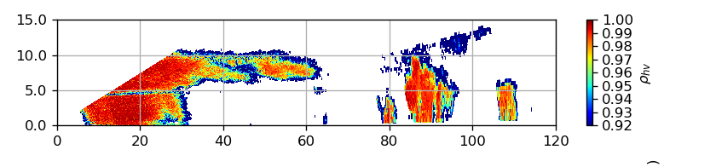
0146 – RHIs to 132-154, as there is new convection further west. Stratiform not fully topped by FAR or the RHIs, but we are here more for convection, so I will take advantage of the additional sweeps to get more of that.

0201 – RHIs 136-158.

0210 – Long-range view. Precip filling most of the eastern half of the scope.

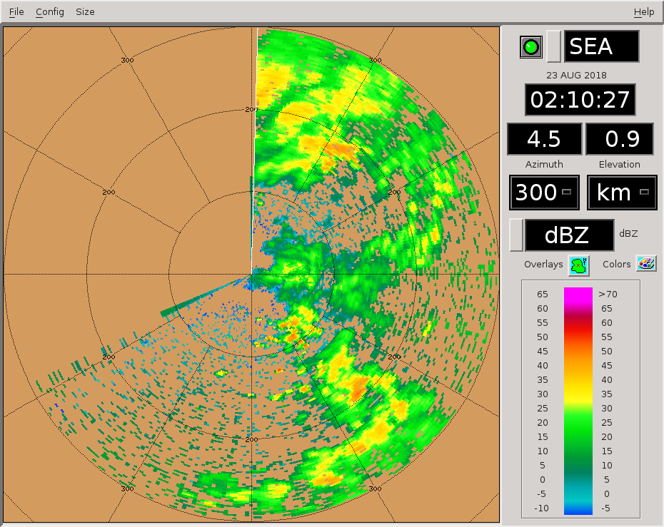
0215 - No RHI changes. Some really interesting negative phase shifts aloft, below the positive shift region evidently associated with dendritic growth. Saw this in certain cells yesterday as well. Heights seem wrong, though. The negative shift is in the -10 to -15 C region, while the positive shift is closer to -30 C. Need to think about this more ...
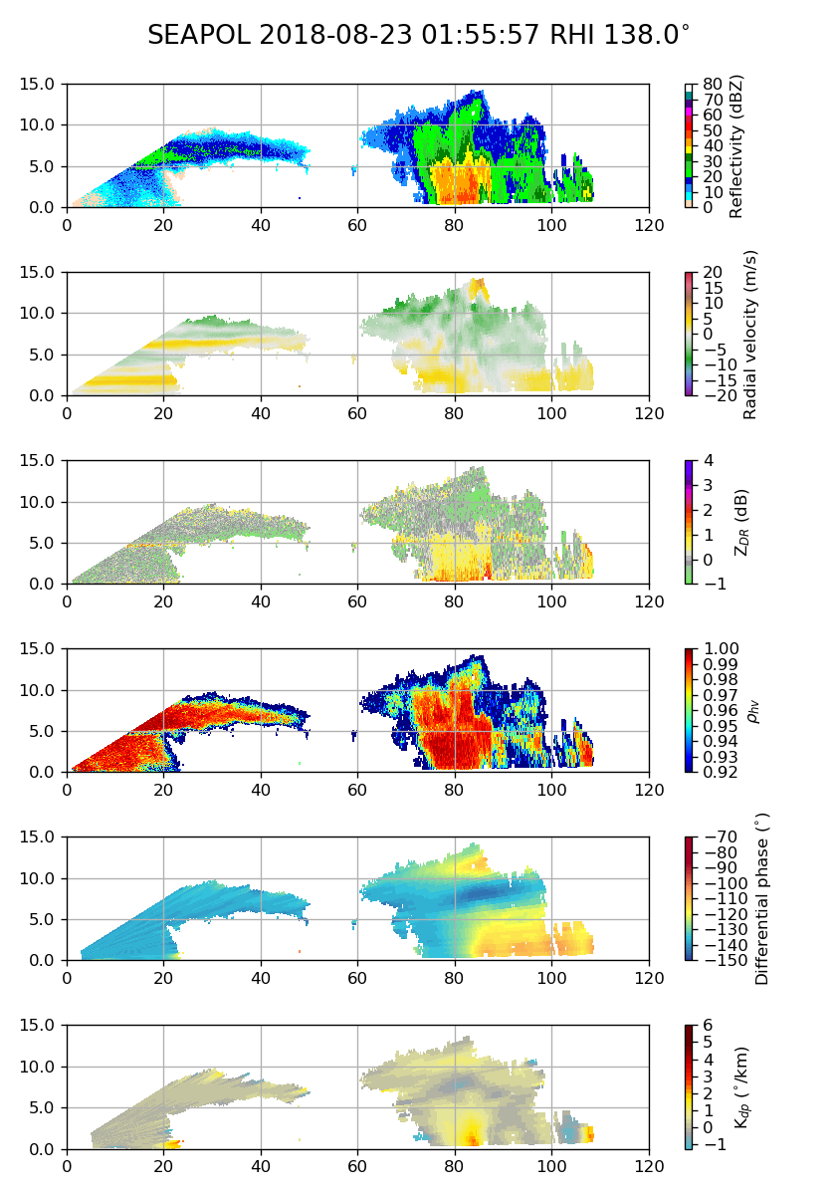

0227 – 0300 Sounding launch. Going to 8/day now, since we are so close to the target PISTON region.

0230 – No RHI changes. Eastern stratiform region has continued to decline in spatial coverage.

0246 – No RHI changes.

0255 – Ship moving very slowly. Will we turn?

0258 - Ship appears to be turning into the wind (from SW). Actually – just facing S right now. This should have no impact on RHI targets for now.

0301 - Ship now back to ~120 heading and moving slowly. RHIs to cover fresher convection between 150 and 180 az.

0310 – Ship back up to speed, heading SE.

0315 – No changes to RHIs.

0319 – Small cell within 25 km to SW.

0323 – Ship slowed down and turned south again.

0326 – Long-range view. Ship rotation prevents a NE look. But still a lot of echo to the SE.

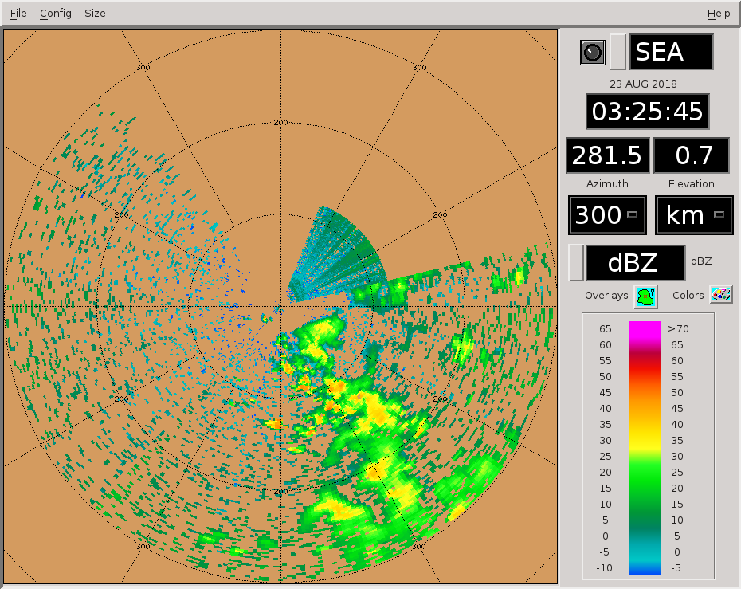
0331 – No changes to RHIs. Storms still well centered near 165 az.

0342 – 20-km wide storm, pretty good for the past few days.

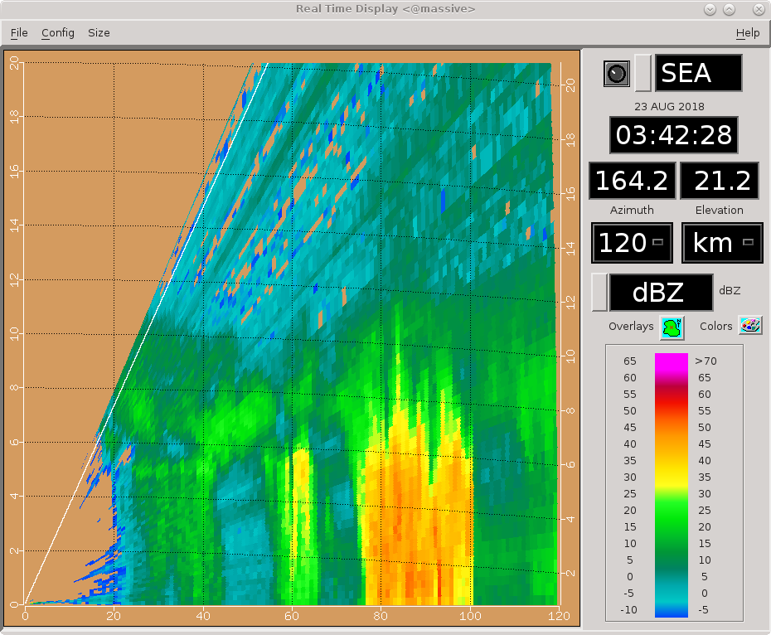
0346 – Only minor RHI adjustments.

0401 – No RHI changes. Still getting great data on the southern storm.

0402 – Interesting multi-layered velocity structure in the stratiform.

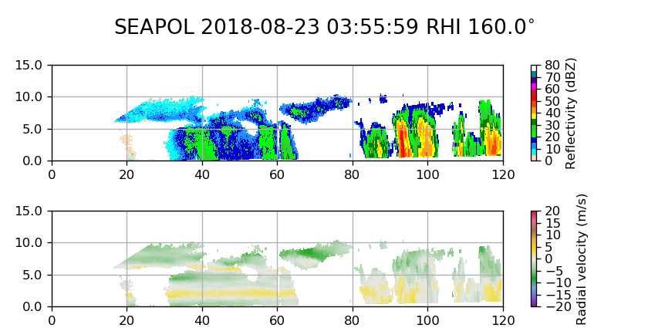
0406 – Moving to PISTON_LOW next round. That small cell to SW petered out.

0415 – No RHI changes. Has been a nice, long-lived storm down there.

0419 – About 10 min until the ship arrives at its first destination (13 N, 134.75 E). I expect some rotation at that point.

0423 – Upping SQI threshold on RT processing to 0.45 from 0.35. Will see whether that improves 2nd trip filtering, without chewing up useful data. This is mainly for quicklooks.

0428 – Main cell still hanging around 164-166. Impressive – it's been at least an hour.

0430 – Ship has slowed down, now pointing southward. No changes to RHIs. Southern convection has matured and there is substantial stratiform surrounding it.

0432 – Ship now pointed SW, into wind. Stationary.

0440 – Long-range view. Echo coverage similar to about an hour ago, given similar FOV.

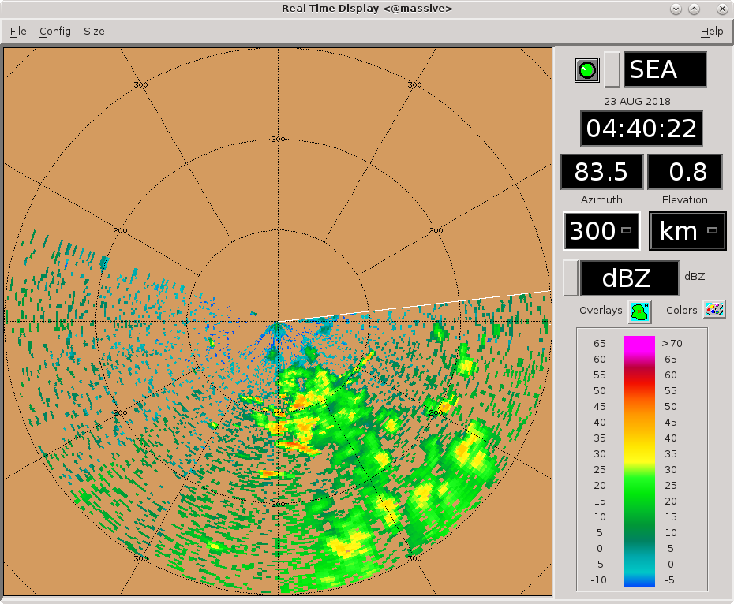
0442 – SQI filter seems to have cleaned up the second trip better, without chewing up everything else.

0446 – No RHI changes.

0457 – Very clean edge to stratiform precip near ship.
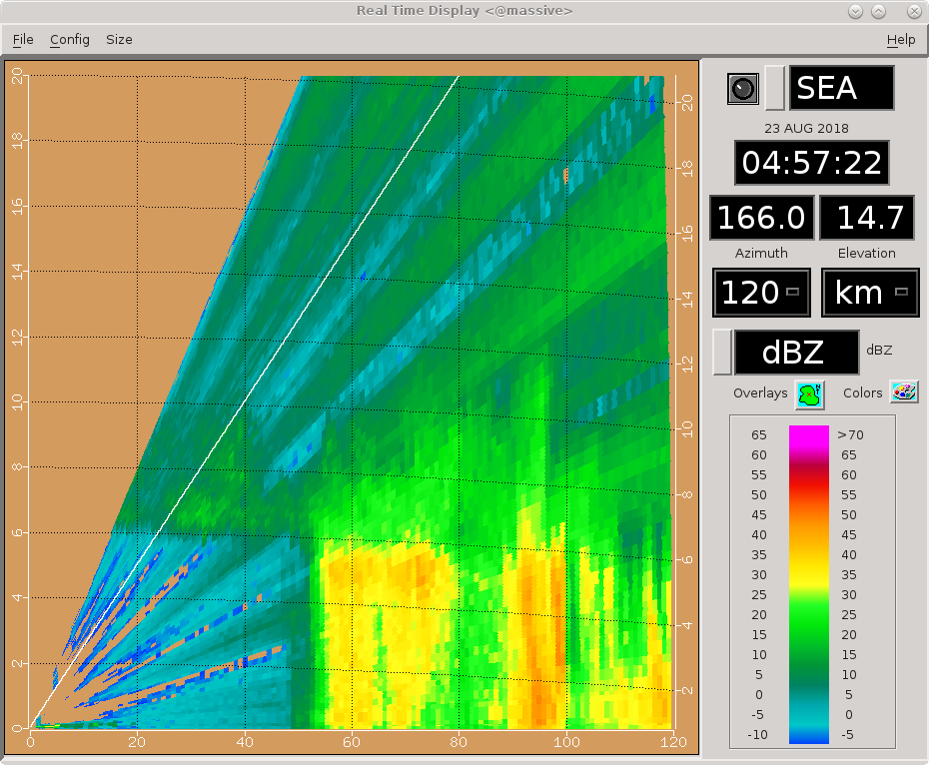
0501 – RHIs 158-180, slight adjustment to capture fresher convection seen on last sweep of previous set.

0519 – Minor shift back to 156-178 az.

0530 – No RHI changes. Southern storm looking more stratified. However, it's the only significant system in view right now. Just a few scattered cells elsewhere on scope.

0546 – RHIs to 154-176. Echo has really gotten more stratiform now. Significant amounts of weak convection and stratiform to the east as well.

0601 – Minor RHI adjustments.

0611 – Ship underway, moving south. Likely the southbound transect has begun.

0616 – No changes to RHIs. Southern storm has really stratified out now.

0631 – Switching to PISTON_FAR next round as a few cells have popped up to our NW. Nothing too special yet, and they may quickly move from our FOV, but just want to ensure we top them. No RHI changes. Echo to south has merged with echo to east to form one large stratiform precipitation system, with occasional embedded convection.

0641 – Long-range view. T3 (Mirai) is roughly 244 km away near 86 az. There is definitely precip in their area.
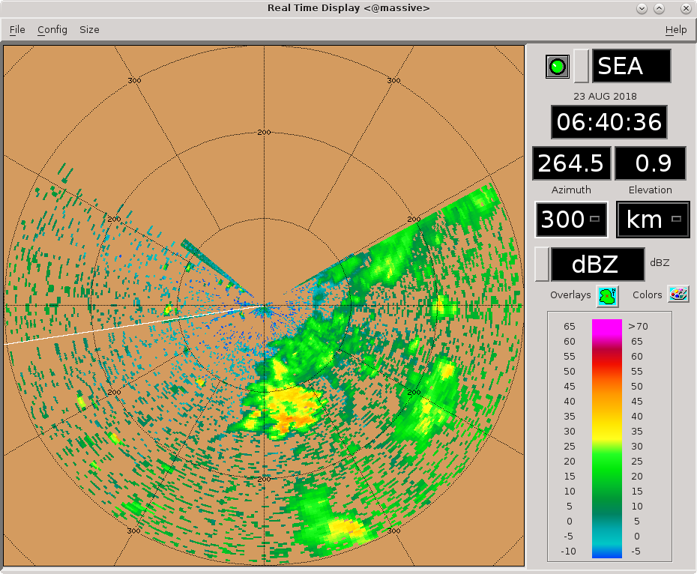
0649 – RHIs to 248-270 to try to get at least one hit on the nearby cell to our W. It is looking healthier.

0700 – Jut hit the storm with like the last RHI sweep. Storm is too tall now for 20-deg max elevation.

0701 – Narrowing RHI sector and raising the max elevation. Going to see if I can get a good hit on the west cell. It won't be in our FOV for long, maybe a couple more rounds.

0707 – Going to make sure the RHI runs before the 300-km surv scan.

0712 – RHI not changing much with each tilt. Think the storm is just translating northward along with the RHI.

0716 – RHIs to 152-174 to cover the intense stratiform to south again. Too difficult to catch these tiny cells translating north at an oblique angle from the radar.

0727 – Very intense stratiform rain!

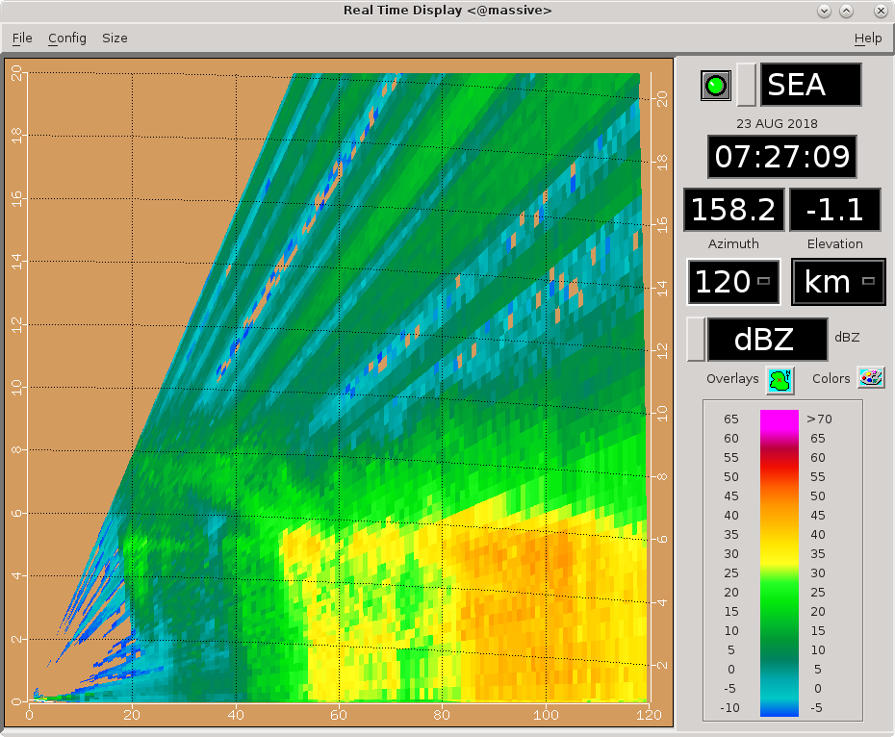
0730: Many spurious negative ZDR values appear in stratiform to SE for this scan (0.7 deg PPI) then go away in next scan.

0731 – No changes to RHIs

0745 – Rotating RHIs slightly counterclockwise. Sticking with the intense stratiform to finish off the shift.

Shift Summary
Substantial mesoscale echo to our east and southeast “followed” the boat for much of the shift, as the boat moved southeast. A lot of this echo was beyond normal max range but significant amounts were in range. Multiple rounds were observed of convective cells that developed, grew upscale, became stratiform, then decayed. The strongest convection hit 14 km altitude, but 8-12 km was a more typical peak for each cell. The long-range scan was used as a substitute for a few RHI sweeps, helping provide greater context to what was observed. The presence of substantial long-range eastern echo suggests that the planned multi-Doppler operations may be successful, if the pattern can hold. Toward the end of the shift the boat reached its target of 13 N, 134.75 E, then began transecting south. During this time a long-term dataset of RHIs on southern convection transitioning to intense stratiform was obtained.

Night Shift (4p-4a L)
Scott Powell

0816: Cut down on RHI over stratiform to SE and added RHI to capture developing convection to the SW.

1126: RHI scan through decaying stratiform to east of radar.
1143: Did a very high RHI to the east up to 70 deg. Outside, a few small drops were observed, and the RHI indicated stratiform echo very close to above the radar not reaching the surface. High tilts also reveal some weak decaying stratiform echo very near the radar. Filtered out all echoes with RHOHV<0.98 and SQI<0.45. ZDR bias are very slightly high (~0.12 dB), but may have been so because of contamination near the surface.

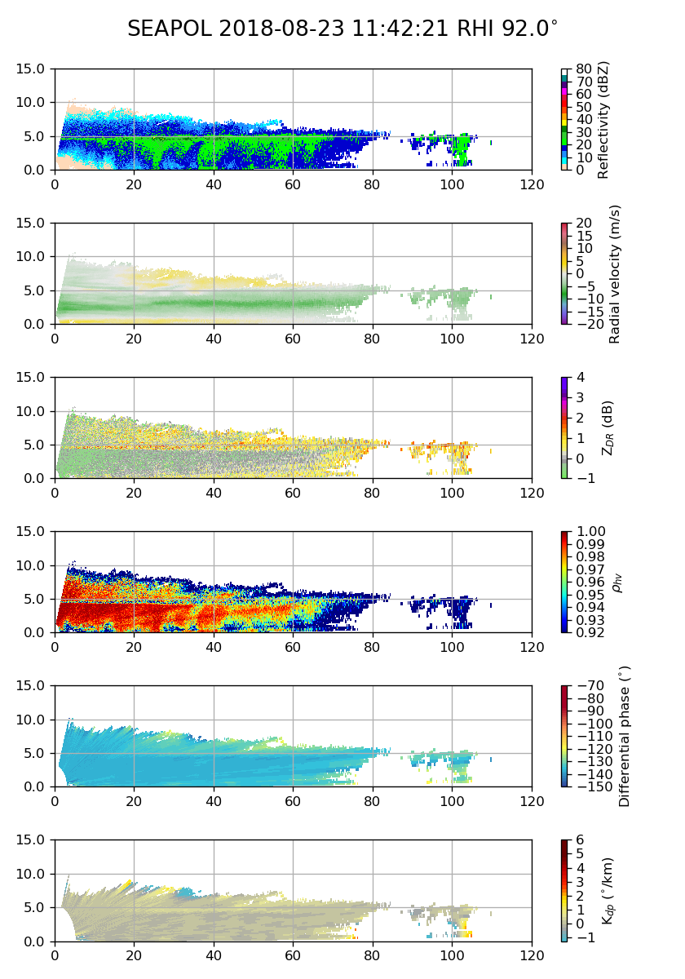

1159: Otherwise, it's a pretty slow evening. A few isolated convective echoes showing up on surveillance well west of ship.

1211: Stratiform over the radar. Light rain occurring outside.

1300: Switching to PISTON_FAR_S in PISTON2 scheduler with regular surveillance. No RHIs.

1347: A cluster of small convective cells persists in the far western portion of the domain. Nothing else.

1400: Reducing top tilt in PISTON_FAR_S to 5.9 deg.

1425: Getting a few RHI scans of convective cell(s) to the west. The 15Z sonde was launched just before entering the Palau EEZ.

1500: Now entering the Palau Exclusive Economic Zone.

1522: SEAPOL is now shut off in Palau EEZ. Will turn transmitter on again when reaching 11.5N.

1554: Running a test scan of the Mirai scan strategy at 16.7 deg/sec with transmitter disabled to see if it finishes in under 7.5 minutes. It did not.

1712: Doing a quick test of the Mirai scan strategy with 17 tilts and the transmitter on to check vertical resolution of a few echoes far from ship. Vertical resolution at echoes 80+ km look acceptable, and scan finished in 7 minutes even.

Day Shift (4a-4p L)
Timothy Lang

2006 – SEAPOL still off, probably another hour before reaching 11.5 N.

2102 – SEAPOL back on in FAR, since we are headed away from Palau EEZ. Not much on scope right now, a few scatter cells. Skipping RHIs this round until I get my bearings.

2110 – Switching to LOW next round.

2113 – Long-range view. Scattered echoes outside of max range, but we are headed their way. Will keep LOW and long-range going sans RHIs until we get something decent on scope to NE.

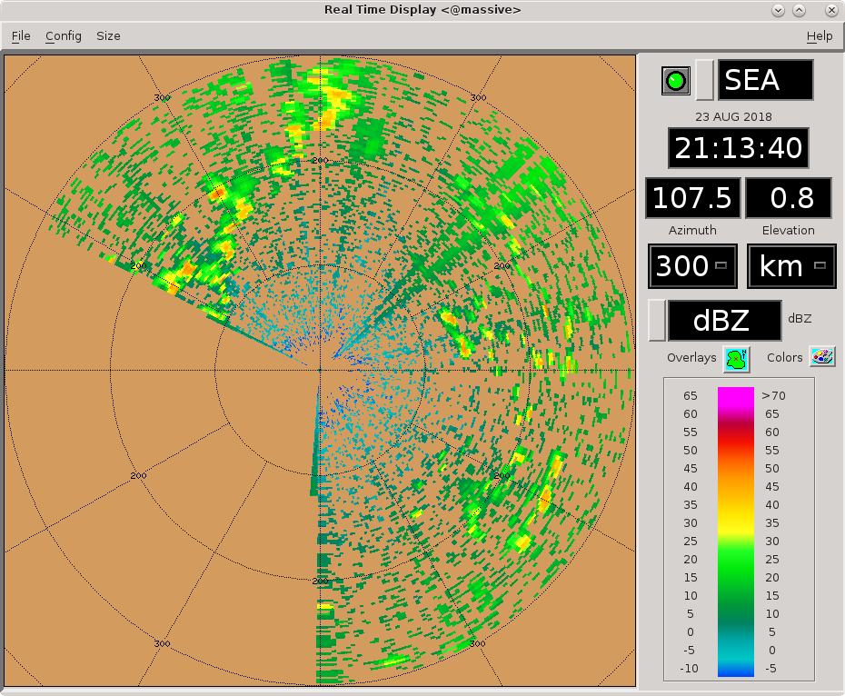
2157 – A couple cells coming into range far to NE. Not really worth RHIs yet, tho.

2202 – RHIs to 64-86 to try to capture the NE cells.

2211- Tops ~6-7 km. RHIs also picking up a shorter cell about 50 km out.

2216 – Slight clockwise rotation of RHI set this round.

2229 – Updated long-range. Eastern quadrant looking promising for DD! Overall increase in echo coverage there during last hour.
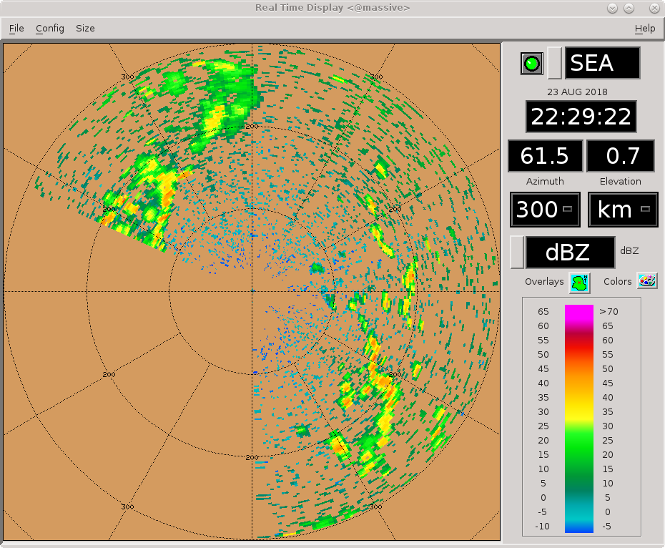
2232 – Trying RHIs 88-110. In-range cells still unfortunately not that exceptional or long-lived.

2245 – Canceling RHIs this round due to lack of decent targets in range. A fair amount of second trip to our east, though.

2310 – Long-range echo coverage to NE decreasing, but still looks good to east and NW.

2340 – Long-range update. NE still looking relatively bare:


