20180825
Day Shift (4a-4p L)
Timothy Lang

0009 – Mesoscale system moving in slowly from east. Leading edge about 75 km out. Come closer … closer …
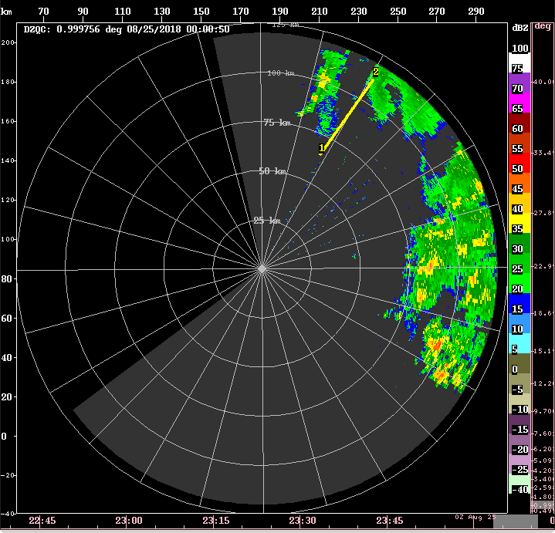
0015 – Ship has been pointing toward 105 az for a while now. This may affect the northern lobe's FOV. RHI to 110.

0023 – A lot of second trip to NE too.

0025 – Some new cells ~50 km out @ 70 az. Hopefully this develops, should be close to lobes, if not within.

0034 – RHI to 75 to try to capture that close storm.

0047 – Confirmed, that eastern cell is mostly within the current southern lobe. It's not going to last, however.

0108 – RHI to 110 to cover SE convection. Still only small. short-lived stuff in the DD lobes (mostly the southern lobe).

0139 – RHI to 120. New development within/near southern lobe. Hopefully this trend continues.

0147 – Confirmed, multiple small cells in southern lobe, growing upscale. Yay!

0203 – The current DD convection is pretty shallow, 4-5 km. There is a stronger cell to the NE, just outside of the lobes.

0219 – With continued eastward drift of boat, and the WNW motion of the convection, the strong NE cell may have moved into the DD lobes, but very close to the baseline right now.

0221 – Movie loops show the development of a linear structure to convection near boat. This line passes SE to NW through both DD lobes. The strong NE cell forms a small appendage sticking eastward from the line.
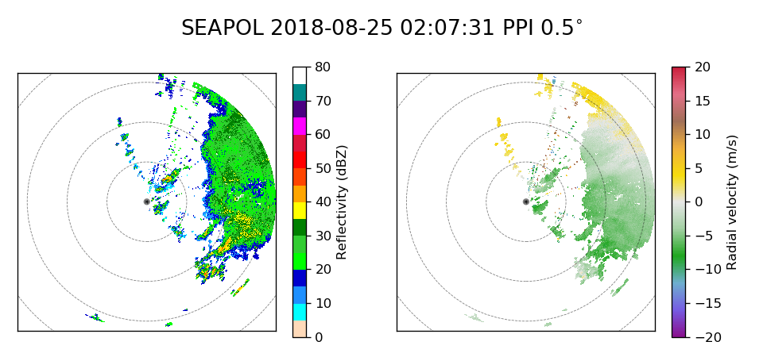
0225 Raining at the boat.

0230 – RHI to 15 az to cover strongest NE cell. This line appeared to develop along outflow from the large MCS to the east, which has remained quasi-stationary and is stratiforming out. The convection farther to our SE continues to approach the boat, however.

0234 – Rain tapered off at ship. The recent balloon launch occurred roughly when the gust front and rain hit the ship.

0238 – RHI to 0 deg.

0247 – Now convection has formed into a SW-NE line just north of the radar. Believe that much of this is in the northern DD lobe.

0255 – Confirmed, that line directly in middle of northern lobe. Beautiful. Tops to 10 km max in this storm. The NW-SE line that was orthogonal to this storm has mostly dissipated or moved off scope.

0307 – There will be multiple CYGNSS overpasses in the general vicinity during the 1600 UTC hour. Since we are in DD ops during these days, best to just use the volumetric data, and maybe we'll get lucky with some syntheses around that time?

0322 – RHI to 355. Small line continues to move north.

0337 – The eastern stratiform region, near max range, is slowly dissipating in place. Northern line has matured, but part of it is off scope.

0355 – Northern storm now exiting N lobe, but decaying stratiform to east close to finally entering southern lobe, although at most it would just sideswipe it.

0404 – Got an update from the Mirai, they are at 13.10 not 13.01 N as their previous email implied. This means they are further north, the lobes are bigger (baseline ~45 km), and thus the northern storm is still well-placed in the northern lobe. In addition, a portion of the eastern stratiform is in the southern lobe. That stratiform echo is decaying toward an W-E linear structure.

0414 – Cross-section along line. A substantial portion of it is off scope now. The rest is fairly shallow and the eastern portion has a stratiform structure. Storm is definitely in its decay phase. Indeed, echo coverage across the entire scope is decreasing steadily. RHIs have been maintained on the northern storm throughout, with occasional adjustments to account for motion/development.

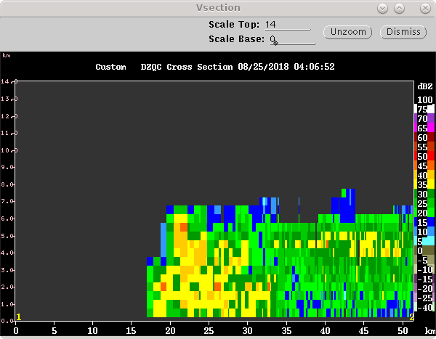
0447 – N storm is more than 50 km out and still weakening. The eastern stratiform is getting swallowed by the RFI.

0502 – Last stratiform appendage from the northern storm leaving the DD lobes. Likely will shut down the radar soon to allow NOAA work atop their trailer.

0515 – Ceasing operations temporarily.

0530 – Restarting ops. NOAA radome patched.

0559 – Can see a small skin paint from the Mirai, right where we expected it to be. In addition, there is a freighter east from us. Can also see that skin paint – it is much bigger though and almost makes an arc around the radar.

0602 – Nothing of real interest on scope. The northern stratiform is getting chewed up by second trip and RFI.

0633 – Still boring.

Shift Summary
A quiet morning eventually gave way to widespread shallow-to-medium height convection and abundant stratiform echo. Most of this echo remained outside of the TGT/Mirai dual-Doppler lobes until later in the shift. The best sampling came when a linear multicellular feature developed within the lobes, evidently supported by an outflow boundary. This was sampled for a couple hours before it exited the lobes and decayed to stratiform echo. Late in the shift the entire echo pattern decayed and the scope was mostly clear except for some weak stratiform in places. The ship slowly drifted toward the Mirai throughout the shift, and is now within 50 km. The radar remained in Mirai dual-Doppler scanning throughout the shift, except for a brief outage to allow some lidar maintenance when the echo subsided. A large number of single-sweep RHIs were also obtained throughout the shift.

Night Shift (4p-4a L)
Scott Powell

0924: There was a GPM overpass at this time, but there was no precipitation to speak of within 120 km of the Thompson.

1312: Just got in from laying on the bow for a while. The mid-level clouds that were long present are gone, and the low-level convection is becoming more impressive. Some echoes are beginning to appear. Unfortunately, the Mirai is probably too close to do any meaningful dual-Doppler analysis unless we get extremely lucky.

1318: Mirai is at 326 deg at 28.6 km range.

1327: Light rain at Thompson.

1359: Trying to shoot fish in a barrel with RHIs of echoes close to radar. Not having much luck. Going to start aiming at 110 where there is some convection farther out. Cross-sections of PPI indicate it goes up to 14 km.

1500: Jhordanne noted that she has had to manually terminate two sondes because they were still rising above 30 mb when it was time to launch the next sonde. Immediately suspected low ascent rate. Data shows that an eyeballed mean ascent rate dropped from 4-6 m/s for launches prior to today to 2-4 m/s starting at 00 UTC today. Probably want to put a little more helium in.

1519: Several showers on the radar, and a few are moving through the tiny DD lobe with Mirai. Request at 1430 to turn bow to 045 denied.

1535: Moderate rain at the ship.

1547: Got the RHI parked around the 115 deg azimuth, and the convection is just marching straight up that radial, so successive RHIs are almost like a time series of those convective elements.

1600: The QC is getting a bit carried away with cutting out the tops and edges of convective echo. Plus, the 0 dBZ echo top height is unreliable with the current QC. Definitely a challenge with all the RFI though. The velocities here could be extremely important for DD analysis of these small echoes if we can resolve those motions.

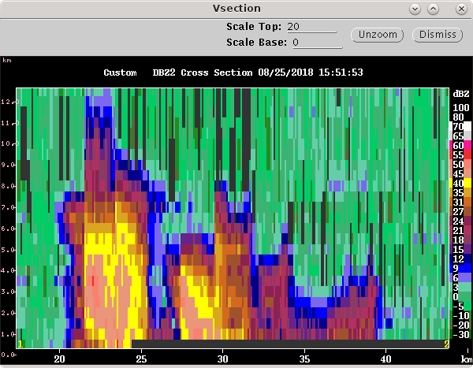
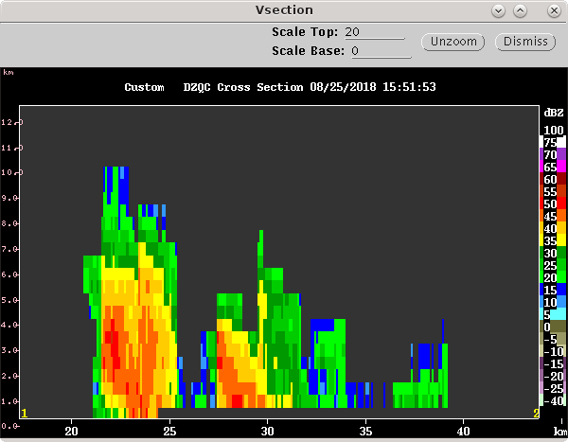

1640: For the 18Z launch, we will try 35 seconds of He instead of 30 seconds. Apparently, units of He are now in seconds so I'm told.

1646: The convection is getting stronger and a little deeper. This might be a harbinger of good things to come this morning. Might be a race against the sun now. The cells seem to be getting sheared less from mid-level southerlies. Seeing a few 8km echoes now and a few 10-12 km. But the mode is definitely 4-5 km.

1700: I'm seeing lot of echo (this is not Qced) with this really weak echo extending above the apparent echo top of some of the convective echoes. What is this?

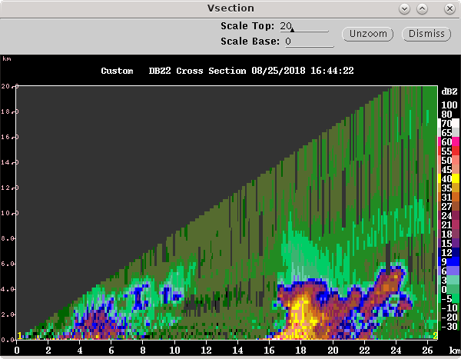
1737: The echo complex approaching the DD lobe is 18 km deep at highest.

1819: Echo complex moving through DD sector, but we are drifting a bit more quickly. Forward speed is about 1 kt.

Day Shift (4a-4p L)
Timothy Lang

1916 – Dual-Doppler with RHIs @ 330 continue. Storm has been confirmed to be at least partially within the dual-Doppler lobes during 1800 hour/. Now this portion is moving out, but there is additional convection to the ESE moving in.

1931 – RHI to 10 az.

1949 – Short new line moving into lobes from east. RHI to 20 az.

1956 - RHI to 10 az.

2003 – Trying RHI at 55 az. Several small cells at close range, difficult to hit them with a single RHI. However, some of these cells should be within the DD lobes.

2007 – Cross-sections suggest 8-10 km tops in this convection. RHI to 45 az.

2015 – Confirmed that this new line is mostly within the DD lobes. Another round! RHI to 30 az.

2023 - RHI to 20 az. Vertical x-section thru strongest nearby convection. This convection is just entering the DD lobes.
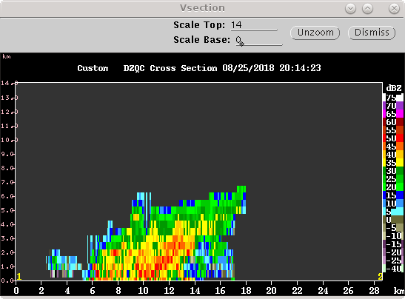
2053 – Continuing to rotate RHIs to NW as the main cell moves past us.

2056 – Line is pretty well centered in the DD lobes now. This is at least the third round of convection thru the lobes this morning, starting with late in the previous shift.

2109 – RHI now to 350.

2132 – Northern convection falling apart, RHI to more distant convection near 178 az.
2143 – Gave new suggested coordinates for reposition of TGT to chief scientist. These coordinates are 12.61 N, 136.34 E. This is ~20 km SW of original position. Starting DD baseline with Mirai point 2 will be 58 km, and shrink from there.

2202 – RHI to 145 az. New convection to SE, about 40 km out.

2240 – Freighter off the port bow, in visual range. Also strong signature in the radar. RHIs have been rotation clockwise to maintain coverage of the southern convection. In addition, there are some small cells to our north, which may be in lobes.

2257 – Notable overpasses on 8/26: GPM @ 2001; CYGNSS @ 0614-15, 0626, 1612, 1642.

2301 – RHI to 30. Every target is small out there, RHIs will be a crapshoot. But some of these little cells may be in the lobes.

2326 – For the foreseeable future, RHIs are going to attempt to hit random cells at various azimuths in the domain. Since everything is pretty small, it's going to be hit-or-miss for a while. Not going to report specific angles until the situation settles down. Right now it's is basically scattered popcorn.

