20180828
Day Shift (4a-4p L)
Timothy Lang

0008 – RHI to near 95 az to cover a new storm near 75 km.

0034 – Oceanographic equipment will be pulled after lunch, around 0330.Then a CTD will occur, and then we will turn and move closer to Mirai at the drifting buoy recovery location.

0101 – RHI to near 110 az to capture convection within 75 km.

0107 – Big whiff on the RHI. Would it kill the atmosphere to make a storm wider than 5 km once in a while?

0115 – Finally hit a SE cell with an RHI. Tops to almost 10 km.

0116 – These are the cells I am trying to hit down south. They are about 50 km out and are trying to organize.
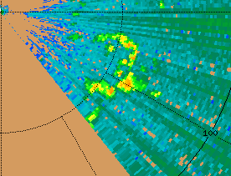

0139 – SE convection now forming a SW-NE line Much easier to hit with a single RHI.

0141 – This SE storm just grazes the DD lobes, but there are a couple cells north of it that are in the lobes.

0144 – RHIs suggesting around 8-km tops. CIDD agrees
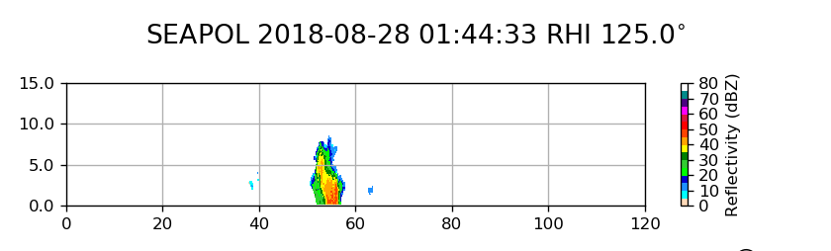
0202 – RHI to ~90 az for a different cell, due to the other storm moving out of our FOV.

0208 – Hit on the RHI. The E storm is pretty healthy:
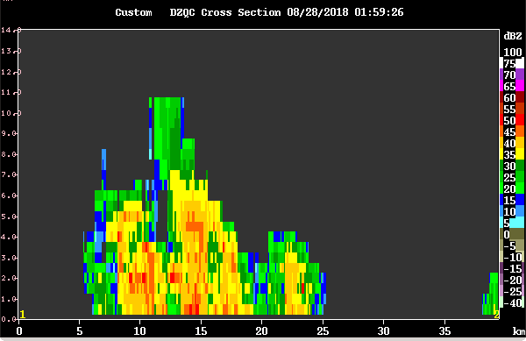
0210 – The E storm is in the north lobe, so we are capturing its development well. The SE storm is in the southern lobe now, but mostly outside our FOV.

0215 – RHI shows echo tops ~12 km. Looking good!

0221 – Took a picture of E cell, kind of hard to see all of it from ship.

0223 – East storm is basically a N-S line ~20 km long. Continues to be 12 km or taller. Continue to rotate RHI slightly clockwise to account for ship-relative motion. The DD lobes have caught its full evolution, as nearly as I can tell.

0226 – Small cell right to our west has blown up recently. I can see it right out the computer lab port hole.

0229 - Haven't seen many storms today with really high ZDR or KDP values. Everything has been mostly 1-1.5 dB (or deg/km).

0249 – E storm definitely in its decaying stage. Been a great lifecycle study, though!

0252 – Southern portion of line may be along baseline.

0302 – Canceling RHIs due to decay of E line.

0324 – Pretty intense second-trip far to our SE, peak Z in the 40s. There are scattered small cells to our W. Watching them to see if they develop upscale. Otherwise, the lobes are pretty quiet and/or blanked to our SW. Oceanographic recovery ops starting, and Mirai has likely left its station by now. Ship has rotated to 35 deg.

0355 – Trying an RHI near 309 az. Will see if I can hit some of this NW convection. Overall see an increasing trend toward organization to the NW. There is the near convection, but also another group at range.

0400 – Mostly whiffed on the RHI. Trying one near 60 az. Storm near 100 km.

0416 – Surf Otter out of the water. RHI suggests shallow convection to NE, 5 km or so.

0425 – Ship[ is rotating clockwise. Now pointing SE and still turning. Canceling RHIs until the turning is settled.

0427 – Ship now pointed south.

0432 – Ship seems to have finished its pointing maneuver at 205 deg. RFI OK for now. Should have a great view of new DD lobes.

0445 – Mirai seen in a skin paint due south of us. Range is about 32 km.

0455 – Told martech to have the ship back up slowly, ~1 kt, to gradually grow the baseline. They will do this once the CTD is done.

0501 – RHI attempt near 135 az. Tiny but intense cell there, Z close to 60.

0517 – Ship now backing up ~1 kt. RFI might be slightly enhanced with this SSW heading, but manageable. Not like the other day.

0523 – Ship heading is 217.

0530 – Storm near 150 az is up to 12 km tall!

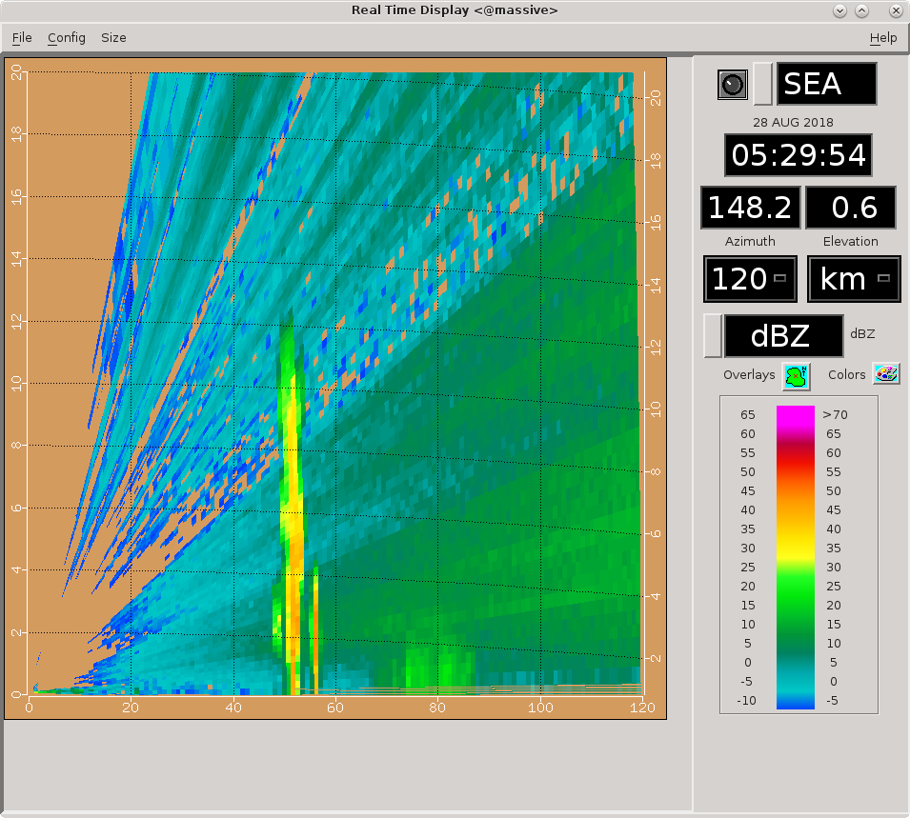
0541 – This storm to our SE is frustratingly just outside the DD lobes. A lot of new development near the storm, however. If things can keep growing and build westward we will be in business.

0548 – Baseline likely ~33 km right now.

0553 – SE cells now organizing in an interesting arc pattern.

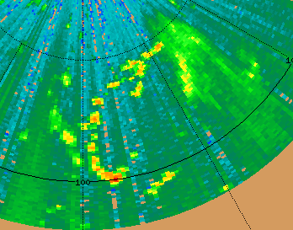

0600 – Cell to our NW might move into western lobe if it hangs together. Changing RHI to near 310 to check it out.

0602 – Couple new cells popping up within 25 km to our south. One is probably on baseline, the other is probably within the eastern lobe.

0607 – Tops close to 12 km in NW storm.

0610 – NW storm just entering west lobe. This little cell to our SE is in the east lobe.

0612 – Looks like something might be moving into our FOV in the east as well.

0624 – RHI to the small cell in the lobes near 195, about 20 km out. This will likely be within/near the CYGNSS footprint near the ship.

0626 – Also will be dual-Doppler on all cells within the lobes, many of which should be visible to CYGNSS. Not a bad overpass!

0630 – Nice hit on RHI, about 4-km top to cell.

0632 – Keeping RHI on this cell for one more round, then will switch back to WNW storm.

0638 – CYGNSS overpass complete. Got another hit on that small cell. We are actually a bit north of overpass line, so southern RHIs not a bad approach. Switching to 280 to look at WNW storm again.

0642 – Mirai of course also would support the CYGNSS overpass. WNW storm almost completely within dual-Doppler lobes, but appears to be decaying. Baseline up to ~38.5 km.

0652 – Mostly whiffed on that RHI. Rotating a bit counterclockwise.

Shift Summary
Multiple rounds of unicellular and multicellular convection passed thru the dual-Doppler lobes with the Mirai. The best case was a N-S-oriented short line that largely went thru its full lifecycle within the lobes. By shift's end we were free to turn the boat however, so we looked SW toward Mirai and backed up slowly to increase the baseline. Several cells were entering the lobes toward the end of the shift. CYGNSS overpass occurred near the ship around 0636 UTC, and was supported with PISTON_MIRAI and a few rounds of single RHI sweeps on nearby convection.

Night Shift (4p-4a L)
Scott Powell

0824: GPM overpass. We are blind to the northeast, but several isolated cells were in the vicinity of SEAPOL. Generally convection is 8-10 km deep, although looking off the stern, it seems there might be something deeper in the blind spot. See science report for details.

1045: RHIs canceled. Convection has decayed. Mirai long-range scan indicates there is convection to our northeast, but it will not arrive before the end of DD operations.

1200: Dual-Doppler ended. Now scanning with PISTON_FAR_S in PISTON2 scheduler. Surveillance scans will follow each volume.

1312: Going to switch to PISTON_LOW because I keep adding tilts to FAR_S to get above a growing echo to the north.

1430: Switching to PISTON_FAR since the echo to our north has grown taller.

1500: Switching to PISTON_NEAR to capture the echo now closer to the radar. Just a few echoes farther out.

1600: Back to PISTON_FAR since echo close to radar has weakened.

1626: Lightning in the distance aft of the starboard side. Looks like generally some pretty deep convection and extensive anvils back where we left from a few hours ago. Satellite imagery shows a nice blob of cold cloud tops directly over where we were just trying to do dual-Doppler.

1742: Got an RHI of an 8-10 km deep cell directly off the bow a few miles. It's moving in generally the same direction and we can't seem to catch up. I think this is storm chasing.

1846: This is the longest-lived convection we've seen with SEAPOL so far during PISTON. Luckily, it's traveling with us, so we are essentially viewing its lifecycle.

Day Shift (4a-4p L)
Timothy Lang

1903 – RHIs to 240-270.

1910 – Switching to PISTON_NEAR next round. Accidentally interrupted RHIs and started NEAR early. Back to RHIs. They may get cut off before 1915 hits.

1912 - Here is recent situation. Widespread mesoscale convection. NEAR will be used to top the nearby convection to our SW.
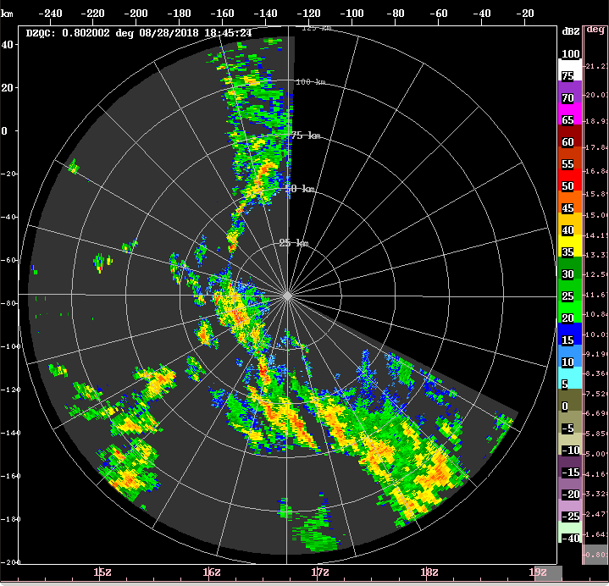
1914 – Tops over 15 km in some of these storms.

1916 – Next round of RHIs to 240-258, 10 sweeps to 30 deg elev.

1928 - Seeing tops to 16 km.

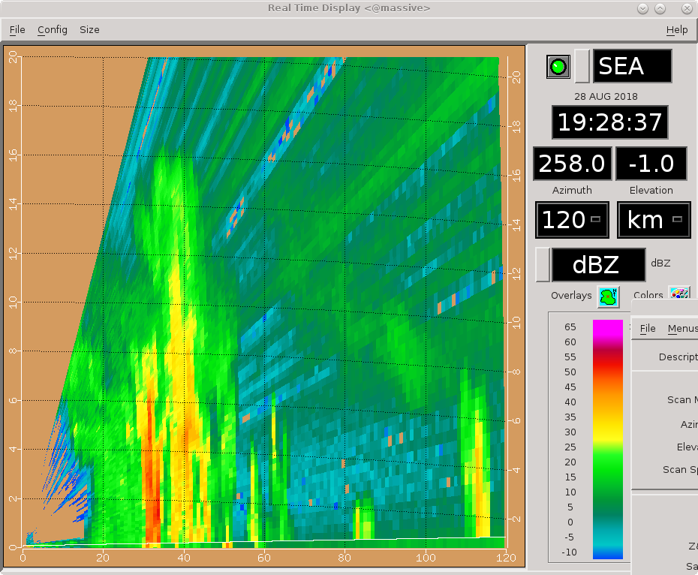
1930 – No RHI changes, except to add another tilt (240-260). Trying to minimize dead time.

1933 – These are some really beautiful RHIs. The change in velocity structure near the 40-km convection is very interesting.

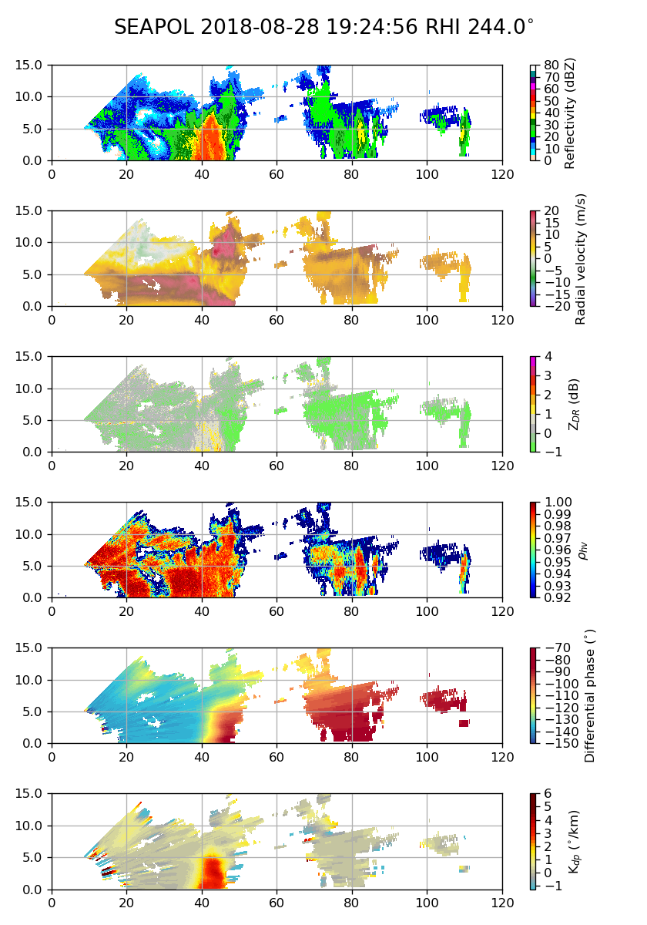
1951 – GPM overpass. Much precip on scope.
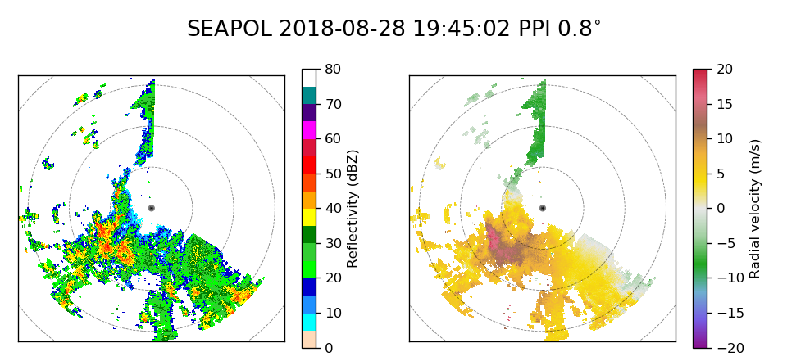
2026 – Storm continues to keep pace with us, and continues to produce very impressive RHIs. Getting great data right now!

2032 – Switching to FAR right now as mostly just stratiform up close at this point. Added another tilt to RHIs (up to 12 now) and rotating counterclockwise to account for movement.

2038 – Sprinkling at ship. 21 UTC balloon launched on time. Pretty sunrise so far!

2046 – Adding more RHIs, 16 sweeps 0-20. Azimuths 236-256. Saw some lightning visually in the storms we are scanning. Not surprising.

2101 – Starting to look pretty soupy out there. Convection not as well defined.

2131 – Trying RHIs along 180-210. Also convection down that way. Most convection in the storm we've been following is pretty distant, with mostly stratiform rain between us and it. There is a more convection to the NW, within about 50 km. Watching this for possible future RHIs.

2143 – Ship nearing its target of 12 N, 134.75 E. This likely will cause some turning while on station. Current is easterly.

2146 – RHIs 270-2300 to capture NW convection.

2157 – Tops to 14 k m in this NW line.

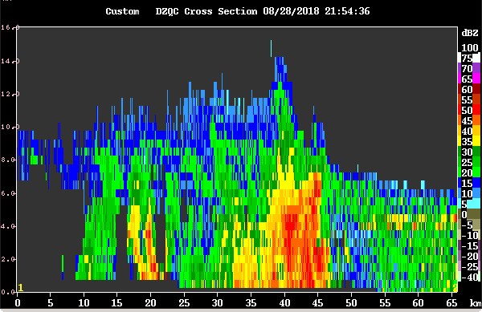
2201 – RHIs to 260-280. Anticipate ship rotating within this 15-min period, however.

2209 – PISTON_FAR not topping western storm, switching to NEAR next round.

2210 – Ship turning, now pointed NW. This will help keep RHIs going for now.

2212 – Ship now pointed north. RHIs still OK.

2214 – Western convection looking pretty good! Tops to at least 14 km, according to CIDD.

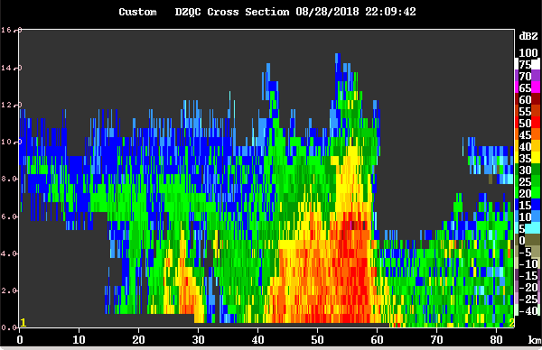
2215 – Ship seems to have stabilized near 24 deg heading. CTD beginning so should be stable for 30-45 min.

2217 – Actually ship up to 34 deg heading. Switching RHIs to convection near ship, 92-114 (30-deg tops).

2228 – Missing on the nearby convection, but got some good RHI passes thru more distant precip.

2229 – Ship rotated to near 60 deg.

2232 – Rotating RHIs clockwise to try to hit near convection.

2243 – Hitting SE convection but it ain't much to look at.

2245 – Switching to FAR next round. RHIs 80-110.

2254 – Ship turning and getting underway again. Canceling RHIs.

2259 – No good CYGNSS overpasses on 8/29. GPM overpass at 1859 on 8/29 (right near shift change).

2302 – RHIs to 240-270. Heading west. RHIs should be safe during upcoming southward turn. RHI pretty strong with this westward heading.

2317 – RHIs rotated clockwise to capture some convection to WNW. The RFI is chewing up the stratiform echo that fills much of the SW quadrant.

2322 – Ship heading north near cruising speed.

2326 – Convection topping out around 12 km in RHIs.

2331- RHIs to 300-330. More convection in that region, and that area also more protected against minor heading changes.

