20180829
Day Shift (4a-4p L)
Timothy Lang

0002 – RHIs rotated counterclockwise to stay on NW storms.

0026 – Tops over 14 km in NW convection.

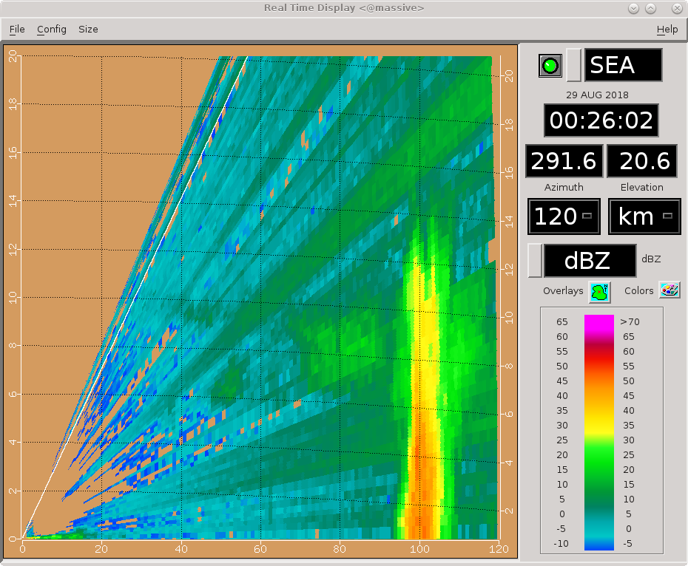
0031 – Trimming sweeps, going 271-303. Healthy storm, but not huge.

0046 – Rotating RHIs a bit counterclockwise to keep up with storm.

0101 – Rotating RHIs a bit and adding a surveillance scan, to help fill the dead time. There is very little out there within 100 km. Almost everything is at range.

0116 – Trying RHIs centered near 120 az. Really just not a lot of good targets out there. Storms all distant. A lot of RHI sweeps whiff.

0119 – Check that, going with 330-360. Storms distant but actually moving toward radar rather than away. RHIs more likely to hit something.

0133 – Maintaining RHI sector as is. There is another nice cell near 300 az, however. But more oblique angle to it and the swath that will cover it is narrower. Tougher to hit. The NW storm appears to have formed along an outflow boundary from convection that is off scope.

0135 – Maloney assessment: “We're running away from convection right now.” However, we will turn around and head back after hitting 13 N. Currently at 12.37.

0138 – By the way, have been in PISTON_LOW for a while now.

0142 – 16 km!
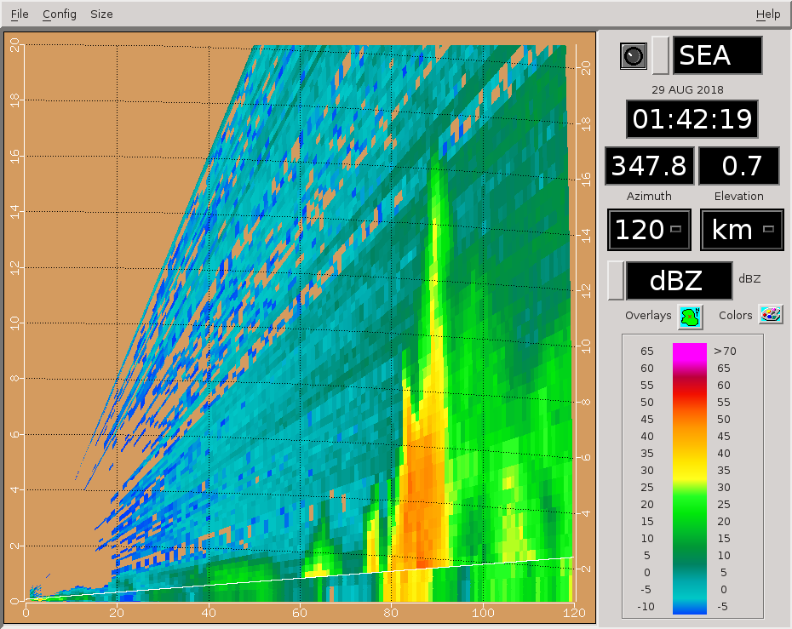
0146 – Rotating RHIs counterclockwise a bit. Ship is also slowing down to 1 kt for a while.

0147 – Some convection nearby, also switching to FAR next round.

0150 – Almost looks like a weak echo vault in this RHI, near 90 km.
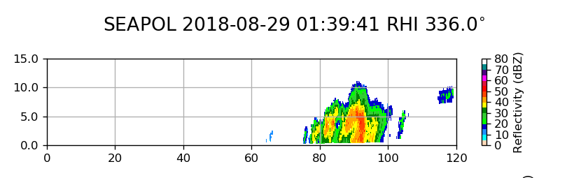
0231 – NW stuff dying out. RHIs to western distant storm, 268-283 (1-deg steps).

0242 – Western convection not very tall, maybe 6-8 km.

0246 – A number of small cells popping up in eastern half of domain. Watching this for now., but maintaining RHIs (with slight adjustments) on western storm.

0255 – Tops to 10 km in a couple of the RHI sweeps.

0301 – Getting limited in how much I can rotate the RHIs on the west storm, which will soon be outside the FOV. This will probably be the final round on that storm.

0316 – RHIs to 90-120. Only some of these sweeps will hit, but there are a lot of small cells to the east.

0331 – RHIs 70-100.

0401 – RHIs 75-90. One cell has coalesced and gotten bigger.

0416 – RHIs expanded back to 75-105. Ship at cruising speed again, so echoes will move by faster.

0430 – Canceling RHIs for a bit. The cells are getting too small for this to be useful. Adding a 300-km surveillance scan instead.

0503 – Trying some sweeps within 320-340 az. Small storm there, and pretty weak. Not much else on scope though.

0514 – Long range view. Main domain pretty empty. Some storms with more structure far to west; otherwise, mostly small cells.
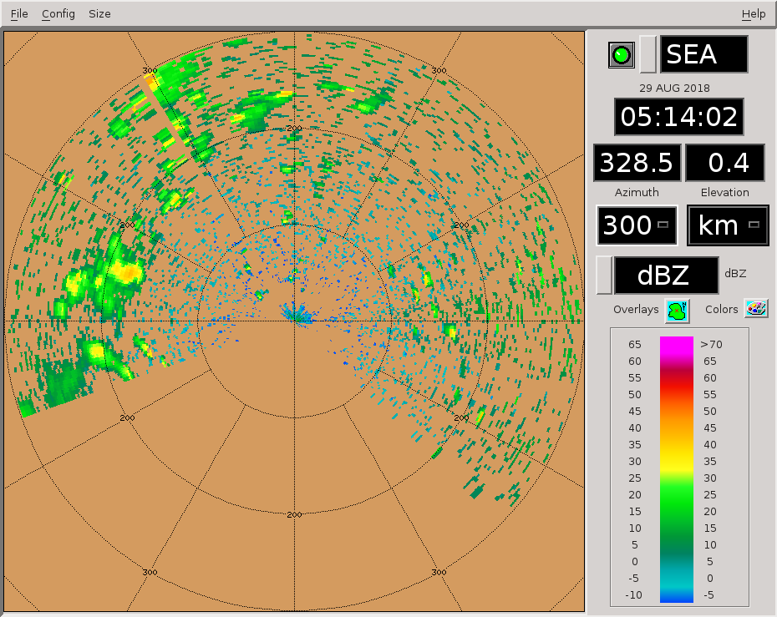
0516 – Trying RHIs 350-10. Couple small cells in range.

0526 – Cells about 4 km tall.

0531 – Canceling surveillance and adding more RHI sweeps, to ensure some hits on these northern cells. They are about 40 km out.

0533 – Roughly an hour before we reach 13 N.

0546 – RHIs to 330-0. Multiple small cells in this swath, all fairly short (4-6 km).

0601 – RHIs to 320-350. Not much to look at but am still getting hits on shallow convection at least.

0602 – Scheduling PISTON_LOW to run next round.

0616 – Canceling RHIs for now. Last round was pretty bad, and the subsequent low-tilt PPI provided no worthwhile options. Adding back surveillance.

0655 – Ship has reached 13 N and is turning.

Shift Summary
Substantial mesoscale convection followed the ship as it cruised toward its first CTD location, near 12 N. There was excellent precip during the GPM overpass at 1951 UTC. That convection passed thru the domain to the south as the ship headed north toward 13 N. Periodic bouts of convection were found on scope afterward, some of which grew over 10 km. However, by shift's end we had moved clear of the region containing substantive convection, and were left to scan most shallow storms (4-6 km).

Night Shift (4p-4a L)
Scott Powell

1200: Some deepening convection finally approaching the radar. Switching to PISTON_NEAR..

1230: Moderate to heavy rain at the ship.

1300: That one cell that passed over the ship was strongly tilted. Other echoes in that area were also tilted. However, the echoes in the far field do not appear to be so tilted, so the effect was apparently local.

1530: This cell to the SW is a winner.

1640: Been following the complex of convection to the southeast for a while, but it's at the edge of the domain now. Probably going to switch to RHIs on shallower convection close to the radar for the following cycle.

1746: There is much convection close to the radar now, and much of it far out to the west is out of the domain now, so going to switch to PISTON_NEAR for the next cycle.

1812: The wind has definitely picked up on deck as we intersect a gust front just outside a cell to our south.

1853: Most of the echo close to the radar is in our blind spot, so switching to PISTON_FAR for the next cycle.

1859: GPM overpass was for 12N, 134.75E. We are at 11N, 134.6E and blind to the north. The overpass was to the northeast of the 12N, 134.75E point, so the radar has no view of the GPM swath. We should turn around soon and get a view of convection to the north.

Day Shift (4a-4p L)
Timothy Lang and Kyle Chudler

1902 – RHIs to 143-157 (8 sweeps)

1910 – 14 km on this convection.

1913 – Ship turning around. Lots of precip to our north. Ship will go east for ~0.5 h until it turns back north.

1916 – RHIs to 345-3 az, a nice line – nearly radially aligned – in that swath about 50 km out.

1922 – Switching to PISTON_NEAR next round to get better topping of close storms.

1931 – Hit well on last set of RHIs, but line too close to FOV edge for RHIs to be safe there this round/. Switching to convection in 20-38 az.
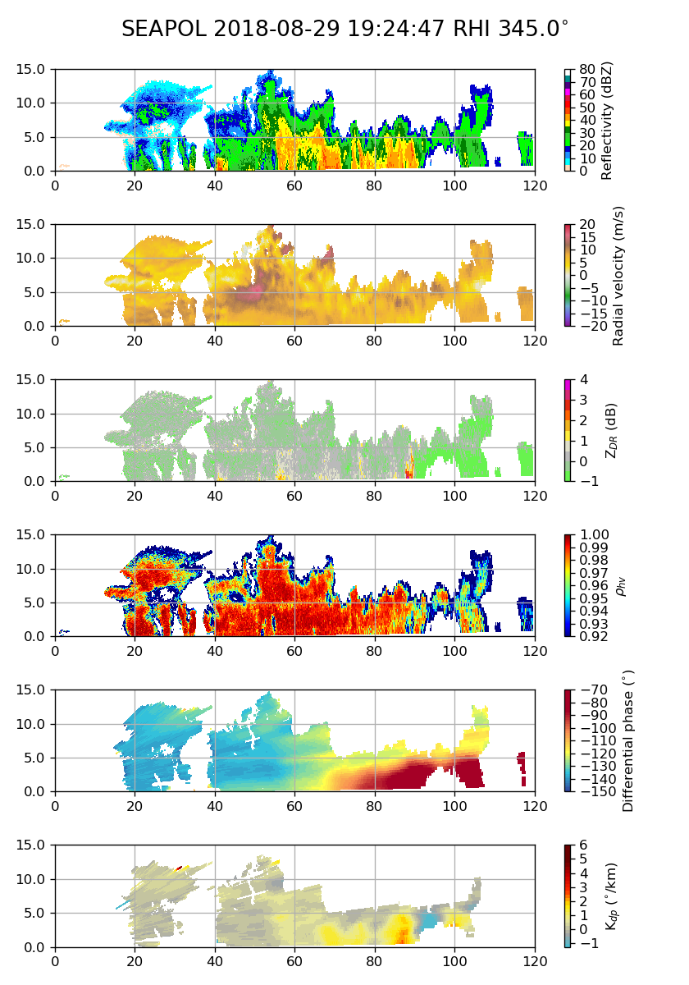

1934 – Ship will turn ~5 min from now.

1935 – Great phase shift through the northern line.

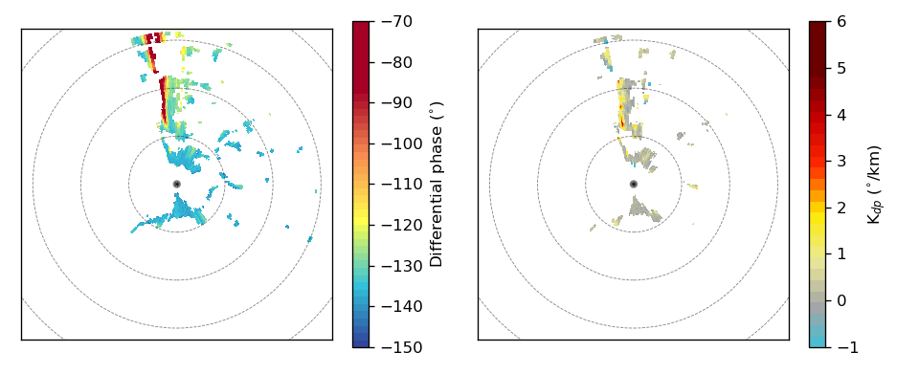
1943 – Ship now moving north. RHIs OK – hitting convection.

1952 – RHIs to 12-30. Multiple cells close to radar, even NEAR having issues topping everything.

2001 – RHIs back to NW line, 318-345 (3-deg spacing). CIDD suggest tops over 16 km in this convection.

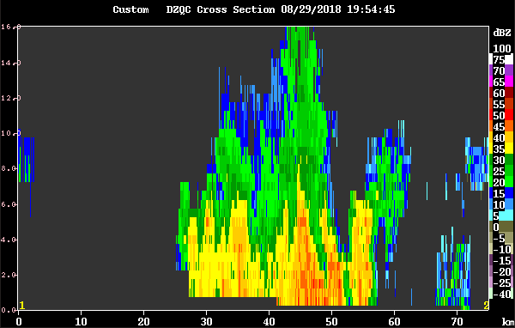
2016 – Canceling surveillance to provide more sweeps to the RHIs. Focusing on 350-12 az, for convection dead ahead of us.

2104 – Switching to FAR next round, and adding more RHI sweeps with a lower upper elev (20 deg) this round.
21:26 – Cross section through convection at ~80 km to North
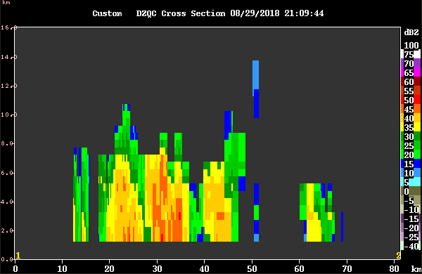

21:31 – Shifted RHIs to 330 – 0 to follow convection to NW. Tracking small cluster of cells.

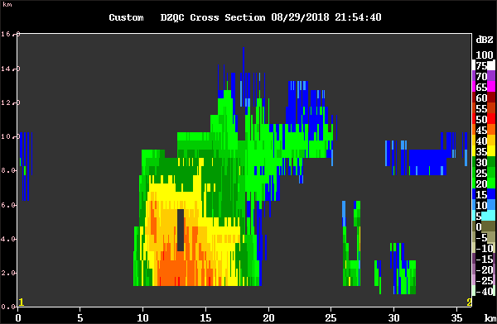
22:03 – Continuing to track cluster to NNW. Tops to 14 km, nice anvil apparent on CIDD
22:20 – Switching to RHIs from 314 to 344 to track smaller developing cell to NW at 50km
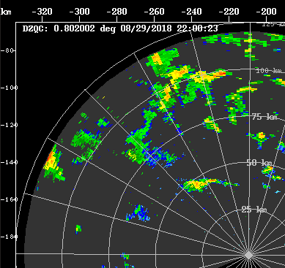

2247 – RHIs to 350-20, trying to avoid significant dead space between sweeps.

2257 – Much of the NE convection shallow, 6-8 km. Trend has been toward more isolated storms as the organized convection moves off scope to the west.

2303 – RHIs 330-360. Just trying to have as many storms as possible in the sector, so that empty sweeps are minimized.

2316 – No changes to RHIs.

2331 – RHIs 344-014.

