20180830
Day Shift (4a-4p L)
Timothy Lang and Kyle Chudler

00:41 – Convection waning/moving out of range. Only isolated shallow cells left.

01:03 – Switching the RHIs from 76 to 106. These isolated storms are moving north along with ship and aren't changing in azimuth much.

0118 – RHIs to 15-45. There is a small line within 25 km that fills at least this swath.

0132 – RHIs to 0-30 to keep on this shallow line.

0141 – Ship has basically stopped, oceanographic instruments going into the water. Heading ~44 deg, no impact on current RHI set.

0145 – Heading now ~90 deg.

0147 – Convection now surrounding the ship in kind of an oval pattern. RHIs to look at the 120-150 az storms.

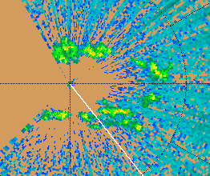

0156 – Whopping 3-km tops on these cells.

0201 – RHIs to 60-90. Nearby storm in that sector has intensified. For the foreseeable future, TGT will likely be pointed SE (right now ~105 az) while we perform the Moum creeping maneuver against the current. Could be multiple days like this in a row. Right now flow and storm motion is easterly, so this is a good heading for watching the storms come in.

0214 – Peak altitude about 8-10 km, according to RHIs.

0216 – RHIs 54-84. General trend the last couple days has been for deep mesoscale convection in the morning to transition to more scattered, isolated, shallow convection by afternoon.

0224 – Tiny cell just a few km to our south that is not getting topped by FAR. Not worrying about it for now. Too close/small.

0237 – Interesting westward sheared structure aloft in NE storm. This matches the latest sounding wind profile, which shows increasing strong east-southeasterlies with height.

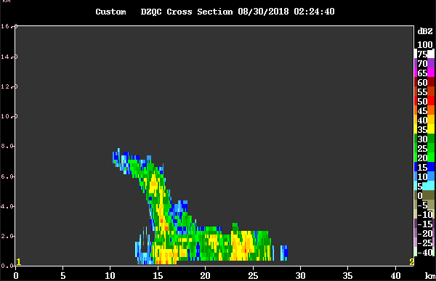
0246 – RHIs to 83-113 az. Multiple cells in this swath. Some close, the others near 50 km. Previous NE storm dying out.

0257 – W-E cross-section thru convection to east. Tops about 8 km.

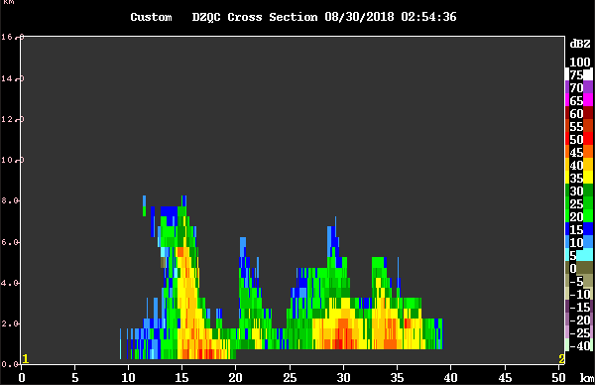

0309 – Cell very close to NE, within 10 km, not completely topped with FAR scan. Letting this be for now.

0311 – Storm to east up to 14 km tall!

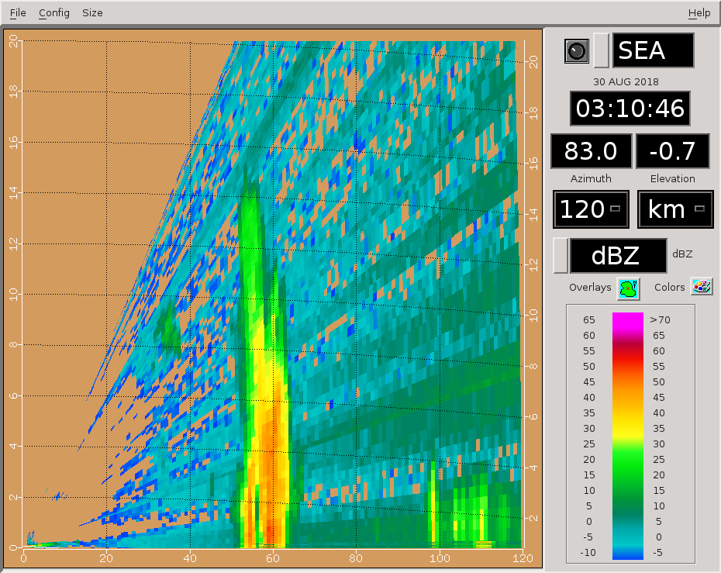
0345 – Continuing to rotate RHIs to stay on this east storm. Been getting a good lifecycle analysis on it.

0417 – RHIs to another storm at range in 90-120 az.

0436 – Echo tops above 10 km. Respectable storm given the relatively shallow nature of most convection at this time.

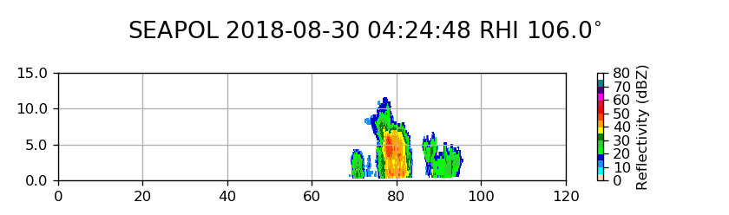
0441 – Now tops over 12 km.

0457 – 14 km tall at 110 az.

0508 – Been a trend toward increasing convective strength the last hour or so. This is different than yesterday when convection got really shallow and suppressed around this time.

0531 – RHIs to convection within 0-30 az. The ESE storm is dying out.

0538 – Switching to PISTON_NEAR as there is a nearby storm that is not getting topped.

0546 – RHIs to 330-360. Storms moving west, trying to keep up. Some RHIs were pretty empty last round.

0601- Close convection moving off scope, so reverting to FAR next round. Slight rotation clockwise of RHI sector.

0617 – Storms getting smaller, so cutting some RHIs and adding a surveillance sweep.

0631 – RHIs rotated slightly counterclockwise, since everything is moving west.

0646 – Continuing to rotate counterclockwise. Northern storm moving off scope soon, though.

0647 – Long range doesn't show much out there besides what is within normal SEAPOL range right now.
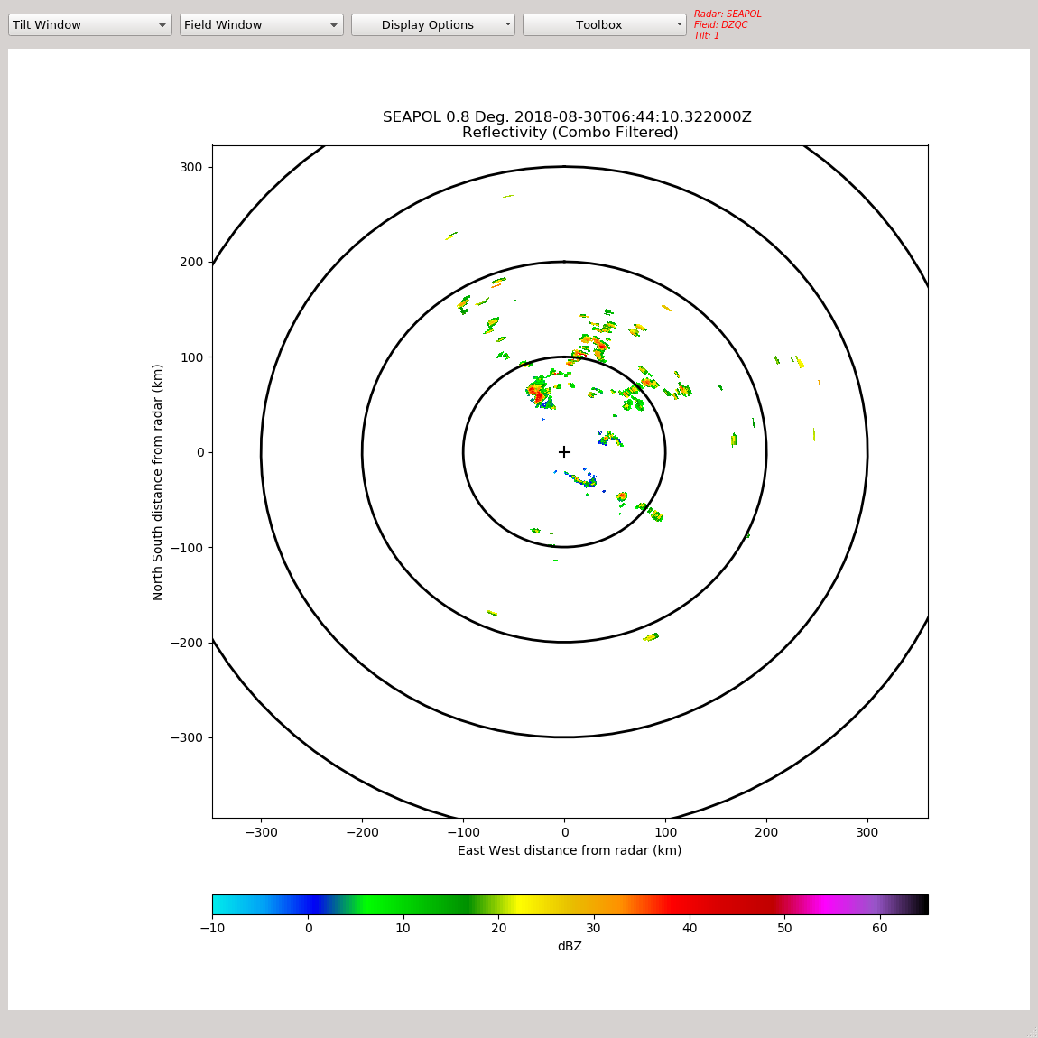
Shift Summary
Similar pattern to yesterday, with the first few hours filled with substantial and intense mesoscale echo. Then, by late local morning the echo coverage had decreased. However, unlike yesterday, the storms were not reduced to only scattered shallow cells. There also were examples of multicell storms that developed 10-14-km turrets, and these persisted late in the shift. Successful RHI sectors were maintained throughout the shift. During the shift the ship moved from 11 to 12 N, and became quasi-stationary and pointed into the current, to facilitate Chameleon and Surf Otter sampling.

Night Shift (4p-4a L)
Scott Powell

0810: Switching to LOW next cycle.

0814: GPM overpass to the northwest. Isolated convection viewed. Radar was near 12N, 134.7E

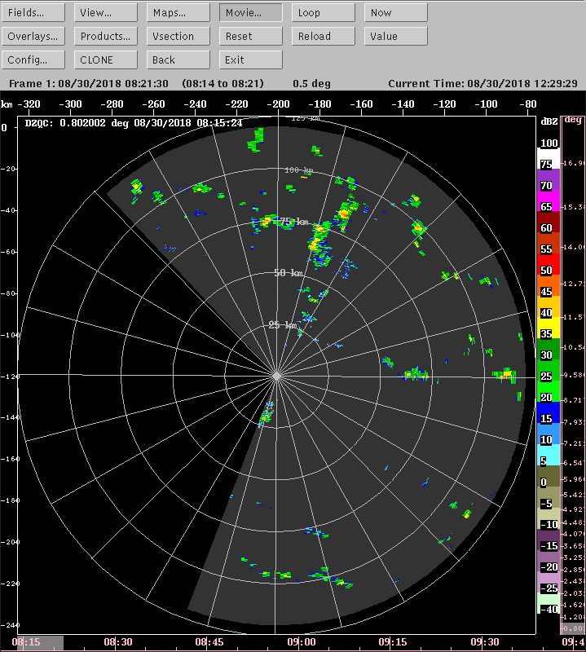

1045: Just some isolated convection remains. RHIs suspended and LOW volume scan continues.

1127: Running RHIs at a few angles to see some isolated convection.

1329: Shallow convection seems to be organized into a few rolls.

1520: Empty RHI at 120 for CYGNSS overpass. (TJL: Was scattered shallow echo on scope, however).

Day Shift (4a-4p L)
Timothy Lang and Kyle Chudler

1902 – RHIs to 171-189 to cover some shallow convection within 50 km to S. Not every sweep will hit.

1911 – Wow, this stuff is all 2-4 km tall.

1917 – RHIs to cover 120 az region. More convection there.

1935 – Some stuff along those RHIs. All fairly shallow, but going to keep the RHIs the same this round.

1938 – Switching to FAR next round as there is a nearby shallow cell.

1946 – Still some distant stuff along the 120 radial, keeping up RHIs. A bit more echo coverage last few vols.

2030 – This convection at range along 120 az has stuck around for quite a while now. Been just keeping 12 sweeps in that area – not every sweep hits, but we do get a few decent RHIs every vol. Convection remains in the 4-6 km altitude range for the most part.

2031 – It helps that the echoes @120 az are basically moving toward 300 deg. That helps keep them radially aligned well.

2106 – Rotating RHIs a bit counterclockwise last few rounds, in order to maximize filled sweeps. New line also has developed closer to us, a bit more toward due east. Visually, that convection is really shallow.

2114 – Long-range view. Mostly just scattered cells throughout the NE quadrant or so.

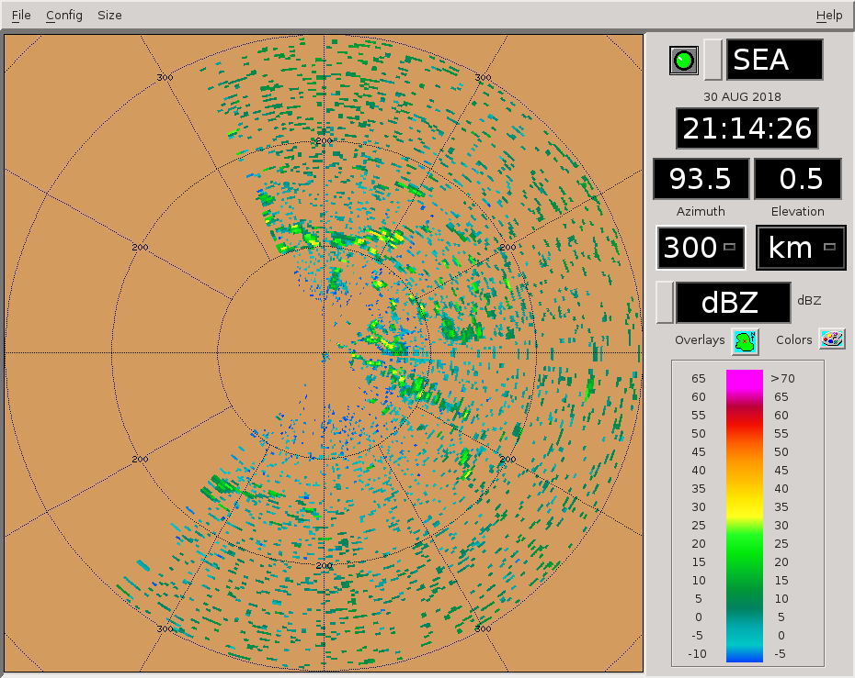
2116 – Trying RHIs within 62-88 for a change, 14 tilts to 15 deg elev, with the surveillance scan thrown in.

2211 – RHIs maintained on ENE storm. It has formed a NW-SE line near about 40 km out. Tops 4-6 km.

2214 – Actually ~7-8 km max tops.

2217 – RHIs to 60-86, slight adjustment. Storm is a bit too big to cover with a single RHI volume, so just hitting some of the highlights.

22:31 – Convection to NE organizing slightly into a line. Tops approaching 10km now
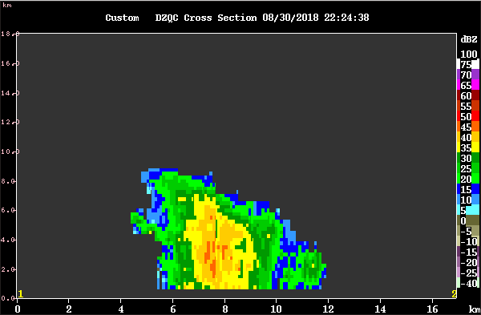

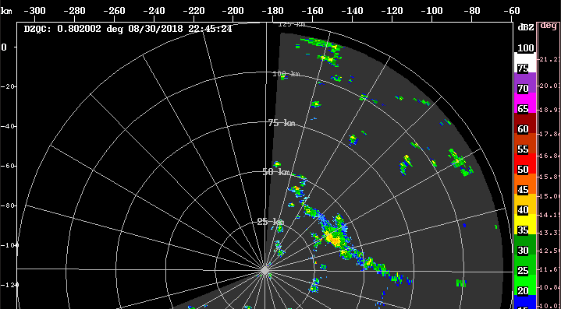
23:02 – Increased RHI angles up to 20 to top nearby line but removed two azimuth angles to leave time for SUR scan

2315 – Dropping surveillance for now and adding more tilts, focusing on the line within 40-70 az.

2331 – The whole line now fills 0-90 az at a minimum, so we have plenty of choices for RHI sectors. Trying 60-90 now.

2354 – Switching to NEAR next round due to storm proximity. RHIs to 50-80.

