20180901
Day Shift (4a-4p L)
Timothy Lang and Kyle Chudler

0001 – Slight rotation counterclockwise of RHI, to keep up with storm. Good time series on this system so far., as the RHI sectors cover the majority, if not all, of the storm.

0007 – Moving to PISTON_LOW next round, due to lack of nearby convection.

0031 – Expanding RHIs to 210-240 (2-deg spacing), as the storm is within 50 km and fills a bigger arc. Also, there is additional convection behind it at range, moving into this swath.

0050 – Switching back to PISTON_FAR to capture convection moving into range

0102 – Moving RHIs 225 – 255 to tagret convection incoming from SW

0117 – Tops approaching 14 km on organizing line to SW

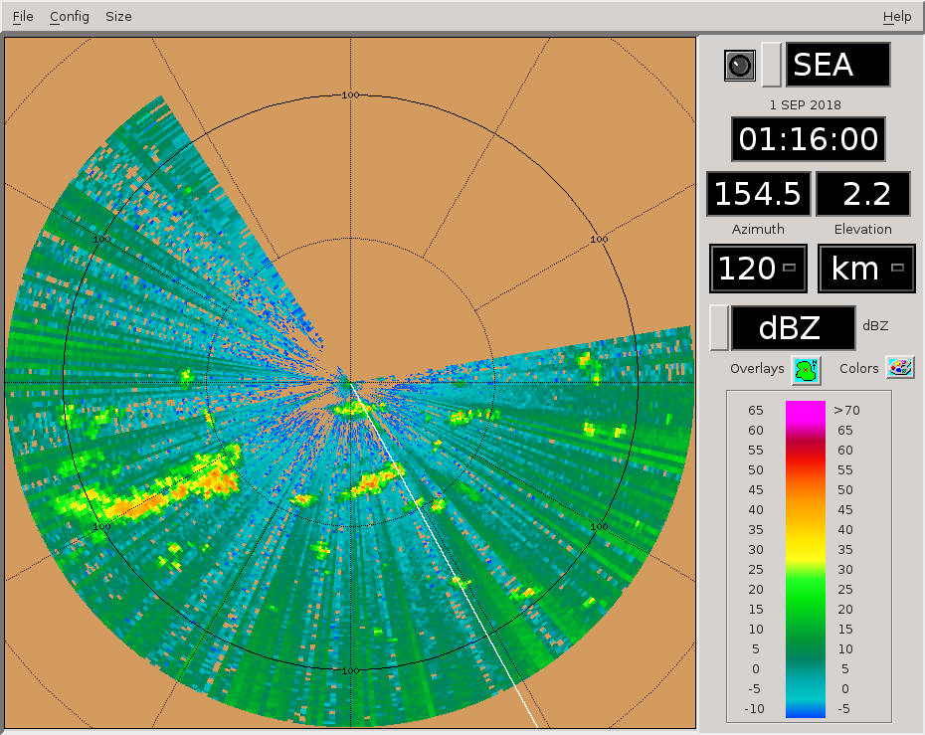

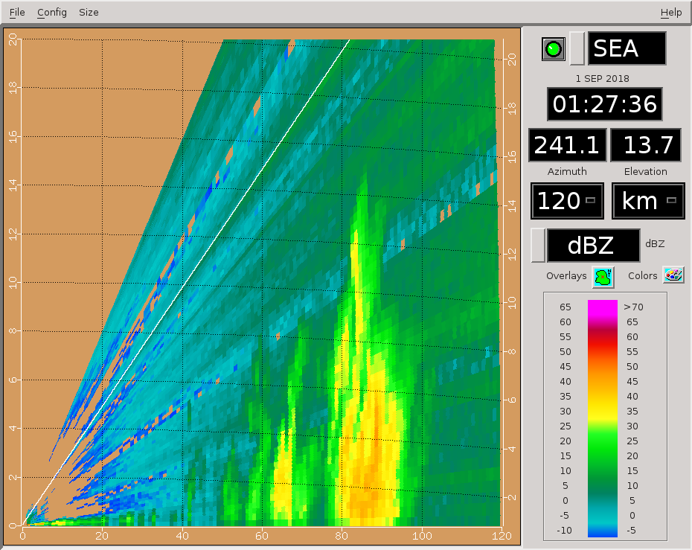

1:46 – Squall line getting more organized

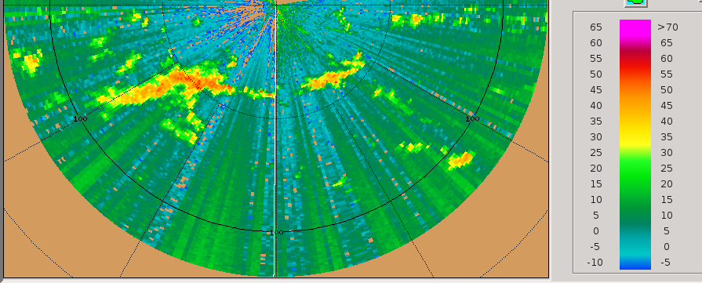

0206 – RHIs to 197-242, 3-deg spacing. Trying to sample the bulk of this SW storm's length. Dealiasing issue noted in recent Doppler fields.
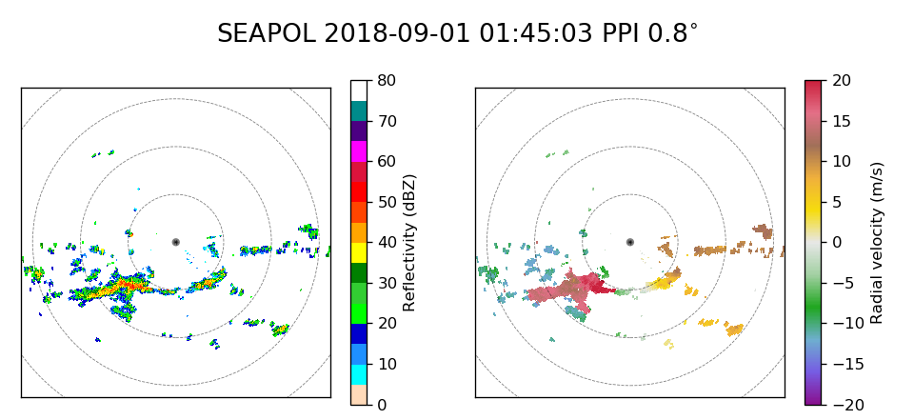
0208 – Can see hints of updrafts (tilted ones at that) in the Doppler data, very neat.
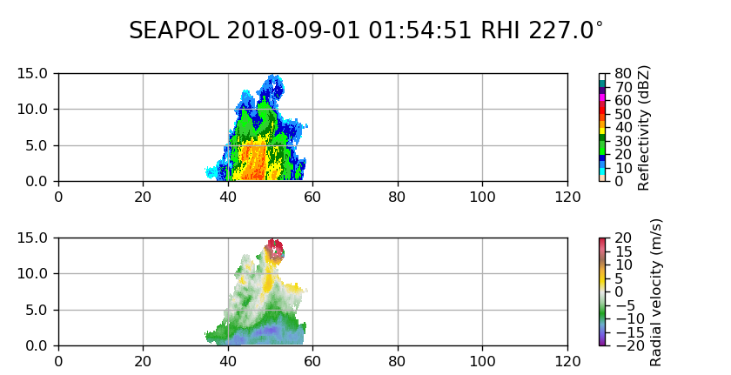
0209 – RFI noted to be a little worse with this southward heading we've had the last few hours.

0216 – RHIs 182-227, still too few to capture full system length. Bulk of storm within 50 km, so spans a very large azimuthal swath.

0231 – RHIs 150-195 az, to keep up with storm. Aiming for strongest portions.

0236 – Picture of storm from around 0150, by Kyle:
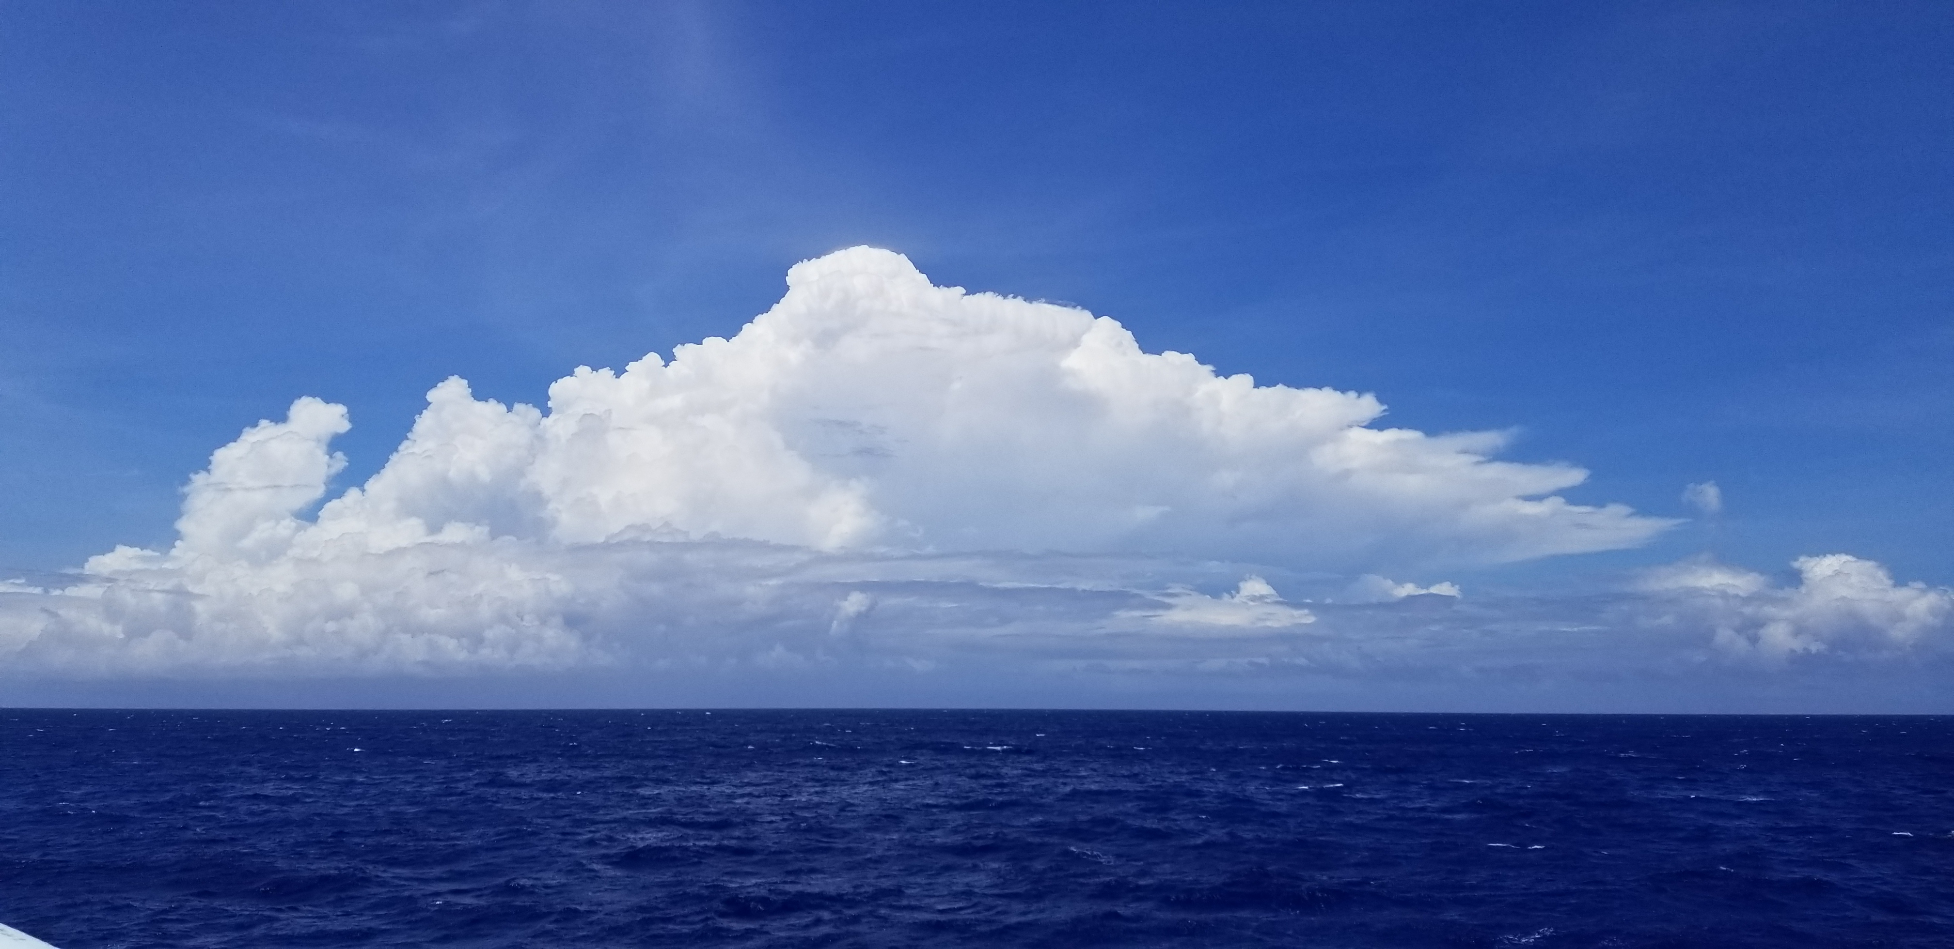
0238 – Ship heading 215 deg, looks like it changed during this vol.

0246 – RHIs 135-180.

0250 – One cell looks like over 60 dBZ at 168 az last round, in a cell behind the main storm.
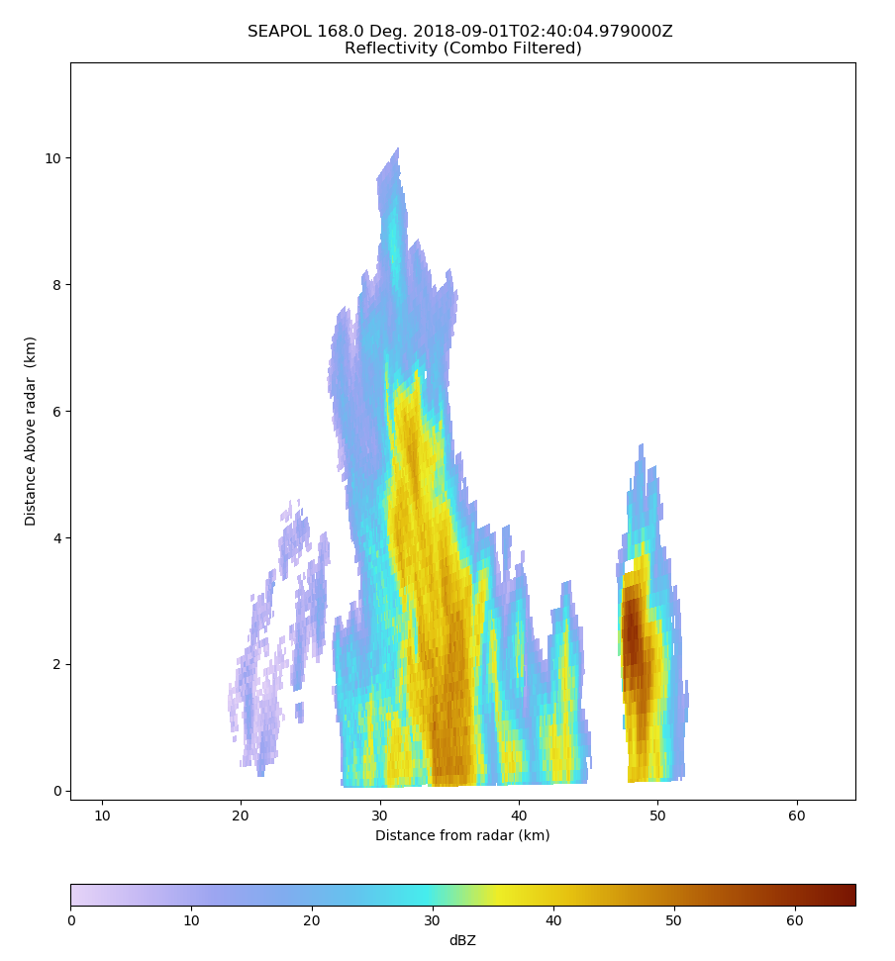

0251 - This cell had high ZDR too.

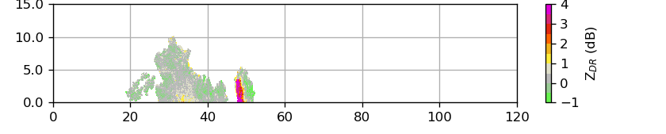
0256 – RHIs not always topping storm due to proximity (20-deg elev max).

0257 – Not going to adjust max elev on anything since storm is booking by so fast. By the time NEAR is set it will be obsolete.

0301 – RHIs 120-165 az.

0305 – Anvil from storm streaming westward, this is due to the significant zonal shear in 0Z sounding.
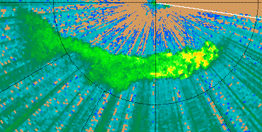

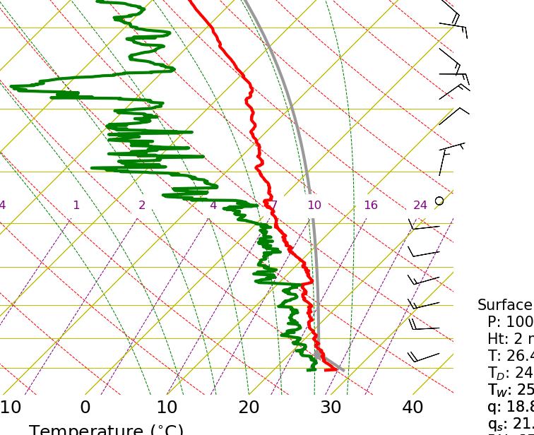

0316 - Keeping RHIs at current angles. Storm is moving eastward quickly so running out of effective azimuths that direction, given SW heading of boat. Instead, we will begin to sample the west portion of the storm, as well as a few cells at further range.

0318 – Now that's a pretty sweep. Note, however, the modest ZDR values. These storms are really tilted westward.
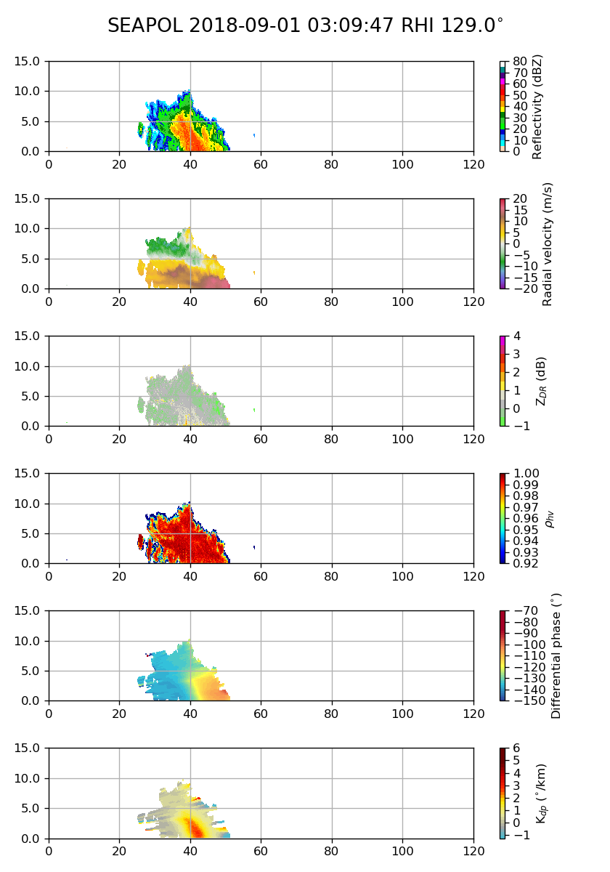

0323 – W-E cross-section across main storm:
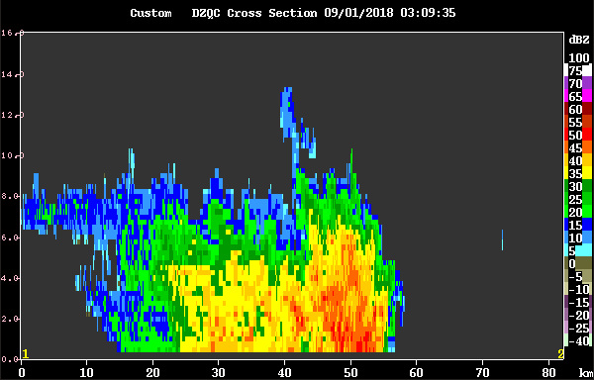
0331 – RHI to 216-246 to cover new storm about 75 km out.

0346 – Cutting a few RHIs to allow a long-range SUR. Just going to check out what's beyond us.

0351 – Cool electric blue fish with yellow tail of port bow recently. It spooked some flying fish to fly away.

0355 – Well, at least we are well positioned to sample literally the only interesting stuff within 300 km. Another storm moving east on the heels of the SW storm.http://seapol:20910/rhi_ta_latest_viewer.htmlhttp://seapol:20910/rhi_ta_latest_viewer.html
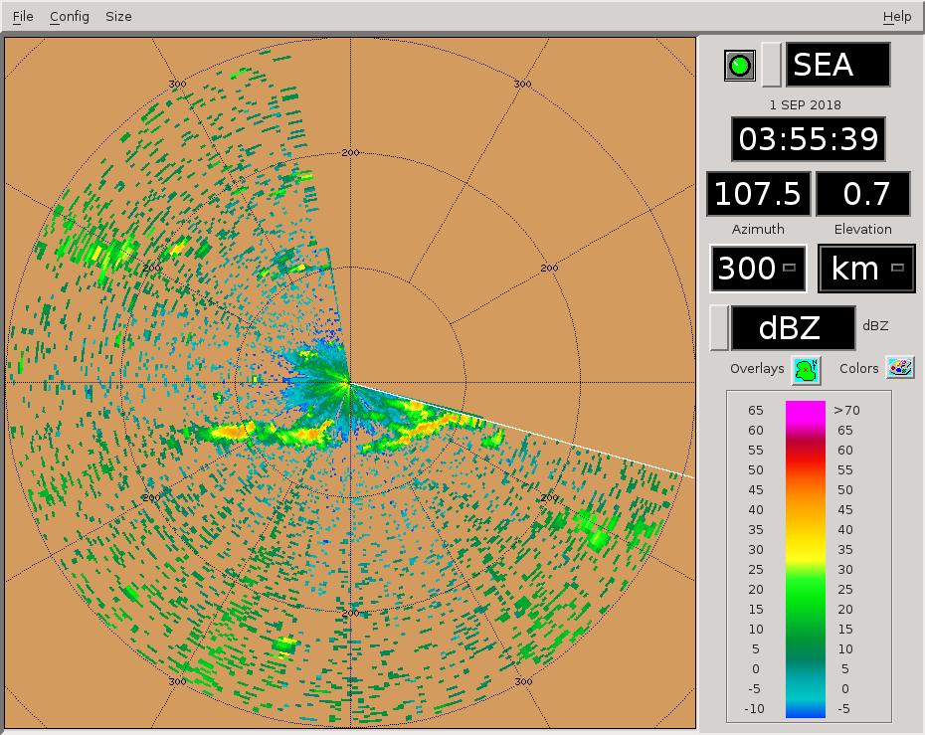
0358 – Tops to 14 km in SW storm.

0401 – RHIs to 194-224 az. Dropping SUR. All the interesting stuff is close to us.

0416 – RHIs 178-208 az. Just trying to keep up with the storm. It has elongated out similar to the last line.

0423 – Wonder how the vertical shear may be helping to elongate these storms in the W-E direction.

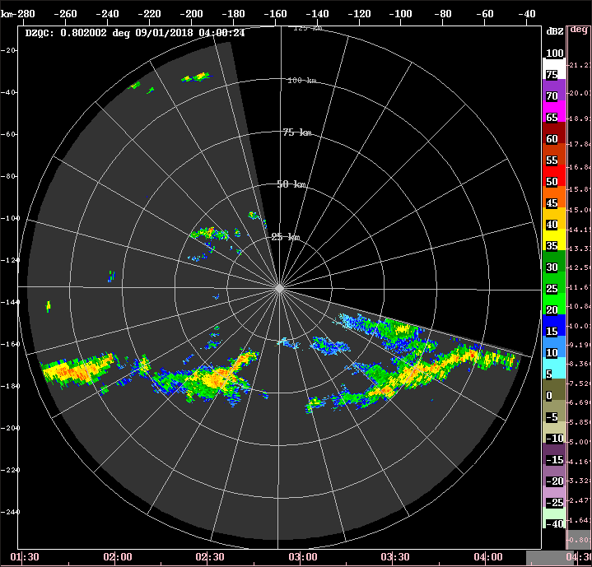
0427 – Visible satellite suggests these storms are part of a long filament of clouds that run along the flow toward, but not really reaching Jebi, which is ~800 km to our NE.

0431 – RHIs 160-190.

0445 – RHIs not topping everything. However, seems like FAR will get us well into the anvil. Not sure what's up.

0446 – RHIs to 146-176 az.

0454 – Vertical cross-section through southern storm. Tops to 14 km.
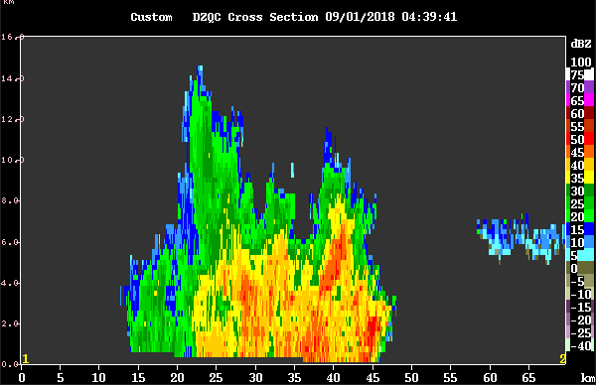
0456 – Going to NEAR for a bit next round. Probably 1-2 rounds too late for the tallest, closest stuff.

0503 – RHIs to 138-160 az, max elev 30 deg.

0517 – RHIs to 210-232 to cover the incoming storm to the SW. CIDD suggests 14 km tops in this storm.
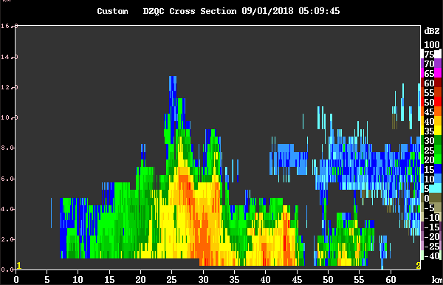
0530 – RHIs to 180-202 az.

0546 – RHIs to 160-182. Keeping on leading eastern edge of convection. No storm has followed this last one into the domain. Will run SUR once we get out of having to run high-tilt scans.

0557 – Couple other cells north of the main storms, close to the boat. Getting a bit of misting from them outside, due to the strong westerly flow (still ~20 kt).

0602 – RHIs 156-178 az, starting to transition toward the western part of the storm.

0616 – RHIs 140-162 az.

0617 – Adam Sobel noted that RHIs are looking less sheared lately. This is likely due to them mostly being pointed southward, across the shear vector.

0620 - Have been seeing multiple examples of the strongest phase shifts being elevated from the surface, yet still below the freezing altitude.

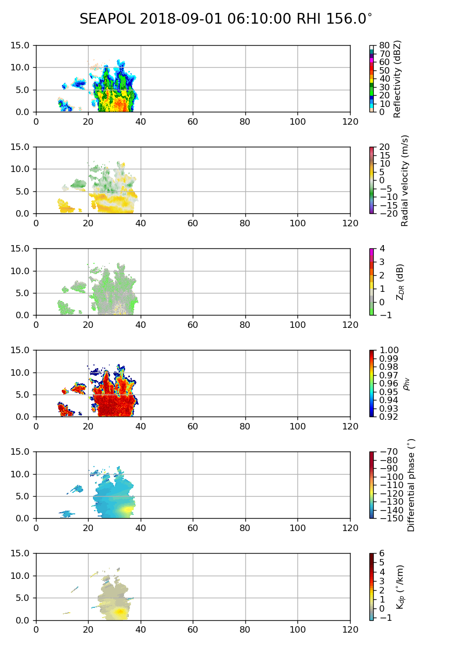
0631 – RHIs 118-140 az, switching to PISTON_FAR next round as the storm has moved away. Adding in SUR scan.

0641 – Long-range suggests a bit more development to the west, since last we checked in.
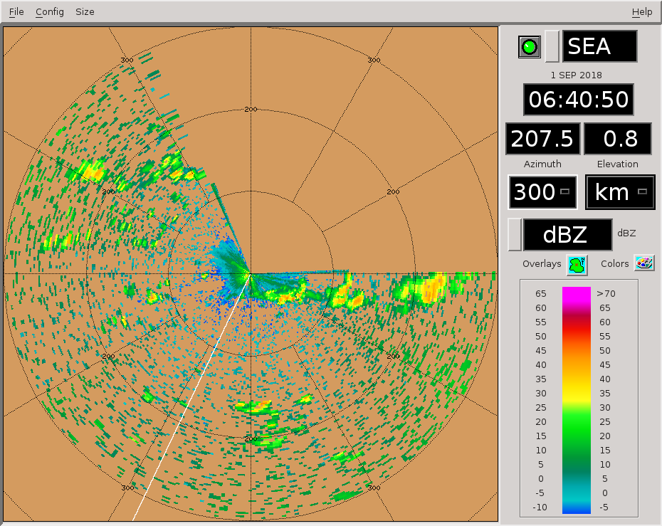
0646 – RHIs to 106-128 az.

Shift Summary
Strong westerly flow (~20 kt at ship) brought continuous bouts of convection west to east across our southern-facing FOV. The strong flow was due to with increased monsoon winds related to the passage of Typhoon Jebi, far to our NE. Within the first few hours, the convection transitioned to become more organized, and subsequently grew taller. Many hours of RHI sectors were taken through this intense, organized convection. Echo tops ~12-14 km were common. The strong vertical shear (westerlies near the surface, easterlies aloft) led to significantly westward-tilted echoes. Phase shift was strong through the storms, but ZDR tended to be modest except in smaller, more isolated cells. This suggested heavy rains made of smaller drops in the biggest storms. There were at least three significant organized storms during latter half of the shift, each following the other as they entered the domain from the west and rocketed past us to the east. Closest approach of each storm to the ship was ~25 km or less. This sometimes forced switching to a NEAR-type scanning strategy.

Night Shift (4p-4a L)
Scott Powell

0810: Stopping RHIs for a bit as the convective complex has moved east out of the domain. But there looks to be more coming based on the long-range scan.

1047: PISTON_LOW next cycle starting at 1100.

1052: Lots of small echoes with strong ZDR signatures down low tonight. Most of the high ZDR and reflectivities are found on northeast parts of cells tonight.

1600: Still the same scan strategy. Spray and pray RHI method for some isolated convection in lieu of going all in for the bigger stuff on the domain edge.

1842: No other major changes to the scan strategy tonight.

Day Shift (4a-4p L)
Timothy Lang and Kyle Chudler

1902 – RHIs to 102-124 az. There is a u-shaped cell there about 45 km out. Ship's heading about 210 deg.

1914 – Long-range shows a large area of W-E convection beyond normal max range.

1916 – No RHI changes, will catch the back half of the main cell, plus a shallow yet intense new cell behind it.

1926 – Tops to 10 km in the main storm.

1931 – RHIs to 289-300 az to cover a cell about 75 km away.

1946 – RHIs to 294-305. Not sure I actually executed the last RHI sequence due to crappy Sigmet interface.

1959 – Long-range view. Some storms to our west likely to move into range soon.

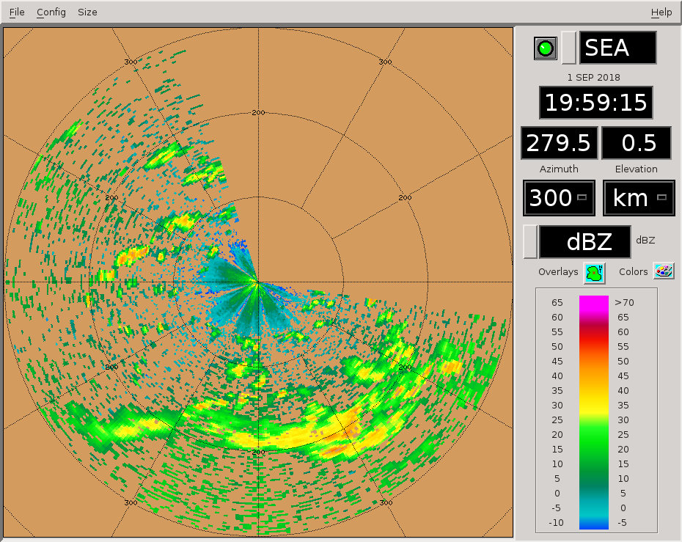
2002 – Expanding RHIs to 298-320. Another storm moving in on scope and should be covered by these sweeps too.
2016 – RHIs to 304-326 az.

2017 – Interesting positive ZDR aloft in this particular sweep. Kind of like a detached ZDR column.
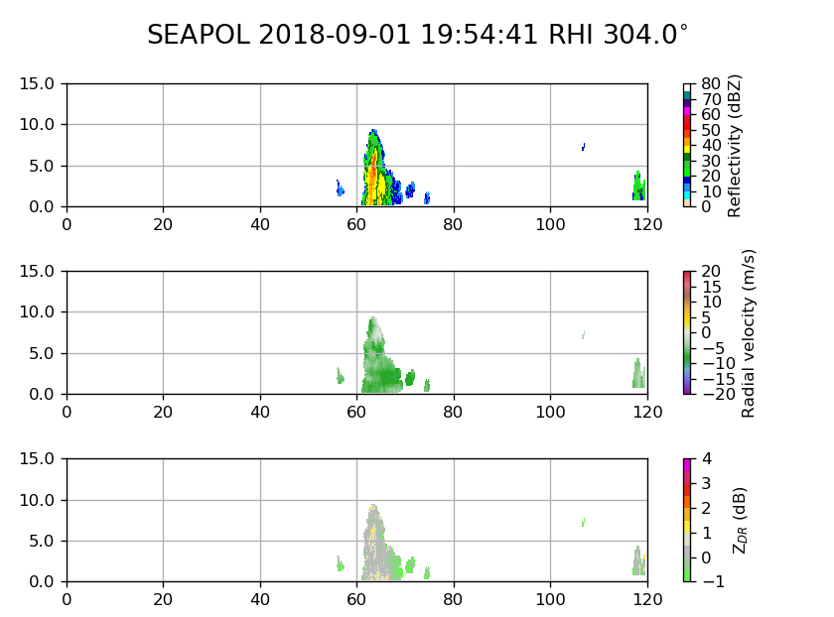

2031 – RHIs to 158-180 az. Line of cells has formed there. Gradual trend toward increasing echo coverage on scope.

2047 – RHIs to 144-166 az to keep up with line. Some nice strong young cores with high Z/ZDR.

2050 – Getting some nearby cells, switching to FAR next round.

2101 – RHIs to 275-305 to cover this nascent line of cells with in 50 km to our NW. We have enough echo on scope that I am killing the SUR for now.

2136 – RHIs from 210 to 240 to capture multicell line moving up form the South. Also switched to PISTON_NEAR to try to top convection

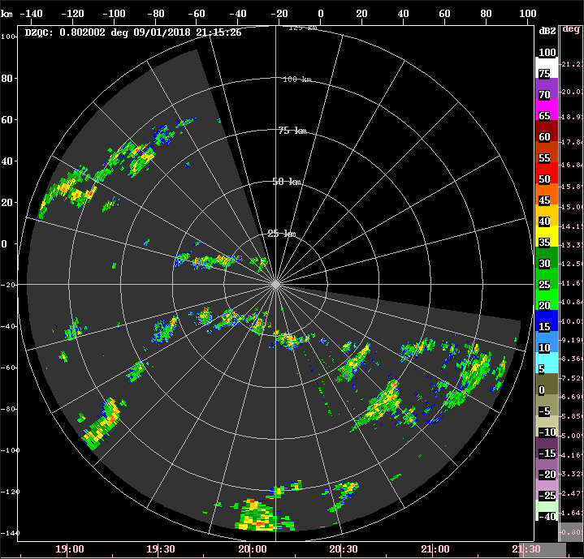

2146 – Keeping RHIs where they are but switching back to PISTON_FAR to capture cell 100km to SW, which had a top at 12km last scan
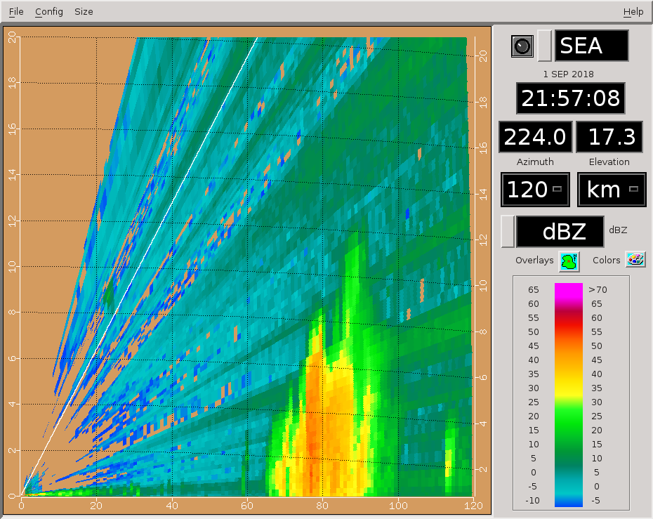

2216 – Few more larger cells moving into scope from the SW. Will keep the RHIs as are, the storms are moving almost directly towards the radar

2223 – Winds gusting up to 25 kts, probably from outflow from small cell to West

2244 – Small area of 60+ dBZ on cell 100km to SW.
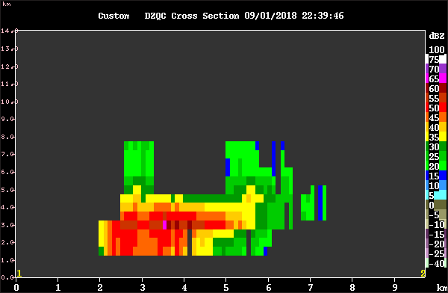
2316 – RHIs 185-215 on this southern storm.

2333 – RHIs to 177-207 az.

2344 -RHIs show tops to at least 14-15 km.

