20180902
Day Shift (4a-4p L)
Timothy Lang

0001 – RHIs to 165-195. The convection to our south is forming a healthy and long SW-NE line.
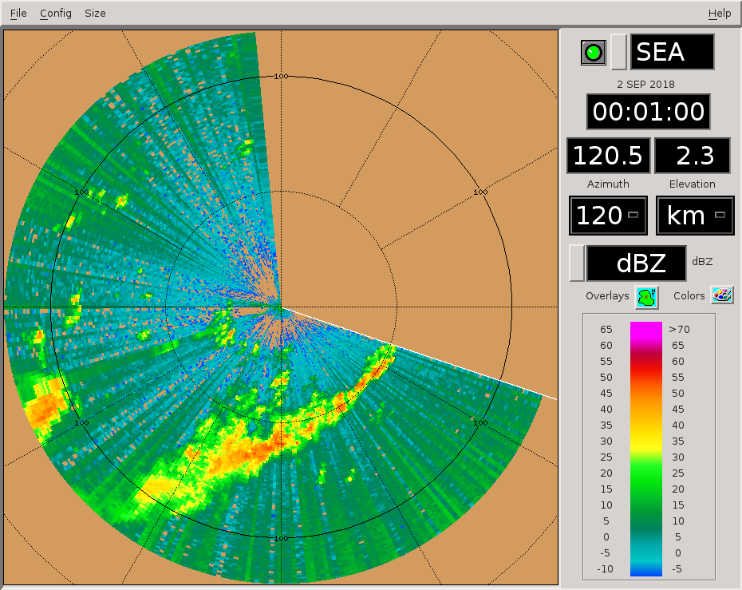
0003 – This sweep really shows the dichotomy between young convection with big drops (near 60 km) and older convection with strong phase shifts (beyond this range).
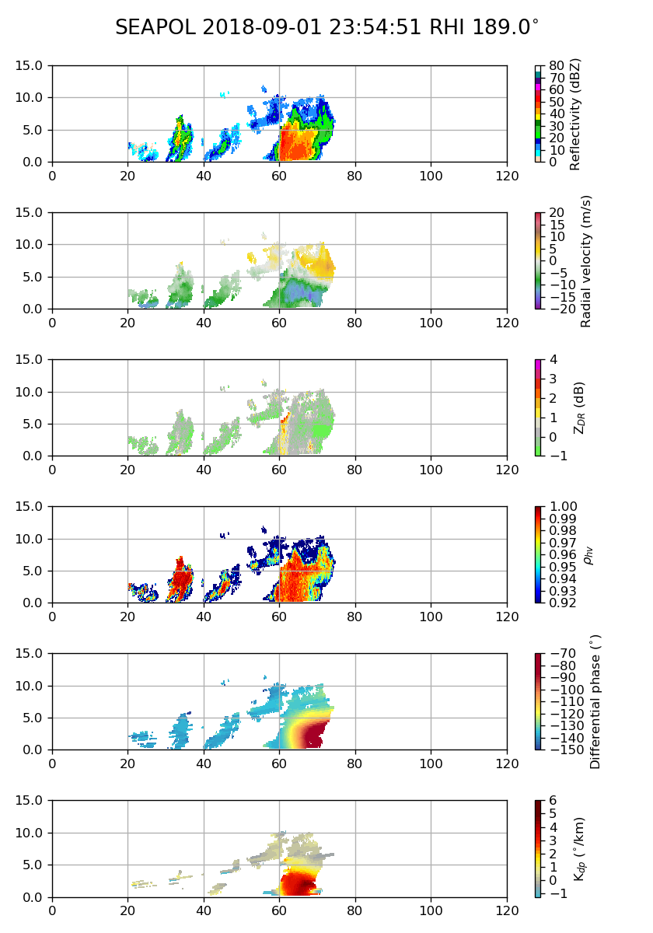

0016 – RHIs to 150-180 az.

0031 – Slight adjustment to account for storm movement.

0033 – Real issues with Doppler aliasing on this windy day. I believe this is caused by the Fuchs software getting spoofed into dealiasing.

0037 – Movie loops show another decent storm moving on scope from the west. So far today has been qualitatively similar to yesterday, in terms of echo behavior.

0046 – RHIs to 134-164, following the storm. Echo tops have stayed within the 12-15 km altitude range.

0102 – RHIs to 120-150 az.

0116 – Switching to the SW storm. RHIs to 225-255 az.

0132 – RHIs to 205-235 az. SW convection starting to fill much of the western half of the domain.

0147 – RHIs to 185-215. Here is how the convection looked recently. Note the Doppler aliasing issues.
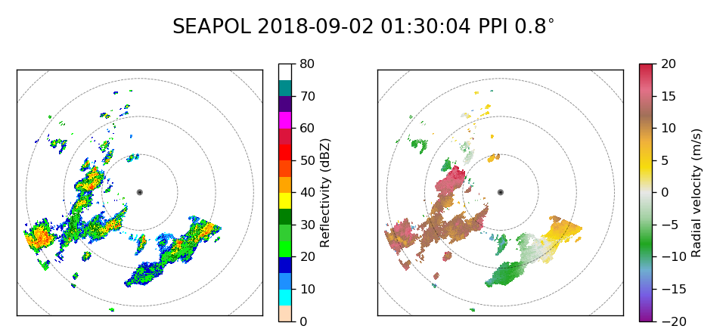
0202 – RHIs to 150-180 az.

0205 – Movie loops show the western convection splitting open like a mouth, surrounding the ship.

0216 – No changes to RHIs. Significant portion of line still within the swath. The eastern portion has moved off scope.

0227 – Vertical cross-section along line to our south. Tops have generally been in the 10-km altitude range.
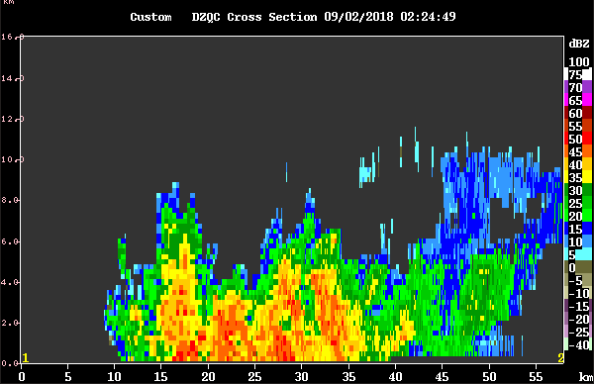
0230 – RHIs to 225-256 az, to prep for CYGNSS overpass in an hour. There is another line of convection moving in from west.

0233 – Ship heading up to 240. Great for CYGNSS (~240-60 az), but RFI is increased as well.

0246 – RHIs 224-254 az.

0316 – Good chunk of storm located within 210-240, so switching RHI azimuths to that to support CYGNSS overpass at 0328.

0321 – Here is a vertical cross-section along the SW line. It is relatively well aligned for the CYGNSS overpass.

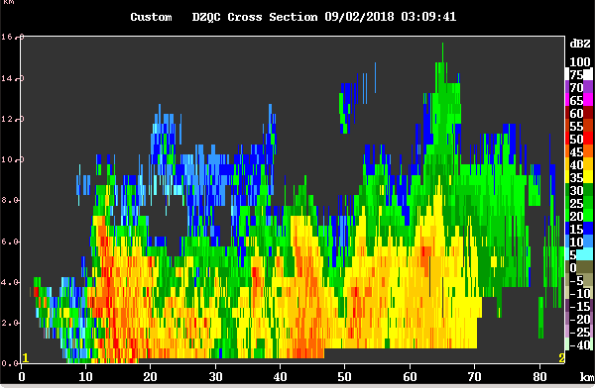
0324 – Switching to NEAR next round.

0327 – RHI hit lower limit after a few sweeps and scan stopped. Trying to restart antenna.

0328 – CYGNSS overpass. Radar not operational. Here is last overpass after crash. Really healthy line. Usable data up until failure, though, so this is still a viable overpass to analyze.
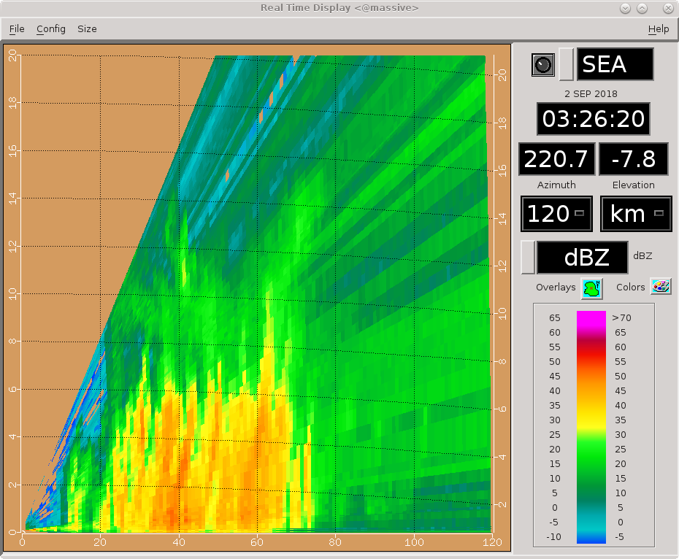
0330 – PPI volume restarted normally. Radar ops back. Going to wait on engineer advice before doing any RHIs. Currently in PISTON_NEAR.

0336 – Adding SUR scan to make up for expected lack of RHIs this round.

0343 – Here is the long-range view right now. More convection to our NW, but otherwise this long line we are scanning is the main system in town.
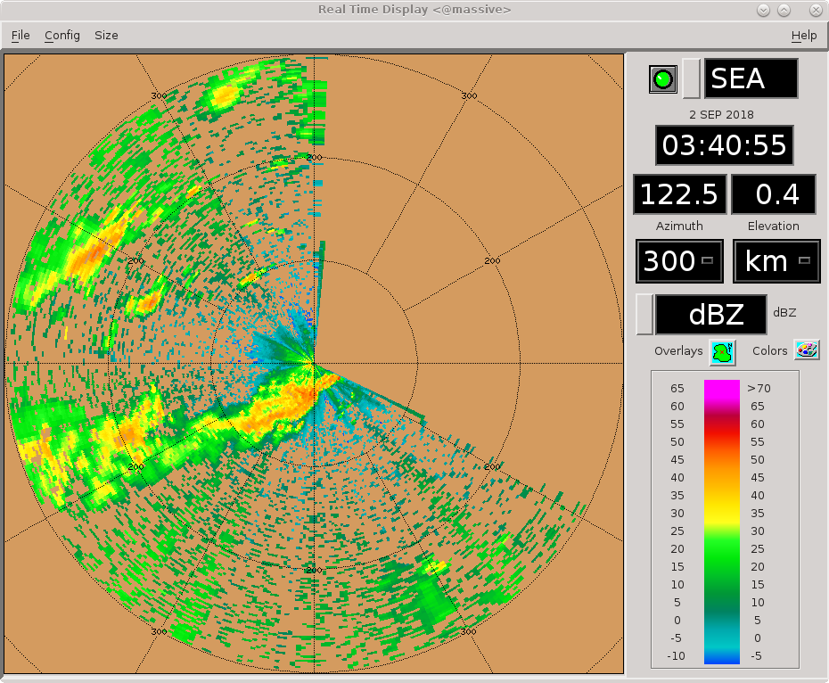
0351 – RHIs to 180-210. We'll see how this goes.

0353 – Sfc winds up to 30 kt from the SW. That means Doppler velocities might be aliased right off the bat looking toward the SW. We turned off the dealiasing since it wasn't working anyway. Here is the most recent uncorrected velocity image.
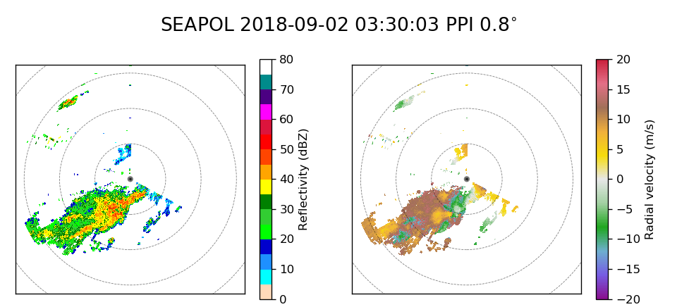
0401 – RHIs 154-176 az (12 tilts, 2-deg spacing). Too many azimuths to cover, we are simply covering one portion of this line. RHIs changed to 0.5-30 deg, adding a bit of low-end buffer to reduce chances of hitting antenna lower limit in these swells.

0403 – Some beautiful cross-sections through this storm

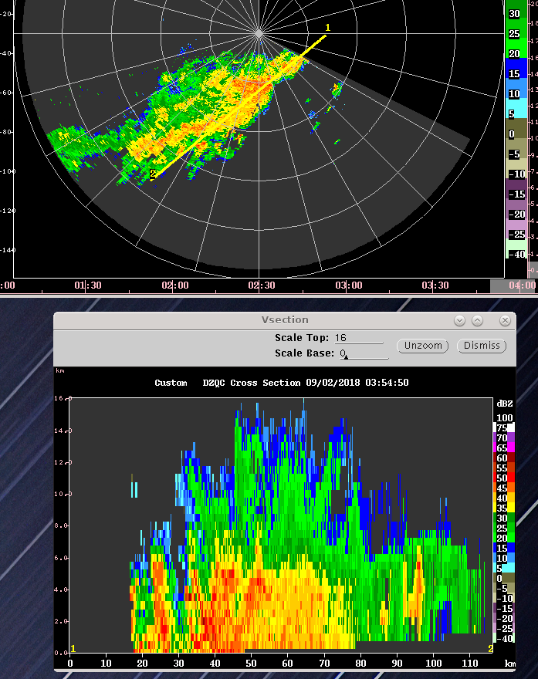
0417 – Ladder on seatainer needs to be secured. Will shut down for a bit to remove after this NEAR vol finishes. We will miss at least this round of RHIs.

0428 – Ladder issue resolved. Back to RHIs, only a partial volume though.

0430 – Nice phase shift in this thing.
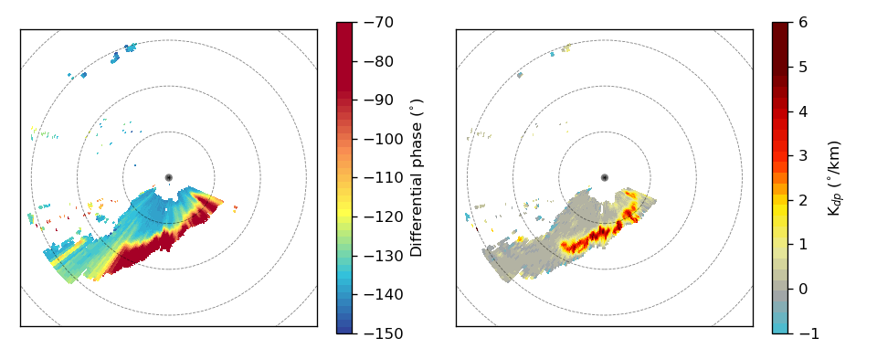
0431 – RHIs 148-170 az.

0432 – Despite all the issues today, we've really only missed out on a couple sets of RHIs so far.

0434 – Areas of negative phase shift aloft, maybe around 7-8 km or -20 C (0410 UTC, 162 deg). Also, too, positive shift above that altitude.

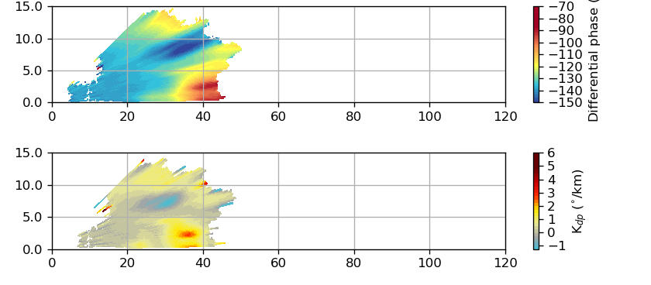
0437 – Line moving away from us, switching to FAR next round. Will update RHIs then too.

0449 – RHIs 136-166 az, max elev 20 deg.

0453 – Some small rain cells behind the main line may not get topped this round.

0457 – Unless we started going backwards sometime in the last hour, there are hints of southeastward propagation with this line. Gust front dynamics, maybe? Definitely looks more like a classic mid-latitude QLCS lately.

0501 – RHIs to 120-150 az. Got another storm popping up to our west, moving in on scope. Another line? Will try a SUR soon.

0516 – Like that “Distracted Boyfriend” meme, I am switching to the new storm to the west. RHIs to 230-252, cutting sweeps to add a SUR.

0519 – The rainfall accumulation imagery finally looking interesting this case. Giving it some love below.
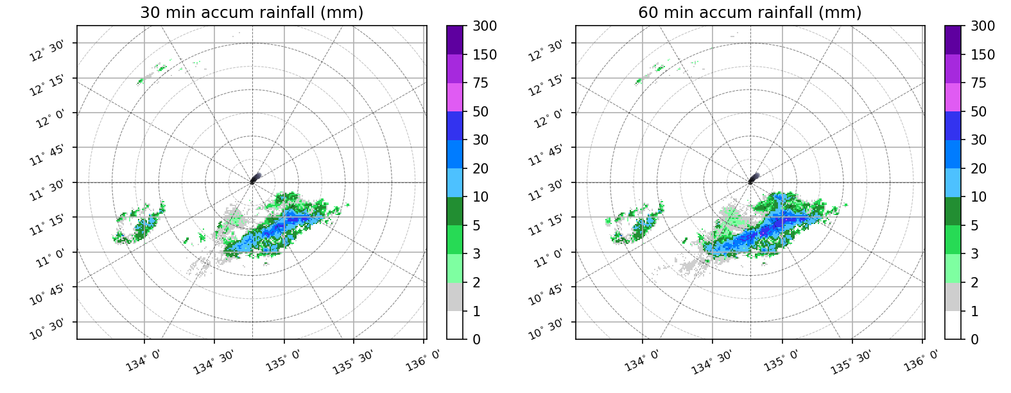
0526 – Long-range. These are full-on Jebi monsoon tail rainbands, methinks. Stuff is just going to keep streaming in for the foreseeable future.
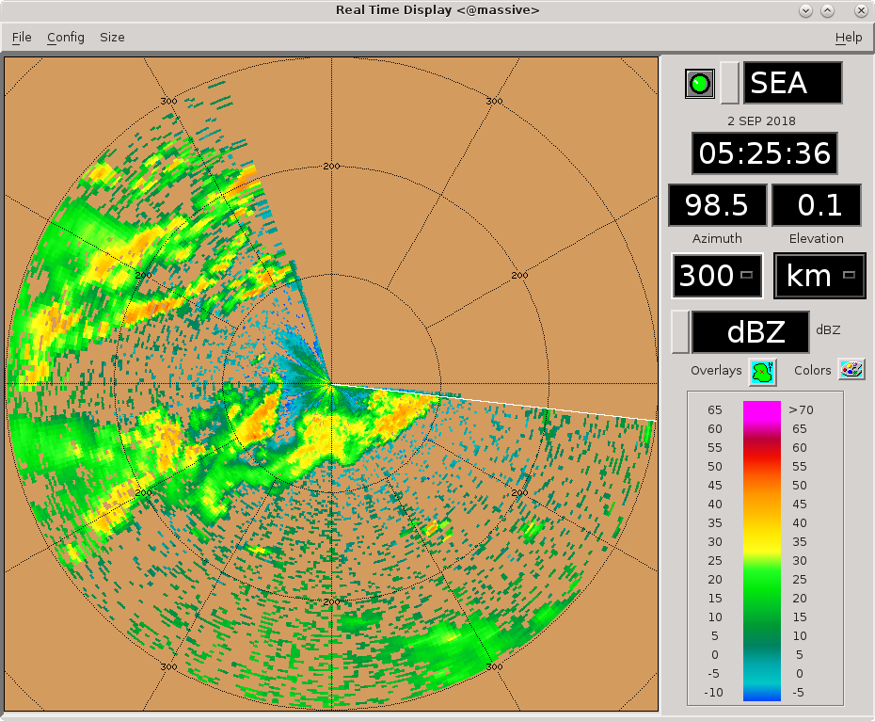
0531 – RHIs to 240-270. Arc of new convection jutting out from the NE part of storm, these RHIs will capture part of that in addition to main storm.

0558 – Switching to PISTON_NEAR next round. West storm getting pretty close, RHIs suggest we will not top it without NEAR.

0601 – RHIs to 30-deg elev. Swath will be 255-288, 3-deg spacing w/ 12 sweeps.

0617 – Overall, convection seems weaker and more stratified the last few volumes. Reflectivities and phase shifts have both decreased from peak values.

0623 – Due to reduction in convective strength, and passage of nearby cell out of our FOV, switching to FAR next round.

0630 – Look at how tilted these echoes are. That is some shear!
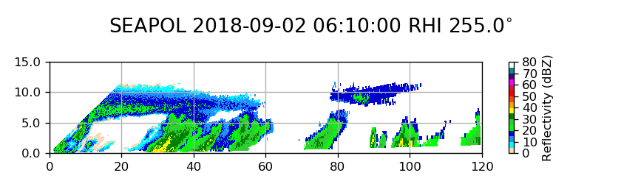
0632 – Cutting some RHI sweeps and adding a SUR. Still focused on the NW quadrant.

0641 – Long-range. A few different west-east streaming bands. We only have a good view of one of the bands in our main domain.
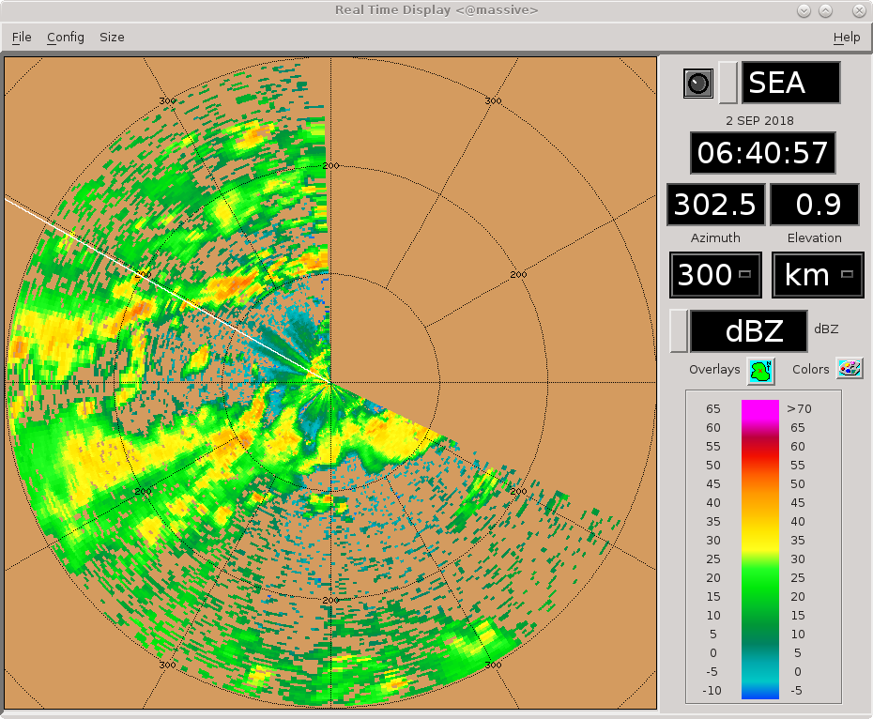
0646 – RHIs to 240-267, keeping SUR in anticipation of GPM. RHI elev reduced to 25 deg to help with timing. The storm in the targeted RHI swath is about 80 km out.

Shift Summary
This day was at least qualitatively similar to yesterday - precipitation systems streaming from west to east across our FOV. However, today was a bit different. Winds were stronger, up to 30-kt sustained near the sfc at times. In addition, the storms were larger and more organized. The highlight of the shift came after 0300. A long line became well organized and showed evidence of shifting to gust-front-driven propagation to the SE as it became akin to a mid-latitude QLCS in appearance. This system also was present for a CYGNSS overpass around 0328 UTC. A minor radar failure prevented a full set of RHIs during CYGNSS, unfortunately. PPI volumes before, during, and after CYGNSS, as well as RHI volumes from ~5 min before and ~30 min after CYGNSS, are available. After the radar failure, the lower limit of RHIs was set to 0.5 deg until the swell settles down. Scanning of the west-to-east convection continues as of shift end. It is continually moving onto scope, and appears to be associated with a tropical low that was once the monsoon tail of Typhoon Jebi. We should be well set for a productive GPM overpass at 0712 UTC.

Night Shift (4p-4a L)
Scott Powell

0714: Surveillance did not quite finish. One too many RHIs. Iris lied about how long it would take. Below is the long-range scan for 0658. Looks basically the same. Good volume scan for GPM however. Widespread zonally oriented convective and stratiform convection for the centered GPM overpass. Convective bands propagating eastward with stratiform extending just south of west of the deepest convection. Ship is near 11.4N, 134.6E.

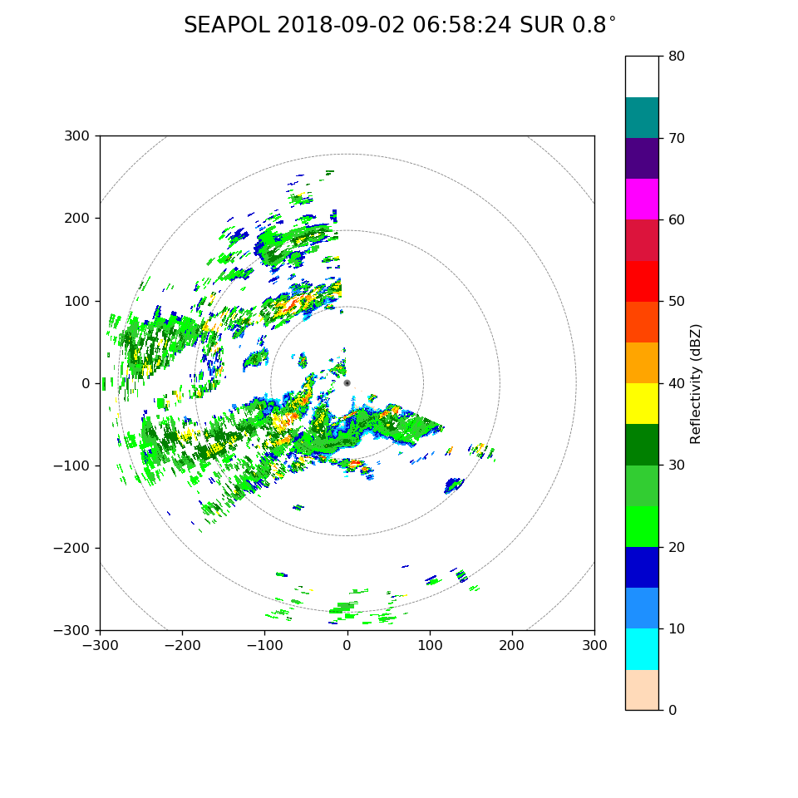
0743: RHIs have some what looks to be stratiform with 40+ dBZ fall streaks. It might be shallow embedded convection. This is the kind of stuff I really wish we had DD in.

0814: SEAPOL looks to be challenged by the pitch today. Up to 8 degrees. Seeing some weird stuff in the RHIs.

1045: Nothing but decayed stratiform right now. Looks like more convection out west. RHIs stopped for now.

1145: Nothing to see. Switching to FAR_S to reduce scan time.

1321: There are enough cells to switch to LOW. This cycle will have a short FAR_S scan and an unfinished LOW scan that tops the convection within 50 km of SEAPOL. A few RHIs will continue next cycle.

1825: After a long wait, looks like new convection is starting to blow up west of the ship.

1900: Next cycle will start on FAR scan. Convection is close to radar but it isn't deep yet. Too tall to keep on LOW though. Otherwise there's not much convection. A couple of strong looking echoes far out to the northwest.

Day Shift (4a-4p L)
Timothy Lang and Kyle Chudler

1902 – No changes to RHIs.

1909 – Check that, upping highest tilt to 30 deg and dropping to 12 sweeps and no SUR. Storm's are truckin' today! Going NEAR next round.

1916 – RHIs 257-279 to cover rapidly inbound western convective line. This line is oriented roughly N-S. Then there is an E-W appendage that is running past to our south.
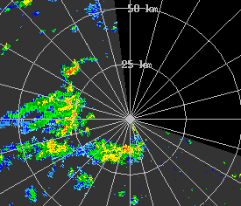

1925 – Even NEAR not getting everything to our west – it's too close now.

1932 – Definitely raining at the ship now. No RHI changes.

1933 – Now there is some nice radially aligned phase shift, 1925Z @ 271 az. Multiple heavily raining storms along this radial.
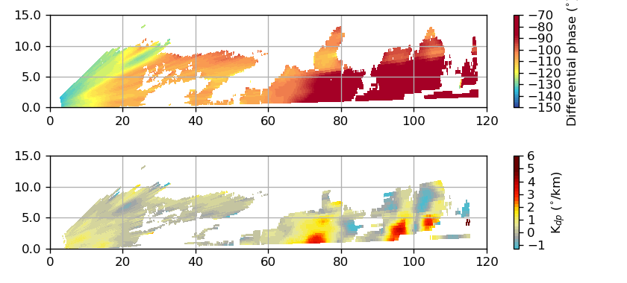
1947 – RHIs 264-275, 1-deg spacing. Long, thin W-E line that is moving basically to the east. Could be really rainy at the ship for a while, if this keeps up.

2007 – Minor RHI adjustments only this round. Storm really well aligned near 270 az. Ship's heading ~234 deg, been pretty stable for a while now that the current and winds have finally aligned.

2031 – RHIs to 267-278. Still well-aligned to our west.

2040 – One of the crew mentioned “big drops” outside

2103 – Continuing to track the line to our west as it begins to move to our NW. More cells moving in from the SW as well
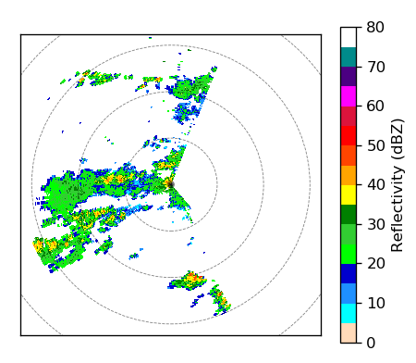

2118 – Switching RHIs 212-234, 2-degree spacing, to the line strengthening to the SW
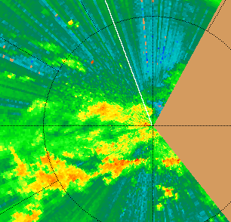

2120 – Switch is pointing almost due west now. This will maximize RFI. Starting to see impacts from this, especially in anvil. 21Z sounding appears caught near the freezing level.

2146 – RHIs to 180-202.

2157 – RHIs not topping this nearby convection, even at 30 deg elev. Too close.

2205 – RHIs 158-180 to follow the storm.

2215 – Ship back to 223 heading, better RFI now.

2216 – RHIs to 180-213, 3-deg spacing. Storm has evolved into a SW-NE line.
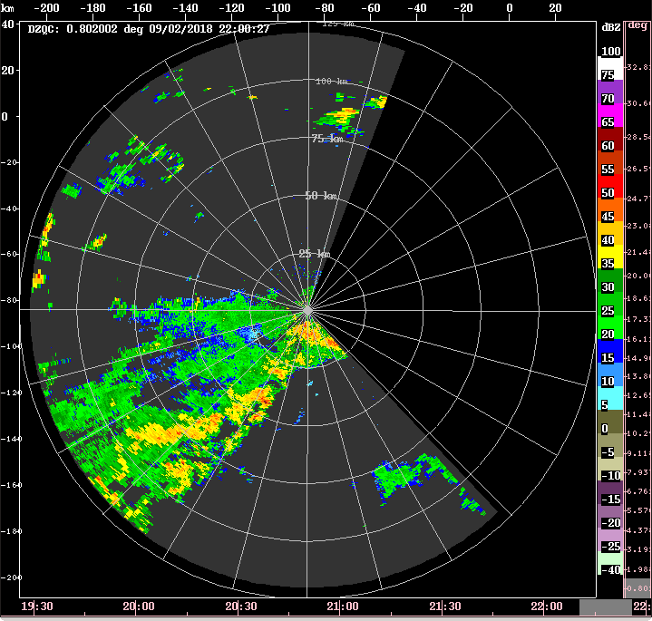
2229 – Tops to 16 km in the convection to our south.
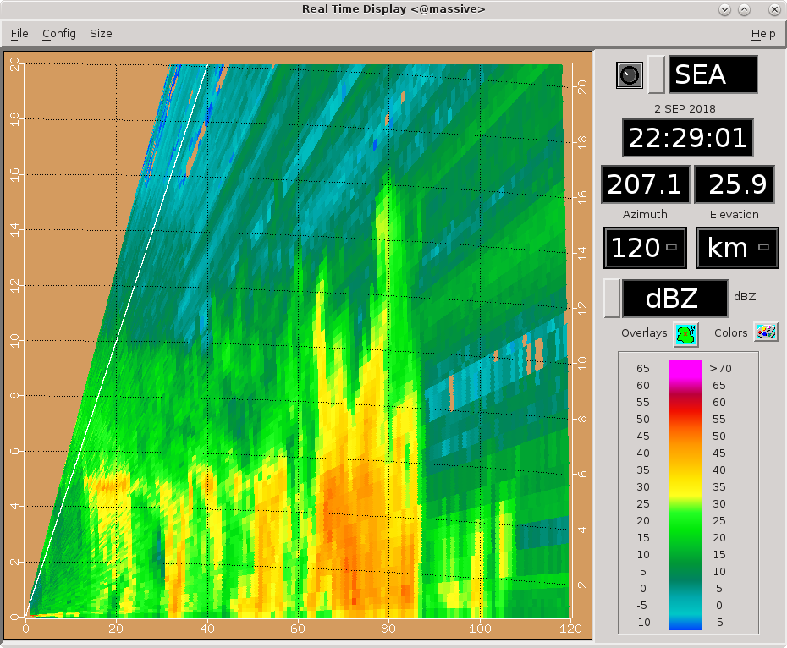
2244 – Switching to FAR next round. Will update RHIs too. Mostly just stratiform near the radar at the moment.

2246 – RHIs 168-213, 3-deg spacing, 20-deg elev, 16 sweeps.

2302 – RHIs 150-195 az.

2303 – Close to a classic LLTS structure here. The stratiform is northwest of the eastward-moving convection. A bit of slope to the melting level in these RHIs, likely due to incompletely corrected ship motion.
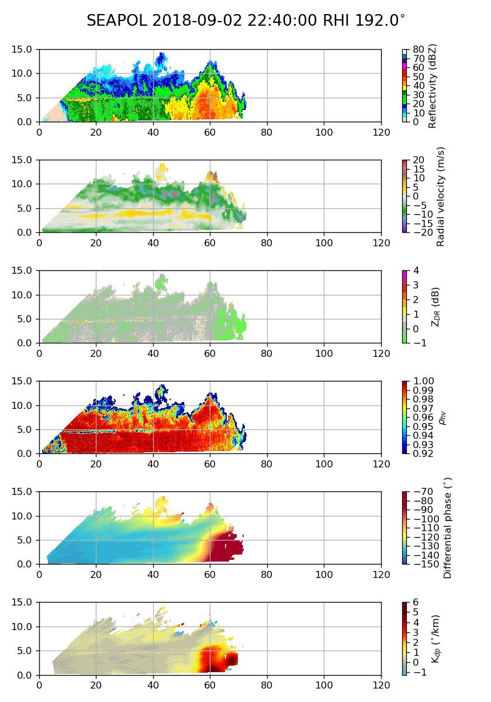

2328 – The front-to-rear flow from (convection to stratiform) apparent on the above RHI has continued with this storm. Also the apparent rear-to-front flow aloft within the stratiform region. Very classic LLTS-type structure.

2332 – RHIs to 165-210, rotating to try to get some sweeps through an interesting SE-NW convective protrusion into the stratiform region.

2346 – Very distinct regions of convective and stratiform precip here

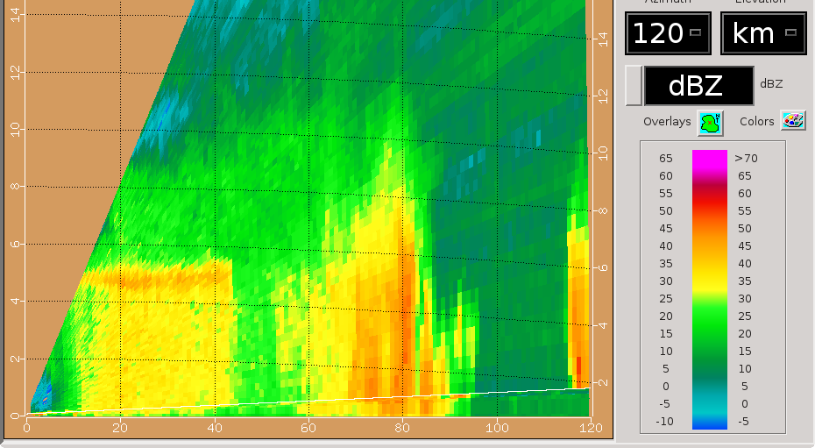

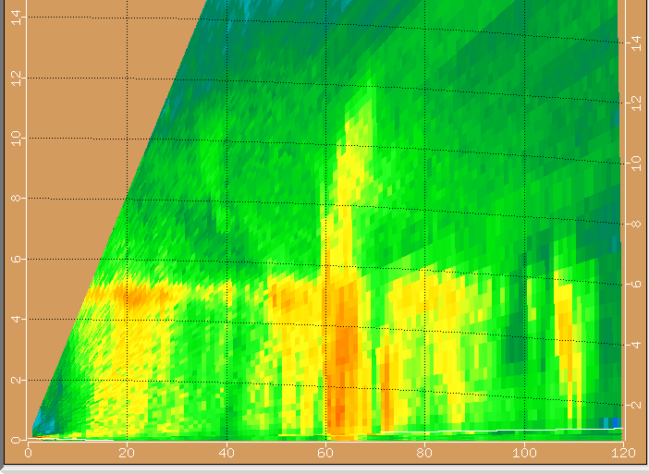
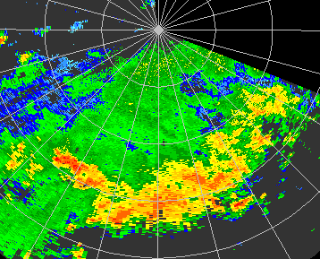
2347 – The convective protrusion mentioned at 2332.

