20180905
Day Shift (4a-4p L)
Timothy Lang

0001 – RHIs to 257-317, 4-deg spacing. Trying to capture a large cell that reaches up to 14+ km to our NW.
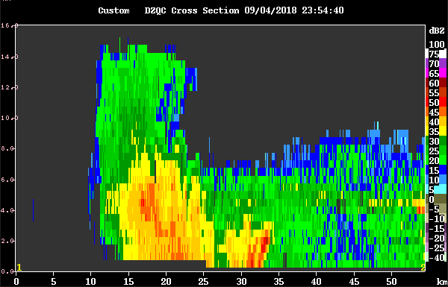
0017 – RHIs 269-314 az, 3-deg spacing.

0018 – Ship at 260 heading, RFI worse.

0047 – Now ship is at 275, killing RHIs for now due to bad RFI, adding SUR.

0053 – Ship supposedly will begin rotating back toward 250 deg soon. That should help with RFI. Was pointed more clockwise due to the recent squalls coming thru.

0056 – Long range. Still substantial echo to our west.

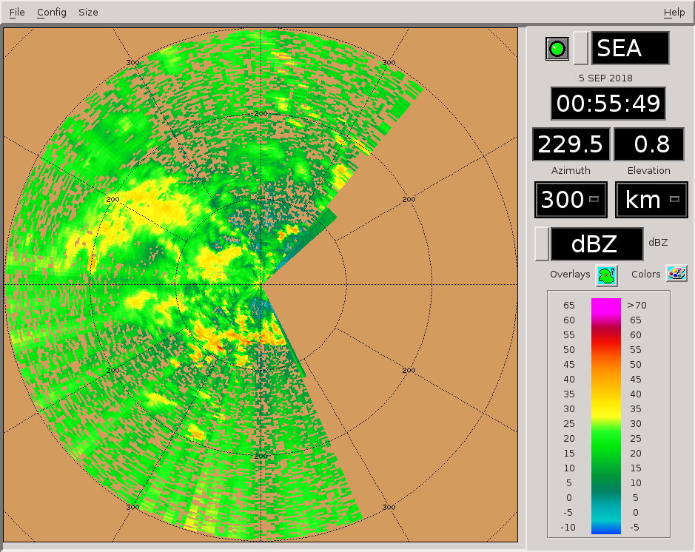
0059 – Satcomm going off as apparently ship can't rotate as planned.

0101 – RFI much better, RHIs to 180-210 az, to cover a portion of the W-E convective line to our south.

0131 -Ship back to 250 deg, satcomm going back on.

0139 – Ship will have to rotate back toward 270, satcomm going back off.

0156 – Note again the relative altitude offset in the maxima for ZDR vs. KDP, in the tallest core.
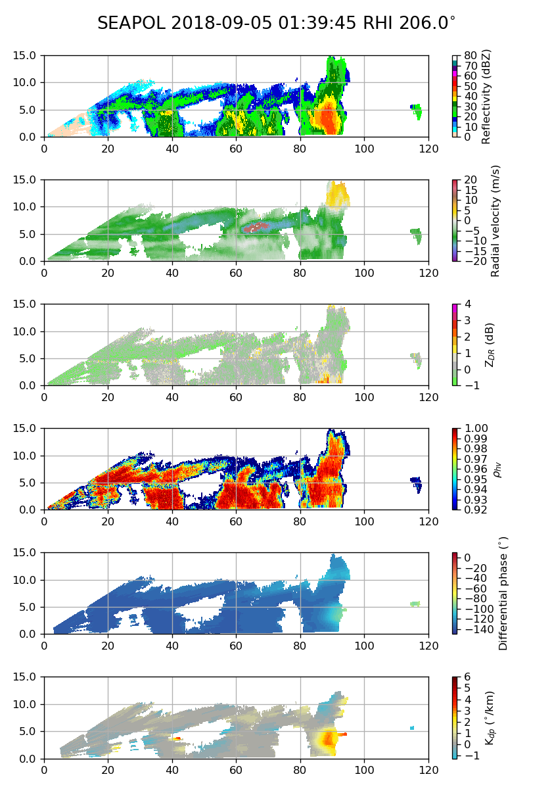
0157 - Note, all during today's shift RHIs have been set to go down to 0 deg elev. We no longer have that 0.5-deg buffer like we did during the heaviest swell.

0201 – RHIs to 150-180 az. There is more radially aligned convection in that swath.

0215 – Convection is all mainly south of us, while to our W and NW there is mainly stratiform echo.

0239 – Switching to PISTON_LOW next round. Only stratiform echo near the radar at this point.

0340 – Killing RHIs for a bit after this round. Almost all convection either off scope or beyond 100 km. There is still a fair amount of weak stratiform around. Ship heading to 240 deg.

0417 – Long range does not suggest any hope of echo moving into our domain soon.

0505 – Scope continues to clear out. Just a couple small patches of stratiform echo remains.

0603 – Coming into GPM overpass this round (0611 UTC), scope essentially clear, maybe 1-2 stratiform patches near the surface, plus some anvil aloft.

Shift Summary
Once again, multiple rounds of weakly organized mesoscale precipitation systems passed through the domain, from west to east. Some of these systems reach 14 km in height. Lightning was visible from the ship at one point. However, except for squall passages, surface winds generally decreased throughout the day. About 2/3 of the way thru the shift, convective precip left the scope and only scattered patches of stratiform echo remained. Even this eventually dissipated. The GPM overpass at 0611 UTC was a bust.

Night Shift (4p-4a L)
Scott Powell

1047: Absolutely zero echo on SEAPOL. FAR_S still running with just 6 tilts. Continuing surveillance.

1500: Still absolutely nothing to see. A few scattered echoes well to the south on long-range scan. But there is frequent lightning to our aft. Lots of squid surfacing to eat tiny animals on the surface that are jumping around like frogs when trying to escape. Squid turn red when they attack. Couple hundred down there schooling together.

1739: GPM overpass. Nothing here.

Day Shift (4a-4p L)
Timothy Lang

1900 – Here is the most recent 8-h rainfall report. Nada. Scope still effectively clear.

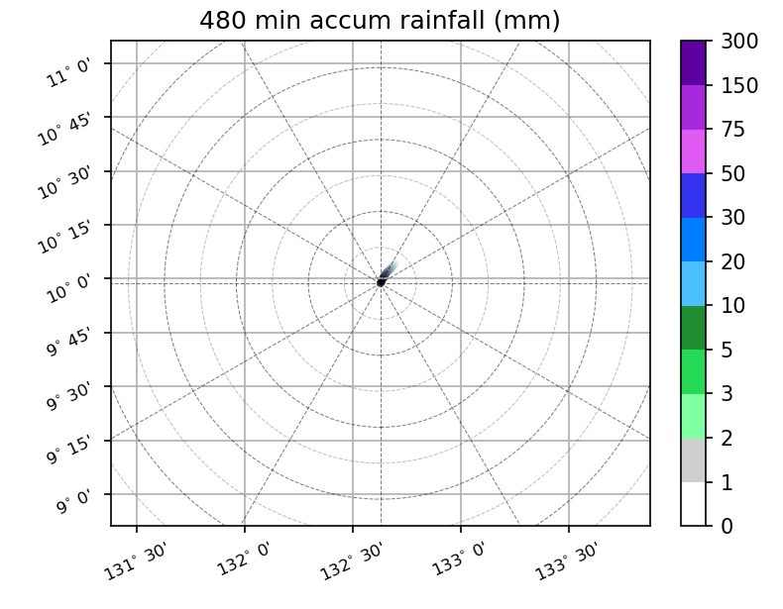

2001 – Small cell on scope, near max range to SW. No scan changes yet. Still FAR_S and SUR only.

2018 – Scheduling LOW for next round, just in case this cell grows and/or gets closer, and/or more echoes pop up.

2141 – That cell petered out, going back to FAR_S.

2332 – Very small cell near max range to south. No scan changes, as cell is very shallow/far.

2337 – Cell already gone in the most recent volume.

