20180916
Morning Shift (9A-1P L)
Ben Trabing

0000 – Continue far volume scans and intermittent surveillance scans. There remains scattered areas of shallow stratiform precipitation.

0015 – Set 9 angle PPI volume scan to run every 15 minutes with 15 minute surveillance due to shallow scattered stratiform precipitation around the ship.

0130 – Precip has reduced around the ship, but some scattered cells beyond 100 km can be seen in the surveillance scans.

0215 – Scans halted for radar maintenance.

0230 – PPI scans resume.

0250 – Switch to 24 angle volume scan as the ship moves closer to isolated convective cells to the north.

0333 – The ship moving north is approaching scattered showers that can be seen in the image below.

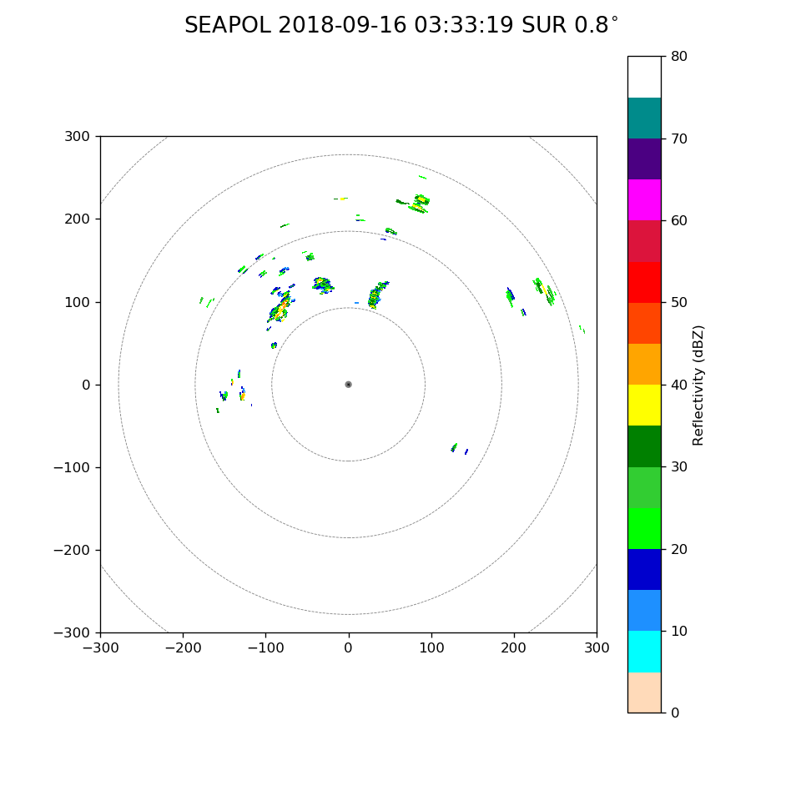

Afternoon Shift (1P-9P L)
Weixin Xu

0445 – Run in the FAR PPI scan mode (24 tilts), as some convective cells appeared in the 100km radar domain.

0500 – Switch to the LOW PPI scan (24 tilts from 0.8 to 16.9), considering t he shallow nature of the convection, e.g., echo-top height mostly lower than 6 km or lower than 3.5 degree at 100 km.

0558 – Run 5 RHIs between 330 and 335 with the max range of 100 km. One of the convective cells went up to 8km with 35 dBZ up to 7 km.

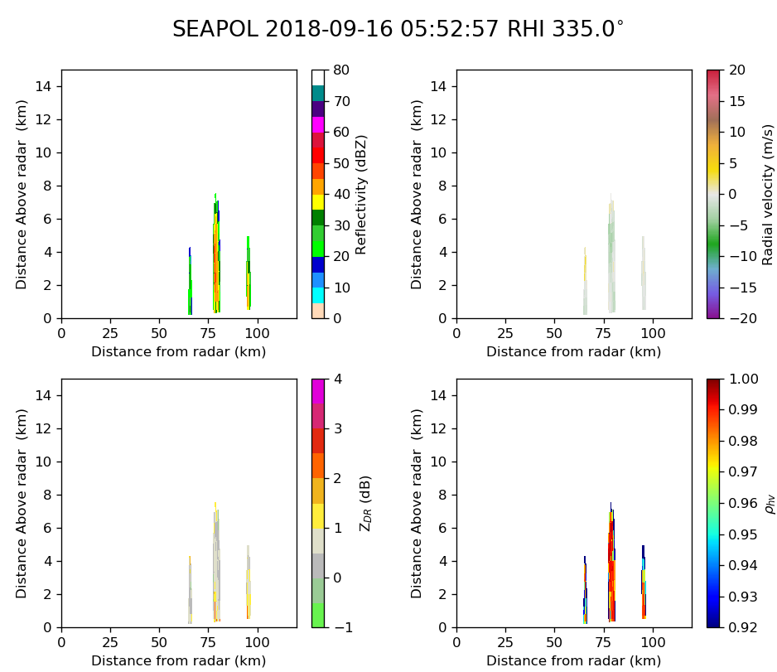
0600 – Set up to run RHIs following the PPI scans (LOW) every 15 min. Some moderately deep (7-8 km) cells develop in the northwest (315-345 degree).

0615 – Switch PPI scans to FAR mode, as the LOW scan can’t top the convection. Still doing RHIs following the PPI scans.

0630 – Return to Surveillance and FAR_S PPI scans (8 angles) mode, all convection is out of the scope of the radar as the ship moving eastward.

0645 – Scan in FAR PPI mode to catch the convection moving into the radar domain from the east with the ship moving further eastward.

0815 – RHIs(6 azimuth angles from 90 to 100) are added following the PPI scans. Some isolated convection to the east of the ship develops up to 9-10 km.

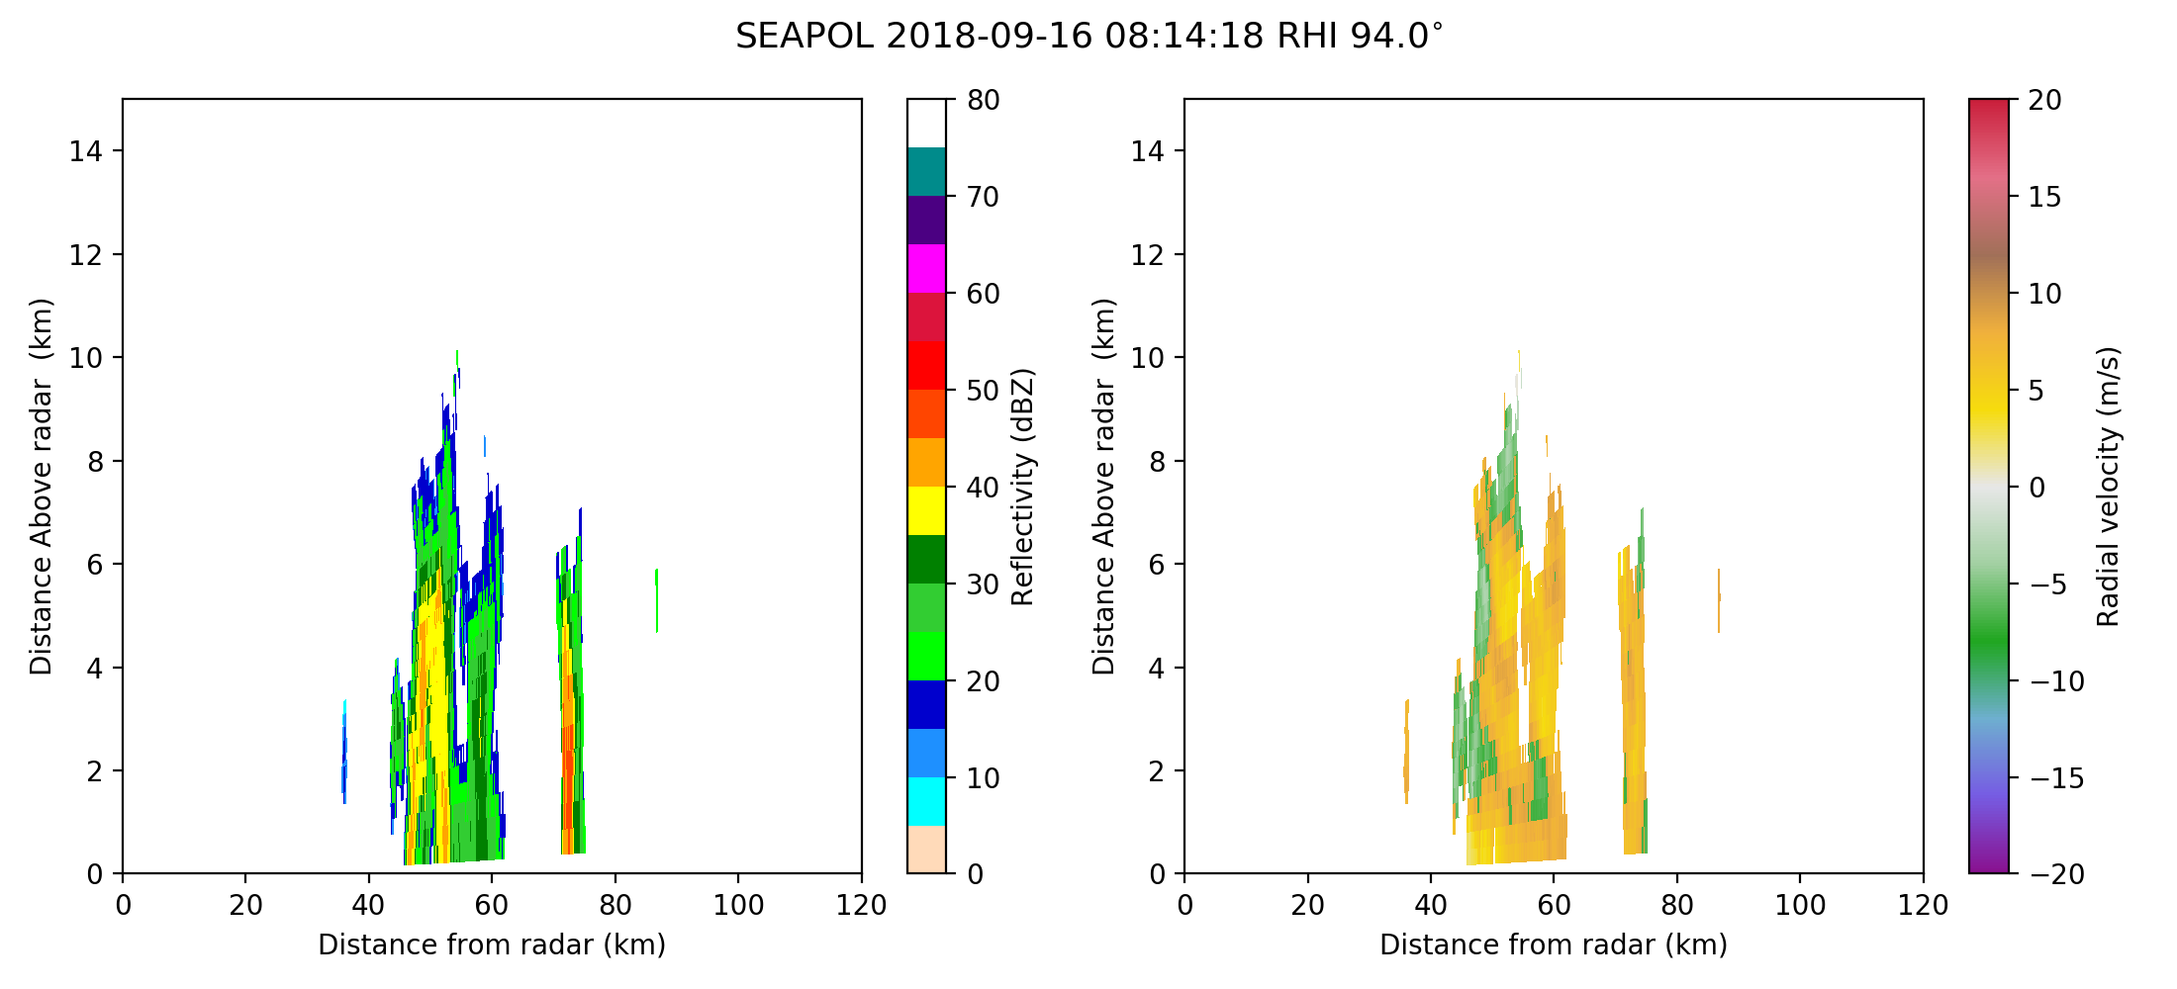
0915 – Change PPI scans to NEAR mode, as the convection is very close to the ship (10-20 km). Then followed by 5 RHIs.

0945 – Back to the FAR PPI scans. Rain showers just passed the ship, while new convection is further south of the ship. Scattered convection was propagated from the east.

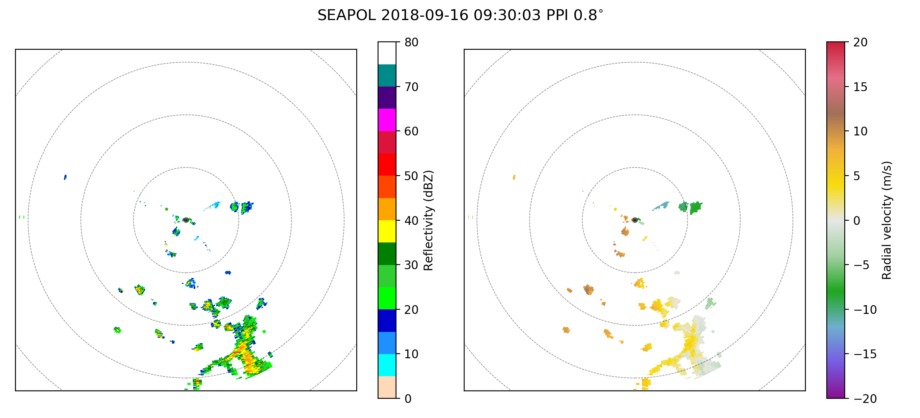
0948 – Following the PPI scans, RHIs are taken toward the south-southwest (5 azimuths from 170 to 182).

1030 – RHIs stopped as taller convection is dying out and becomes stratiform.. Only FAR PPI scans are running now.

Night Shift (9P-4A L)
Chelsea Nam

1200 – No significant convection in the domain right now. Change into surveillance mode when the 1200 FAR mode is done.
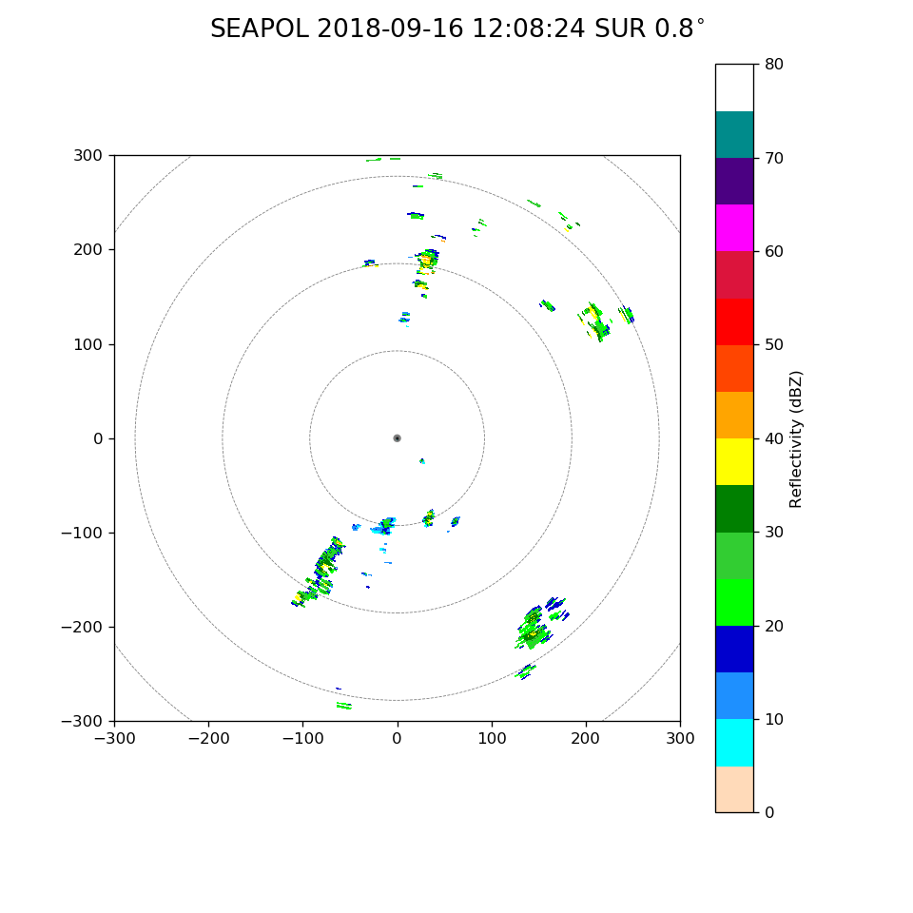
1210 – Scattered convection in almost all directions beyond 100 km from surveillance scan.

1330 – Keeping surveillance mode for the convective cells are very scattered and far from the radar.

1400 – The ship is not moving for we are doing ship CTD in advance to mooring deployment. So, the radar scan has been not changing much, and the convection is continued to be far beyond 120 km range.

1530 – Switched to a volume scan LOW for there were some convection in 70-120 km range between 0 to 45 degree angle. Echo top is about 6 km at 40 km range 90 degree.

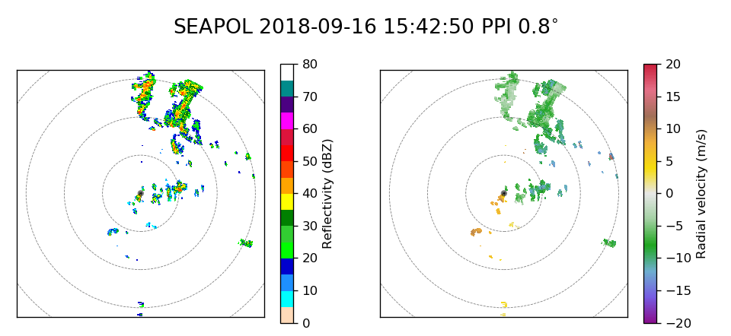
1605 – Run RHI volume scan with 16 angles in 0-30 degree azimuths

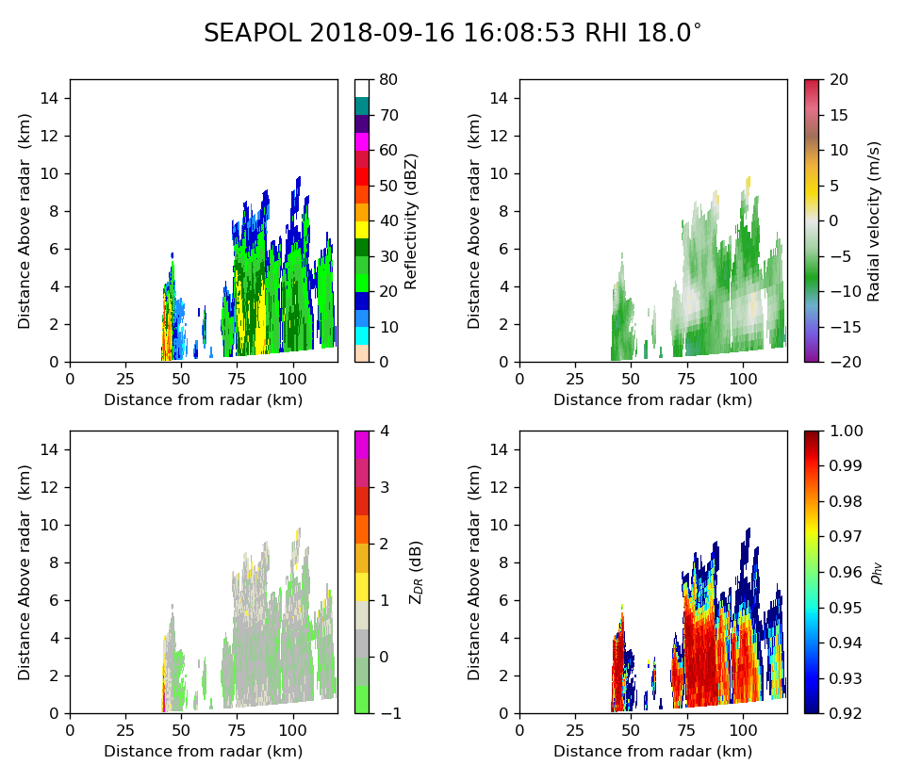
1626 – Switched to PPI volume scan (FAR)

1640 – Switched to the surveillance mode with 15 min interval as there is no new cells in the domain.

1745 – isolated pop corn convection scattered all over the surveillance domain. It is not raining outside though. Keep the surveillance mode with 15 min interval.

Morning Shift (4A-12P L)
Ben Trabing

1900 – Surveillance mode indicates some isolated convection towards the south south-southwest. Switch to 9 angle volume scan.

1920 – Started near volume scan due to the presence of a convective cell ~50 km away. The 9 angle volume scan did not resolve the top. The top of the reflectivity is between 6-7 km. Return to PISTON_FAR.

2030 – Convection approaching ship from the east. Shallow patch of convection oriented southwest to north east reaching ~8 km.

2115 – Switch to near volume scan. Shallow band of precipitation approaching ship shown below.

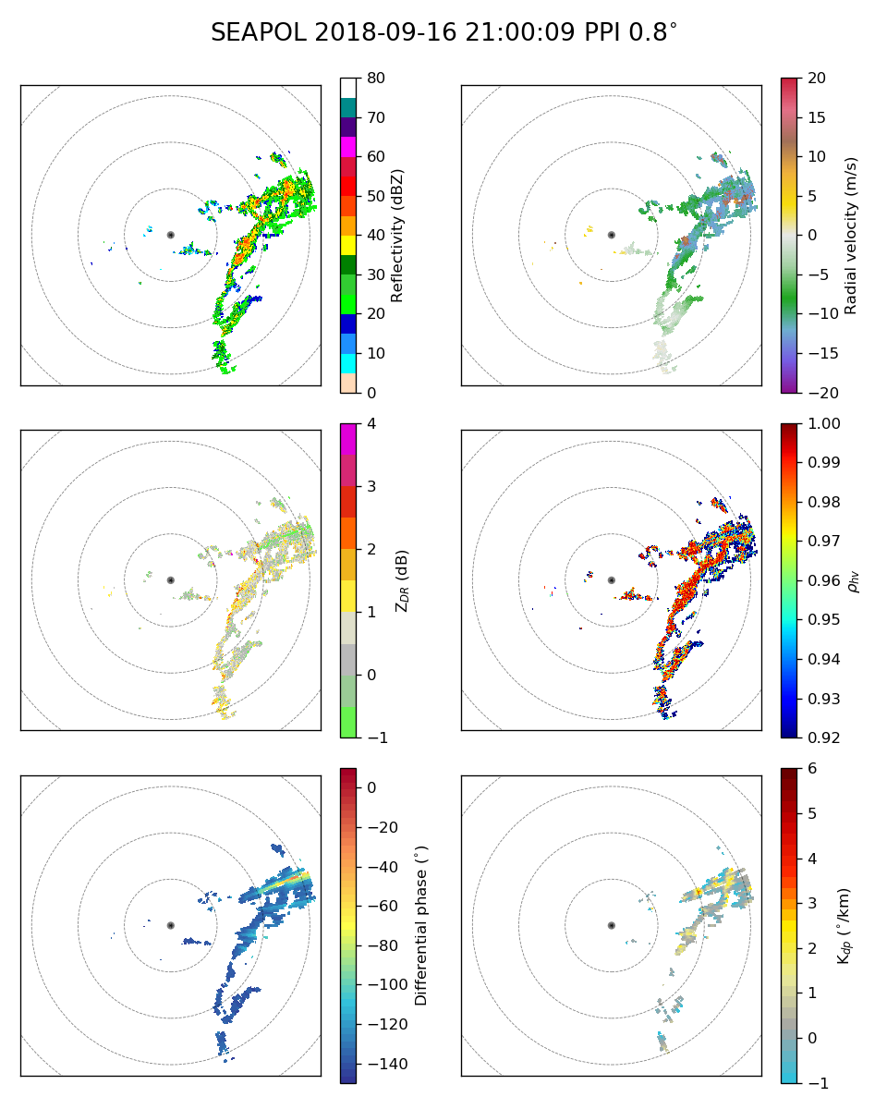

2130 – Some of the clouds appear to be reaching the tropopause just east of the ship, but ice scattering by ice seems low. PISTON Near volumes scan now conducted with high reflectivity within 50 km.

2145 – Near ship scan shows convection increasing in height to 10-12 km east around 50 km away.2 RHIs are conducted showing leading edge of shallow convection with stratiform decaying cells behind that reach >10km.

2200 – Return to near volume scan. Himawari IR imagery with ~30 minute latency shows the re-development of this southwest to northeast oriented band of convection from a narrow band of previously present clouds. Radiative effects likely played a role in enhancement of shallow cells which was near sunrise.

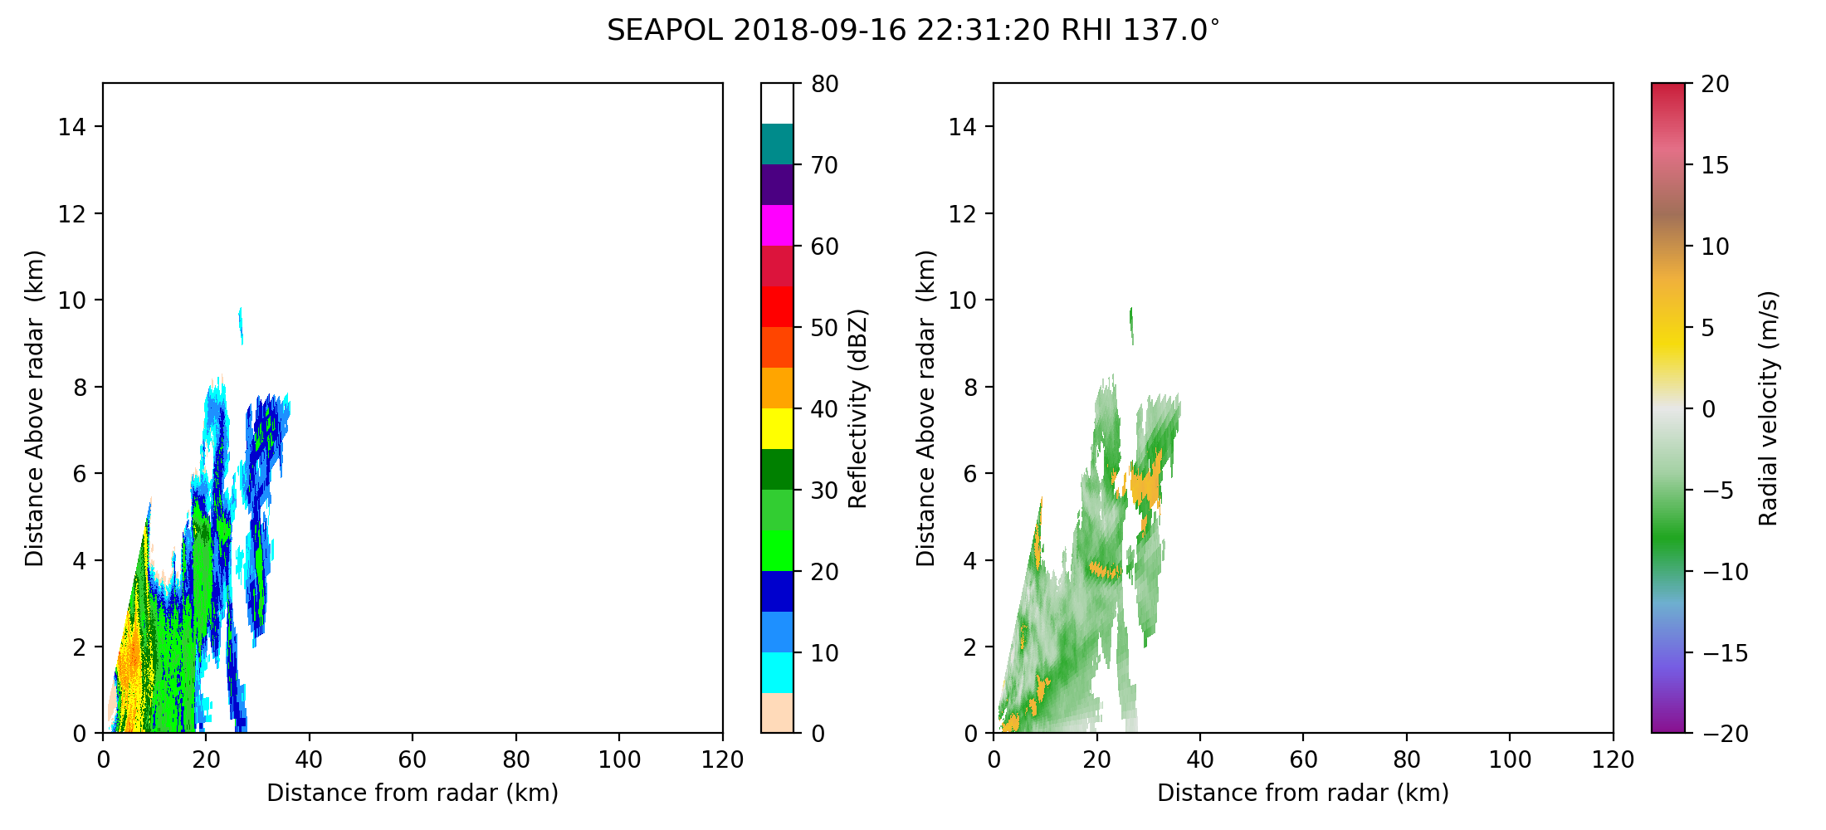
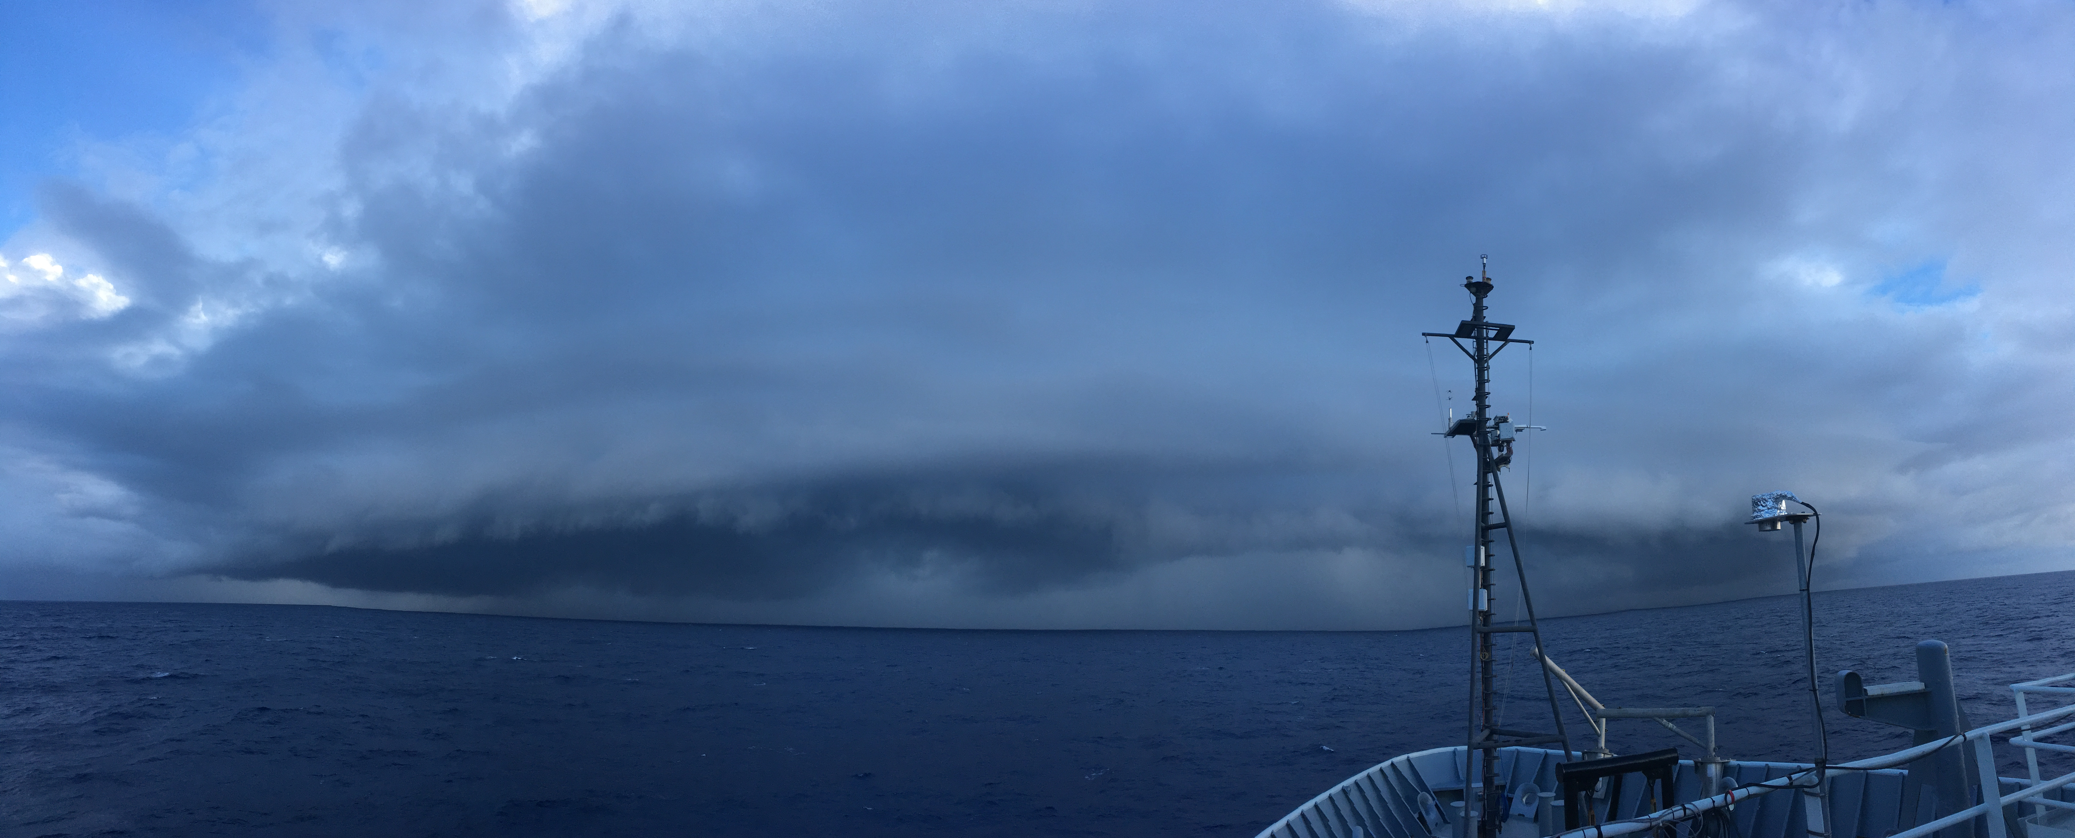
2230 – The convection to the south has a pronounced shelf cloud, RHIs scheduled. Weak low level radial inflow can be seen associated with the shelf cloud. (Photo: Ben Trabing: See Naufal Razin)

2250 – Return to volume scan over near range.
2345 – Start long-range volume scan since most convection is now > 50 km away.

