20180918
Morning Shift (9A-1P L)
Ben Trabing

0000 – Isolated shallow precipitation is located around the ship. Continue shallow far PPI scans.

0100 – Switch to near PPI for some shallow convection within 50 km of the ship.

0200 – Stopped for radar maintenance.

0210 - Resumed scanning with near strategy but switched to low-level PPI immediately after.

0300 – Switch to near PPI for some random convection nearby.

Afternoon Shift (12P-9PL)
Weixin Xu

0400 – Run in the LOW PPI scan mode (24 angles from 0.8 to 16.9) as convection is generally shallow and isolated in nature. This scan strategy will provide high resolution for these shallow convection.

0815 – Switch to NEAR PPI considering some scattered convection very close to the radar.

0930 – Keep in the NEAR PPI scan mode. Convective cells merged and form a slightly organized convective band. The convective line move close to the radar from south as the ship heading southward. The convective cores vertically develop up to 6 km, and some stratiform precipitation tops near 10-11 km.

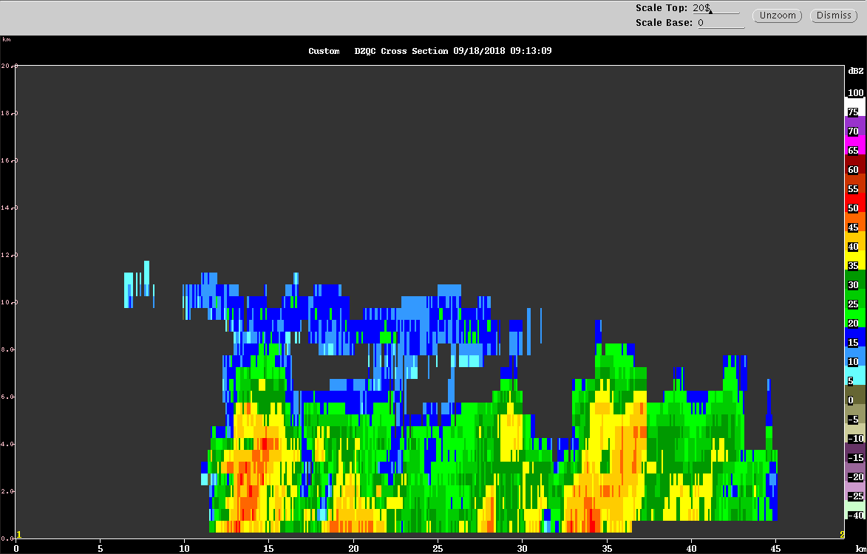

1130 – Turn to FAR PPI scan mode, as the convection is away from the radar.

Night Shift (9P-4A L)
Chelsea Nam

1230 – Switched to FAR_S volume scan (8 tilts) for we have only few shallow convection far.

1330 – Switched to LOW PPI mode to see some tiny convection popping up in the domain with better resolution

1400 – Volume scan shows tiny short cells (~echo top < 4km, horizontal coverage ~ 5km) having high reflectivity and high zdr (close to 4dB)
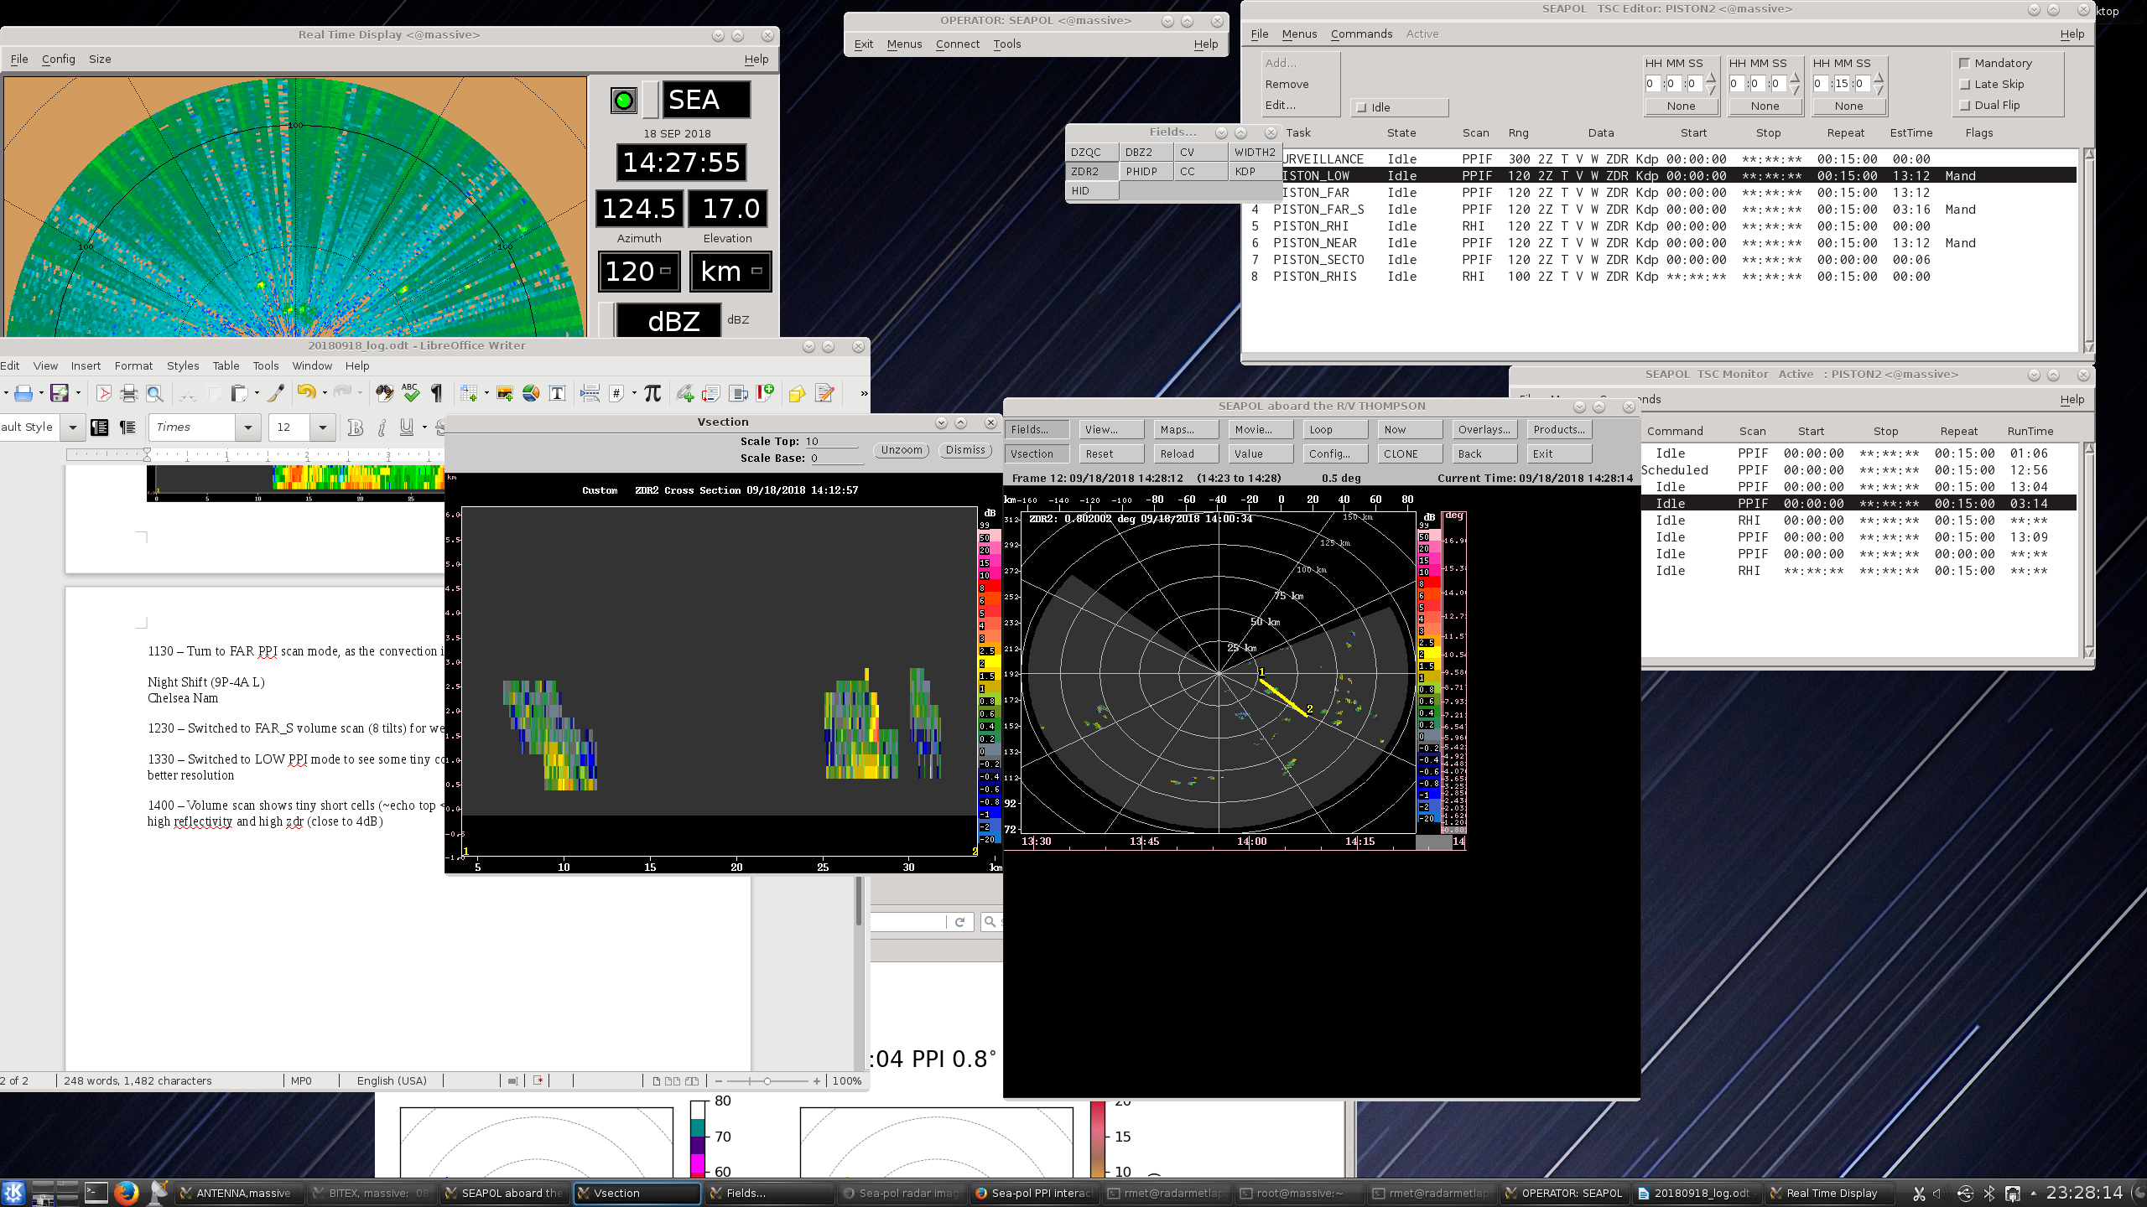
<convective cell with zdr ~4dB>

1415 – Similar high dbz and zdr but very young and shallow convective cells in the domain. Will keep the LOW PPI.
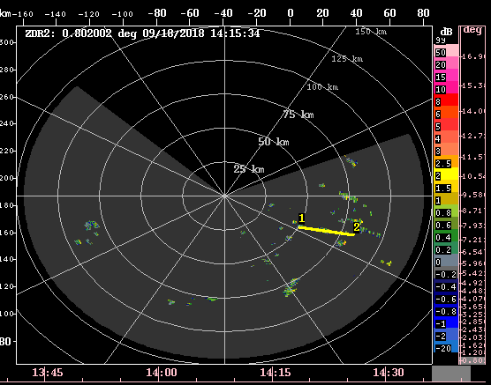
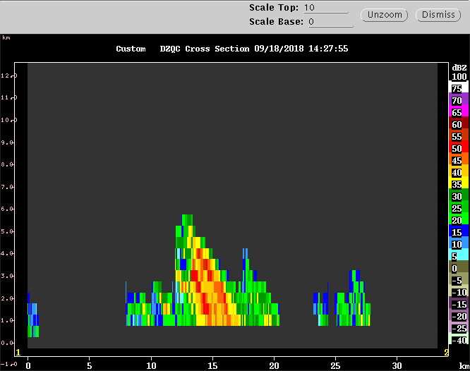
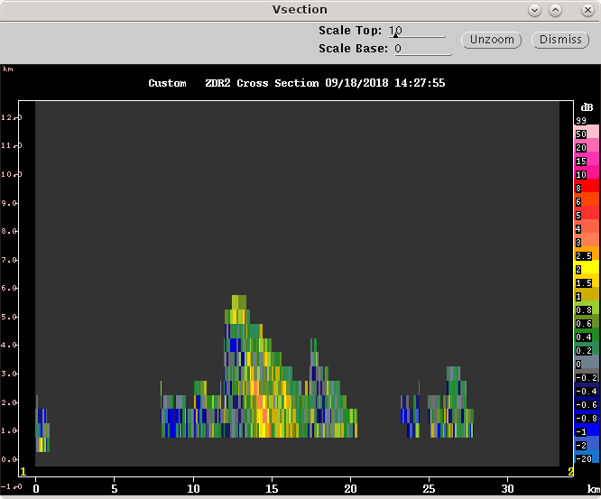

<sheared convective cell: left – dbz maximum ~ 55 dB , right – zdr maximum ~ 3 dB>

1400 – Ran surveillance mode to see activity at a far distance. Tiny developing cells are scattered in the south. As the ship is moving to the south, we will encounter more of these cells. Will keep the LOW volume scan mode.

1600 – The cells southeast from the radar as above cells are all tilted westward. The most recent sounding shows 10 kts of easterly sfc-700mb shear.

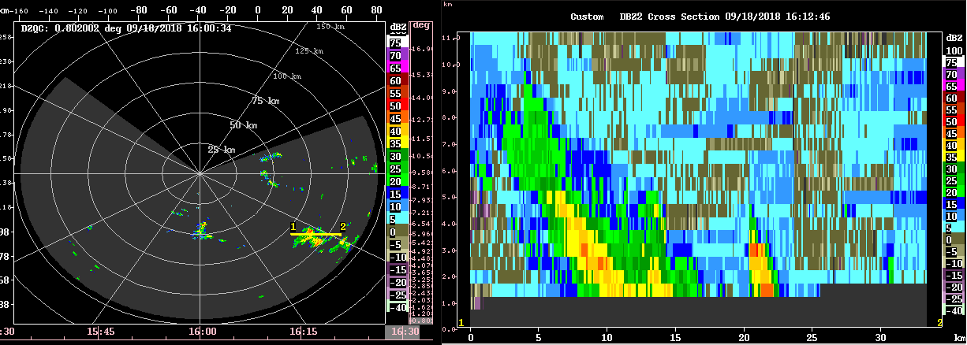
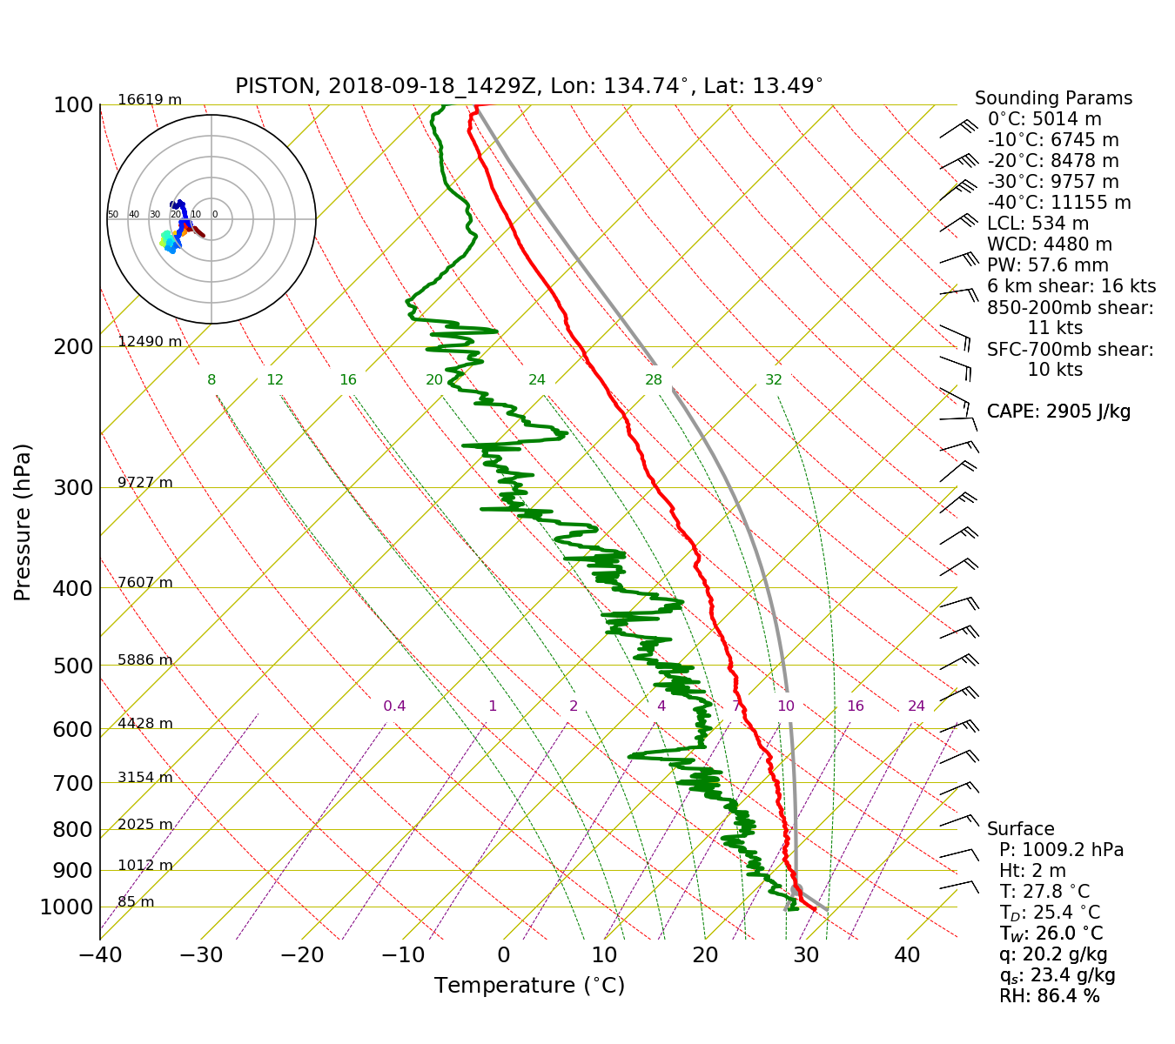

1700 – A high zdr sample at a close distance (30km) collected
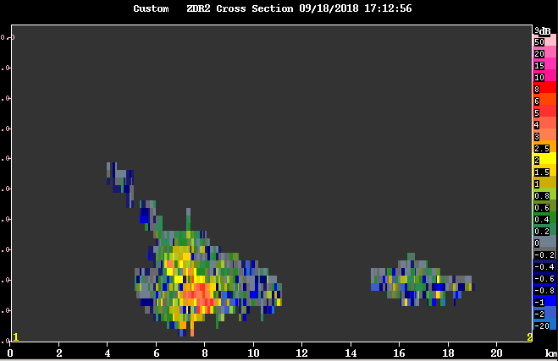
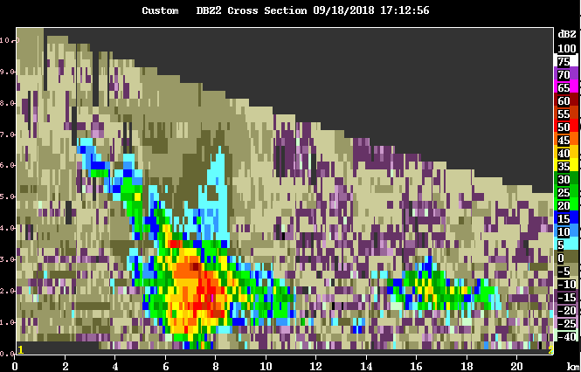
<top: dbz, bottom: zdr, vertical axis: altitude 0 to 10 km>

1730 – Continued young convective cells with high zdr appearing on the domain

Morning Shift (4A-9A L)
Ben Trabing

2125 – Switch to near PPI to examine cells within 50 km.

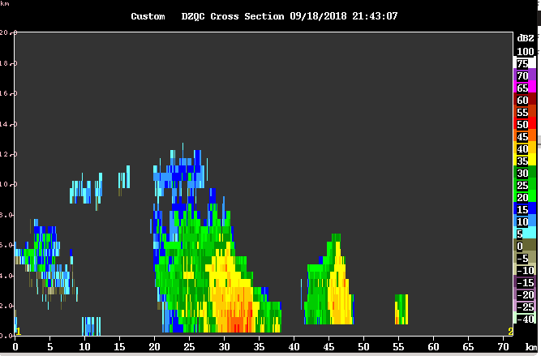
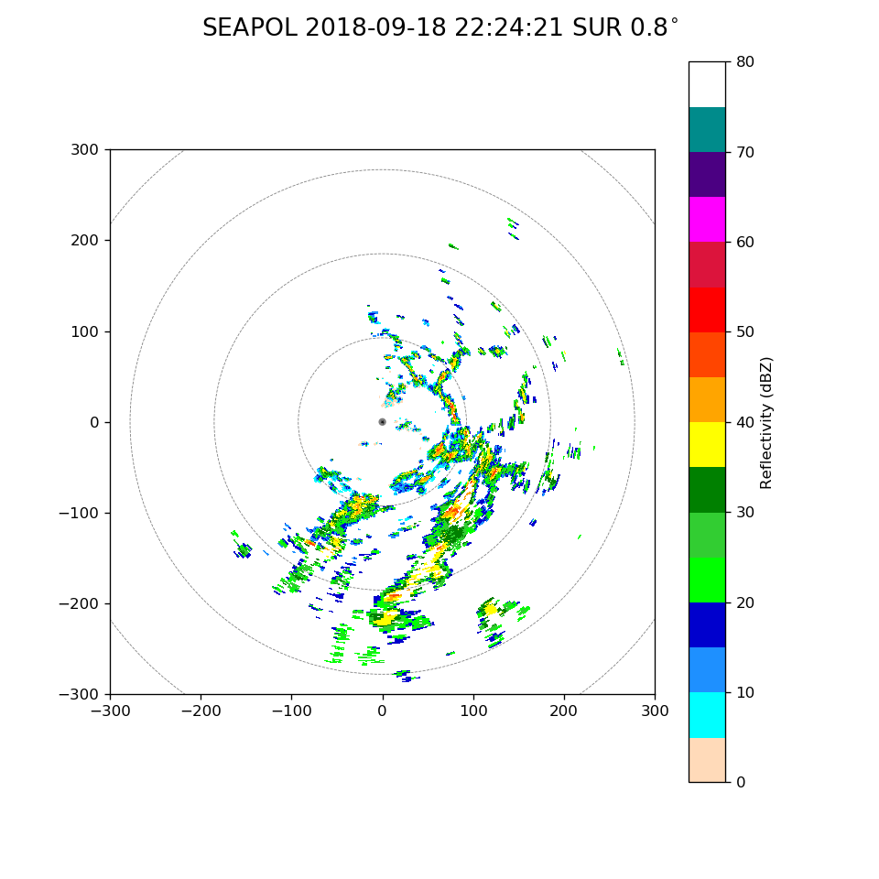
2200 – More active areas of scattered convection are now present towards the east and south. They remain mostly shallow with ice signatures aloft from the decaying cells.

2230 – Himawari indicates that we should be seeing some convection with cold brightness temperatures around -70 C towards our east south east. Will do one surveillance and far scan before switching back to near. Long range surveillance confirms convection beyond 120 km to the southeast. Continue to do volume scans with higher elevation angles.

2345 – Halted scanning for lidar maintenance.
2355 – Resume scanning.



