20180922
Morning Shift (9A-1P L)
Ben Trabing

0000 – Low angle PPI scans continue with little to no convection in the area.

0100– Stopped scans for maintenance

0115 – Resumed low angle PPI scans.

0200 – Visible Himawari imagery shows deep convection to our southeast outside of our range. Surveillance scan shows that it is >200 km away.

Afternoon Shift (12P-9P L)
Weixin Xu

0335 – Radar turned off for flux tower maintenance.

0400 – Radar operation resumed. Run in the FAR scan mode, as some scattered convection appeared within 100 km from the radar, and more convection is approaching the radar further N-NE. FAR_S mode only has 8 elevation angles, while FAR includes 24 elevations.

0545 – Stay at the FAR scan mode. More scattered develop within the radar domain, but they are relatively shallow and isolated.

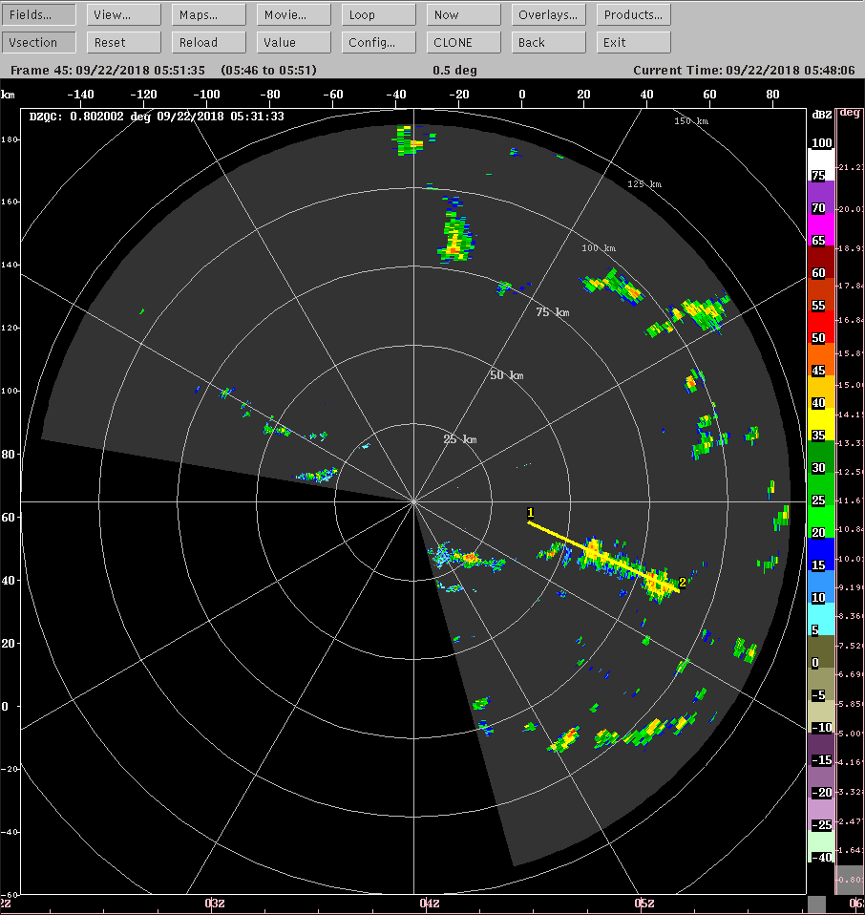

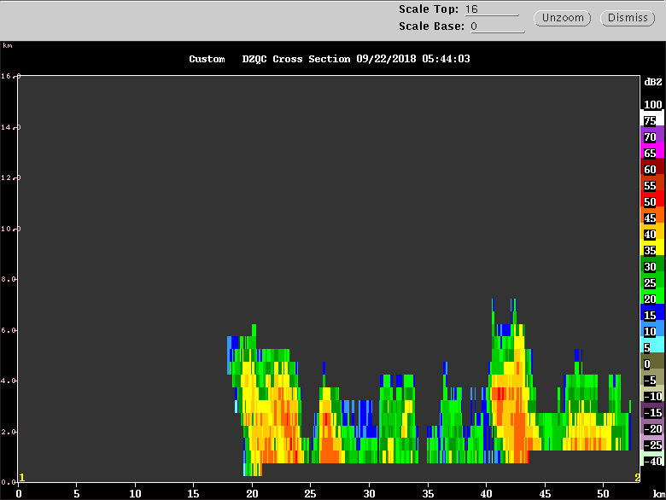

Figure. Cross section along the yellow line in the above PPI figure.

0630 – Keep scanning in the FAR mode. Isolated convective population is increasing toward to afternoon, but they are still in shallow nature.

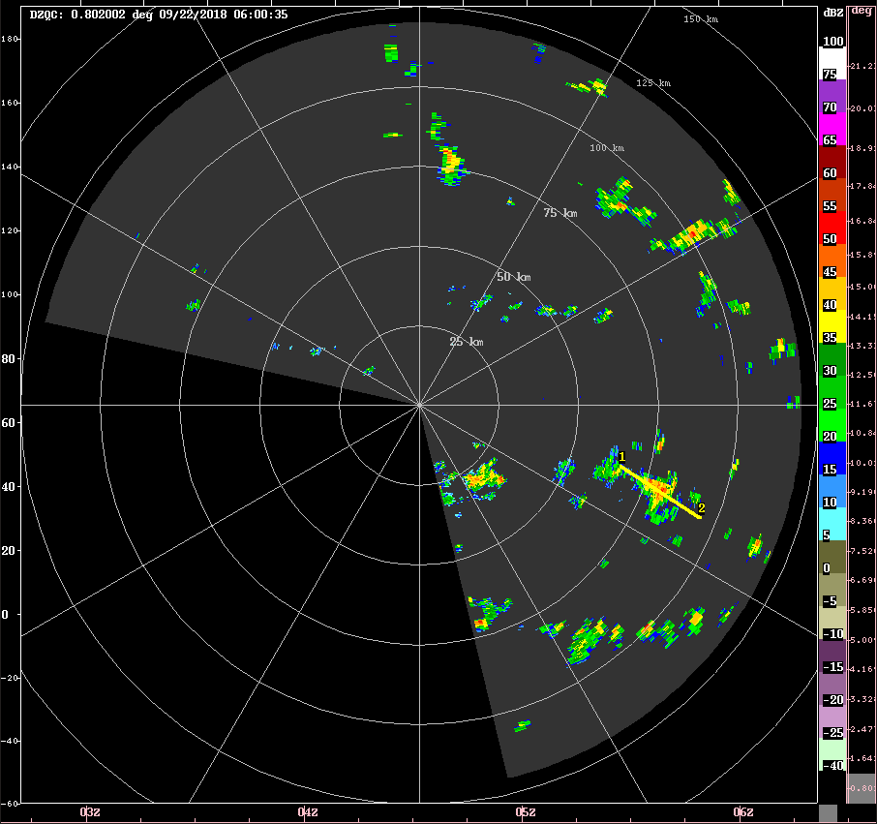
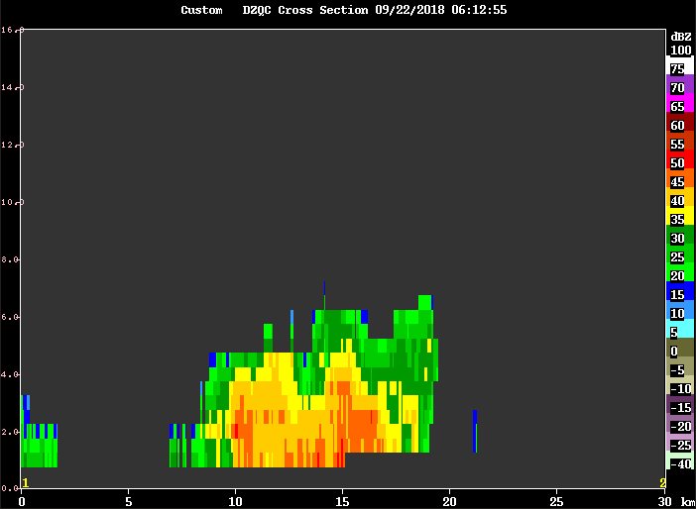

0900 – Remained in the FAR scanning. An impressive day for popcorn convection.

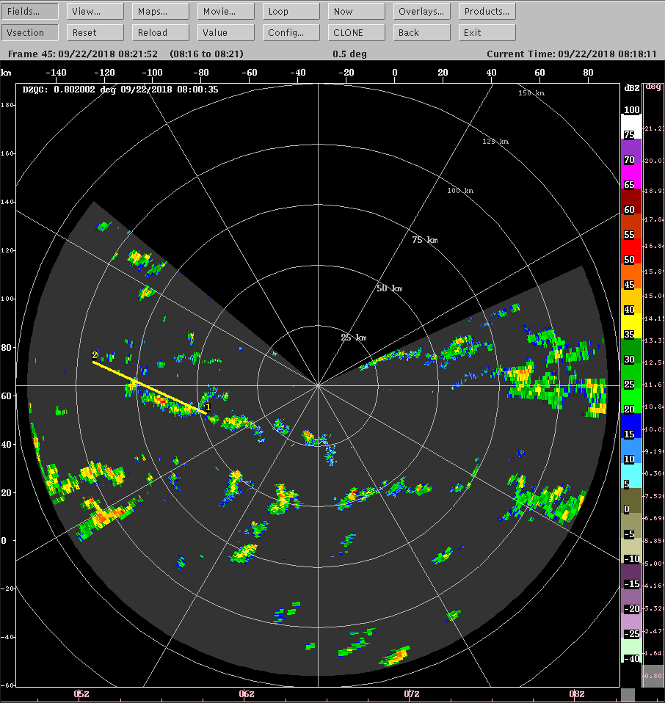

Night Shift (9P - 4A L)
Chelsea Nam

1245 – Switch to SURVEILLANCE plus FAR_S, as condition calms down and nearly no convection appeared within the 100km radar domain.

1345 – Swithed to LOW for there are some shallow convection with high Z (~50 dBZ) but not too high Zdr (~1.5 dB). 15 dBZ echo tip ~ 6 km. See below figures.

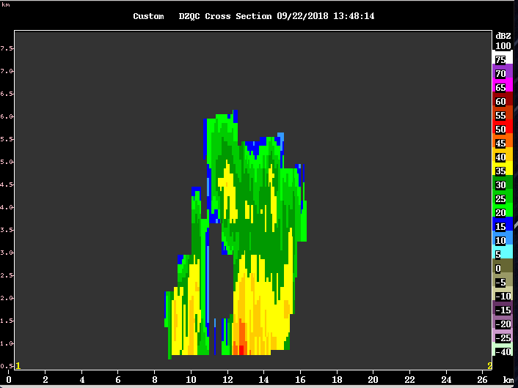

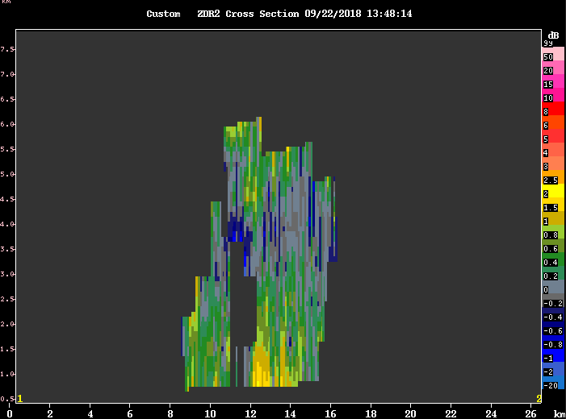

1400 – Some of the shallow cells show high Zdr features now.
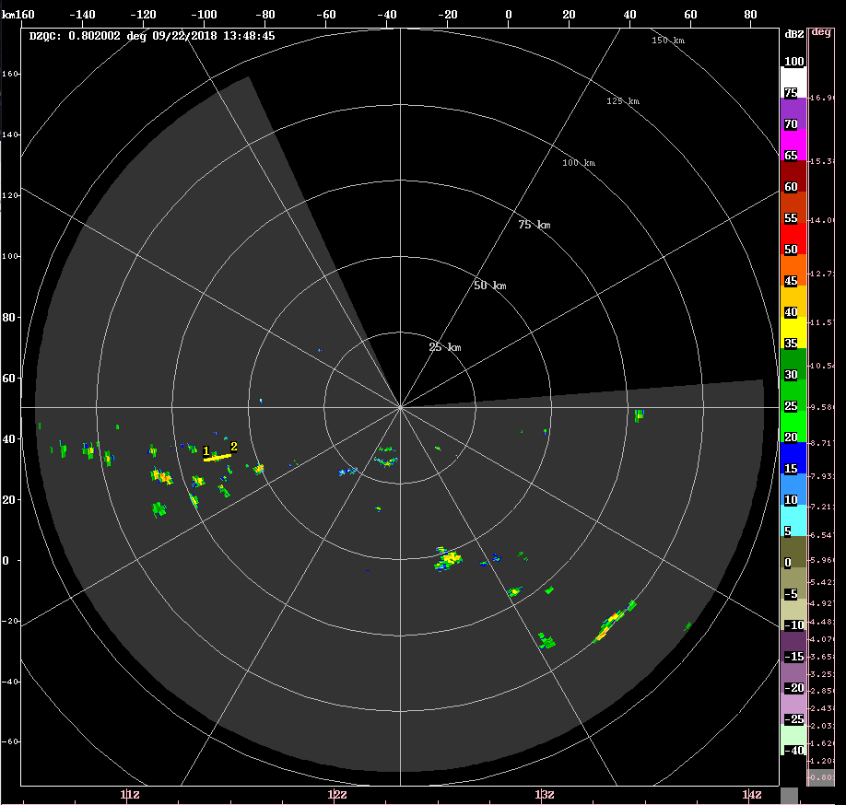
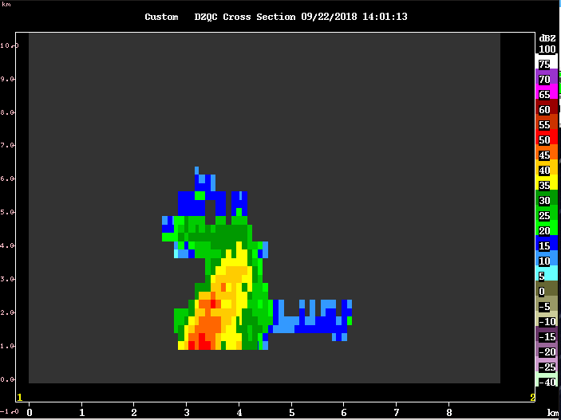
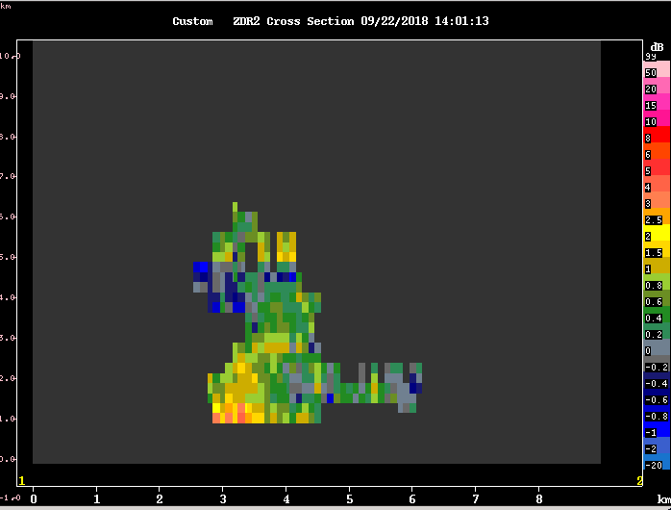

1410 – In ten minutes, the convective cells grow deeper (6km echo top to 10 km echo top), and Zdr of these cells decreased.

1430 – there are new cells generating in the domain, and they have similar high Zdr pixels. Changed the configuration FAR_S to have 12 tilts not 8 tilts to have higer resolution of these convective cells. Running this new FAR_S scan with 5 minutes repeat time.
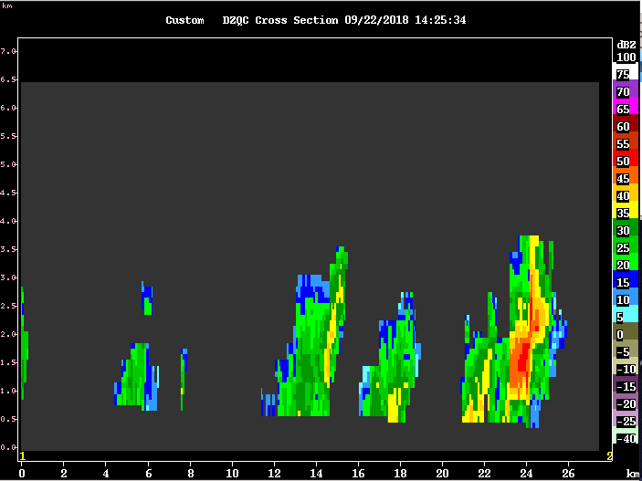

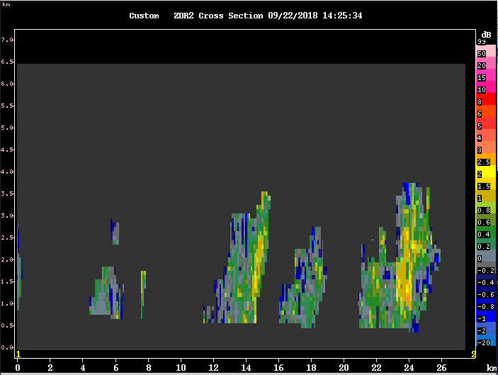

1440 – The run time is 05:06 for the new FAR_S, so I changed it to 11 angles reducing one, to make the 5 minutes repeat time possible.

1500 – The line of convection west of SEAPOL that contained these high Zdr cells is now decaying.

1530 – High Zdr core from convective cells east to SEAPOL.

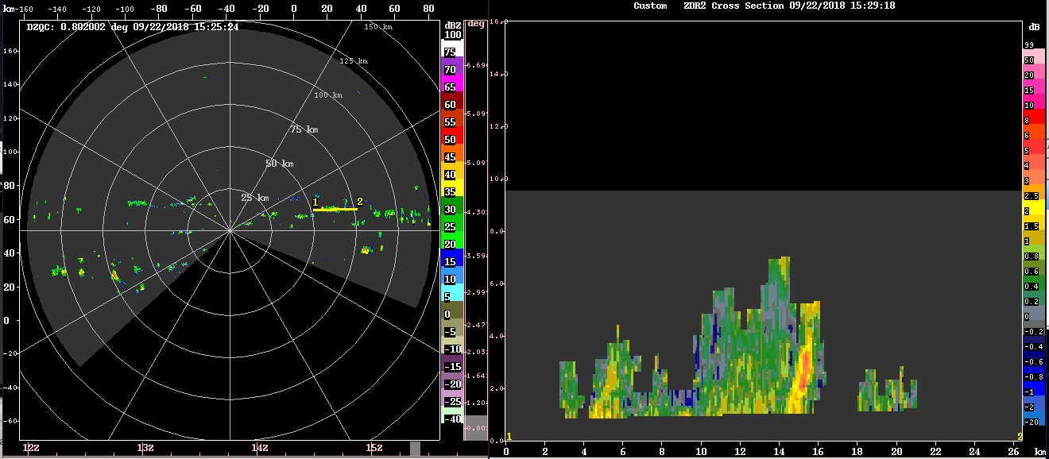
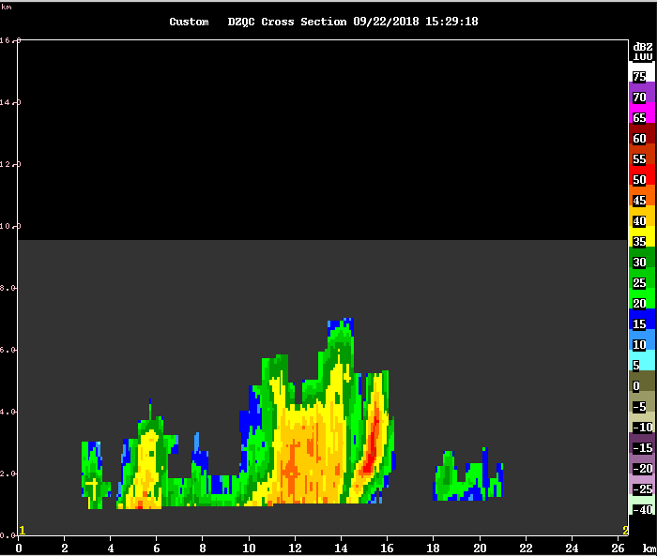

1600 – Still many of high Zdr core warm convection on the domain. The convection seems moving to the east. Both 1130 and 1430 UTC soundings show westerly of 10 knots from the surface to 600 hPa associated with cyclonic circulation of Trami north to the ship location (see below sounding figures, and satellite imagery)

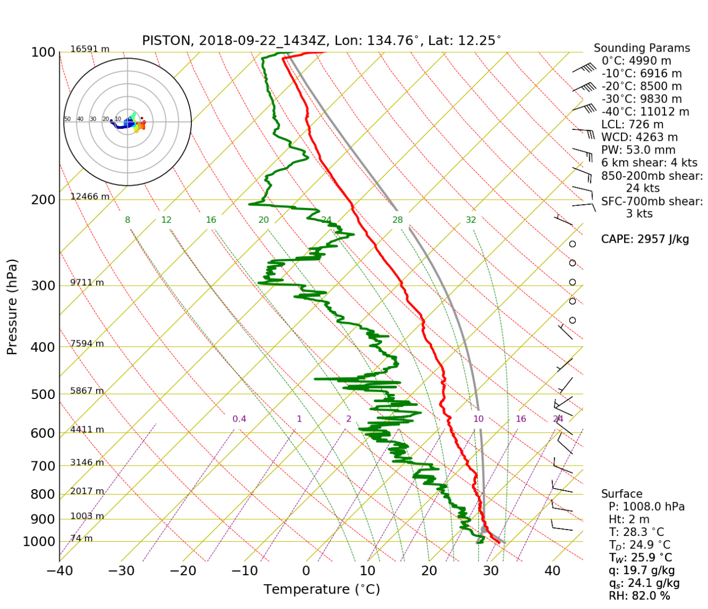

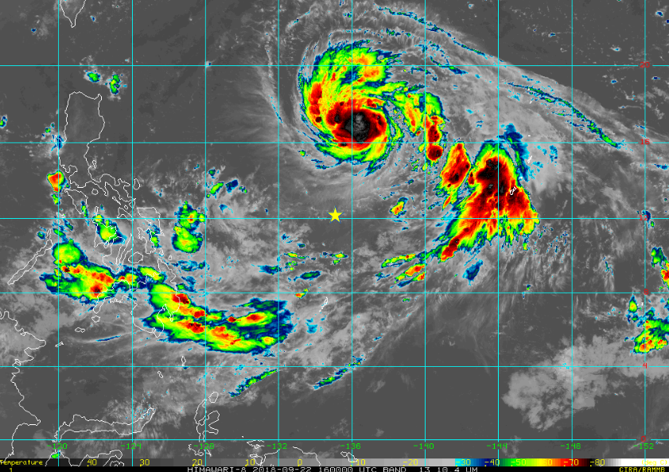
Figure. Himawari-8 IR at 0922 1600 UTC. Yellow star denotes the ship location.

1605 – Another great example of high Zdr and Z core (below figure)
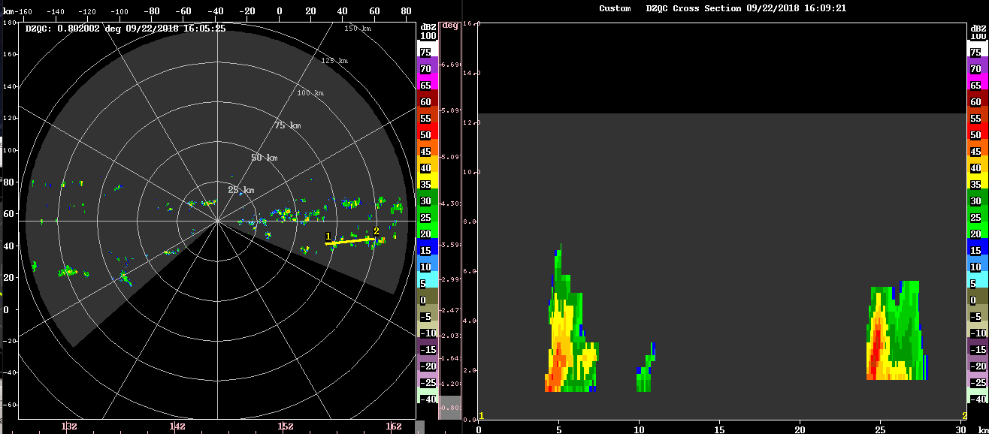

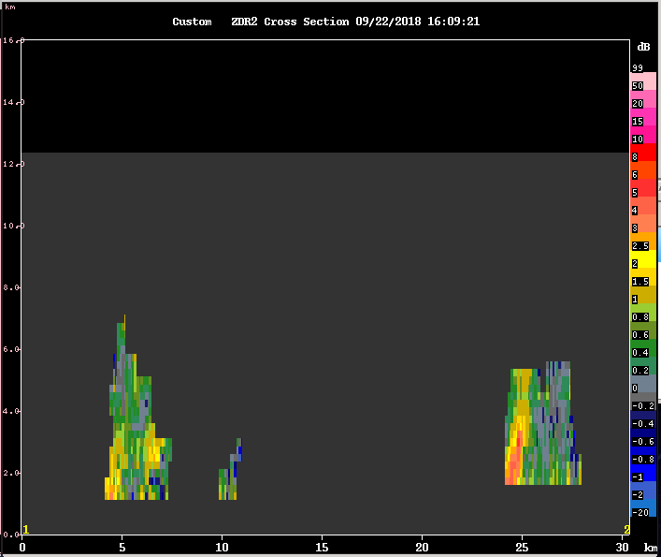

1610 – Same cross section line but 5 minutes later from above figures.
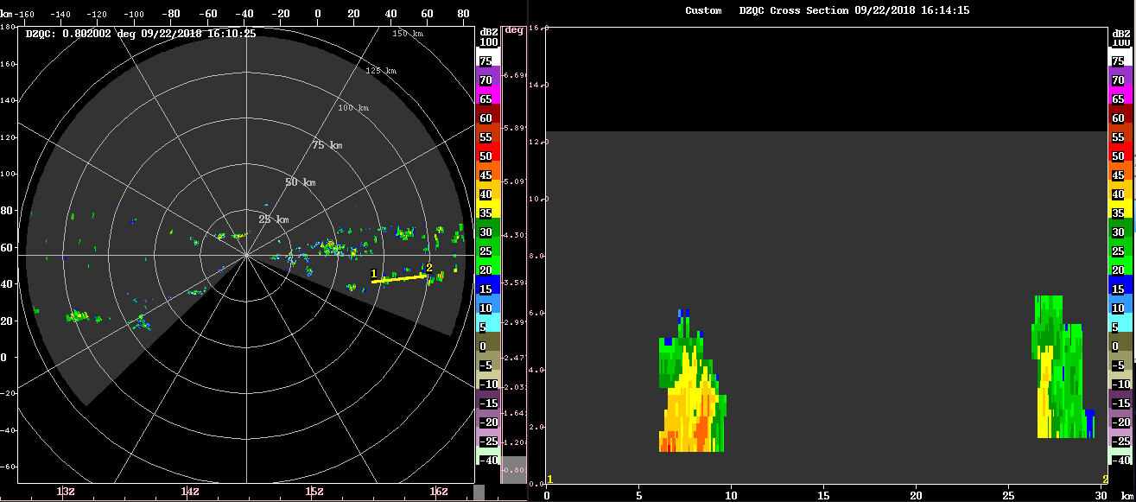
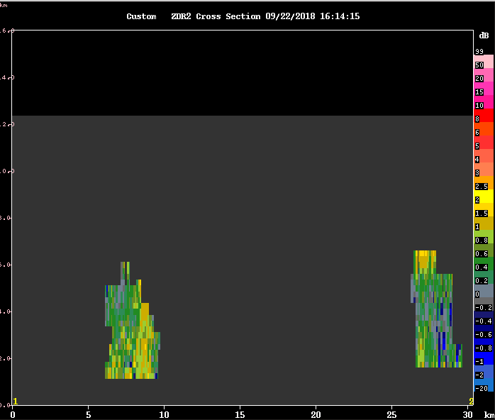
It seems like the large rain drops form very quickly and precipitate out very quickly too. Even with 5 minute interval, the cells are transient. Rough guess of the longevity of high zdr core, from tracking the cells advecting to the east, is 10~15 minutes.

1700 – Most of convection in the domain has decayed. Changing into 15 minutes interval.

Morning Shift (4A - 9A L)
Ben Trabing

1935 – run surveillance scan to see if any convection is present at larger ranges.

2100 – surveillance scan shows some convection to the east >120 km away. Continue low angle PPI scans with intermittent surveillance.

2130 – Several small cells have popped up south of the radar and the low angle PPI is not topping some of the cells. Switch to far PPI with 24 angles.

2220 – The spatial coverage of 35-40 dBZ cells has increased with few reaching higher than 4 km

2245 – A cell has reached 6 km. And a shallow band of precipitation has formed to the southwest that seems to be intensifying with echos now reaching up to 8 km.


