20180923
Morning Shift (9A-1P L)
Ben Trabing

0000 – 24 angle PPI scans continue with some shallow convection towards the south and southeast.

0130 – Switch to 9 angle PPI scan due to near zero echos in the area. Surveillance scans will be run intermittently.

0300-- Suppressed convection continues with a dry layer extending from 450-250 mb.
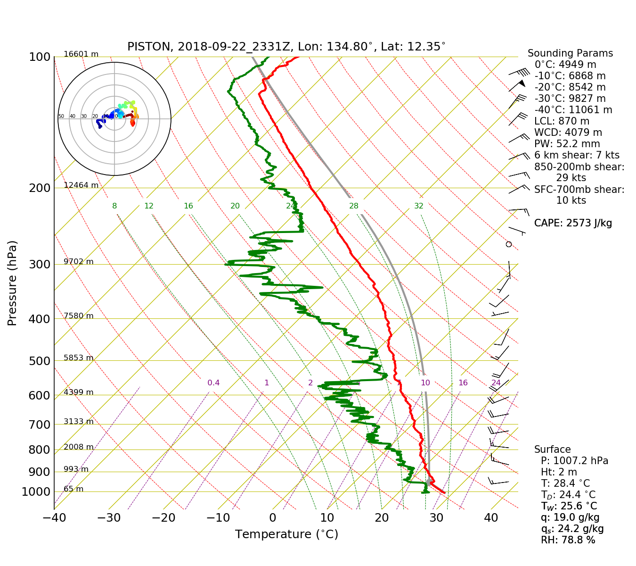

Afternoon Shift (1P-9P L)
Weixin Xu

0400 – Operate in SURVEILLANCE (1 angle) plus FAR_S (24 angles) scans. Convection is totally quiet within the long-range surveillance scan (300 km). The trailing rainbands related to Typhoon Trami are located to the south of the operation areas.

0445 – Schedule to run the FAR scans, as scattered convection approaches the radar from the south and southwest within 100 km.

0800 – Operate in SURVEILLANCE plus FAR_S scans again, as virtually no convection within the 100 km radar range.

0815 – Switch to FAR scan mode. The ship change direction and move northward, and scattered convection appears in the most southeastern portion.

0835 – Observed shallow convection with large raindrops indicated by high ZDR.

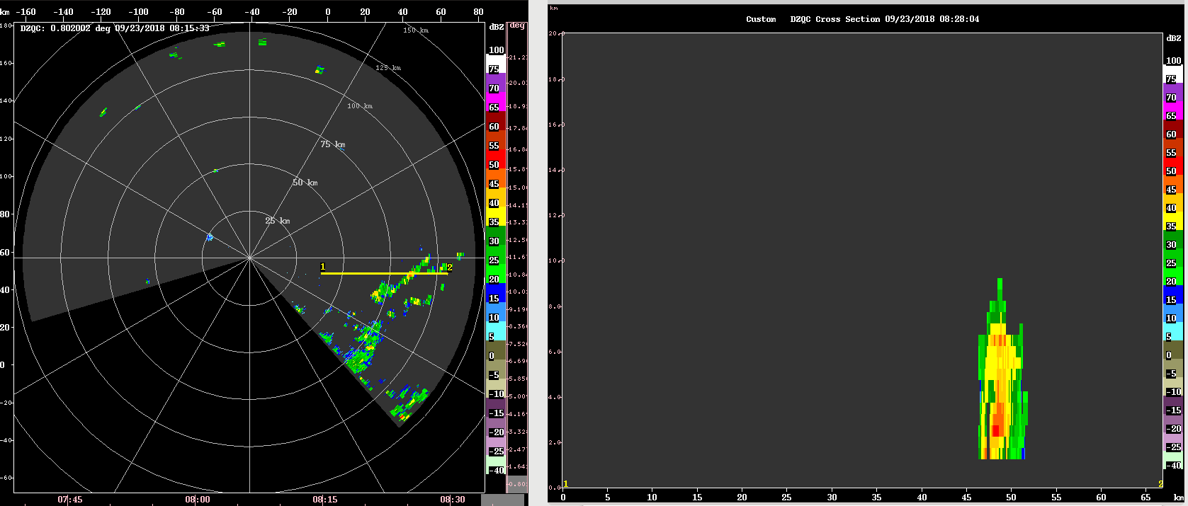

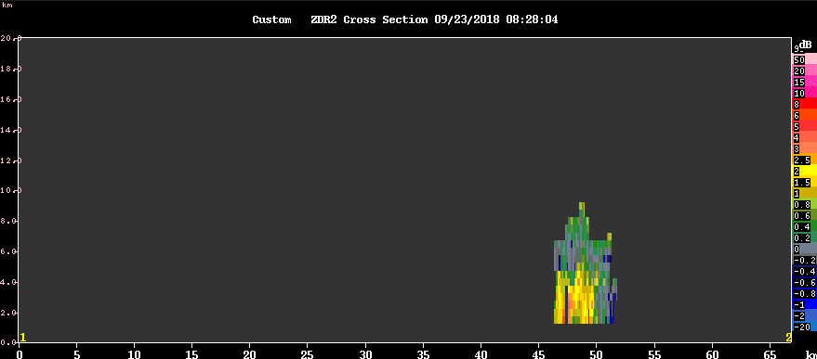

0900 – Convection to the southeast is more persistent with some echoes reaching up to 10 km. The ship heading has been turning more to the northeast to account for the surf otter motion so hopefully more of the convection will be seen by the radar.
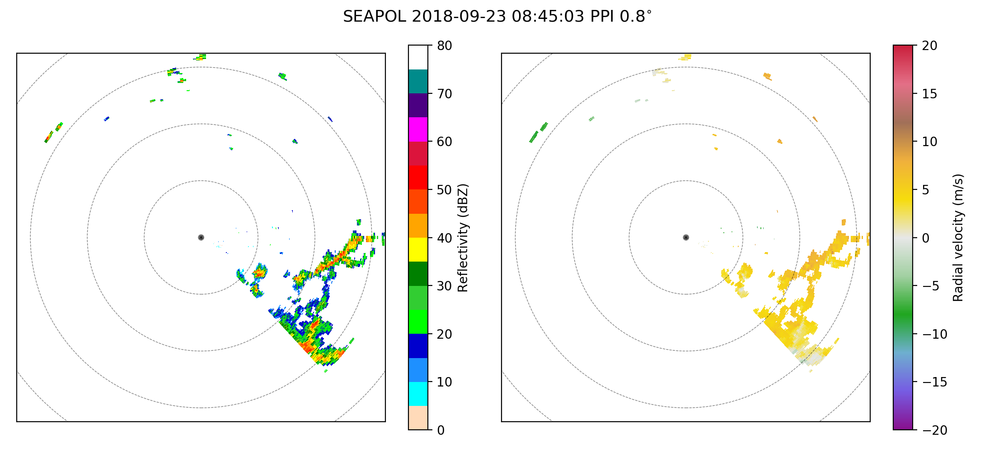

0915 – Continue Far full volume scan with 24 elevation angles. 16 degrees should be enough to top the convection with is largely outside of R = 60 km.

0930 – Additional surveillance scan is added to check out the convection 200-300 km away. Convection to the southeast of the radar becomes more organized, and may be associated with the trailing rainbands of Typhoon Trami. Surveillance scan shows a broader area of stratiform precipitation coming up from the south and southeast. Some of the stratiform precipitation shows bright band feature, which seems the first time being seen in Leg 3.

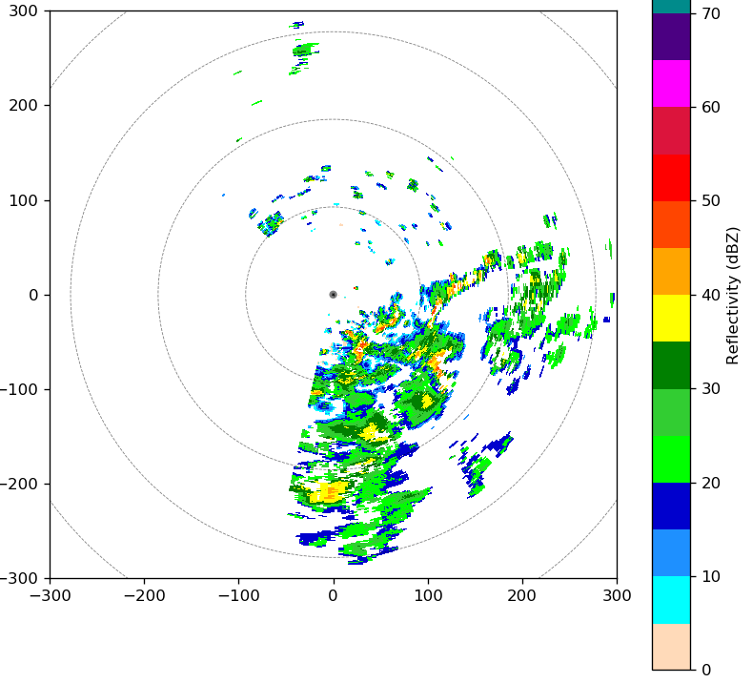
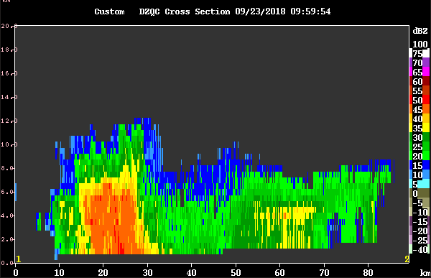

1030 – Keep running in the FAR mode for wider-spread precipitation. Stratiform precipitation growing and covering a larger area. Bright band signature becomes more obvious.
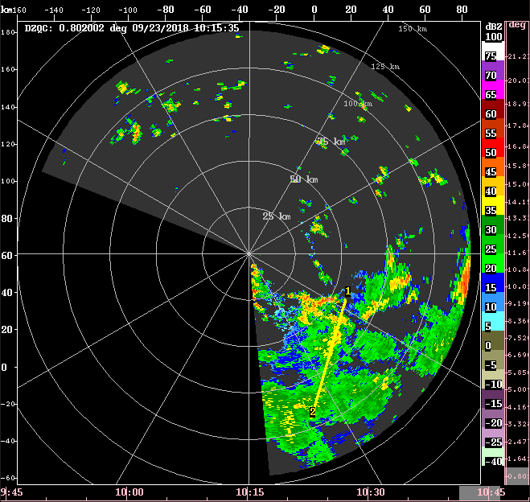

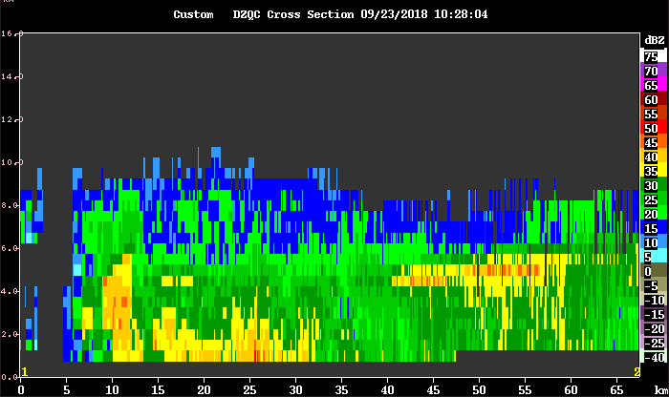

1045 – Extra SURVEILLANCE scan is run to see longer-range condition. The precipitate area has been broaden further, mostly formed by stratiform precipitation. The IR imagery shows a MCS-like feature approaching the operation area from the south. Obviously, this broad precipitation feature is associated with the TC trailing rain band. The nearest sounding from the ship shows strong vertical wind shear (43 kts) between 850-200mb, which is supposed to promote stratiform precipitation development. In addition, the middle-level (700-600 mb) was moistened, as such the dry layer at these levels seen earlier today disappears.

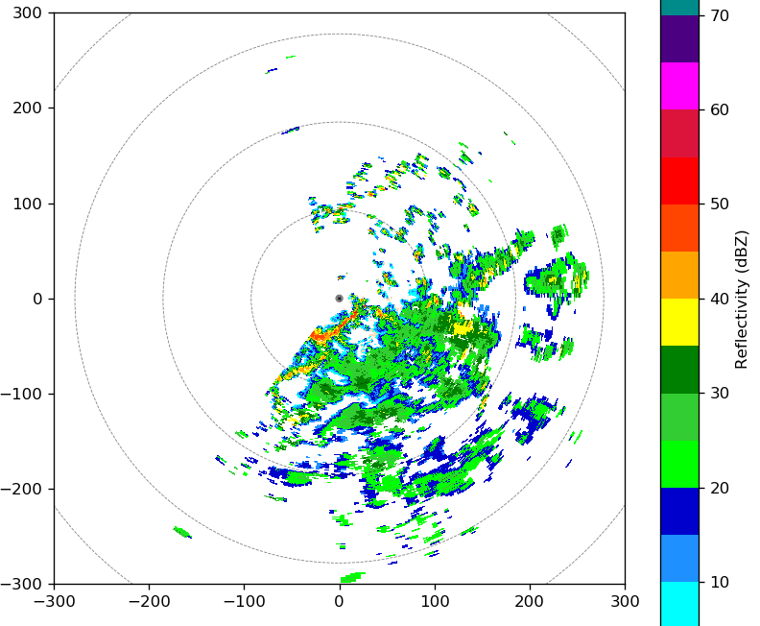

1100 – Switch to the NEAR scan mode, as a convective line with deeper convection moves very close to the radar. It looks like this convective line is the leading edge of the entire broader convective system. Stratiform precipitation behind has now decayed very much.

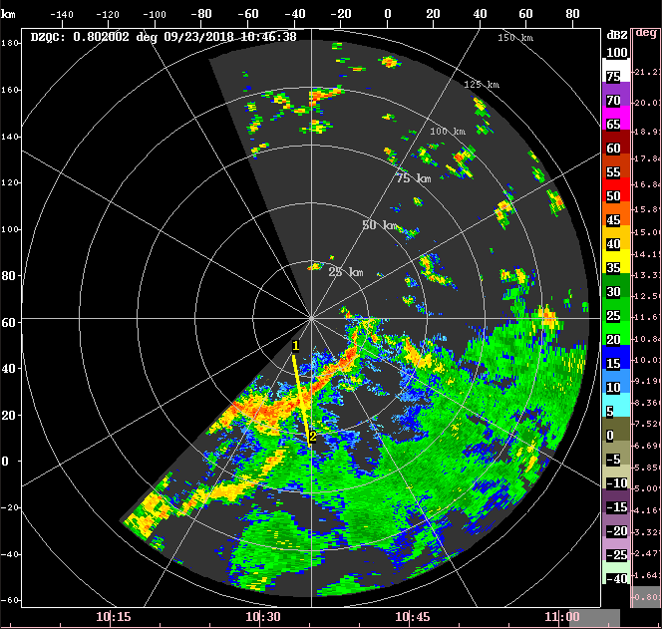

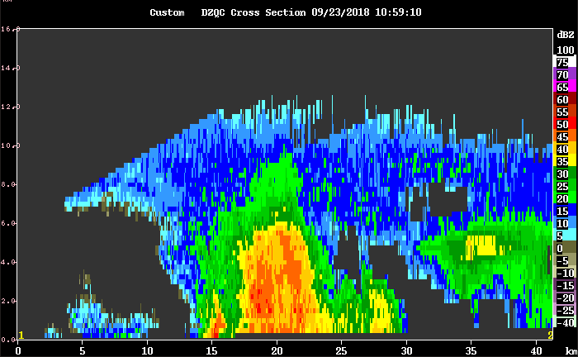

1130 – Radar is down. Alex came in and it turned out to be RCP 8 motion server issue. He restarted the software and now it works again.

1200 – Back to FAR scanning, as deep convection move out of the near radar range. The NEAR scan strategy provides higher elevation tilts but lower resolution at the lower-to-middle levels (below 7-8 km) where the stratiform precipitation top mostly located.

Night Shift (9P-4A L)
Chelsea Nam

1310 - Change into NEAR scan to top the convection 15 km from SEAPOL

1335 – RCP 8 crashed again - lost motion control.

1343 - Alex restarted RCP 8 software. Ran Surveillance to check if radar works now, and it does.

1348 – Go back to NEAR mode.

1420 – Switch to FAR mode for we have shallow stratiform convection over the domain.

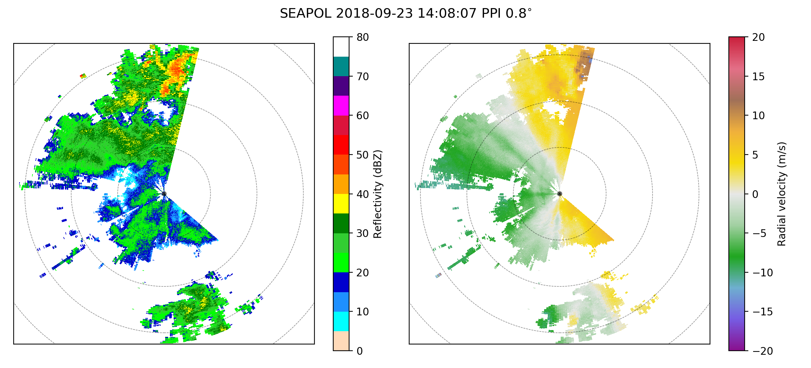
1500 – RCP 8 was down. We had to restart it again.

1530 – We will shut down the radar to inspect the cable.

1830 – Lightning outside port side of the boat.

Morning Shift (4A-9A L)
Ben Trabing

1900 – Radar is down for for the time being.

1935 – Radar is back up and running. Start far high angle PPI scans

2000 – switch to 5 minute 9 angle PPI scans for higher temporal scans.

2100 – Shallow convection in the domain has largely disappeared. Switching to surveillance scans.

2130 – Some deeper convection is intensifying to our east and south shown by the surveillance scan and Himawari but is still outside of 120 km away. We may see some convection popping up near the ship with a favorable environment (mid-upper level moisture has increased). There is a weak subsidence inversion near 5 km and another inversion near 925 hpa which may help promote deeper convection later . Will switch to far low PPI scans.

2250 – RCP has died.

2310 – RCP manually restarted, run surveillance scan. Not much precip present yest so surveillance and far PPI with 9 elevation angles will be run.

2325 – RCP died again, fixed, Alex is going to try to test cables to see if we can fix the problem. Radar may be down for ~ hour. Hopefully maintenance now will be done before next GMW overpass.

Alex did a complete radar shut down and restart which appears to have fixed some of the issues. The Iris realtime display is no longer working.

