20180928
Morning Shift (9A-1P L)
Ben Trabing

0000 – Near volume scans continue with heavy precipitation nearby.

0045-- Lots of rain nearby evident by the reflectivity below with echotops behind the leading convective region reaching 14 km. The presence of an upper troposphere inversion in the 20Z sounding is likely getting wiped out with the diabatic heating and upper-level mixing.

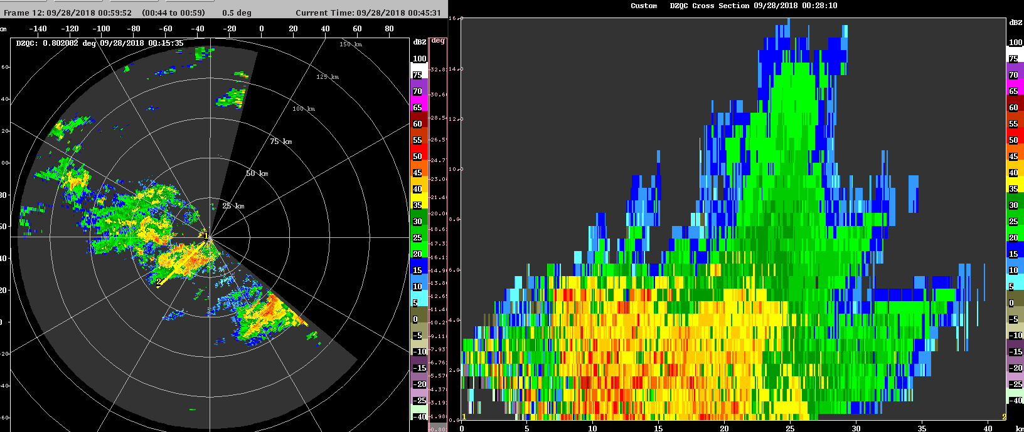

0215 – Most of the deep convection has weakened and moved off to the northeast. Some ice scattering can still be seen up to 12 km.

Afternoon Shift (1P-9P L)
Weixin Xu

0400 – Scans changed to FAR PPIs. Previous convection close the radar decayed and died out. Some convection locates at 100km northeast to the radar.

0530 – Relieve the radar to SURVEILLANCE and FAR_S scans, as the convective activity is extremely calm now.

0600 – Radar stops operation for radar tour to other scientist.

0620 – Resume operation and run the SURVEILLANCE scan, followed by FAR_S scans.
0945 – Switch to FAR PPI scans. Scattered convection appear in the 100 km radar domain.

1030 – Keep operating in the FAR PPI mode. Still only scattered isolated convection occur.

1140 – Maintain in FAR scans, and mostly shallow warm rain showers developed.

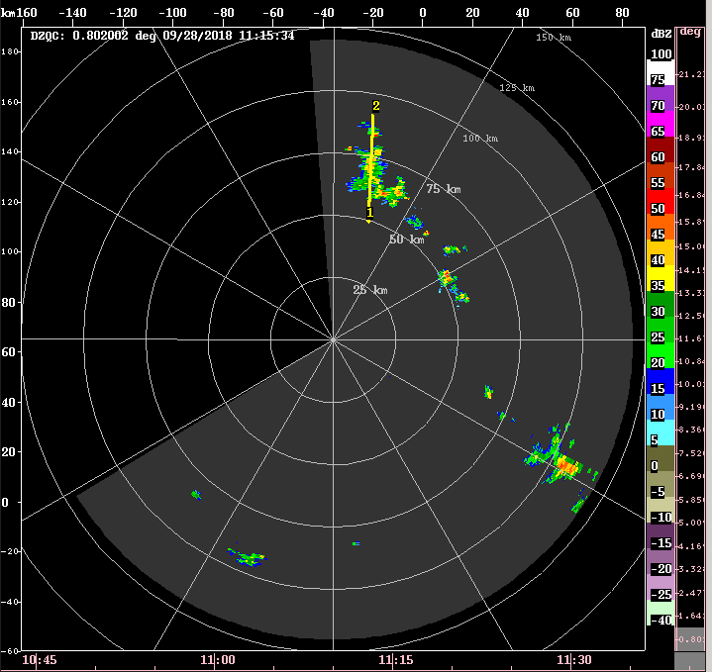

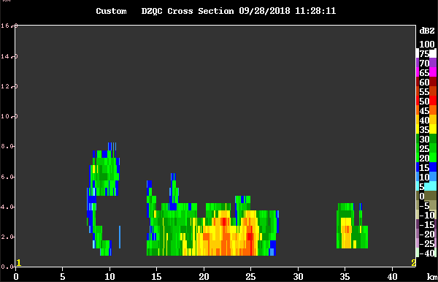

Night Shift (9P-4A L)
Chelsea Nam

1400 – There is a linear convective system located northeast to SeaPol moderate depth (~8 km) in 50 km range. We can still top the system with the FAR mode.

1500 – The linear convective system is now generally stratiform. The ship heading southward so the system is blocked by the bridge in the current scan. There is a convective blurb in the southeast at 100 km range.

1700 – Generally suppressed over the domain having only a few shallow convection.

1830 – Clear sky without any convection over the radar domain upto 120 km range. Change into Surveillance plus FAR_S mode.

Morning Shift (4A-9A L)
Ben Trabing

1900 – Surveillance indicates no convection outside of a small blip to the south ~120 km away.

2000 – Orientation of the ship is blocking any precip to the east but we should be turning soon. Areas of deep convection propagating ahead of TD30 should start making their way way into out domain or decay.

2100 – There are more isolated shallow cells with high reflectivity and high ZDR around cloud base moving in from the southwest.

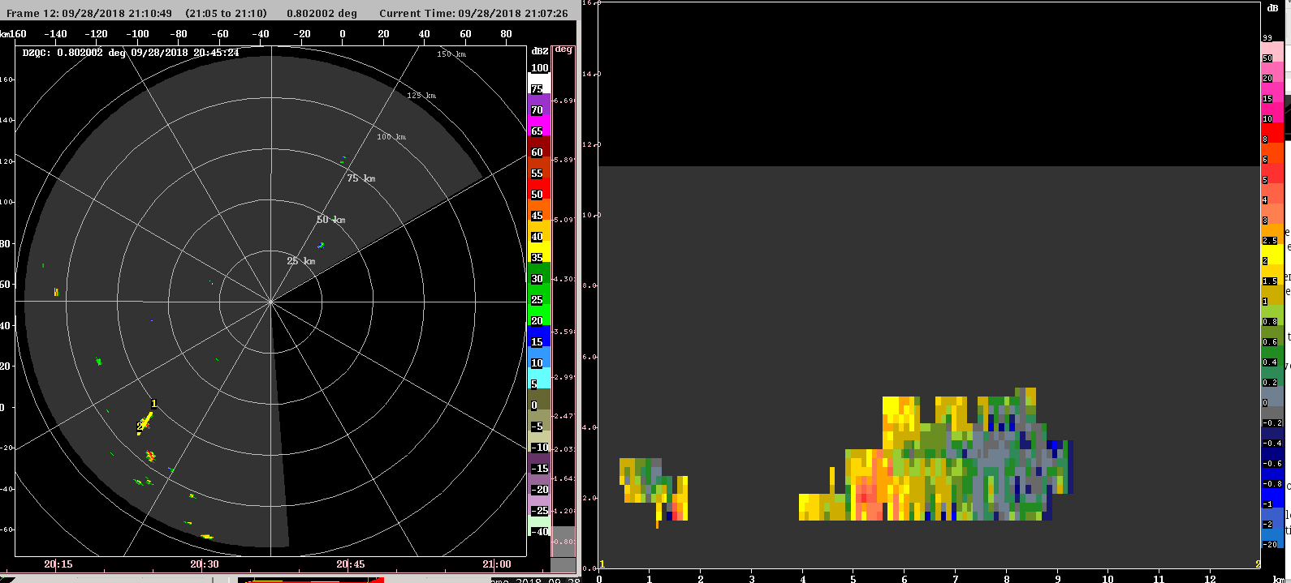
22245 – A cell has managed to reach above 5 km about 75 km to the southwest, switch to FAR volume scan.

