20180929
Morning Shift (9A-1P L)
Ben Trabing

0000 – Continue FAR volume scan with some isolated shallow precipitation to the east.

0200 – Switching to surveillance and fewer tilt volume scans as the one interesting cell moves out of the domain.

Afternoon Shift (12P-9P L)
Weixin Xu

0300 – Radar scans in SURVEILLANCE plus FAR_S strategy, as there is virtually no convection within 100km radar range.

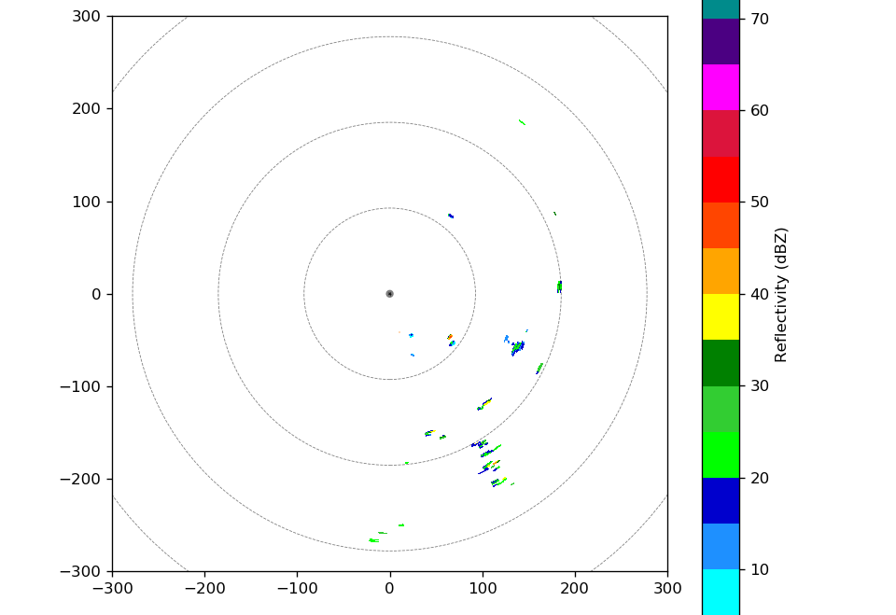

0600 – Keep scanning in SURVEILLANCE and FAR_S mode, as convection is still highly suppressed.

1000 – Still run in the SURVEILLANCE AND FAR_S scans. Scattered convection appears 100-200km south to the radar.

1030 – Radar not operating due to RCP software crash.

1100 – RCP restart and radar resume operating.

1115 – Switch the FAR_S scans to FAR scans, as some convection appear within the 100km radar range.

Night Shift (9P-4A L)
Chelsea Nam

1230 – Ship heading is 280 deg, and it gives very strong interference over 15 dBZ. Running SURVEILLANCE mode because there is no convection inside 120 km range.

1300 – Run SURVEILLANCE plus FAR_S mode.

1348 – RCP8 connection was lost. Restarted it and not it works again.

1447 – Changing into FAR mode from the next scan (1500) as there is scattered convection over 120 km range the domain.

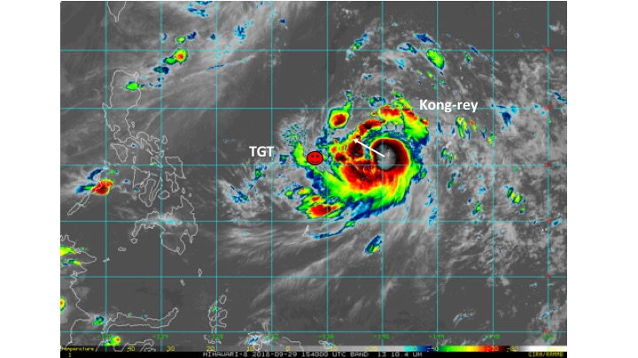

1630 – SeaPol stopped operating so we had to end the scan and restart. We ran SURVEILLANCE from then and it shows broad area of convection from the east in 200 km range (see the figure below), presumably a tip of trailing rainband of TS Kong-rey. whow Switched to SURVELLANCE mode + FAR_S mode.
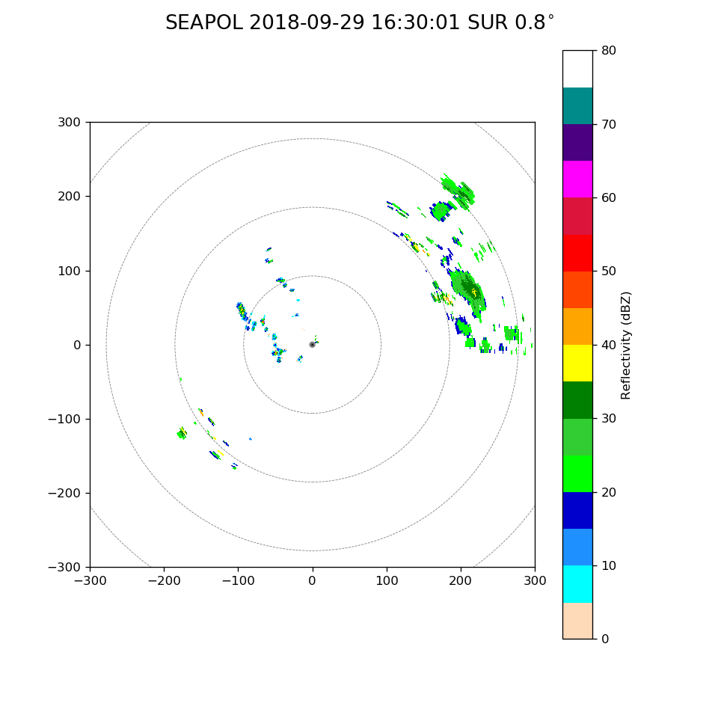

1633 – RCP 8 died. Restarted and it works again.

1645 – Warm cells with high zdr core in the 120km domain.

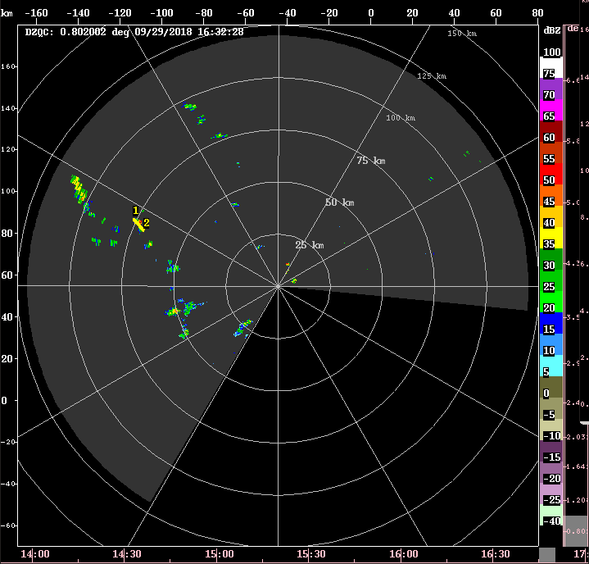
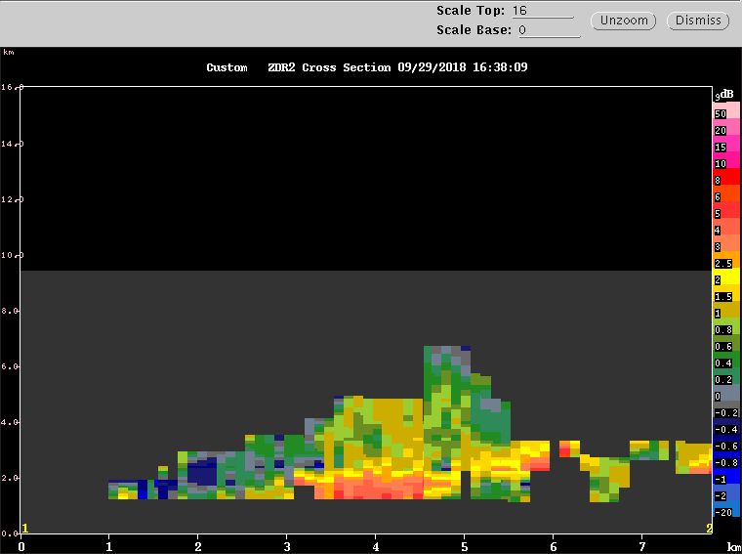

1704 – RCP 8 died again. It took several tries of restarting this time. It kept dyinig after restarting, but we regained the motion control.

1715 – Switched into SURVEILLANCE plus FAR mode.

1722 – RCP8 crashed again.

1724 – RCP8 crashed again.

1728 – RCP8 crashed again.

1731 – Came back to the combination of FAR_S and SURVEILLANCE mode. Wide spread convection in the east and south above 150 km range.

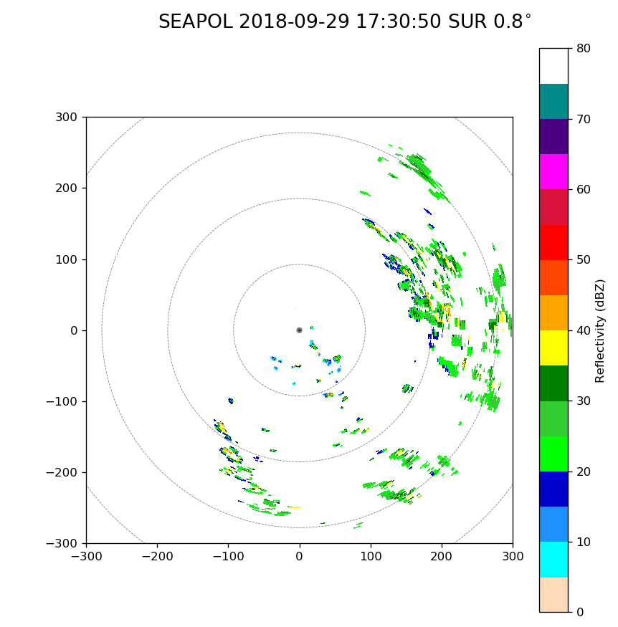

1748 – RCP8 crashed again. Restarted.
1749 – RCP8 crashed again. Restarted.
1751 – RCP8 crashed again. Restarted.

1812 – Changed into FAR from FAR_S as we could not top the convection in range 40~50 km at 150 deg azimuth.

1832 – RCP8 crashed again. Restarted. This is the tenth time for today.

Morning Shift (4A-9A L)
Ben Trabing

1900 – Widespread convection nearer to our east now.
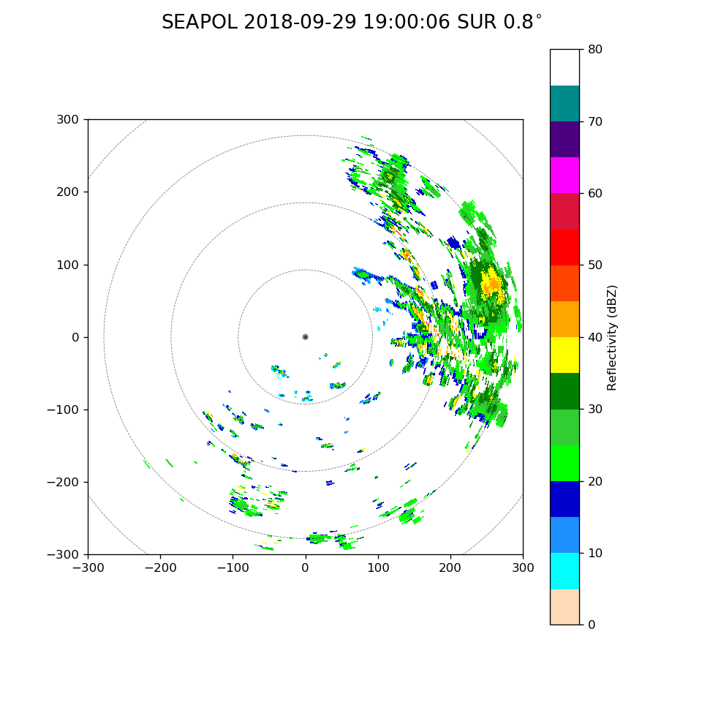
1900 – Run surveillance scan, most of the deep convection closer to Kong-Rey appears to be outside of 120 km.

2000 – Convection remains >120 km away but stratfiform precipitation to the east can be seen. Switched to PISTON LOW to try and resolve precipitation >75km away.

2100 – Ship has made a turn towards the west around the mooring so east convection is now blocked. Should turn towards the northwest soon.

2120 – There looks to be growing convection near the ship, so the LOW Volume scan will be switched to FAR in order to still well resolve the approaching convection towards the northeast.
2130 – Its raining just to our west.

2200 – Surveillance scan shows the leading rainband edge moving closer with surrounding stratiform.
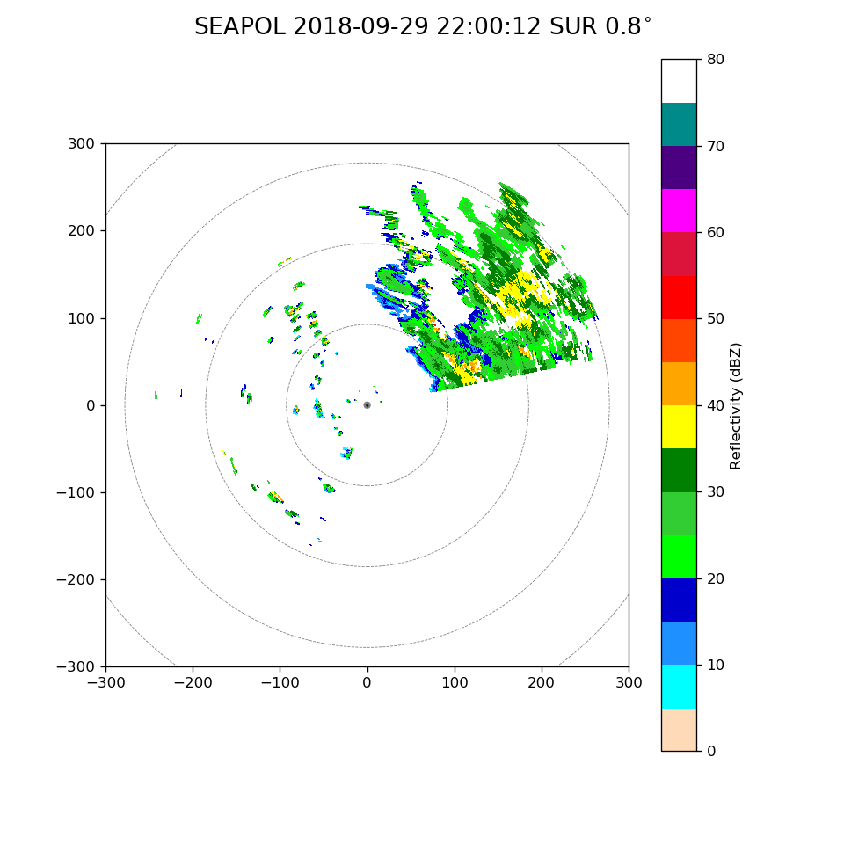

2225 – RCP diead
2230 – RCP rebooted and SEAPOL is scanning again. Return to PISTON FAR after 1 surveillance scan.
2235 – Radar stopped Far Scan and is not moving. Toggled servo power to fix.
2335 – Some of the deep convection has dissipated leaving a larger area of stratiform region radially outside of the rainband with stronger convective cells radially inward towards the center of Kong-Rey. Scattering just above the freezing level can be seen closer to the radar.


