20181002
Morning Shift (9A-1P L)
Ben Trabing

0000 – NEAR switched to FAR scan as the stratiform precip decays. We had a narrow convective band form out of nowhere from the dissipation of the stratiform precip. Could this be cold pool driven convection?

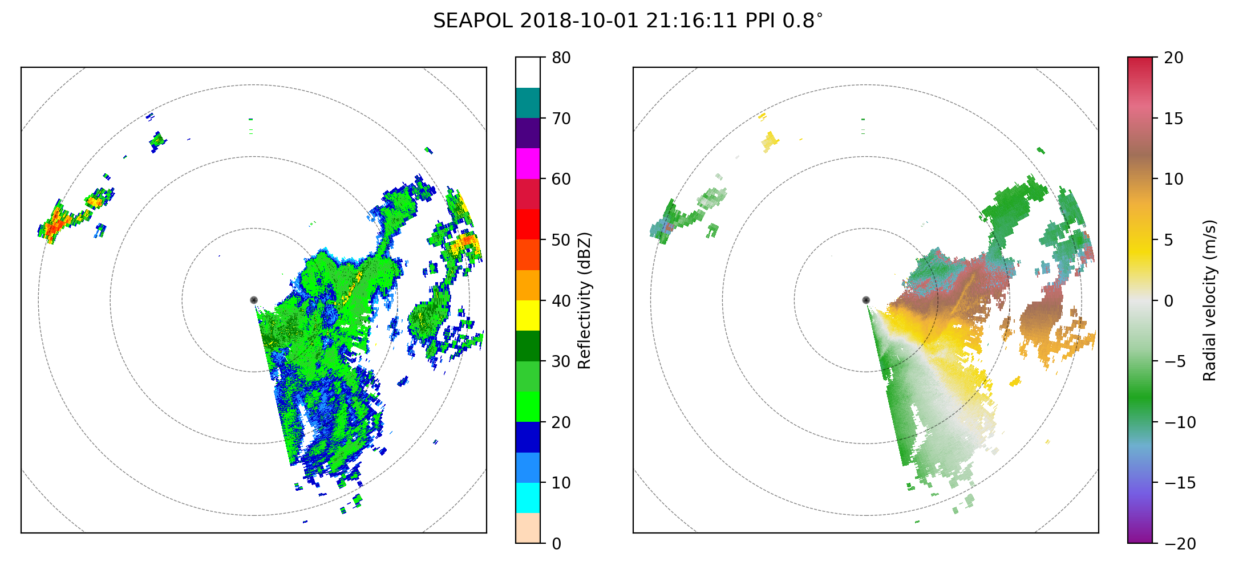
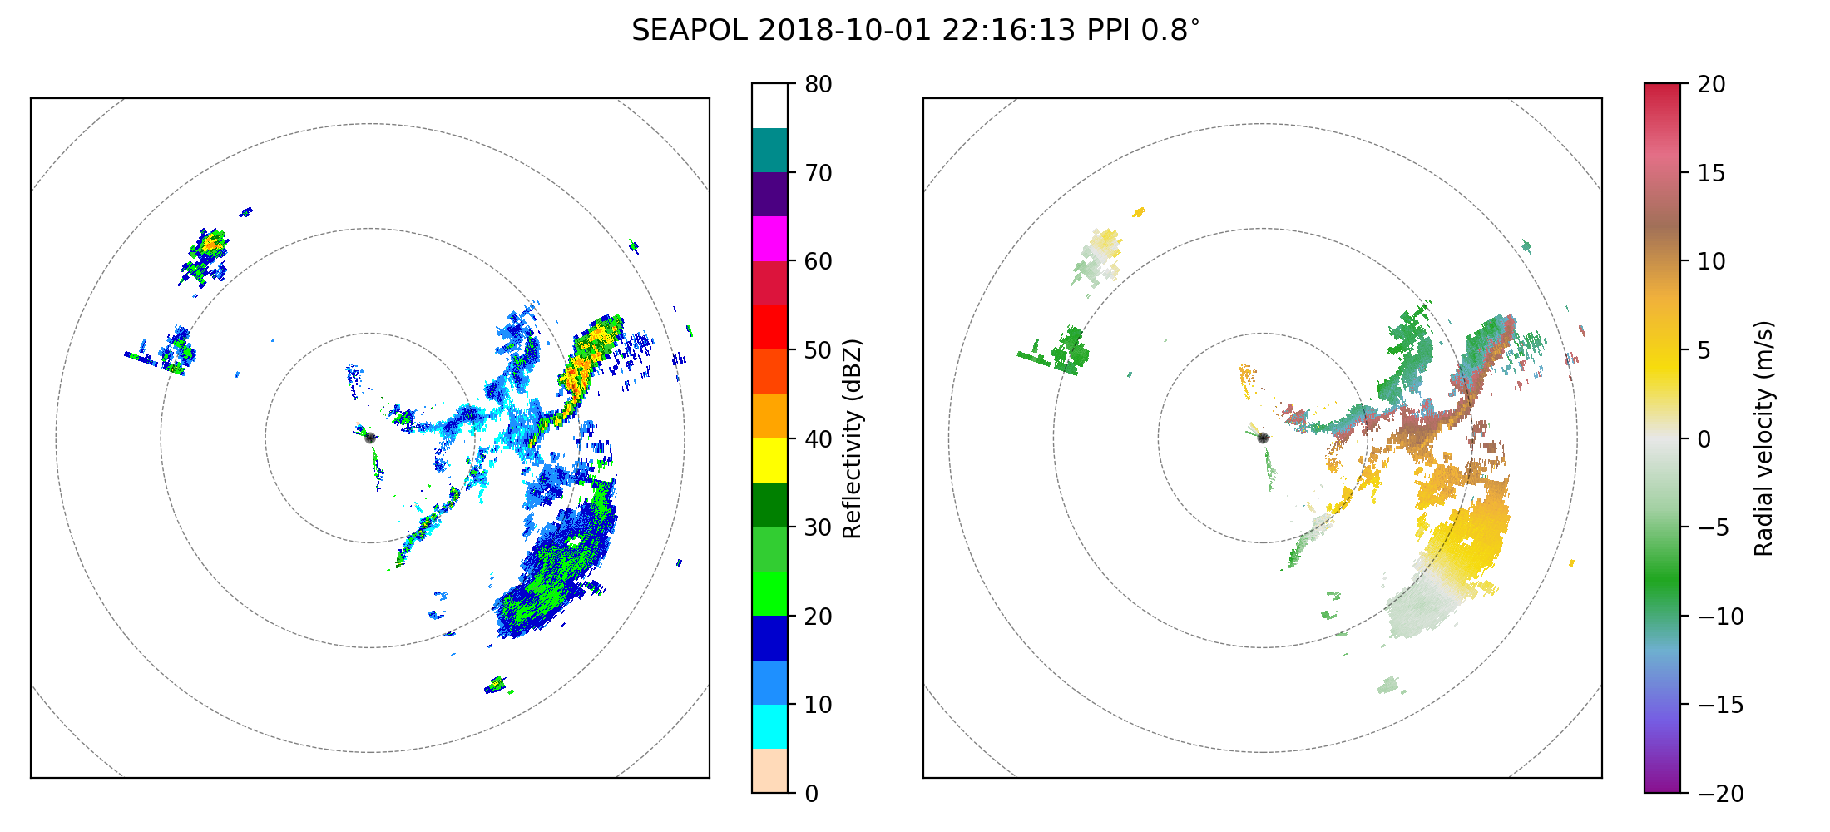

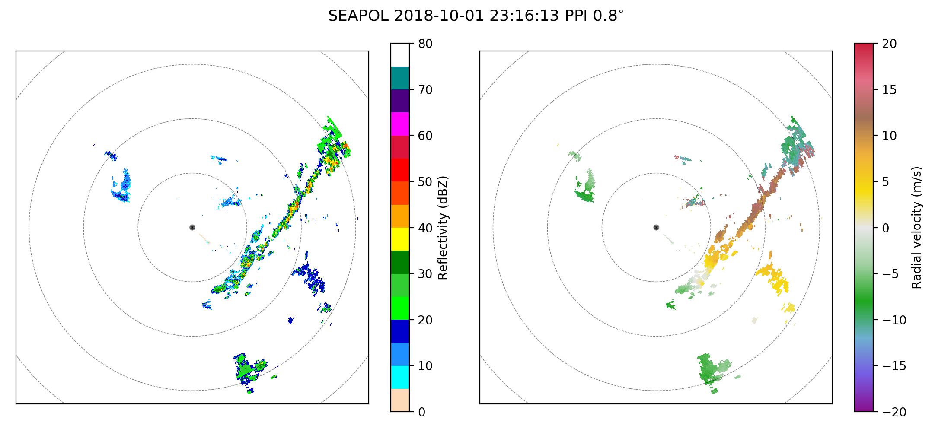
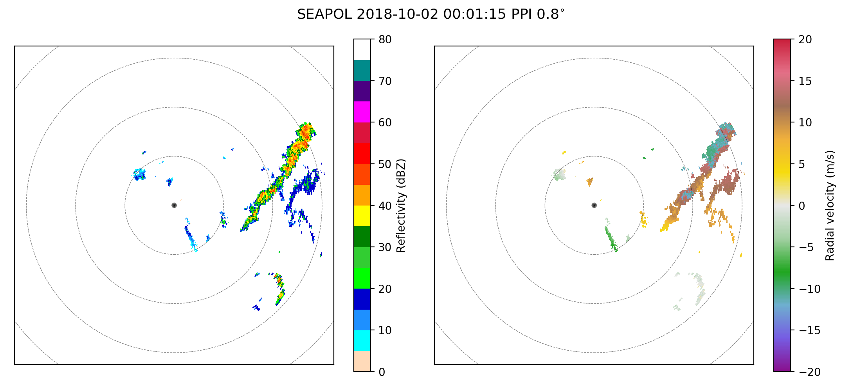
0015 – RCP died and had to reset it.

0020 – Back up and running with FAR PPI scans.

0045 – Some scattered areas of precipitation to the west can now be seen as the ship has rotated again. A couple of the cells are deep with echoes above 10 km.

0130 – A bow echo is moving very quickly northeast towards the radar with deep convection on the leading edge and suppressed convection behind with an area of stratiform detached and trailing the system. Switch to NEAR since this line of convection is moving quickly and should be within 40 km very soon.

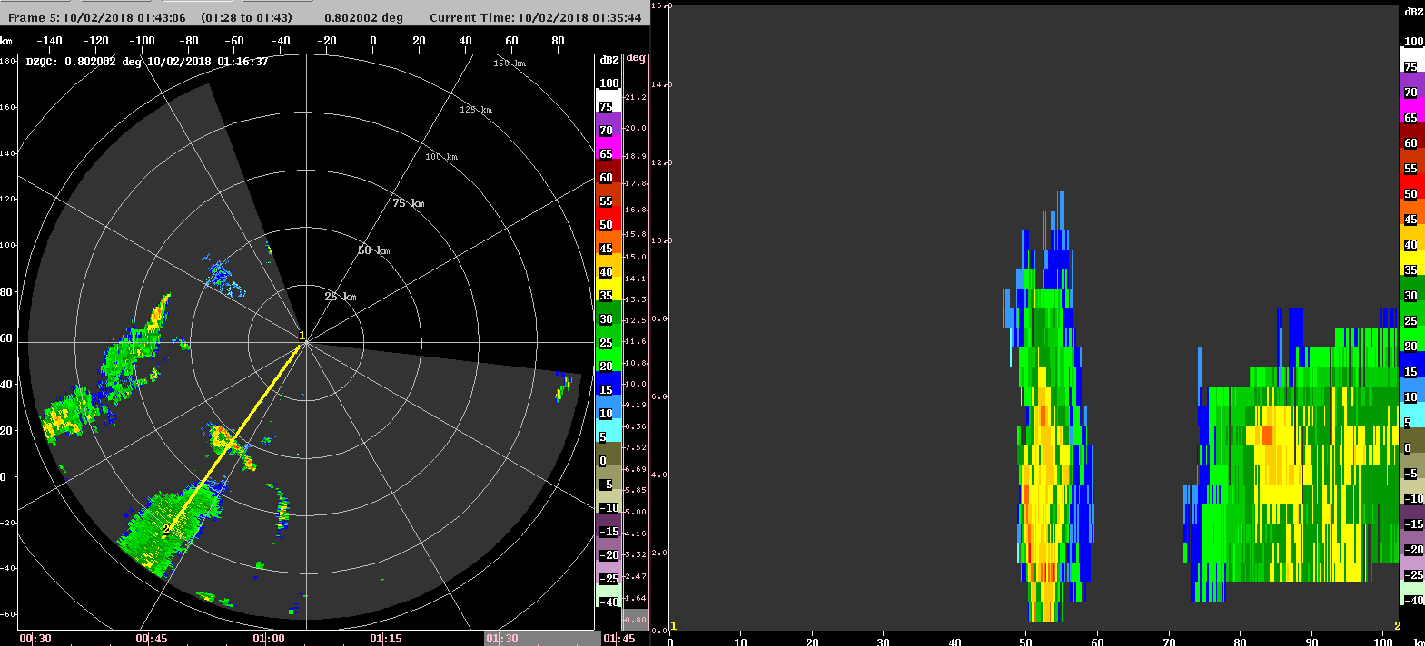

0200 – The bands of convection that have been seen on radar seem to be generated by cold pool boundaries from dissipating stratiform precipitation.

0320 – More convective lines have generated that look to be generated by the dissipating stratiform regions.
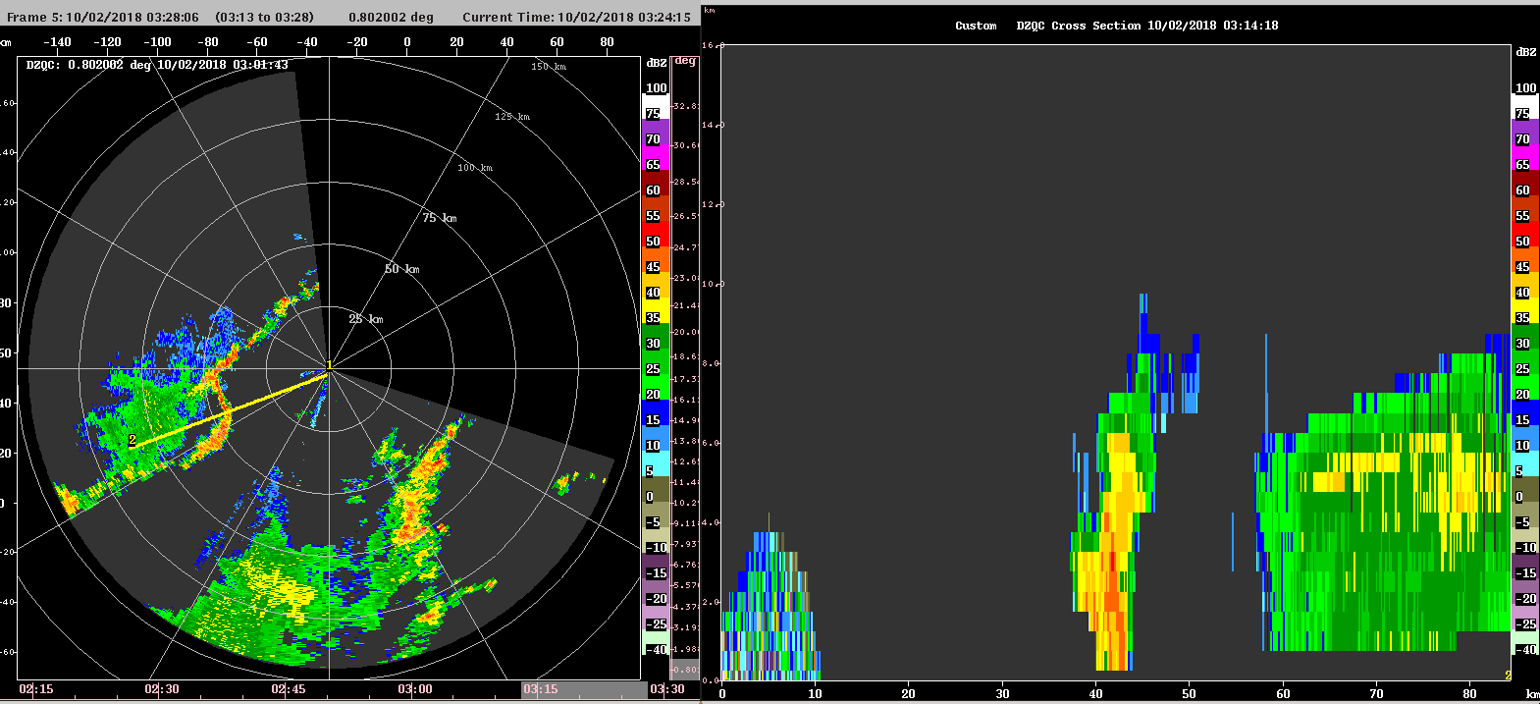

0320 --RHIs were scheduled for band of convection to the west. The RHIs were very pixelated and the rocking of the ship is making the signal

Afternoon Shift (12P-9P L)
Weixin Xu

0445 – Switch back to FAR PPI scans, as nearby deep condition passed by, and the radar domain is mainly stratiform precipitation.

0645 – Make a SURVEILLANCE scan and turn to FAR_S scans. There is virtually no convection within the 100km radar range, and only lightning rain (10-15 dBZ) left from the previous convective systems.

SURVEILLANCE scan shows some convective clusters 200-300km east/northeast to the radar.

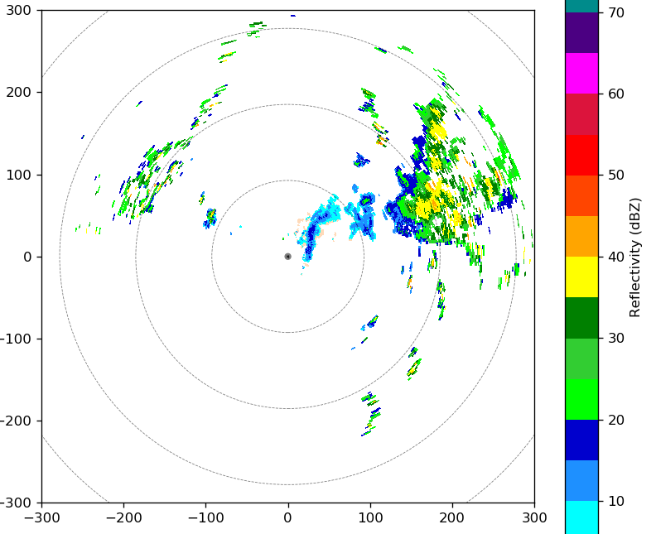

0900 – Run in FAR PPIs, some scattered isolated convection develop to the north and northwest of the radar domain.

1000 – Stay in FAR scanning mode. Mostly scattered convection. Some of the convective cells are very intense (35dBZ up to 10 km). Lightning in these cells are quite persistent (3-4 fl/min) during the last 15-20 min.
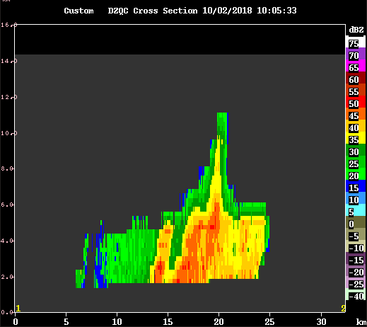

1045 – Several RHIs have been conducted toward a leading line and trailing stratiform MCS, which is moving into the radar domain. The leading convection is quite intense with large ZDR values at low-levels.

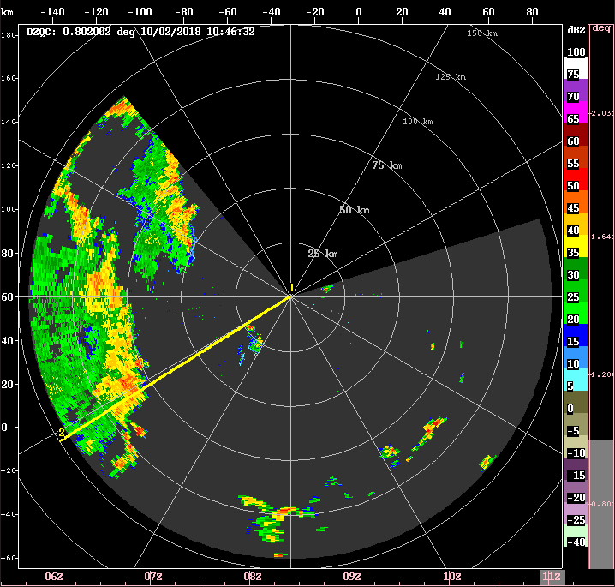

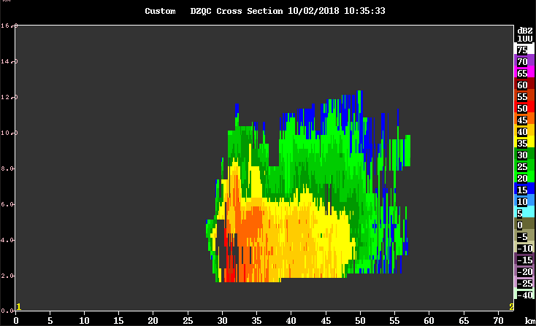

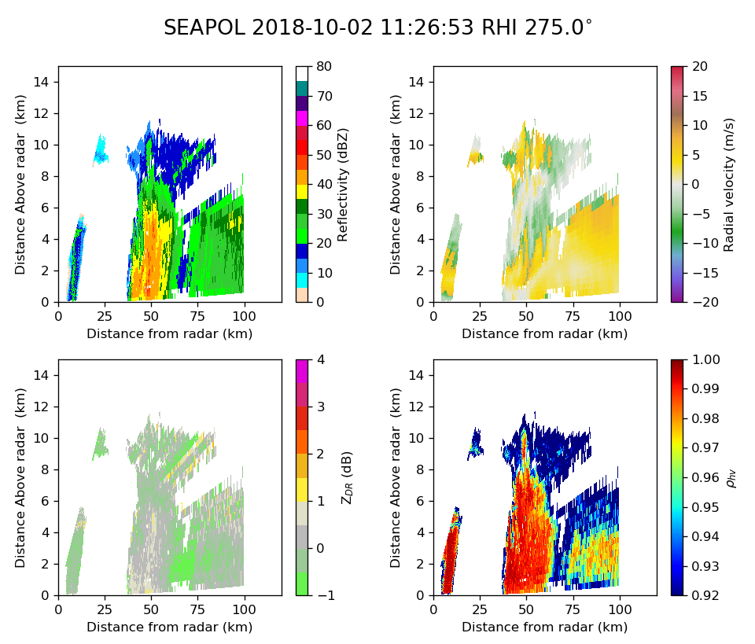

1145 – Radar operate in the FAR PPI scan mode. The MCS is decaying and broad stratiform precipitation area formed.

Night Shift (9P-4A L)
Naufal Razin

1149 – Tracking MCS mentioned by Weixin. Leading convective line and trailing stratiform precipitation is moving towards the radar, with convective line located around 50 km containing reflectivity reaching 12 km altitude. Scheduled NEAR PPI scan after the current FAR PPI scan is completed as the convective line approaches the radar. SURVEILLANCE scan is scheduled after each NEAR PPI scan.

1206 – Last scan (before NEAR PPI was scheduled) shows much of the convective line decaying except for a portion of it to the south, with this porting having 50 dBZ reflectivity up to 8 km.
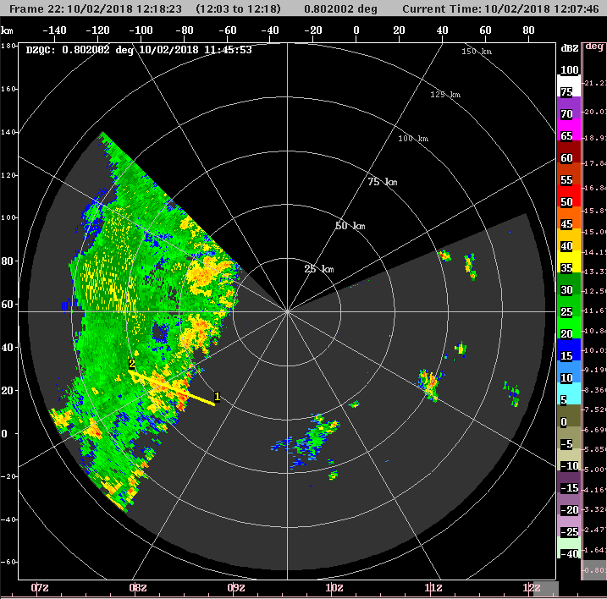

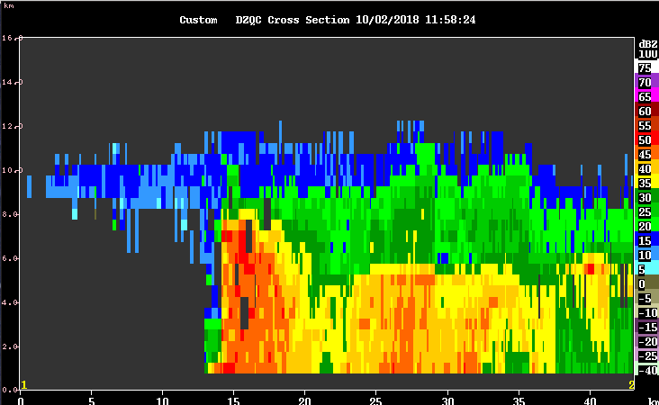

1241 – Convection in the distance to our west is associated with really large drops, with ZDR of up to 5 dB. This was also observed in at
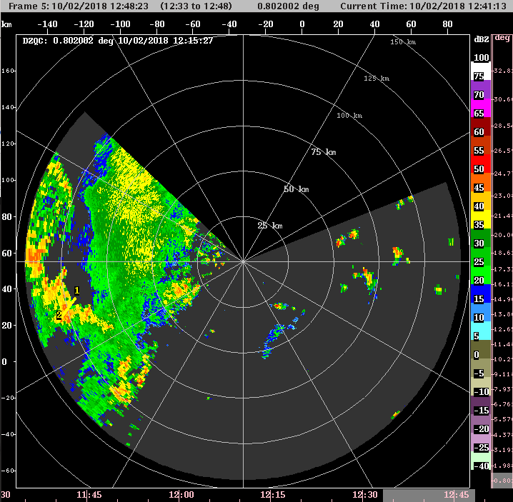
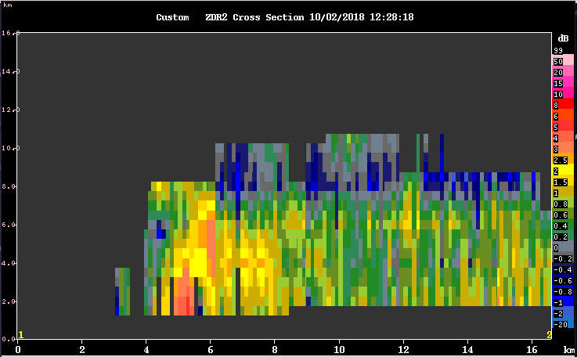

1250 – Nearby convection has turned to stratiform. Scheduling FAR PPI scan to capture distant convection with high ZDR at better scanning resolution.

1305 – Another convective line can be seen moving eastward towards the ship, behind the previous convective line that is now almost completely stratiform.

1326 – Distant convective band has echo tops at 14 km altitude. Interestingly, large ZDR values are found to the northeast of the 14 km echo tops, where the echo tops are shallower.

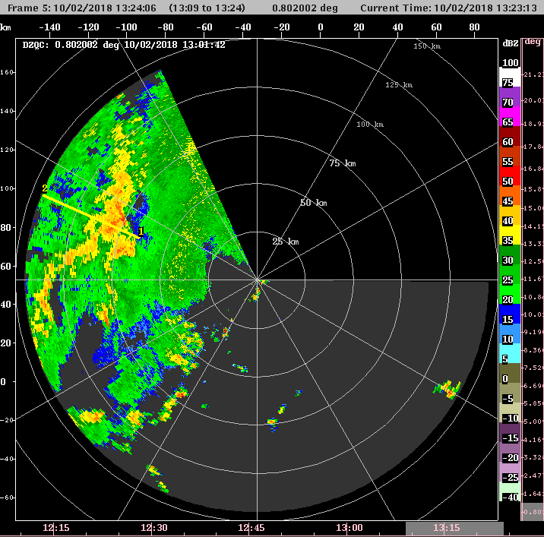
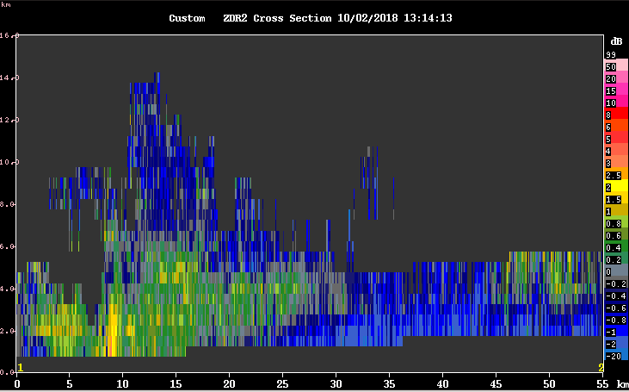

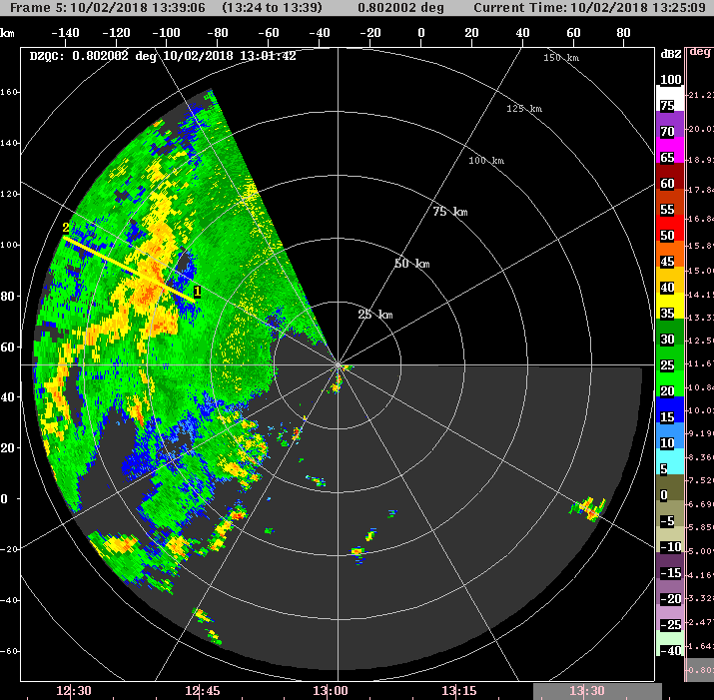
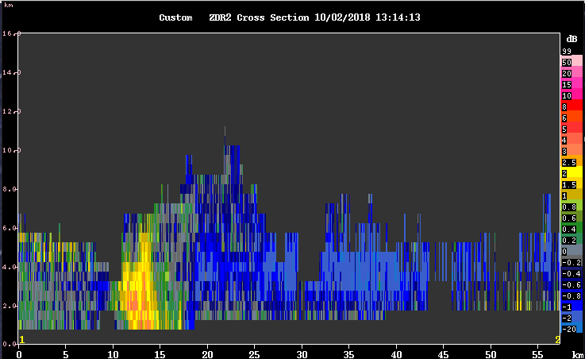

1349 – Distant convective line appears to be dying as it approaches the ship – surprise, surprise.

1419 – New line of convection formed close to the radar. Scheduled NEAR PPI scan to observe this convective line
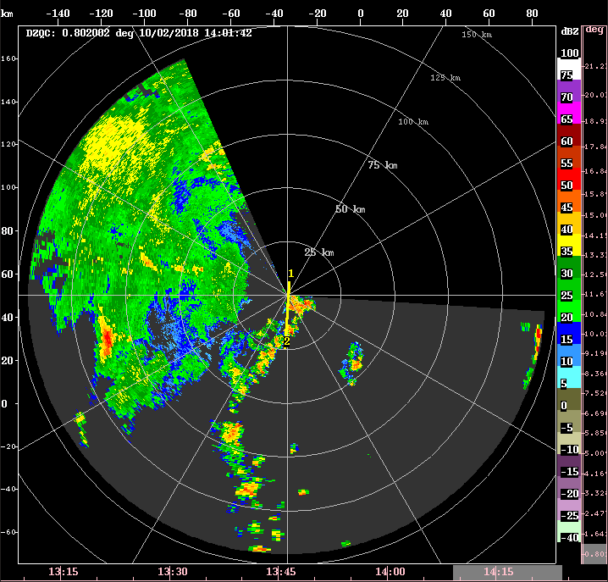

1457 – Came back from helping Ben Toms with a balloon launch. Some time between the last log entry and now, the ship had turned to face northward. The southern portion of the new line of convection can no longer be observed. But the line of convection had moved eastward and away from the radar, allowing some observation of the convective line’s northern portion.

1533 – Most of the aforementioned convective line has moved beyond 50 km away from the ship, to the east. Switched scanning mode back to FAR PPI, with SURVEILLANCE after every one volume scan.

1743 – Aside from a small line of convection to our west, most of the precipitation within the observable domain, convective or stratiform, have weakened significantly or dissipated. The small line of convection is interesting, considering that it has persisted for a while.
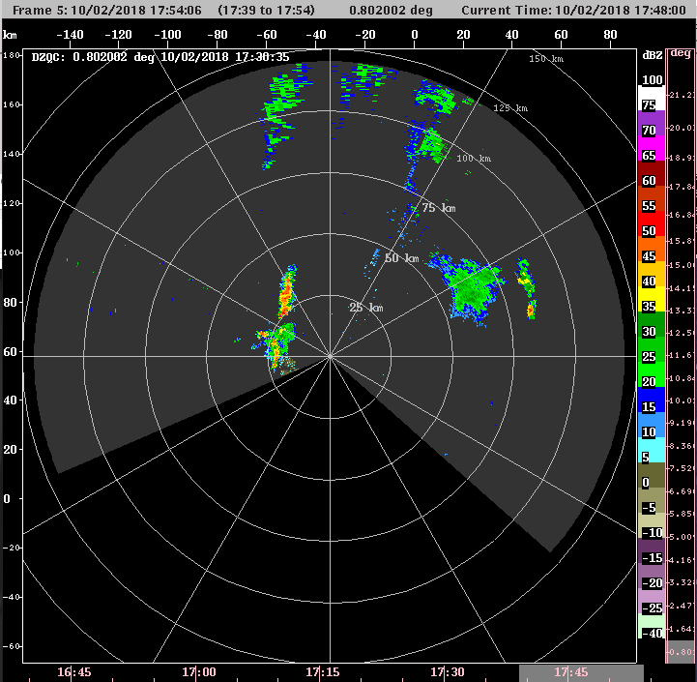

Morning Shift (4A-9A L)
Ben Trabing

1945 – Quite a bit of lightning seen which looks to be from a storm moving in from the southwest. The bridge is blocking the southwest so its unclear how extensive the convection is, but just switched to NEAR mode.

2130-- Switch to FAR PPI scans since the deep convection near the ship has largely dissipated.
2300 – Continue FAR with surveillance since there there are very few echos on radar.

