20181008
Morning Shift (9A-1P L)
Ben Trabing

0020 – Use FAR scans with fewer elevation angles to reduce stress on radar. No precipitation is indicated in the radar domain.

0255 – There is still nothing going on on in radar range.
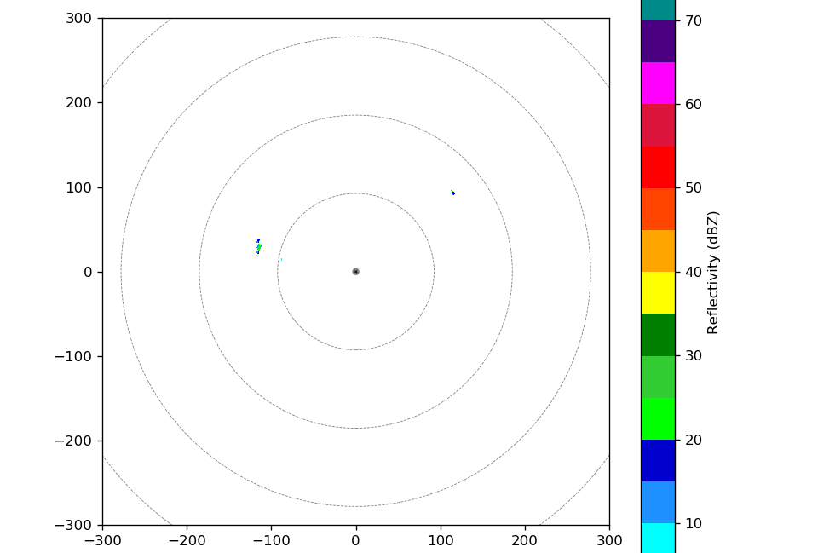

Afternoon Shift (1P-9P L)
Weixin Xu

0400 – Operate SURVEILLANCE and FAR_S scans because of none convective activity even within the 300 km radar range.

0800 – Switch to LOW PPI scanning, as shallow condition started to develop and increase. Most of the convection is very shallow with echo-top only up to 2-3 km altitude.
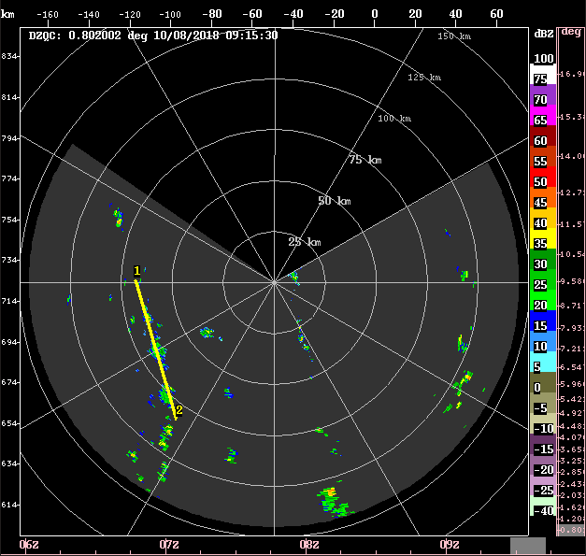
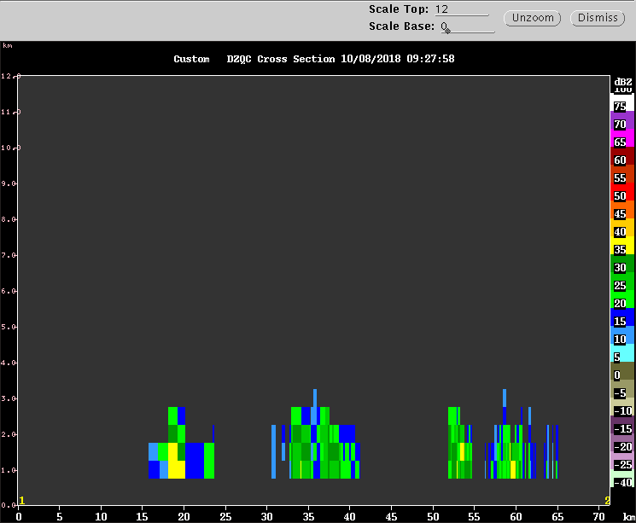

1115 – Keep running in the LOW PPI mode. Convection is still mainly warm rain shower, rarely grow above the freezing level before decaying.

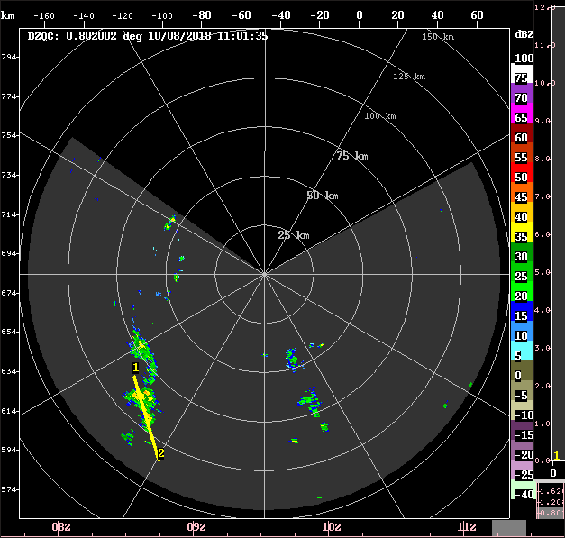
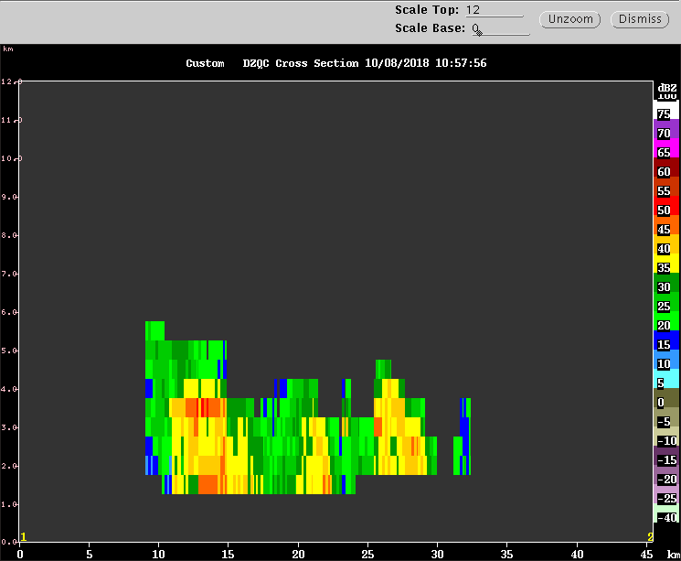

Night Shift (9P-4A L)
Naufal Razin

1207 – Continue with low and surveillance scans.

Morning Shift (4A-9A L)
Ben Trabing

1900-- Nothing going on, going on, continue scanning strategy.

