Cruise Report Notes, NOAA/ESRL, PISTON Leg 3
Ludovic Bariteau and Aditya Choukulkar
NOAA PSD, CSD and OSU deployed and operated a variety of systems for atmospheric profiling, bulk meteorology, and turbulent fluxes. Most meteorology sensors are on the jackstaff for best exposure to undistorted flow (Fig. 1). The downward IR and Solar flux sensors were on top of the container housing the Wband and doppler Lidar, and the remaining instruments were on the 03 deck (Fig. 2). The seasnake SST sensor (not shown) was towed through the water from a boom off the port side. The table below details the various systems and general status throughout Leg 3.

NOAA | Frequency | Status
Anemometer, sonic 3D, Gill | uvw winds @ 10 Hz | Functional
Motion Pack | accel. & rot. @ 10 HZ | Functional
Fast water vapor, Licor 7500 | H₂O @ 10 Hz | Functional
Bulk air T & RH, Vaisala | 1 min avg | Functional
Laser rangefinder, Riegl | 20 Hz, for wave height | Functional but not always return due to tilt and weak seas.
Rain rate, OSI ORG optical | 1 min avg | Functional
Air pressure, Vaisala | 1 min avg | Functional
Solar flux, Eppley PSP (2) | 1 min avg | Functional
IR flux, Eppley PIR (2) | 1 min avg | Functional
SST, sea snake | 1 min avg, 5 cm depth | Functional
Heading, GPS | 10 Hz | Functional, some heading intermittencies up to doy 272
Ceilometer, Vaisala CL31 | 15 sec avg profiles | Functional
W band cloud radar | 2 Hz profiles | Functional
Profiling microwave radiometer, Radiometrics | 15 sec | Functional, but will require significant post-processing
Doppler Lidar | 2 Hz profiles | Functional but motion compensation not working.  2 days of downtime.
OSU | Frequency | Status
Rain rate, OSI ORG optical | 1 min avg | Functional

The PSD data have been processed while on the ship. Various plots and summary statistics were generated for each day of the cruise leg and made available on the cruise share. For now, we suggest using the hourly flux files as they have been QC’d for some wind direction and other maneuvering contamination. If using the 10min data file, use the provided flags like jplume and jmanuv in addition to the relative wind direction. Those data are still preliminary and more QC will be performed in the next months to deliver a final QC’d dataset of the surface and flux data.
Summaries of the meteorological time series (Fig. 3), the flux time series (Fig. 4), and the rainfall time series (Fig. 5) are shown.
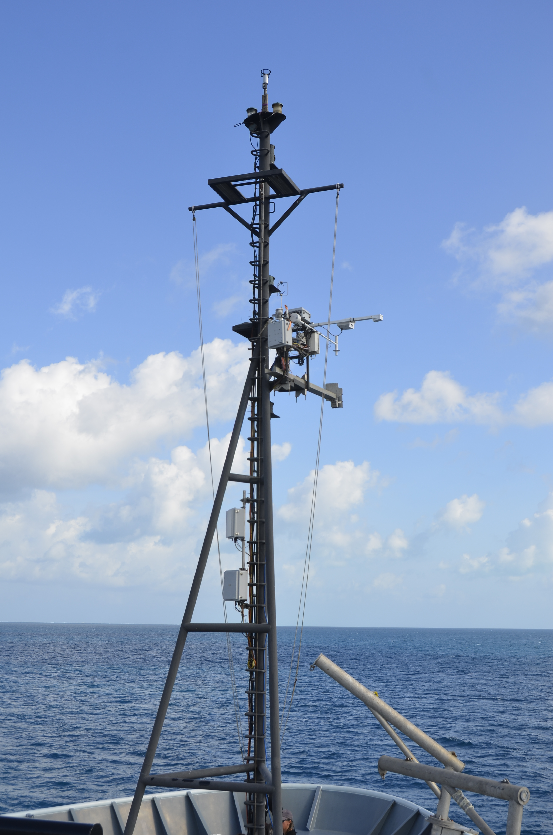
Figure 1. PSD flux instruments on the jackstaff.
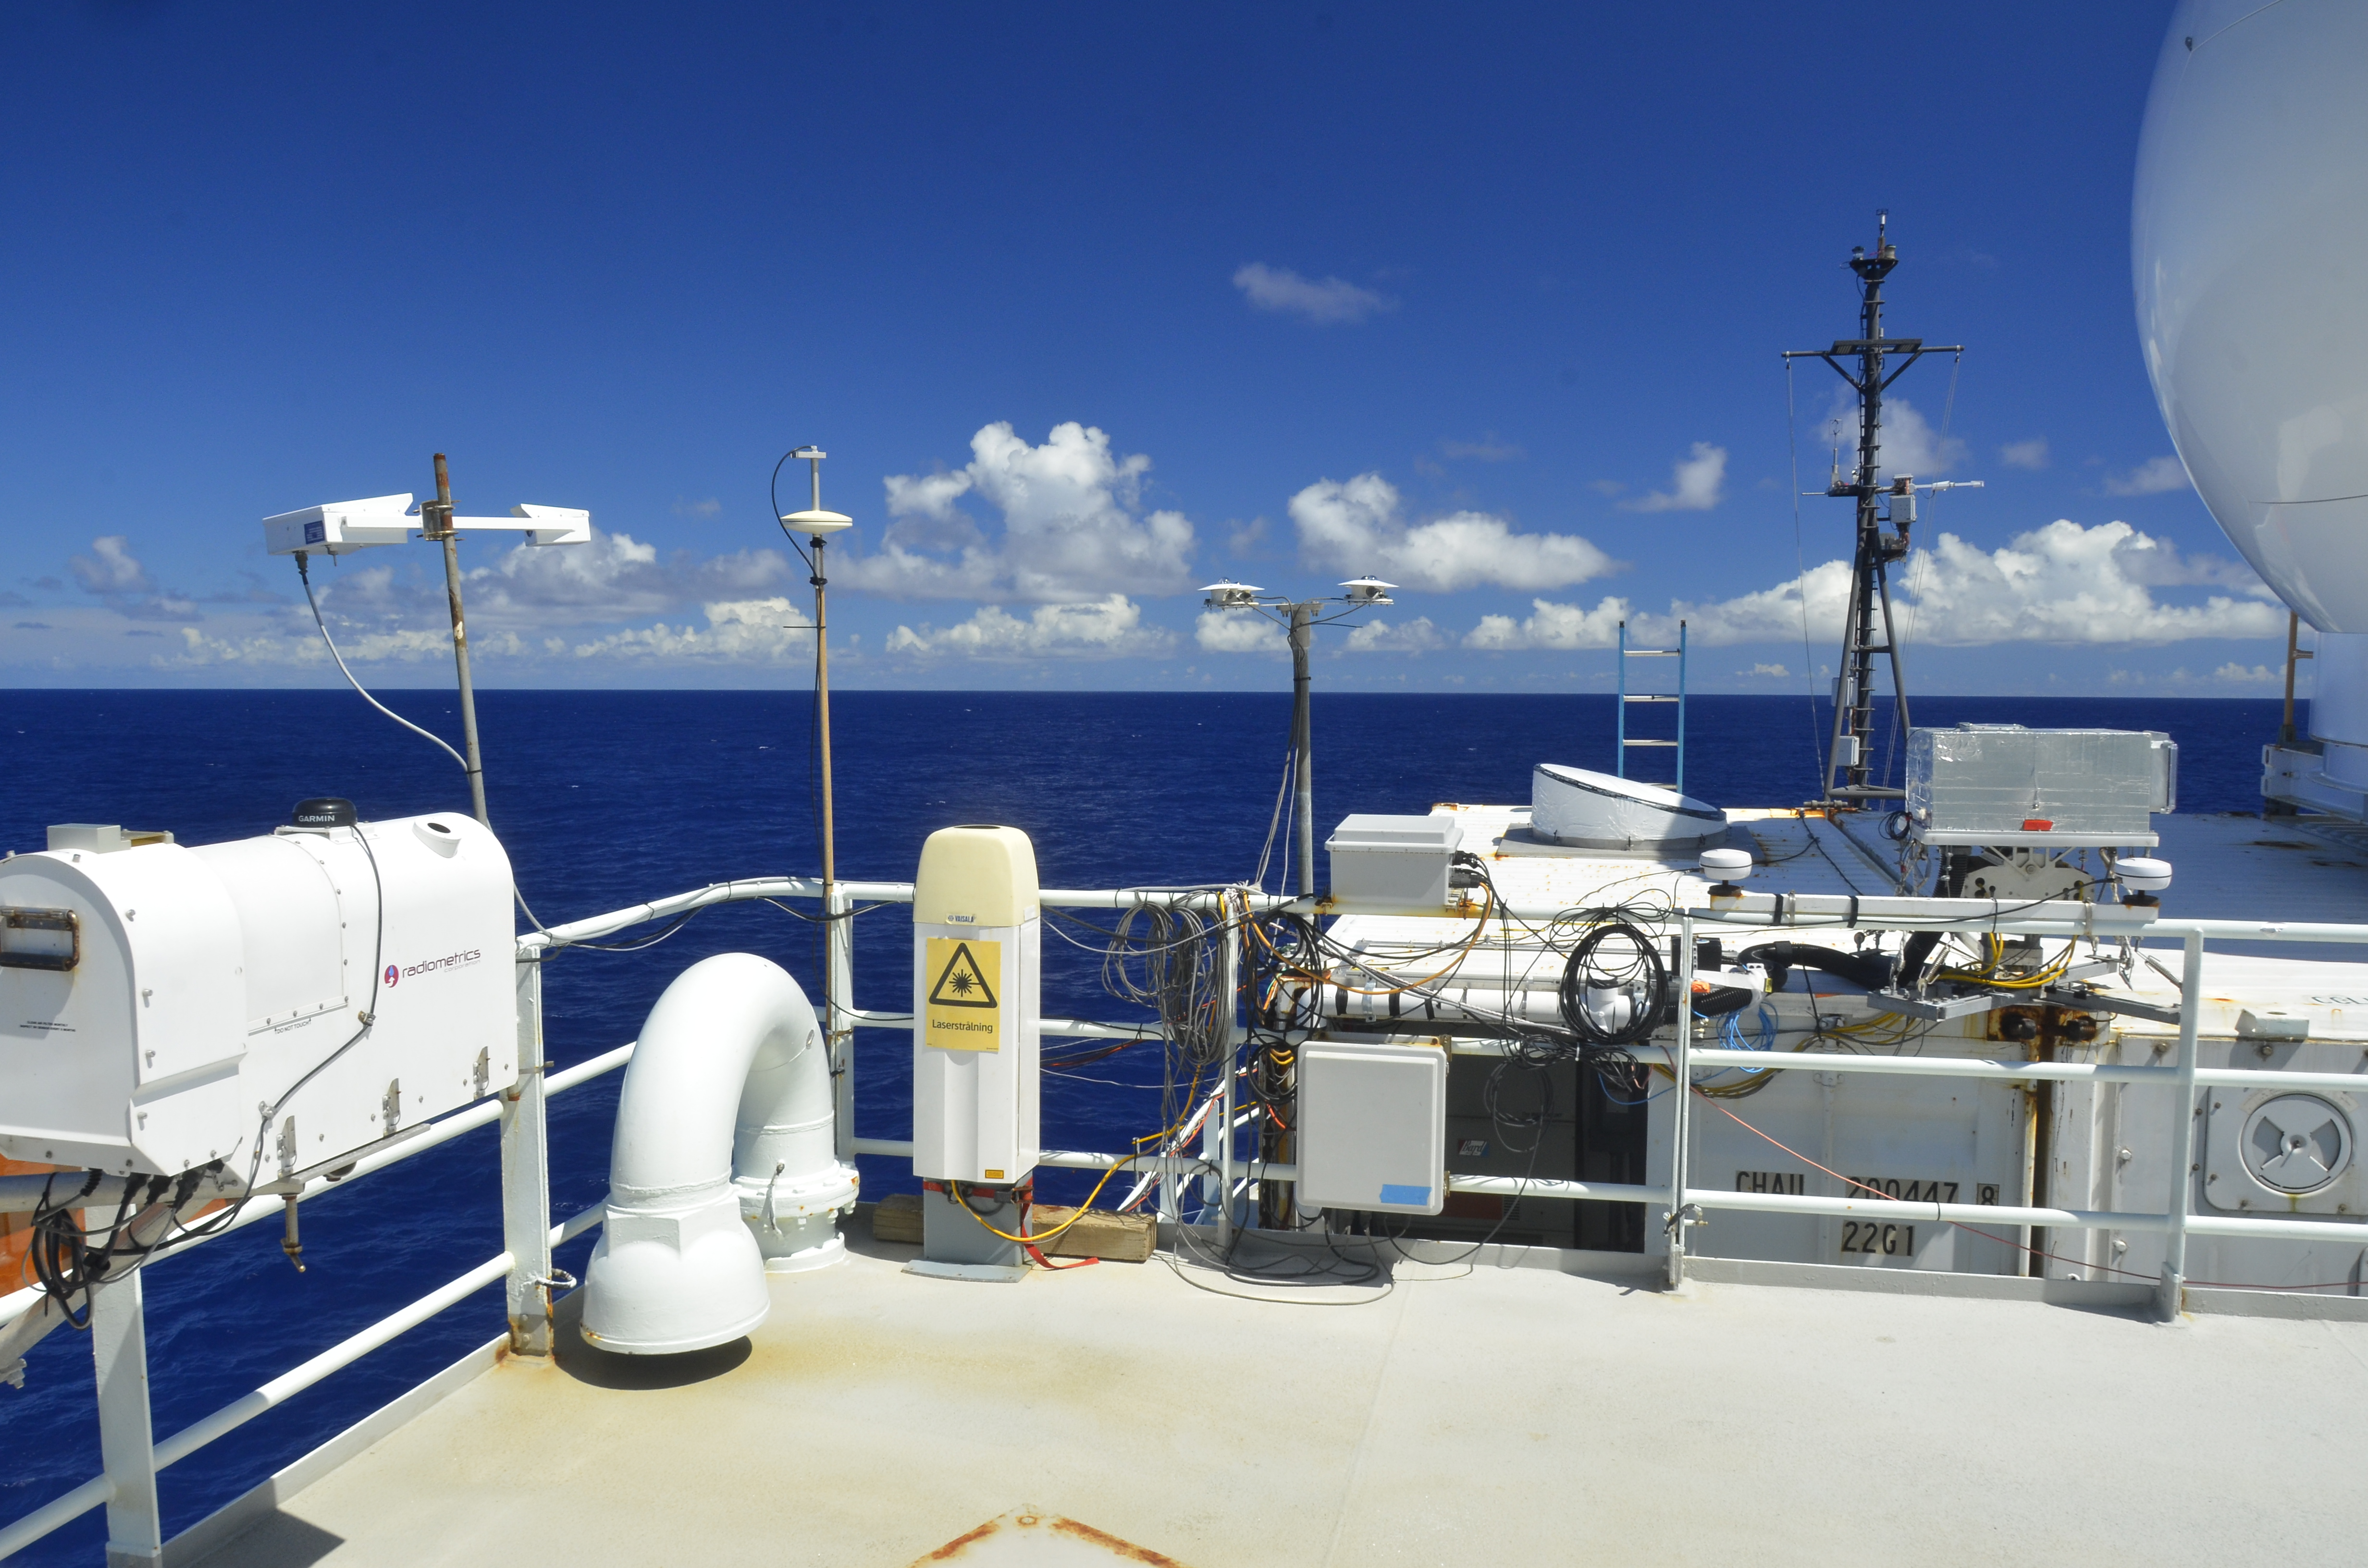
Doppler Lidar
Wband radar
PSP/PIR
Ceilometer
Microwave radiometer
OSU rain
Pressure
Figure 2. PSD meteorological and atmospheric profiling instruments on 02 and 03 decks.

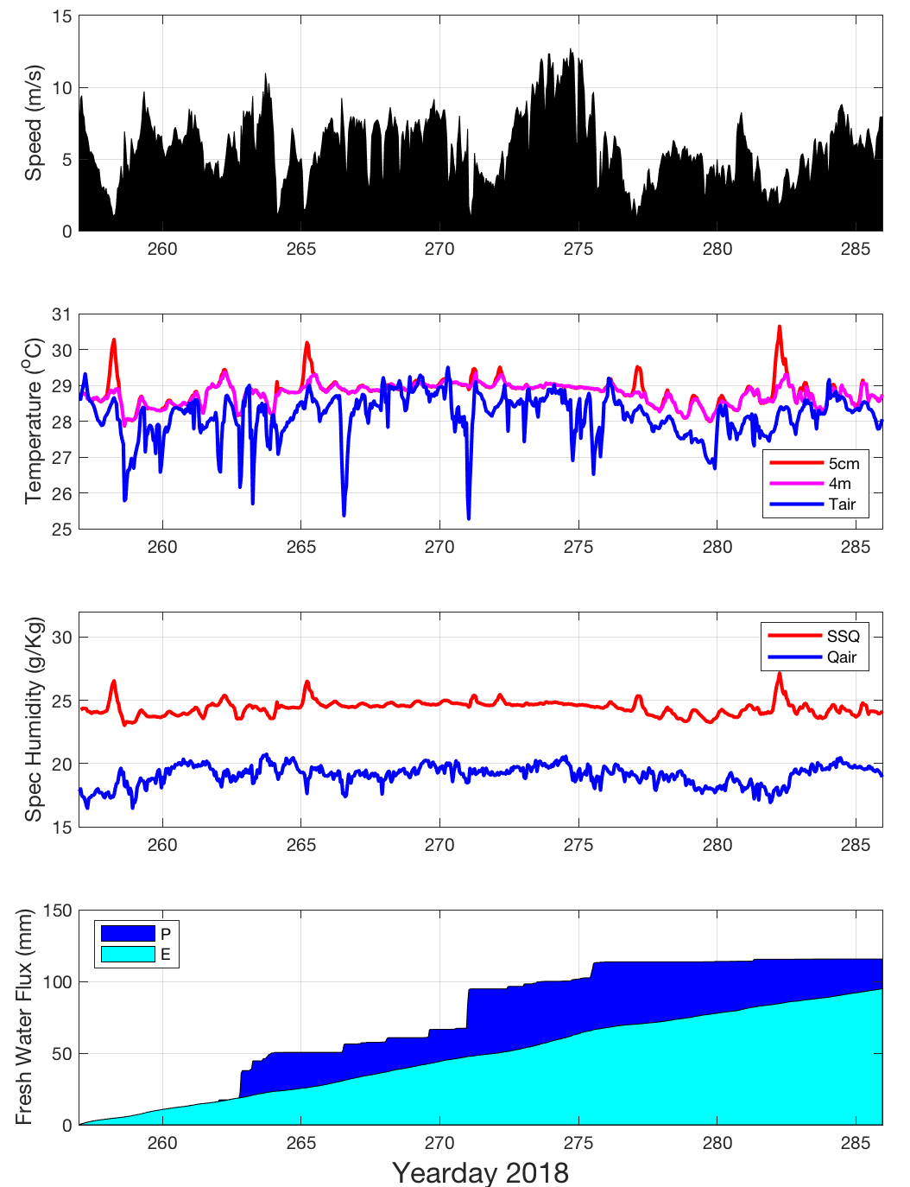
Figure 3. Mean near-surface meteorology time series for PISTON leg3. From top to bottom: Wind speed; air (blue) and sea temperature at 5cm (red) and 4m (magenta); air and sea specific humidity (blue and red respectively); Precipitation (blue) and Evaporation (cyan).

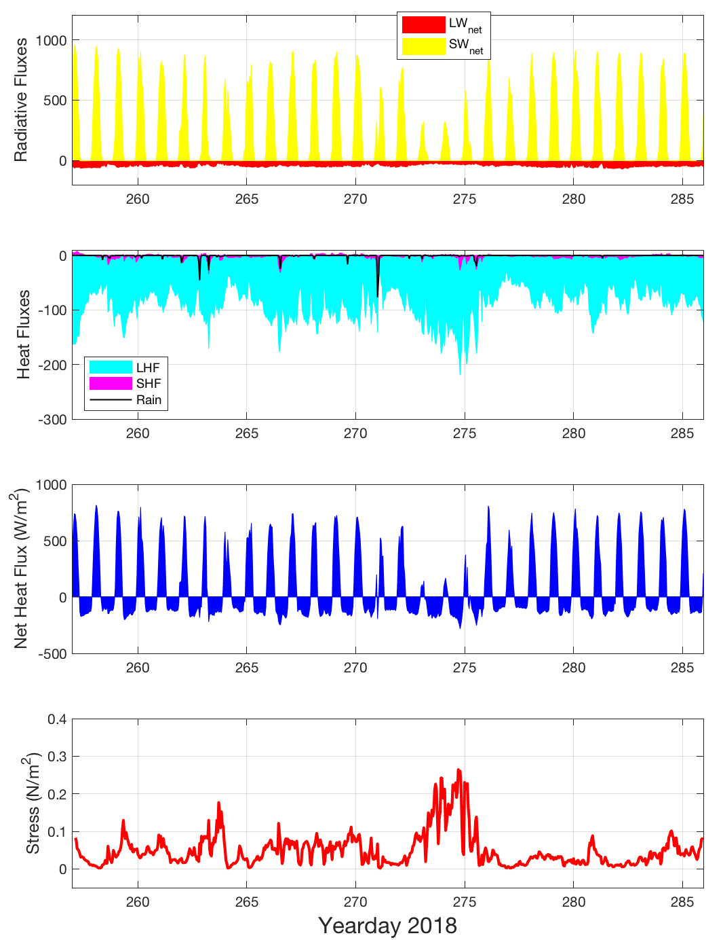
Figure 4. Mean near-surface air-sea flux time series for PISTON leg3. From top to bottom: net shortwave (SWnet) and longwave (LWnet) radiations; latent heat flux (LHF), latent heat flux (SHF) and the sensible heat contributed by rain (Rain); net heat flux into the ocean (blue); and wind stress. Oceanographic sign conventions are used in this plot.

The Wband radar and the Doppler lidar were able to make continuous measurements during leg 3.
During this time the Doppler lidar made measurements of vertical velocity from close to ocean surface to top of the bounday layer. These measurements were used to estimate vertical velocity variance and boundary layer height in real-time. The results were posted to a website in real time during the period of the cruise. It was attempted to reduced the effect of motion contamination on the Doppler lidar velocities due to improper motion correction. Using the decorrelation technique, the appropriate fraction of the beam column average is removed at all levels. This seems to provide the most effective correction for the contamination as shown in Figure 5 below.

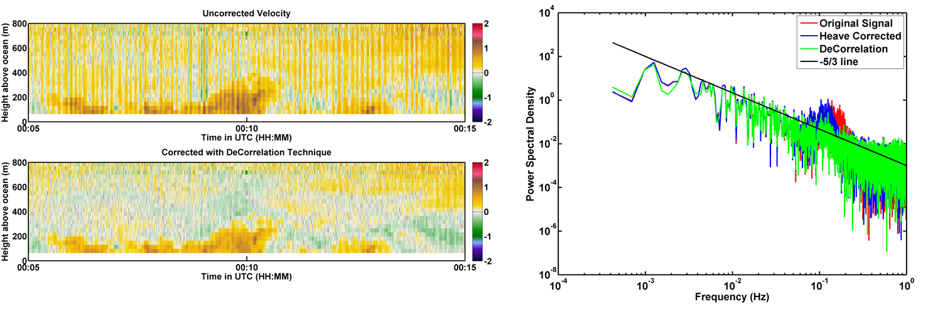
Figure 5. Effect of correction of motion contamination using the decorrelation technique.

In order to retrieve the clear air velocities from the Wband, the Pinsky et al 2010 approach is used. Using this technique the clear air velocities can be used to estimate profiles of vertical velocity turbulence. These profiles of turbulence can then be combined with those obtained from the Doppler lidar to get continuous profiles from near the ocean surface to the top of the cloud. The clear air velocities retrieved from the Wband for an example 1 hour period are shown in Figure 6.
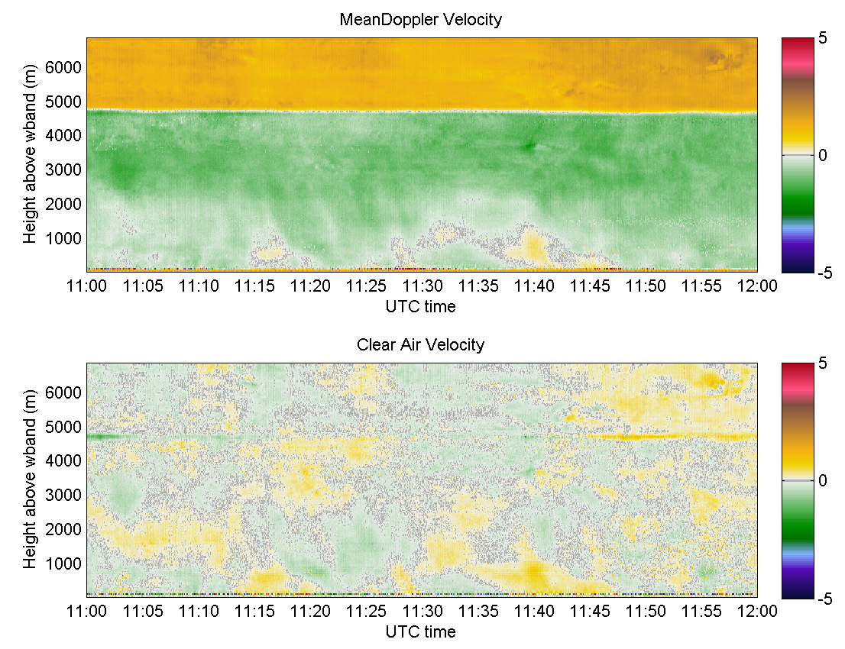
Figure 6. Wband measured Doppler velocity (top) and the retrived clear air velocity (bottom)

