This proprietary RDX information.
Rev 1.0 01/24/2013

MP-3000A-IAF with MCM_C Check List before shipment
1. Set IP to DHCP mode.
- Clean FTP data.
- Set timezone and RTC
- Upload default mp.cfg file
- Program Model and Serial number.

New unit initial configuration.

- Install MOD5441X module on the MCM_C board. RJ45 connector should be oriented to the left. Plug in short Ethernet cable connecting MOD5441X and RJ45 connector on the bottom of the unit.
- Write down in Unit’s traveler document the MAC address of the installed module. MAC address is 12-hex digits printed on the white sticker on the MOD5441X modules. The MAC is always begins with the following digits: 0003F4xxxxxx, where first 6 digits is vendor specific. The MAC address is unique for all Ethernet devices produced worldwide.
- Connect Ethernet cable to the available Ethernet outlet or use a switch to connect your desktop and the unit to the company’s network. Turn unit ON.
- Configure network settings of the unit. For that run application IPSetup.exe located here: \\rmds2\RDX\documents\manufacture\Radiometer_Codes\MP-3000C_Firmware\Tools
You should see the following screen:
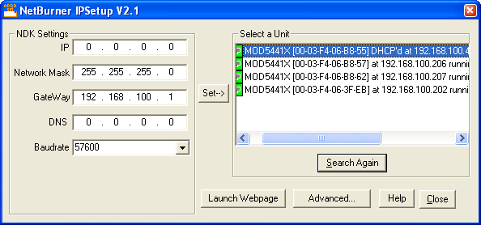
It shows all the units on the local network. Please, be aware that you may not see the unit if it is connected to a different subnet or segment of your local net separated by routers. The best practice is to use personal Ethernet switch.
Identify your unit by MAC address. (It is HEX pattern in square brackets). Each unit may have either static IP address or use dynamic IP address assigned to the unit by the RDX server at power. In this case it is shown as: DHCP’d at 192.168.100.45 - like shown on the picture. If it shows 0.0.0.0 you need to cycle the power of the unit and then click “Search Again”.
Select your unit. On the left side enter valid IP address belonging to RDX local network. Typically use addresses in the upper range: 180 – 220. Before using new address, make sure it is not already used. For that type in DOS window command:
ping 192.168.100.xxx where xxx is desired last 3 digits of IP address.
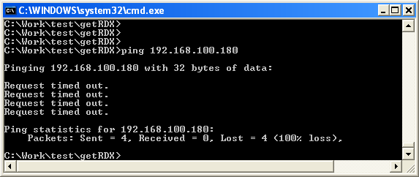
Type in the desired address in IP field and set other fields as shown on the picture and click “Set->” button.
To check the settings enter Unit’s IP address in address field of browser and see it you can open the Units’ WEB page.

- Flashing the MCM_C software. For that run application AutoUpdate.exe located in the mentioned above directory on RMDS2.
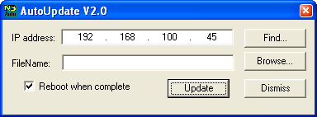
Click “Find” button to locate your units. Select your unit and click “OK”.
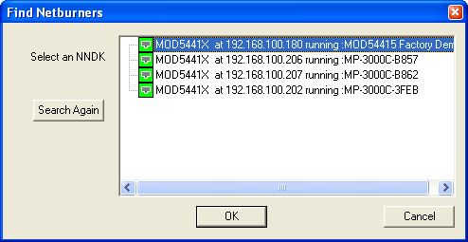
Open the required file with image of MCM_C software.
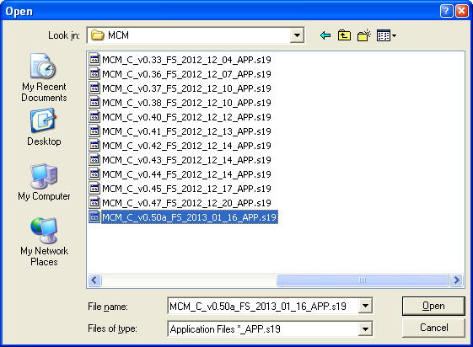
The files are usually located on this directory:
\\rmds2\RDX\documents\manufacture\Radiometer_Codes\MP-3000C_Firmware\MCM
Tip. To quickly open the directory copy this link and paste to “File Name” field.
Select the file with required revision and click “OK” button.
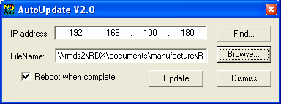
Warning! Make sure once again that you programming your unit, not somebody’s else!
Click “Update” button. First time it won’t ask for password. If unit was programmed before you’ll need to know the password used when it was programmed. User: RDX Password: RDXIES2013
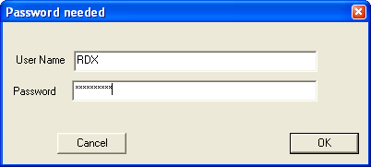
Click OK to close AutoUpdate utility.
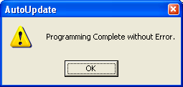

- Open Unit’s embedded WEB page. For that enter in browser http://192.168.100.xxx
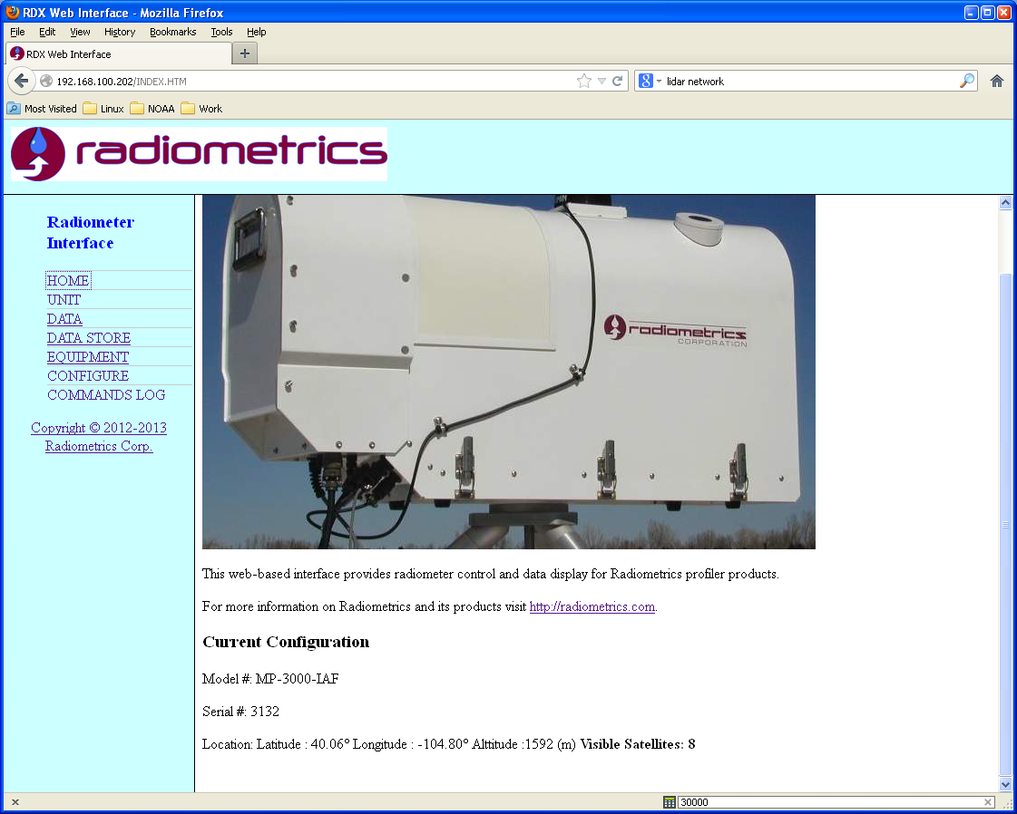
Check if Model number and serial number are set. If not program it using serial interface to the unit. The easiest way is to use Telnet connection: click START/Run telnet 192.168.100.xxx
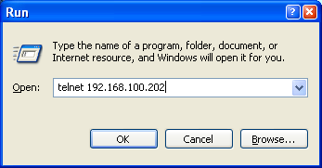
Enter serial number with “x” command and model number with “y” command.
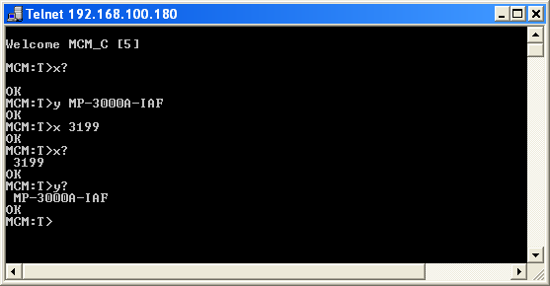

- Configure RTC. On the WEB page click on “CONFIGURE” button.
It will ask for password. Use: User: owner Password: owner
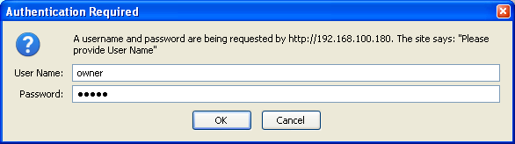
On this page set timezone. “-7” is Mountain. Set 0 for UTC.
Synchronize RTC. It can be done to GPS is number of satellite > 0 or to NTP time server. The unit uses 3 preselected default time servers. It is possible to synch to local time server when available: just enter address of the server and click “Sync NTP”
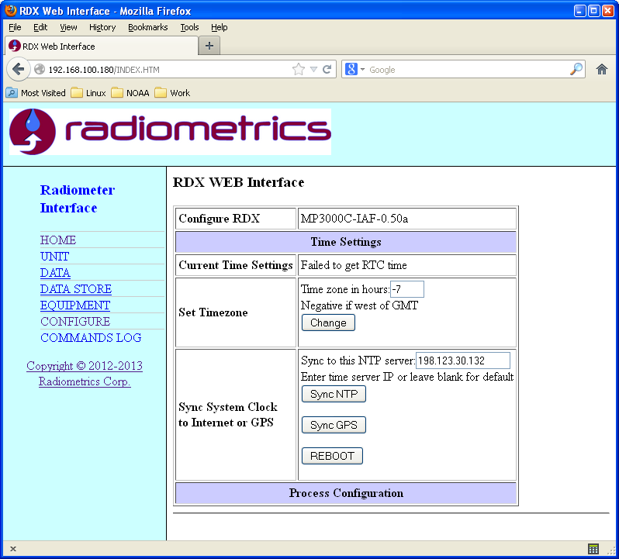
Important. After uploading new MCM_C software is is necessary to either cycle the power of the unit or reboot the MCM_C by clicking “REBOOT” button.

- Check functionality of other pages.
Tab UNIT
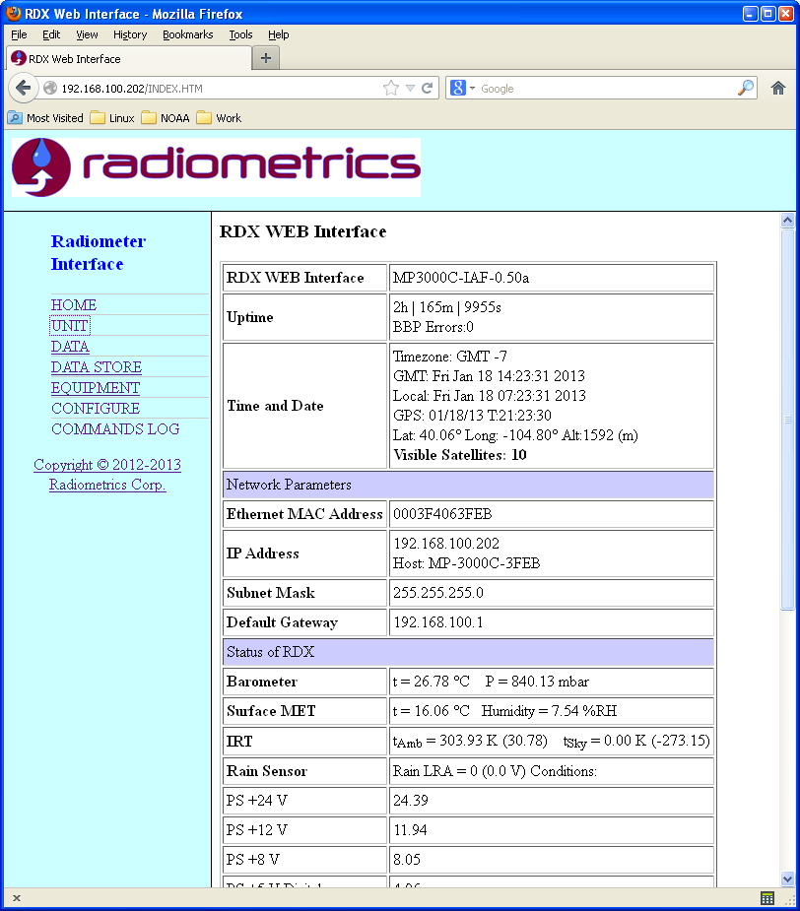
Tab DATA. Shows the latest measured voltages. First panel also shows calculated sky temperatures. The calculations are done using internal calibration values. It is necessary to upload these values for sky temperatures to be shown correctly.

- Uploading calibration constants. It is necessary for showing reasonable sky temperatures. For that use application RDXCCI.exe located in Tools directory mentioned above. This step is not obligatory. If calibration is not set, the DATA tab will continue to show voltages.
Connect to the unit. Open configuration file by clicking “Open” button at the right. Select mp.cfg file. Click “Activate” button which will parse the file and fill all fields in the GUI including bottom frequencies calibration section. Click “Upload” buttons. All these settings will be transferred to the unit. Click “Store in Flash” button to remember all setting in non volatile memory of the units.
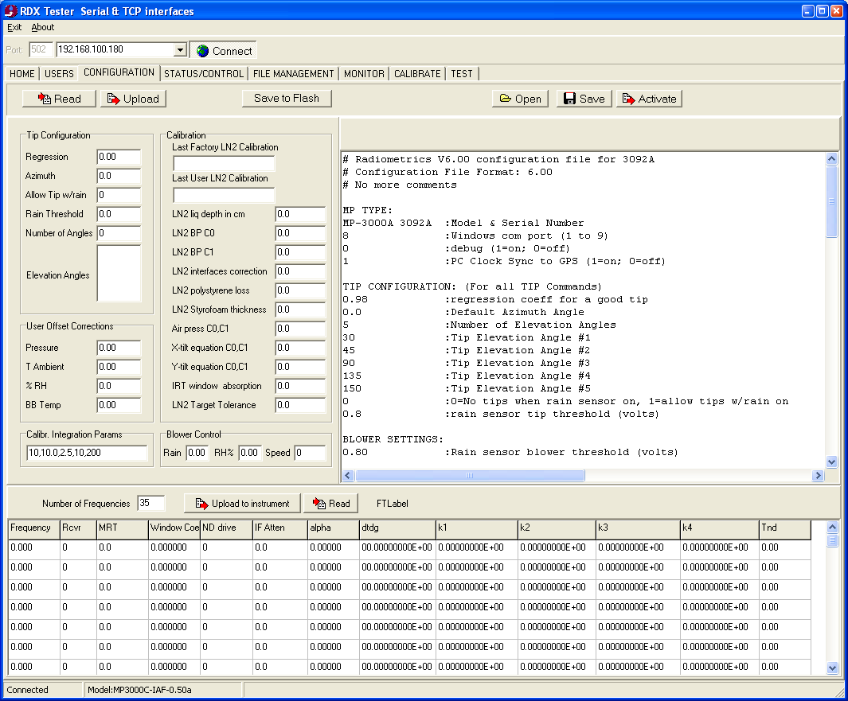

- Clean the SD card.
Open unit’s FTP server. For that right click on “DATA STORE” link and select “Copy Link Location”. Then paste it to Windows Explorer or just type in ftp://192.168.100.xxx in address filed.
Delete all unnecessary files. (Be ware that internal FTP uses 8.3 file naming format, so the file name will be changed after uploading).
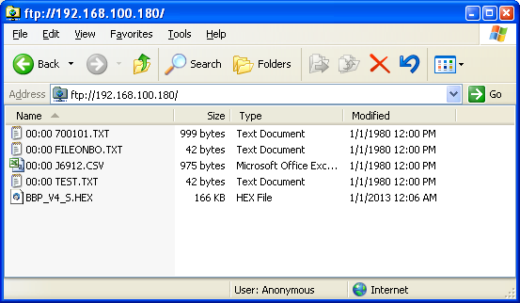

- FTP server. Click “DATA STORE” link to open internal WEB server. It can be opened in Firefox. In IE you may need to copy “shortcut” and paste into address filed of IE. Chrome does not support FTP at all.
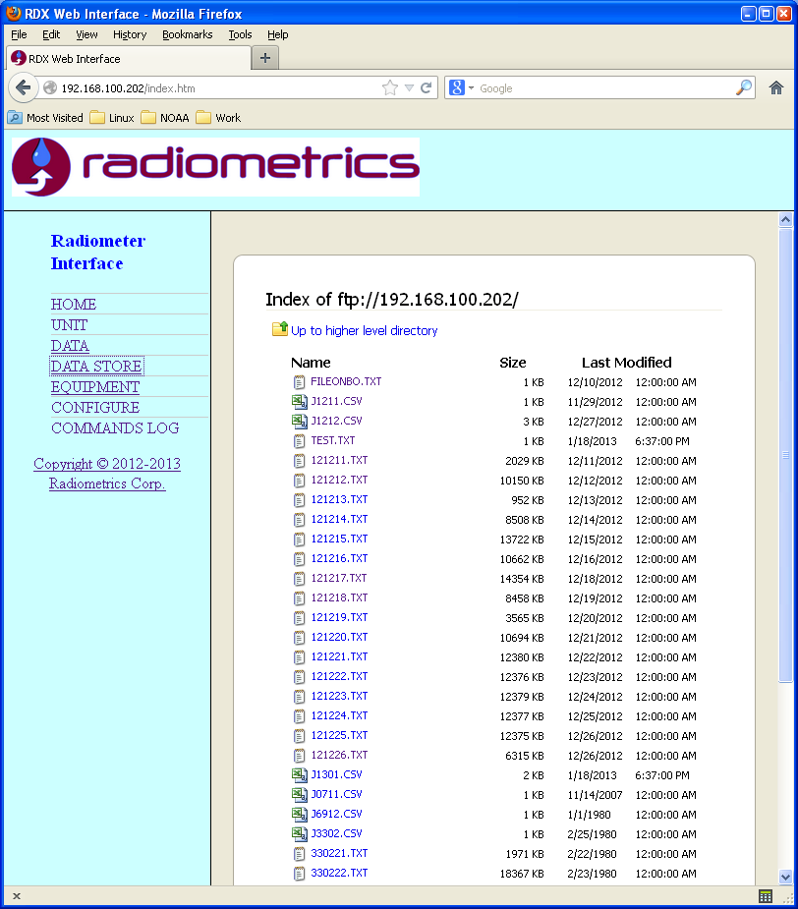
In current version FTP site list two types of files:
J1301 - 13 – year 2013, 01 – January. This file contains records of unit restarts.
130110.txt Name is: YYMMDD for year, month day. Contains some error records.
Upgrade of receiver’s software is also done using this FTP site. Instruction for upgrading receivers software will be provided later.

- MCM_C supporting three interfaces:
ComPort A - 57600, RS422
Aux Port B - 57600, RS422
Telnet.
Do not use more than one port simultaneously. It is possible in manual mode, but not recommended. The interface on second port is non responsive during execution of “long” commands, such as o8.

- Flashing new software to the receivers.
a. Upload the HEX file with BBP software to units FTP site. For that use open FTP in Windows Explorer and drag and drop the file. The file is typically called: BBP_V4_STM32_v1.19_MP_series.hex. When you drop it to FTP, it will be renamed to 8.3 format as BBP_V4_S.HEX by taking first 8 characters of name.
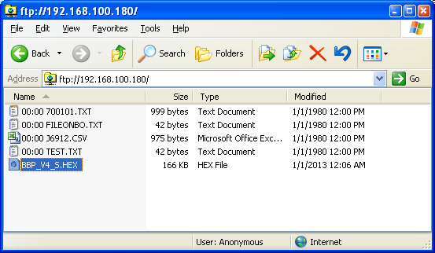
Connect to unit using either serial port or Telnet. Enter command: upload 0 for receiver 0 or “upload 1” for receiver 1. Unit will output ++++++++++++ characters for each programmed record and “done” at the end.

- There are several console commands besides those used by mp.exe.
rcvr 0 CMD data | send command to receiver “0”, command “CMD” with data for the command.
ip | Show IP
mac | Show MAC address
upload 0 | Upload previously loaded into FTP HEX file to receiver 0 (or 1)
reboot | Reboot MCM_C
version | Reports MCM_C revision
setup | Run IP setup in console mode. Serial PortA only !
tilt | Read tilt data from EL drive.

