EPIC Cruise Radiometer Report
Hughs
September 14, 2006
Duane Hazen

Summary
The Microwave Radiometer from the Hughs radiometer data has been reprocessed. The tip curve calibration hand calculated from all the tip curves taken. The main point used for good or bad was symmetry of the tip curve, the next was the air mass error.

NOTE: The liquid and vapor was found from a three channel retrieval if the 90 GHs brightness temperature was greater than 2.75 K and less than total mean radiating temperature.

The Radiometer and Sond vapor and liquid for the cruise looked like this.
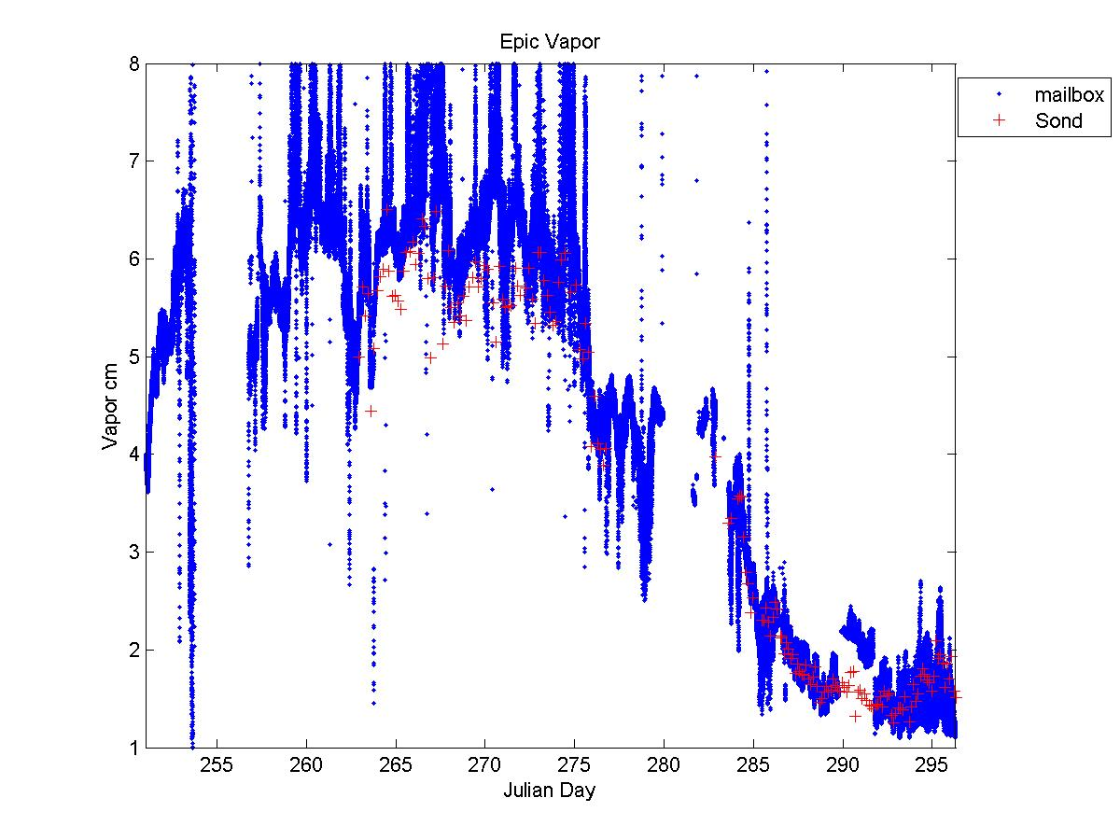
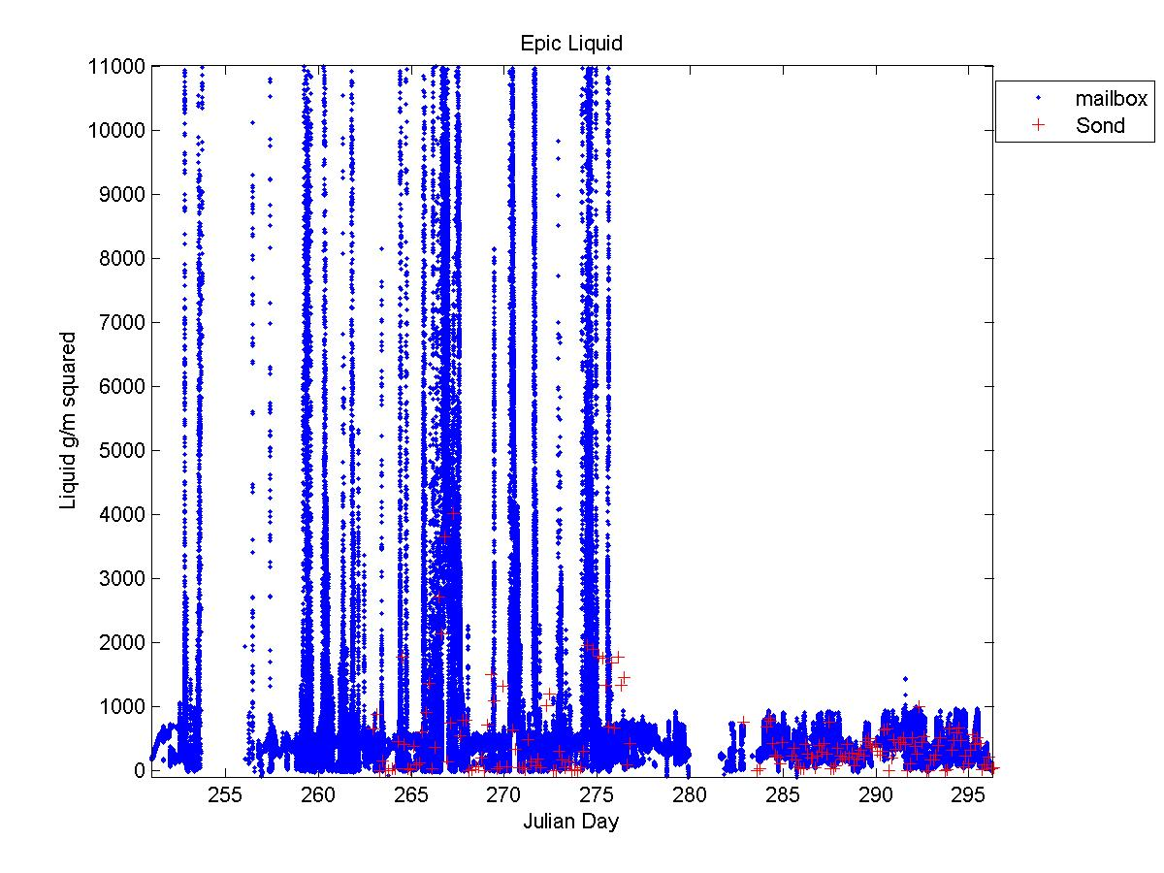

NOTE: The data is presented in units of cm for vapor and g/m² for liquid. The spikes in liquid indicate major rain events

Scatter plot of sond verses radiometer look like this.

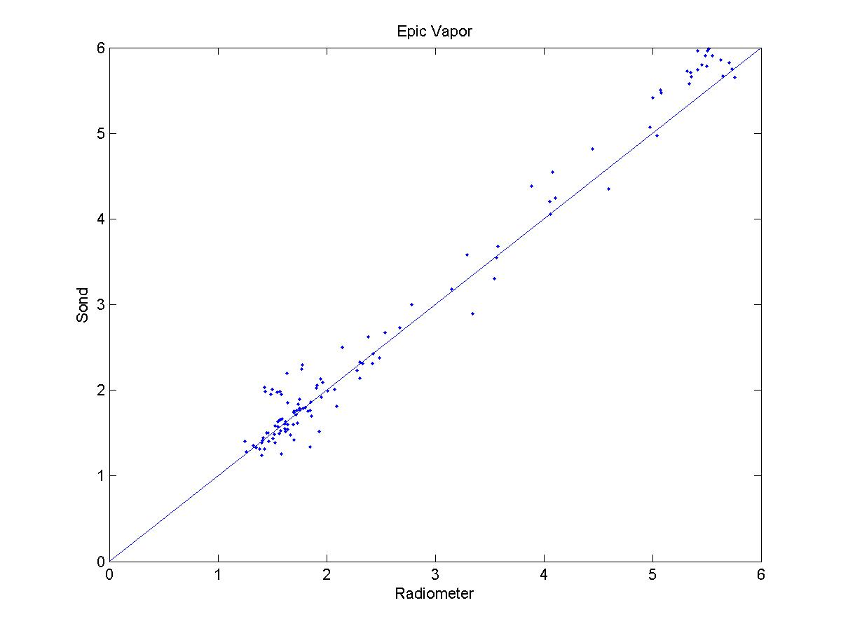
The Brightness temperature looked like this.
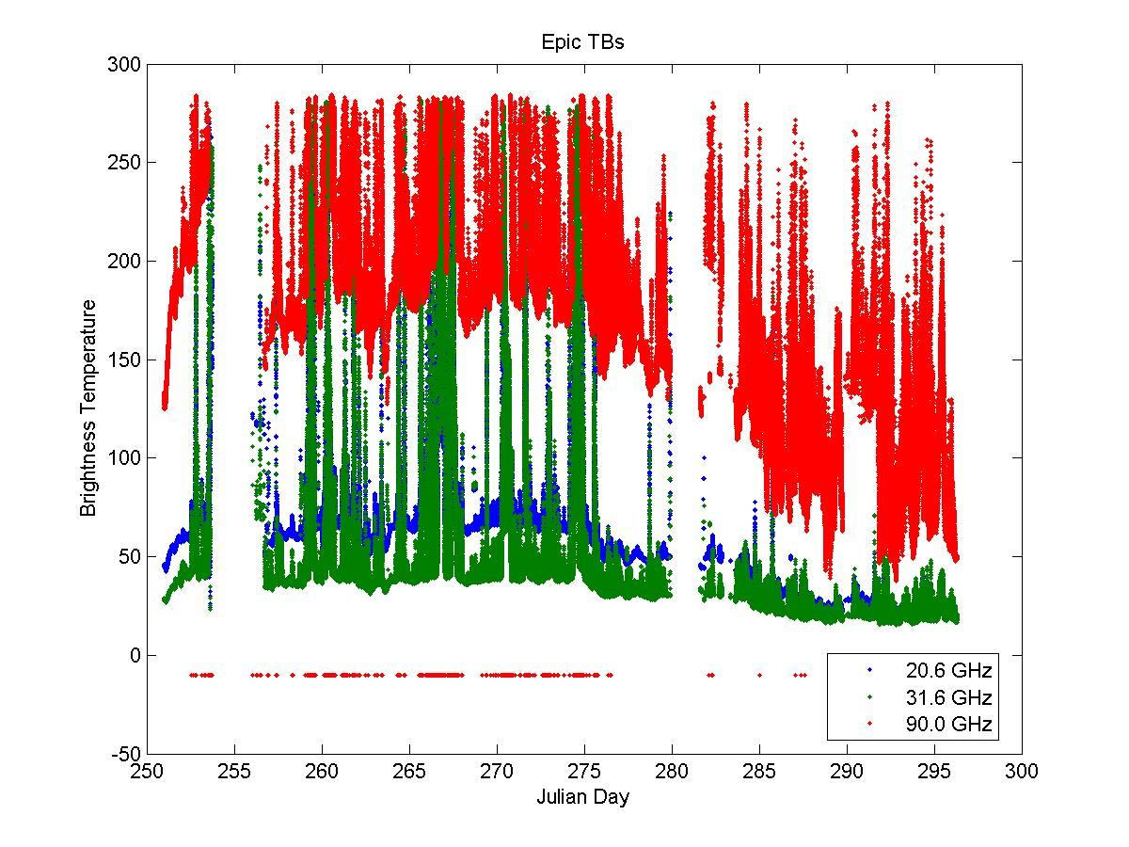
NOTE: That where the 90.00 GHz TB shows as -9.999 (software error code) that the Brightness temperature was greater than the total mean radiating temperature.

The mean difference numbers are. (Sond – Mailbox)

Variable | Mean Difference
TB 20.6 GHz | 14.359
TB 31.6 GHz | 6.667
TB 90.0 GHz | -1.541
Vapor | -0.230
Liquid | -14.243

