Daily Science Report
Stratus2007 Cruise
NOAA Ship Ronald H. Brown
C. W. Fairall (NOAA/ESRL) and R. A. Weller (WHOI)
Report #1 October 18, 2007

Background:

A team of scientists from the Woods Hole Oceanographic Institution (WHOI), the NOAA Earth System Research Laboratory (ESRL) will be onboard the NOAA Ship Ronald H. Brown for a climate processes study in the marine stratocumulus region off Northern Chile. Also on board are scientists from Ecuadorian Instituto Oceanográfico de la Armada (INOCAR), the Insituto del Mar del Peru (IMARPE), the Peruvian Hydrographic Service, and CSIRO Australia. The cruise begins on October 16, 2007 in Panama, proceeds along the west coast of South America to a Chilean tsunami warning buoy (Servicio Hydrografico y Oceanografico del la Armada de Chile or SHOA) buoy at 20 S, 75 W that has been equipped with WHOI meteorological sensors, then to an experimental area centered at a WHOI climate reference buoy at 20 S 85 W, and ends in the Galapagos Islands on November 6 (Fig. 1). This investigation will address problems in prediction of short-term climate variations in sea surface temperature and upper ocean structure and related phenomena such as El Niño. The ESRL observations (conducted while the WHOI buoy at the site is serviced) provide a more detailed atmospheric context for the buoy data, which cover the annual cycle. While underway surface drifter and Argo profiling floats will be deployed and an underway profiling CTD (conductivity-temperature-depth) profiler will document the structure of the upper ~200 m of the ocean.

This experiment will be the seventh in an annual series of research cruises to this marine stratocumulus region, performed as part of NOAA’s Climate Predictions Program for the Americas (CCPA) and Climate Observations (CO) Programs. The combined ship and buoy observations are intended to reveal coupled ocean-atmosphere processes in the upwelling/stratocumulus system off Chile. Included in this experiment are atmospheric systems that measure coincident cloud microphysics (i.e., size and number of cloud droplets) and near-surface aerosols (i.e., size and number of atmospheric aerosol particles). Marine aerosols may be transported from land sources or generated locally by sea spray and gas emissions from oceanic plankton. These simultaneous observations will permit direct measurements of aerosol effects on the reflectivity and precipitation of marine stratus clouds. The WHOI flux reference buoy is the principal oceanographic observations system, but a number of supplementary observations (underway CTD, current profiler, oceanic PCO2 and DMS) are done from the ship during the cruise.

The southeastern Pacific Ocean is an important climatic region where the interactions between the atmosphere and ocean affect regional and global climate variability. Present climate models have well-known sea surface temperature biases in stratocumulus regions, which are believed to be partly related to overly simplified treatments of cloud, air-sea interaction, and oceanic mixing processes. This research supports NOAA's climate goal by providing better understanding of the effects of persistent stratus cloud coverage on ocean temperatures in order to improve climate models and predictions.

Summary of Recent Activities

The ship departed Panama as planned the morning of October 16. Observations were officially begun on October 18. The ship reached 3 S 81.8 W by the end of October 18 (Fig. 2). The ESRL observations include air-sea fluxes/near-surface bulk meteorology, cloud ceilometers, radar wind profiler, scanning Doppler C-band precipitation radar, a microwave radiometer for column water vapor/liquid, and aerosols in the 0.1 to 6 micrometer range. Rawinsonde launches began at 1200 GMT and will continue every 6 hours until reaching the buoy location at 20 S 85 W when the frequency will increase to every 4 hours. A sample rawinsonde profile is shown in Fig. 3; a strong subsidence inversion typical of stratocumulus regions is visible at a height of 500 m. Fig. 4 is a photograph taken later in the day. The cloud ceilometer return for the day is shown in Fig. 5.

Underway CTD observations clearly show the change of oceanographic regimes as the ship went from the heavy precipitation region in the Gulf of Panama into the cold upwelling region off Ecuador. This surface temperature is superposed on the ship track in Fig. 6. A waterfall plot of the temperature and salinity is shown for the transect in Fig. 7.

The ship will continue underway SSE for about three more days before reaching the SHOA tsunami buoy at 20 S 75 W.

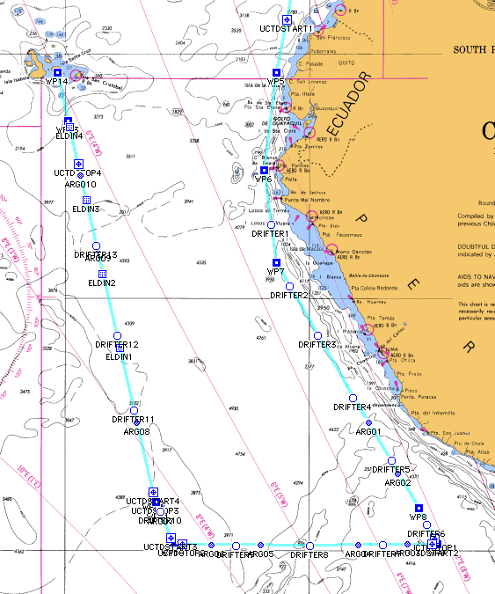

Figure 1. Planned cruise track for the NOAA Ship Ronald H. Brown for the Stratus07 field program.

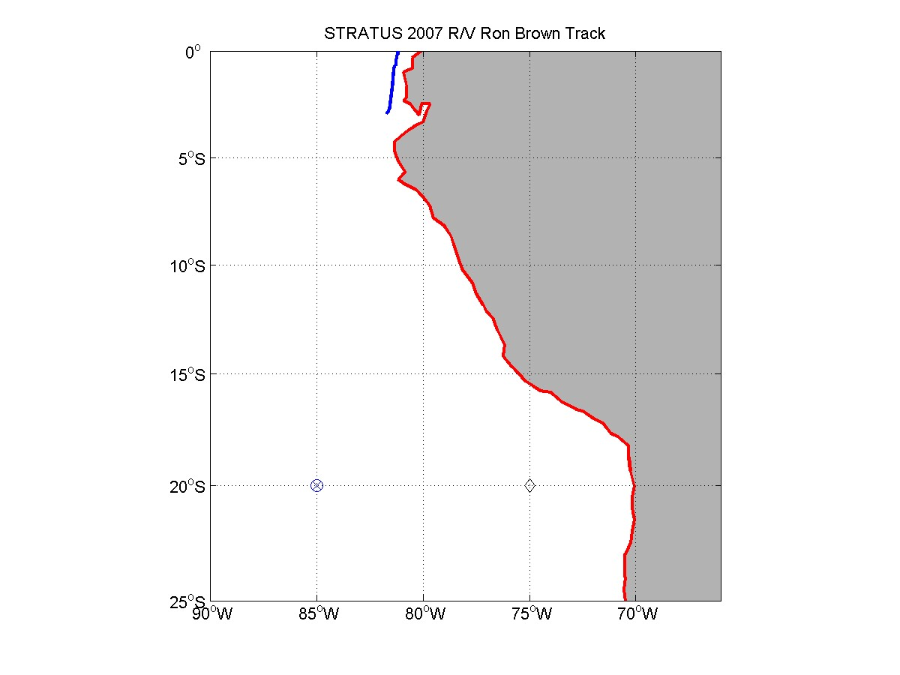
Figure 2. RHB cruise track on JD291 (Oct. 18). The diamond at 75 W is the SHOA tsunami buoy; the circle/plus at 85 W is the WHOI buoy.

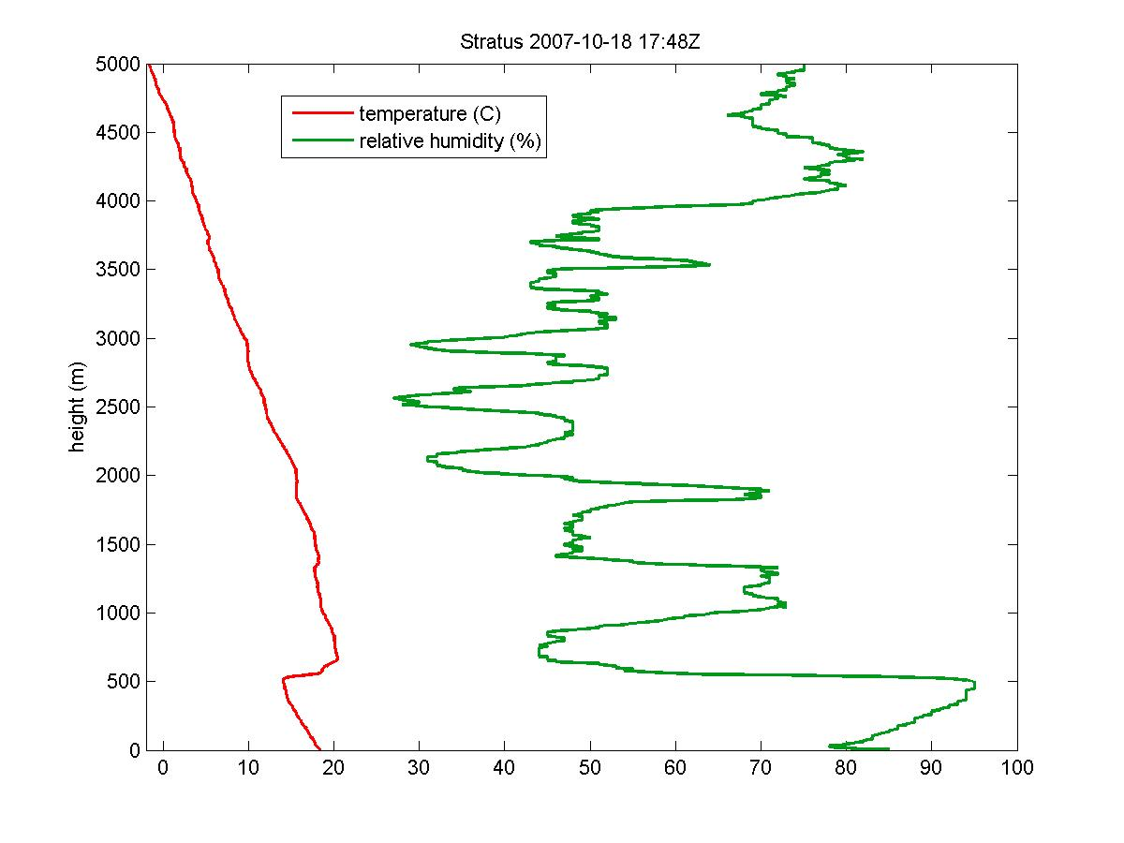

Figure 3. Rawinsonde profile 2300 GMT October 18.

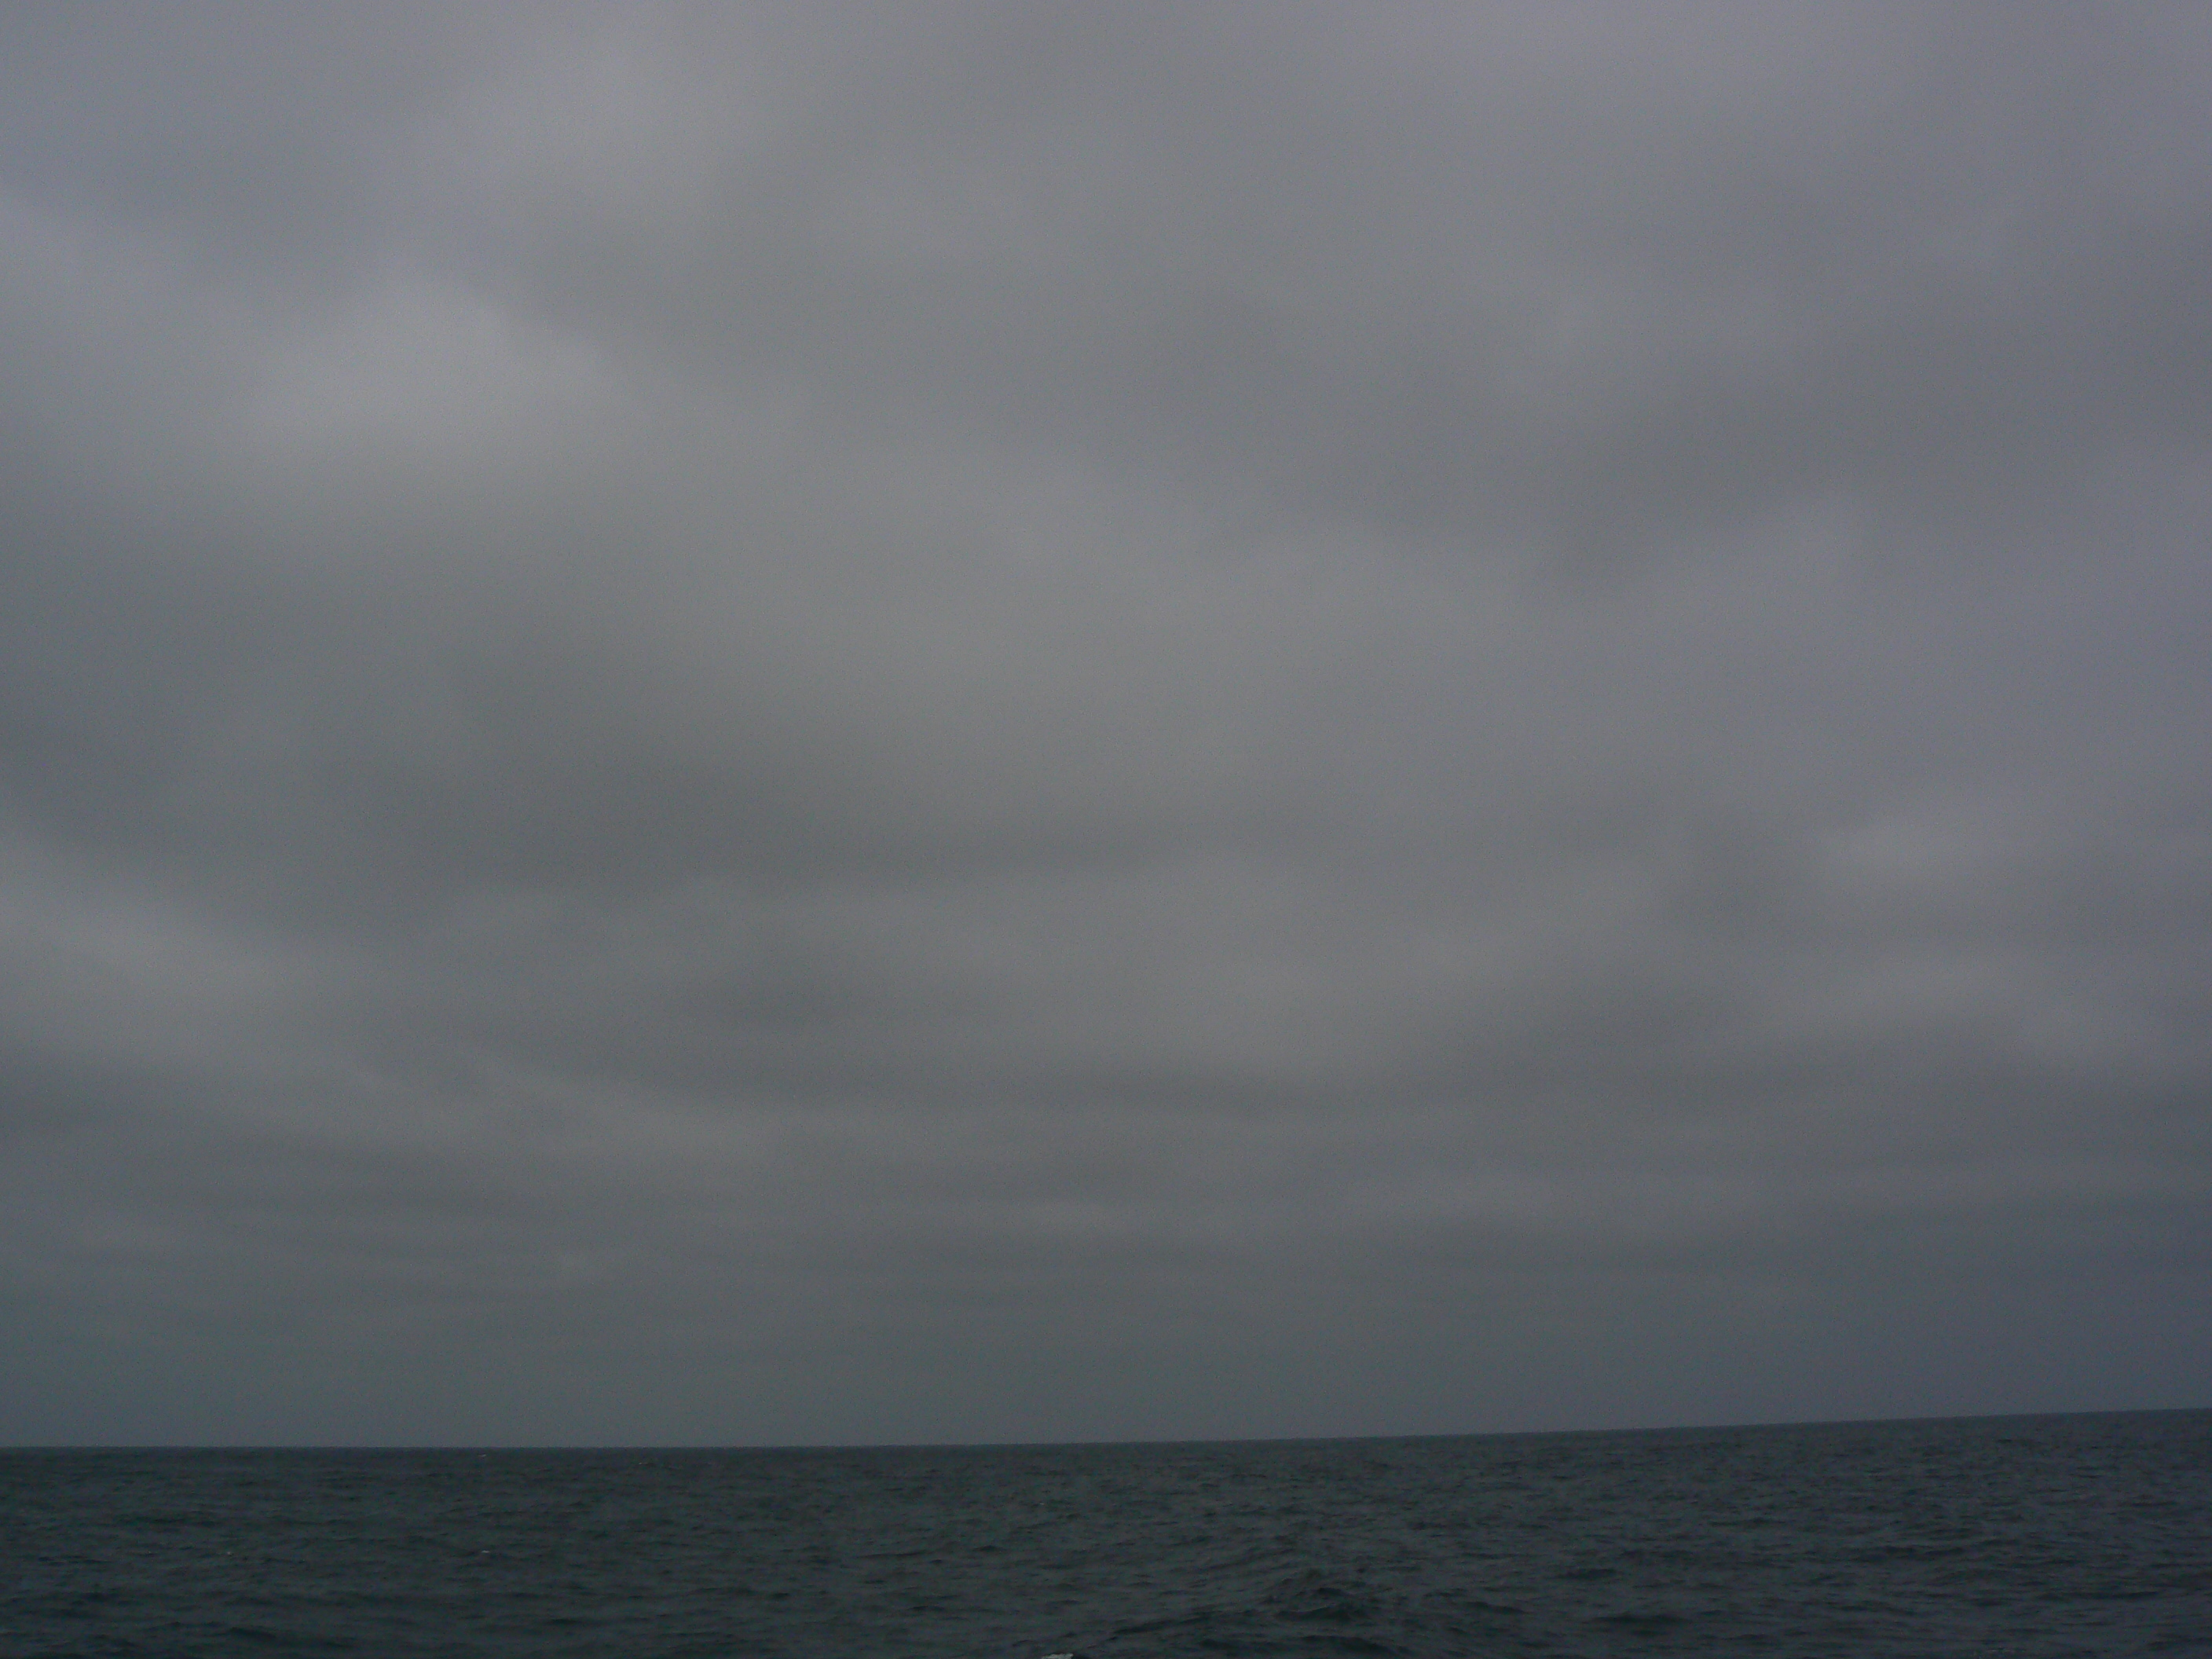
Figure 4. Photograph of stratocumulus clouds 1800 GMT October 18 at 4 S 82 W.

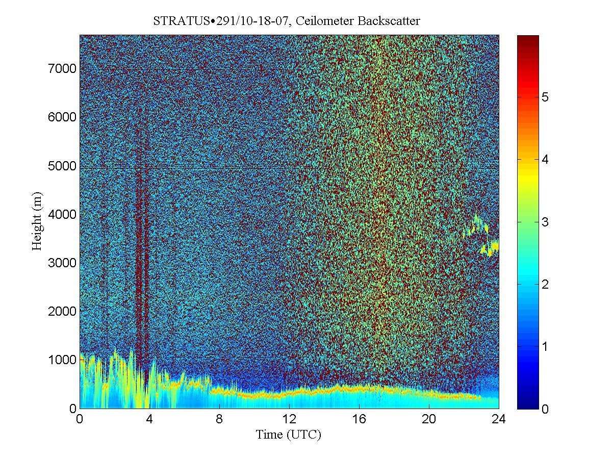
Figure 5. Time height cross section of ceilometer backscatter signal.

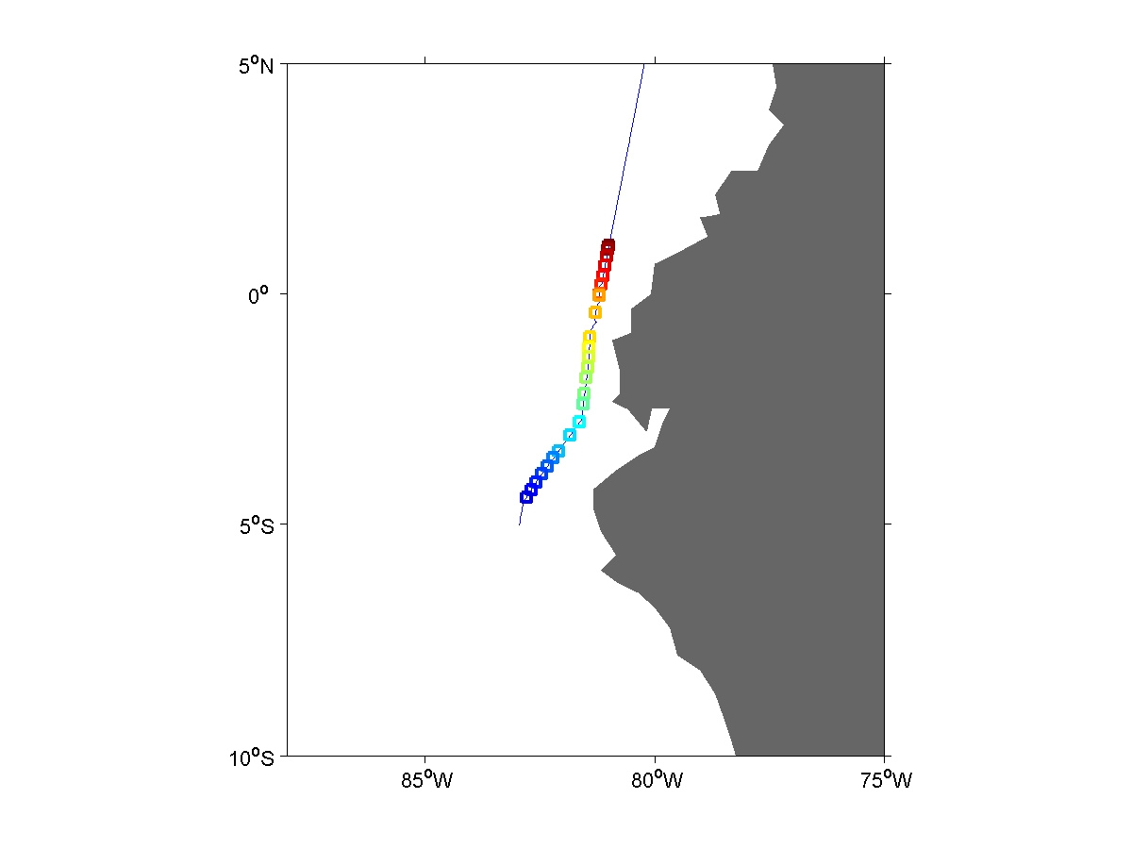
Figure 6. RHB cruise track with underway CTD near-surface SST superposed as color.

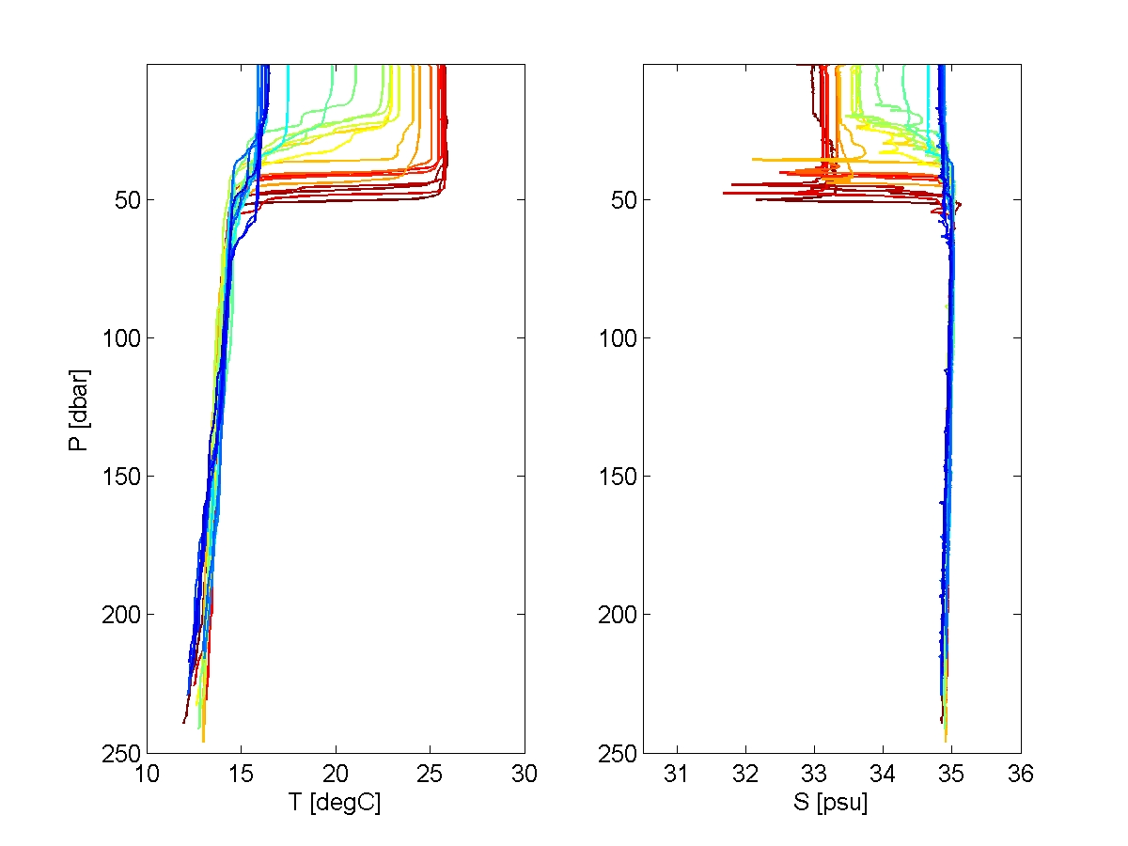

Figure 7. Waterfall plot of CTD temperature (left panel) and salinity (right panel) versus depth for the cruise track shown in Fig. 5.

