Daily Science Report
Stratus2007 Cruise
NOAA Ship Ronald H. Brown
C. W. Fairall (NOAA/ESRL) and R. A. Weller (WHOI)
Report #14 October 31, 2007

Summary of Recent Activities

The ship departed Panama as planned the morning of October 16. Observations were officially begun on October 18. The ship reached 20 S 75 W by the end of October 22 and spent almost two days at that location before departing to the west on October 24 and arriving at the WHOI buoy at 20 S 85 W on about 1200 GMT October 26 (Fig. 1). We departed this location 1200 GMT October 31. The ESRL observations include air-sea fluxes/near-surface bulk meteorology, cloud ceilometers, radar wind profiler, scanning Doppler C-band precipitation radar, a microwave radiometer for column water vapor/liquid, and aerosols in the 0.1 to 6 micrometer range. Rawinsonde launches are being made every 4 hours (since arriving at the WHOI buoy). A sample rawinsonde profile taken at mid-afternoon local (1600 GMT) is shown in Fig. 2. This sounding shows a transition approaching a trade wind structure with a strong subsidence inversion at a height of about 1600 m and a secondary (cloudbase) inversion at about 600 m. Fig. 3 is a photograph taken at 1800 GMT.

The cloud ceilometer cloudbase height for the last six days is shown in Fig. 4; this figure shows an apparent diurnal cycle in cloud base height although much of the lower cloud base heights are associated with scud clouds and drizzling systems. POC periods are apparent as periods of streaks of drizzle and scud clouds. In Fig. 5 we show the time height cross section of backscatter intensity from the wind profiler which gives cloud top (inversion) height with cloud base from the ceilometer. This day contrasts sharply with yesterday (where clouds were unusually thick for the first 16 hours of the day, then abruptly cleared at 1700) where a transition state to trade cumulus is apparent. Here a fairly think stratus layer is visible with tops at 1.5 km while small cumulus clouds with cloud bases at 600 m are seen occasionally. Both the soundings and the cloud measurements suggest a transition to a different cloud regime.

In Fig. 6 we show the data from the aerosol system for the period from October 22 through October 31. The passage of a small POC is apparent as the W-shaped feature in the aerosol concentration on JD 301 and another on JD302. In both cases it looks like the depletion of aerosols was a maximum at the leading and following edge of the POC. The clear period on October 30 does not appear to be associated with a POC. The high values at the end of the period are contamination by the ship’s plume resulting from running downwind.

Major oceanographic activities centered on data transfers after the previous day’s buoy operations and preparations for deployment of a Tsunami buoy tomorrow.

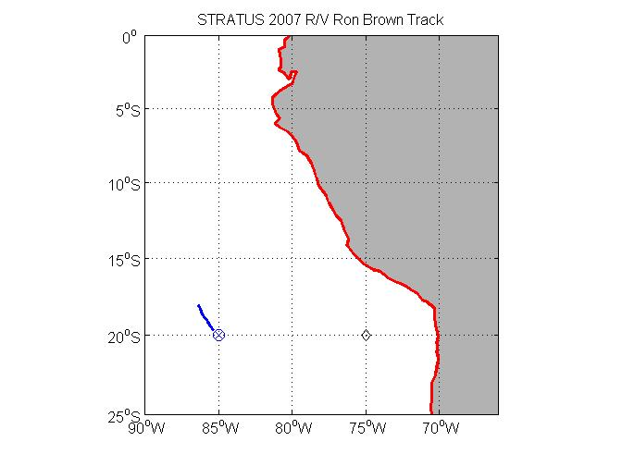
Figure 1. RHB cruise track on JD304 (Oct. 31). The diamond at 75 W is the SHOA tsunami buoy; the circle/plus at 85 W is the WHOI buoy.
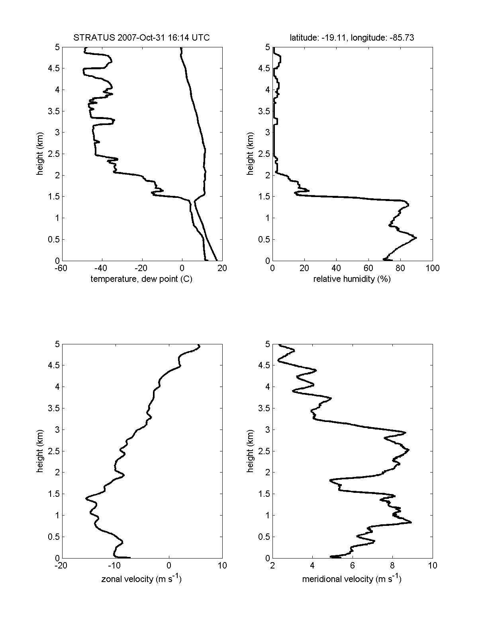
Figure 2. Rawinsonde profile 1600 GMT October 31.

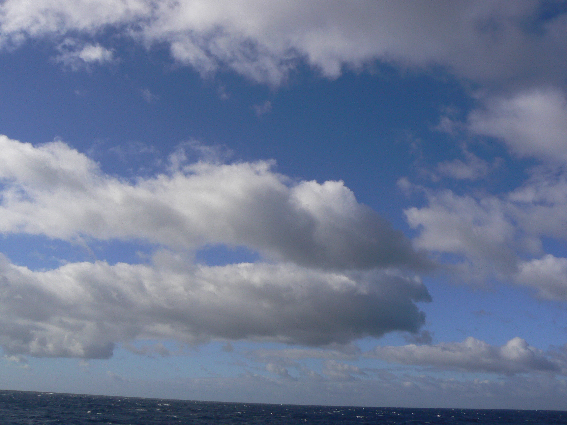
Figure 3. Photograph of stratocumulus clouds 1800 GMT October 30 at 20 S 85 W.
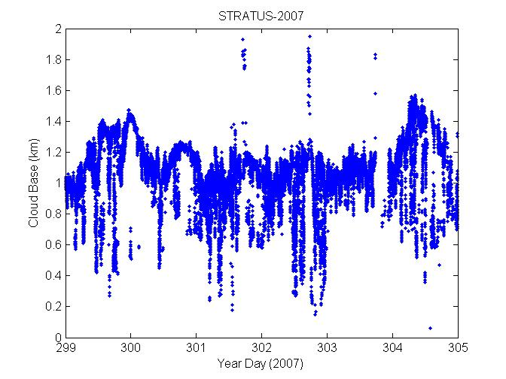
Figure 4. Time series of ceilometer cloudbase height from October 26 through October 31.

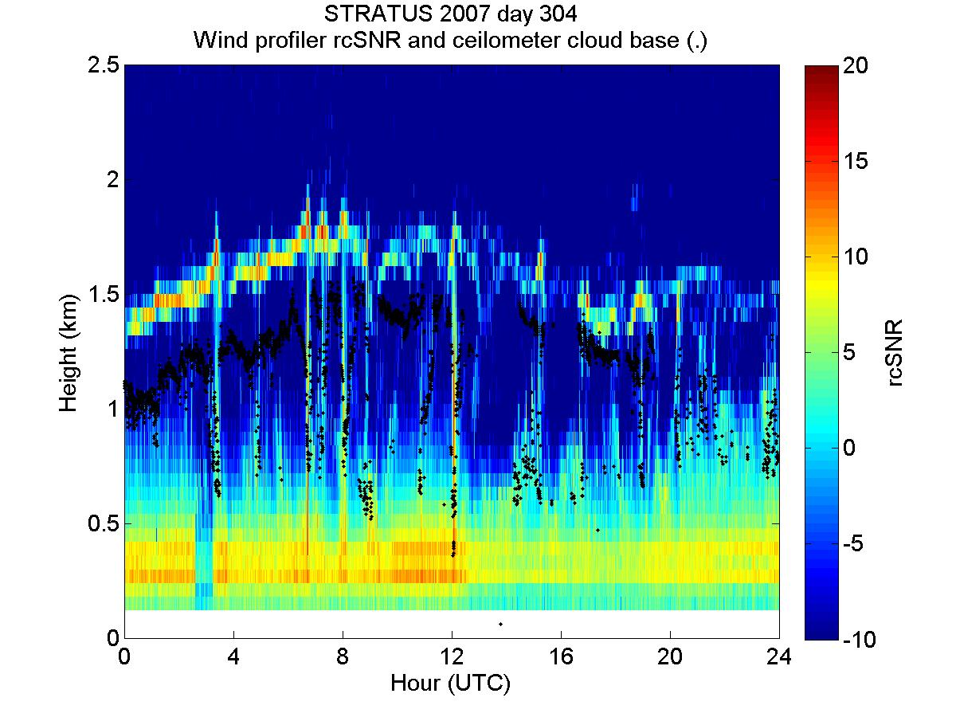
Figure 5. Time-height cross section of radar wind profiler backscatter intensity (color contours) with ceilometer cloud base heights (black dots) for October 31.
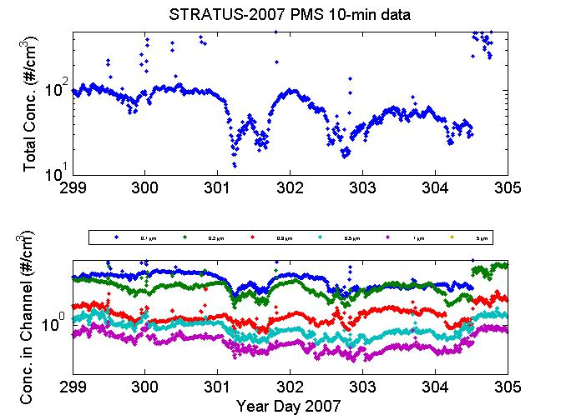
Figure 6. Time series of aerosol concentrations from October 26 through October 31. Upper panel: Total concentration for sizes from 0.1 to 5 micrometer. Lower panel: size resolved concentrations.

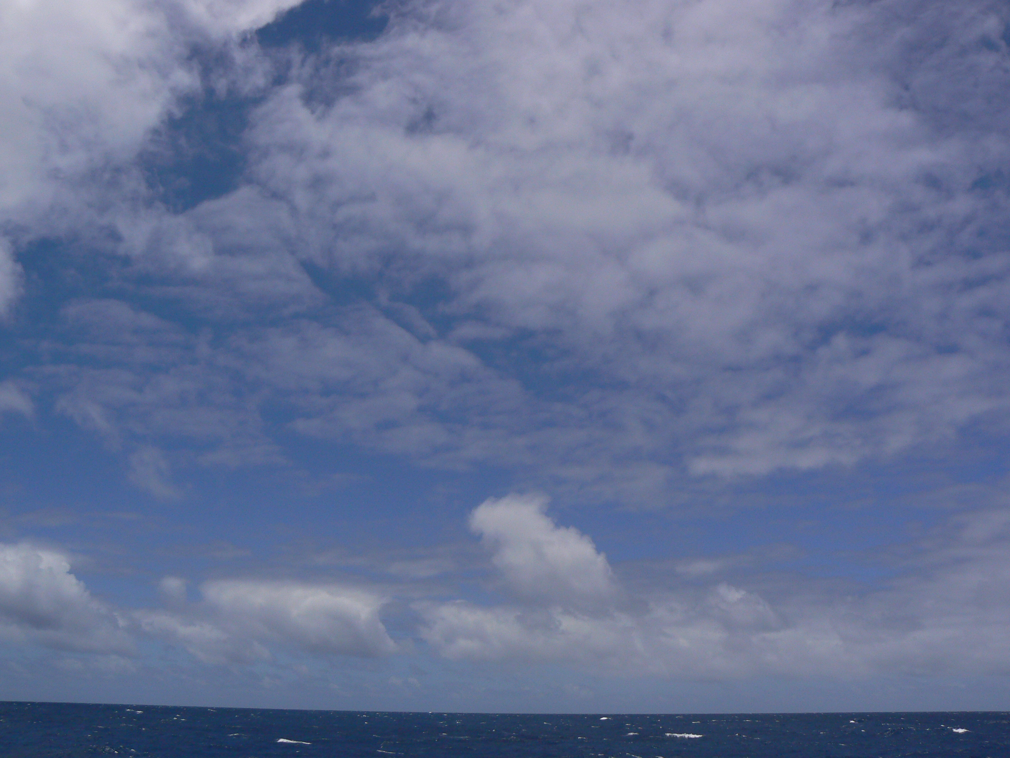
Figure 7. Photograph of clouds on October 31.

