SKQ201512S / SeaState DRI: Brief Analysis of Bulk Met Observations

Byron Blomquist, Ola Persson, Chris Fairall, Sergio Pezoa

NOAA ESRL/Physical Sciences Division
And
University of Colorado, CIRES

Oct 2015

Summary:

This report is a brief analysis of various bulk meteorological data during the SeaState cruise. The main conclusions are:

1) Wind speed measurements for NOAA and ship anemometers agree well but show the inevitable effects of air flow distortion. Flow correction factors for mean wind are somewhat uncertain for this ship and should be investigated.

2) Agreement among air temperature measurements looks great.

3) The ship’s RH measurement is malfunctioning or out of calibration.

4) The ship’s IR flux measurement is affected by bad case and dome temperature values. The IR flux could be recomputed using temperatures estimated from other sources.

5) The ship’s solar flux measurement has a fairly large negative bias but otherwise follows the trend of the NOAA PSPs. We need to evaluate the specifics of shading interference for all the sensors.

6) The various atmospheric pressure sensors are in excellent agreement under calm conditions but show rather large biases in moderate to high winds due to dynamic pressure effects.

7) SST / surface temperature….

Wind Speed:

NOAA/PSD installed two Metek 3D sonics (heated) on the bow: one at the top of the tower and another on a davit at the nose of the bow. The ship’s 2D Gill sonic (also heated) is located ~ 70 cm to port of the NOAA sonic and 25 cm lower. The ship has two additional 2D heated Gill sonics on the main mast (port & starboard).

In general, wind speeds from anemometers on the bow tower compare very well (Figure 1).

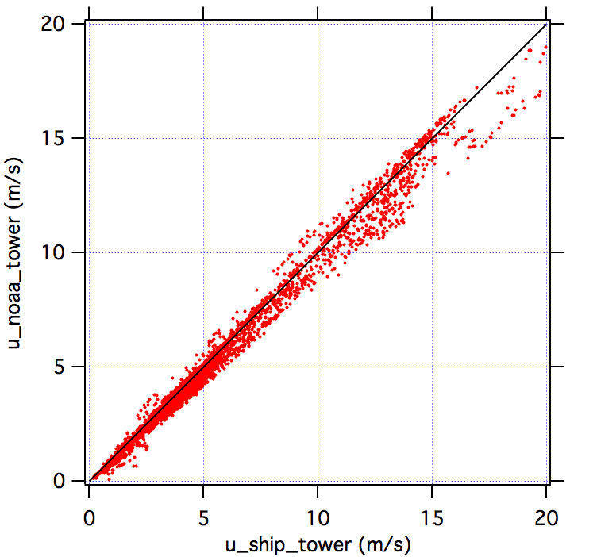
Figure 1: True speed from bow tower sonic anemometers (10-min averages).

Differences between the ship and NOAA tower sonics are a function of relative wind direction, illustrating the effects of airflow distortion over the tower superstructure and differences that arise for even modest displacement distances between identical sensors (Figure 2). For wind from port or starboard directions the ship anemometer reads 1–2 m/s higher than the NOAA sonic. For bow-on winds the difference is much less significant. When the relative wind direction exceeds +/- 90° neither sonic should be trusted; the main mast anemometers are likely better.
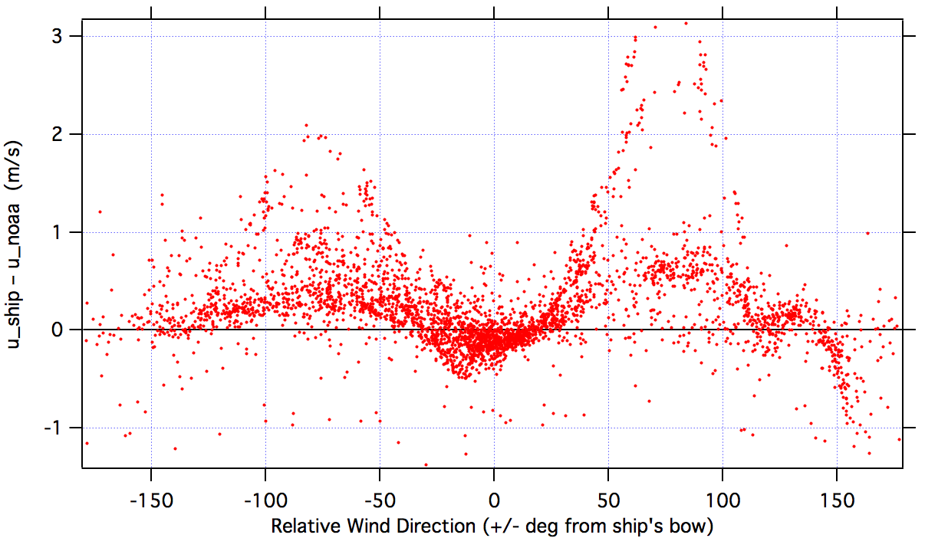
Figure 2: Difference in 10-min average true wind speed between the NOAA and ship tower sonics vs relative wind direction. Negative relative wind direction is to-port.

Airflow distortion is further illustrated by the observed flow tilt angle at the locations of the two NOAA sonics (Figure 3). The 5–7° flow tilt on the tower is comparable to most ships we have worked on. Flow tilt and distortion is strongly influenced by relative wind direction at the lower position on the bow davit. The true tilt angle for the lower sonic may be less than indicated because the sonic mounted with a slight backward tilt.
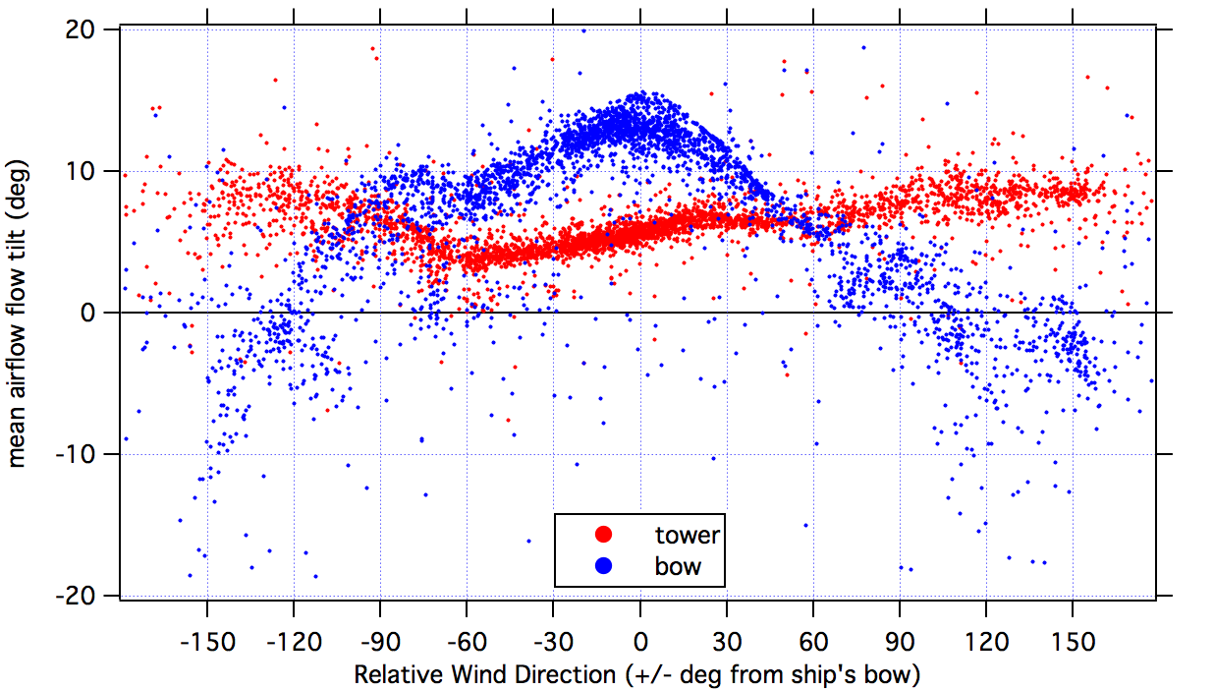
Figure 3: Airflow upward tilt angle for the two NOAA sonics vs relative wind direction.

Flow distortion leads to a bias in true wind speed and direction. NOAA/PSD has determined correction factors for wind speed bias on the bow towers of several comparable research ships (Brown, Knorr, Revelle). We typically apply a correction factor of 0.95 to the U (fore-aft) wind component and a factor of 1.15 to the V (port-stbd) component. R/V Sikuliaq has a bit different wind profile from these ships and these correction factors may not be appropriate.

Sikuliaq is tentatively scheduled for a HOT cruise out of Honolulu in Fall 2016. If this cruise goes forward it presents an ideal opportunity to compare the ship’s wind measurements with the Woods Hole WHOTS buoy at station ALOHA. Trade winds at the HOT site are consistently 8-12 m/s easterlies. Recording wind at a variety of headings in the vicinity of the buoy should provide sufficient data to evaluate the effects of flow distortion on mean true wind speeds from the ship’s various anemometers.

Air Temperature:

NOAA installed two T/RH systems at the top of the bow tower: an aspirated, non-heated T/RH probe (Vaisala HMT 335) and a similar non-aspirated system with separate T and heated RH probes (Vaisala HMT 337). The ship uses a 3-in-1 T/RH/P instrument (Vaisala PTU 307), also with separate T and heated RH probes. The PTU 307 and HMT 337 sensors were mounted within 1 m of each other on the port side of the tower. The HMT 335 was on the starboard side of the tower platform. Air temperatures from the 3 systems agree to within 0.2°C. Comparison of the HMT 337 and PTU 307 systems is shown in Figure 4.

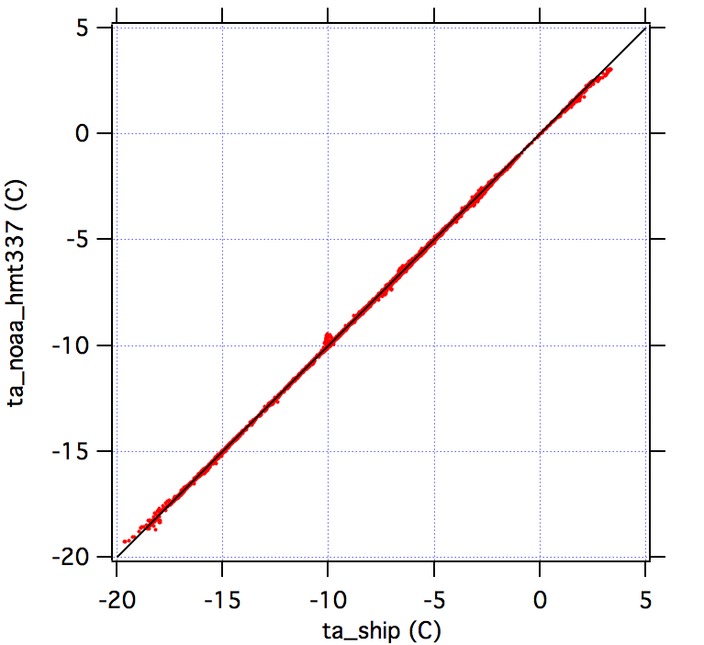
Figure 4: Comparison of NOAA HMT 337 and ship PTU 307 air temperature.

Relative Humidity:

The two NOAA RH sensors generally agree within ~2% except for periods when the unheated HMT 335 sensor is iced up, as in Figure 5 during the first half of day 283 (Oct 10). PTU 307 RH shows more variability than the NOAA HMT 337 and is generally biased high by 10–15% RH, exceeding100% RH much of the time. The ship’s RH probe should be calibrated or replaced as necessary.

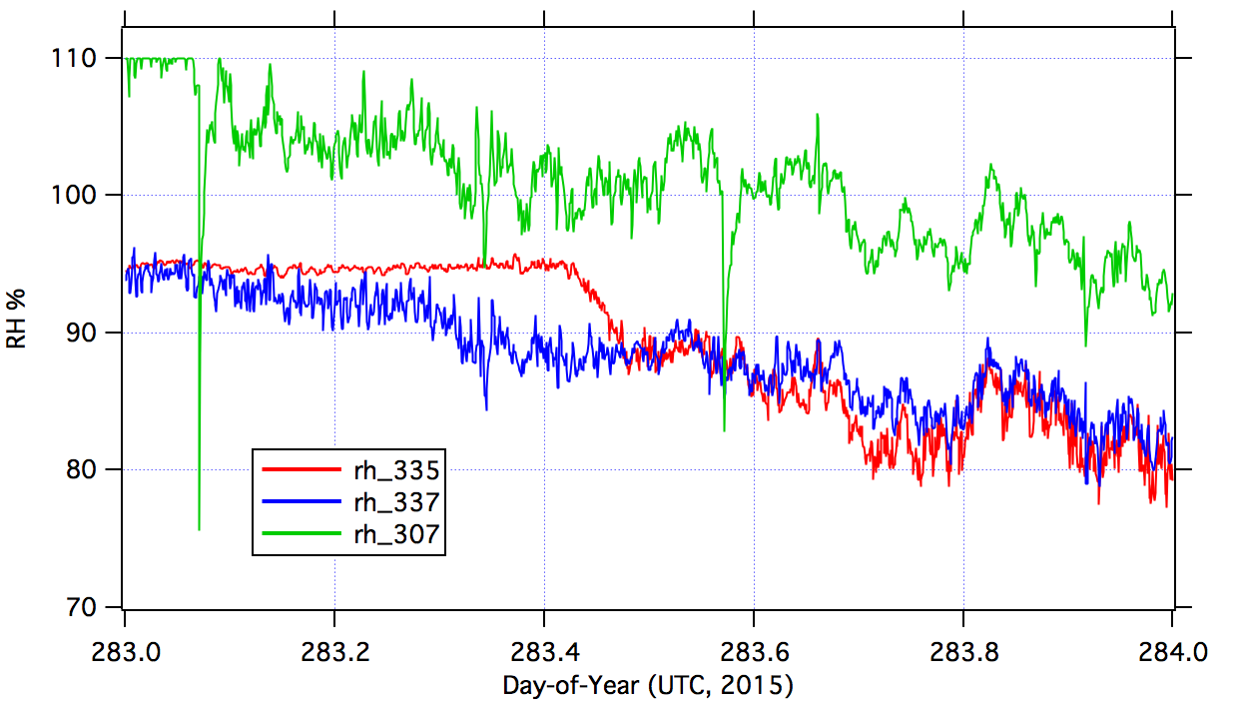
Figure 5: RH time series for Oct 10 (DOY 283)

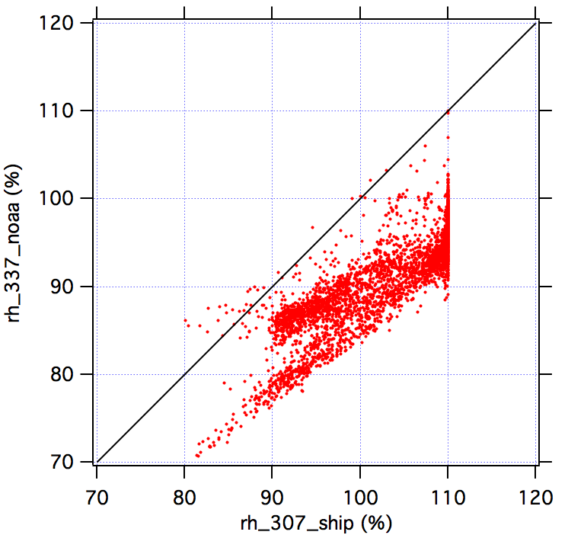

Figure 6: Comparison of HMT 337 and PTU 307 relative humidity.

Longwave Downwelling Radiation (Eppley PIR):

NOAA installed two Eppley PIRs on the aft port-side railing of the bridge roof (05 level). The ship’s radiometers are located on the starboard-side 03 level at mid-ship, on the aft wheelhouse roof. The NOAA data logger records raw PIR output and computes the IR flux with coefficients from the most recent Eppley calibrations. The ship’s PIR and PSP radiometers are an integrated system from RMR Co. with direct serial output.

The two locations are undoubtedly subject to different shading and interference patterns, which we plan to evaluate as part of the post-cruise analysis. At times the IR measurements are comparable but often the ship sensor is more than 50 W/m² higher than the NOAA PIRs (Figures 7 & 8).

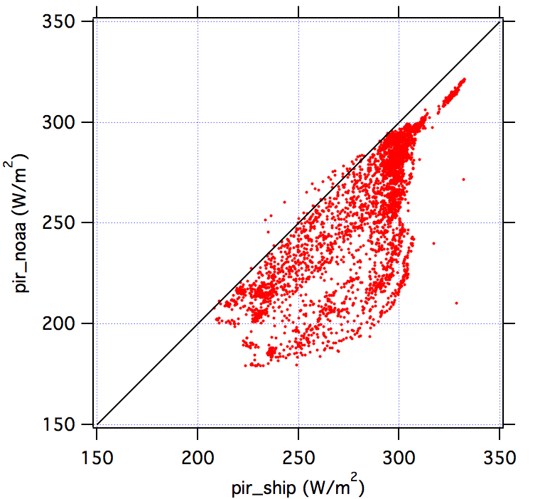

Figure 7: Comparison of ship and NOAA IR flux.

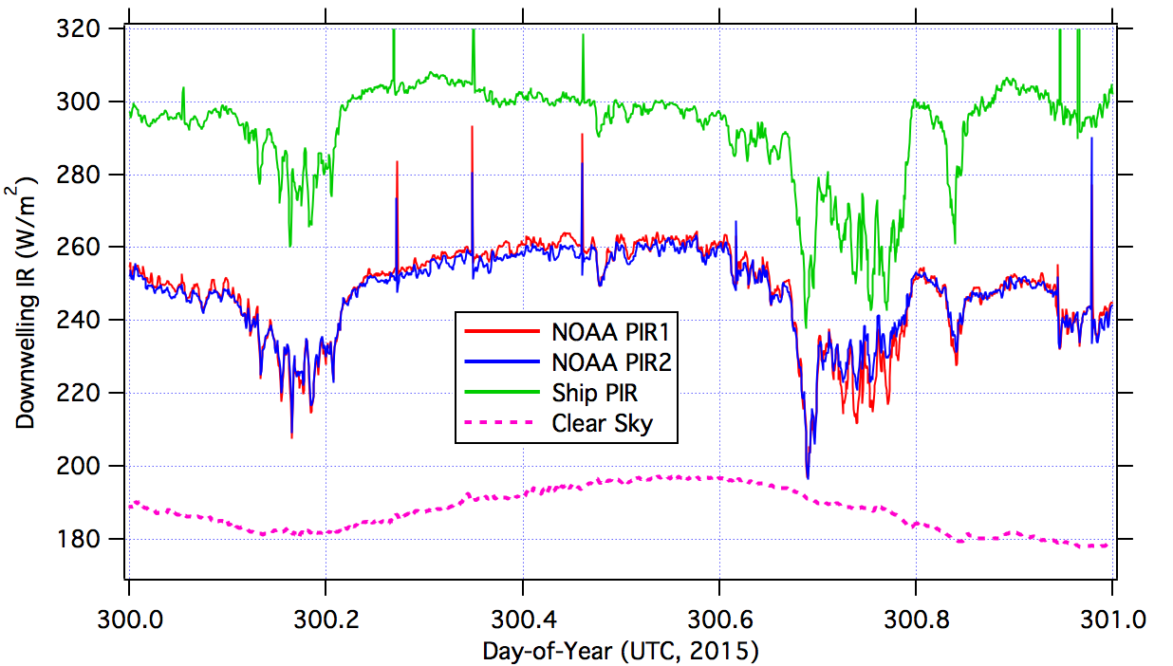
Figure 8: Comparison of downwelling IR on a generally cloudy day with little or no sensor icing. Sharp positive spikes are heat from hand cleanings. Breaks in cloud cover are downward spikes. ‘Clear sky’ is the expected IR flux for cloud-free conditions for this latitude at ambient temperature and specific humidity.

Bias in the ship PIR is due to bad case and dome temperatures. On DOY 300 (Oct 27), for example, case and dome temperatures in the raw file are constant at about –2.8°C all day while air temperatures varied from –11 to –16°C. There’s clearly a problem with the ship’s PIR temperature sensors or the RMR logger. At night and in cloudy conditions PIR case and dome temperatures should closely follow the air temperature. In clear sunlight they will be a bit warmer than air temperature. The IR correction can be recomputed from the raw data substituting observed air temperature or case/dome temperatures from the NOAA PIRs.

The effects of sensor icing are illustrated in Figure 9. This is the most significant problem for radiation measurements in cold conditions. For the PIR it is greatest on clear, cold days when IR flux should approach the expected clear sky value. Instead, the sensor is sees IR emission from the frost at roughly the ambient air temperature, which is warmer than the clear sky blackbody temperature leading to positive bias.

To fill in periods of frost-affected data we can use the clear sky IR value for cloud-free days, validated by the occasional good PIR value immediately following a cleaning. On days with patchy cloud we will need to rely on the readings immediately following cleaning and interpolate for periods when the sensor is frosted. Cloud base temperature (or ambient air temperature in foggy conditions?) should represent the maximum expected downwelling IR flux.

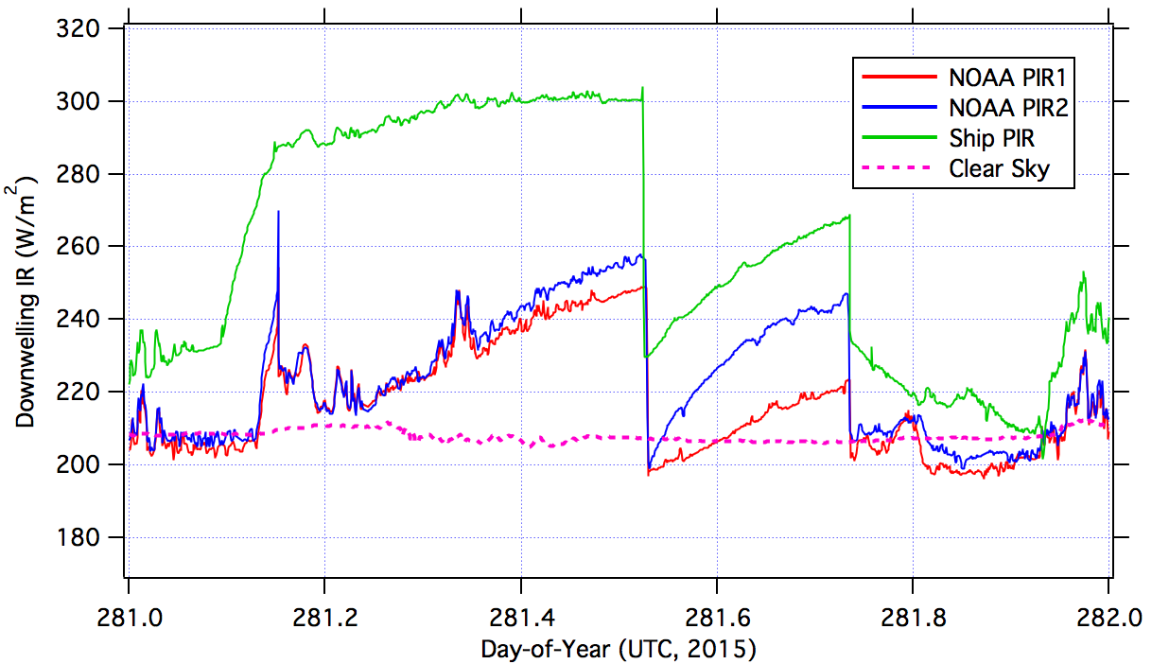
Figure 9: Comparison of downwelling IR on a clear day with significant sensor icing. The observed IR flux should be close to the theoretical clear sky value. It increases significantly as frost forms on the sensor dome, dropping to the clear sky value following each a cleaning. On this day the NOAA PIR1 shows a bit less frost formation. Frost conditions abate toward the end of the day.

Solar Downwelling Radiation (Eppley PSP):

The ship PSP shortwave flux shows a large negative bias relative to the two NOAA radiometers (Figure 10). Nighttime shortwave flux should be near zero or a few watts negative. The linear correlation between the PSP sensors looks fine (Figure 11).

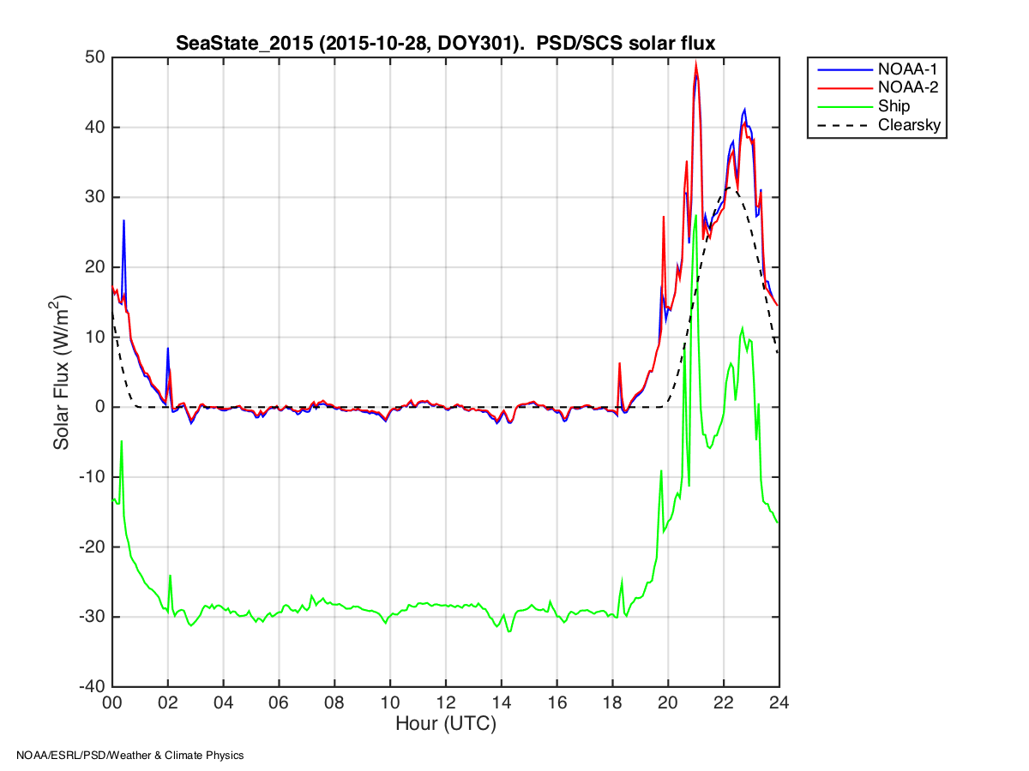

Figure 10: PSP solar flux for DOY 301 (Oct 28).

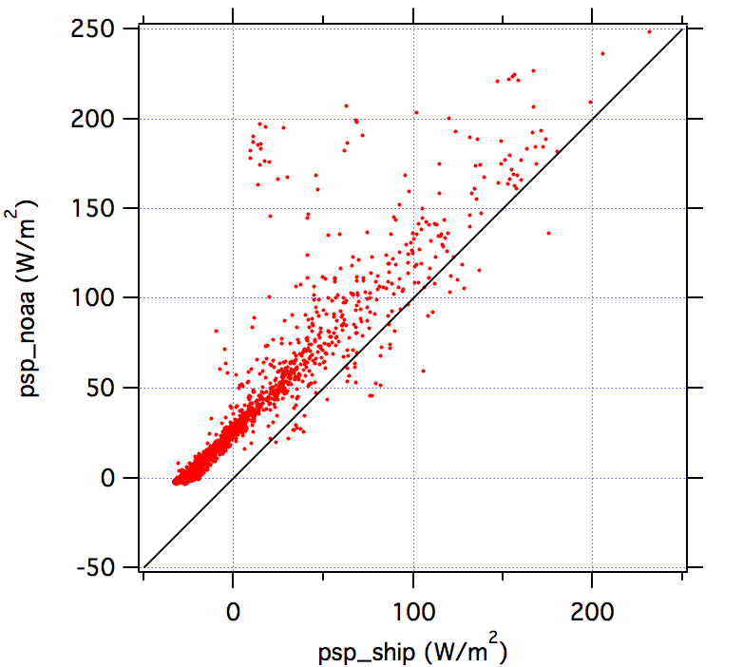

Figure 11: Comparison of ship and NOAA solar radiation sensors.

Pressure:

NOAA installed 3 pressure instruments for this cruise: a mean pressure sensor (Vaisala PTB 220) on the bridge roof (05 level) and two fast response pressure sensors (Paro Scientific 6000) on the bow, at the top of the tower and on the lower davit. The ship’s pressure sensor is from the PTU 307 system on the top of the bow tower.

Corrected to sea level the four pressure sensors agree to within ~0.2 mb under calm conditions or when the relative wind direction is from aft. For wind speeds in excess of ~ 5m/s the pressure measurements diverge by more than 1 mb, illustrating the effects of airflow distortion noted in the discussion on wind speed (Figure 12).

It’s interesting to note the ship pressure and NOAA fast pressure from the tower top differ by more than 1 mb in moderate winds even though they are mounted less than 1 m apart. There’s clearly a local flow distortion over the tower platform affecting both wind speed and pressure measurements. Elevating the anemometers and pressure inlets 1-2 m above the platform can minimize this. It’s also desirable to use an omnidirectional pressure inlet to minimize dynamic pressure effects at the inlet tip.

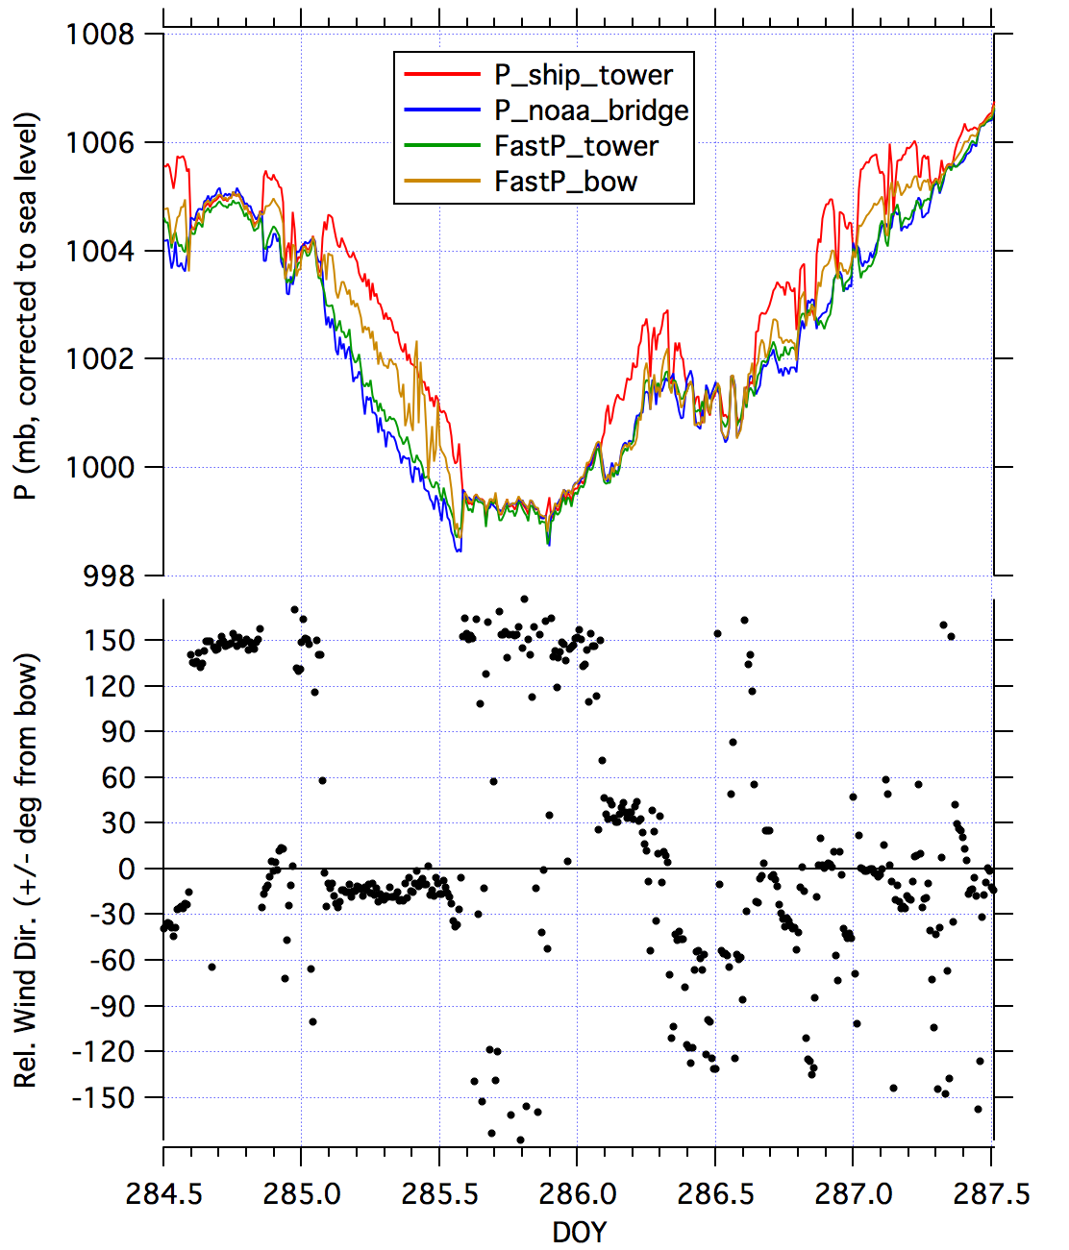
Figure 12: Pressure data for DOY 286, correct to sea surface. When relative wind is in the +/- 60° sector the various pressure measurements differ significantly due to flow distortion and dynamic pressure gradients over the ship superstructure. When wind is from the ship’s stern turbulence over the front of the ship largely eliminates the pressure gradients and the four sensors show close agreement, as they do during calm conditions.

Sea Surface Temperature:

