All times are UTC
All files are ASCII
Contacts for data questions
Daniel.wolfe@noaa.gov
mamille4@ncsu.edu
dpainemal@rsmas.miami.edu

Instrument Filename

90GHz 2channel micro-wave radiometer 20081021.sci
(YYYMMDD year month day)

2008 10 21 0 0 16 4 1 0.000 90.000 -9.99999 -9.99999 0.00 3.54 3.94 861.53 152.148453 0.827091 0.000000 0.000000 0
Col 1 year
Col 2 month
Col 3 day
Col 4 hour
Col 5 min
Col 6 sec
Cols 7-16 ignore
Col 17 Brightness temperature (degrees K)

Passive micro-wave sensor measuring atmospheric emittance at 90GHz, 30 sec sampling

Balloon 0810071415_EDT_LATLON.txt
(year month day hour min)

Time Height Pressure Temp Dew P. RH W Spd W Dir Lat Long GPS Alt
sec mtrs hPa øC øC Pct m/s Az ø Decimal ø Decimal ø mtrs
-0.04 7.0 1012.9 19.65 18.7 94 6.0 181.0 -3.5333545 -83.2567203 7.5
0.96 11.8 1012.3 19.65 18.7 94 4.7 169.3 -3.5333569 -83.2567425 12.9

Vaisala RS-02 digital radiosonde measure T, P, RH and GPS winds

Sonic son00828401_raw.txt
(08=year 284=yearday 01=hour)

10/21/2008 12:00 GILL ANEMOMETER-1210R3 (SN: 0137)
0000029 06,01,-10.84,-05.98,+01.40,+23.31,08

Col 1 mmss.sss
Cols 2 -3 ignore
Col 4 U (m/s)
Col 5 V (m/s)
Col 6 W (m/s)
Col 7 Temperature (degrees C)
Col 8 ignore

3-axis sonic anemometer for measure winds sampled at 10Hz
Motion mot00828401_raw.txt
(mot0=id year yearday hour)

10/21/2008 13:00 SYSTRON AND DONNER-100 (SN: 1124)
0000062 0.03936206,0.02307431,0.02035968,0.1370885,0.2524601,-3.432075,-3.431286

Col 1 mmss.sss
Col 2 accx
Col 3 accy
Col 4 ratex
Col 5 ratey
Col 6 ratez
Col 7 ignore

As mounted: motion-pak
% X is toward port
% Y is toward bow
% Z is down

3-axis accelerometer measure ship motion for correcting sonic anemometer sampled at 20Hz

Flux flux_30hf295.txt
(30 min average Yearday 295)

285.00000 7.83 49.67 31.41 29.61 35.91 29.13 28.34 18.95 -0.92 429.08 -0.03 2.95 138.89 10.37 302.21 16.7708 -81.1652 0.05 0.03 0.085 19.36 230.21 -0.14 29.72 21.59 7.02 53.83 5.00 419.76 1009.10 75.01

IMET refers to the ship's standard meteorological sensors.
PSD refers to NOAA/ESRL/Physical Sciences Division sensors.
These data are provisional and have not been quality controlled.
% Data is formatted in 32 columns representing the following variables:
ydy=x(:,1); % decimal yearday at beginning of time average
U=x(:,2); % true wind, PSD sonic (m/s)
dir=x(:,3); % true wind direction, PSD sonic (deg)
tsnk=x(:,4); % sea snake temperature, PSD, 0.05 m depth (C)
tsg=x(:,5); % sea chest thermosalinograph water temperature, 5.6 m depth, (C)
sal=x(:,6); % tsg salinity (psu)
ta=x(:,7); % air temperature, PSD (C) (z=15 m)
qse=x(:,8); % sea surface specific humidity,from snake (g/kg)
qa=x(:,9); % air specific humidity, PSD (g/kg) (z=15 m)
psp=x(:,10); % downward solar flux, PSD units (W/m²)
rl=x(:,11); % downward IR flux, PSD units (W/m²)
org1=x(:,12); % rainrate, PSD STI optical rain gauge, uncorrected (mm/hr)
ushp=x(:,13); % ship speed, SCS gps (m/s)
head=x(:,14); % ship heading, deg clockwise rel north, SCS laser ring gyro (deg)
urel=x(:,15); % relative wind speed, PSD (m/s)
reldir=x(:,16); % relative wind direction (from),clockwise rel ship's bow, PSD sonic (deg)
lat=x(:,17); % latitude, deg (SCS pcode)
lon=x(:,18); % longitude, deg (SCS pcode)
zts=x(:,19); % depth for bulk flux Ts reference, =0.05 when snake is used
sig_u=x(:,20); % std dev of ship speed, m/s (>.2 indicates maneuver during half hour average)
taub=x(:,21); % bulk wind stress along mean wind, N/m²
hsb=x(:,22); % bulk sensible heat flux, W/m²
hlb=x(:,23); % bulk latent heat flux, W/m² (includes Webb et al. correction)
hrain=x(:,24); % rain heat flux, as per Gosnell et al 1995, JGR, 18437-18442, (W/m²)
ta_im=x(:,25); % IMET air temp, C (z=15 m)
qa_im=x(:,26); % IMET air specific humidity, g/kg (z=15 m)
s_ship=x(:,27); % IMET true wind speed, m/s (z=15 m)
dir_ship=x(:,28); % IMET true wind direction, deg (z=15 m)
psp_ship=x(:,29); % IMET solar flux, W/m²
pir_ship=x(:,30); % IMET IR flux, W/m²
barpress=x(:,31); % PSD atmospheric pressure, mb
RH=x(:,32); % PSD Relative Humidity, %

The air-sea flux system consists of: a fast turbulence system with ship motion corrections mounted on the jackstaff. The fast sensors are: a GILL Sonic anemometer and a Systron-Donner motion-pak. There are several mean sensors: T/RH sensor in an aspirator on the jackstaff, Solar and IR radiometers (Eppley pyranometers and pyrgeometers) mounted on top of a seatainer on the 02 deck, a near surface sea surface temperature sensor consisting of a floating thermistor deployed off port side with outrigger, and an optical rain gauge mounted on the jackstaff. Slow mean data (T/RH, PIR/PSP, etc) are digitized on a Campbell 23x datalogger and transmitted via a combination of RS-232 and wireless as 1-minute averages. A central data acquisition computer logs all sources of data via RS-232 digital transmission:

2 Channel micro-wave radiometer 44_20081027_100013.dat

Output file convention:
nn_yyymmdd_hhmmss.TMP:
nn:radiometer serial number
yyyy: year
mm: month
dd: days of the month
hh: hour
mm: minute
ss: minute at the time the file was created.

Passive micro-wave radiometer measuring atmospheric emittance at 23 and 31GHz

The format of the data in each data file is as follows:
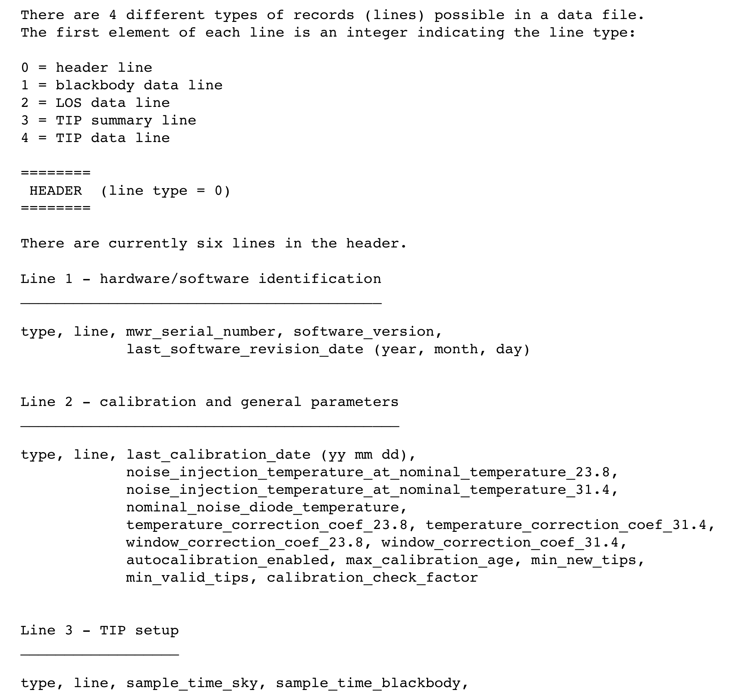

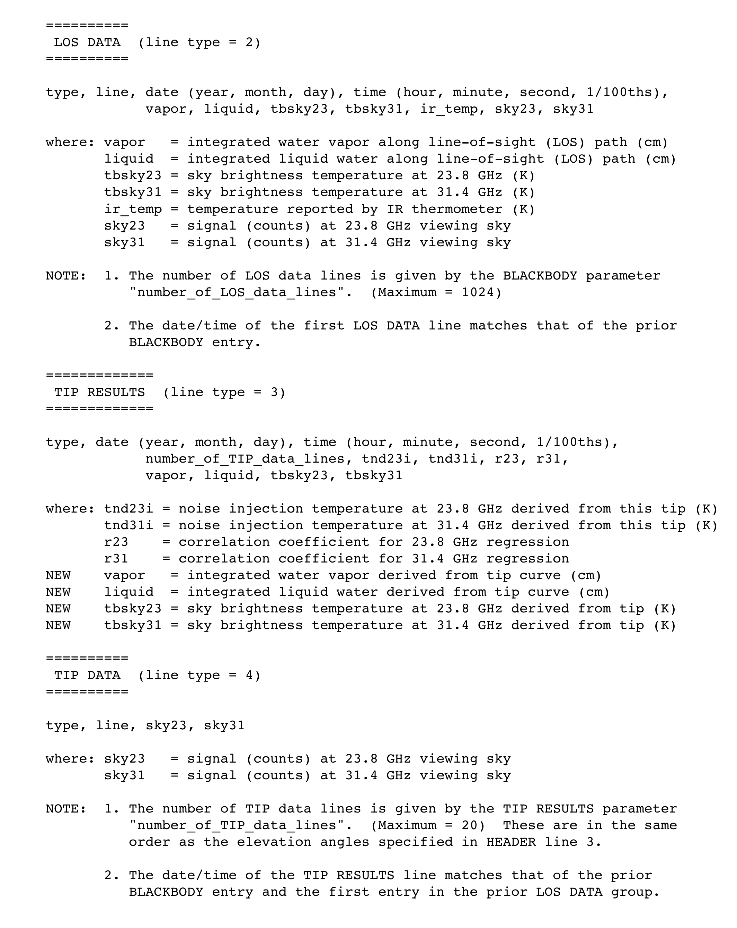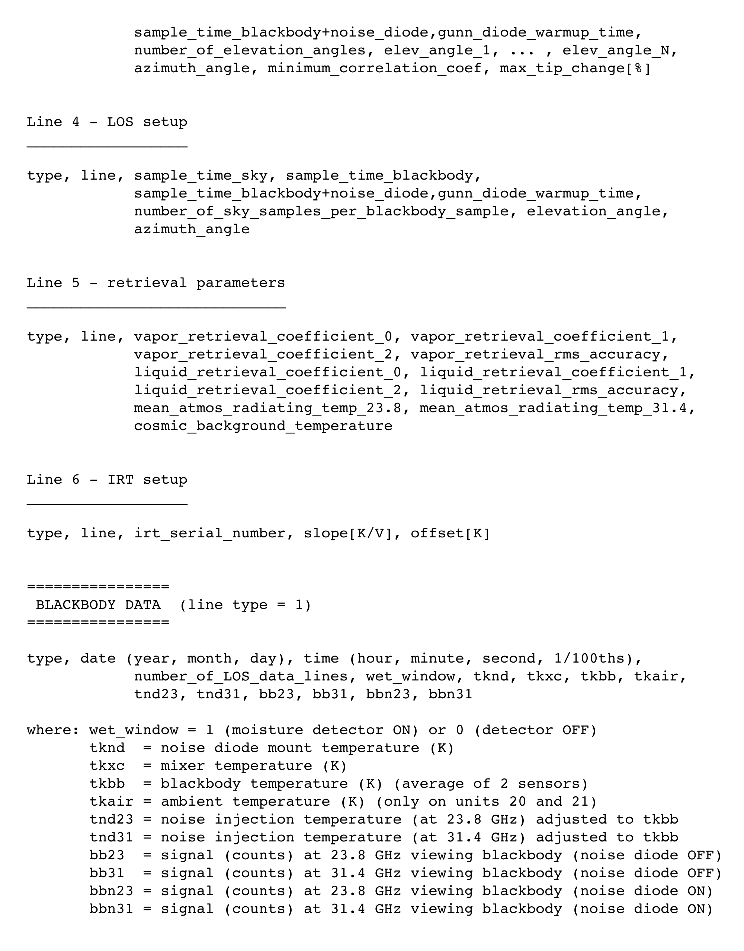

183GHz micor-wave radiometer 2008-10-27_00-00-03_lv1.csv

Output file name convention:
yyy-mm-dd-hh-mm-ss_xxx.csv

yyyy:year
mm:month
dd: day of the month
hh:hour
mm=minute of the hour
ss:seconds

xxx=level1

Passive micro-wave radiometer measuring atmospheric emittance around 183GHz, 5 Hz sampling

File description

Level 1 files contain real-time brightness temperatures for each channel. The files contain the following records types:

Record Type | Description of the record type
40 | Header for surface met records
41 | Surface met data record
50 | Header for sky observations
51 | Obs command sky observation data records

Ceilometer cloudbase20081021_295.txt
(year month day yearday)

1 3395 NaN NaN 0 0 7 295

Col 1 No of cloud bases detected
Col 2 Ht of lowest cloud base (m)
Col 3 Ht of second lowest cloud b (m)
Col 4 Ht of highest cloud base (m)
Col 5 Hour
Col 6 Min
Col 7 Sec
Col 8 Year Day
Measurement range: 0-7600 m
Measurement Cycle: 15 secs
Reporting Resolution: 5m
Measurement Accuracy: greater of +-% or +- 5m
Laser: InGaAs diode, 910nm
Light backscatter relating to cloud-base height.

C-Band radar rb1081021110006.RAW2837.gz
(rb1=radar id year month day yearday)

UF (short for “Universal Format”) is a radar data format originally
proposed and documented in the “Report on a Meeting to Establish a Common
Doppler Radar Data Exchange Format”, page 1401 of the November 1980
Bulletin of the American Meteorological Society.

C-band Radar Characteristics and Sampling Strategy

The C-band radar aboard the RV Ronald H. Brown is a single polarization scanning Doppler radar. The radar transmits a microwave pulse with a wavelength of 5 cm and a beam width of 1 degree. For the VOCALS project the C-band radar aboard the RV Ronald H. Brown was configured to have a pulse repetition frequency of 2000 Hz with a maximum range of 60 km and a Nyquest velocity of 26.8 m/s. The C-band radar features an active motion compensation system that will adjust the pointing direction of the radar antenna to compensation for the motion of the ship while at sea.

The scan strategy for the VOCALS project alternates between PPI volume scans and RHI vertical cross-section scans. A PPI and RHI volume pair is collected every three minuets. For the PPI volume, the radar scans at 6 elevation angles at 20 degrees per second azimuthal velocity. The elevations scanned are 1, 2, 3, 4, 5, and 4 degrees elevation. For the RHI volume, 4 vertical cross-sections are taken at orthogonal directions. For the RHI volume, the 35, 125, 215, and 305 degree azimuths are scanned. The azimuthal directions used in the RHI scans are based on the climatological mean wind directions for the Southeast Pacific stratocumulus region. All volume scans record total reflectivity, clutter filtered reflectivity, Doppler velocity, and spectral width. Data are archived in both the Sigmet IRIS proprietary format and the open source universal radar format (.uf).

