Daily Science Report
VOCALS2008 Cruise
NOAA Ship Ronald H. Brown
C. W. Fairall (NOAA/ESRL) and R. A. Weller (WHOI)
Report #18 November 28, 2008

Summary of Recent Activities

The ship spent most of November 26 heading 070 toward the eddy site at 75 W 20 S and then turning to 090 for a slow transit (Image 1). The ESRL/NCSU/U Miami observations include air-sea fluxes/near-surface bulk meteorology, cloud ceilometers, cloud radars, radar wind profiler, scanning Doppler C-band precipitation radar, and three microwave radiometers for column water vapor/liquid. Rawinsonde launches are currently every 4 hours and we plan to maintain that frequency.

The highlight of the day was Thanksgiving Dinner followed by a nice sunny late afternoon that permitted the 1830 science meeting to be held out on deck. Most of the day had solid cloud cover but an increasing cloud base height starting about 1500 UTC, The cloud ceilometer return for the day is shown in Image 2. A number of drizzle disturbances passed over the ship but with no gauge-detectable amounts at the surface. Rawinsonde profiles at 1238 UTC are shown in Image 3. The PSD radar observation for at 1200 is shown in Image 4.

On the oceanographic side, we had two CTD stations en route. We resumed UCTD once we reached the edge of the eddy around 75 W. Water temperature has begun to increase again and oceanic DMS remains patchy and variable. The SST is almost 2 C warmer than it was when we passed this location on Day 304 (Image 5).

Just for more grins, we analyzed the W-band radar for cloud top height and plotted it with the ceilometer cloud base heights for November 22 (Image 6) and November 27 (Image 7). These two days show contrasting patterns in diurnal behavior at 85 W (Image 6) and 75 W (Image 7). At 75 W cloud base height fairly constant except for increase after noon probably associated with decoupling. The cloud top height has two peaks because the diurnal solar heating cycle and the diurnal subsidence wave are out of phase. Maximum cloud thickness (about 400 m) occurs about 0800 local time. At 85 W (Image 6) there is a single peak in the diurnal cycle. Cloud base is fairly constant and cloud top peaks about 0800 UTC. When cloud thickness exceeds about 300 m, drizzle is triggered. Drizzle is indicated by fall velocity exceeding about 0.2 m/s and/or scattering exceeding -17 dBZ.

Image 1. RHB cruise track on JD332 (Nov. 27). The diamond at 75 W is the SHOA tsunami buoy; the circle/plus at 85 W is the WHOI buoy.

Image 2. Time series of ceilometer cloudbase height for November 27.

Image 3. Rawindsonde profile from November 27 at 1202 UTC. Upper left panel - temperature and dewpoint; right panel – relative humidity; lower left panel – zonal wind component; lower right panel – meridional wind component.

Image 4. Time-height cross section from 1 hour of data beginning at 1200 on Nov. 27 from ESRL/PSD W-band cloud radar. The top panel is the radar reflectivity (dBZ); the middle panel is the mean Doppler velocity (m/s, positive down); the bottom panel is the Doppler width (m/s) of the return.

Image 5. Map of the VOCALS cruise track with the color designating the SST (scale given on colorbar). The numbers on the track denote the Julian Day.

Image 6. Time series of cloud properties for November 22, 2008. Upper panel: cloud top height (circle with solid line; ±1 standard deviation, dashed line) and cloud base height (diamonds with solid line; 1 standard deviation, dots). Lower panel: mean radar backscatter for the cloud/drizzle layer (circle with solid line) and mean droplet fall speed (x’s with solid line) multiplied by 10 (in m/s).

Image 7. Time series of cloud properties for November 27, 2008. Upper panel: cloud top height (circle with solid line; ±1 standard deviation, dashed line) and cloud base height (diamonds with solid line; 1 standard deviation, dots). Lower panel: mean radar backscatter for the cloud/drizzle layer (circle with solid line) and mean droplet fall speed (x’s with solid line) multiplied by 10 (in m/s).

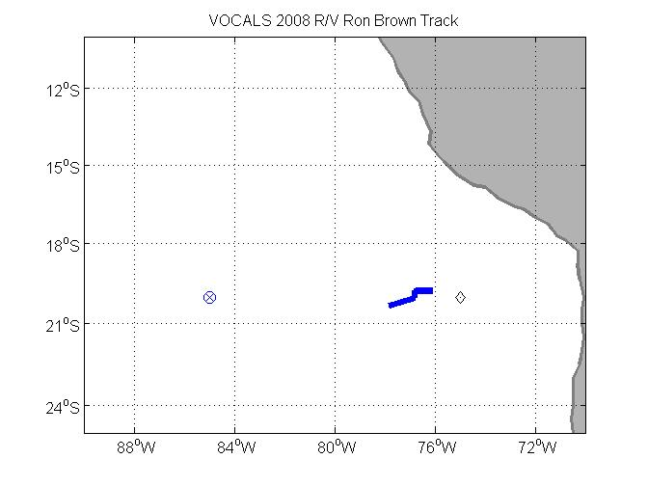
Image 1. RHB cruise track on JD332 (Nov. 27). The diamond at 75 W is the SHOA tsunami buoy; the circle/plus at 85 W is the WHOI buoy.
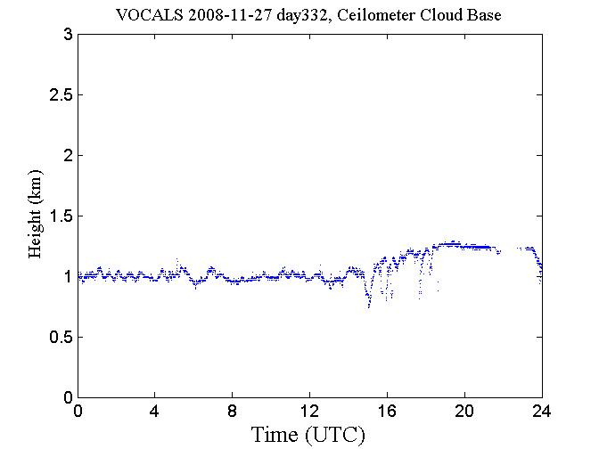
Image 2. Time series of ceilometer cloudbase height for November 27.

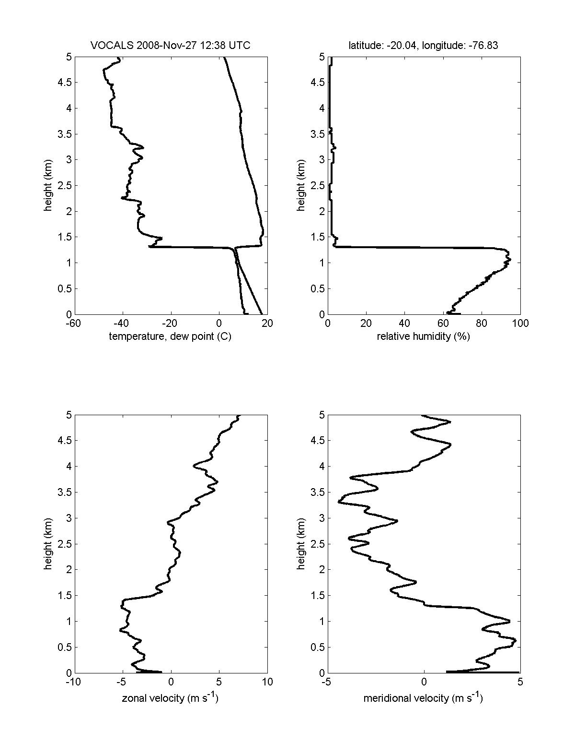
Image 3. Rawindsonde profile from November 27 at 1238 UTC. Upper left panel - temperature and dewpoint; right panel – relative humidity; lower left panel – zonal wind component; lower right panel – meridional wind component.

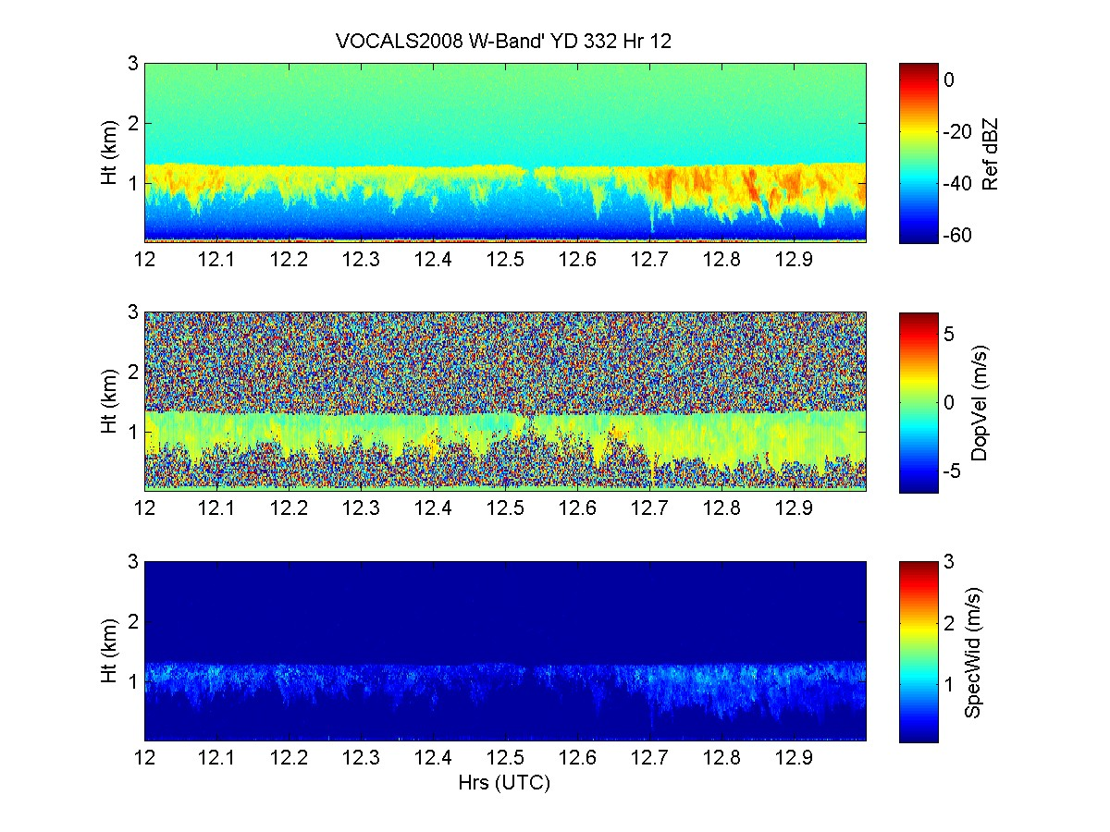
Image 4. Time-height cross section from 1 hour of data beginning at 1200 on Nov. 27 from ESRL/PSD W-band cloud radar. The top panel is the radar reflectivity (dBZ); the middle panel is the mean Doppler velocity (m/s, positive down); the bottom panel is the Doppler width (m/s) of the return.

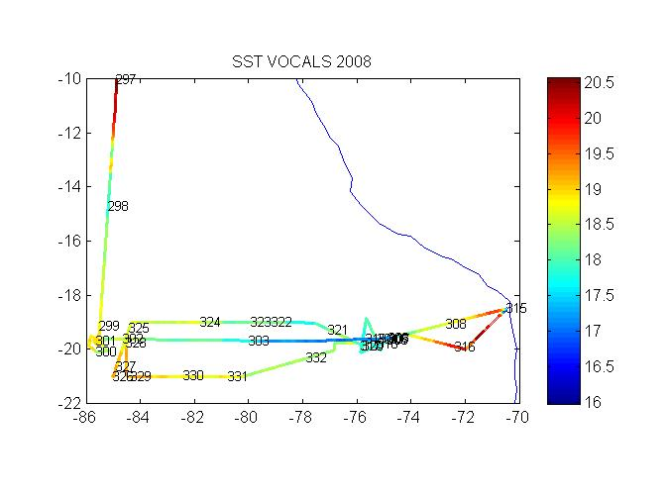
Image 5. Map of the VOCALS cruise track with the color designating the SST (scale given on colorbar). The numbers on the track denote the Julian Day.

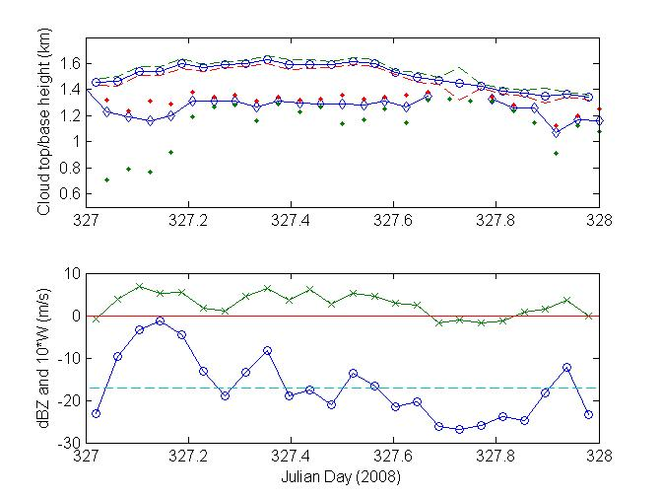
Image 6. Time series of cloud properties for November 22, 2008. Upper panel: cloud top height (circle with solid line; ±1 standard deviation, dashed line) and cloud base height (diamonds with solid line; 1 standard deviation, dots). Lower panel: mean radar backscatter for the cloud/drizzle layer (circle with solid line) and mean droplet fall speed (x’s with solid line) multiplied by 10 (in m/s).

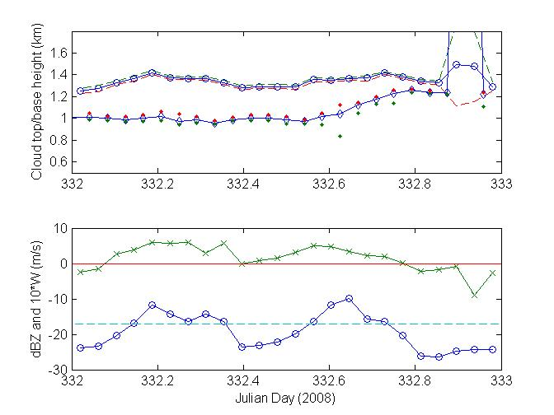
Image 7. Time series of cloud properties for November 27, 2008. Upper panel: cloud top height (circle with solid line; ±1 standard deviation, dashed line) and cloud base height (diamonds with solid line; 1 standard deviation, dots). Lower panel: mean radar backscatter for the cloud/drizzle layer (circle with solid line) and mean droplet fall speed (x’s with solid line) multiplied by 10 (in m/s).

