Daily Science Report
VOCALS2008 Cruise
NOAA Ship Ronald H. Brown
C. W. Fairall (NOAA/ESRL) and R. A. Weller (WHOI)
Report #2 November 12, 2008

Summary of Recent Activities

The ship spent most of November 11 moving west close to 20 S (Image 1). The ESRL/NCSU/U Miami observations include air-sea fluxes/near-surface bulk meteorology, cloud ceilometers, cloud radars, radar wind profiler, scanning Doppler C-band precipitation radar, and three microwave radiometers for column water vapor/liquid. Rawinsonde launches are currently every 4 hours and we plan to maintain that frequency.

The highlight of the day was joint observations with the NCAR C-130 at 1900. The cloud ceilometer return for the day is shown in Image 2. The rawinsonde profile near this time is shown in Image 3. At this location cloud top is fairly low and the clouds are not thick with some clearing in the afternoon. A sample image from the ESRL W-band cloud radar during the C-130 pass at 1900 on November 11 is shown in Image 4. The cloud top is at about 1.1 km and appears to thicken in the middle of the hour with a brief drizzle event that probably reaches the surface. Motions in the cloud (middle panel) are about +- 1 m/s.

Underway CTD observations started after we departed Point Alpha. Watch this space for a preliminary report.

On November 12 the ship turned North and begin executing the eddy pattern near the SHOA tsunami buoy at 20 S 75 W. One amusing development is the large increase in atmospheric DMS in this region (Image 5). More analysis to follow. It appears that the eddy has moved west, so we are recomputing a new survey.

A spiffy picture of the C-130 is shown in Image 6.

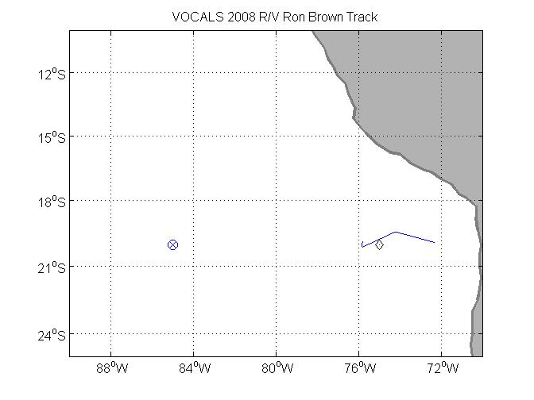
Image 1. RHB cruise track on JD316 (Nov. 11). The diamond at 75 W is the SHOA tsunami buoy; the circle/plus at 85 W is the WHOI buoy.

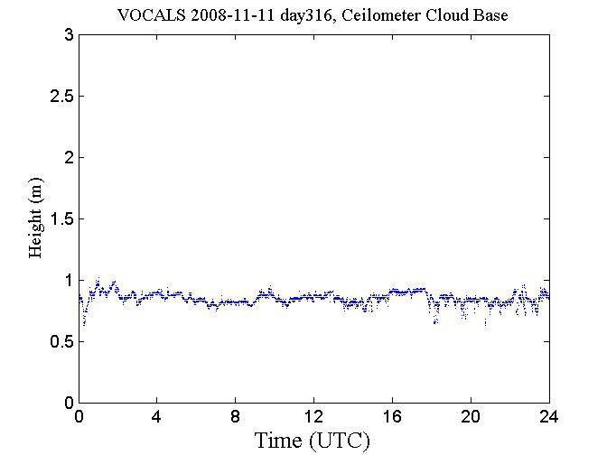
Image 2. Time series of ceilometer cloud base height for November 11.

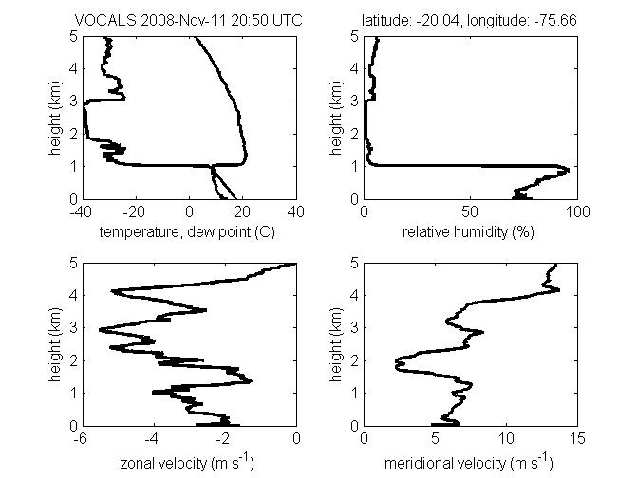
Image 3. Rawindsonde profile from November 11 at 2050 UTC. Upper left panel - temperature and dewpoint; right panel – relative humidity; lower left panel – zonal wind component; lower right panel – meridional wind component.

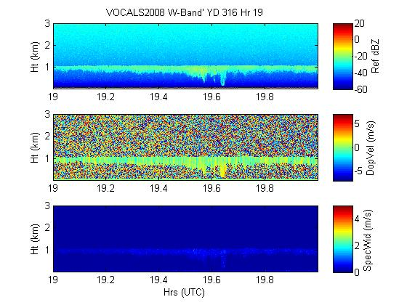
Image 4. Time-height cross section from 1 hour of data beginning at 1700 on Nov. 11 from ESRL/PSD W-band cloud radar. The top panel is the radar reflectivity (dBZ); the middle panel is the mean Doppler velocity (m/s, positive down); the bottom panel is the Doppler width (m/s) of the return.

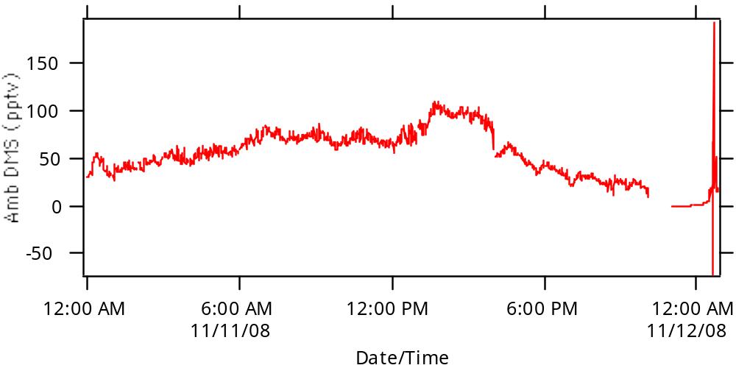

Image 5. Time series of atmospheric DMS concentration on November 11, 2008.

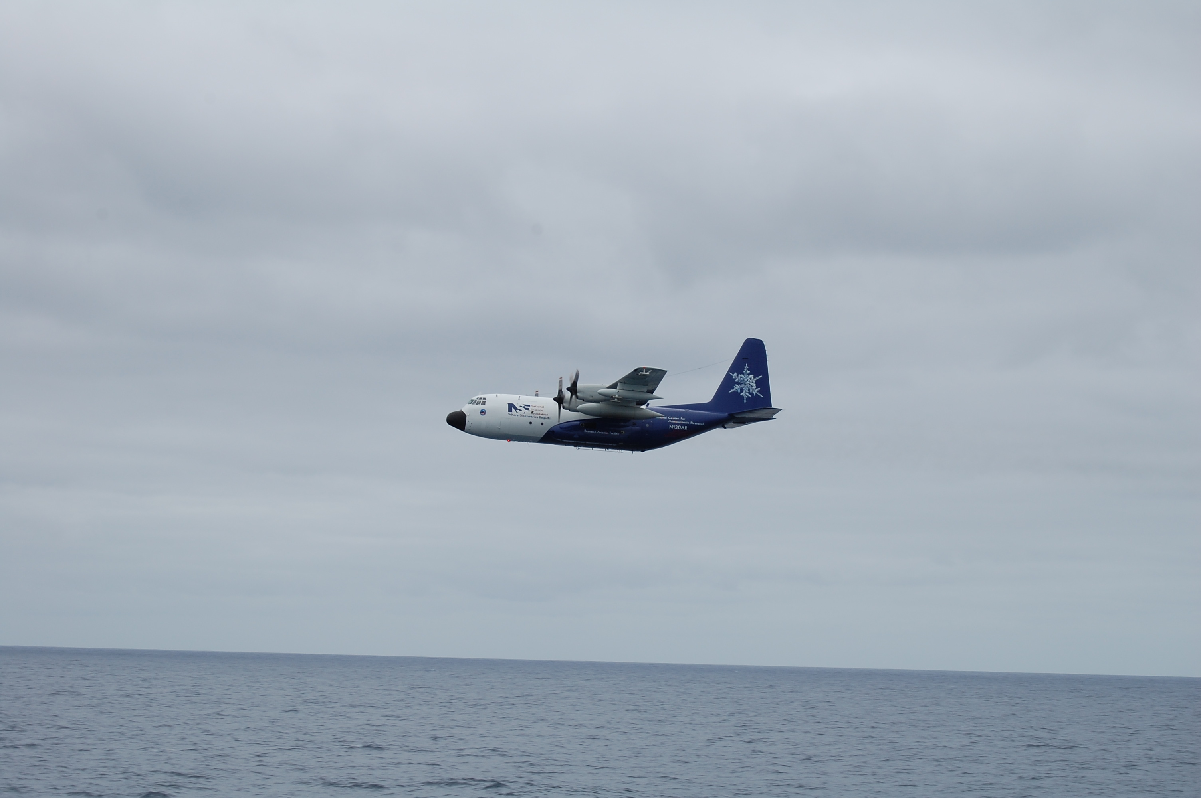

Image 6. Photo of NCAR C-130 taken from the Ronald H. Brown on November 11, 2008

