Daily Science Report
VOCALS2008 Cruise
NOAA Ship Ronald H. Brown
C. W. Fairall (NOAA/ESRL) and R. A. Weller (WHOI)
Report #6 November 16, 2008

Summary of Recent Activities

The ship spent part of November 15 stationary close to 20 S 75 W and part moving WNW heading toward 19 S (Image 1). The ESRL/NCSU/U Miami observations include air-sea fluxes/near-surface bulk meteorology, cloud ceilometers, cloud radars, radar wind profiler, scanning Doppler C-band precipitation radar, and three microwave radiometers for column water vapor/liquid. Rawinsonde launches are currently every 4 hours and we plan to maintain that frequency.

The highlight of the day was abrupt clearing of clouds about 1700 UTC. This clearing event was accompanied with a big increase in aerosols. The cloud ceilometer return for the day is shown in Image 2. Rawinsonde profiles at 1600 and 2000 UTC are shown in Image 3 and Image 4. The solar flux increased abruptly to clear-sky values (Image 5) while the IR flux (Image 6) showed a more gradual transition associated with the gradual disappearance of a few thin clouds.

Earlier in the night we had the passage of a weakly precipitating line of convection that was dissipating as it approached our location. No rain was recorded at the surface but a strong signature in the moisture time series similar to the previous night) was observed (Image 7). Corresponding data from the ESRL W-band cloud radar at 600 shows the cloud and precipitation structure of the event (Image 8). The rain gauge (Image 6) indicates a peak rain rate of around 0.3 mm/h. From the C-band radar we could that this event was part of a loosely organized line of convection oriented parallel to the wind direction (Image 9) and moving to the North. Although this system had much less precipitation than the one the previous evening, it produced a stronger response in the surface layer humidity.

On the oceanographic side, we started a schedule of underway CTD sections of about 8 hrs duration followed by stationary periods of 6-10 hours. The stationary periods are to allow atmospheric sampling (underway to the west cause unfavorable relative wind directions for atmospheric in situ sampling), CTD, and VMP observations.

Image 1. RHB cruise track on JD320 (Nov. 15). The diamond at 75 W is the SHOA tsunami buoy; the circle/plus at 85 W is the WHOI buoy.

Image 2. Time series of ceilometer cloudbase height for November 15.

Image 3. Rawindsonde profile from November 15 at 1558 UTC. Upper left panel - temperature and dewpoint; right panel – relative humidity; lower left panel – zonal wind component; lower right panel – meridional wind component.

Image 4. Rawindsonde profile from November 15 at 2008 UTC. Upper left panel - temperature and dewpoint; right panel – relative humidity; lower left panel – zonal wind component; lower right panel – meridional wind component.

Image 5. Time series of downward solar flux on November 15, 2008. The observations are the blue dots (ESRL sensors) and green dots (RHB sensor); the red line is a clear sky (i.e., cloud free) model.

Image 6. Time series of downward IR flux on November 15, 2008. The observations are the blue dots (ESRL sensors) and green dots (RHB sensor); the red line is a clear sky (i.e., cloud free) model.

Image 7. Time series of atmospheric specific humidity for November 14 through November 15, 2008.

Image 8. Time-height cross section from 1 hour of data beginning at 0600 on Nov. 15 from ESRL/PSD W-band cloud radar. The top panel is the radar reflectivity (dBZ); the middle panel is the mean Doppler velocity (m/s, positive down); the bottom panel is the Doppler width (m/s) of the return.

Image 9. Polar plot of radar backscatter intensity (in dBZ) from the C-band radar at 0511 November 15. Range rings are 10 km; dBZ color bar is along the bottom of the graph. The zero degree orientation corresponds to true North.

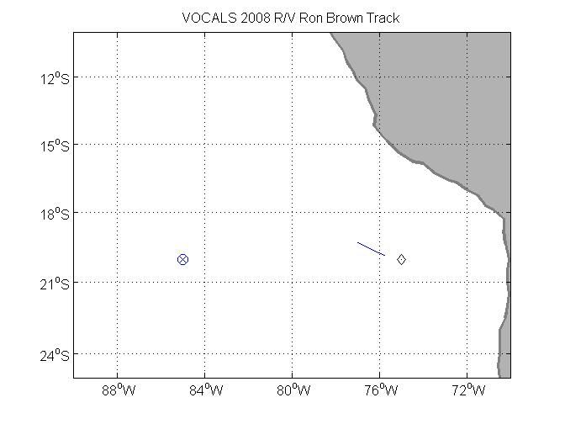
Image 1. RHB cruise track on JD320 (Nov. 15). The diamond at 75 W is the SHOA tsunami buoy; the circle/plus at 85 W is the WHOI buoy.

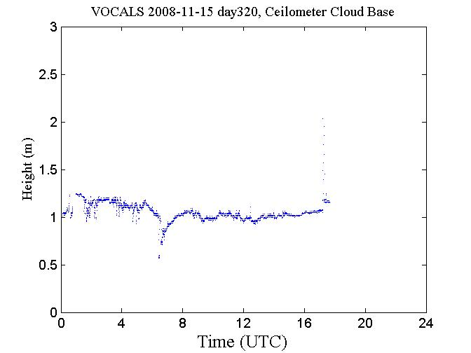
Image 2. Time series of ceilometer cloudbase height for November 15.

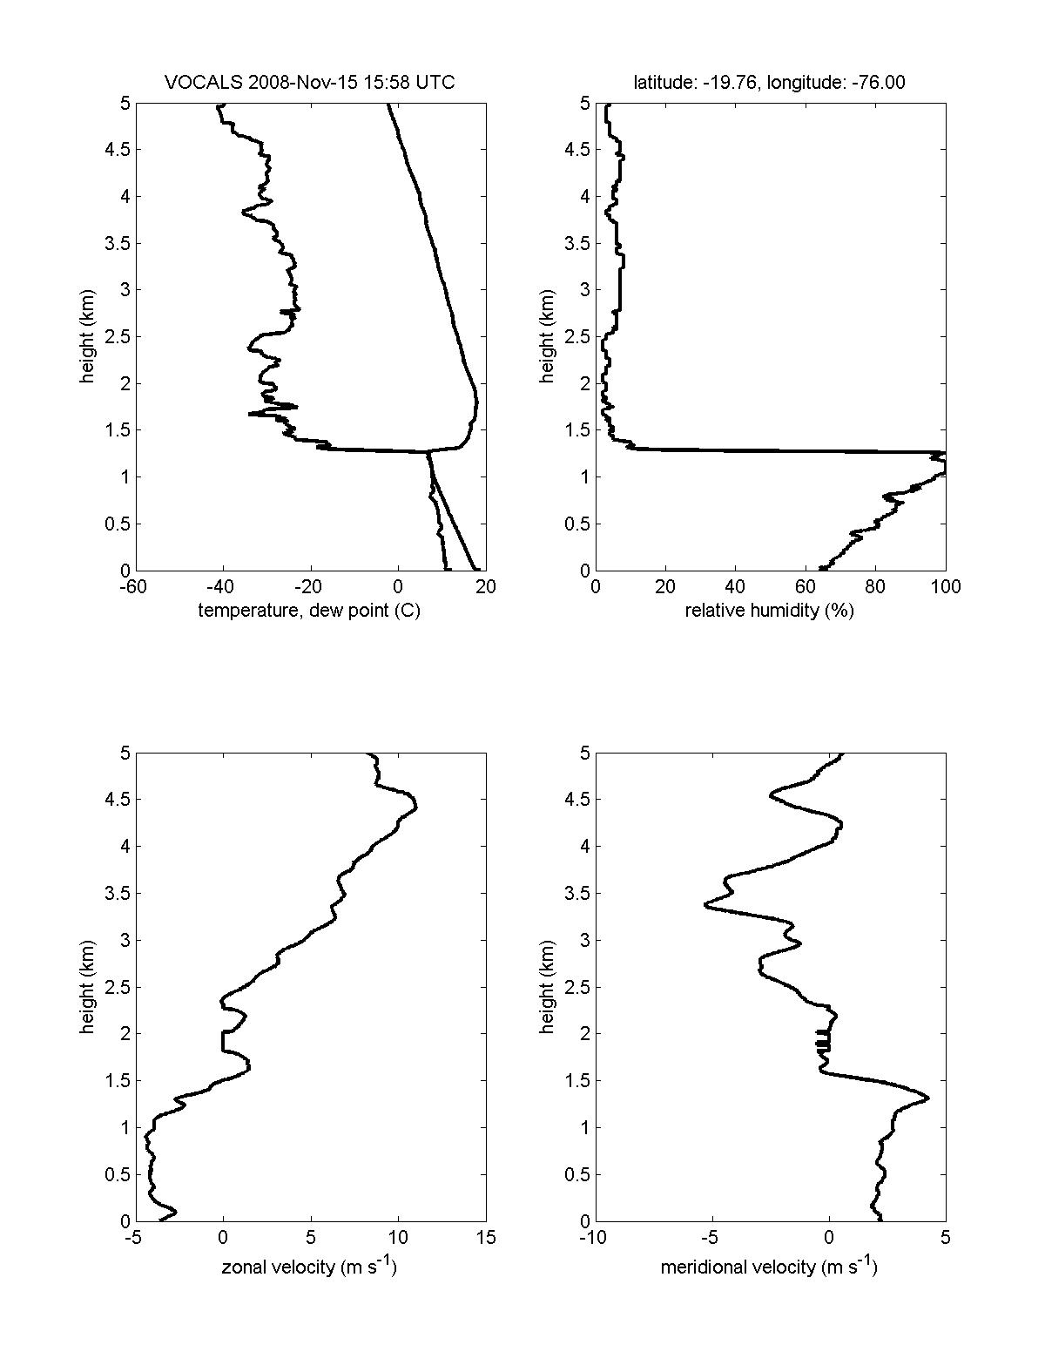
Image 3. Rawindsonde profile from November 15 at 1558 UTC. Upper left panel - temperature and dewpoint; right panel – relative humidity; lower left panel – zonal wind component; lower right panel – meridional wind component.

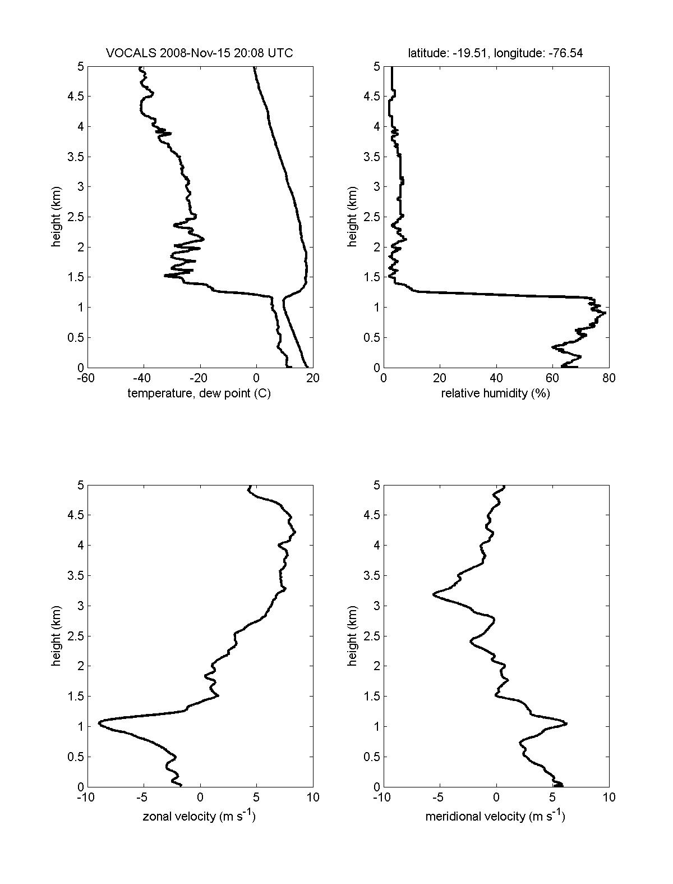
Image 4. Rawindsonde profile from November 15 at 2008 UTC. Upper left panel - temperature and dewpoint; right panel – relative humidity; lower left panel – zonal wind component; lower right panel – meridional wind component.

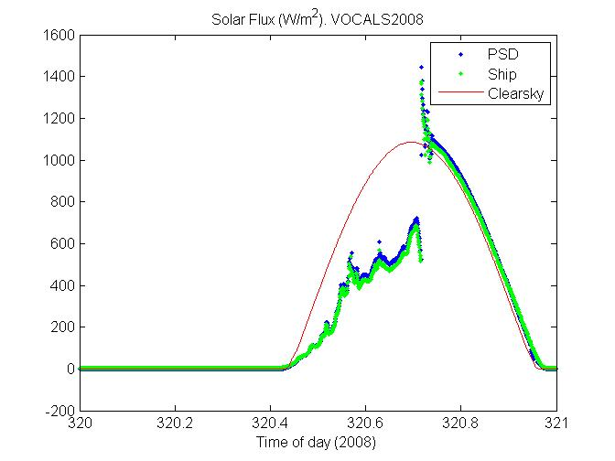
Image 5. Time series of downward solar flux on November 15, 2008. The observations are the blue dots (ESRL sensors) and green dots (RHB sensor); the red line is a clear sky (i.e., cloud free) model.

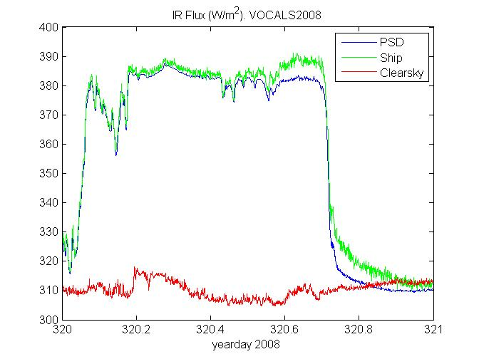
Image 6. Time series of downward IR flux on November 15, 2008. The observations are the blue dots (ESRL sensors) and green dots (RHB sensor); the red line is a clear sky (i.e., cloud free) model.

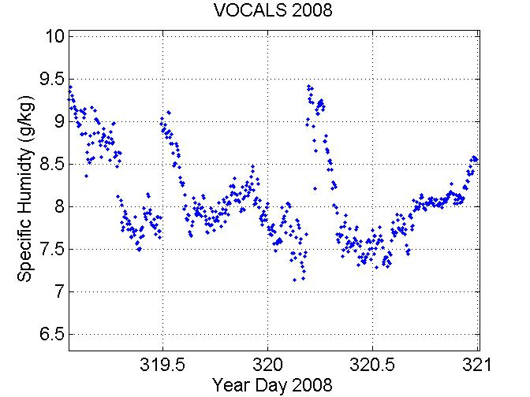
Image 7. Time series of atmospheric specific humidity for November 14 through November 15, 2008.

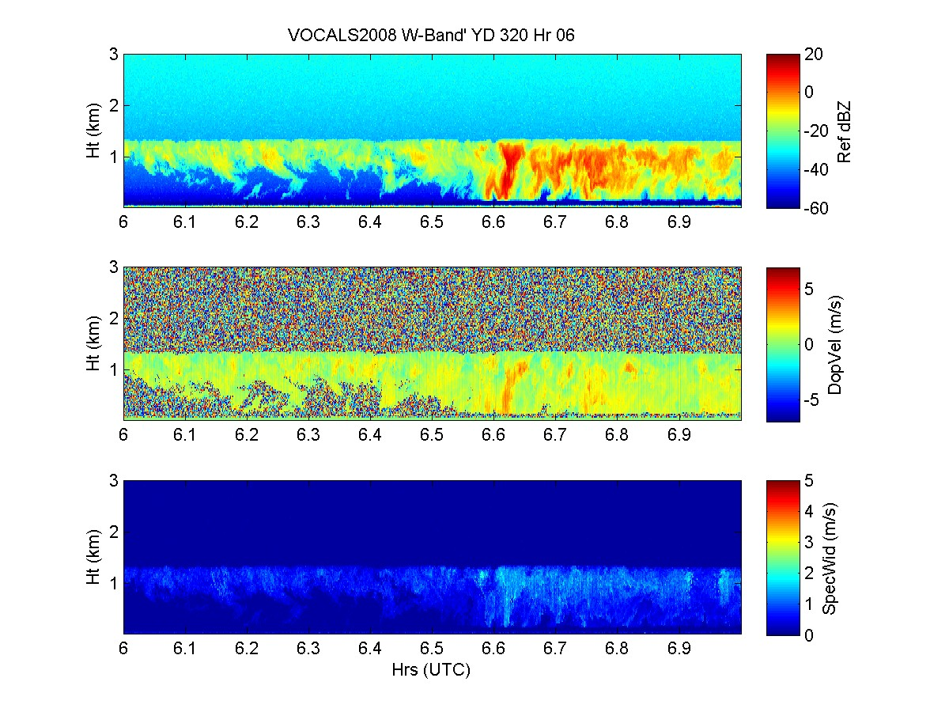
Image 8. Time-height cross section from 1 hour of data beginning at 0600 on Nov. 15 from ESRL/PSD W-band cloud radar. The top panel is the radar reflectivity (dBZ); the middle panel is the mean Doppler velocity (m/s, positive down); the bottom panel is the Doppler width (m/s) of the return.

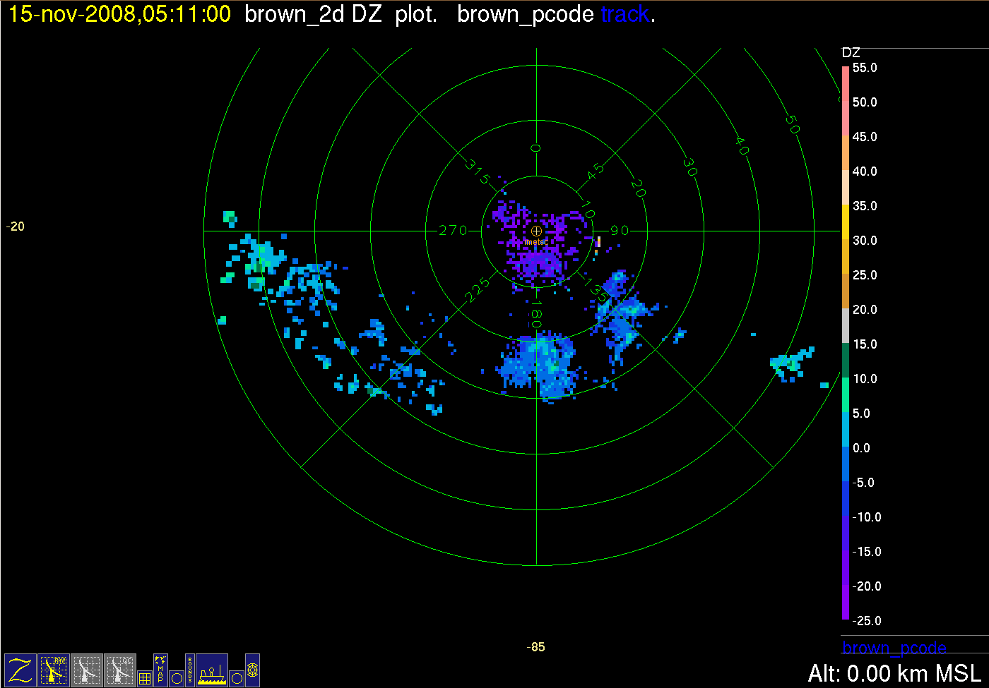

Image 9. Polar plot of radar backscatter intensity (in dBZ) from the C-band radar at 0511 November 15. Range rings are 10 km; dBZ color bar is along the bottom of the graph. The zero degree orientation corresponds to true North.

