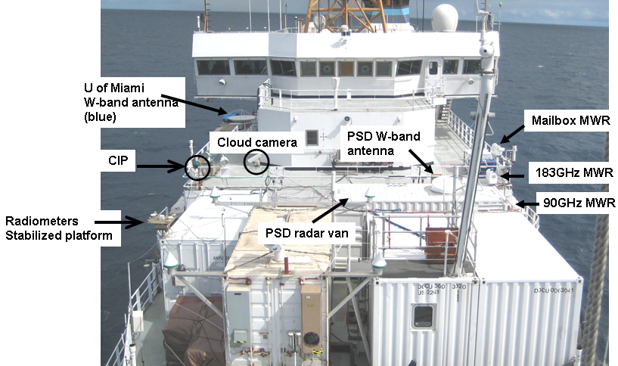
Figure 1. O2 deck PSD instrumentation
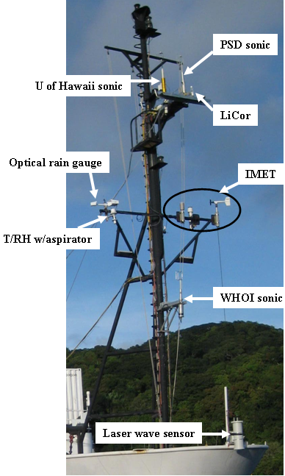
Figure 2. Forward mast (jackstaff) instrumentation. IMET is ship instruments (T/RH/P/Rain).
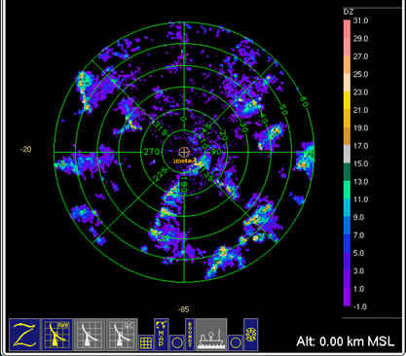
Figure 3. C-Band Doppler radar PPI scan. 1100 UTC October 25, 2008 created by Zebra
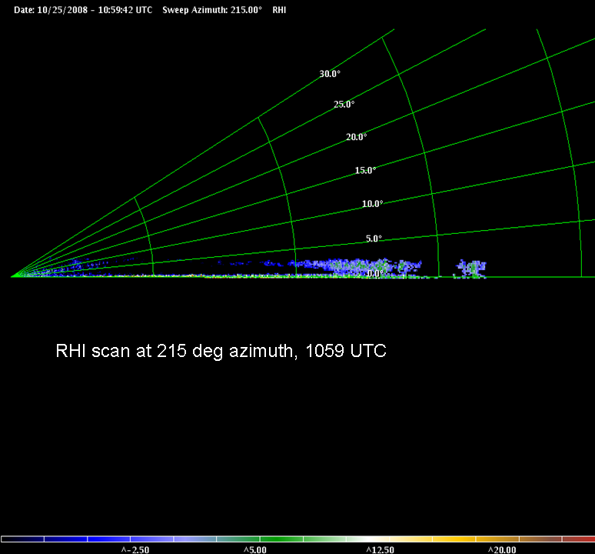
Figure 4. C-Band Doppler radar RHI scan. 1059 UTC October 25, 2008 created by Zebra
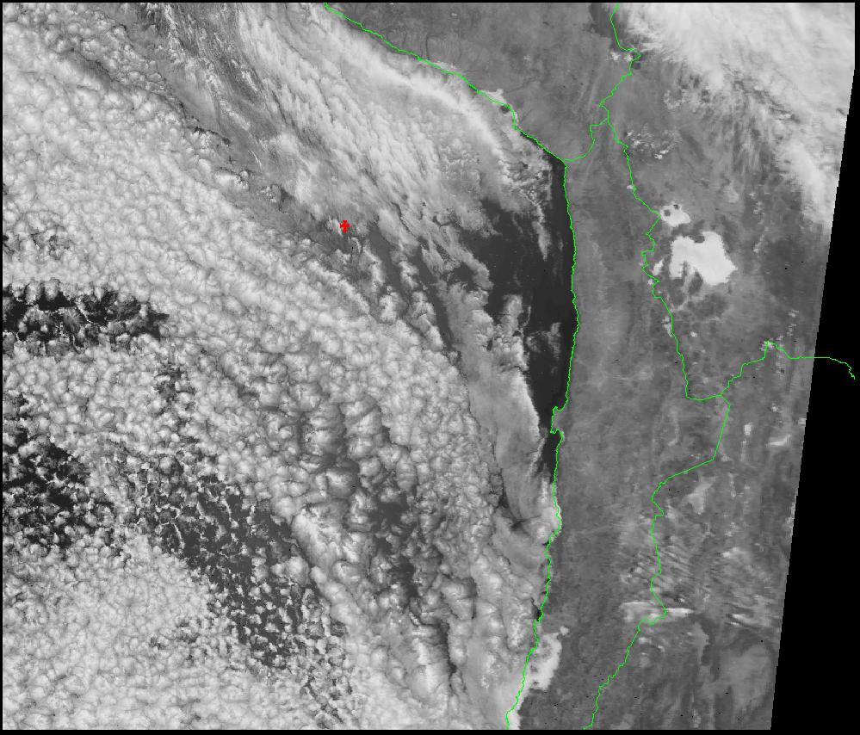
Figure 5. Terascan satellite visible 1442 UTC October 31, 2008. Red + is the location of the ship near the DART buoy (20 S, 75 W)
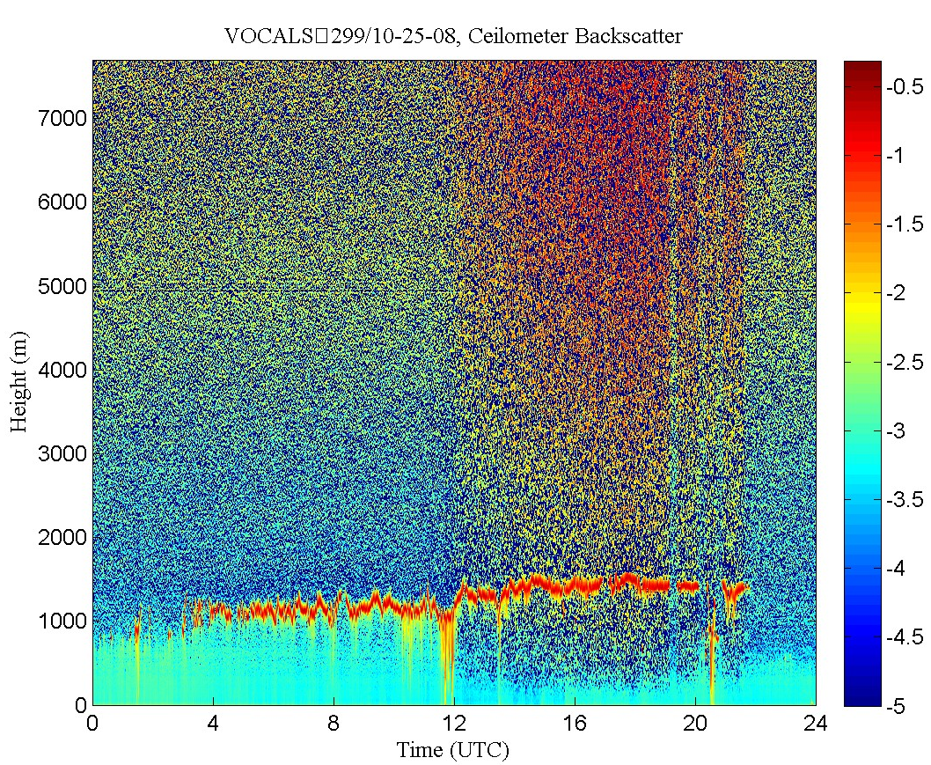
Figure 6. Ceilometer backscatter day 299 (Oct 25, 200)
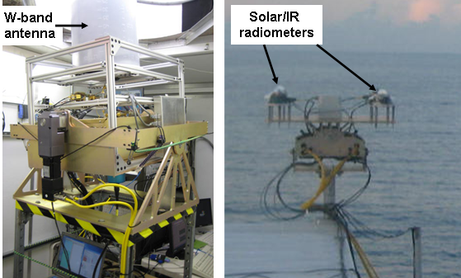
Figure 7. Left panel W-band stabilized platform, right panel radiometer stabilized platform

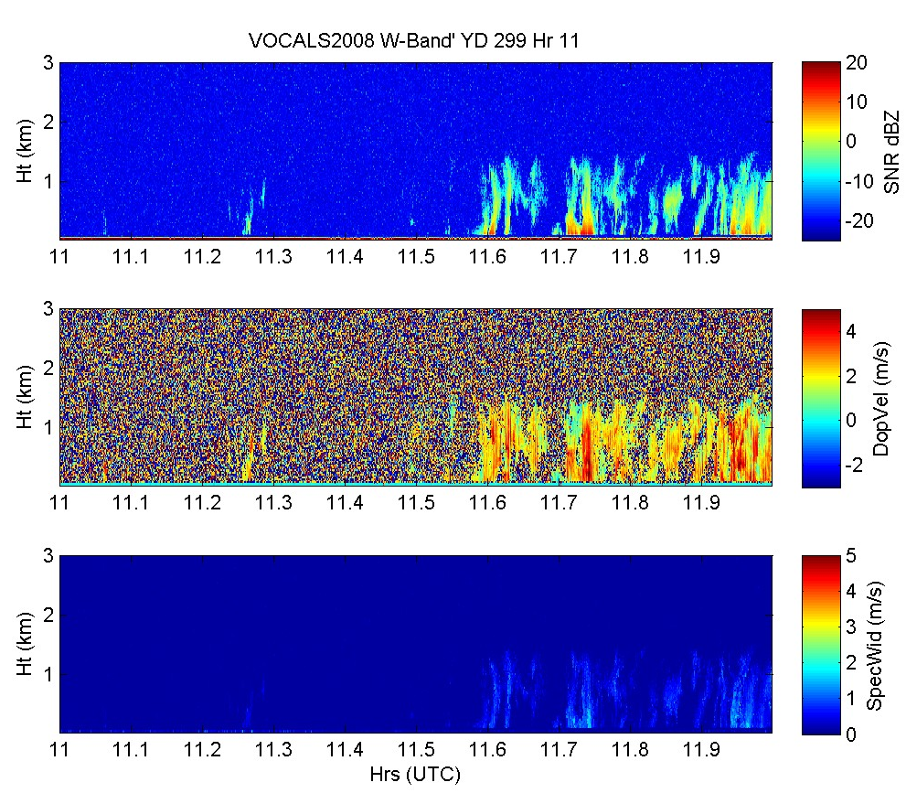
Figure 8. Time-height data from PSD W-band cloud radar data for day 299 (October 25, 2008): SNR, vertical velocity, and spectral width after loss in gain.
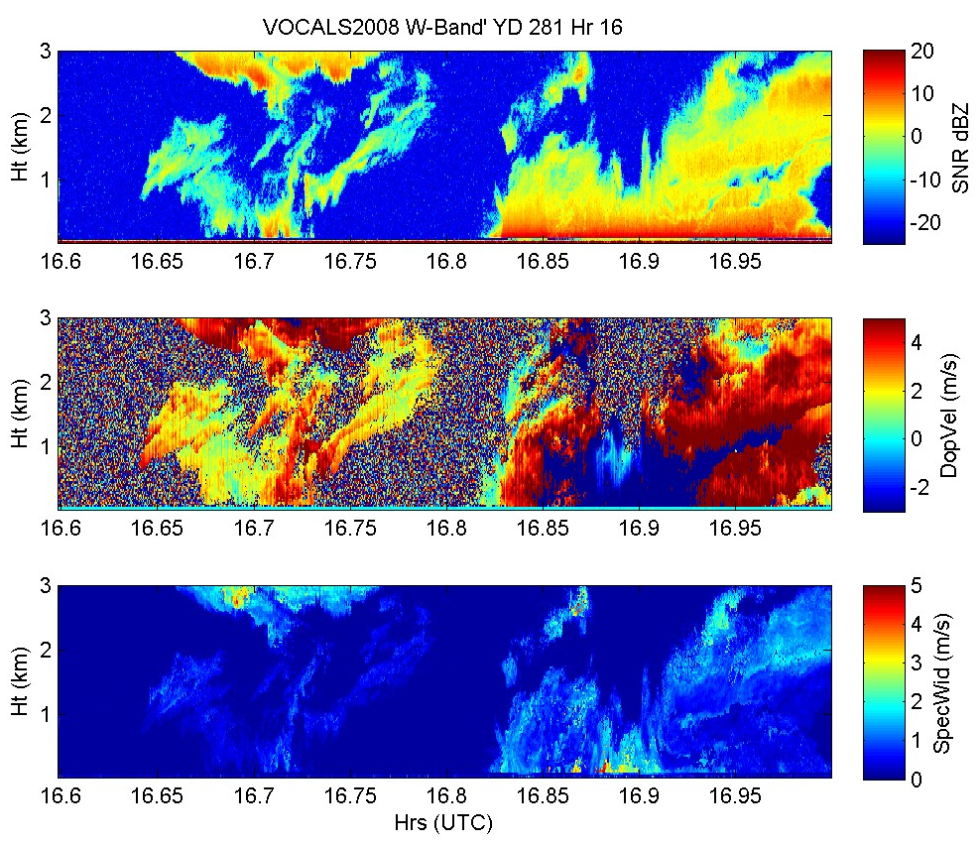
Figure 9. Time-height data from PSD W-band cloud radar data for day 281 (7 Oct) SNR, Doppler vertical velocity, and spectral width. This is the very first cloud image from the radar prior to loss in gain.
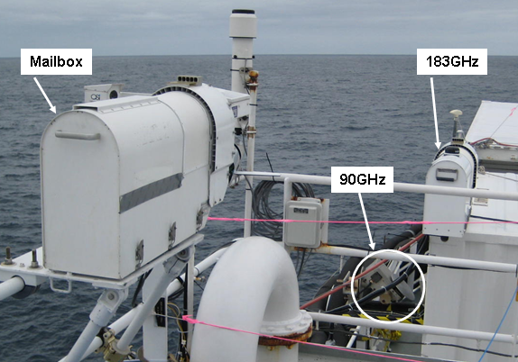

Figure 10. Microwave radiometers mounted on the O3 deck and W-band van

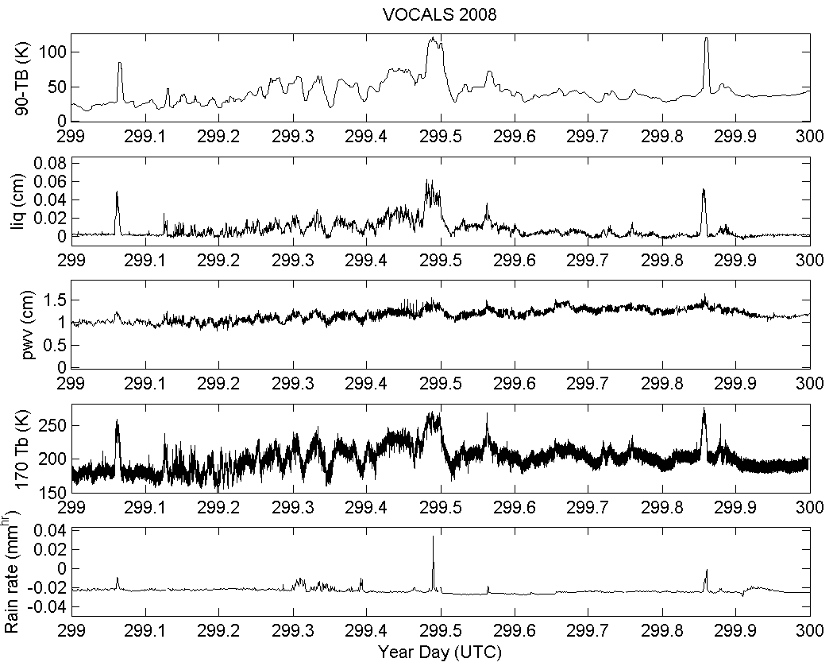
Figure 11. Time series from the microwave radiometers and optical rain gauge for day 299 (October 25, 2008). From top to bottom the panels are 90GHz TB, Mailbox LWP, Mailbox PWV, 170GHz TB, and optical rain gauge (mm/hr).

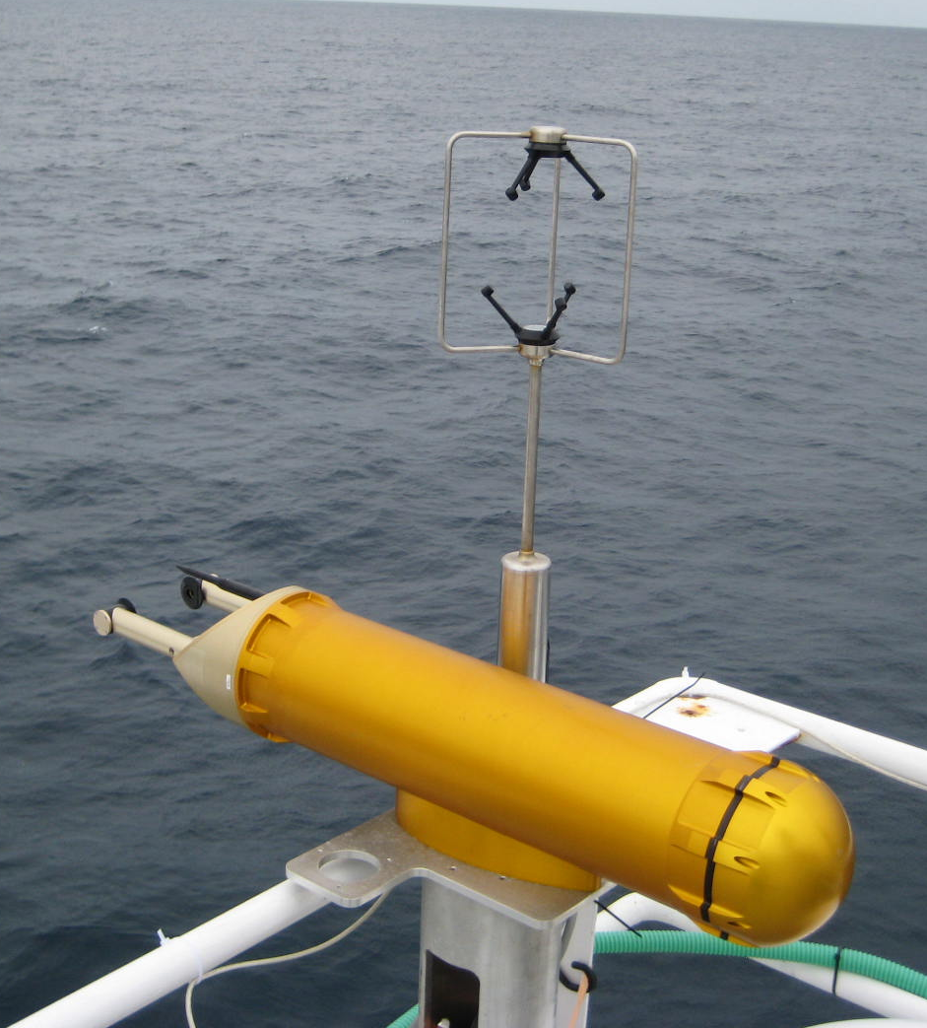
Figure 12. Cloud Imaging Probe and sonic anemometer mounted on O3 deck.

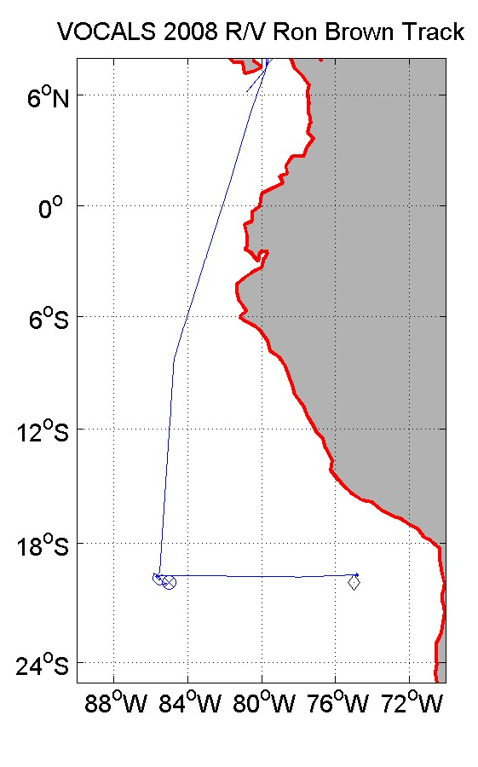
Figure 13. Cruise track for Ronald H. Brown from Panama City Panama to Arica, Chile. The x marks the WHOI buoy location; the diamond is the DART buoy. Start of formal sampling entering Ecuadorian waters (~2 º 8.6’N 81º27.6’W red diamond).
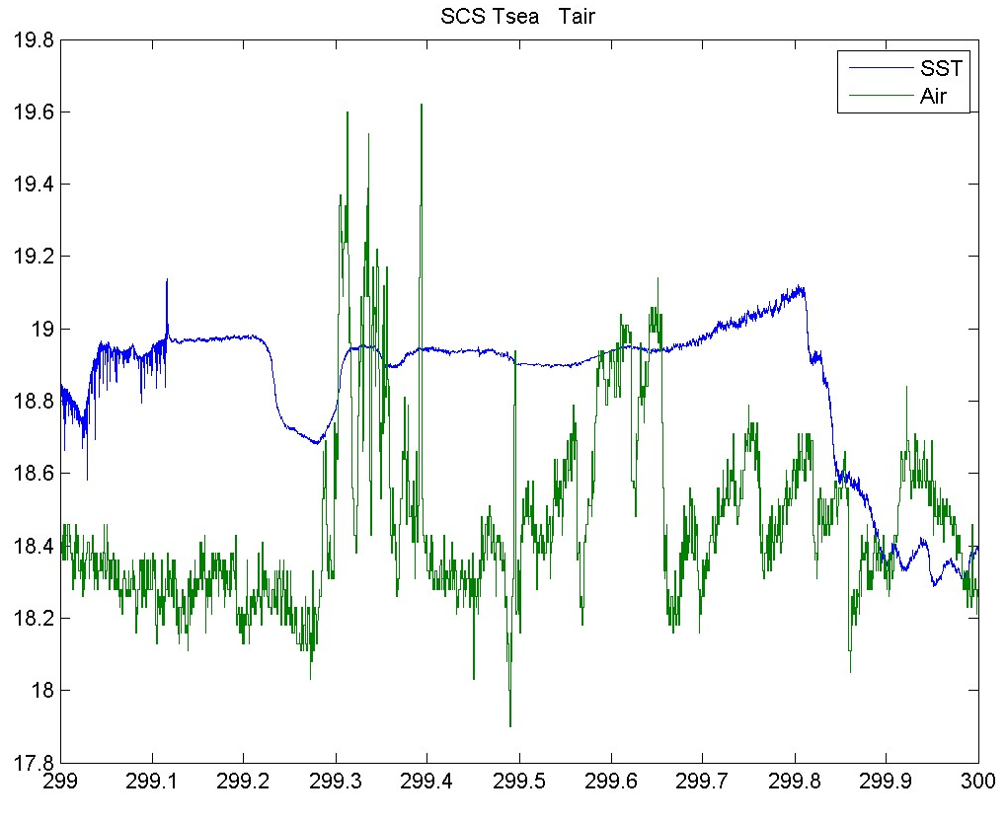
Figure 14. Time series of near-surface ocean temperature (blue) and 17-m air temperature (green).

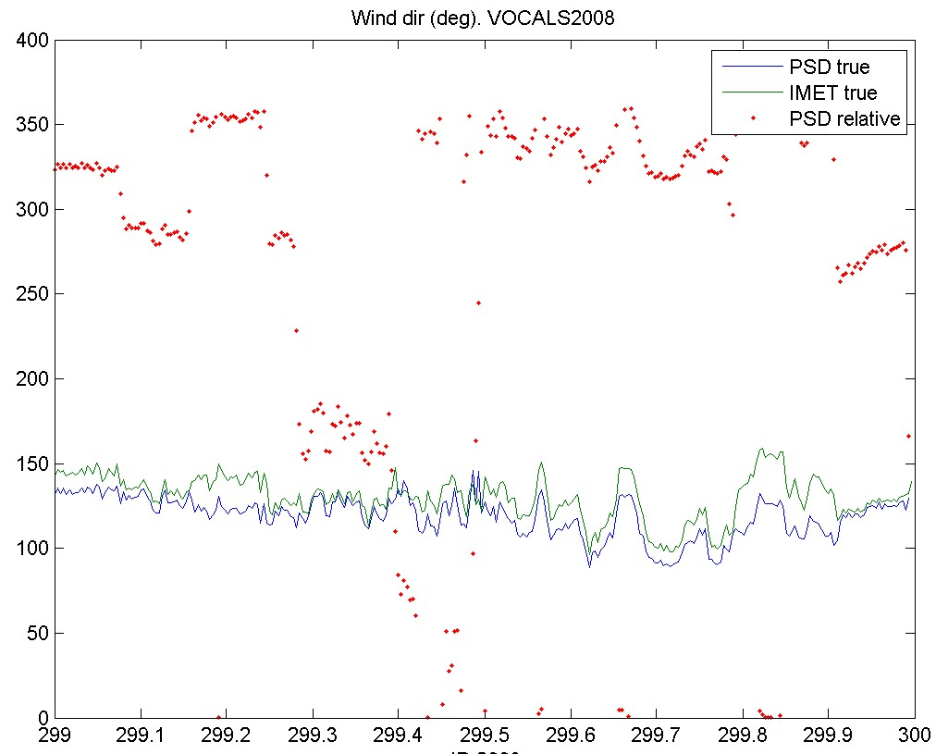
Figure 15. True wind directions from the PSD sonic anemometer (18 m) and IMET propvane (17 m). Red dots are ship relative winds from the jackstaff sonic. Winds from 0 degrees are head on to the ship.
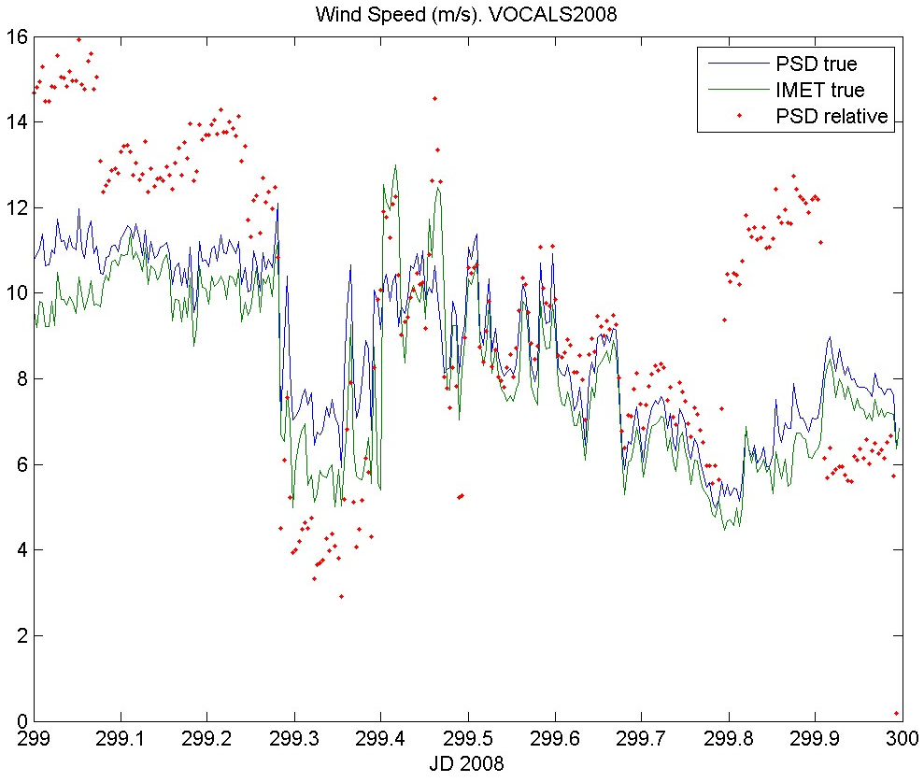
Figure 16. True wind speed from the PSD sonic anemometer (18 m) and the ship’s propvane (15 m).

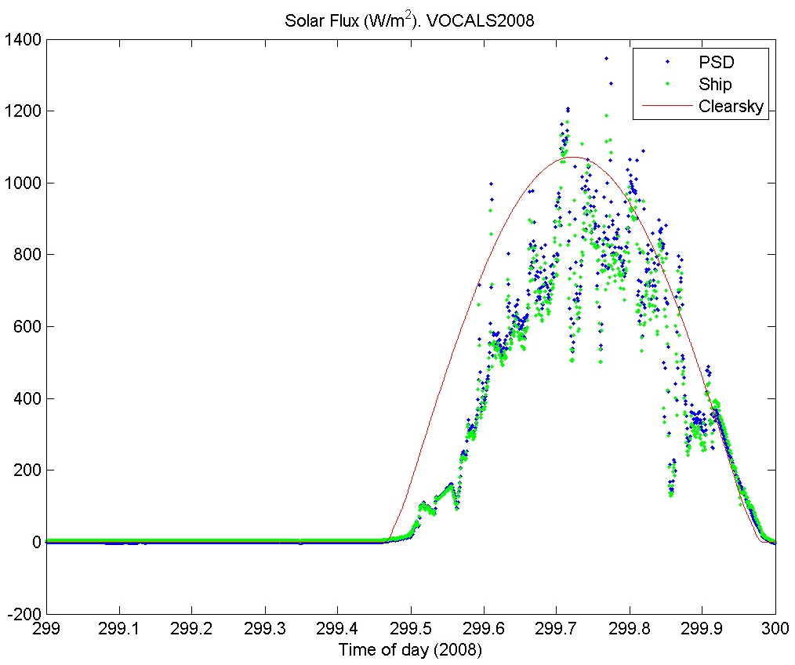
Figure 17. Time series of downward solar flux from PSD and ship Eppley sensors. The green line is a model of the expected clear sky value.
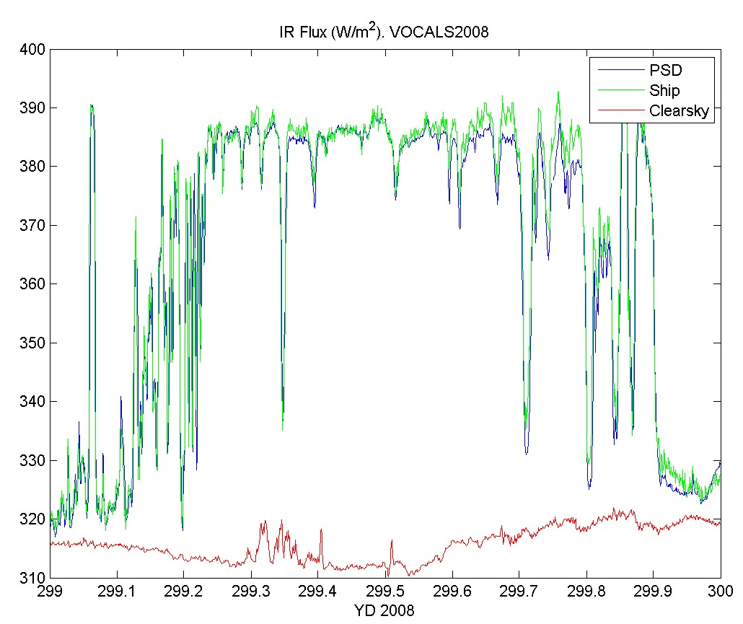
Figure 18. Time series of downward IR flux from PSD and ship Eppley sensors. The red line is a model of the expected clear sky value.

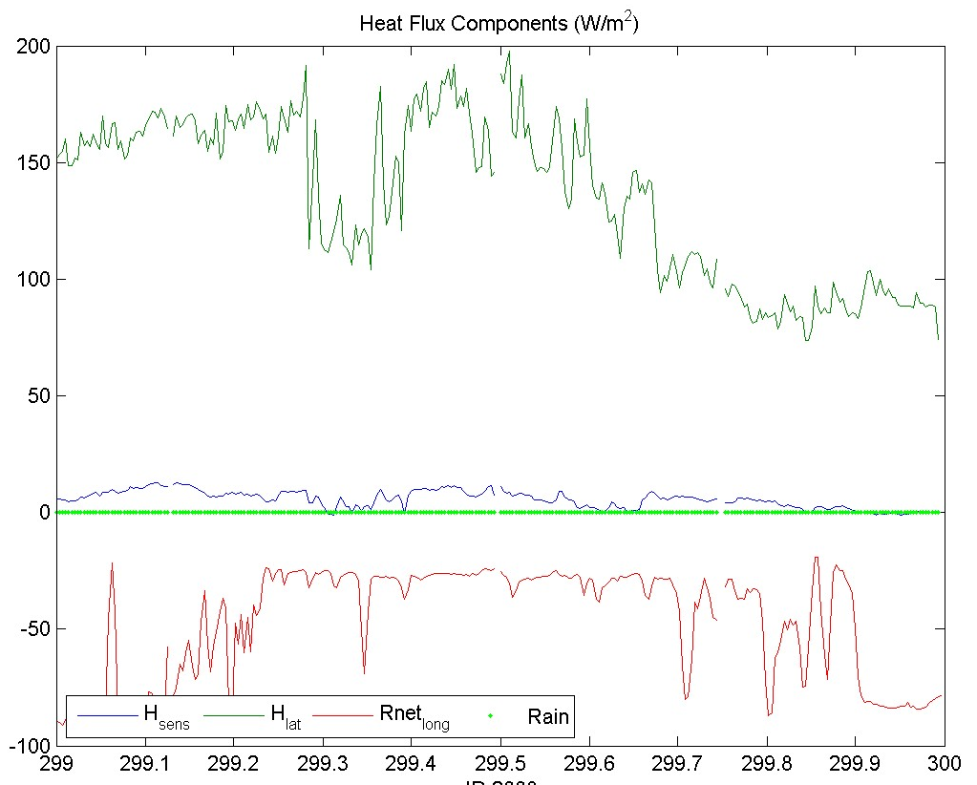
Figure 19. Time series of non-solar surface heat flux components.
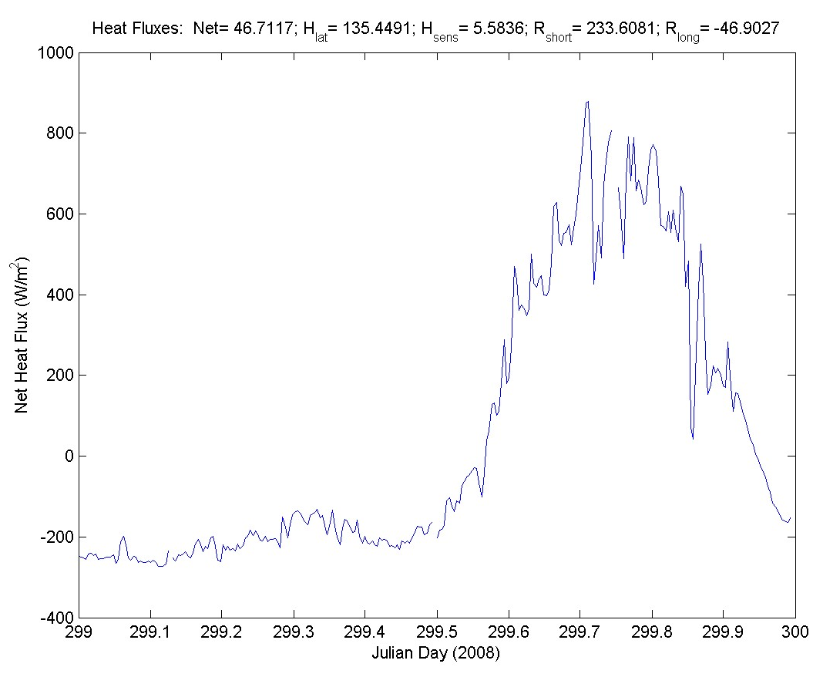
Figure 20. Time series of net heat flux to the ocean surface. The values at the top of the graph are the average for the day for each component of the flux.
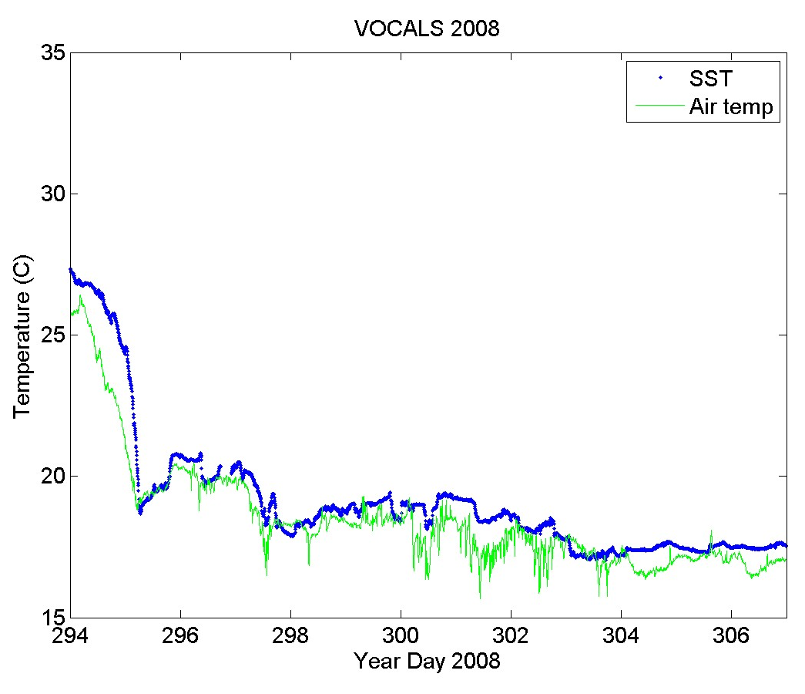Figure 21 Time series of near-surface ocean temperature (blue) and 15-m air temperature (green) for the 2008 RHB Stratus cruise
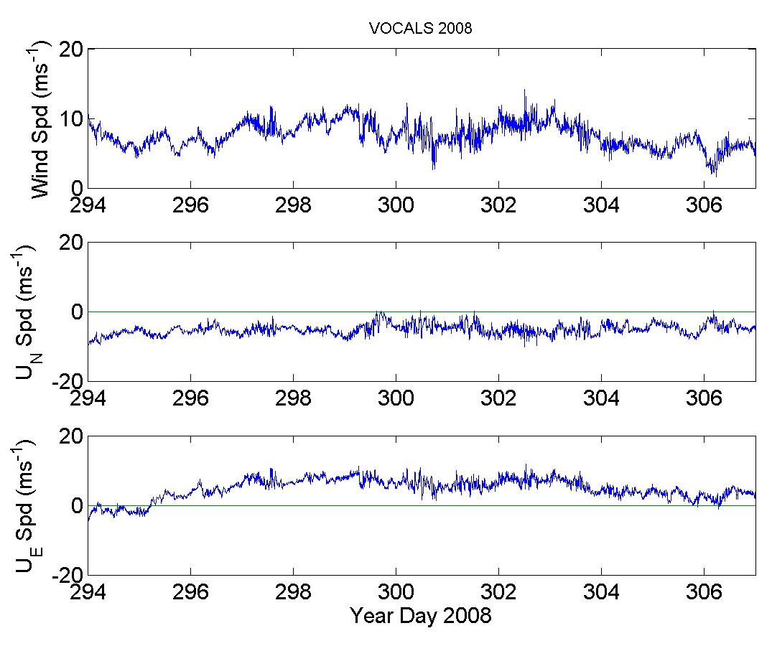
Figure 22. Time series of wind speed (upper panel), northerly component (middle panel), and easterly component (lower panel.
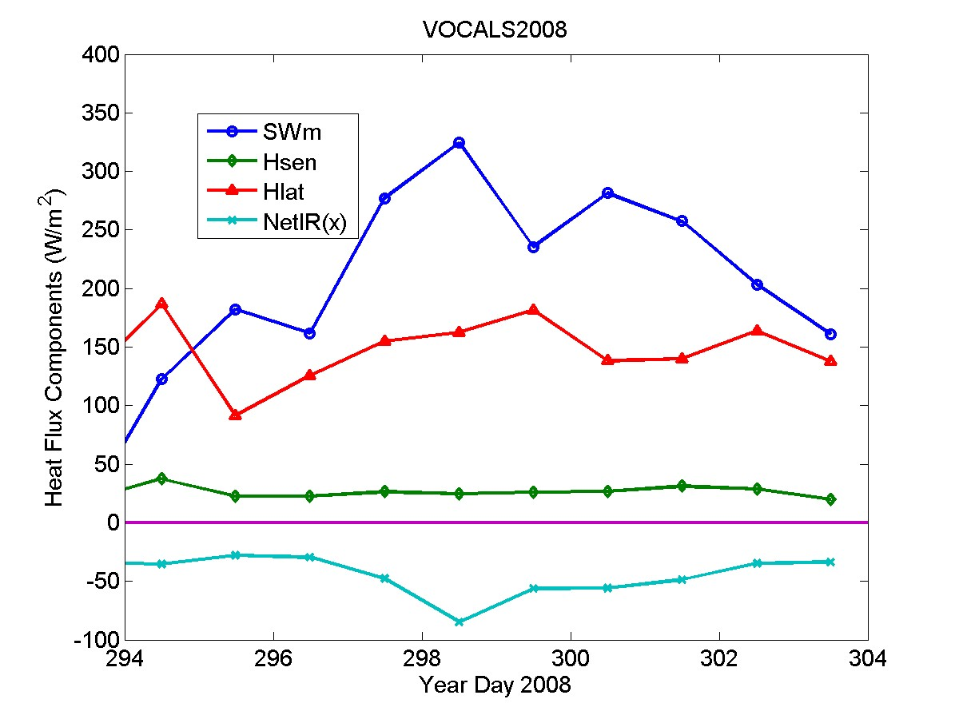
Figure 23. Time series of 24-hr average heat flux components: SWm-solar flux; Hlat-latent heat flux; Hsen-sensible heat flux; NetIR-net IR flux.

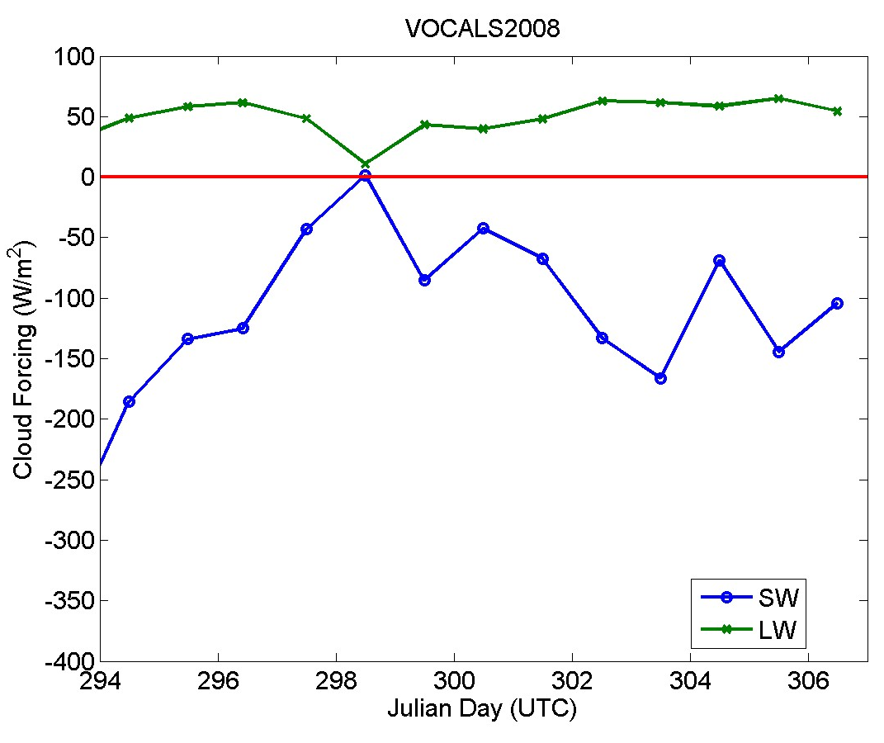
Figure 24. Time series of daily averaged radiative cloud forcing.
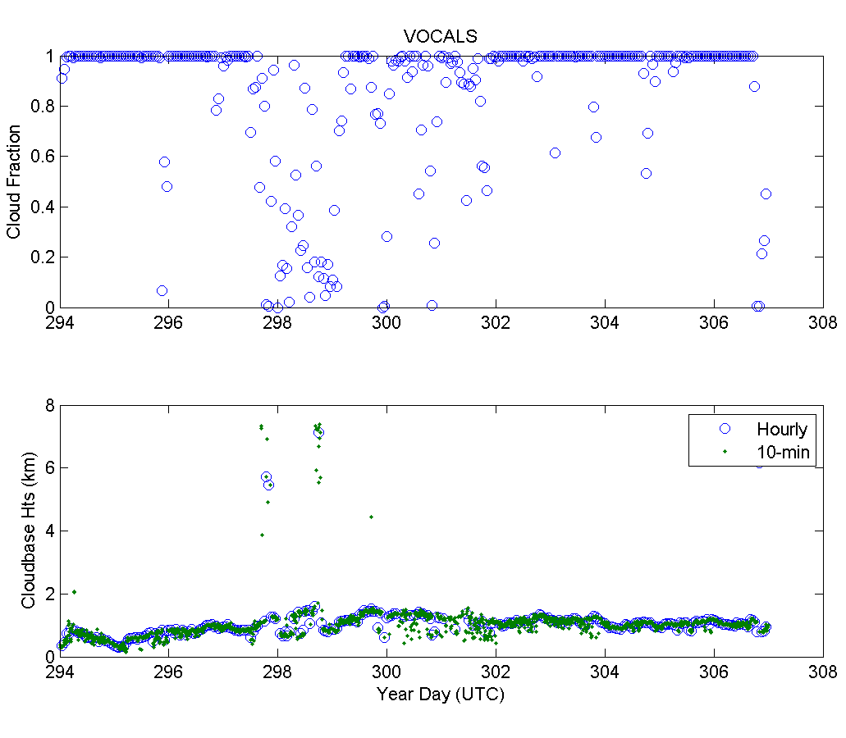
Figure 25. Time series of ceilometer cloud base bottom panel) and cloud fraction (top panel)

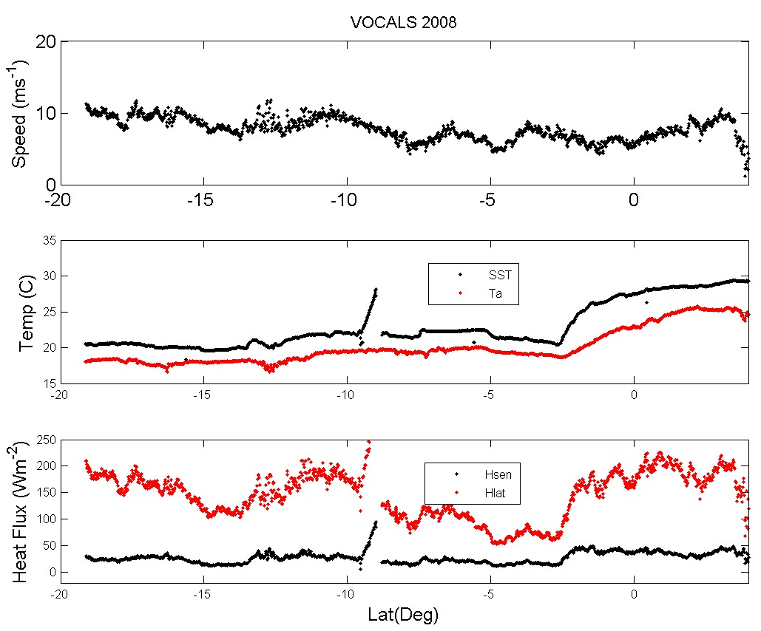
Figure 26. Selected variables from the N-S transect along 85 W. Upper panel is wind speed; the middle panel is sea surface and air temperatures; the lower panel shows sensible (Hsen) and latent (Hlat) heat fluxes.
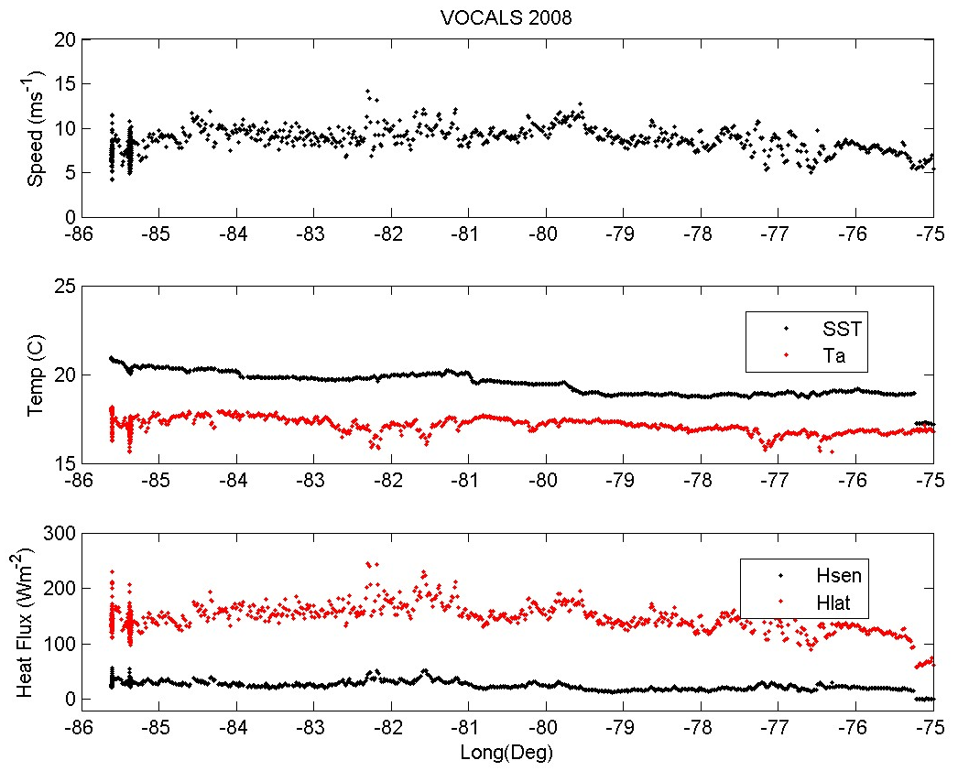
Figure 27. Same as Fig. 26, but for the W-E transect along 20 S from 85 W to 70 W.

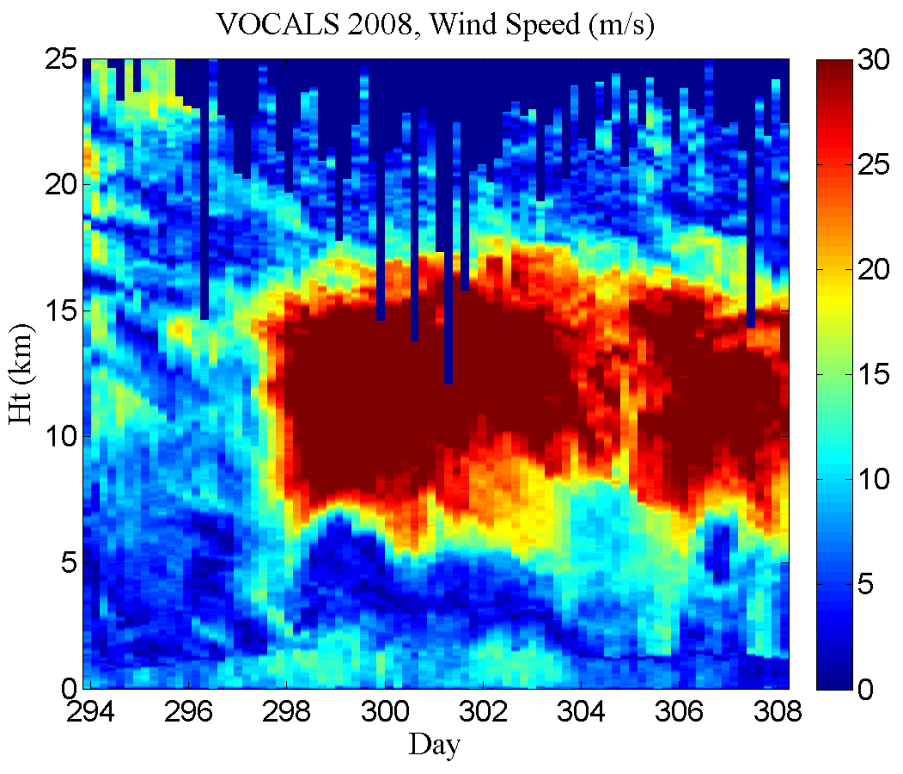
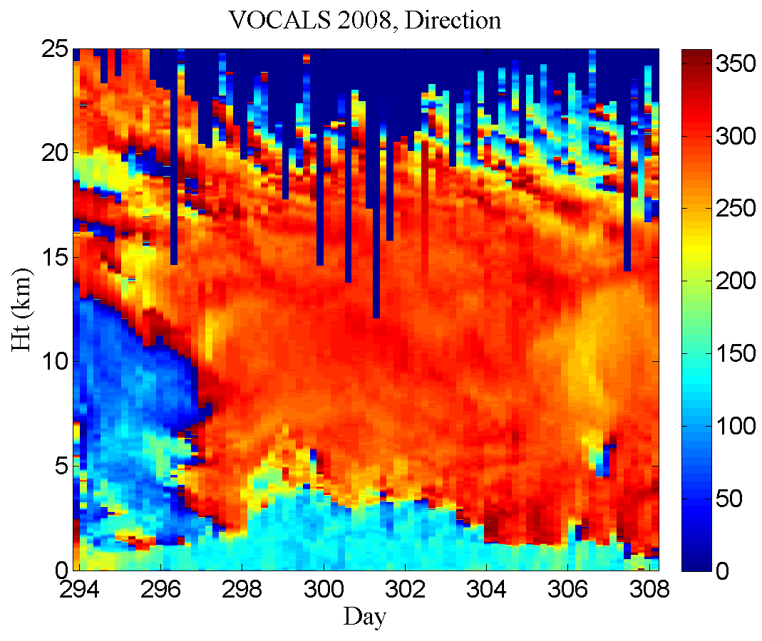
Figure 28. Time-height color contour plots from radiosondes launched during the 2008 Stratus cruise. The upper panel is wind speed and the lower panel is wind direction

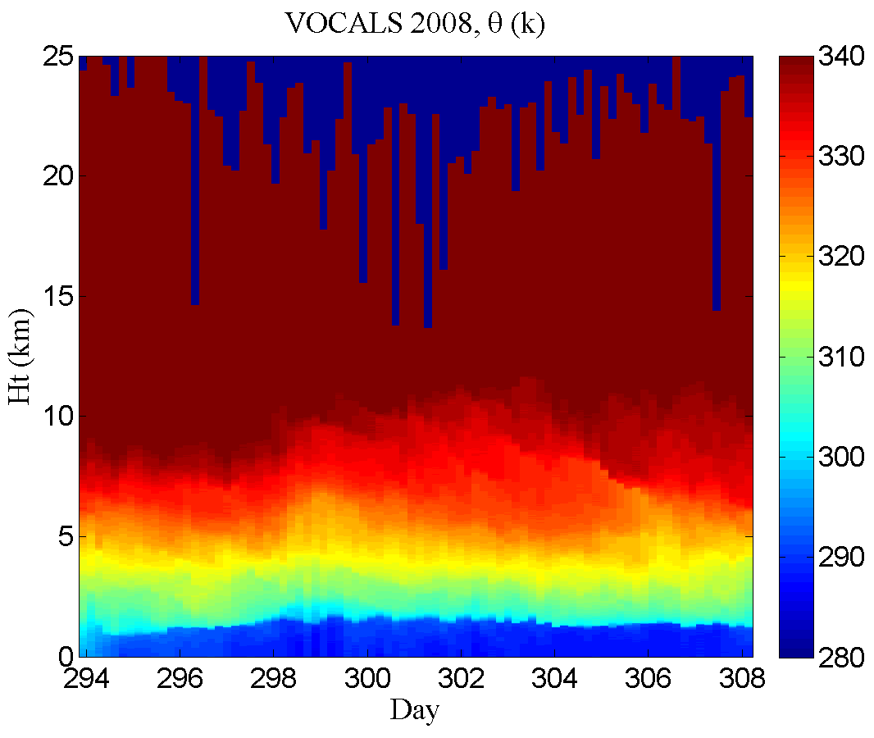
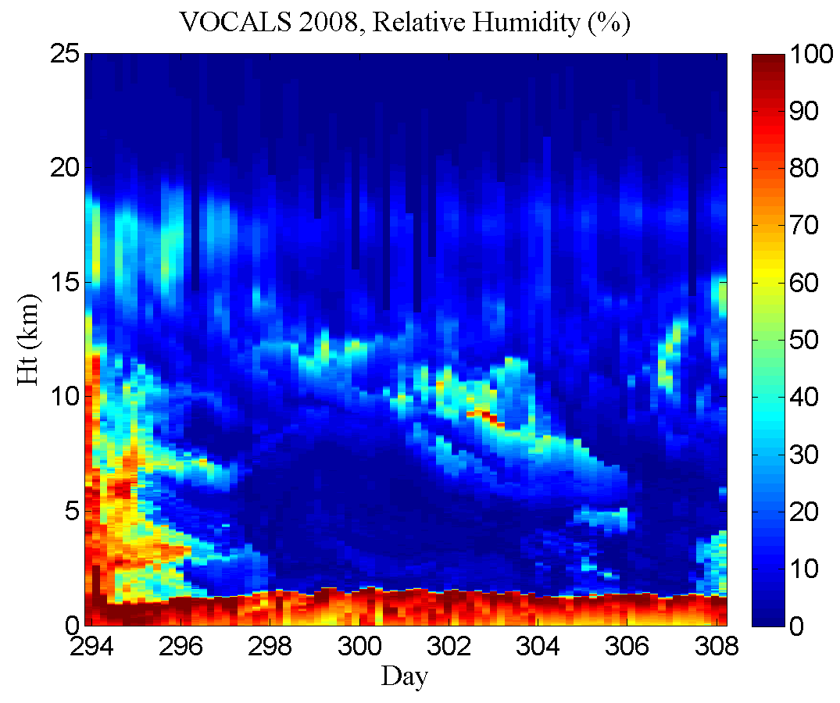
Figure 29. Time-height color contour plots from radiosondes launched during the 2008 stratus cruise. The upper panel is theta; the lower panel is relative humidity with respect to ice.

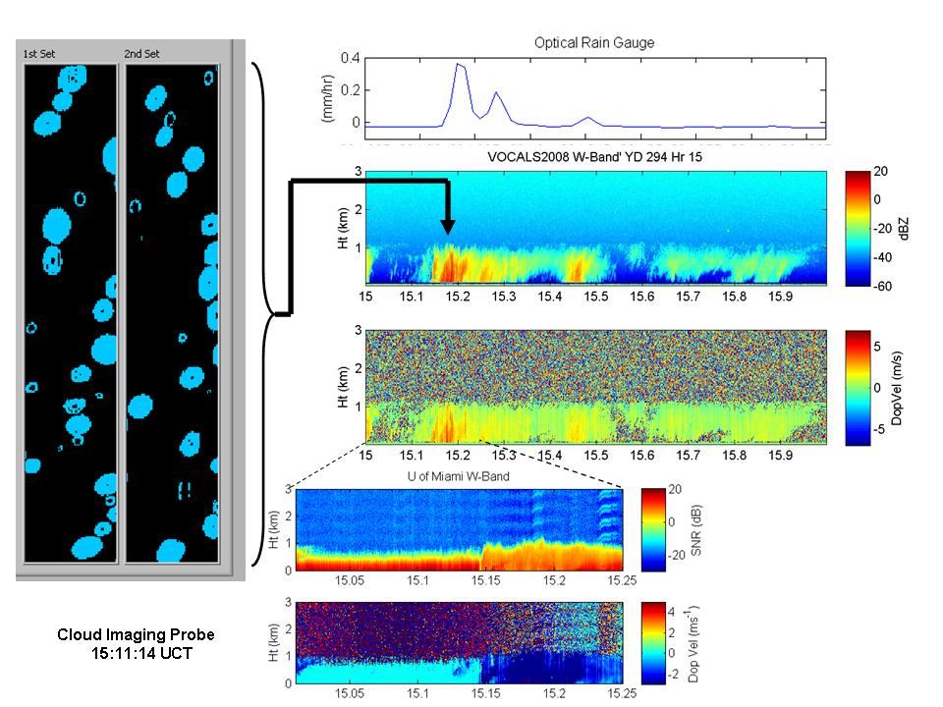
Figure 30. Inter-comparison of drizzle case on Oct 20, 2008. Left panel is Cloud Imaging Probe 2-D depiction of light drizzle, upper right panel is time series of rain rate (mm/hr) from the optical rain gauge, the middle right 2 panels are reflectivity and Doppler vertical velocity from the PSD W-band radar for 15-16 UTC and the lower right 2 panels are SNR and Doppler vertical velocity from the U of Miami W-band radar for 1500-1515 UTC.
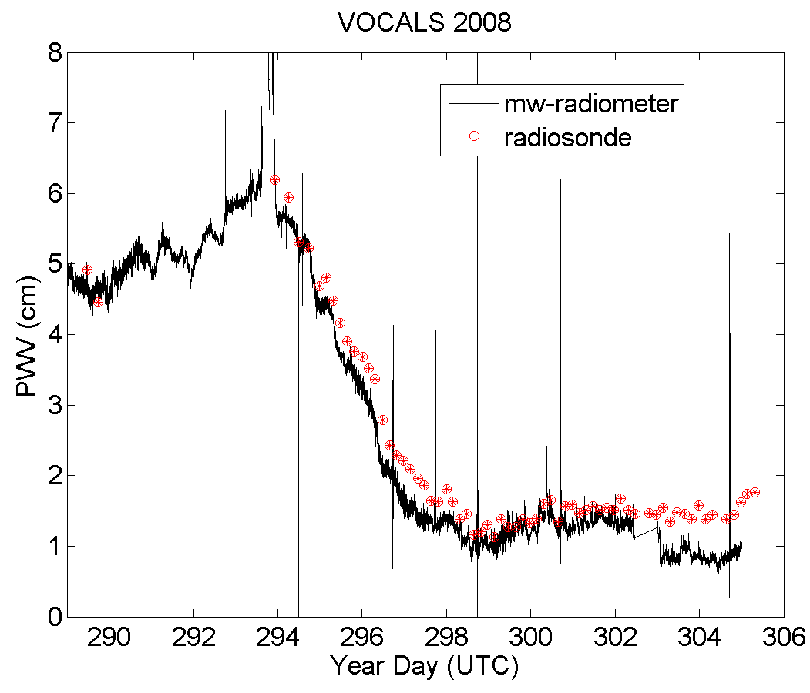
Figure 31. Time series of column integrated water vapor for the microwave radiometer and column and the radiosonde.

