University of Hawaii Cruise Report, VOCALS Leg 2
Barry Huebert, huebert@hawaii.edu, 1 December 2008
Rebecca Simpson, rmcs@hawaii.edu
We measured the flux of dimethyl sulfide gas (DMS) from the ocean to the atmosphere, using eddy covariance and an Atmospheric Pressure Ionization Mass Spectrometer (see picture below). DMS was measured very rapidly, in updrafts and downdrafts of air, to determine its flux (rate of emission). The APIMS makes that fast measurement on air brought down to the lab from an inlet on the Brown’s jackstaff. Next to that inlet was a three-dimensional anemometer (wind gauge) that measured updrafts and downdrafts 50 times each second.
DMS is produced naturally by phytoplankton. A small fraction of it volatilizes from the ocean’s surface into the atmosphere, where is oxidized to form sulfate particles. These particles control the whiteness of clouds, so they play a large role in the climate system. Much of our work is directed at understanding what controls the emission rate of DMS from the ocean; wind certainly increases the emissions, but so do a range of other factors, such as sea state and surface films. Identifying those other factors is one of our major goals.
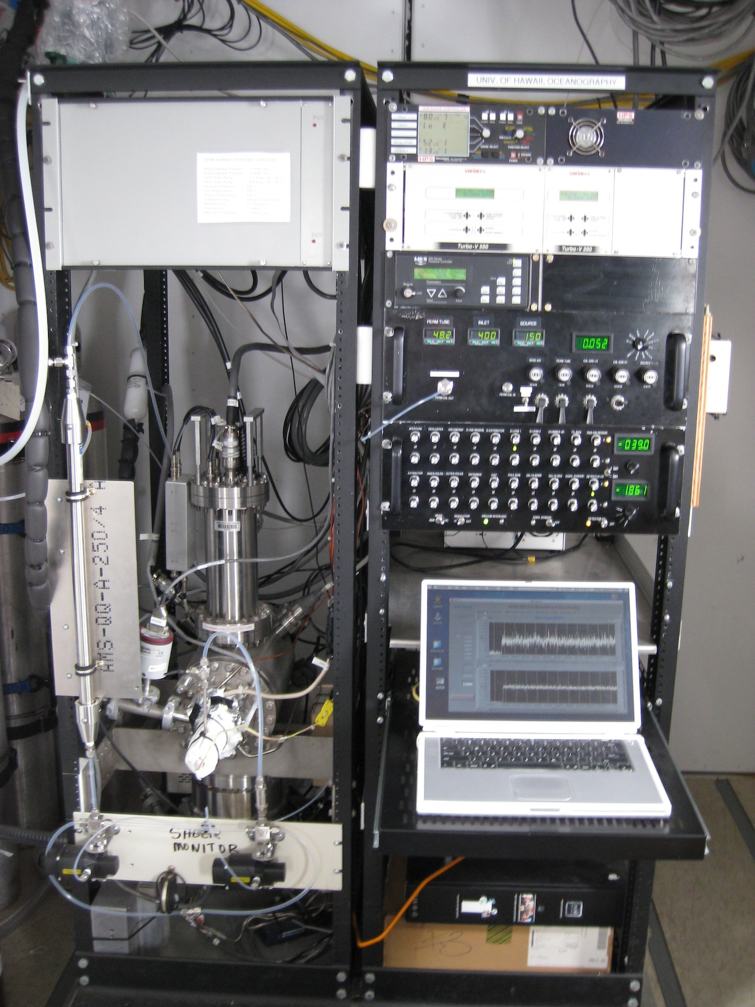
During VOCALS we also used an automated instrument belonging to NOAA’s Pacific Marine Environmental Lab to measure the amount of DMS in the sea water itself. We were surprised to see what a good indicator of water mass mixing DMS is. At virtually every front between cold and warm waters (or one eddy with another), the spot where those were mixing inevitably showed a big peak in the sea water DMS concentration. We will be looking very closely at this aspect of our data, to determine the ways in which DMS measurements may become useful tools for physical oceanography and fisheries studies.

