**6. Meteorological Intercomparison**

**a. Overview**

In order to assess the performance of the buoy meteorological systems, a 48 h period of observations at each buoy was planned following the deployment of the WHOTS-11 mooring and prior to recovery of the WHOTS-10 mooring. Due to the approach of tropical storm “Wali” and the threat of bad weather on the WHOTS-10 recovery day, it was decided to recover the WHOTS-10 mooring one day early. To accommodate this change, the intercomparison sequence was modified. The modified plan broke the intercomparison into three phases: 24 h at WHOTS-11 immediately after deployment, 48 h at WHOTS-10 prior to recovery, and another 24 h at WHOTS-11 after the WHOTS-10 recovery. The actual time spent on the three phases was 27 h, 52, h, and 31 h.

Hourly ASIMET data were obtained by intercepting the Argos PTT transmissions from the buoy with an Alpha-Omega satellite uplink receiver and a whip antenna mounted on a forward deck rail. Consistent receptions were obtained with the ship standing-off at a distance of about 0.15 nm from the buoy. Due to substantial drift (up to 3 nm) during CTD operations, and subsequent maneuvering, Argos data acquisition suffered some drop outs. In addition, the ~6 nm separation of the buoys meant that only one buoy could be monitored at a time. The resulting gaps in the directly received Argos data were supplemented by telemetered data served from the WHOI UOP web site.

Two other sets of meteorological sensors were available for comparison with the buoys: The ship’s meteorological measurements obtained via the Scientific Computer System (SCS) as described in Sec. 6.b, and the ESRL system installed on a bow mast as described in Sec. 6.c.

**b. Shipboard Instruments**

The HA was outfitted with sensors for air temperature (AT), relative humidity (RH), barometric pressure (BP), sea surface temperature (SST) and sea surface salinity (SSS), wind speed (WSPD), and wind direction (WDIR). An effort was made to document the data sources and instrument locations for the variables being collected. AT and RH were measured by a RM Young model 41372 sensor mounted along the ship centerline on a short mast above the pilot house. The AT/RH sensor height was estimated to be about 15 m. BP was measured by a Vaisala model PTB330 mounted in the aft section of the bridge on the 03 deck. The BP sensor was estimated to be 12 m above the waterline. Wind speed and direction were measured by a RM Young sonic anemometer mounted above the pilot house at about 15 m height. The anemometer measured relative wind speed and direction, which was corrected to absolute speed and direction by the SCS system. There were two potential sources for SST, a SBE-38 digital thermometer and a SBE-21 thermosalinograph. Both measured water from the bow intake estimated to be at 4 m depth. The SBE-38 probe was located near the intake, whereas the SBE-21 measured water that had been pumped from the forward intake to the Wet Lab at the aft of the ship. Thus, the SBE-38 was the preferred sensor for SST. Sea surface salinity (SSS) was measured by the SBE-21.

SCS data were averaged to 1 minute and recorded to ASCII text files on the ship’s SCS computer. Security firewalls between the ship’s servers and the network available to the science party made it difficult to obtain the SCS Event files onboard. Since the *Hi’ialakai* routinely transmits underway data to the Shipboard Automated Meteorological and Oceanographic System (SAMOS), a work-around was to download the 1 min average SCS data files from the SAMOS web site (<http://samos.coaps.fsu.edu>). Note that the only SST variable reported to SAMOS was the SBE-38, not the SBE-21 TSG, despite the “TSGWT” variable name. Due to an issue with TSG processing, the SAMOS data up to 19 July did not contain either SST or salinity data.

**c. ESRL/PSD flux system**

The ESRL Physical Science Division (PSD) air-sea flux group collected surface meteorology and sea surface temperature data during the cruise. The flux measurement system consists of six components:

1. A turbulent wind measurement system with motion correction.
2. Solar and infrared radiation sensors measuring downward radiative fluxes.
3. Bulk meteorology sensors (air temperature, relative humidity and precipitation)
4. A CO2/H2O gas analyzer (installed but did not function during the cruise)
5. A differential GPS unit measuring heading, pitch and roll information.
6. A sea surface temperature measurement made with a floating thermistor.

The turbulent wind system, AT/RH sensor and gas analyzer were mounted on a portable 10 m tall meteorological tower at the bow of the HA. The radiometers were mounted above the pilot house. The pressure sensor was mounted on the starboard side midship at a height of xx m. An outrigger was used to deploy the floating thermistor (“sea snake”), a water temperature sensor that drags near the surface, off the port bow. These sensors were logged in the ship’s lab using equipment supplied by ESRL. The sensor configuration details are summarized in Table 9. The systems were run continuously through the cruise. The ship’s SCS system with a set of navigation and meteorological data was archived along with the ESRL data. Note that the best situation for obtaining flux data is with the ship going slow ahead and the wind within 45 degrees of the bow.

ADD HEIGHTS TO ESRL SENSOR TABLE



**d. WHOTS-11 Intercomparison**

The WHOTS-11 comparison occurred in two phases: from 0700 UTC on 17 July to 1000 UTC on 18 July and from 0800 UTC on 21 July to 1500 UTC on 22 July. Results obtained during the first phase of the WHOTS-11 comparison (17 July) are presented. Comparisons for AT, RH, BP, SST, SWR, LWR, WSPD and WDIR are shown in Figs. 13 through 20. The ESRL/PSD and ship’s data are averaged to 1 hour intervals and compared to the 1 hour averaged buoy data obtained from Argos telemetry. SST was not available in the SAMOS SCS data during this period. SSS and PRC were not available from either the ESRL/PSD or SCS.

TheHAdrifted away from the WHOTS-11 buoy several times for CTD casts and occasionally steamed away for sewage discharge. These excursions can cause short-term discrepancies in the sensor comparisons. To identify excursions, the distance from the ship to the WHOTS-11 anchor is shown in each figure. The buoy was about 2 nm from the anchor. Excursions to > 3 nm indicate CTD casts or sewage discharge runs. For the 17 July period evaluated here, it is notable that the ship was completing the anchor triangulation survey until about 0700 UTC and drifted about 7 nm from the anchor near 1800 UTC.

The WHOTS-11 buoy sensor pairs showed goodagreement (differences between like sensors were within the expected short-term accuracy) for all variables. Examination of the buoy data in conjunction with the ESRL meteorology sensors provided further understanding of discrepancies, and resulted in other useful observations about system performance, as described below.

The WHOTS-11 buoy AT pair agreed to within about 0.15°C at night, and the difference did not increase at mid day. The ERSL AT was within 0.2°C of the buoy pair, although consistently lower. Offsets of about -0.2°C for shipboard AT sensors (mounted at ~10 m height) relative to the buoys have been seen in previous comparisons, and attributed to vertical gradients. So the ESRL AT offset is plausible. The SCS AT was biased high by about 1°C, as had been observed on previous cruises on the *Hi’ialakai*.

The WHOTS-11 buoy RH pair typically agreed to within 1%, which is the resolution of the Argos telemetry data. The ERSL RH was 2-3% lower than the buoy pair. Shipboard RH sensors (mounted at ~10 m height) reading a few percent lower than the buoys has been seen in previous comparisons, and attributed to vertical gradients. So the offset of the buoy RH from ESRL is plausible.

The WHOTS-11 buoy BP pair agreed within the 1.0 mb resolution of the Argos telemetry data. None of the pressures were adjusted to sea level. The height difference between buoy and ESRL sensors was estimated to be about 5 m. The relatively good agreement (+/- 0.5 mb) between the buoy and ESRL pressures was plausible, particularly given the limited precision of the telemetered buoy BP data. The SCS BP was consistently lower than the buoy BP, as expected with the ship’s sensor higher than the buoy sensor. However, the offset of <0.5 mb was less than expected given the ~10 m height difference.

The WHOTS-11 buoy SSTs were indistinguishable within the 0.01°C resolution of the Argos telemetry data. The best comparison with ESRL SST was at night when the ship held a stable position near the buoy (0700-1400 UTC). Differences of 0.1°C to 0.2°C during the day may be due to a combination of vertical gradients (buoy thermistor at ~1 m depth vs. ESRL thermistor floating at the sea surface) and horizontal gradients as the distance between the ship and the buoy varied.

The WHOTS-11 buoy SWR pair agreed to within 10-20 W/m2 during the day, or 1-2% of the maximum insolation of 1000 W/m2. The buoy pair agreed well with ESRL PSP-1, but not as well with ESRL PSP-2. Comparison of values at mid day was compromised by missing data.

The WHOTS-11 buoy LWR pair agreed to within 2-4 W/m2. The buoy pair agreed well with ESRL PIR-1throughout the day. All four systems were within a few W/m2 from 0700-1500 UTC when the ship held a stable position near the buoy. The two ESRL PIRs, mounted on the same platform, diverged from each other before 0700 and after 1800. This was attributed to calibration problems with ESRL PIR-2.

The WHOTS-11 buoy WND pair showed speed differences of about 0.3 m/s. The ESRL wind speeds were about 1 m/s higher than the buoy values, but such a difference would be expected given the xx m height difference between the two measurements. An adjustment of ESRL wind speed to 3 m improved the comparison significantly. The SCS winds were consistently higher than the ESRL winds despite being measured at a lower height. It was suspected that flow distortion at the leading edge of the bridge contributed to overspeeding.

The WHOTS-11 buoy WND pair showed direction differences of a few degrees. The buoy, ESRL and SCS directions all agreed well except for a brief period when the ship was over 5 nm away from the anchor (so several nm away from the buoy).

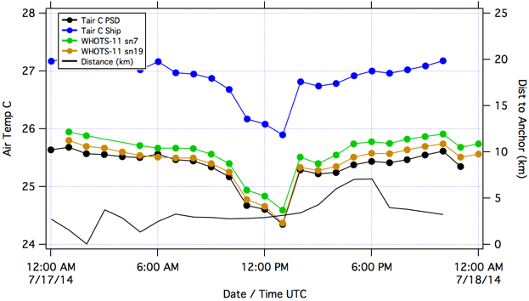

Figure 13. Air temperature for the WHOTS-11 buoy systems (SN 7 and SN 19), the SCS system (blue) and

the ESRL/PSD system (black) during the intercomparison period. The thin black line in this and subsequent plots indicates the distance from the ship to the WHOTS-11 anchor.

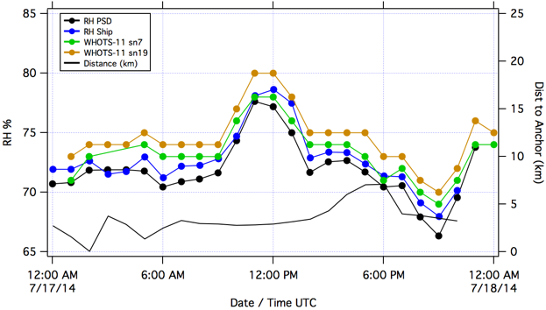

Figure 14. Relative humidity for the WHOTS-11 buoy systems (SN 7 and SN 19) the SCS system (blue) and the ESRL/PSD system (black) during the intercomparison period.

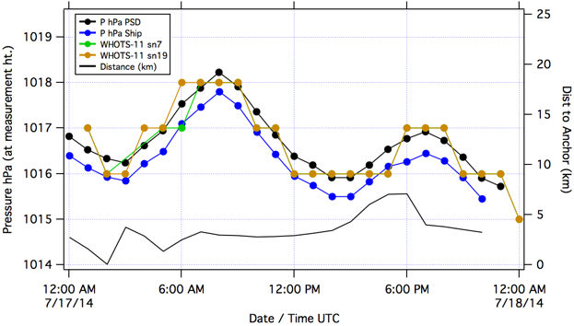

**Figure 15.** **Barometric pressure for the WHOTS-11 buoy systems (SN 7 and SN 19) the SCS system (blue) and the ESRL/PSD system (black) during the intercomparison period.**

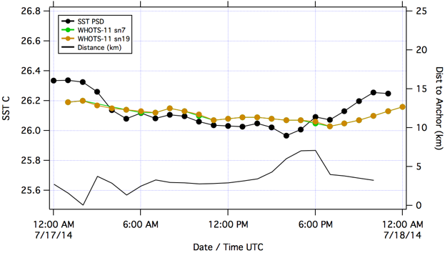

**Figure 16.** **Sea Surface Temperature for the WHOTS-11 buoy systems (SN 7 and SN 19) and ESRL/PSD system (black) during the intercomparison period. SCS SST was not available.**

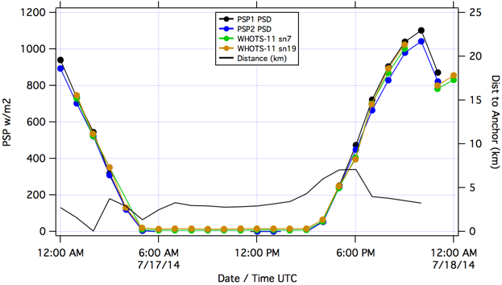

**Figure 17.** **Shortwave radiation for the WHOTS-11 buoy systems (SN 7 and SN 19) and ESRL/PSD systems (black, blue) during the intercomparison period. SCS SWR was not available.**

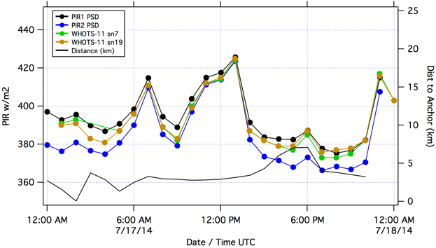

**Figure 18.** **Longwave radiation for the WHOTS-11 buoy systems (SN 7 and SN 19) and ESRL/PSD systems (black, blue) during the intercomparison period. SCS LWR was not available.**

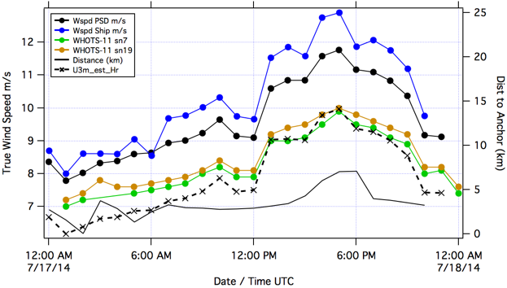

Figure 19. Wind speed for the WHOTS-11 buoy systems (SN 7 and SN 19) the SCS system (blue) and the ESRL/PSD system (black) during the intercomparison period. An estimate of the ESRL wind speed adjusted to 3 m height is shown as a dashed line.

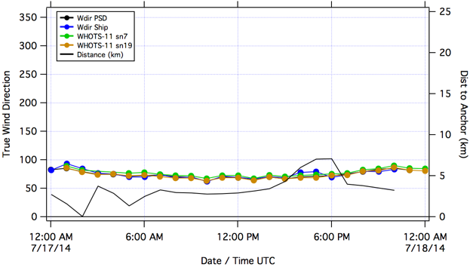

Figure 20. Wind direction for the WHOTS-11 buoy systems (SN 7 and SN 19) the SCS system (blue) and the ESRL/PSD system (black) during the intercomparison period.

**e. WHOTS-10 Intercomparison**

The WHOTS-10 comparison took place from 1100 UTC on 18 July to 1500 UTC on 20 July. Results obtained during the middle of the WHOTS-10 comparison period (19 July) are presented. Comparisons for AT, RH, BP, SST, SWR, LWR, WSPD and WDIR are shown in Figs. 21 through 28. The ESRL/PSD and ship’s data are averaged to 1 hour intervals and compared to the 1 hour averaged buoy data obtained from Argos telemetry. SSS and PRC were not available from either the ESRL/PSD or SCS.

TheHAdrifted away from the WHOTS-10 buoy several times for CTD casts and occasionally steamed away for sewage discharge. These excursions can cause short-term discrepancies in the sensor comparisons. To identify excursions, the distance from the ship to the WHOTS-11 anchor is shown in each figure. The buoy was about 2 nm from the anchor. Excursions to > 3 nm indicate CTD casts or sewage discharge runs.

The WHOTS-10 buoy sensor pairs showed goodagreement (differences between like sensors were within the expected short-term accuracy) for all variables except wind direction…. Examination of the buoy data in conjunction with the ESRL meteorology sensors provided further understanding of discrepancies, and resulted in other useful observations about system performance, as described below.

The WHOTS-10 buoy AT pair agreed to within 0.1°C at night. The magnitude of the difference did not increase significantly during the day, but a change in sign suggested differences in self-heating. The ERSL AT was about 0.1°C lower than the buoy pair at night. Offsets of about -0.2°C for shipboard AT sensors (mounted at ~10 m height) relative to the buoys have been seen in previous comparisons, and attributed to vertical gradients. So the AutoIMET and ESRL AT offsets are plausible. Increasing differences (0.2-0.3°C) between buoy and ESRL AT during the day are consistent with self heating of the buoy sensors. It was concluded that the WHOTS-10 AT sensors were operating as expected, with evidence of self heating. The SCS AT was biased high by about 1°C, as had been observed on previous cruises on the *Hi’ialakai*.

The WHOTS-10 buoy RH pair typically agreed to within 1%, which is the resolution of the Argos telemetry data. The ERSL RH was within 1-2% of the buoy pair. Shipboard RH sensors (mounted at ~10 m height) typically read a few percent lower than the buoys due to vertical gradients. Thus, these results indicate that the WHOTS-10 RH may be biased low. A more careful comparison, including the WHOTS-11 buoy RH during the period of overlap, would be warranted.

The WHOTS-11 buoy BP pair agreed within the 1.0 mb resolution of the Argos telemetry data. None of the pressures were adjusted to sea level. The height difference between buoy and ESRL sensors was estimated to be about 5 m. The relatively good agreement (+/- 0.5 mb) between the buoy and ESRL pressures was plausible, particularly given the limited precision of the telemetered buoy BP data. The SCS BP was consistently lower than the buoy BP, as expected with the ship’s sensor higher than the buoy sensor. However, the offset of <0.5 mb was less than expected given the ~10 m height difference.

The WHOTS-10 buoy SSTs were indistinguishable within the 0.01°C resolution of the Argos telemetry data. The best comparison with ESRL SST was at night (0500-1500 UTC). Differences of 0.1-0.2°C during the day were assumed to result from vertical gradients given the different measurement depths (buoy thermistor at ~1 m depth and ESRL thermistor floating at the sea surface). The SCS SST appears to be biased high by about 0.2°C.

The WHOTS-10 buoy SWR pair agreed to within 10-20 W/m2, through the diurnal cycle or 1-2% of the maximum insolation of 1000 W/m2. The buoy pair showed reasonable agreement (+/- 30 W/m2) with the ESRL PSP values.

The WHOTS-10 buoy LWR pair agreed to within 3-5 W/m2. The buoy pair agreed well with ESRL PIR-1throughout the day. ESRL PIR-2, mounted on the same platform as PIR-1, was consistently low by about 10 W/m2. This was attributed to a calibration problem with ESRL PIR-2.

The WHOTS-10 buoy WND pair showed a persistent speed difference of about 0.5 m/s. The ESRL wind speeds were about 1 m/s higher than the buoy values, but such a difference would be expected given the xx m height difference between the two measurements. An adjustment of ESRL wind speed to 3 m improved the comparison, but did not completely resolve the disagreement. The SCS winds were consistently higher than the ESRL winds despite being measured at a lower height. It was suspected that flow distortion at the leading edge of the bridge contributed to overspeeding.

The WHOTS-10 buoy WND pair showed a direction difference of about 10°. The buoy L15, ESRL and SCS directions all agreed well. It was concluded that the WHOTS-10 L08 wind direction was biased high by about 10°.

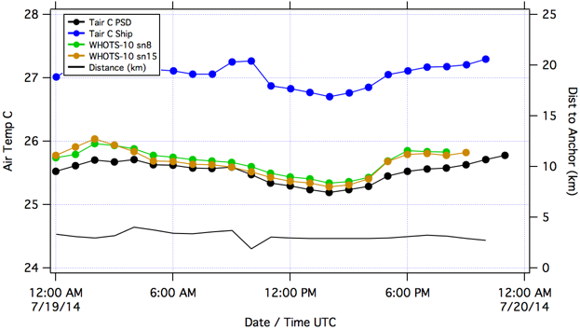

Figure 21. Air temperature for the WHOTS-10 buoy systems (SN 8 and SN 15), the SCS system (blue) and the ESRL/PSD system (black) during the intercomparison period. The thin black line in this and subsequent plots indicates the distance from the ship to the WHOTS-11 anchor.

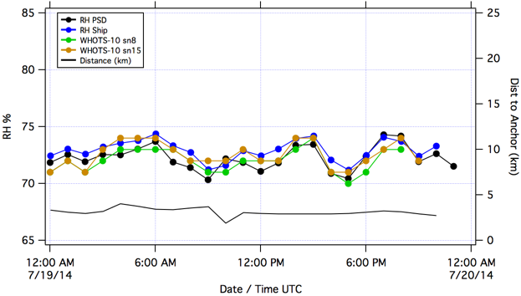

Figure 22. Relative humidity for the WHOTS-10 buoy systems (SN 8 and SN 15), the SCS system (blue) and the ESRL/PSD system (black) during the intercomparison period.

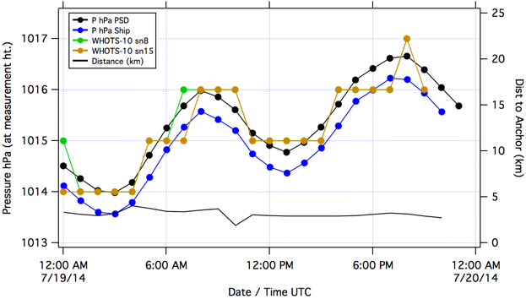

Figure 23. Barometric pressure for the WHOTS-10 buoy systems (SN 8 and SN 15), the SCS system (blue) and the ESRL/PSD system (black) during the intercomparison period.

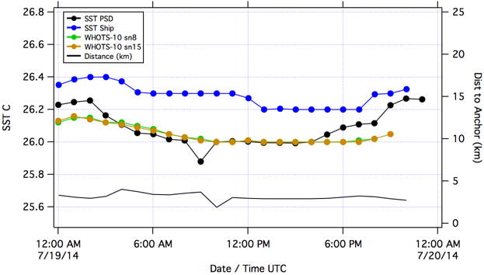

Figure 24. Sea surface temperature for the WHOTS-10 buoy systems (SN 8 and SN 15), the SCS system (blue) and the ESRL/PSD system (black) during the intercomparison period.

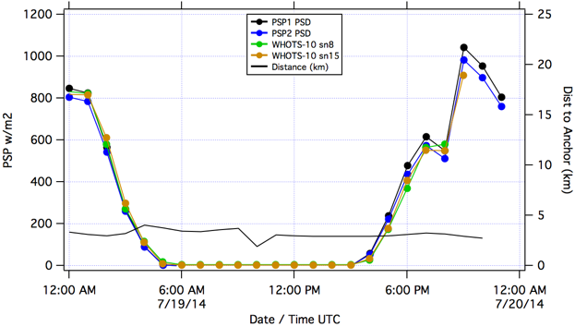

Figure 25. Shortwave radiation for the WHOTS-10 buoy systems (SN 7 and SN 19) and ESRL/PSD systems (black, blue) during the intercomparison period. SCS SWR was not available.

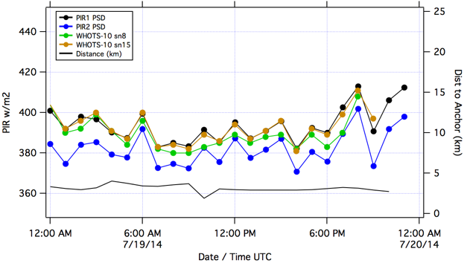

Figure 26. Longwave radiation for the WHOTS-10 buoy systems (SN 7 and SN 19) and ESRL/PSD systems (black, blue) during the intercomparison period. SCS SWR was not available.

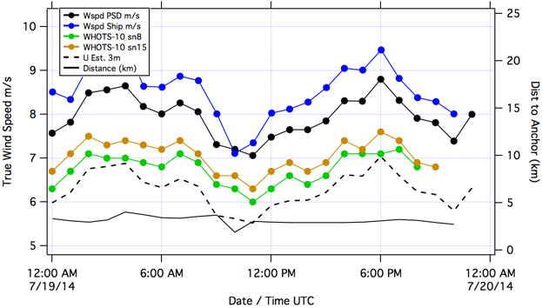

Figure 27. Wind speed for the WHOTS-10 buoy systems (SN 7 and SN 19) the SCS system (blue) and the ESRL/PSD system (black) during the intercomparison period. An estimate of the ESRL wind speed adjusted to 3 m height is shown as a dashed line.

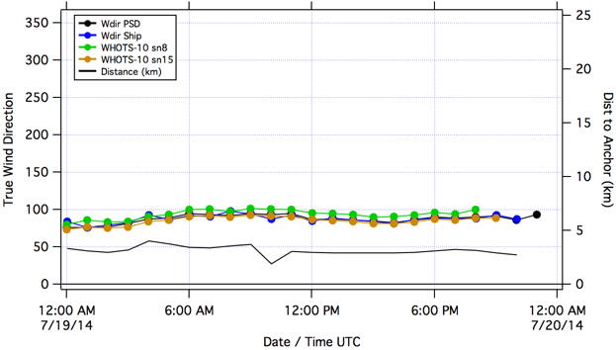

Figure 28. Wind direction for the WHOTS-10 buoy systems (SN 7 and SN 19) the SCS system (blue) and the ESRL/PSD system (black) during the intercomparison period.