APPENDICES

Appendix A: The ESRL/PSD Turbulent Flux System

The PSD Turbulent Flux Measurement System consists of six components (Table 1):

- A turbulent wind measurement system with motion correction mounted on the top of a 30’ high portable tower located near the foremast.
- Solar and infrared radiation sensors. Radiometers are mounted on top of bridge house by the port side.
- Bulk Meteorology sensors (air temperature, relative humidity, sea surface temperature and precipitation). These instruments are mounted on the top of a 30’ high portable tower. The sensors are:
- A CO2/H2O gas analyzer - mounted on the top of a 30’ high portable tower located near the foremast.
- One differential GPS units measuring heading and pitch information. These instruments are usually installed on top of a sea container.
- A sea surface temperature measurement made with a floating thermistor deployed off a port or starboard side with outrigger.

Table 1. Instruments and measurements for air-sea interaction studies
Item | System | Measurement
1 | Air-sea flux system | Motion corrected turbulent fluxes
2 | Pyranometer &Pyrgeometer | Downward solar radiative, IR flux
3 | Bulk meteorology | Surface Water Temp, Air Temp, RH, Wind Speed, Rain rate
4 | Open Path LI-7500 Analyzer | CO2 and HO2
5 | GPS | Ship Heading, pith and roll.
6 | “Sea Snake” | Near surface sea temperature

These instrument measurements are logged in a ship’s lab or in a sea container supplied by ESRL. The systems will run continuously through the cruise. An RS-232 real-time feed from the ship’s SCS system with a set of navigation and meteorological data (TBD, ASCII formatted) is requested. The best situation for obtaining flux data is with the ship going slow ahead and the wind within 45 degrees of the bow.
ESRL will mount items 1, 3, and 4 from Table 1 on a portable 30’ tall meteorological tower at the bow of the HA (Fig. A-1). The tower has a base plate using 4 x 7/8-9 bolts on a 2-ft square pattern which has been previously welded to the deck, and will be used again (Fig. A-1). The radiometers, GPS (Table 1, items 2 & 5) and various electronics packages will be mounted above the pilot house (Fig. A-2). ESRL will also mount an outrigger to deploy the “sea snake”, a water temperature sensor (Table 1, item 6) that drags near the surface.

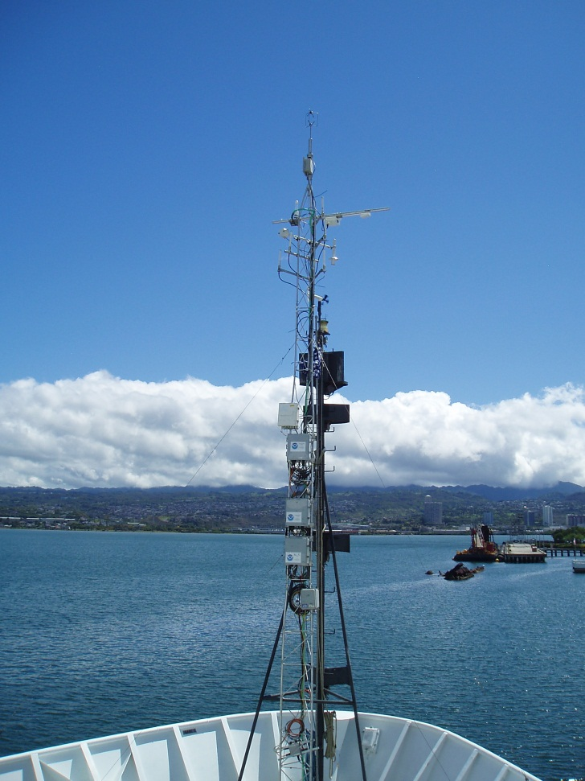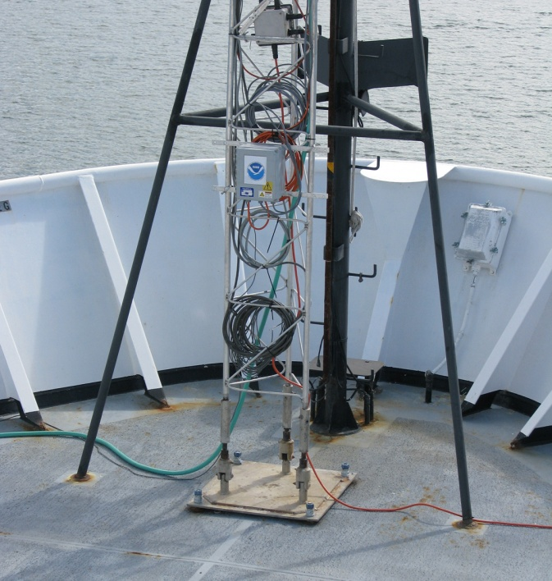

Figure A-1. ESRL/PSD mast mounted on the Hi’ialakai, showing the location and height of the tower relative to the ship’s forward mast (left) and attachment of the tower base to the deck via a welded plate (right).

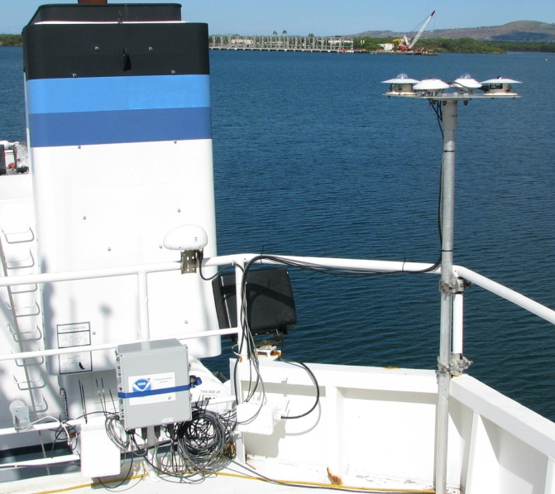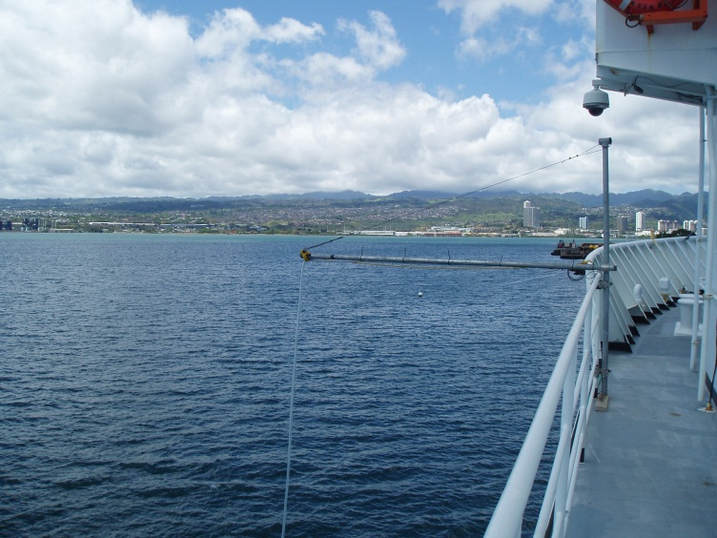

Figure A-2. ESRL/PSD radiometers (left) mounted on deck above the pilot house and the “sea snake” (right) mounted port side of first deck on Hi’ialakai.

