WHOTS 2021 FLUX SYSTEM DETAILS (Aug 2021, Sergio P. and Byron B.)

Instruments:

One Vaisala weather sensor model WXT520 serial number G2950010, calibration 2021
One Vaisala weather sensor model WXT520 serial number L4720496, calibration 2021
One K&Z PSP (PSP1) model CM22 serial number 50122, calibration 9.00 – 2017 (calibration can be re-verified post-cruise)
One K&Z PSP (PSP2) model CMP22 serial number 170518, calibration 9.51 – 2017 (calibration can be re-verified post-cruise)
One Eppley PIR (PIR1) serial number 38519, calibration 2.96 (old cal. 2.92), Dome coef. 7.62 – July 2021
One Eppley PIR (PIR2) serial number 38521, calibration 2.57 (old cal. 2.48), Dome coef. 6.69 – July 2021
One Vaisala Pressure sensor model PTB330 serial number L2820128
One Surface temperature sensor (sea snake)

Installation: (see photos on following pages)

The two WXT weather stations were mounted on the bow jackstaff at the same height on two horizontal arms, projecting approximately 2 ft. forward of the mast and separated by approximately 4 ft on the port-starboard axis.
The seasnake was mounted to the starboard 02 deck railing near the bow.
All other sensors (PTB pressure, heading/GPS and IR/solar radiometers were mounted on the starboard side of the pilothouse roof. The location for the radiometers was judged to be the best compromise in terms of clear sky visibility, but some obstruction of the field of view is expected by the main mast.
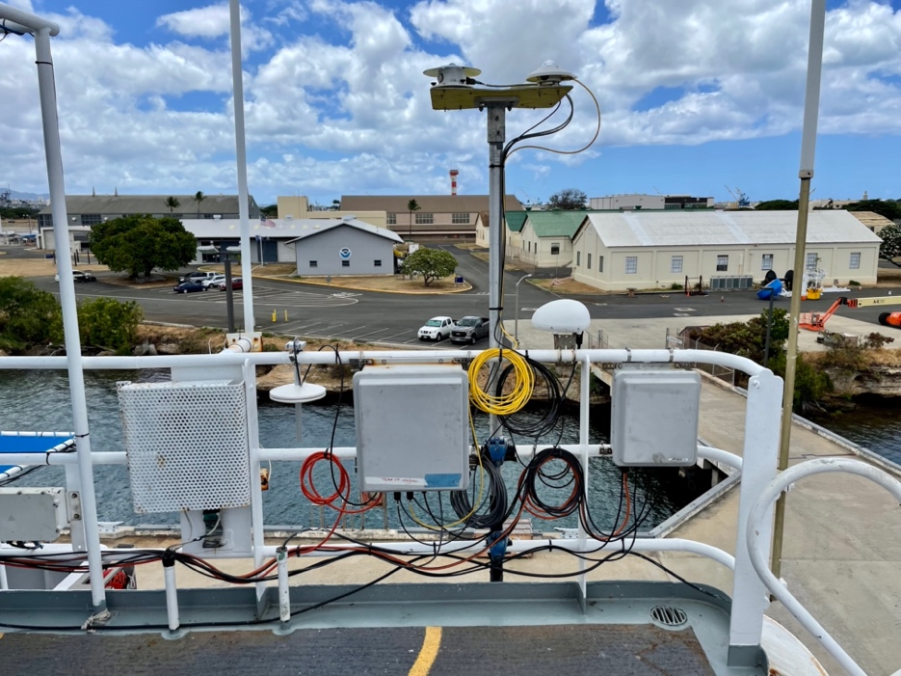
Figure 1: Radiometer mount, logger/pressure sensor box and ethernet switch box mounted to starboard railing on the pilot house roof.

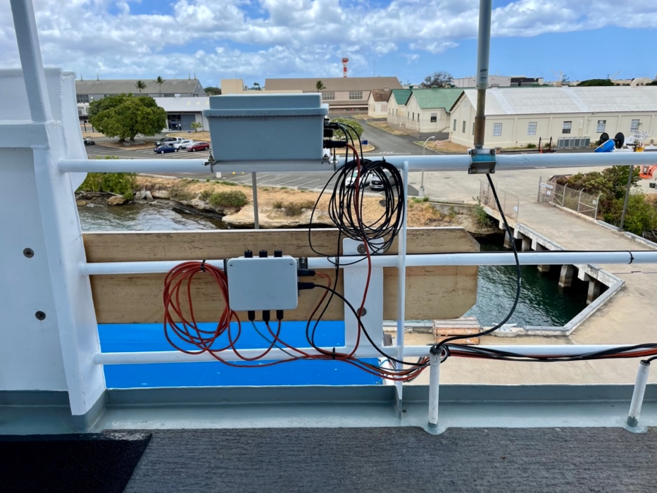
Figure 2: Heading system box and power distribution box, mounted on starboard side railing on the pilot house roof.

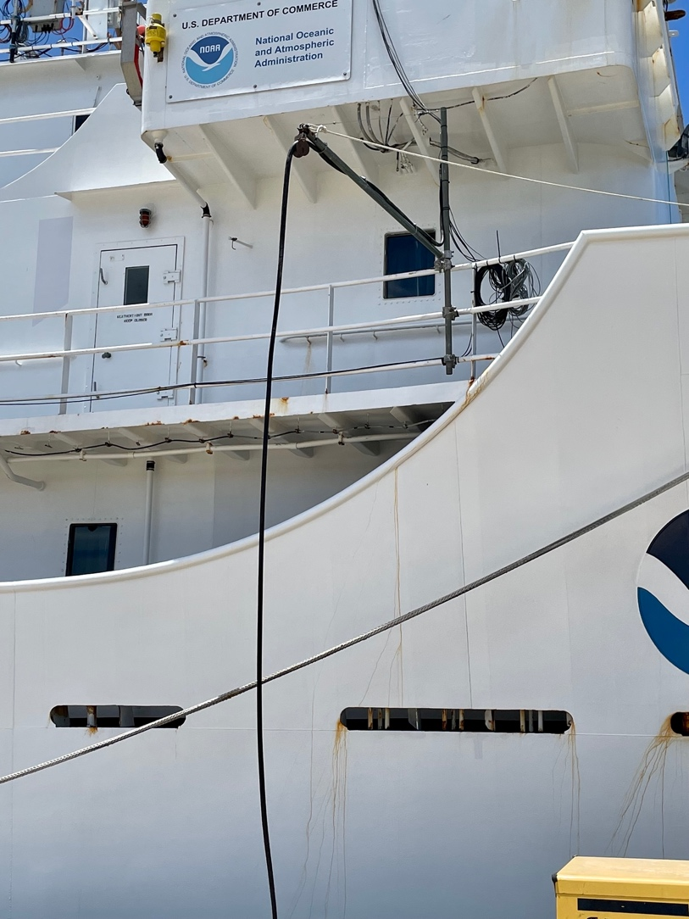
Figure 3: Seasnake SST system on starboard railing just aft of the bow deck.
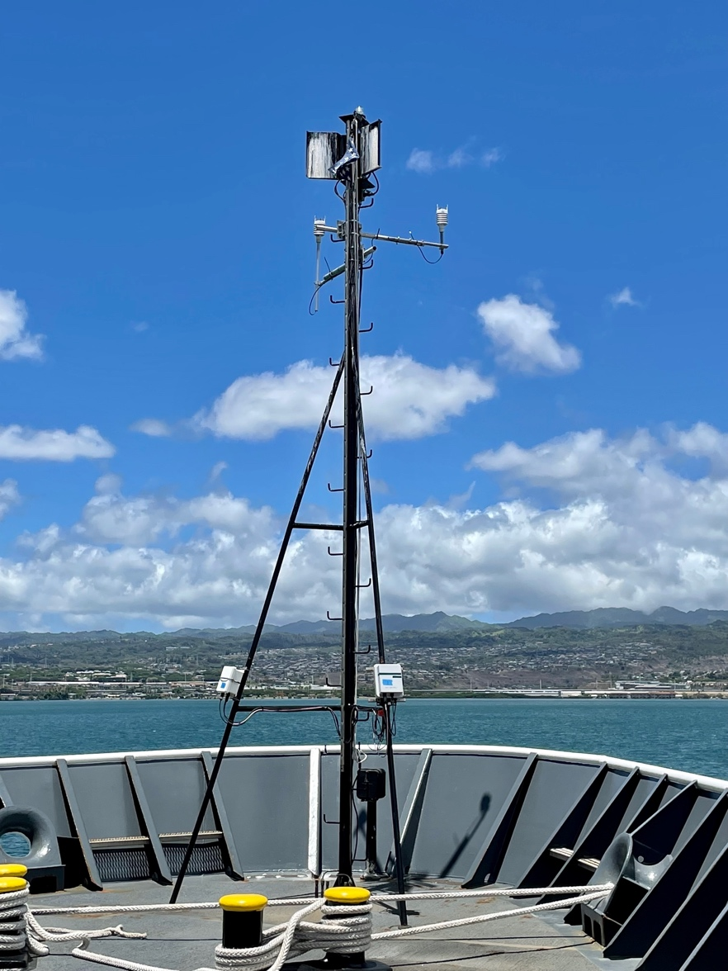
Figure 4: WXT met stations mounted to the bow jackstaff.

Measurement heights (provisional pending remeasurement at end of cruise)

1) WXT weather stations: 13.7m asl
2) PTB pressure sensor: 12.9m asl
3) Seasnake SST: ~5-10cm (depth)

Datalogger Program (for seasnake, radiometers and pressure):

'First System 2xPSP,2xPIR,Sea Snake, Relative Pressure by Spezoa
'CR1000
'Mean2
'Logs Sea snake with 4 wires, PSP, PIR and Pressure
'Declare Variables and Units
'Two pyranometer from EPPLEY,
'Two pyrgeometer from EPPLEY,
'One Sea Snake
'One Atmospheric Pressure
'channels used as:

'1H=Eppley PIR1 Case Temp 1
'1L=Eppley PIR1 Dome Temp 3
'2H=Eppley PIR1 thermopile 5
'2L=Eppley PIR1 thermopile 6
'----------
'3H=Eppley PSP1 thermopile
'3L=Eppley PSP1 thermopile
'----------
'4H=Eppley PIR2 Case Temp 1
'4L=Eppley PIR2 Dome Temp 3
'5H=Eppley PIR2 Thermopile 5
'5L=Eppley PIR2 Thermopile 6
'-----------
'6H= Eppley PSP2 Thermopile
'6L= Eppley PSP2 Thermopile
'-----------------------------------------------------
'sea snake Half Bridge, 4 Wire measurements Seatemp_r4W:
'7H & 7L ,8H & 8L ,E3
'(wire1,2) ==/\/\/\/\/\== (wire3,4)
'CH7- wire1(yellow)to 7H / 10k resistor between 7H and 7L/7L to E3
'wire3(green)to GND
'CH8- wire2(red)to 8H / wire4(blue)to 8L
'----------
'Pressure sensor PTB220 voltage
' via COM1 of logger
'-----------
'Declare Variables and Units
Public Batt_Volt,PTemp
Public Case_Res1(2)
Public PIR1_V, PSP1_V
Public Case_Res2(2)
Public PIR2_V, PSP2_V
Public PIR1_wm2, PIR2_wm2
Public PSP1_wm2, PSP2_wm2
Public Case1_R,Dome1_R
Public Case2_R,Dome2_R
Public Case1_T,Case2_T
Public Dome1_T,Dome2_T
Public Snake_R,Snake_C
'000000
Public String1 As String * 100
Public String2 As String * 100
Public String3 As String * 100
'Public String4 As String * 100
'Public String5 As String * 100
'Public String6 As String * 40
Public TimeValue As String * 20
Public hpa As String * 10
Public hpat As String * 10
Alias Case_Res1(1) = CaseRes1
Alias Case_Res1(2) = DomeRes1
Alias Case_Res2(1)= CaseRes2
Alias Case_Res2(2)= DomeRes2

'Declare Other Variables

'Declare Constants
'PSP and PIR constants from document 10/23/97 requested by J Hare to Eppley
' using YSI 44031
Const c1=0.0010295
Const c2=0.0002391
Const c3=0.0000001568
'Constants for YSI serie 46040 c4,c5,c6 changed March/4/2015
Const c4=0.001404694 'was 0.001399937
Const c5=0.000237006 'was 0.000237854
Const c6=0.000000101 'was 0.000000097

'Contant wire resistance for seasnake
'Const r_cond=5.130 NOT USED OCT 2019
'PIR1 s/n 38519F3 calibration on Jul/2019 Eppley
Const PIR1_Cnt = 0.00296
'----------------------
'PIR2 s/n 38521 calibration on Jul/2019 Eppley
Const PIR2_Cnt = 0.00257
'--------------------------
'PSP1 s/n CM22 calibration on 2017 K&Z
Const PSP1_Cnt = 0.00900
'---------------------------
'PSP2 s/n CMP22 calibration on 2017 K&Z
Const PSP2_Cnt = 0.00951
'--------------------------------
Const high=true
Const low = false
'Coefficients for YSI 46040 PIR1 0 to 45C Oct 2019
' to calculate thermistor temp
'0-40 Const c7=0.001017394
'0-40 Const c8=0.000241046
'0-40 Const c9=0.000000149
Const c7=0.001404694
Const c8=0.000237006
Const c9=0.000000101
SequentialMode
'Define Data Tables
DataTable(Met1,True,-1)
DataInterval(0,60,Sec,-1)
'Average
Sample(1,Batt_Volt,FP2)
Sample (1,PTemp,FP2)
'000000
Average (1,Case1_R,IEEE4,0)
Average (1,Case1_T,IEEE4,0)
Average (1,Dome1_R,IEEE4,0)
Average (1,Dome1_T,IEEE4,0)
Average (1,Case2_R,IEEE4,0)
Average (1,Case2_T,IEEE4,0)
Average (1,Dome2_R,IEEE4,0)
Average (1,Dome2_T,IEEE4,0)
'000000
Average (1,PIR1_V,IEEE4,0)
Average (1,PIR1_wm2,IEEE4,0)
Average (1,PSP1_V,IEEE4,0)
Average (1,PSP1_wm2,IEEE4,0)
'000000
Average (1,PIR2_V,IEEE4,0)
Average (1,PIR2_wm2,IEEE4,0)
Average (1,PSP2_V,IEEE4,0)
Average (1,PSP2_wm2,IEEE4,0)
'000000
Median (1,Snake_R,60,IEEE4,False)
Median (1,Snake_C,60,IEEE4,False)
Average (1,hpat,IEEE4,0)

'Standard Deviation
'StdDev (1,Case1_R,FP2,False)
'StdDev (1,Case1_T,FP2,False)
'StdDev (1,Dome1_R,FP2,False)
'StdDev (1,Dome1_T,FP2,False)
'StdDev (1,Case2_R,FP2,False)
'StdDev (1,Case2_T,FP2,False)
'StdDev (1,Dome2_R,FP2,False)
'StdDev (1,Dome2_T,FP2,False)
'StdDev (1,PIR1_V,FP2,False)
'StdDev (1,PIR1_wm2,FP2,False)
'StdDev (1,PSP1_V,FP2,False)
'StdDev (1,PSP1_wm2,FP2,False)
'StdDev (1,PIR2_V,FP2,False)
'StdDev (1,PIR2_wm2,FP2,False)
'StdDev (1,PSP2_V,FP2,False)
'StdDev (1,PSP2_wm2,FP2,False)
'StdDev (1,Snake_R,FP2,False)
'StdDev (1,Snake_C,FP2,False)

EndTable

'Main Program

BeginProg
SerialOpen (ComRS232,9600,0,0,100)
'Measure hpa via Com1
SerialOpen (Com1,9600,10,100,100)
Scan(1,Sec,5,0)
Battery(Batt_Volt)
PanelTemp(PTemp,250)
'Timestamp
TimeValue = Met1.Timestamp(1,1)
'Generic Half Bridge Case1, Dome1 measurements from Eppley PIR1:
'1H case resistance with 9990.6 resistor between 1H and E1
'1L dome resistance with 9996 resistor between 1L and E1
BrHalf(Case_Res1(),2,mV2500,1,Vx1,2,200,False,0,250,1,0)
Case1_R=10000 *(CaseRes1/(1-CaseRes1))
Dome1_R=10004 *(DomeRes1/(1-DomeRes1))
Case1_T = 1/(c1+c2*LN(Case1_R)+c3*PWR(LN(Case1_R),3))+(-273.16)
Dome1_T = 1/(c1+c2*LN(Dome1_R)+c3*PWR(LN(Dome1_R),3))+(-273.16)
'Generic Differential Voltage measurements Eppley PIR PIR_V:
'Diff 2H,2L
VoltDiff(PIR1_V,1,mV2_5,2,False,0,_60Hz,1.0,0)
PIR1_wm2=(1/PIR1_Cnt)*PIR1_V

'Generic Differential Voltage measurements Eppley PSP1 3H, 3L
'VoltDiff(PSP1_V,1,mV7_5,3,False,0,_60Hz,1.0,0)
VoltDiff(PSP1_V,1,mV25,3,False,0,_60Hz,1.0,0)
PSP1_wm2=(1/PSP1_Cnt)*PSP1_V *-1

'Generic Half Bridge Case2, Dome2 measurements from Eppley PIR2:
'4H case resistance with 9,987.5 ohms resistor between 1H and E3
'4L dome resistance with 9,992.0 ohms resistor between 1L and E3
BrHalf(Case_Res2(),2,mV2500,7,Vx3,2,200,False,0,250,1,0)
Case2_R=9994.6*(CaseRes2/(1-CaseRes2))
Dome2_R=9996.6*(DomeRes2/(1-DomeRes2))
Case2_T = 1/(c1+c2*LN(Case2_R)+c3*PWR(LN(Case2_R),3))+(-273.16)
Dome2_T = 1/(c1+c2*LN(Dome2_R)+c3*PWR(LN(Dome2_R),3))+(-273.16)
'Generic Differential Voltage measurements Eppley PIR PIR_V:
'Diff 5H,5L
VoltDiff(PIR2_V,1,mV2_5,5,False,0,_60Hz,1.0,0)
PIR2_wm2=(1/PIR2_Cnt)*PIR2_V

'Generic Differential Voltage measurements Eppley PSP2 6H, 6L
'VoltDiff(PSP2_V,1,mV7_5,6,False,0,_60Hz,1.0,0)
VoltDiff(PSP2_V,1,mV25,6,False,0,_60Hz,1.0,0)
PSP2_wm2=(1/PSP2_Cnt)*PSP2_V *-1
'EndIf
'-----------------------------------------------------
'sea snake Half Bridge, 4 Wire measurements Seatemp_r4W:
'7H & 7L ,8H & 8L ,E3
'(wire1,2) ==/\/\/\/\/\== (wire3,4)
'CH7- wire1(yellow)to 7H / 10k resistor between 7H and 7L/7L to E3
'wire3(green)to GND
'CH8- wire2(red)to 8H / wire4(blue)to 8L
BrHalf4W(Snake_R,1,mV2500,mV2500,7,Vx2,1,2400,False,False,3000,_60Hz,-10027,0)
Snake_C = 1/(c4+c5*LN(Snake_R)+c6*PWR(LN(Snake_R),3))+(-273.16)
'---------------------------------------------------
'Vaisala Presure measuremnet via Com1
'hpa = pressure_v*120+495.25
'boulder height h=1655meters
'hpa= pressure+0.1176*h
SerialIn (hpa,Com1,10,CHR(13)+CHR(10),11)
SplitStr(hpat,hpa,CHR(13)+CHR(10),1,0)
'Call Data Tables and Store Data
CallTable(Met1)
If TimeIntoInterval(0,60,sec) Then

String1= Batt_Volt+CHR(44)+PTemp+CHR(44)+Met1.Case1_R_Avg+CHR(44)+Met1.Case1_T_Avg+CHR(44)+Met1.Dome1_R_Avg+CHR(44)+Met1.Dome1_T_Avg+CHR(44)+Met1.Case2_R_Avg+CHR(44)+Met1.Case2_T_Avg+CHR(44)
String2= Met1.Dome2_R_Avg+CHR(44)+Met1.Dome2_T_Avg+CHR(44)+Met1.PIR1_V_Avg+CHR(44)+Met1.PIR1_wm2_Avg+CHR(44)+Met1.PSP1_V_Avg+CHR(44)+Met1.PSP1_wm2_Avg+CHR(44)+Met1.PIR2_V_Avg+CHR(44)
String3= Met1.PIR2_wm2_Avg+CHR(44)+Met1.PSP2_V_Avg+CHR(44)+Met1.PSP2_wm2_Avg+CHR(44)+Met1.Snake_R_Med+CHR(44)+Met1.Snake_C_Med+CHR(44)+hpat+CHR(13)+CHR(10)
'Met1.Case1_R_Std+CHR(44)+Met1.Case1_T_Std+CHR(44)
'String4= Met1.Dome1_R_Std+CHR(44)+Met1.Dome1_T_Std+CHR(44)+Met1.Case2_R_Std+CHR(44)+Met1.Case2_T_Std+CHR(44)+Met1.Dome2_R_Std+CHR(44)+Met1.Dome2_T_Std+CHR(44)+Met1.PIR1_V_Std+CHR(44)+Met1.PIR1_wm2_Std+CHR(44)
'String5= Met1.PSP1_V_Std+CHR(44)+Met1.PSP1_wm2_Std+CHR(44)+Met1.PIR2_V_Std+CHR(44)+Met1.PIR2_wm2_Std+CHR(44)+Met1.PSP2_V_Std+CHR(44)+Met1.PSP2_wm2_Std+CHR(44)+Met1.Snake_R_Std+CHR(44)+Met1.Snake_C_Std+CHR(13)+CHR(10)

SerialOut (ComRS232,String1+String2+String3,"",0,0)
SerialFlush (Com1)
EndIf
NextScan

EndProg

Datalogger Values Table

----------------------------------------------------
Table: Met1 These are the output field to data file
Interval: 60 SEC
Fields:
Batt_Volt
PTemp
Case1_R_Avg
Case1_T_Avg
Dome1_R_Avg
Dome1_T_Avg
Case2_R_Avg
Case2_T_Avg
Dome2_R_Avg
Dome2_T_Avg
PIR1_V_Avg
PIR1_wm2_Avg
PSP1_V_Avg
PSP1_wm2_Avg
PIR2_V_Avg
PIR2_wm2_Avg
PSP2_V_Avg
PSP2_wm2_Avg
Snake_R_Med
Snake_C_Med
hpat_Avg

----------------------------------------------------
Table: DataTableInfo
Fields:
DataTableName(1)
SkippedRecord
DataRecordSize(1,1) Units: records
DataRecordSize(1,2) Units: records
SecsPerRecord
DataFillDays(1,1) Units: days
DataFillDays(1,2) Units: days

----------------------------------------------------
Table: Public These are output fields while running Loggernet
Fields:
Batt_Volt
PTemp
CaseRes1
DomeRes1
PIR1_V
PSP1_V
CaseRes2
DomeRes2
PIR2_V
PSP2_V
PIR1_wm2
PIR2_wm2
PSP1_wm2
PSP2_wm2
Case1_R
Dome1_R
Case2_R
Dome2_R
Case1_T
Case2_T
Dome1_T
Dome2_T
Snake_R
Snake_C
String1
String2
String3
TimeValue
hpa
hpat

Moxas Configuration

Master 8 port
[Network Settings]
IP Address=192.168.127.1
Netmask=255.255.255.0
Gateway=192.168.127.254
IP Configuration=0
DNS Server 1=
DNS Server 2=
[Serial]
Port1=9600,3,0,0,0,Mean_2
Port2=19200,3,0,0,0,
Port3=19200,3,0,1,0,WXT520_1
Port4=115200,3,1,1,0,
Port5=19200,3,0,1,0,WXT520_2
Port6=115200,3,1,1,0,
Port7=19200,3,0,0,0,GPS
Port8=19200,3,0,1,0,Heading
[Operating Mode Option 1]
Port1=7,192.168.127.11,4001
Port2=7,192.168.127.12,4002
Port3=7,192.168.127.13,4003
Port4=7,192.168.127.14,4004
Port5=7,192.168.127.15,4005
Port6=7,192.168.127.16,4006
Port7=7,192.168.127.17,4007
Port8=7,192.168.127.18,4008

Mean 2
[Network Settings]
IP Address=192.168.127.11
Netmask=255.255.255.0
Gateway=
IP Configuration=0
DNS Server 1=
DNS Server 2=
[Serial]
Port1=9600,3,0,0,0,Mean_2
[Operating Mode Option 1]
Port1=7,4001

WXT520_Slave_1
[Network Settings]
IP Address=192.168.127.13
Netmask=255.255.255.0
Gateway=
IP Configuration=0
DNS Server 1=
DNS Server 2=
[Serial]
Port1=19200,3,0,0,0,WXT520
[Operating Mode]
Port1=0
Port1=7,4003

WXT520_slave_2
[Network Settings]
IP Address=192.168.127.15
Netmask=255.255.255.0
Gateway=
IP Configuration=0
DNS Server 1=
DNS Server 2=
[Serial]
Port1=19200,3,0,0,0,WXT520
[Operating Mode]
Port1=0
Port1=7,4005

GPS
[Network Settings]
IP Address=192.168.127.17
Netmask=255.255.255.0
Gateway=
IP Configuration=0
DNS Server 1=
DNS Server 2=
[Serial]
Port1=19200,3,0,0,0,GPS_Slave
[Operating Mode]
Port1=0
Port1=7,4007

Heading
[Network Settings]
IP Address=192.168.127.18
Netmask=255.255.255.0
Gateway=
IP Configuration=0
DNS Server 1=
DNS Server 2=
[Serial]
Port1=19200,3,0,0,0,Heading_Slave
[Operating Mode]
Port1=0
Port1=7,4008

